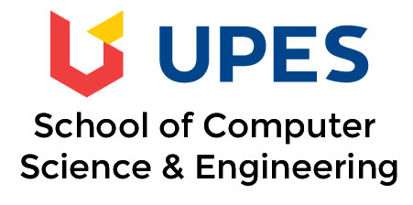

**Format No. QSP/7.1/01.F01 (B) Issue No.05 Rev. No 5 Dated: Jan 1, 2017**

**________________________________________________________________**

**UNIVERSITY OF PETROLEUM & ENERGY STUDIES**

**College of Engineering Studies**

**Dehradun**

**COURSE PLAN**

Programme : B. Tech CSE DevOps

Course : Source Code Management Lab

Subject Code : CSDV 1102

No. of credits : 1

Semester : II

Session : 2018-19

Batch : 2018-22

Prepared by : Monit Kapoor

Email : mkapoor@ddn.upes.ac.in

**Approved By**

Faculty HOD/ Prog. Head

UPES Campus Tel : +91-135-2770137

“Energy Acres” Fax : +91 135- 27760904

P.O. Bidholi, , Dehradun

**COURSE PLAN**

1. **PREREQUISITE:**

a. Basic Knowledge of Programming

1. **COURSE OUTLINE**

The course provides the deep understanding of Software Version Control tool with exercises on Git Client and github platform

Subject: **Source Code Management Course:** B.Tech-CSE-DevOps Duration/Session: **120 Minutes**

**Course Objectives:**

1. Examine the functionality of Software Version Control Systems.
2. Utilize the functionality of GIT to support version control of source code.
3. Assess workflows in various version control system like Git.
4. Apply the workflows to create collaboration with Co Participants
5. **COURSE OUTLINE**
6. Introducing Version Control

* Installing git CLI and git GUI , Initializing the repository and exploring git --help

1. Exploring Github and Creating a Public Repository
2. Working With Git

* Git status, add, commit, stage

1. Git Configuration Files

* Git attributes and gitignore, Staging files

1. Working With Git History

* Log, graphical history, undo changes in history

1. Merge Resolution In Git

* Git branch, basic conflict and merge resolution workflow

1. Project
2. **PEDAGOGY**  
   **Lab sessions with hands on sessions on Git commands and using them for version control**.
3. **COURSE COMPLETION PLAN**

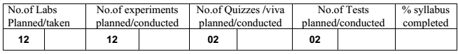

1. **EVALUATION & GRADING**

Students will be evaluated based on the following 2 stages.

Internal assessment - 50%

End term Examination - 50%

**INTERNAL ASSESSMENT:**

WEIGHTAGE- 50% Internal Assessment shall be based on the following:

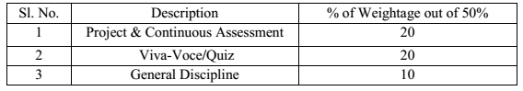

**Internal Assessment Record Sheet** will be displayed on LMS at the end of the  
semester i.e. in the last week of regular classroom teaching.

**CONTINUOUS ASSESSMENT:** Based on the weekly evaluation of the experiments actually performed by the students in the Laboratory and submitted on the same day or on the very next turn. A group project will be submitted and that will be evaluated.

*The continuous Assessment will be displayed on LMS/ICOS on monthly basis i.e. on*  
*the last two or three working days of every month.*

**MANDATORY: A group project assignment will be submitted by the students.**  
**Project progress / VIVA:** Progress of the project work will be discussed by the students twice the term each time a viva based exercise will be followed. Those who fail to do so shall be marked as absent and shall lose their marks.

The marks obtained by the students will be displayed on LMS after evaluation.

**GENERAL DISCIPLINE:** Based on student’s regularity, punctuality, sincerity and behavior in the class.  
The marks obtained by the students will be displayed on LMS at the end of semester.

**END TERM EXAMINATION: WEIGHTAGE – 50%**

Continuous evaluation mechanism shall be followed. Two viva voce shall be conducted at least alongwith project work evaluation which is also a important constituent of evaluation.

**GRADING:** The overall marks obtained at the end of the semester comprising the above two mentioned shall be converted to a grade.

1. **DETAILED SESSION PLAN**
2. Introducing Version Control – Git client(CLI,GUI), Linux environment Emulation
3. Installing git CLI and git GUI , Initializing the repository and exploring git --help
4. Exploring Github and Creating a Public Repository – Creating repository, understanding controls on the panel, working on Git Hub alone, realizing significance of Git Client for Github utilization
5. Working With Git – Commands for initiating repos, managing repos
6. Git status, add, commit, stage – Life cycle of a file in Git managed in Repos
7. Git Configuration Files – creating persolized configurations
8. Git attributes and gitignore, Staging files - /attributes for managing , filtering,masking
9. Working With Git History – Forensics on GIT logs
10. Log, graphical history, undo changes in history – creating presentable GUI for GIT activity in versioned repos
11. Merge Resolution In Git – Branching, tagging branches, creating test,dev,prod branches Scenario creation for conflict creation while merging branches by single user,multiple users
12. Git branch, basic conflict and merge resolution workflow- Resolution of merge conflicts
13. Project with team work demonstrating all aspects of GIT
14. **SUGGESTED READINGS:**

**G: 1 TEXT BOOKS:**

Source Code Management Lab Manual by Xebia  
**G: 2 REFERENCE BOOKS**  
Pro Git by Github

**G : 3 VIDEO RESOURCES (URL LINK) AND NPTEL LECTURES**

**Github.com/resources**

**GUIDELINES**  
***Cell Phones and other Electronic Communication Devices*:** Cell phones and other electronic communication devices (such as Blackberries/Laptops) are not permitted in classes during Tests or the Mid/Final Examination. Such devices MUST be turned off in the class room.  
***E-Mail and LMS:*** Each student in the class should have an e-mail id and a pass word to access the LMS system regularly. Regularly, important information – Date of conducting class tests, guest lectures, via LMS. The best way to arrange meetings with us or ask specific questions is by email and prior appointment. All the assignments preferably should be uploaded on LMS. Various research papers/reference material will be mailed/uploaded on LMS time to time.  
***Attendance:*** Students are required to have **minimum attendance of 75%** in each subject. Students with less than said percentage shall **NOT** be allowed to appear in the end semester examination.  
***Passing criterion:*** Student has to secure minimum 35 marks in total in order to pass in that lab subject.Students shall be evaluated in continuous learning mode

* Passing Criterion for B. Tech: minimum pass marks 35