History of Wildfires in Canada: UI Prototype
Marius Triboi | Project #23 | OSS4008A | November 12, 2026
Project #23 now has a working dashboard button and time slider in Colab: clicking Wildfires loads MODIS burned area for the year picked on the slider (2001-2023) over a satellite basemap.

The Wildfires button
Each project gets one button on the shared course dashboard. Clicking Wildfires loads the burned-area layer for the selected year.
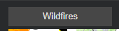

The year slider
Because this is a history project, a slider sets the year from 2001 to 2023. Moving it reloads the layer for that year.
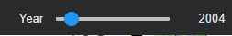

Full interface
The button, slider and interactive Google Earth Engine map work together, with zoom and box drawing from the map toolbar. Colours show the day of the year each area burned: yellow earlier, red later. This view shows 2023. The data is MODIS MCD64A1 at 500 m, so figures are estimates.
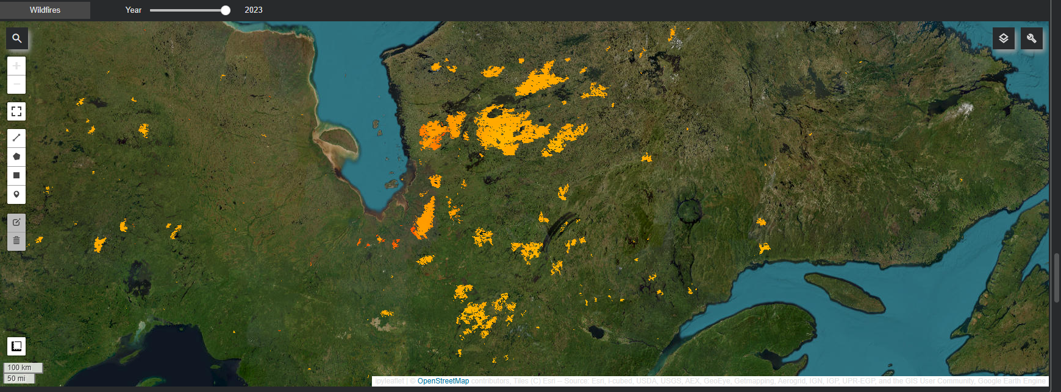

Planned AI panel
The dashboard sketch puts a chat-style AI panel beside the map. This is planned for Progress 3 and not built yet.
Example prompt | Planned response
Show wildfires on the map | Loads the burned-area layer for the selected year
Which year had the most burned area? | Reads the yearly results (2001-2023) and reports the top year
Compare 2023 with 2015 | Shows both years' layers and their burned area side by side

Status and next steps
- Built: Wildfires button, year slider, interactive map, yearly burned-area chart
- Next: annotated burn-scar data and AI model training, then connection to the shared dashboard and the AI panel

