QuantPredict: Next-Day Stock Direction Prediction Using Machine Learning, LSTM, Vision Transformer and Adaptive Ensemble Voting
BITE497J – Project I
Submitted in partial fulfillment of the requirements for the degree of
Bachelor of Technology
in
Information Technology
by
ADITYA RAI
23BIT0019
Under the guidance of
Dr. Brijendra Singh
School of Computer Science Engineering and Information Systems
VIT, Vellore

November, 2026

DECLARATION
I hereby declare that the BITE497J – Project I thesis entitled “QuantPredict: Next-Day Stock Direction Prediction Using Machine Learning, LSTM, Vision Transformer and Adaptive Ensemble Voting” submitted by me, for the award of the degree of Bachelor of Technology in Information Technology, School of Computer Science Engineering and Information Systems to VIT is a record of bonafide work carried out by me under the supervision of Dr. Brijendra Singh, SCORE, VIT, Vellore.
I further declare that the work reported in this thesis has not been submitted and will not be submitted, either in part or in full, for the award of any other degree or diploma in this institute or any other institute or university.

Place: Vellore
Date:

Signature of the Candidate
CERTIFICATE
This is to certify that the BITE497J – Project I thesis entitled “QuantPredict: Next-Day Stock Direction Prediction Using Machine Learning, LSTM, Vision Transformer and Adaptive Ensemble Voting” submitted by Aditya Rai (23BIT0019), SCORE, VIT, for the award of the degree of Bachelor of Technology in Information Technology, School of Computer Science Engineering and Information Systems, is a record of bonafide work carried out by the candidate under my supervision during the period, 06.07.2026 to 03.11.2026, as per the VIT code of academic and research ethics.
The contents of this report have not been submitted and will not be submitted either in part or in full, for the award of any other degree or diploma in this institute or any other institute or university. The thesis fulfills the requirements and regulations of the University and in my opinion meets the necessary standards for submission.

Place: Vellore
Date:

Signature of the Guide

Internal Examiner External Examiner

Head of the Department
Department of Information Technology
ACKNOWLEDGEMENT
It is my pleasure to express with a deep sense of gratitude to my BITE497 - Project I guide Dr. Brijendra Singh, School of Computer Science Engineering and Information Systems, Vellore Institute of Technology, Vellore for the constant guidance and continual encouragement in my endeavor. My association with my guide is not confined to academics only, but it is a great opportunity on my part to work with an intellectual and an expert in the field of machine learning and data analytics.
I would like to express my heartfelt gratitude to Honorable Chancellor Dr. G Viswanathan; respected Vice Presidents Dr. Sankar Viswanathan, Dr. Sekar Viswanathan, Vice Chancellor Dr. V. S. Kanchana Bhaaskaran; Pro-Vice Chancellor Dr. Partha Sharathi Mallick; and Registrar Dr. Jayabarathi T.
My whole-hearted thanks to Dean Dr. Daphne Lopez, School of Computer Science Engineering and Information Systems, Head, Department of Information Technology, Dr. Arivuselvan K, Information Technology Project Coordinator Dr. Suganya P, SCORE School Project Coordinator Dr. Karthikeyan P, all faculty, staff and members working as limbs of our university for their continuous guidance throughout my course of study in unlimited ways.
It is indeed a pleasure to thank my parents and friends who persuaded and encouraged me to take up and complete my project successfully. Last, but not least, I express my gratitude and appreciation to all those who have helped me directly or indirectly towards the successful completion of the project.

Place: Vellore
Date: Aditya Rai
Executive Summary
QuantPredict predicts whether the next day's closing price of a NIFTY-50 stock will finish above or below today's close. The final system uses 21 years of daily NSE data for Reliance Industries (2000 to 2021). It cleans the data, removes false price crashes caused by bonus issues and a demerger, and turns technical indicators into 37 stationary features. Eight models share one chronological 80/20 split: six classical classifiers, an LSTM and a Vision Transformer that reads each 20-day feature matrix as a patched image. Their outputs are combined through majority, soft, F1-weighted, adaptive weighted and stacked voting. All weights and tuning choices come from walk-forward validation inside the training years, and 18 automated checks confirm that no future information leaks into training.
On 1,052 unseen test days, Gradient Boosting was the strongest single model (53.6% accuracy). Adaptive weighted voting was the best voting rule (52.1%, 1.2 points above plain majority voting), and stacking with the ViT reached 52.4%. Every one of these gaps lies inside the ±3-point sampling band, which agrees with the view that next-day direction is close to a coin flip. The main outcome is an honest, leakage-free framework for comparing models and ensembles.
CONTENTS

Chapter | Title | Page No.
 | Acknowledgement | iv
 | Executive Summary | v
 | Table of Contents | vi
 | List of Figures | viii
 | List of Tables | ix
 | List of Abbreviations | x
 | Symbols and Notations | xi
1 | INTRODUCTION | 1
 | 1.1 Objective | 2
 | 1.2 Motivation | 3
 | 1.3 Background | 4
 | 1.4 Organisation of the Report | 6
2 | PROJECT DESCRIPTION AND GOALS | 7
 | 2.1 Problem Statement | 7
 | 2.2 Literature Survey | 7
 | 2.3 Findings from the Literature and Research Gap | 10
 | 2.4 Research Questions | 11
 | 2.5 Project Goals and Deliverables | 11
 | 2.6 Scope and Limitations | 12
3 | TECHNICAL SPECIFICATION | 13
 | 3.1 Hardware Requirements | 13
 | 3.2 Software Requirements | 13
 | 3.3 Dataset Specification | 14
 | 3.4 Functional Requirements | 15
 | 3.5 Non-Functional Requirements | 15
 | 3.6 Key Configuration Parameters | 16
4 | DESIGN APPROACH AND DETAILS | 17
 | 4.1 Design Approach / Materials and Methods | 17
 | 4.2 Codes and Standards | 41
 | 4.3 Constraints, Alternatives and Tradeoffs | 42
5 | SCHEDULE, TASKS AND MILESTONES | 44
 | 5.1 Project Timeline | 44
 | 5.2 Milestones | 45
 | 5.3 Task Breakdown | 45
 | 5.4 Challenges Faced and How They Were Resolved | 46
6 | PROJECT DEMONSTRATION | 48
 | 6.1 Running the System | 48
 | 6.2 Data Loading, Cleaning and Corporate Actions | 48
 | 6.3 Feature Engineering and Dataset Summary | 49
 | 6.4 Feature Selection | 50
 | 6.5 Training the Deep Models | 51
 | 6.6 Walk-Forward Validation | 52
 | 6.7 Ensemble Construction | 52
 | 6.8 Next-Day Prediction | 53
 | 6.9 Integrity Checklist | 54
 | 6.10 Generated Artefacts | 55
7 | RESULT AND DISCUSSION | 56
 | 7.1 Reading the Results: Two Reference Points | 56
 | 7.2 Performance of the Individual Models | 56
 | 7.3 Behaviour of the Deep Models | 58
 | 7.4 Feature Selection (Experiment 3) | 59
 | 7.5 Walk-Forward Validation Scores and Static Weights | 61
 | 7.6 Ensemble Results | 62
 | 7.7 Majority Versus Static Weighted Versus Adaptive Weighted Voting | 65
 | 7.8 Stacking | 67
 | 7.9 Statistical Significance | 68
 | 7.10 Comparison with Review-I and with the Literature | 69
 | 7.11 Discussion | 69
 | 7.12 Threats to Validity | 70
8 | SUMMARY | 71
 | 8.1 Key Findings | 71
 | 8.2 Contributions | 72
 | 8.3 Limitations | 72
 | 8.4 Recommendations and Future Work | 72
9 | REFERENCES | 74
 | APPENDIX A
List of Figures

Figure No. | Title | Page No.
4.1 | System Architecture of QuantPredict | 18
4.2 | Pipeline Flow from STEP 1 to STEP 18 | 19
4.3 | RELIANCE Close Price Before (a) and After (b) Corporate-Action Adjustment | 21
4.4 | Technical Indicators for RELIANCE over the Last 300 Trading Days | 23
4.5 | Class Balance of the Next-Day Target | 24
4.6 | Distribution of Adjusted Daily Returns of RELIANCE | 26
4.7 | Correlation Matrix of the 37 Features (Training Period) | 26
4.8 | Chronological Train/Test Split and Out-of-Fold Region | 27
4.9 | Alignment of 20-Day Input Windows with the Next-Day Label | 28
4.10 | Architecture of the LSTM Classifier | 30
4.11 | Patching a 20 × 37 Feature Window into Eight ViT Tokens | 31
4.12 | Architecture of the Vision Transformer for Financial Feature Matrices | 33
4.13 | Expanding-Window Walk-Forward Folds inside the Training Period | 34
4.14 | Ensemble Strategies Compared in QuantPredict | 35
4.15 | Information Available When the Adaptive Vote for Day t Is Cast | 37
4.16 | Use Case Diagram of QuantPredict | 40
4.17 | Conceptual Class Diagram of the Pipeline Modules | 40
4.18 | Sequence Diagram for One Complete Run | 41
5.1 | Gantt Chart of the Project Schedule | 44
6.1 | Adjusted Historical Close Price of RELIANCE (Pipeline Output) | 49
6.2 | Adjusted Daily Traded Volume of RELIANCE (Pipeline Output) | 49
6.3 | Mutual-Information and Random-Forest Feature Rankings (Training Data Only) | 50
6.4 | Training and Validation Loss of the LSTM and the Vision Transformer | 52
6.5 | Model Probabilities for the Trading Day After 30 April 2021 | 54
7.1 | Test Accuracy of the Individual Models with the Majority-Class Baseline | 57
7.2 | Confusion Matrices of the Best Model, the ViT and Four Ensembles | 58
7.3 | ROC-AUC of the Individual Models and the Ensembles on the Test Period | 58
7.4 | Walk-Forward Validation F1 of the Three Candidate Feature Sets | 60
7.5 | Test Accuracy with All Features Versus the Feature-Selected Variants | 61
7.6 | Out-of-Fold Validation Scores of the Eight Models | 62
7.7 | Test Accuracy of the Ensembles Compared with the Best Individual Model | 63
7.8 | F1-Score of the Individual Models (Purple) and the Ensembles (Teal) | 64
7.9 | Test Accuracy and F1 of the Three Voting Methods (7 Models) | 65
7.10 | OOF Accuracy for Each Adaptive Window and Sharpness Setting | 66
7.11 | Static Weights Versus Adaptive Weights (Mean and Range over the Test Period) | 66
7.12 | Adaptive Weights over the Test Period and Rolling 60-Day Accuracy of the Three Voting Methods | 67
7.13 | Coefficients of the Stacking Meta-Model (7- and 8-Model Versions) | 68
List of Tables

Table No. | Title | Page No.
1.1 | Review-I Baseline Versus the Final QuantPredict System | 6
2.1 | Summary of the Twenty Reviewed Studies (2024–2026) | 8
3.1 | Hardware Used and Minimum Requirements | 13
3.2 | Software Stack and Versions Used | 14
3.3 | Columns of the NSE Daily Data File (RELIANCE.csv) | 14
3.4 | Functional Requirements | 15
3.5 | Non-Functional Requirements | 15
3.6 | Key Configuration Constants in Quantpredict.py | 16
4.1 | Corporate Actions Detected and Adjusted for RELIANCE | 21
4.2 | The 37 Stationary Features Used by All Models | 25
4.3 | Classical Models and Their Hyperparameters | 29
4.4 | Vision Transformer Configuration | 33
4.5 | Walk-Forward Folds Used for Validation | 34
4.6 | Codes and Standards Followed | 41
4.7 | Design Alternatives Considered and the Choices Made | 42
5.1 | Project Phases, Periods and Outputs | 44
5.2 | Project Milestones | 45
5.3 | Work Packages and Approximate Share of Effort | 46
6.1 | Top-20 Features Chosen by Each Selector (Ranked) | 50
6.2 | Predictions for the Trading Day After 30 April 2021 | 53
6.3 | Output of the STEP 17 Leakage and Integrity Checklist | 54
6.4 | Files Written to the outputs Folder | 55
7.1 | Test Performance of the Eight Individual Models (All 37 Features) | 57
7.2 | Test Performance of the Feature-Selected Model Variants | 60
7.3 | Walk-Forward Validation Scores (Training Period Only) and Static Weights | 61
7.4 | Test Performance of the Fifteen Ensemble Variants | 63
7.5 | Final Comparison of the Three Voting Methods (STEP 18) | 65
7.6 | Significance of the Main Results (n = 1,052 Test Days) | 68
A.1 | Complete Test Results of All Individual, Ensemble and Feature-Selected Rows | 85
List of Abbreviations
ADX | Average Directional Index
API | Application Programming Interface
ATR | Average True Range
AUC | Area Under the (ROC) Curve
BB | Bollinger Bands
BCE | Binary Cross-Entropy
CPU | Central Processing Unit
CSV | Comma-Separated Values
DL | Deep Learning
EDA | Exploratory Data Analysis
EMA | Exponential Moving Average
FN | False Negative
FP | False Positive
GB | Gradient Boosting
GELU | Gaussian Error Linear Unit
GPU | Graphics Processing Unit
INR | Indian Rupee
KNN | K-Nearest Neighbours
LR | Logistic Regression
LSTM | Long Short-Term Memory
MACD | Moving Average Convergence Divergence
MHSA | Multi-Head Self-Attention
MI | Mutual Information
ML | Machine Learning
MLP | Multi-Layer Perceptron
NIFTY-50 | National Stock Exchange Fifty (benchmark index)
NSE | National Stock Exchange of India
OBV | On-Balance Volume
OHLCV | Open, High, Low, Close, Volume
OOF | Out-Of-Fold
RBF | Radial Basis Function
ReLU | Rectified Linear Unit
RF | Random Forest
RNN | Recurrent Neural Network
ROC | Receiver Operating Characteristic
RSI | Relative Strength Index
SMA | Simple Moving Average
SVM | Support Vector Machine
TN | True Negative
TP | True Positive
ViT | Vision Transformer
XGBoost | Extreme Gradient Boosting
Symbols and Notations
O_{t}, H_{t}, L_{t}, C_{t}, V_{t} | Open, high, low, close price and volume on trading day t
r_{t} | Simple daily return, C_{t} / C_{t-1} − 1
y_{t} | Target label of day t (1 = next close higher, 0 = otherwise)
x_{t} | Vector of the 37 standardised features of day t
L | Sequence length used by the LSTM and ViT (20 trading days)
N | Number of modelling samples (5,256)
μ, σ | Mean and standard deviation (scaler statistics, volatility)
z | Standardised feature value
h_{t}, c_{t} | LSTM hidden state and cell state
f_{t}, i_{t}, o_{t} | LSTM forget, input and output gates
σ(·) | Logistic sigmoid function
⊙ | Element-wise (Hadamard) product
Q, K, V | Query, key and value matrices in self-attention
d_{k} | Dimension of each attention head (16)
M | Number of base models in an ensemble (6, 7 or 8)
p_{i} | Probability P(UP) output by model i
ŷ_{i} | Hard UP/DOWN prediction of model i
w_{i} | Static voting weight of model i
w_{i}(t) | Adaptive voting weight of model i on day t
a_{i}(t) | Accuracy of model i over the last W known days
W | Look-back window of adaptive voting (250 days chosen)
β | Sharpness (inverse temperature) of the adaptive softmax (20 chosen)
θ | Decision threshold on P(UP) (0.5)
I(X; Y) | Mutual information between a feature and the target

CHAPTER 1
INTRODUCTION
Every trading day the National Stock Exchange of India (NSE) records five numbers for each listed company: the opening price, the day's high, the day's low, the closing price and the number of shares traded. Over twenty years these numbers form a long and noisy time series that investors, analysts and, more recently, machine-learning researchers try to read. One question sounds almost trivial: will tomorrow's close be higher or lower than today's? In practice it is one of the harder problems in applied machine learning. Prices react to news that is not in the data, the behaviour of the market drifts from one period to the next, and any pattern that is easy to find tends to be traded away once enough people find it (Fama, 1970; Lo, 2004).
QuantPredict is my attempt to study that question carefully instead of promising an answer to it. The project is a complete Python pipeline that takes the daily OHLCV history of one NIFTY-50 stock, engineers technical features, trains eight different models and then combines them through several voting and stacking schemes. The guiding idea is fair comparison. Every model is tested on the same 1,052 trading days that come after the training period, every tuning decision is taken without looking at those days, and the code checks itself for look-ahead leakage before it reports anything. Compared with the Review-I baseline, which had six classical classifiers and a simple majority vote, the final system adds an LSTM, a Vision Transformer adapted to financial feature matrices, corporate-action adjustment of prices, stationary features, leakage-safe feature selection, walk-forward validation, performance-weighted voting, adaptive weighted voting and stacking.
The results are modest and they are reported as they came out. The best single model, Gradient Boosting, was right on 53.6% of the test days. The best voting rule, adaptive weighted voting, reached 52.1% and beat plain majority voting by 1.2 percentage points, but that gap is smaller than the random variation one should expect from a test set of this size. So the project does two things: it shows how to measure these effects without fooling oneself, and it shows that, for next-day direction on a large Indian stock, the effects are small.

1.1 Objective
The primary objective of this project is to develop a reproducible, leakage-free machine-learning framework that predicts the next-day direction (UP or DOWN) of a NIFTY-50 stock from its historical OHLCV data, and to find out experimentally whether combining heterogeneous models, with weights that follow their recent performance, predicts better than the individual models do. The specific objectives are listed below.
- Load, clean and corporate-action-adjust the raw NSE daily price files so that bonus issues, splits and demergers do not show up as fake price crashes.
- Compute standard technical indicators (MACD, RSI, SMA, EMA, Bollinger Bands, ATR, OBV and ADX) and convert them into 37 stationary, scale-free features.
- Train six classical classifiers (Logistic Regression, Random Forest, Gradient Boosting, XGBoost, SVM and KNN) as baselines on a chronological 80/20 split.
- Add two deep sequence models that read the last 20 trading days: an LSTM, and a Vision Transformer (ViT) that treats each 20 × 37 feature window as a small image cut into patches.
- Select features with mutual information and tree importance fitted on training data only, and report the feature-selected models as separate, clearly labelled experiments.
- Produce walk-forward out-of-fold predictions inside the training period and use them, and nothing else, to set ensemble weights, tune adaptive voting and train a stacking meta-model.
- Compare majority, soft, static weighted, adaptive weighted and stacked ensembles on one common test period using accuracy, precision, recall, F1-score and ROC-AUC.
- Verify in code that no scaler, selector, weight or meta-model has seen future data, and give a clearly labelled prediction for the trading day after the last date in the data.

1.2 Motivation
Retail participation in Indian equities has grown quickly, and with it the number of tools, blog posts and videos that claim to forecast stock prices with machine learning. While reading this material during the literature survey, I noticed how often the reported results quietly break a basic rule of time-series evaluation. A random train/test split lets a model learn from days that come after the days it is tested on. A scaler fitted on the whole dataset passes the future mean and variance into the training data. A sequence window that ends one day too late places tomorrow's price inside today's input. Any one of these mistakes can make a weak model look strong on paper, and the mistake is usually invisible in the final accuracy table. Building a pipeline in which these mistakes are checked for, rather than assumed away, was the first motivation for this project.
The second motivation came from the Review-I discussion. Financial markets are non-stationary: a model that does well in a calm, trending year can do badly in a volatile one. If that is true, giving every model an equal and permanent vote is a strong assumption. It seemed worth testing whether the votes should instead follow each model's recent track record, which is the idea behind the adaptive weighted voting implemented here. Online-learning theory has studied this kind of re-weighting for a long time (Littlestone & Warmuth, 1994; Freund & Schapire, 1997), but it is rarely tested carefully on Indian equity data with heterogeneous classical and deep models in the same ensemble.
The third motivation was curiosity about transformers. Vision Transformers changed image recognition by cutting an image into patches and letting self-attention relate the patches to each other (Dosovitskiy et al., 2021). A window of technical indicators is also a two-dimensional grid, with time on one axis and features on the other. Because the LSTM already builds exactly these 20-day windows, adding a ViT that reads the same windows was cheap to try, and it gives a direct, like-for-like comparison between a recurrent model and an attention model on the same inputs.
Finally, a careful baseline is useful in its own right. Future work on news sentiment, more stocks or intraday data needs a trustworthy reference point. A pipeline that reports “the ensemble did not help” when it did not help is more useful as such a reference than one that always reports success.

1.3 Background

1.3.1 The Indian Equity Market and the NIFTY-50
The NIFTY-50 is the benchmark index of the NSE and tracks fifty large, liquid companies across sectors such as energy, banking, information technology and consumer goods. Daily data for the index constituents is publicly available, and this project uses the widely used Kaggle collection of NSE daily files covering January 2000 to April 2021 (Rao, 2021). Reliance Industries Ltd. (symbol RELIANCE), listed under the energy industry in the dataset's metadata file, is one of the largest companies in the index by market capitalisation. Its long history, high liquidity and several corporate actions (two 1:1 bonus issues and a demerger) make it a good and demanding test case. The pipeline is not tied to this stock: changing a single constant (STOCK_SYMBOL) runs the same experiment on any other file in the collection.

1.3.2 Predicting Direction Instead of Price
Stock forecasting can be framed as regression (predict the price) or as classification (predict the direction of the move). Price regression has a well-known trap: a model that simply copies today's close as tomorrow's forecast achieves a very low error because prices change little from day to day, yet it carries no useful information. Direction is the quantity a trader actually acts on, it is invariant to the price level, and it gives a clean, interpretable baseline. In this dataset 51.6% of days are followed by a higher close, so a useful model has to beat roughly 52% rather than 50%. QuantPredict therefore treats the task as binary classification, in line with many of the reviewed studies (Patel et al., 2015; Ballings et al., 2015; Kundu & Pinsky, 2025).

1.3.3 Machine Learning and Deep Learning for Financial Time Series
Classical machine-learning models such as logistic regression, random forests, gradient-boosted trees, support vector machines and nearest-neighbour classifiers have been applied to stock direction for many years (Patel et al., 2015; Ballings et al., 2015; Krauss et al., 2017). They work on a fixed vector of features for each day and are fast to train. Recurrent networks, and LSTMs in particular (Hochreiter & Schmidhuber, 1997), read a sequence of days and can, in principle, learn temporal patterns that a single-day feature vector misses; Fischer and Krauss (2018) is a frequently cited example on S&P 500 stocks, and later surveys document how common LSTMs have become in this area (Sezer et al., 2020; Jiang, 2021).
Transformers (Vaswani et al., 2017) replaced recurrence with self-attention. In vision, the ViT showed that cutting an image into patches and treating the patches as tokens works well (Dosovitskiy et al., 2021). Patch-based transformers have since been applied to time series, for example PatchTST (Nie et al., 2023). At the same time, Zeng et al. (2023) questioned whether transformers really beat simple models on time series. That debate is one reason the ViT in this project is evaluated side by side with simpler models rather than assumed to be better.

1.3.4 Ensemble Learning
An ensemble combines several models so that their individual errors partly cancel out (Dietterich, 2000). The simplest rule is majority voting. Soft voting averages predicted probabilities, and weighted voting gives more say to models that validated better (Kittler et al., 1998). Stacking goes one step further and trains a second-level model on the base models' predictions (Wolpert, 1992). When the data change over time, a fixed combination can become stale; dynamic selection and concept-drift adaptation methods try to re-weight models as conditions change (Gama et al., 2014; Cruz et al., 2018). The adaptive weighted voting in QuantPredict belongs to this family: weights are recomputed every day from each model's accuracy over the most recent days whose outcomes are already known.

1.3.5 Data Leakage in Time-Series Evaluation
Standard k-fold cross-validation shuffles the data, which is harmless for independent samples but not for time series, where neighbouring days are related and the future must never inform the past (Bergmeir & Benítez, 2012). López de Prado (2018) describes many ways in which financial backtests leak information, from overlapping labels to selection on the test set. QuantPredict follows three simple rules that address the most common forms: split chronologically, fit every data-dependent step (scalers, selectors, weights, meta-models) on past data only, and validate with expanding walk-forward folds that never cross into the test period.

1.3.6 Progress Since Review-I
Review-I presented the baseline pipeline and the research gap. Since then the system has changed in almost every stage. Table 1.1 summarises the differences between the Review-I baseline and the final implementation described in this report.
Table 1.1 Review-I Baseline Versus the Final QuantPredict System
Aspect | Review-I baseline | Final system (this report)
Data preparation | Cleaning and sorting only | Cleaning plus automatic split/bonus/demerger adjustment (3 events found for RELIANCE)
Features | OHLCV levels, indicators, lags and rolling statistics (38 inputs) | 37 stationary features: returns, ratios to close, oscillators, volume ratios and lags
Models | 6 classical classifiers | 6 classical + LSTM + Vision Transformer (8 models)
Feature selection | None | Mutual Information and tree-importance Top-20, chosen by walk-forward F1
Validation | Single chronological split | Chronological split plus 4-fold expanding walk-forward validation inside the training period
Ensembles | Majority voting | Majority, soft, static weighted, adaptive weighted voting and stacking (15 variants)
Leakage control | Manual care | 18 automated PASS/FAIL integrity checks, including a label-scrambling test
Reporting | Accuracy-type metrics | Accuracy, precision, recall, F1, ROC-AUC, majority-class baseline and sampling-noise band

1.4 Organisation of the Report
Chapter 2 states the problem, reviews twenty recent studies and derives the research questions. Chapter 3 gives the technical specification: hardware, software, dataset and requirements. Chapter 4 describes the design in detail, including every equation used by the pipeline, the model architectures, the validation scheme, the ensemble rules and the UML diagrams, followed by the codes and standards and the design trade-offs. Chapter 5 presents the schedule and milestones. Chapter 6 demonstrates a complete run of the system with its console output and generated artefacts. Chapter 7 reports and discusses the results. Chapter 8 summarises the work and lists recommendations for future work, and Chapter 9 lists the references. Appendix A contains selected source-code excerpts and the complete results table.

CHAPTER 2
PROJECT DESCRIPTION AND GOALS
This chapter defines the prediction problem formally, reviews recent work on stock-direction prediction, identifies the gap that QuantPredict addresses and states the research questions and goals that shaped the final system.

2.1 Problem Statement
Let C_{t} be the adjusted closing price of a stock on trading day t, and let x_{t} be a vector of features computed only from information available at the close of day t. The task is to learn a classifier that outputs the label y_{t} defined in Eqn. 2.1, using x_{t} (for the classical models) or the window of the last 20 feature vectors (for the sequence models).
 | $$y_{t}=\left\{\begin{matrix}1 (UP), & C_{t+1}>C_{t} \\ 0 (DOWN), & otherwise\end{matrix}\right.$$ | (2.1)

In Eqn. 2.1 a day on which the price is unchanged counts as DOWN. The prediction for day t is made after the close of day t and is judged when the close of day t+1 is known. The problem statement for the project can therefore be written as follows: design and evaluate a data-driven system that predicts whether a NIFTY-50 stock will close higher on the next trading day, compare eight heterogeneous models under one leakage-free protocol, and test whether weighted, adaptive or stacked combinations of these models predict better than equal majority voting and better than the best single model.
Three constraints make the problem realistic. First, the evaluation must be chronological: no information from a later day may influence a prediction for an earlier day. Second, all models must be scored on exactly the same test days, otherwise their numbers cannot be compared. Third, the reported results must include negative findings, because a method that does not beat a simple baseline is still an informative result.

2.2 Literature Survey
The survey from Review-I was kept and extended. It covers twenty recent studies (2024 to 2026) that are available in open-access form, plus the foundational works on each technique used in the project. The papers span LSTM and GRU models, technical-indicator studies, multimodal fusion, hybrid and ensemble models, and comparative studies on Indian and other emerging markets. Table 2.1 lists each study with its main merit, its main limitation and its relation to QuantPredict.
Table 2.1 Summary of the Twenty Reviewed Studies (2024–2026)
No. | Study | Approach and merits | Limitations | Relation to QuantPredict
1 | Tang, Tang & Wang (2024) | Multi-input LSTM with wavelet denoising; uses Chinese, US and indicator inputs and beats several classical baselines on direction. | Extra preprocessing and several input streams add complexity; results tied to the chosen index data. | Supports sequence learning; QuantPredict keeps one feature set and compares model families fairly.
2 | Saud & Shakya (2024) | MACD, DMI and KST signals with LSTM/GRU across NEPSE, BSE and NYSE stocks. | Results depend on indicator choice and look-back period, and vary by market. | Confirms indicator-driven design; QuantPredict asks whether model influence should vary over time.
3 | Chen, Boukouvalas & Corizzo (2024) | Deep fusion of prices, indicators and news sentiment with LSTM and BERT-type models. | Needs news collection, NLP processing and careful time alignment. | QuantPredict stays numerical and reproducible; news is left for future work.
4 | Lee, Kim & Jung (2024) | Combines ESG news sentiment with technical indicators in a deep model, with ablation analysis. | Depends on external ESG data quality; S&P 500 price prediction. | Shows value of richer data; QuantPredict tests ensemble design without external data.
5 | Phuoc et al. (2024) | LSTM with SMA, MACD and RSI for trend prediction in Vietnam, an emerging market. | Market-specific; may not transfer to Indian equities. | Motivates validation on Indian data across several model families.
6 | Parra-Domínguez & Sanz-Martín (2024) | Evaluates AI models with SMA, EMA, MACD, RSI on the Euro Stoxx 50. | European setting; no adaptive weighting of models. | QuantPredict moves to Indian equities and adds time-varying model weights.
7 | Mochurad & Dereviannyi (2024) | Ensemble of LSTM and ARIMA improves on the individual forecasters. | Price regression with a fixed combination rule. | QuantPredict compares equal, static weighted, adaptive and stacked rules for direction.
8 | Zong et al. (2025) | Gated cross-attention fuses indicator sequences, documents and relational graphs. | Many heterogeneous sources and a complex architecture; sparse and conflicting data. | QuantPredict uses attention (ViT) on numeric indicator windows only.
9 | Zhang et al. (2025) | VMD decomposition, TMFG graph feature selection and LSTM on Shanghai stocks. | Several preprocessing stages; price regression. | QuantPredict uses simpler, leakage-safe MI/tree selection judged by walk-forward F1.
10 | Din et al. (2025) | Attention-customised BiLSTM combined with XGBoost in a decision ensemble. | Focused on BTC-USD price forecasting with one specific architecture. | Shows ML-DL ensembles are established; QuantPredict tests a wider heterogeneous set.
11 | Mostafavi & Hooman (2025) | Evaluates 88 indicators with XGBoost, RF, SVR and LSTM and ranks indicator importance. | Large indicator spaces bring redundancy; S&P 500 regression. | Supports systematic feature analysis; QuantPredict reports MI and tree rankings.
12 | Nugroho et al. (2025) | Hybrid of LSTM, RF and ARIMA with linear regression as meta-learner. | Fixed hybrid structure; price forecasting. | Related to stacking; QuantPredict trains its meta-model on out-of-fold predictions only.
13 | Mohapatra et al. (2025) | RF, GB and XGBoost on 20 Indian bank stocks with technical, fundamental and macro variables. | Longer holding periods and richer inputs than next-day direction. | Indian-market evidence; QuantPredict focuses on a controlled next-day comparison.
14 | Kundu & Pinsky (2025) | Daily direction with LSTM, CNN, RNN and traditional methods; sector-level analysis. | Deep learning does not help for every stock or sector. | Supports comparing models instead of assuming the deep model wins.
15 | Kulkarni et al. (2025) | Compares time-series, ML and DL models and stresses context-specific performance. | No single model is best everywhere. | Directly motivates adaptive, context-dependent model weights.
16 | Bustos, Pomares-Quimbaya & Stellian (2025) | Broad comparative study linking ML forecasting to market efficiency. | Aggregate comparisons can hide period-level differences. | QuantPredict reports rolling accuracy over the test period, not only one number.
17 | Fattoh, El Maghawry Ibrahim & Mousa (2025) | RF, linear regression, LSTM and Bi-LSTM across several Egyptian stocks. | Market-specific; regression metrics; no ensemble voting. | Reinforces the need for market-specific validation.
18 | Chaudhary & Minirani (2025) | ARIMA, SARIMA and LSTM on Indian banking stocks. | Narrow model family and price-error metrics. | QuantPredict widens the model set and uses classification metrics.
19 | Wang et al. (2025) | LSTM with investor sentiment and blockchain-based secure deployment. | Infrastructure complexity beyond the prediction task. | QuantPredict concentrates on prediction and evaluation integrity.
20 | Abd-Elwahab et al. (2026) | Hybrid framework joining technical and fundamental analysis with LSTM. | Needs fundamental data; Egyptian market. | QuantPredict first tests what technical data alone can do, with strict validation.

Several themes come out of Table 2.1. The first is that sequence models are now the default choice. Tang et al. (2024), Phuoc et al. (2024), Zhang et al. (2025) and Abd-Elwahab et al. (2026) all build on LSTMs, and most report gains over classical baselines on their chosen markets. The gains, however, are usually reported for one market and one period, and the studies differ in whether they predict price or direction, which makes it hard to compare them.
The second theme is the use of technical indicators as inputs. Saud and Shakya (2024) and Mostafavi and Hooman (2025) show that the choice and number of indicators matter, and that large indicator sets contain a lot of redundancy. This is consistent with the high correlations found among the moving-average features in QuantPredict (Section 4.1.7) and is one reason the project tests feature selection explicitly.
The third theme is richer data. Chen et al. (2024), Lee et al. (2024) and Zong et al. (2025) add news, ESG sentiment, documents or relational graphs. These studies show that extra information can help, but they also need large data-collection and alignment efforts. QuantPredict deliberately stays with price and volume data so that the effect of model and ensemble design can be isolated.
The fourth theme is combination. Mochurad and Dereviannyi (2024), Din et al. (2025) and Nugroho et al. (2025) combine statistical, machine-learning and deep models, and Mohapatra et al. (2025) use tree ensembles on Indian bank stocks. In nearly all of these the combination rule is fixed once trained. Kulkarni et al. (2025), Kundu and Pinsky (2025) and Bustos et al. (2025) point the other way: they find that the best model depends on context, sector and period, and that deep learning does not help everywhere. If the best model changes over time, a combination rule that also changes over time is a natural thing to test.
Beyond these twenty studies, the design rests on foundational work: LSTMs (Hochreiter & Schmidhuber, 1997), transformers and ViTs (Vaswani et al., 2017; Dosovitskiy et al., 2021), random forests (Breiman, 2001), gradient boosting (Friedman, 2001; Chen & Guestrin, 2016), support vector machines (Cortes & Vapnik, 1995), nearest-neighbour classification (Cover & Hart, 1967), stacked generalisation (Wolpert, 1992), classifier combination (Kittler et al., 1998), mutual-information estimation (Kraskov et al., 2004; Ross, 2014) and time-series validation (Bergmeir & Benítez, 2012).

2.3 Findings from the Literature and Research Gap
The survey led to the following findings, which together define the gap that QuantPredict addresses.
- Individual ML models, LSTMs, hybrid ML-DL systems and ensembles are all established. Adding an LSTM to classical models, or replacing majority voting with weighted voting, is not new in itself and is not claimed as the novelty of this work.
- Reported accuracies are hard to compare and are sometimes inflated by evaluation choices. Few studies state, let alone test, that their scalers, feature selectors and ensemble weights were fitted without the test period.
- Model usefulness is context-dependent and changes over time, yet most ensembles use fixed weights. Whether weights should follow recent performance has received little controlled testing on Indian equity data.
- Vision Transformers are well studied for images, and patch-based transformers for long-horizon forecasting, but a ViT that reads a short window of technical indicators as a patched matrix for next-day direction is rarely compared head-to-head with an LSTM and classical models on identical inputs.
- Negative or near-chance results are under-reported. A transparent framework that states when a method does not beat a simple baseline is itself a useful contribution.
The gap is therefore methodological and comparative. QuantPredict does not claim to invent adaptive ensembles. It builds a transparent, leakage-checked framework for Indian equity data and uses it to measure how much heterogeneous models, a ViT and adaptive model weighting actually add to next-day direction prediction.

2.4 Research Questions
The final system was designed to answer four research questions.
- RQ1. How accurately do six classical models, an LSTM and an adapted Vision Transformer predict next-day direction on the same leakage-free test period, and do any of them beat the majority-class baseline?
- RQ2. Does a Vision Transformer that reads 20-day technical-feature matrices as patched images add value, either on its own or as a member of an ensemble?
- RQ3. Do soft, performance-weighted, adaptive weighted or stacked ensembles beat equal majority voting and the best single model?
- RQ4. Does leakage-safe feature selection (mutual information or tree importance) improve on the full 37-feature set?

2.5 Project Goals and Deliverables
The goals that follow from the research questions, and the deliverable produced for each, are listed below.
- A single, documented pipeline (Quantpredict.py) that runs end to end in Google Colab or locally and is organised into numbered steps from data loading (STEP 1) to the final voting comparison (STEP 18).
- Eight trained models scored on the same 1,052 test days, with accuracy, precision, recall, F1-score and ROC-AUC.
- Fifteen ensemble variants covering majority, soft, static weighted, adaptive weighted voting and stacking, each in a 7-model form (six classical plus LSTM) and, where relevant, an experimental 8-model form that includes the ViT.
- Fourteen feature-selected model variants reported separately from the baseline rows.
- An integrity checklist of 18 programmatic checks that must all pass before the results are trusted.
- Result files and figures: a full comparison table (CSV), a voting comparison table (CSV) and ten figures written to the outputs folder.
- A next-day prediction for the trading day after the last row of data, with each model's probability and each ensemble's decision.

2.6 Scope and Limitations
The project predicts next-day direction from daily price and volume data. The main experiment uses RELIANCE, but any of the 49 usable single-stock files in the dataset can be selected. The project does not predict exact prices, does not use news, fundamentals or intraday data, and does not simulate a trading strategy with transaction costs, slippage or position sizing. The data end on 30 April 2021, so the results describe the period from 2017 to April 2021. The next-day prediction printed by the program is a statistical estimate for study purposes and is not investment advice.

CHAPTER 3
TECHNICAL SPECIFICATION
This chapter lists the hardware and software used to build and run QuantPredict, describes the dataset in detail and sets out the functional and non-functional requirements that the implementation satisfies. It ends with the key configuration constants of the pipeline.

3.1 Hardware Requirements
The pipeline was developed and run on a personal laptop, and it was also kept compatible with Google Colab. Deep-learning code uses a GPU when PyTorch reports one, but the final run reported here used the CPU only, since the installed PyTorch build was the CPU version. A complete run, including the 4-fold walk-forward retraining of all eight models, took about four minutes on the machine in Table 3.1.
Table 3.1 Hardware Used and Minimum Requirements
Component | Used for the final run | Minimum requirement
Processor | Intel Core i9-13900HX (32 logical processors) | Any 64-bit dual-core CPU
Memory (RAM) | 16 GB | 8 GB (Colab default is sufficient)
GPU | Not used (CPU build of PyTorch) | Optional; CUDA is used automatically if available
Storage | About 55 MB for the dataset and 1.2 MB for outputs | 200 MB free space
Operating system | Windows 11 Home (64-bit) | Windows, Linux or macOS; or Google Colab
Run time | About 4 minutes for a full run | Up to 15–20 minutes on a basic Colab CPU

3.2 Software Requirements
QuantPredict is written in Python. It uses pandas and NumPy for data handling, the ta library for technical indicators, scikit-learn and XGBoost for the classical models and evaluation, and either TensorFlow/Keras or PyTorch for the deep models. The deep-learning backend is detected automatically: TensorFlow is used if it is installed (as in Colab), otherwise PyTorch. Both backends implement exactly the same LSTM and ViT architectures, so results remain comparable (Pedregosa et al., 2011; Chen & Guestrin, 2016; Paszke et al., 2019). Table 3.2 lists the versions used for the final run.
Table 3.2 Software Stack and Versions Used
Software / library | Version | Purpose in the project
Python | 3.14.5 | Implementation language
pandas | 3.0.5 | Loading CSV files, cleaning, feature tables
NumPy | 2.5.2 | Arrays, sequence windows, weight calculations
ta (Technical Analysis Library) | 0.11.0 | MACD, RSI, SMA, EMA, Bollinger Bands, ATR, OBV, ADX
scikit-learn | 1.9.0 | LR, RF, GB, SVM, KNN, scaling, feature selection, metrics
XGBoost | 3.4.1 | Extreme gradient boosting classifier
PyTorch | 2.13.0 (CPU) | LSTM and Vision Transformer (backend used in the final run)
TensorFlow / Keras | Optional | Preferred backend when installed (e.g. Google Colab)
matplotlib | 3.11.1 | All result figures
seaborn | 0.13.2 | Confusion-matrix heatmaps and plot styling
Google Colab / Jupyter | Optional | Notebook execution; the script pip-installs ta and xgboost

3.3 Dataset Specification
The data come from the public Kaggle dataset “NIFTY-50 Stock Market Data (2000–2021)” (Rao, 2021). It contains one CSV file per NIFTY-50 constituent, a combined file (NIFTY50_all.csv) and a metadata file (stock_metadata.csv). The loader skips the combined and metadata files and any file smaller than 1 KB, which excludes the empty INFRATEL.csv and leaves 49 usable stock files. The RELIANCE file has 5,306 daily rows from 3 January 2000 to 30 April 2021 and 15 columns, described in Table 3.3.
Table 3.3 Columns of the NSE Daily Data File (RELIANCE.csv)
Column | Description | Used
Date | Trading date (ISO 8601, YYYY-MM-DD) | Yes
Symbol, Series | Ticker (RELIANCE) and series (EQ) | No
Prev Close | Previous day's close (not adjusted for corporate actions) | No
Open, High, Low, Close | Raw traded prices in INR | Yes
Last | Last traded price | No
VWAP | Volume-weighted average price | No
Volume | Number of shares traded | Yes
Turnover | Traded value | No
Trades, Deliverable Volume, %Deliverble | Trade count and delivery data (missing in early years) | No

Only the date and the five OHLCV columns are used. The other columns are either derived from these, missing for the early years, or not adjusted for corporate actions. In the raw file the close ranges from INR 203.20 to INR 3,220.85 and the daily volume from 52,820 to about 65.2 million shares. These raw prices are not adjusted for bonus issues, which is handled in STEP 2a (Section 4.1.4).

3.4 Functional Requirements
Table 3.4 Functional Requirements
ID | Requirement | Pipeline step
FR1 | Load the CSV of a chosen stock symbol, or prompt for an upload in Colab | STEP 1
FR2 | Validate the date and OHLCV columns, remove invalid and duplicate rows, sort by date | STEP 2
FR3 | Detect and back-adjust splits, bonus issues and demergers | STEP 2a
FR4 | Compute technical indicators and 37 stationary features with the next-day target | STEPS 3–4
FR5 | Split chronologically 80/20 and standardise with training statistics only | STEP 5
FR6 | Select features by MI and tree importance using walk-forward validation | STEP 6
FR7 | Train and score six classical models, an LSTM and a ViT | STEPS 7–9, 10A
FR8 | Generate walk-forward out-of-fold predictions for all eight models | STEP 10B
FR9 | Build majority, soft, weighted, adaptive weighted and stacked ensembles | STEPS 11–14
FR10 | Produce comparison tables, CSV files and figures | STEPS 15, 18
FR11 | Predict the direction of the next unseen trading day | STEP 16
FR12 | Run and print the leakage and integrity checklist | STEP 17

3.5 Non-Functional Requirements
Table 3.5 Non-Functional Requirements
Quality | Requirement and how it is met
Temporal correctness | No random shuffling anywhere; all fitted objects see training (or fold-training) rows only; enforced by assertions and STEP 17
Reproducibility | Fixed seed 42 for Python, NumPy, TensorFlow and PyTorch; deterministic TensorFlow settings; seeds re-applied before each deep model
Comparability | Every model and ensemble is scored on the identical 1,052 test days; asserted in code
Portability | Runs in Colab or locally; TensorFlow or PyTorch backend with identical architectures
Performance | Small models and a reduced epoch budget (20) inside walk-forward folds keep a full run within minutes
Maintainability | Numbered steps, a model factory for fresh unfitted models, shared helper functions and extensive comments
Transparency | Baseline rows are never overwritten; negative results (e.g. ensembles not beating the best model) are printed explicitly
Usability | One constant (STOCK_SYMBOL) selects the stock; figures and tables are saved automatically to outputs/

3.6 Key Configuration Parameters
All tunable values are defined as named constants near the step that uses them. Table 3.6 lists the values used for every result in this report.
Table 3.6 Key Configuration Constants in Quantpredict.py
Constant | Value | Meaning
STOCK_SYMBOL | RELIANCE | Stock file used for the experiment
SEED | 42 | Global random seed
CA_THRESHOLD | 0.78 | Open and close below 0.78 × previous close marks a corporate action
WINDOW_SIZE | 20 | Trading days per LSTM / ViT input window
Split ratio | 0.80 | First 80% of days for training, last 20% for testing
TOP_K_FEATURES | 20 | Features kept by each feature selector
WF_N_SPLITS | 4 | Walk-forward folds inside the training period
WF_INITIAL_TRAIN_FRAC | 0.50 | First fold trains on the first half of the training period
WF_DL_EPOCHS | 20 | Maximum deep-learning epochs inside each fold
EPOCHS / BATCH_SIZE | 35 / 32 | LSTM maximum epochs and batch size
LEARNING_RATE / DROPOUT | 0.001 / 0.20 | Adam learning rate and dropout rate (LSTM)
PATIENCE | 8 | Early-stopping patience (LSTM and ViT)
THRESHOLD | 0.50 | P(UP) at or above which UP is predicted
VIT_PATCH_T / VIT_FEATURE_PATCHES | 5 / 2 | Patch height in days / number of feature groups
VIT_D_MODEL / VIT_HEADS / VIT_LAYERS | 64 / 4 / 2 | Embedding size, attention heads, encoder blocks
VIT_MLP_DIM / VIT_EPOCHS | 128 / 40 | Feed-forward width and maximum ViT epochs
ADAPTIVE_WINDOWS | 20, 60, 120, 250 | Candidate look-back windows for adaptive voting
ADAPTIVE_BETAS | 0, 5, 10, 20 | Candidate softmax sharpness values

CHAPTER 4
DESIGN APPROACH AND DETAILS
This chapter explains how QuantPredict is built. Section 4.1 walks through the design from the raw CSV file to the final ensemble decision, giving the equations that the code implements and the reasons behind each choice. Section 4.2 lists the codes and standards that were followed, and Section 4.3 discusses the constraints, the alternatives that were considered and the trade-offs that were accepted.

4.1 Design Approach / Materials and Methods
The whole system lives in a single Python file of about 2,500 lines, organised as a sequence of numbered steps (STEP 1 to STEP 18). The file started life as a Google Colab notebook, and it still runs top to bottom as one script. Three design rules shape every step. First, nothing that is fitted or tuned may see data from its own future: scalers, feature selectors, voting weights and the stacking meta-model learn from training rows only. Second, nothing is shuffled, so the chronological order of the days is preserved everywhere, including inside the deep-learning data loaders. Third, baseline results are never overwritten; each new experiment is added as a separate, labelled row.

4.1.1 System Architecture
Fig. 4.1 shows the layered architecture of the final system. The data layer reads and cleans the raw file. The feature layer adjusts prices for corporate actions, computes indicators, builds the target and the 37 stationary features, splits the data chronologically and selects features. The model layer holds the three families of predictors: six classical classifiers that see one day's features, and two sequence models (LSTM and ViT) that see 20-day windows. The validation layer re-trains every model inside the training period to produce out-of-fold predictions. The ensemble layer combines the models in five different ways, and the evaluation layer scores everything on the common test period, runs the integrity checks and issues the next-day prediction.
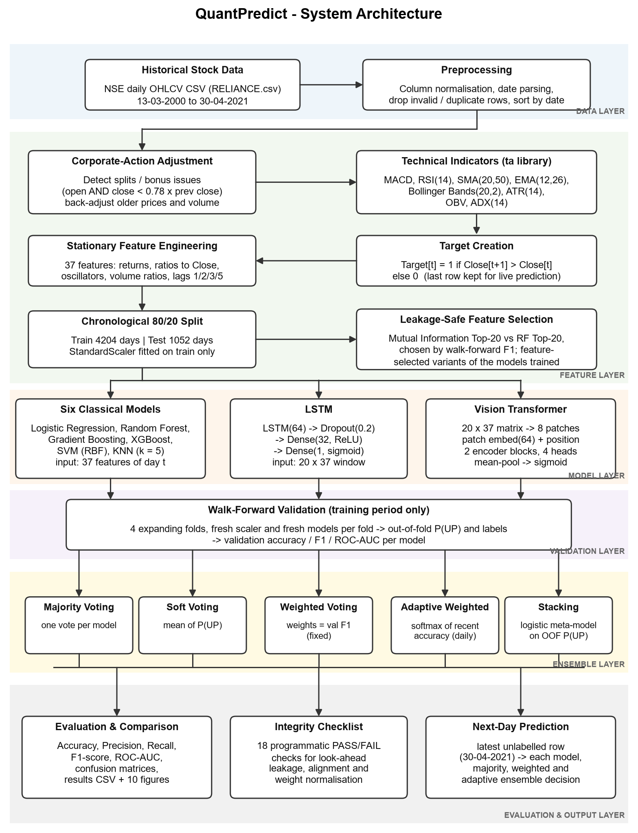
Fig. 4.1 System Architecture of QuantPredict
Compared with the Review-I architecture, two things stand out. The ViT is a third branch that shares the LSTM's input windows, so adding it did not require a new data path. The validation layer is new: it sits between the models and the ensembles, and it is the only source of information the ensembles are allowed to learn from.

4.1.2 Pipeline Flow
Fig. 4.2 shows the order in which the steps run. Steps 1 to 6 prepare the data, steps 7 to 10A train and score the individual models, step 10B generates the walk-forward predictions, steps 11 to 14 build the ensembles and steps 15 to 18 report, predict and verify. The order matters because later steps read variables created by earlier ones, for example the model_predictions and model_probabilities dictionaries that every ensemble consumes.
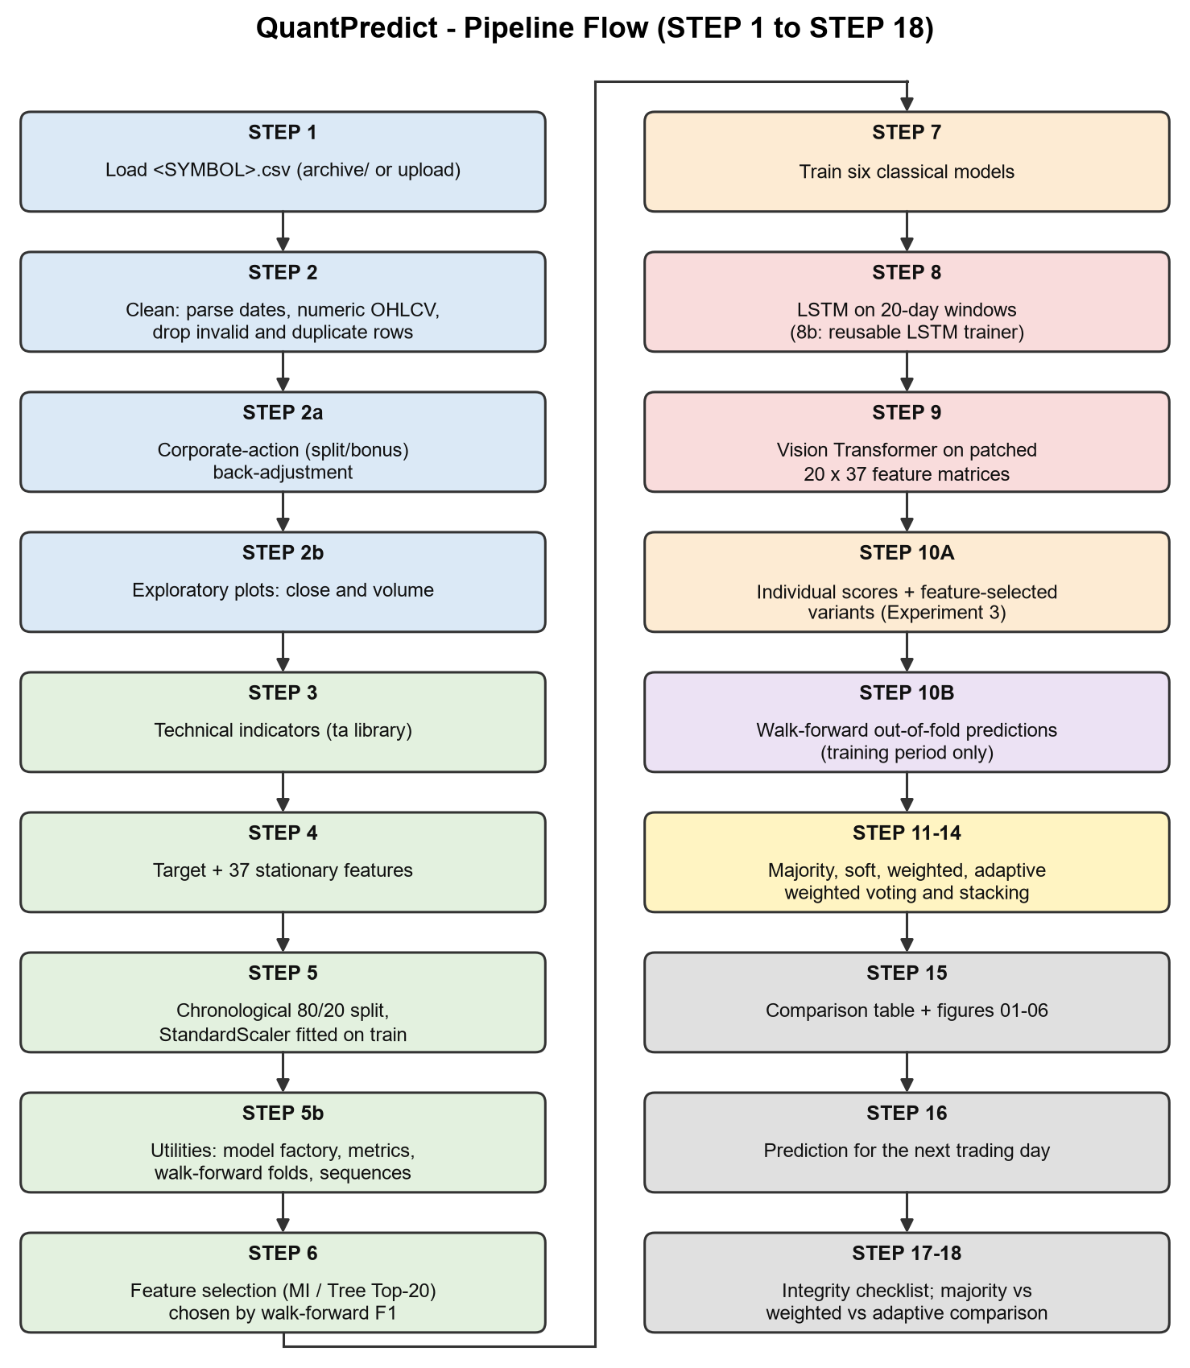
Fig. 4.2 Pipeline Flow from STEP 1 to STEP 18

4.1.3 Data Loading and Cleaning
STEP 1 looks for <STOCK_SYMBOL>.csv in the working folder and in the archive folder. In Colab, if the file is missing, it asks the user to upload one. As a last resort it falls back to the first valid stock file and prints a warning. A helper, is_stock_csv(), rejects the combined NIFTY50_all.csv, the metadata file and any file under 1 KB, so the empty INFRATEL.csv can never be picked by accident.
STEP 2 normalises column names (for example “ close ” becomes “Close”), accepts several common names for the date column, converts the OHLCV columns to numbers and removes rows with missing values, non-positive prices or duplicate dates. The rows are then sorted from oldest to newest. For RELIANCE all 5,306 rows passed these checks, so no rows were dropped.

4.1.4 Corporate-Action Adjustment
The NSE files contain raw traded prices. When a company issues one bonus share for every share held, the price halves overnight even though nothing happened to the value of the company. Left alone, such a day looks like a 50% crash. It creates a false DOWN label, and it corrupts every lag, moving average and volatility value around it for weeks. Panel (a) of Fig. 4.3 shows three such cliffs in the raw RELIANCE series.
STEP 2a detects these events with a simple rule, given in Eqn. 4.1: a day is treated as a corporate action only when both the opening price and the closing price fall below 78% of the previous close.
 | $$\frac{O_{t}}{C_{t-1}}<0.78 and \frac{C_{t}}{C_{t-1}}<0.78$$ | (4.1)

The threshold separates corporate actions from genuine crashes. During the sharpest real sell-offs in the data, such as March 2020, the stock opened at roughly 0.90 of the previous close, while bonus issues and splits open at clean ratios such as 1/2, 2/3 or 3/4. The observed overnight ratio is snapped to the nearest clean fraction a/b with b ≤ 10 if it lies within 4% of it; otherwise (as can happen with a demerger) the observed ratio is used. All rows before the event are then rescaled as in Eqn. 4.2, where f is the factor and s runs over the earlier days.
 | $$P_{s}←f·P_{s} (P∈\{O,H,L,C\}), V_{s}←\frac{V_{s}}{f}, s<t$$ | (4.2)

Older prices are scaled rather than newer ones, so the most recent prices stay exactly as traded and the next-day prediction is made on real price levels. Volume is divided by the same factor because there are more shares after a bonus issue. Only the ratio observed on the event day itself is used, and that ratio is public on the ex-date, so the adjustment does not leak any future price information. Table 4.1 lists the three events found for RELIANCE.
Table 4.1 Corporate Actions Detected and Adjusted for RELIANCE
Event date | Observed overnight ratio | Factor applied | Interpretation
18-01-2006 | 0.625 | 0.6250 (= 5/8) | Consistent with the 2006 demerger of group businesses
26-11-2009 | 0.506 | 0.5000 (= 1/2) | 1:1 bonus issue
07-09-2017 | 0.500 | 0.5000 (= 1/2) | 1:1 bonus issue

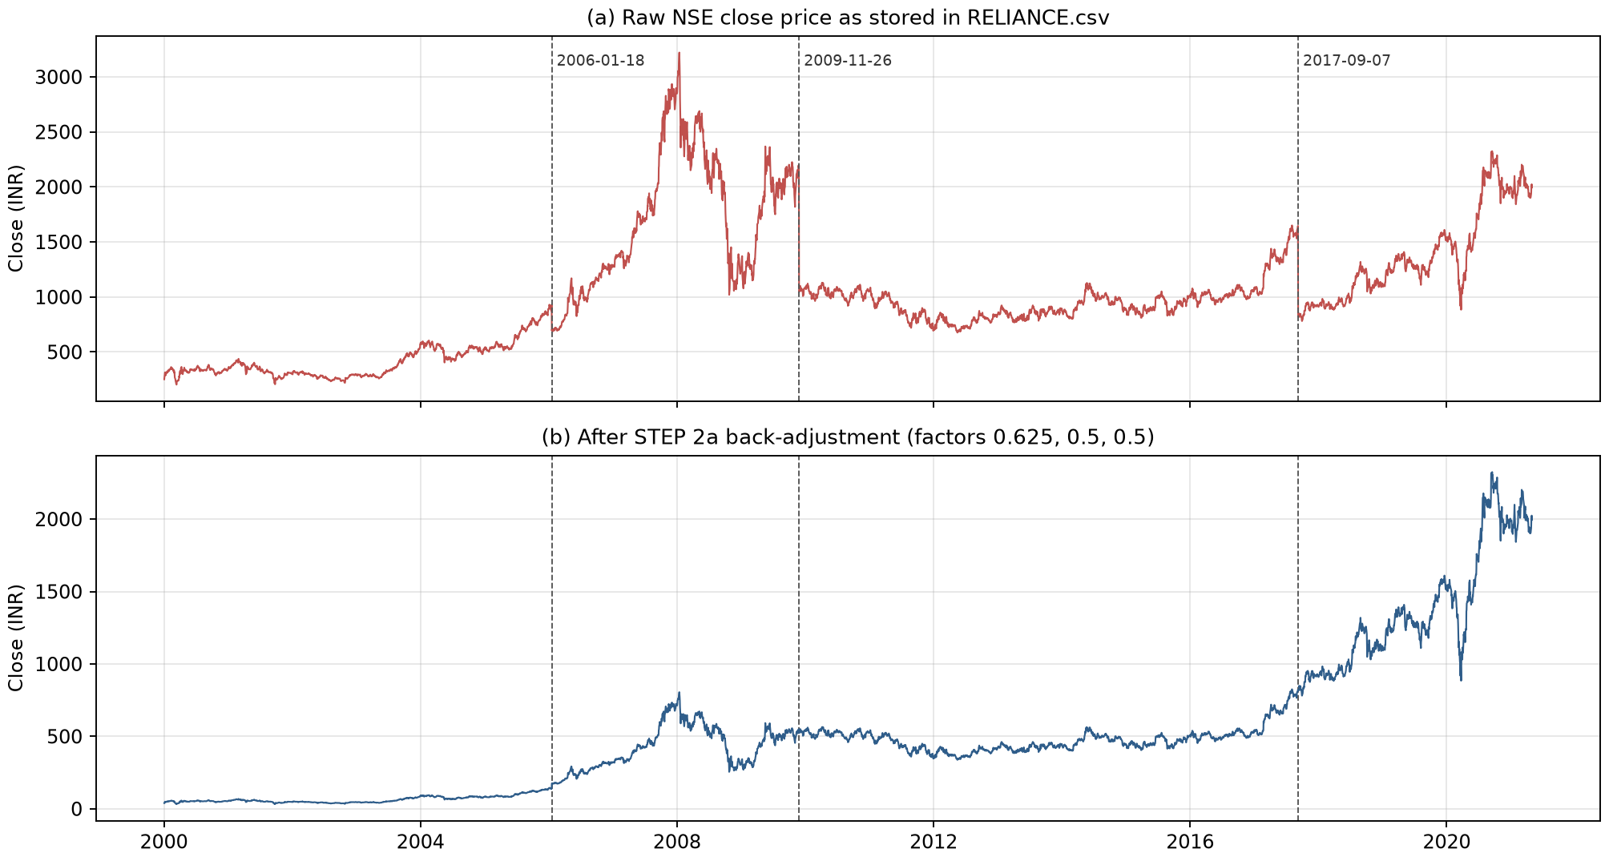
Fig. 4.3 RELIANCE Close Price Before (a) and After (b) Corporate-Action Adjustment
After the adjustment the series in panel (b) of Fig. 4.3 has no artificial cliffs. The genuine crashes of 2008 and March 2020 remain, which is the intended behaviour.

4.1.5 Technical Indicators
STEP 3 computes the indicators with the ta library (Padial, 2018). Every indicator uses only past and current values (rolling or recursive windows), so none of them looks ahead. They are first computed in price units and converted into scale-free features in STEP 4. The exponential moving average that several indicators rely on is defined in Eqn. 4.3, with smoothing factor α = 2/(n+1) for an n-day EMA.
 | $${EMA}_{t}^{\left(n\right)}=αC_{t}+(1-α){EMA}_{t-1}^{\left(n\right)}, α=\frac{2}{n+1}$$ | (4.3)

MACD (Appel, 2005) measures trend and momentum as the gap between a fast and a slow EMA. The signal line is a 9-day EMA of the MACD and the histogram is the difference between the two (Eqn. 4.4 and Eqn. 4.5).
 | $${MACD}_{t}={EMA}_{t}^{\left(12\right)}-{EMA}_{t}^{\left(26\right)}$$ | (4.4)

 | $${Signal}_{t}={EMA}^{\left(9\right)}(MACD)_{t}, {Hist}_{t}={MACD}_{t}-{Signal}_{t}$$ | (4.5)

RSI (Wilder, 1978) compares the size of recent gains with recent losses over 14 days. Values above 70 are conventionally read as overbought and values below 30 as oversold (Eqn. 4.6).
 | $${RSI}_{t}=100-\frac{100}{1+RS_{t}}, RS_{t}=\frac{average gain over 14 days}{average loss over 14 days}$$ | (4.6)

Simple and exponential moving averages of 20 and 50 days (SMA) and 12 and 26 days (EMA) describe the short- and medium-term trend. Bollinger Bands (Bollinger, 2002) place an envelope two standard deviations around the 20-day SMA. Two scale-free quantities are taken from them, the %B position and the band width (Eqn. 4.7 and Eqn. 4.8).
 | $$MB_{t}={SMA}_{t}^{\left(20\right)}, UB_{t}=MB_{t}+2σ_{t}, LB_{t}=MB_{t}-2σ_{t}$$ | (4.7)

 | $$\%B_{t}=\frac{C_{t}-LB_{t}}{UB_{t}-LB_{t}}, {Width}_{t}=\frac{UB_{t}-LB_{t}}{MB_{t}}$$ | (4.8)

ATR (Wilder, 1978) is the 14-day average of the true range in Eqn. 4.9, a measure of how far the price moves in a typical day, including overnight gaps.
 | $$TR_{t}=max\left(H_{t}-L_{t}, |H_{t}-C_{t-1}|, |L_{t}-C_{t-1}|\right)$$ | (4.9)

OBV (Granville, 1963) is a running total of volume that adds the day's volume on up days and subtracts it on down days (Eqn. 4.10). Its slope is read as buying or selling pressure.
 | $${OBV}_{t}={OBV}_{t-1}+sign(C_{t}-C_{t-1})V_{t}$$ | (4.10)

ADX (Wilder, 1978) measures the strength of a trend regardless of its direction. It is a 14-day smoothed version of the directional index DX in Eqn. 4.11, where DI⁺ and DI⁻ are the smoothed upward and downward directional movements.
 | $$DX_{t}=100·\frac{\left|DI_{t}^{+} − DI_{t}^{-}\right|}{DI_{t}^{+}+DI_{t}^{-}}$$ | (4.11)

Fig. 4.4 shows several of these indicators over the last 300 trading days of the data, from early 2020 to April 2021. The COVID-19 crash of March 2020 is visible as a deep fall below the lower Bollinger band, RSI values near 20 and a strongly negative MACD, followed by the recovery and the overbought readings of mid-2020.
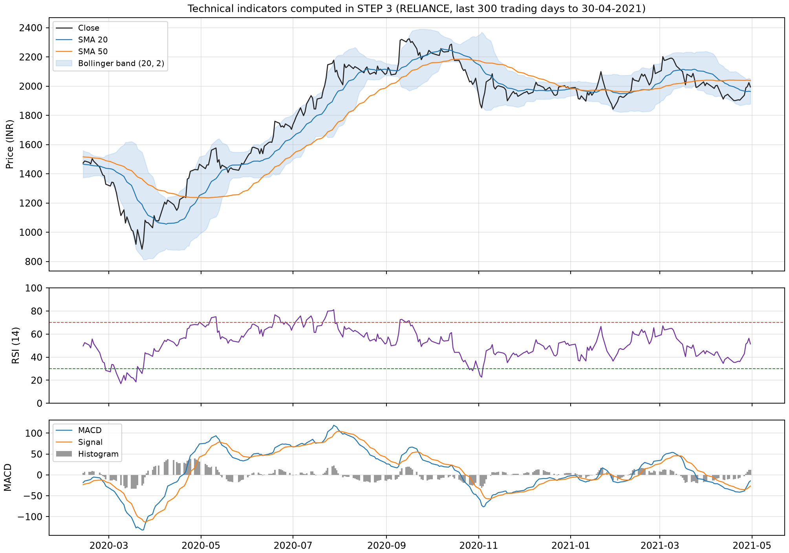
Fig. 4.4 Technical Indicators for RELIANCE over the Last 300 Trading Days

4.1.6 Target Definition
STEP 4 first moves tomorrow's close onto today's row (Next_Close = Close shifted by −1) and sets the label with Eqn. 2.1. The last row of the data, 30 April 2021, has no next close, so it cannot be used for training or testing. The code keeps two tables for this reason: df_feature_complete, which contains every row with complete features including the last day, and df_model, which drops the last day. The last day is used only once, in STEP 16, to make the live-style prediction. After the first 49 rows are removed because the 50-day moving average and similar features are not yet defined, df_model holds 5,256 labelled days from 13 March 2000 to 29 April 2021.
Fig. 4.5 shows that the classes are close to balanced but not exactly: 51.6% of all days are UP days. The share is 51.6% in the training period and 51.9% in the test period. This small imbalance matters for interpretation, because a model that always predicts UP would already score 51.9% on the test set.
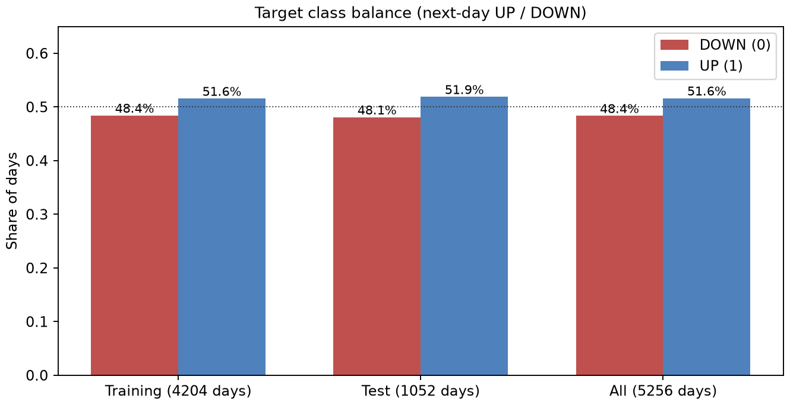
Fig. 4.5 Class Balance of the Next-Day Target

4.1.7 Stationary Feature Engineering
Review-I used raw price levels, such as the close, its lags and the moving averages, as inputs. Over twenty years the RELIANCE price moves from around INR 50 (after adjustment) to above INR 2,000. A scaler fitted on the training years then sees test-year prices far outside anything it learned, and the models effectively extrapolate. The final design replaces every level with a stationary quantity: a return, a ratio to the current close, a bounded oscillator, or a volume ratio. Eqn. 4.12 and Eqn. 4.13 give the three main patterns.
 | $${Return}_{k}=\frac{C_{t}}{C_{t-k}}-1, {Dist}_{MA}=\frac{C_{t}}{{MA}_{t}}-1$$ | (4.12)

 | $${VolRatio}_{20}=\frac{V_{t}}{\frac{1}{20}\sum_{s=t-19}^{t}{V_{s}}}$$ | (4.13)

These quantities have similar distributions in 2003 and in 2020, so the same scaler and the same model remain meaningful across decades and across stocks. Infinite values that can arise from a division by zero volume are set to missing and those rows are dropped. Table 4.2 lists all 37 features in the order in which they enter the models.
Table 4.2 The 37 Stationary Features Used by All Models
No. | Feature | Group | Definition
1 | Return_1 | Price action | C_{t} / C_{t-1} − 1 (one-day return)
2 | Return_5 | Price action | C_{t} / C_{t-5} − 1 (one-week momentum)
3 | Return_20 | Price action | C_{t} / C_{t-20} − 1 (one-month momentum)
4 | Overnight_Gap | Price action | O_{t} / C_{t-1} − 1
5 | Intraday_Return | Price action | C_{t} / O_{t} − 1
6 | High_Low_Range | Price action | H_{t} / L_{t} − 1
7 | Close_Position | Price action | (C_{t} − L_{t}) / (H_{t} − L_{t}); 0.5 when H_{t} = L_{t}
8 | MACD_Pct | Indicator | MACD_{t} / C_{t}
9 | MACD_Signal_Pct | Indicator | MACD signal line / C_{t}
10 | MACD_Hist_Pct | Indicator | MACD histogram / C_{t}
11 | RSI | Indicator | 14-day Relative Strength Index (0–100)
12 | ADX | Indicator | 14-day Average Directional Index (0–100)
13 | SMA_20_Dist | Indicator | C_{t} / SMA₂₀ − 1
14 | SMA_50_Dist | Indicator | C_{t} / SMA₅₀ − 1
15 | EMA_12_Dist | Indicator | C_{t} / EMA₁₂ − 1
16 | EMA_26_Dist | Indicator | C_{t} / EMA₂₆ − 1
17 | Rolling_Mean_5_Dist | Indicator | C_{t} / (5-day mean close) − 1
18 | BB_PctB | Indicator | (C_{t} − lower band) / (upper − lower band)
19 | BB_Width | Indicator | (upper − lower band) / middle band
20 | ATR_Pct | Indicator | ATR₁₄ / C_{t}
21 | OBV_Slope_5 | Indicator | (OBV_{t} − OBV_{t-5}) / (5 × 20-day mean volume)
22 | Volatility_5 | Volatility | Standard deviation of daily returns over 5 days
23 | Volatility_20 | Volatility | Standard deviation of daily returns over 20 days
24 | Volume_Change | Volume | ln((V_{t} + 1) / (V_{t-1} + 1))
25 | Volume_Ratio_20 | Volume | V_{t} / 20-day mean volume
26–29 | Return_Lag_1, _2, _3, _5 | Lag | Daily return 1, 2, 3 and 5 days earlier
30–33 | Volume_Ratio_Lag_1, _2, _3, _5 | Lag | Volume_Ratio_20 1, 2, 3 and 5 days earlier
34–37 | RSI_Lag_1, _2, _3, _5 | Lag | RSI 1, 2, 3 and 5 days earlier

The distribution of the target's driving quantity, the daily return, is shown in Fig. 4.6. It has a mean of about 0.10% and a standard deviation of 2.18%, with a positive skew of 0.35 and an excess kurtosis of 7.9. The heavy tails mean that large moves happen far more often than a normal distribution would suggest; 162 days in the data moved by more than 5% in either direction.
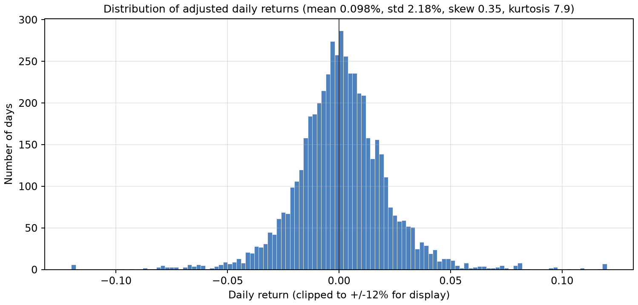
Fig. 4.6 Distribution of Adjusted Daily Returns of RELIANCE
Fig. 4.7 shows the correlations between the 37 features on the training rows. Several groups are strongly related. The distances from the 20-day SMA and the 12- and 26-day EMAs correlate above 0.95 with each other, the MACD and its signal line correlate at 0.95, and the RSI lags correlate at about 0.93. This redundancy is one of the reasons for testing feature selection in STEP 6.
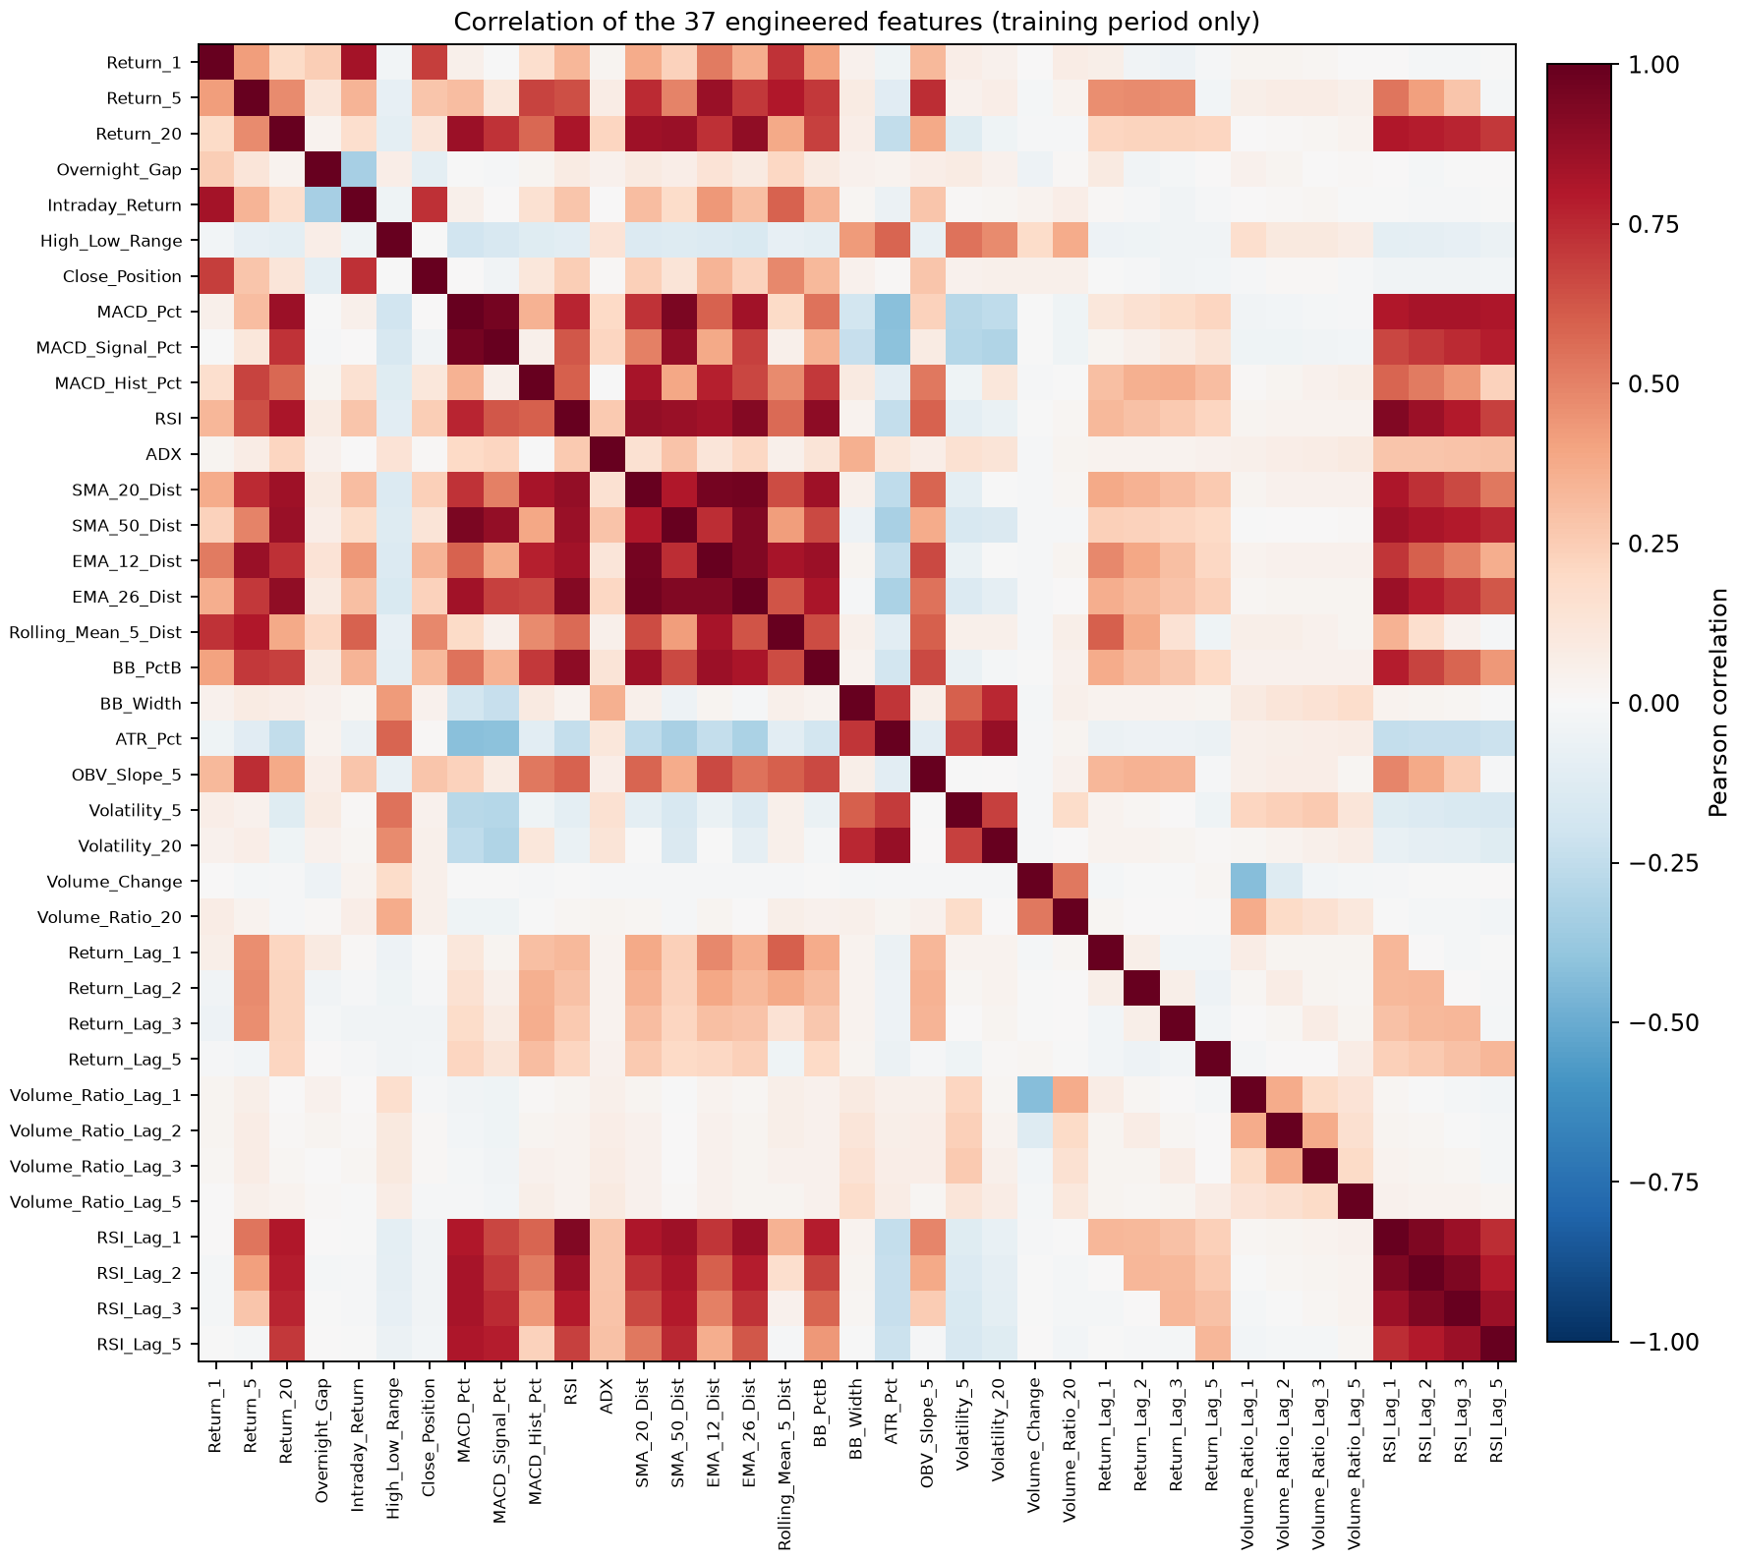
Fig. 4.7 Correlation Matrix of the 37 Features (Training Period)

4.1.8 Chronological Split and Standardisation
STEP 5 splits the 5,256 labelled days chronologically. The split index is computed as in Eqn. 4.14, which gives 4,204 training days (13 March 2000 to 25 January 2017) and 1,052 test days (27 January 2017 to 29 April 2021). Fig. 4.8 shows the split on a time line.
 | $$split_idx=⌊0.8N⌋=⌊0.8×5256⌋=4204$$ | (4.14)

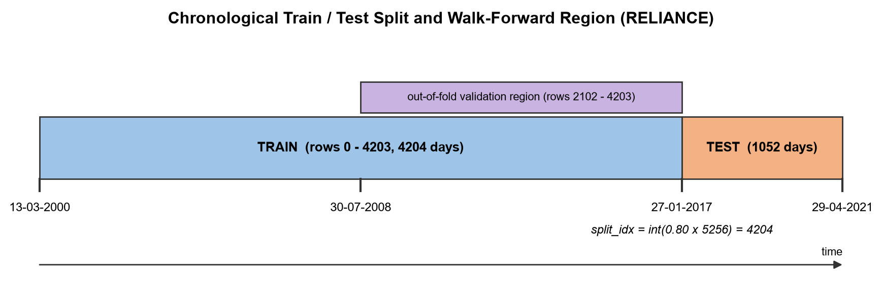
Fig. 4.8 Chronological Train/Test Split and Out-of-Fold Region
Each feature is then standardised with the mean and standard deviation of the training rows only (Eqn. 4.15). The same fitted scaler is applied unchanged to the test rows and, later, to the latest row used for the next-day prediction. Fitting the scaler on all rows would have been a subtle leak: the test period's average level would then influence the training inputs.
 | $$z_{t,j}=\frac{x_{t,j}-μ_{j}^{train}}{σ_{j}^{train}}$$ | (4.15)

4.1.9 Sequence Construction for the LSTM and ViT
The two deep models read the last L = 20 days of scaled features. The alignment of these windows with the labels is the most error-prone part of any sequence model for this task. Because y_{t} compares C_{t+1} with C_{t}, the window that predicts y_{i} must include day i itself and must stop there (Eqn. 4.16). Fig. 4.9 illustrates the alignment.
 | $$X^{\left(i\right)}=\left[x_{i-19} , x_{i-18} , … , x_{i}\right]∈R^{20×37} ⟶ y_{i}$$ | (4.16)

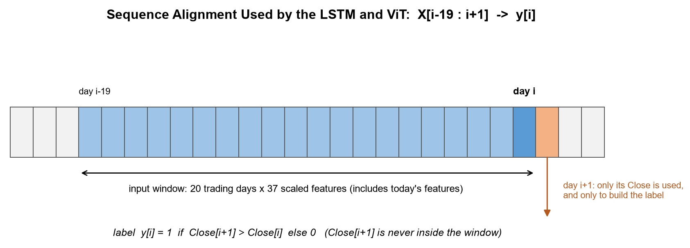
Fig. 4.9 Alignment of 20-Day Input Windows with the Next-Day Label
Two mistakes are easy to make here. Ending each window one day early throws away the most recent information, and ending it one day late leaks the answer into the input. The alignment was corrected during development (the code still labels this step “corrected alignment”), and the final code builds windows X[i−19 : i+1] → y[i] and asserts the expected counts: 4,185 training windows (from i = 19 to 4,203) and 1,052 test windows (from i = 4,204 to 5,255). The first test window reaches back into the last 19 training days, which is allowed because those days are in the past when the prediction is made. The last 15% of the training windows (628 windows) are held back for early stopping, leaving 3,557 windows for gradient updates.

4.1.10 Leakage-Safe Feature Selection
STEP 6 tests whether a smaller set of features helps. Two selectors are fitted on the training partition only, and each keeps its top K = 20 features. The first, SelectKBest with mutual information, measures how much knowing a feature reduces uncertainty about the label (Eqn. 4.17). Because mutual information is not limited to linear relations, it can detect a feature that matters only at extreme values. Scikit-learn estimates it with a nearest-neighbour method (Kraskov et al., 2004; Ross, 2014).
 | $$I(X;Y)=\sum_{y∈\{0,1\}}{∫p(x,y)log}\frac{p(x,y)}{p(x)p(y)}dx$$ | (4.17)

The second selector ranks features by the impurity-based importance of a 300-tree random forest (maximum depth 10), again trained only on training rows, and keeps the top 20 with SelectFromModel. The two candidate subsets and the full 37-feature set are then compared with walk-forward validation (Section 4.1.14) using the six classical models, a fresh scaler per fold and validation F1 as the score. The set with the highest mean validation F1 is reported as the preferred set. The test period plays no part in this decision.
Feature selection is treated as an experiment, not as a replacement for the baseline. The main models keep all 37 features, and the feature-selected versions of the six classical models (for both subsets) and of the two deep models (for the validation-preferred subset) are added as separate rows labelled, for example, “Random Forest [MI Top-20]”.

4.1.11 Classical Machine-Learning Models
The six classical models are created by a factory function, make_classical_models(), which returns fresh, unfitted estimators every time it is called. This matters because the walk-forward loops refit every model once per fold, and reusing a fitted object would silently carry information from one fold into the next. Table 4.3 lists the models and their settings.
Logistic regression, the simplest model, turns a weighted sum of the features into a probability with the sigmoid function (Eqn. 4.18). The other models are non-linear: the tree ensembles split the feature space into regions, the SVM finds a curved boundary in a kernel space, and KNN compares each day directly with the most similar days in the training history.
Table 4.3 Classical Models and Their Hyperparameters
Model | Key settings | Idea
Logistic Regression | max_iter = 1000, L2 regularisation (C = 1.0) | Linear score passed through a sigmoid (Eqn. below)
Random Forest | 200 trees, max_depth = 10 | Average vote of decorrelated decision trees (Breiman, 2001)
Gradient Boosting | 100 trees, learning_rate = 0.1, max_depth = 5 | Trees added one at a time to correct residual errors (Friedman, 2001)
XGBoost | 100 trees, learning_rate = 0.1, max_depth = 5, log-loss | Regularised, optimised gradient boosting (Chen & Guestrin, 2016)
SVM | RBF kernel, C = 1.0, Platt probabilities | Maximum-margin non-linear boundary (Cortes & Vapnik, 1995)
KNN | k = 5, distance weighting | Outcome of the five most similar past days (Cover & Hart, 1967)

 | $$P(y_{t}=1∣x_{t})=σ(w^{⊤}x_{t}+b)=\frac{1}{1+e^{-(w^{⊤}x_{t}+b)}}$$ | (4.18)

All six models are trained once on the 4,204 training days in STEP 7 and then predict every test day. For each test day the pipeline stores the hard label and the probability of UP, because the soft, weighted and stacked ensembles need probabilities rather than labels. The SVM uses probability=True for this reason, which adds an internal calibration step; inside the feature-selection loop, where only labels are needed, it runs with probability=False to save time.

4.1.12 Long Short-Term Memory Network
The LSTM (Hochreiter & Schmidhuber, 1997) reads the 20 days of a window in order and carries a memory from one day to the next. At each step it updates a cell state c_{t} through three gates that decide what to forget, what to add and what to output (Eqn. 4.19 to Eqn. 4.22). Here σ is the sigmoid function, ⊙ is element-wise multiplication and [h_{t-1}, x_{t}] is the concatenation of the previous hidden state with the current input.
 | $$f_{t}=σ\left(W_{f}[h_{t-1},x_{t}]+b_{f}\right)$$ | (4.19)

 | $$i_{t}=σ\left(W_{i}[h_{t-1},x_{t}]+b_{i}\right), {\overset{\sim }{c}}_{t}=tanh\left(W_{c}[h_{t-1},x_{t}]+b_{c}\right)$$ | (4.20)

 | $$c_{t}=f_{t}⊙c_{t-1}+i_{t}⊙{\overset{\sim }{c}}_{t}$$ | (4.21)

 | $$o_{t}=σ\left(W_{o}[h_{t-1},x_{t}]+b_{o}\right), h_{t}=o_{t}⊙tanh(c_{t})$$ | (4.22)

Fig. 4.10 shows the architecture used. A single LSTM layer with 64 units reads the window and passes its final hidden state h_{i} to a dropout layer (rate 0.2), a dense layer of 32 ReLU units and a single sigmoid output that gives P(UP). The network has 28,481 trainable parameters in the PyTorch version.
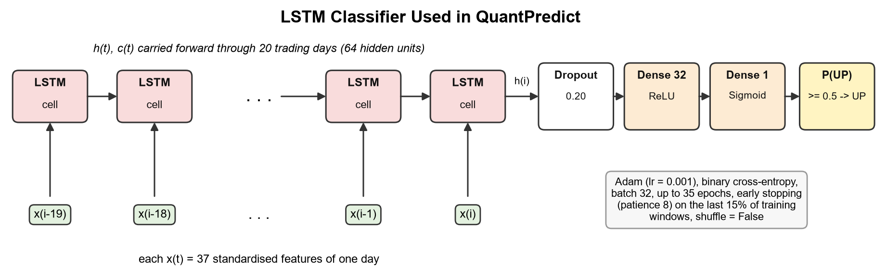
Fig. 4.10 Architecture of the LSTM Classifier
Training minimises the binary cross-entropy in Eqn. 4.23 with the Adam optimiser (Kingma & Ba, 2015) at a learning rate of 0.001 and batches of 32 windows, for at most 35 epochs. Early stopping watches the loss on the held-back last 15% of training windows, stops after 8 epochs without improvement and restores the best weights. Mini-batches are drawn in date order (shuffle = False).
 | $$L=-\frac{1}{n}\sum_{k=1}^{n}{\left[y_{k}logp_{k}+(1-y_{k})log(1-p_{k})\right]}$$ | (4.23)

The same architecture is re-created by a helper, train_lstm_model(), for the walk-forward folds and the feature-selected experiment. The baseline LSTM is never modified by these later runs.

4.1.13 Vision Transformer Adapted for Financial Feature Matrices
The ViT in QuantPredict is not an image classifier and no images are generated or downloaded. Each training example is the same 20 × 37 matrix of scaled features that the LSTM reads. The idea taken from the original ViT (Dosovitskiy et al., 2021) is the treatment of this matrix as a small single-channel image that is cut into non-overlapping rectangular patches. The time axis is cut into four blocks of five days and the feature axis into two groups. Since 37 is odd, the feature axis is padded with one column of zeros to 38; because the features are standardised, a zero equals the training mean and adds no information. The result is a grid of 4 × 2 = 8 patches, each holding 5 days × 19 features = 95 values, as shown in Fig. 4.11.
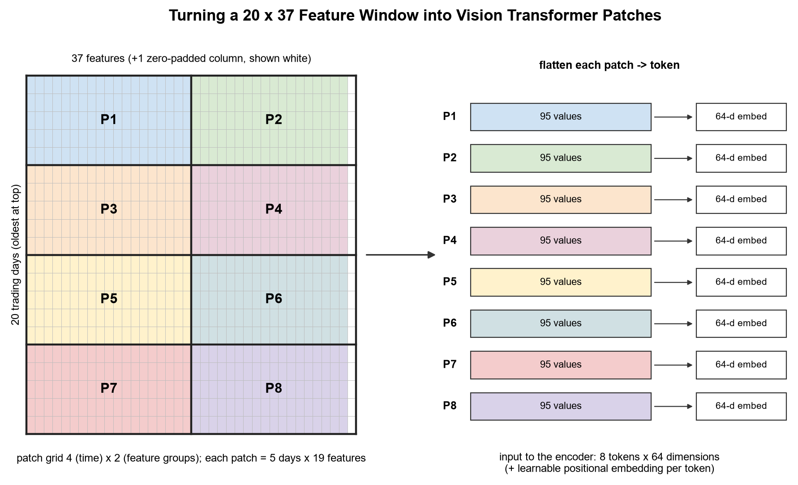
Fig. 4.11 Patching a 20 × 37 Feature Window into Eight ViT Tokens
Each flattened patch is mapped to a 64-dimensional embedding by a learned linear layer, and a learnable positional embedding is added so that the model knows which time block and which feature group a token came from (Eqn. 4.24).
 | $$z_{0}=\left[p_{1}E; p_{2}E; …; p_{8}E\right]+E_{pos}, E∈R^{95×64}$$ | (4.24)

The token sequence passes through two pre-norm transformer encoder blocks. In each block, multi-head self-attention with four heads (each of dimension d_{k} = 16) lets every patch attend to every other patch (Eqn. 4.25); a two-layer MLP with 128 hidden GELU units (Hendrycks & Gimpel, 2016) then transforms each token, and residual connections with layer normalisation (He et al., 2016; Ba et al., 2016) wrap both parts (Eqn. 4.26).
 | $$Attention(Q,K,V)=softmax\left(\frac{QK^{⊤}}{\sqrt{d_{k}}}\right)V$$ | (4.25)

 | $$z^{'}=z+MHSA\left(LN(z)\right), z^{″}=z^{'}+MLP\left(LN(z^{'})\right)$$ | (4.26)

After the last block, the tokens are normalised and averaged (global average pooling), and a small head (dropout, 32 ReLU units, one sigmoid unit) outputs P(UP), as in Eqn. 4.27. Fig. 4.12 shows the full network. It has 75,841 trainable parameters, about 2.7 times as many as the LSTM.
 | $$\overline{h}=\frac{1}{8}\sum_{k=1}^{8}{LN}(z_{L})_{k}, P(UP)=σ\left(w_{2}^{⊤}ReLU(W_{1}\overline{h})\right)$$ | (4.27)

The patch shape is a design choice with a clear reading. A patch of five consecutive days and half of the features summarises one trading week of one feature group, so attention between patches compares weeks and feature groups with each other. The ViT is trained exactly like the LSTM: Adam at 0.001, batches of 32, at most 40 epochs, early stopping with patience 8 on the same held-back windows, no shuffling, and the same seed. Because the target, the split, the scaler and the window alignment are identical, the ViT's results are directly comparable with the LSTM's. Table 4.4 summarises the configuration.

4.1.14 Walk-Forward Validation and Out-of-Fold Predictions
Ensemble weights, the adaptive voting settings and the stacking meta-model all need an estimate of how good each model is on days it has not seen. Using the test period for this would be leakage, and using a model's own training predictions would be optimistic. STEP 10B therefore builds expanding-window walk-forward folds inside the training period (Fig. 4.13). The first fold trains on the first half of the training days, and the remaining half is cut into four consecutive validation blocks (Eqn. 4.28).
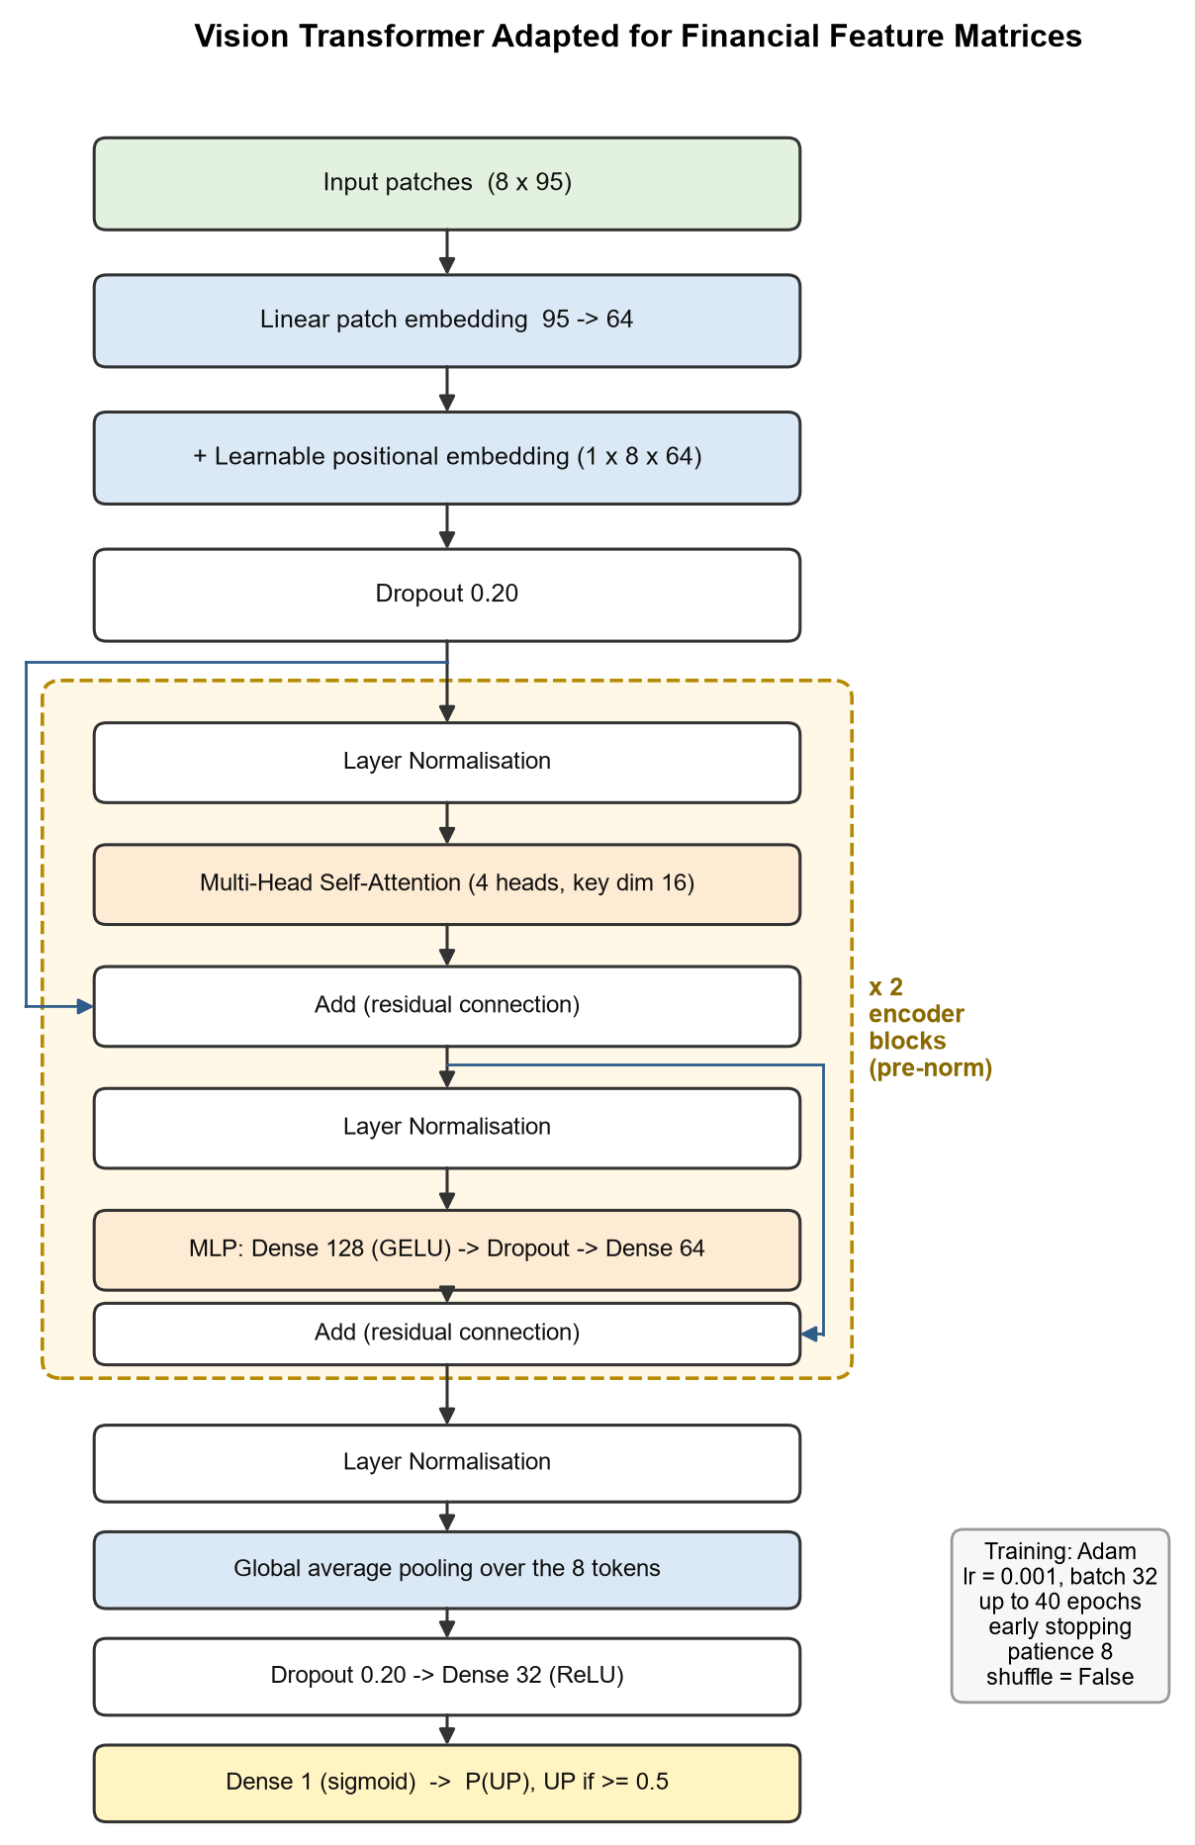
Fig. 4.12 Architecture of the Vision Transformer for Financial Feature Matrices
Table 4.4 Vision Transformer Configuration
Parameter | Value | Parameter | Value
Input matrix | 20 days × 37 features | Embedding size (d_model) | 64
Patch size | 5 days × 19 features | Attention heads | 4 (16 dimensions each)
Patch grid | 4 × 2 = 8 patches | Encoder blocks | 2 (pre-norm)
Flattened patch length | 95 | MLP width / activation | 128 / GELU
Padding | 1 zero column (37 → 38) | Dropout | 0.20
Positional embedding | Learnable, 8 × 64 | Optimiser / learning rate | Adam / 0.001
Pooling | Global average over tokens | Epochs / patience | ≤ 40 / 8
Output | Sigmoid P(UP) | Trainable parameters | 75,841

 | $$T_{0}=⌊0.5×4204⌋=2102, B=\left\lfloor \frac{4204-2102}{4}\right\rfloor =525$$ | (4.28)

Table 4.5 Walk-Forward Folds Used for Validation
Fold | Training rows | Validation rows | Validation dates | Days
1 | 0 – 2101 | 2102 – 2626 | 30-07-2008 to 20-09-2010 | 525
2 | 0 – 2626 | 2627 – 3151 | 21-09-2010 to 23-10-2012 | 525
3 | 0 – 3151 | 3152 – 3676 | 25-10-2012 to 10-12-2014 | 525
4 | 0 – 3676 | 3677 – 4203 | 11-12-2014 to 25-01-2017 | 527

In every fold a fresh scaler is fitted on that fold's training rows, fresh copies of all eight models are trained, and the models predict the fold's validation block, which always lies strictly after the training block. The deep models use a reduced budget of 20 epochs in the folds to keep the run time reasonable. Concatenating the four validation blocks gives one out-of-fold (OOF) prediction per model for each of the 2,102 days from 30 July 2008 to 25 January 2017. Every OOF value was produced by a model that had never seen that day, which is what makes it safe to learn weights from. An assertion guarantees that the OOF region ends exactly at the start of the test period.
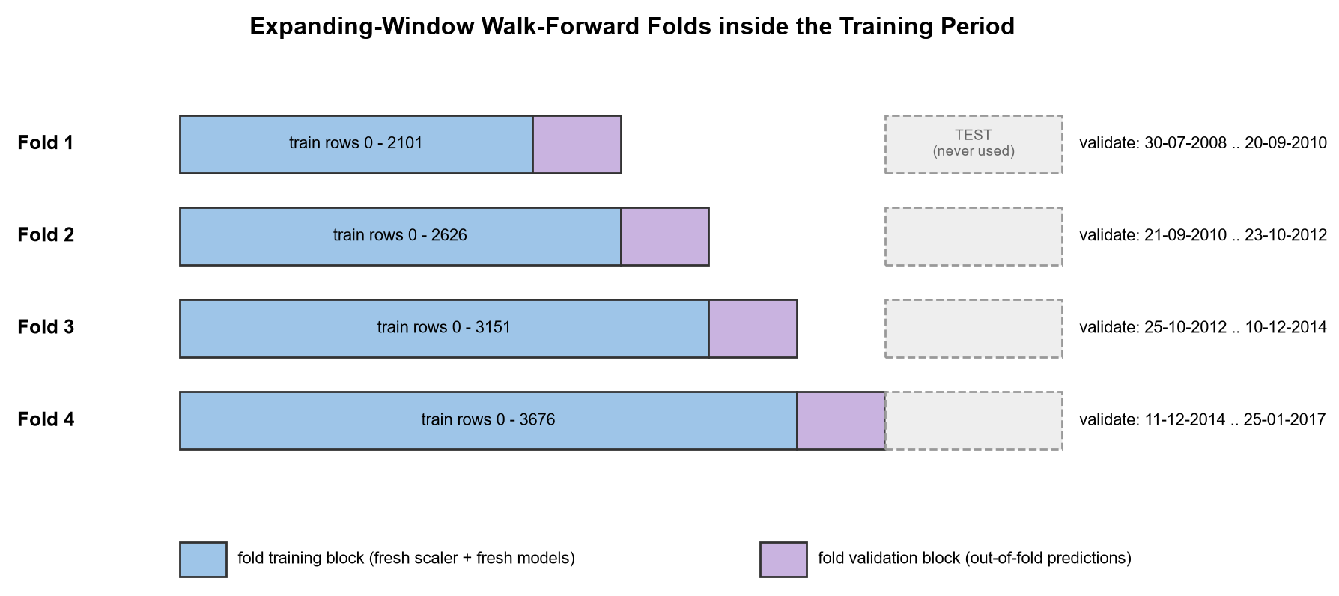
Fig. 4.13 Expanding-Window Walk-Forward Folds inside the Training Period
The same fold generator, make_walk_forward_folds(), is used for the feature-set comparison in STEP 6. It contains its own leakage guard that raises an error if any validation block reaches the test period.

4.1.15 Ensemble Methods
Five combination strategies are compared (Fig. 4.14). Each is built for the main 7-model ensemble (the six classical models plus the LSTM), and, as an experiment, for an 8-model ensemble that also includes the ViT. The ViT is kept out of the main ensemble on purpose, so that its effect can be seen by comparing the 7- and 8-model rows. Majority voting is also reported for the six classical models alone.
Majority voting (STEP 11) gives every model one vote and predicts UP when more than half of the M models say UP (Eqn. 4.29). With seven models this means at least four UP votes; with eight, a 4–4 tie is resolved as DOWN.
 | $${\hat{y}}^{maj}=1\left[\sum_{i=1}^{M}{{\hat{y}}_{i}} > \frac{M}{2}\right]$$ | (4.29)

Soft voting (STEP 12) averages the probabilities instead of the labels, so a model that is 90% sure counts for more than one that is 51% sure (Eqn. 4.30).
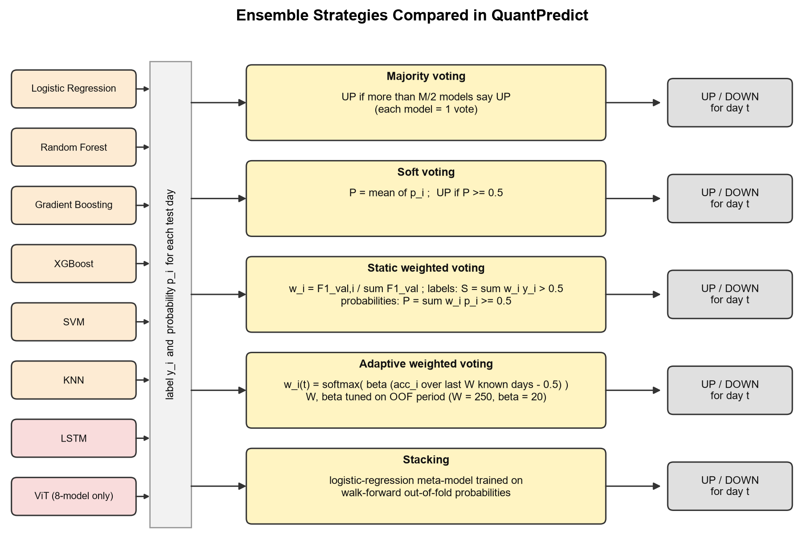
Fig. 4.14 Ensemble Strategies Compared in QuantPredict
 | $$P^{soft}=\frac{1}{M}\sum_{i=1}^{M}{p_{i}}, \hat{y}=1\left[P^{soft} ≥ 0.5\right]$$ | (4.30)

Performance-weighted voting (STEP 13) gives each model a fixed weight proportional to its walk-forward validation F1-score (Eqn. 4.31). Two decision rules are reported: a label rule that weights the hard votes and a probability rule that weights the probabilities (Eqn. 4.32 and Eqn. 4.33). The probability rule is statistically the sounder of the two because it keeps each model's confidence.
 | $$w_{i}=\frac{F1_{i}^{val}}{\sum_{j=1}^{M}{F}1_{j}^{val}}, \sum_{i=1}^{M}{w_{i}}=1$$ | (4.31)

 | $$S=\sum_{i=1}^{M}{w_{i}}{\hat{y}}_{i}, \hat{y}=1\left[S > 0.5\right]$$ | (4.32)

 | $$P=\sum_{i=1}^{M}{w_{i}}p_{i}, \hat{y}=1\left[P ≥ 0.5\right]$$ | (4.33)

Stacking (STEP 14) replaces the fixed rule with a learned one (Wolpert, 1992). A logistic-regression meta-model is trained on the OOF probabilities of the base models and their true OOF labels (Eqn. 4.34). At test time it receives the probabilities of the base models that were trained on the full training period. Training the meta-model on in-sample base predictions would have taught it to trust overfitted models, which is why the OOF predictions are essential here.
 | $$P^{stack}=σ\left(γ_{0} + \sum_{i=1}^{M}{γ_{i}}p_{i}\right)$$ | (4.34)

4.1.16 Adaptive Weighted Voting
Static weights are set once, from validation data that ends in January 2017, and then held fixed for four years of testing. Adaptive weighted voting (STEP 13B) recomputes the weights every day. For day t it measures each model's accuracy over the most recent W days whose outcomes are already known (Eqn. 4.35), and turns these accuracies into weights with a softmax centred on the coin-flip level of 0.5 (Eqn. 4.36).
 | $$a_{i}(t)=\frac{1}{W}\sum_{s=t-W}^{t-1}{1}\left[{\hat{y}}_{i,s} = y_{s}\right]$$ | (4.35)

 | $$w_{i}(t)=\frac{exp\left(β(a_{i}(t)-0.5)\right)}{\sum_{j=1}^{M}{exp}\left(β(a_{j}(t)-0.5)\right)}$$ | (4.36)

 | $$P(t)=\sum_{i=1}^{M}{w_{i}}(t)p_{i}(t), S(t)=\sum_{i=1}^{M}{w_{i}}(t){\hat{y}}_{i}(t)$$ | (4.37)

The parameter β controls how strongly the vote follows recent winners. With β = 0 all weights are equal, so the rule reduces to equal-weight soft voting. With β = 20, a model at 60% recent accuracy gets about exp(20 × 0.1) ≈ 7.4 times the weight of a model at 50%. This exponential re-weighting is closely related to the weighted-majority and Hedge algorithms from online learning (Littlestone & Warmuth, 1994; Freund & Schapire, 1997), applied here over a sliding window so that old performance is forgotten.
Timing is the critical detail, and Fig. 4.15 shows it. The vote for day t is cast after the close of day t. The newest label it may use is y_{t-1}, which compares C_{t} with C_{t-1} and is therefore known. The label y_{t} needs C_{t+1} and is never used for day t's weights. During the test period the weights learn only from test days that are already in the past, which is exactly what a live system could do. The history used for the windows is the OOF predictions followed by the test predictions, so the first test day already has a full window of 250 known outcomes.
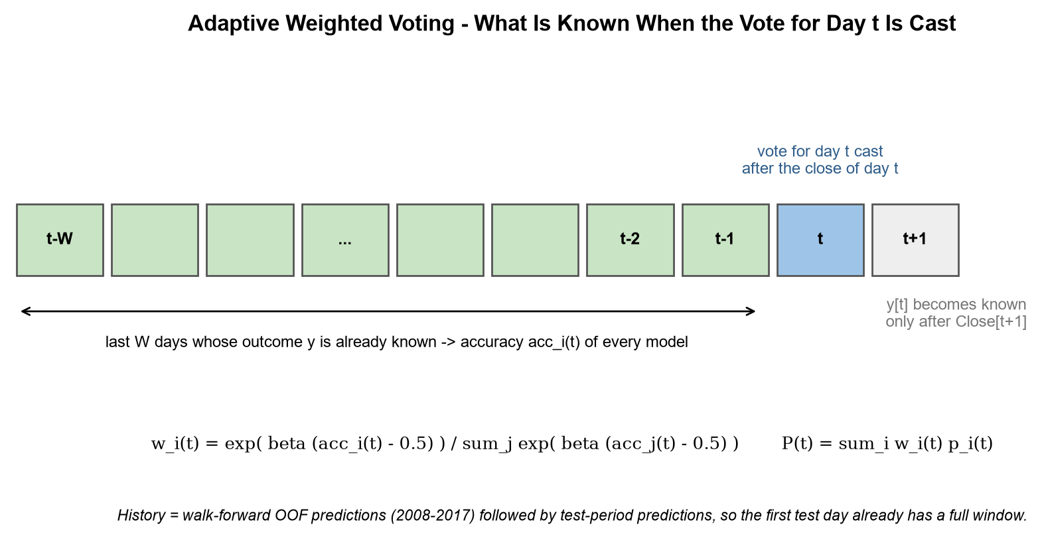
Fig. 4.15 Information Available When the Adaptive Vote for Day t Is Cast
The window W and the sharpness β are chosen on the OOF period only, from W ∈ {20, 60, 120, 250} and β ∈ {0, 5, 10, 20}. Each of the 16 combinations is scored by the accuracy of the adaptive probability vote on the OOF rows from index 250 onwards, so that every setting is judged on the same 1,852 days. Ties are resolved in favour of β = 0, which means that adaptation is only used if it actually beat equal weighting in validation. The core of the implementation is short:
def adaptive_weight_path(correct, window, beta):
n, m = correct.shape # rows = days, columns = models (1 = hit)
csum = np.vstack([np.zeros((1, m)), np.cumsum(correct, axis=0)])
weights = np.full((n + 1, m), 1.0 / m) # day 0 has no history -> equal weights
for t in range(1, n + 1):
lo = max(0, t - window)
acc = (csum[t] - csum[lo]) / (t - lo) # accuracy on rows < t only
z = np.exp(beta * (acc - 0.5))
weights[t] = z / z.sum()
return weights

4.1.17 Evaluation Metrics
Every individual model, ensemble and feature-selected variant is scored on the same 1,052 test days with the metrics in Eqn. 4.38 to Eqn. 4.41, computed from the counts of true positives (TP), true negatives (TN), false positives (FP) and false negatives (FN), where UP is the positive class (Sokolova & Lapalme, 2009).
 | $$Accuracy=\frac{TP+TN}{TP+TN+FP+FN}$$ | (4.38)

 | $$Precision=\frac{TP}{TP+FP}, Recall=\frac{TP}{TP+FN}$$ | (4.39)

 | $$F_{1}=\frac{2·Precision·Recall}{Precision+Recall}$$ | (4.40)

 | $$BalAcc=\frac{1}{2}\left(\frac{TP}{TP+FN} + \frac{TN}{TN+FP}\right)$$ | (4.41)

ROC-AUC measures how well the predicted probabilities rank UP days above DOWN days, independently of the 0.5 threshold; 0.5 means no ranking ability (Fawcett, 2006). Balanced accuracy is reported for the validation scores because it is not inflated by the slight UP majority. Two reference points are printed next to the results. The first is the majority-class rate, the accuracy of always predicting the more frequent class in the test period (0.519). The second is the approximate 95% sampling band for an accuracy near 0.5 (Eqn. 4.42): differences smaller than this are within the noise of a single test period.
 | $$±1.96\sqrt{\frac{0.25}{n_{test}}}=±1.96\sqrt{\frac{0.25}{1052}}≈±0.030$$ | (4.42)

4.1.18 Leakage and Integrity Safeguards
Leakage prevention is enforced at two levels. Inside the steps, assertions stop the program as soon as an invariant is broken: the split must leave enough rows for the windows, the selectors must have seen exactly split_idx rows, every walk-forward fold must end before the test period, the classical and sequence models must be scored on identical test labels, and the OOF arrays must be completely filled. At the end, STEP 17 re-checks 18 conditions and prints PASS or FAIL for each. The most interesting check scrambles the test labels from some day k onwards and confirms that the adaptive weights up to day k do not change; if they did, the weights would be using future labels. The full list and its output are given in Chapter 6.

4.1.19 UML Diagrams
The use case diagram in Fig. 4.16 shows how the student or analyst interacts with the system. The user selects a stock, runs the pipeline, reads the comparison table and plots, reviews the integrity checklist and obtains the next-day prediction. Running the pipeline includes loading, adjusting, feature engineering, feature selection, walk-forward validation and ensemble construction; walk-forward validation in turn includes training of the three model families. The NSE data archive is a secondary actor that supplies the CSV files.
Quantpredict.py is a procedural script, not an object-oriented program, but its steps and helper functions group naturally into responsibilities. Fig. 4.17 presents these groups as a conceptual class diagram. Each box lists the main constants (attributes) and functions (operations) of one responsibility, and the arrows show the direction in which data flows.
The sequence diagram in Fig. 4.18 shows the order of interactions during one complete run, from the user setting the stock symbol to the delivery of the next-day prediction. Solid arrows are calls and dashed arrows are returned results. The self-calls mark internal work: feature construction inside the data component, the parameter search inside the ensemble engine and the integrity checks inside the pipeline.
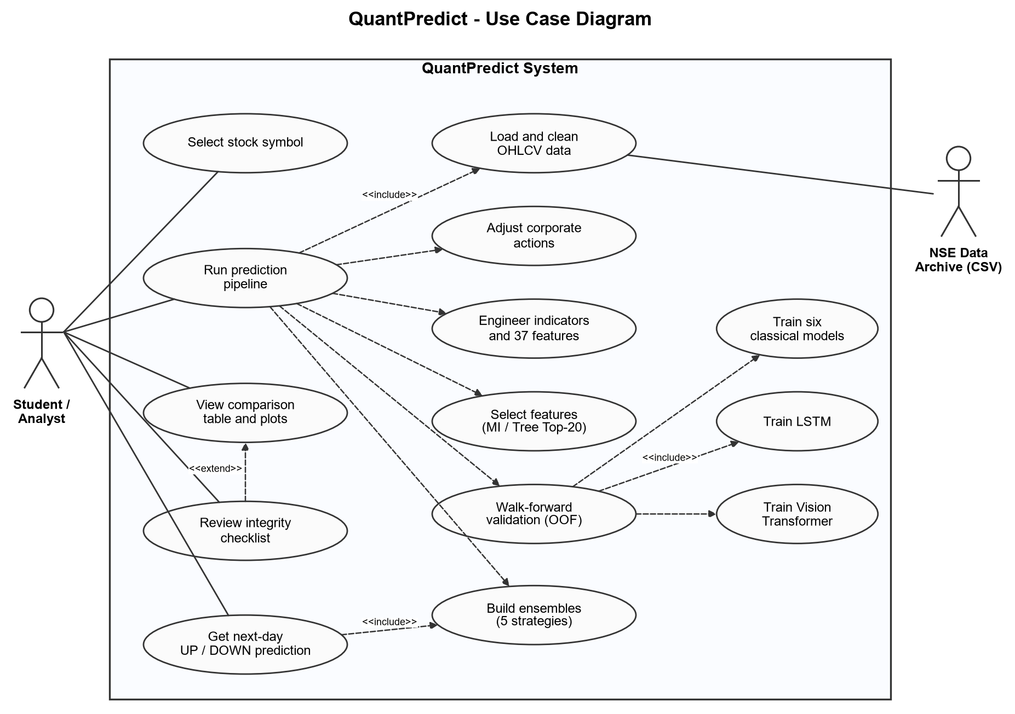
Fig. 4.16 Use Case Diagram of QuantPredict
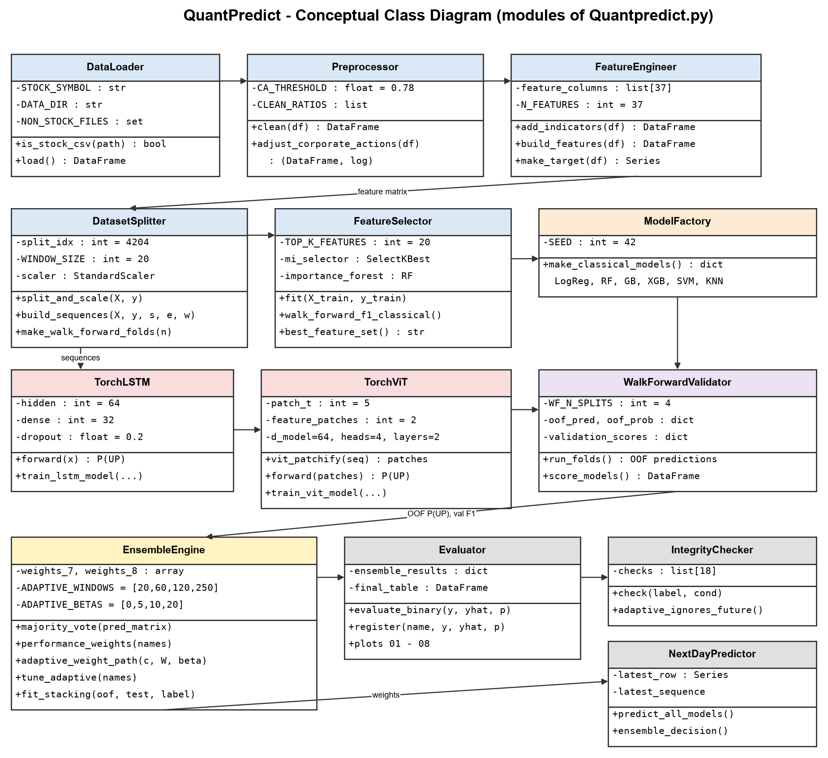
Fig. 4.17 Conceptual Class Diagram of the Pipeline Modules
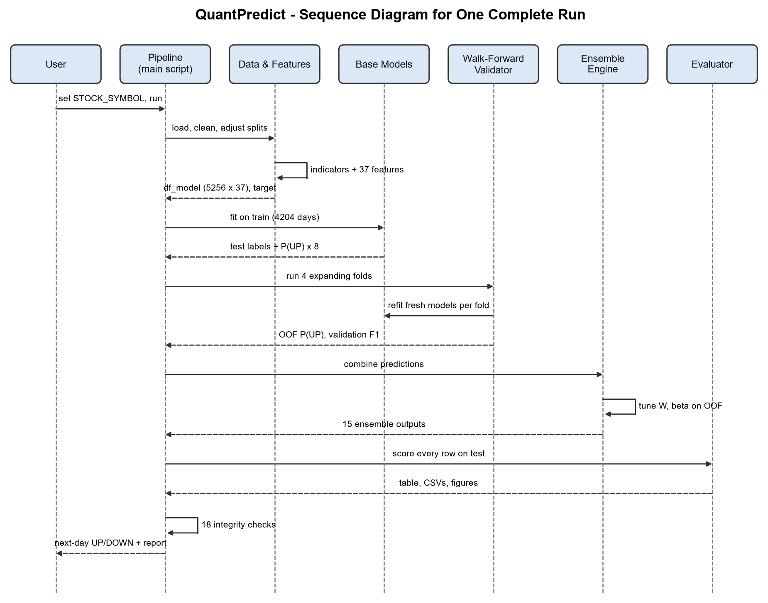
Fig. 4.18 Sequence Diagram for One Complete Run

4.2 Codes and Standards
QuantPredict is a research prototype rather than a regulated product, but it follows a number of established codes and standards so that it is readable, reproducible and easy to verify. Table 4.6 lists them together with where they are applied.
Two of these deserve a comment. Following the scikit-learn estimator interface is what makes the model factory and the walk-forward loops so short: every classical model can be created, fitted and asked for probabilities in the same way. The reproducibility settings mean that two runs on the same machine produce the same numbers; the run used for this report reproduced the saved result tables of the earlier project run exactly, digit for digit.
Table 4.6 Codes and Standards Followed
Standard / convention | Where it is applied
PEP 8 (Python style guide) | Naming (snake_case functions, UPPER_CASE constants), layout and imports
PEP 257 (docstrings) | Docstrings for every helper, e.g. make_walk_forward_folds(), vit_patchify(), adaptive_weight_path()
scikit-learn estimator API | fit / predict / predict_proba interface for all classical models, scalers and selectors (Pedregosa et al., 2011)
ISO 8601 date format | Dates in the input data and in all printed train/test periods (YYYY-MM-DD)
RFC 4180 (CSV) | Input stock files and the two result files written to outputs/
IEEE 754 floating point | float32 feature matrices for the models, float64 for probabilities and metrics
Time-series validation practice | Chronological split, expanding walk-forward folds, no shuffling (Bergmeir & Benítez, 2012)
Reproducibility practice | Fixed seed 42, PYTHONHASHSEED, deterministic TensorFlow options, seeds re-applied before each deep model
APA 7th edition | Citations and reference list in this report
VIT project report template | Margins, fonts, captions, page numbering and chapter structure of this report
Responsible use | The program prints that its prediction is a statistical estimate and not financial advice

4.3 Constraints, Alternatives and Tradeoffs
Several constraints shaped the design. The data are daily, end in April 2021 and contain only prices and volume. The pipeline had to run in a free Colab session and on a laptop CPU, which limited the size of the deep models and the number of walk-forward folds. The project had to be completed within one semester by one student, which favoured a single transparent script over a larger software system. Within these constraints, a number of alternatives were considered. Table 4.7 summarises the main decisions.
The main trade-off running through the table is between strictness and convenience. A random split, a scaler fitted on all data or ensemble weights tuned on the test period would each have produced higher accuracy numbers with less effort. They were rejected because the numbers would not mean what they appear to mean. The cost of this choice is visible in Chapter 7: the honest numbers are close to 50%.
Table 4.7 Design Alternatives Considered and the Choices Made
Decision | Alternatives considered | Choice and trade-off
Task framing | Price regression; multi-class (up / flat / down) | Binary direction: interpretable and decision-relevant, but discards move size
Train/test split | Random split; k-fold CV | Chronological 80/20: realistic, but only one test period
Validation for weights | Single hold-out slice; test-set performance | 4-fold expanding walk-forward: leak-free, but each model is retrained 4 extra times
Input features | Raw price levels (Review-I) | Stationary ratios and returns: comparable across decades, but less intuitive
Price adjustment | Ignore corporate actions; external adjustment data | Self-contained detection rule: no extra data, but heuristic (0.78 threshold)
Sequence model | GRU, CNN, temporal convolution | LSTM: well understood, standard baseline for this task
Attention model | Time-series transformer; PatchTST; CNN on chart images | ViT on patched feature matrices: reuses LSTM windows, but small data for a transformer
DL framework | TensorFlow only; PyTorch only | Both, auto-detected: portable, but every change must be mirrored twice
Ensemble weights | Equal; test-tuned; fixed validation weights | Static and adaptive weights from validation only: fair, but gains are small
Feature count | All features; tuned k | Fixed k = 20 reported as a separate experiment: no tuning on test data
Hyperparameters | Grid or Bayesian search | Sensible defaults: avoids overfitting the search to one period, but may leave accuracy unused

A second trade-off concerns the ViT. Transformers usually need far more data than the roughly 3,500 training windows available for one stock. A pre-trained model or data pooled across many stocks would suit a transformer better, but either would break the like-for-like comparison with the other models. The ViT was therefore kept small (two blocks, 64 dimensions) and regularised with dropout and early stopping, and it is treated as an experimental eighth model.
A third trade-off is runtime. Walk-forward validation retrains every model, including both deep models, four extra times. Reducing the deep-learning epochs inside the folds to 20 keeps a complete run within a few minutes on a laptop, at the price of slightly less trained fold models. Because the fold models are used only to estimate relative quality for weighting and stacking, this was judged acceptable.

CHAPTER 5
SCHEDULE, TASKS AND MILESTONES
The project ran over one semester, from the first week of July 2026 to the final review in November 2026. Work was planned in short phases, each ending with a working version of the pipeline that could be run end to end. This chapter presents the timeline, the milestones, the breakdown of tasks and the main problems that came up along the way.

5.1 Project Timeline
Fig. 5.1 shows the timeline as a Gantt chart, and Table 5.1 gives the same phases with their main outputs. The first half of the semester built and reviewed the baseline. The second half, after Review-I, was spent on the deep models, the data corrections that the deeper analysis revealed, the validation framework and the ensembles, followed by analysis and documentation.
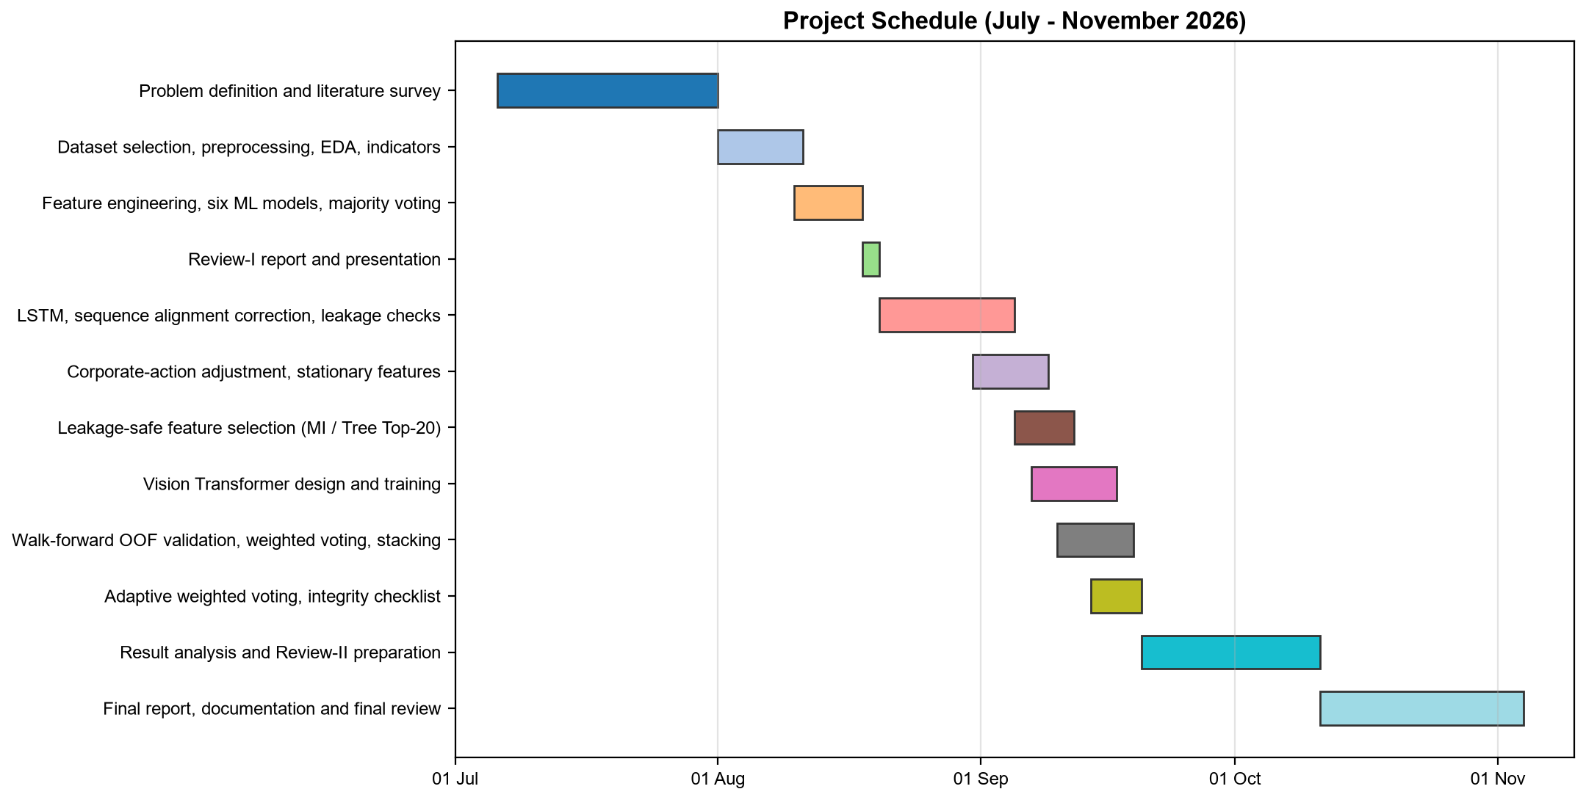
Fig. 5.1 Gantt Chart of the Project Schedule
Table 5.1 Project Phases, Periods and Outputs
Phase | Period (2026) | Main tasks | Output
1 | 06 Jul – 31 Jul | Problem definition, literature search, choice of dataset | Problem statement, initial survey
2 | 01 Aug – 10 Aug | Data loading, cleaning, EDA, technical indicators | Clean data and indicator plots
3 | 10 Aug – 17 Aug | Feature engineering, six classical models, majority voting | Baseline pipeline
4 | 18 Aug – 19 Aug | Review-I report and presentation | Review-I (19 Aug 2026)
5 | 20 Aug – 04 Sep | LSTM, correction of window alignment, first leakage checks | Working LSTM branch
6 | 31 Aug – 08 Sep | Corporate-action adjustment, redesign of features as stationary | 37 stationary features
7 | 05 Sep – 11 Sep | Mutual-information and tree-importance feature selection | Experiment 3
8 | 07 Sep – 16 Sep | Vision Transformer design, patching and training | ViT branch
9 | 10 Sep – 19 Sep | Walk-forward OOF predictions, weighted voting, stacking, adaptive voting, integrity checklist | Complete 18-step pipeline
10 | 20 Sep – 10 Oct | Result analysis, figures, Review-II preparation | Results and Review-II
11 | 11 Oct – 03 Nov | Final report, documentation, final presentation | This report

5.2 Milestones
Seven milestones marked the progress of the work. Each one was tied to a version of the pipeline that ran from start to finish, which made it easy to see whether a change improved or broke something.
Table 5.2 Project Milestones
No. | Milestone | Completion criterion
M1 | Problem and literature finalised | Research question agreed with the guide; 20 open-access papers reviewed
M2 | Review-I baseline | Six classical models and majority voting running on RELIANCE
M3 | Correct sequence model | LSTM windows aligned as X[i−19 : i+1] → y[i] with asserted window counts
M4 | Clean, stationary data | Three corporate actions adjusted; 37 stationary features; scaler fitted on training rows only
M5 | Eight-model system | ViT trained on the same windows and scored on the same test days as all other models
M6 | Leakage-free ensembles | Walk-forward OOF predictions drive weights, adaptive voting and stacking; 18 of 18 checks pass
M7 | Final results and report | Results reproduced from a fresh run; report and presentation completed

5.3 Task Breakdown
Table 5.3 breaks the work into packages and gives a rough share of the total effort for each. The largest share went into validation and ensembles, not into the models themselves. In hindsight this matches where the hard problems were: making the comparison fair took more work than building the models.
Table 5.3 Work Packages and Approximate Share of Effort
Work package | Main activities | Effort
WP1 Literature and planning | Survey, research gap, research questions, schedule | 10%
WP2 Data engineering | Loader, cleaning, corporate-action detection, indicator and feature code | 15%
WP3 Classical models | Model factory, training, evaluation, feature selection | 10%
WP4 Deep models | LSTM and ViT in both PyTorch and TensorFlow, sequence alignment, early stopping | 20%
WP5 Validation and ensembles | Walk-forward folds, OOF predictions, five ensemble strategies, adaptive tuning | 20%
WP6 Verification | Assertions, 18-item integrity checklist, reproducibility checks | 10%
WP7 Analysis and reporting | Figures, tables, interpretation, reviews and this report | 15%

5.4 Challenges Faced and How They Were Resolved
Several problems came up during the work. They are recorded here because each one changed the design, and because most of them are easy to miss in a project of this kind.
Fake crashes in the raw data. The NSE files are not adjusted for bonus issues, so the 1:1 bonus issues of 2009 and 2017 appear in the raw close as 50% one-day crashes, and the 2006 restructuring as a 37.5% drop. These days produce false DOWN labels and distort every lag and rolling feature around them. The corporate-action rule in STEP 2a was written to remove them, and its threshold was chosen so that the genuine crash of March 2020 is not mistaken for a corporate action.
Scaler drift across decades. The earlier feature set included raw price levels such as lagged closes and moving averages. Because the adjusted price rose many times over between 2000 and 2021, the test-period values of these features lay far outside the range the scaler and the models had seen in training, so the models were effectively extrapolating. Rebuilding every feature as a return, ratio or oscillator removed the problem and is the reason the final feature set is fully stationary.
Off-by-one window alignment. Because the label of day i depends on the close of day i+1, it is easy to build windows that either leave out day i or include day i+1. The alignment had to be corrected during development. The final code fixes it in one function, build_sequences(), prints the first and last window indices and asserts the expected number of windows in both partitions.
Where to get honest weights. Weights or meta-models fitted on test-set performance would be circular, and weights fitted on a model's own training predictions would favour the most overfitted models. Moving all weight estimation to walk-forward OOF predictions solved both problems, but it required retraining every model four more times. Reducing the deep-learning epoch budget inside the folds kept the run time manageable.
An odd number of features for the ViT. Cutting 37 features into two equal groups is impossible. Zero-padding one column turned out to be the cleanest solution because, after standardisation, zero is the training mean and carries no signal.
Two deep-learning backends. Colab ships with TensorFlow, while the local machine had only PyTorch. Supporting both meant writing every deep component twice with identical architecture and training rules, and checking that both paths produce comparable behaviour.

CHAPTER 6
PROJECT DEMONSTRATION
This chapter demonstrates a complete run of QuantPredict on the RELIANCE data. The excerpts below are taken from the console output of the final run, shortened where the output is repetitive. The run was repeated from scratch while writing this report, and it reproduced the saved results of the earlier project run exactly.

6.1 Running the System
In Google Colab the file is run as a single cell; it installs the ta and xgboost packages automatically and asks for a CSV upload if the stock file is not found. Locally it runs as a normal script. Setting the MPLBACKEND variable to Agg saves the figures to the outputs folder without opening windows, which is how the run in this chapter was made:
# choose the stock in STEP 1: STOCK_SYMBOL = "RELIANCE"
MPLBACKEND=Agg PYTHONIOENCODING=utf-8 py -u Quantpredict.py > run.txt

On the laptop described in Chapter 3 the full run, including four walk-forward retrainings of all eight models, finished in about four minutes using the PyTorch backend on the CPU.

6.2 Data Loading, Cleaning and Corporate Actions
The first lines of output confirm the backend, the file that was loaded and the result of cleaning and corporate-action detection. No rows were invalid, and the three corporate actions of Table 4.1 were found and adjusted.
QuantPredict - 8 Model Pipeline (6 classical + LSTM + Vision Transformer)
DL backend: pytorch
Loaded: archive\RELIANCE.csv | rows: 5306
Rows after cleaning: 5306 (dropped 0 invalid/duplicate rows)

Corporate-action adjustments applied: 3
2006-01-18 overnight gap 0.625 -> price factor 0.6250
2009-11-26 overnight gap 0.506 -> price factor 0.5000
2017-09-07 overnight gap 0.500 -> price factor 0.5000

STEP 2b then plots the adjusted close price and the traded volume (Fig. 6.1 and Fig. 6.2). The close series no longer has artificial cliffs. The adjusted volume is highest in the early 2000s, partly because volumes before each corporate action are scaled up by the adjustment factor, and it shows isolated spikes, the largest around the 2006 restructuring. Such shifts in the level of volume over two decades are the reason volume enters the models only as ratios to its own 20-day average.
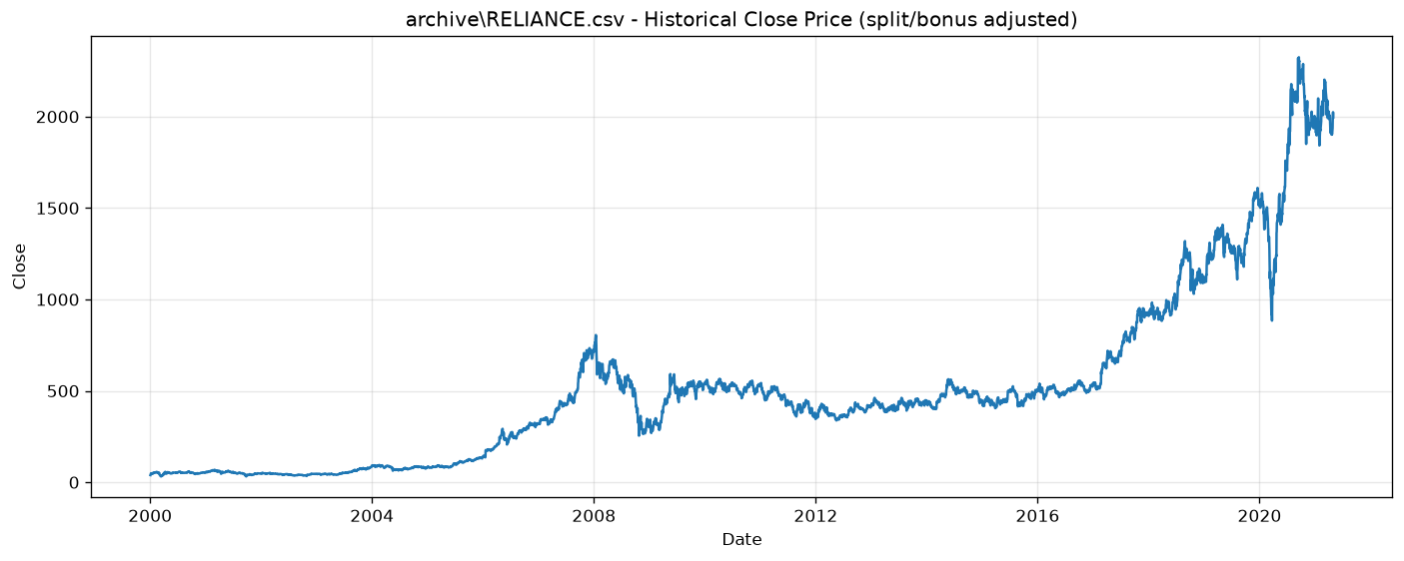
Fig. 6.1 Adjusted Historical Close Price of RELIANCE (Pipeline Output)
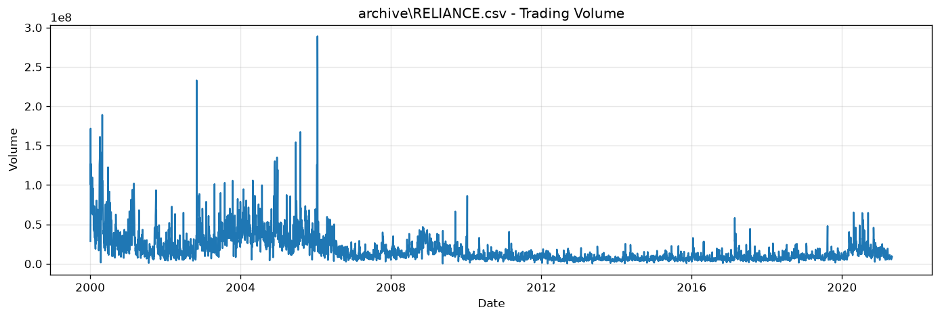
Fig. 6.2 Adjusted Daily Traded Volume of RELIANCE (Pipeline Output)

6.3 Feature Engineering and Dataset Summary
After STEPS 3 and 4, the program prints the class balance and a dataset summary that every later result refers to. Printing the exact train and test dates is a deliberate habit: it makes it obvious which period a number belongs to.
Target class balance:
DOWN (0): 0.4836 (48.4%)
UP (1): 0.5164 (51.6%)
Train: 4204 | Test: 1052

DATASET SUMMARY
Dataset file : RELIANCE.csv
Full date range : 2000-03-13 -> 2021-04-29
Modelling samples : 5256 (complete features AND a real next-day label)
Engineered features : 37
Target definition : Target[t] = 1 if Close[t+1] > Close[t] else 0
Split rule : chronological 80/20, split index = 4204
TRAIN period : 2000-03-13 -> 2017-01-25 (4204 samples)
TEST period : 2017-01-27 -> 2021-04-29 (1052 samples)
Every model and every ensemble below is scored on exactly this TEST period.

6.4 Feature Selection
STEP 6 prints the two top-20 rankings, the twelve features chosen by both methods, the walk-forward folds and the validation F1 of each candidate feature set. The MI Top-20 set had the highest mean validation F1 (0.5607 against 0.5562 for all features), so it is reported as the preferred selected set.
Running walk-forward validation for each feature set ...
All Features mean validation F1 = 0.5562
MI Top-20 mean validation F1 = 0.5607
Tree Top-20 mean validation F1 = 0.5592

Chosen by BOTH methods (12): ['Return_1', 'Overnight_Gap', 'High_Low_Range', 'ADX',
'BB_Width', 'Volatility_5', 'Volume_Ratio_20', 'Return_Lag_1', 'Return_Lag_2',
'Return_Lag_3', 'Volume_Ratio_Lag_2', 'Volume_Ratio_Lag_3']
Feature set chosen by walk-forward VALIDATION: MI Top-20

Fig. 6.3 shows the full rankings. The two methods agree on the importance of recent returns, the overnight gap and the volume ratios, but differ elsewhere: mutual information favours the distance from the 50-day SMA and the intraday return, while the forest favours the OBV slope and the volatility features. Every mutual-information score is also very small (the largest is 0.015), an early hint that no single feature carries much information about the next day's direction.
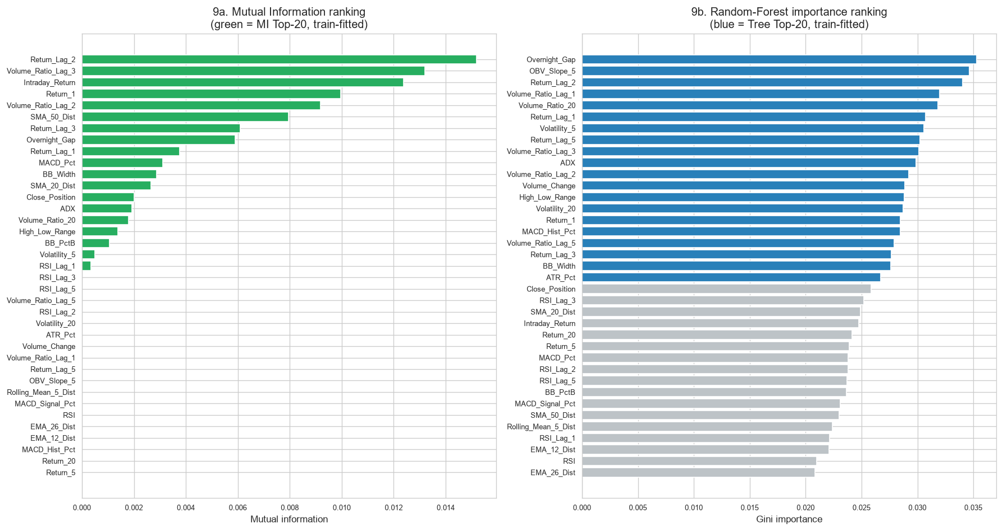
Fig. 6.3 Mutual-Information and Random-Forest Feature Rankings (Training Data Only)
Table 6.1 Top-20 Features Chosen by Each Selector (Ranked)
Rank | Mutual Information Top-20 | MI score | Tree-importance Top-20 | Importance
1 | Return_Lag_2 | 0.01519 | Overnight_Gap | 0.03531
2 | Volume_Ratio_Lag_3 | 0.01320 | OBV_Slope_5 | 0.03465
3 | Intraday_Return | 0.01239 | Return_Lag_2 | 0.03402
4 | Return_1 | 0.00997 | Volume_Ratio_Lag_1 | 0.03196
5 | Volume_Ratio_Lag_2 | 0.00919 | Volume_Ratio_20 | 0.03182
6 | SMA_50_Dist | 0.00795 | Return_Lag_1 | 0.03073
7 | Return_Lag_3 | 0.00610 | Volatility_5 | 0.03060
8 | Overnight_Gap | 0.00590 | Return_Lag_5 | 0.03021
9 | Return_Lag_1 | 0.00376 | Volume_Ratio_Lag_3 | 0.03011
10 | MACD_Pct | 0.00311 | ADX | 0.02987
11 | BB_Width | 0.00287 | Volume_Ratio_Lag_2 | 0.02924
12 | SMA_20_Dist | 0.00266 | Volume_Change | 0.02885
13 | Close_Position | 0.00201 | High_Low_Range | 0.02883
14 | ADX | 0.00192 | Volatility_20 | 0.02870
15 | Volume_Ratio_20 | 0.00180 | Return_1 | 0.02848
16 | High_Low_Range | 0.00137 | MACD_Hist_Pct | 0.02846
17 | BB_PctB | 0.00106 | Volume_Ratio_Lag_5 | 0.02794
18 | Volatility_5 | 0.00050 | Return_Lag_3 | 0.02764
19 | RSI_Lag_1 | 0.00036 | BB_Width | 0.02761
20 | RSI_Lag_5 | 0.00000 | ATR_Pct | 0.02672

6.5 Training the Deep Models
STEPS 8 and 9 print the configuration, the window shapes, the alignment of the first and last windows and a short test summary for each deep model. The alignment lines are worth reading: the last training window ends at row 4,203, just before the split, and the first test window ends at row 4,204, the first test day.
STEP 8: LSTM DEEP LEARNING MODEL
Config -> window=20, epochs=35, batch_size=32, learning_rate=0.001, dropout=0.2,
threshold=0.5, patience=8, seed=42
LSTM sequence shapes Train: (3557, 20, 37) Val: (628, 20, 37) Test: (1052, 20, 37)
First train sequence: 0..19 -> y[19] Last train sequence: 4184..4203 -> y[4203]
First test sequence: 4185..4204 -> y[4204] Last test sequence: 5236..5255 -> y[5255]
Leakage/sequence sanity checks passed
Early stopping at epoch 13
LSTM TEST SUMMARY: UP predicted 403 | DOWN predicted 649 | Accuracy 0.4895 | F1 0.4341

STEP 9: VISION TRANSFORMER (adapted for financial time-series feature matrices)
Input matrix per sample : 20 time steps x 37 features
Patch grid : 4 x 2 = 8 patches
Patch size : 5 days x 19 features -> flattened patch_dim = 95
Patched shapes : train (3557, 8, 95), val (628, 8, 95), test (1052, 8, 95)
VISION TRANSFORMER TEST SUMMARY: UP predicted 905 | DOWN predicted 147 | Accuracy 0.5010

Fig. 6.4 shows the training curves. Both models follow the same pattern. The training loss falls steadily, but the validation loss is lowest within the first few epochs and then rises. The LSTM's validation loss bottomed out at epoch 5 and training stopped at epoch 13; the ViT's was lowest at epoch 1 and training stopped at epoch 9. Early stopping restored the weights from the best epoch in both cases. This is the typical signature of a low signal-to-noise problem: the networks can memorise the training windows, but what they memorise does not carry over to later years.
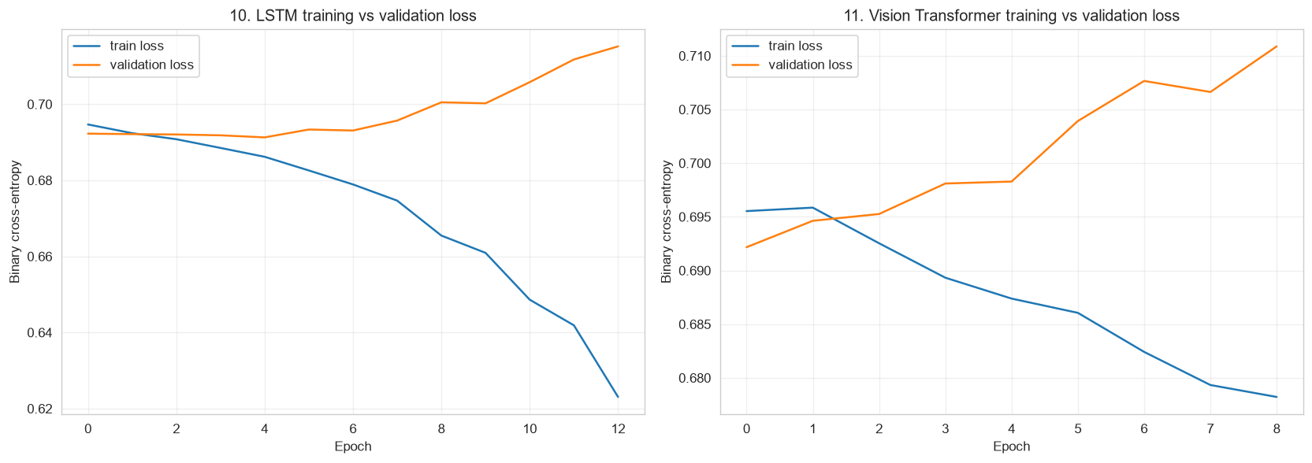
Fig. 6.4 Training and Validation Loss of the LSTM and the Vision Transformer

6.6 Walk-Forward Validation
STEP 10B is the slowest part of the run. For each of the four folds it fits a fresh scaler, retrains the six classical models, the LSTM and the ViT, and stores their predictions for the fold's validation block.
STEP 10B: TIME-AWARE WALK-FORWARD VALIDATION (training period only)
OOF coverage: rows 2102..4203 (2008-07-30 .. 2017-01-25)
OOF samples : 2102 | folds: 4
--- Fold 1/4: train rows 0..2101 -> validate rows 2102..2626 ---
classical models done / LSTM done / ViT done
--- Fold 2/4: train rows 0..2626 -> validate rows 2627..3151 ---
--- Fold 3/4: train rows 0..3151 -> validate rows 3152..3676 ---
--- Fold 4/4: train rows 0..3676 -> validate rows 3677..4203 ---

6.7 Ensemble Construction
STEPS 11 to 14 build the ensembles and print each one's test metrics as it is registered. The weighted voting step also prints the weights and checks that they sum to one; the adaptive step prints its parameter search and the chosen setting.
STEP 13: PERFORMANCE-WEIGHTED VOTING (Experiment 6)
Model Val F1 Val BalAcc Weight
Logistic Regression 0.5896 0.5115 0.1485
Random Forest 0.5701 0.5011 0.1436
Gradient Boosting 0.5486 0.5173 0.1381
XGBoost 0.5270 0.5005 0.1327
SVM 0.5721 0.4933 0.1441
KNN 0.5336 0.5191 0.1344
LSTM 0.6304 0.5006 0.1587
SUM 1.0000

STEP 13B: 7-model adaptive voting - Chosen: window = 250 days, beta = 20

6.8 Next-Day Prediction
STEP 16 is kept strictly separate from the evaluation. It takes the last row of data (30 April 2021, close INR 1,994.50), which was never used for training or testing because its outcome was unknown, scales it with the training scaler, builds the last 20-day window and asks every model and ensemble for a decision about the next trading day. Table 6.2 and Fig. 6.5 show the result.
Table 6.2 Predictions for the Trading Day After 30 April 2021
Model / ensemble | P(UP) or score | Decision
Logistic Regression | 0.5241 | UP
Random Forest | 0.5064 | UP
Gradient Boosting | 0.3885 | DOWN
XGBoost | 0.2958 | DOWN
SVM | 0.5181 | UP
KNN | 0.6158 | UP
LSTM | 0.4924 | DOWN
Vision Transformer | 0.5417 | UP
Majority voting (7 models) | 4 of 7 UP | UP
Weighted voting, labels (7) | S = 0.5704 | UP
Weighted voting, probabilities (7) | P = 0.4789 | DOWN
Majority voting (8) [experimental] | 5 of 8 UP | UP
Weighted labels (8) [experimental] | S = 0.6200 | UP
Weighted probabilities (8) [experimental] | P = 0.4862 | DOWN
Adaptive weighted, labels (7) | S = 0.4698 | DOWN
Adaptive weighted, probabilities (7) | P = 0.4424 | DOWN

The example shows why the combination rule matters. Five of the eight models lean slightly towards UP, so the label-based rules say UP. But the two boosting models are fairly confident about DOWN (0.39 and 0.30), and the probability-based rules, which keep this confidence, say DOWN. The adaptive rule says DOWN more firmly because, over the previous 250 known days, XGBoost and SVM had been the most accurate models and received the largest weights (0.262 and 0.176), while KNN, the most confident UP voter, had fallen to a weight of 0.057. The program closes this step with a printed warning that the output is a statistical estimate and not financial advice.
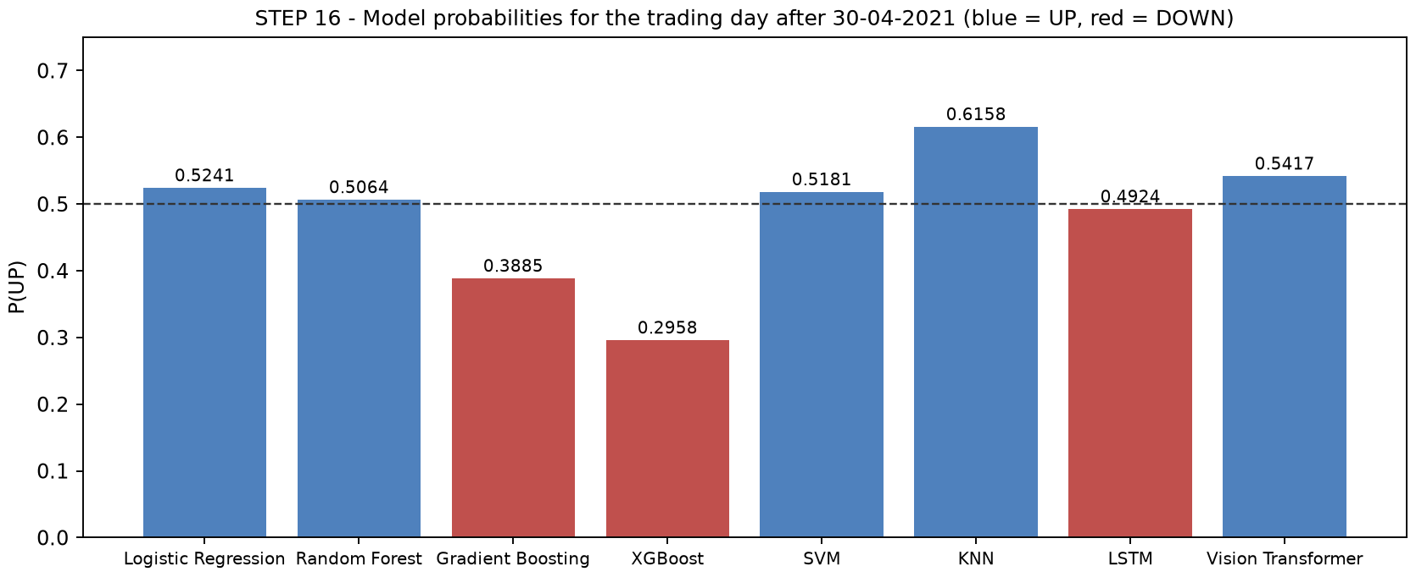
Fig. 6.5 Model Probabilities for the Trading Day After 30 April 2021

6.9 Integrity Checklist
STEP 17 re-checks the leakage and consistency rules after everything has run. All 18 checks passed in the final run (Table 6.3). If any check fails, the program lists it and the results above it should not be trusted.
Table 6.3 Output of the STEP 17 Leakage and Integrity Checklist
No. | Check | Result
1 | Chronological split, test never shuffled | PASS
2 | Main scaler fitted on training rows only | PASS
3 | Selected-feature scaler fitted on training rows only | PASS
4 | MI selector fitted on training rows only | PASS
5 | Tree selector fitted on training rows only | PASS
6 | All walk-forward folds end at or before the test boundary | PASS
7 | Out-of-fold window lies inside the training period | PASS
8 | Voting weights come from validation F1, not test data | PASS
9 | 7-model weights sum to 1 | PASS
10 | Stacking meta-model trained on out-of-fold predictions only | PASS
11 | LSTM sequence alignment X[i-W+1:i+1] -> y[i] preserved | PASS
12 | ViT consumes 20 x 37 financial feature matrices | PASS
13 | Classical and sequence models scored on identical test days | PASS
14 | All models predict the same UP/DOWN target | PASS
15 | Latest-prediction row excluded from training and test | PASS
16 | Adaptive window/beta chosen on the OOF (training) period only | PASS
17 | Adaptive weights for day t never use the label of day t or later | PASS
18 | Adaptive weights sum to 1 on every test day | PASS

6.10 Generated Artefacts
Every run writes its results to the outputs folder, with the stock symbol as a prefix, so that runs on different stocks do not overwrite each other. Table 6.4 lists the files produced by the RELIANCE run.
Table 6.4 Files Written to the outputs Folder
File | Content
RELIANCE_00_close_price.png, RELIANCE_00_volume.png | Adjusted price and volume history (STEP 2b)
RELIANCE_01_individual_accuracy.png | Test accuracy of the eight individual models
RELIANCE_02_ensemble_accuracy.png | Test accuracy of the fifteen ensembles
RELIANCE_03_f1_comparison.png | F1 of individual models and ensembles
RELIANCE_04_confusion_matrices.png | Six confusion matrices on the test period
RELIANCE_05_feature_ranking.png | MI and tree-importance feature rankings
RELIANCE_06_training_curves.png | LSTM and ViT training and validation loss
RELIANCE_07_voting_comparison.png | Majority vs static weighted vs adaptive voting
RELIANCE_08_adaptive_weights_over_time.png | Adaptive weights and rolling 60-day accuracy
RELIANCE_results.csv | All 37 result rows (8 individual, 15 ensemble, 14 feature-selected)
RELIANCE_voting_comparison.csv | The ten-row voting comparison table of STEP 18

CHAPTER 7
RESULT AND DISCUSSION
This chapter reports the results of the final run and discusses what they mean. All numbers refer to the same test period, 27 January 2017 to 29 April 2021 (1,052 trading days), which no model, selector, weight or meta-model saw during training or tuning. The results are presented in the order of the research questions: individual models (RQ1 and RQ2), feature selection (RQ4) and ensembles (RQ3), followed by a statistical assessment and a broader discussion.

7.1 Reading the Results: Two Reference Points
Two numbers are needed to read every table in this chapter. The first is the majority-class rate. In the test period 546 of the 1,052 days (51.9%) were UP days, so a rule that always predicts UP is right 51.9% of the time without learning anything. A model must beat 0.519, not 0.500, to show skill. The same rule would have an F1-score of 0.683, which is higher than every model in the study; F1 alone is therefore a poor guide here, because it rewards predicting UP often.
The second number is the sampling band of Eqn. 4.42. With 1,052 test days, the standard error of an accuracy near 0.5 is about 1.5 percentage points, so differences smaller than about ±3.0 points between two methods could easily be produced by chance alone. Both reference points are printed by the program at the end of STEP 15 and STEP 18.

7.2 Performance of the Individual Models
Table 7.1 and Fig. 7.1 give the test results of the eight individual models, sorted by accuracy.
Gradient Boosting is clearly the best individual model, with 53.6% accuracy (564 of 1,052 days correct), the highest precision (0.551) and the highest ROC-AUC (0.535). It is the only model that is clearly above the majority-class rate; KNN matches it exactly at 0.519. The other six models score between 49.0% and 50.7%, below the majority-class rate, and three of them (Logistic Regression, the ViT and the LSTM) have ROC-AUC values below 0.5, meaning their probabilities ranked UP days slightly worse than random on this period.
Table 7.1 Test Performance of the Eight Individual Models (All 37 Features)
Model | Accuracy | Precision | Recall | F1 | ROC-AUC
Gradient Boosting | 0.5361 | 0.5509 | 0.5751 | 0.5627 | 0.5345
KNN | 0.5190 | 0.5375 | 0.5256 | 0.5315 | 0.5231
XGBoost | 0.5067 | 0.5228 | 0.5678 | 0.5443 | 0.5211
Random Forest | 0.5019 | 0.5175 | 0.5971 | 0.5544 | 0.5122
SVM | 0.5019 | 0.5175 | 0.5952 | 0.5537 | 0.5026
Vision Transformer | 0.5010 | 0.5116 | 0.8480 | 0.6382 | 0.4851
Logistic Regression | 0.4962 | 0.5123 | 0.6081 | 0.5561 | 0.4879
LSTM | 0.4895 | 0.5112 | 0.3773 | 0.4341 | 0.4905

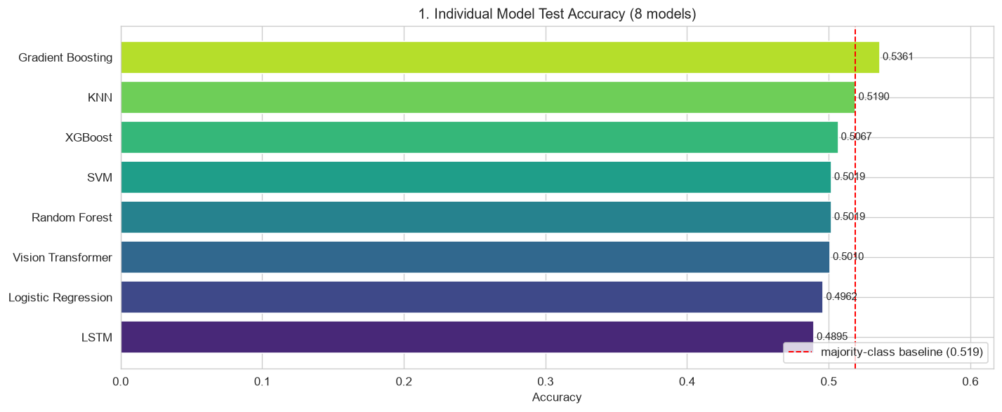
Fig. 7.1 Test Accuracy of the Individual Models with the Majority-Class Baseline
The confusion matrices in Fig. 7.2 show how the models make their mistakes. Gradient Boosting has a fairly balanced profile: it predicted UP on 570 days and DOWN on 482, with 250 true negatives and 314 true positives. The ViT, by contrast, predicted UP on 905 of the 1,052 days. It caught 463 of the 546 UP days (recall 0.848) but identified only 64 of the 506 DOWN days. Its F1 of 0.638 is the highest of the eight models, but it is an artefact of this UP bias and is still below the 0.683 of a model that always predicts UP.
Fig. 7.3 ranks the individual models and the ensembles by ROC-AUC. Gradient Boosting again comes first (0.5345), followed by the two stacking ensembles and the probability-based adaptive and soft voting rules. The ranking ability of every method is weak, which is consistent with the accuracies: the probabilities contain a small amount of real information, and only a few methods extract it consistently.
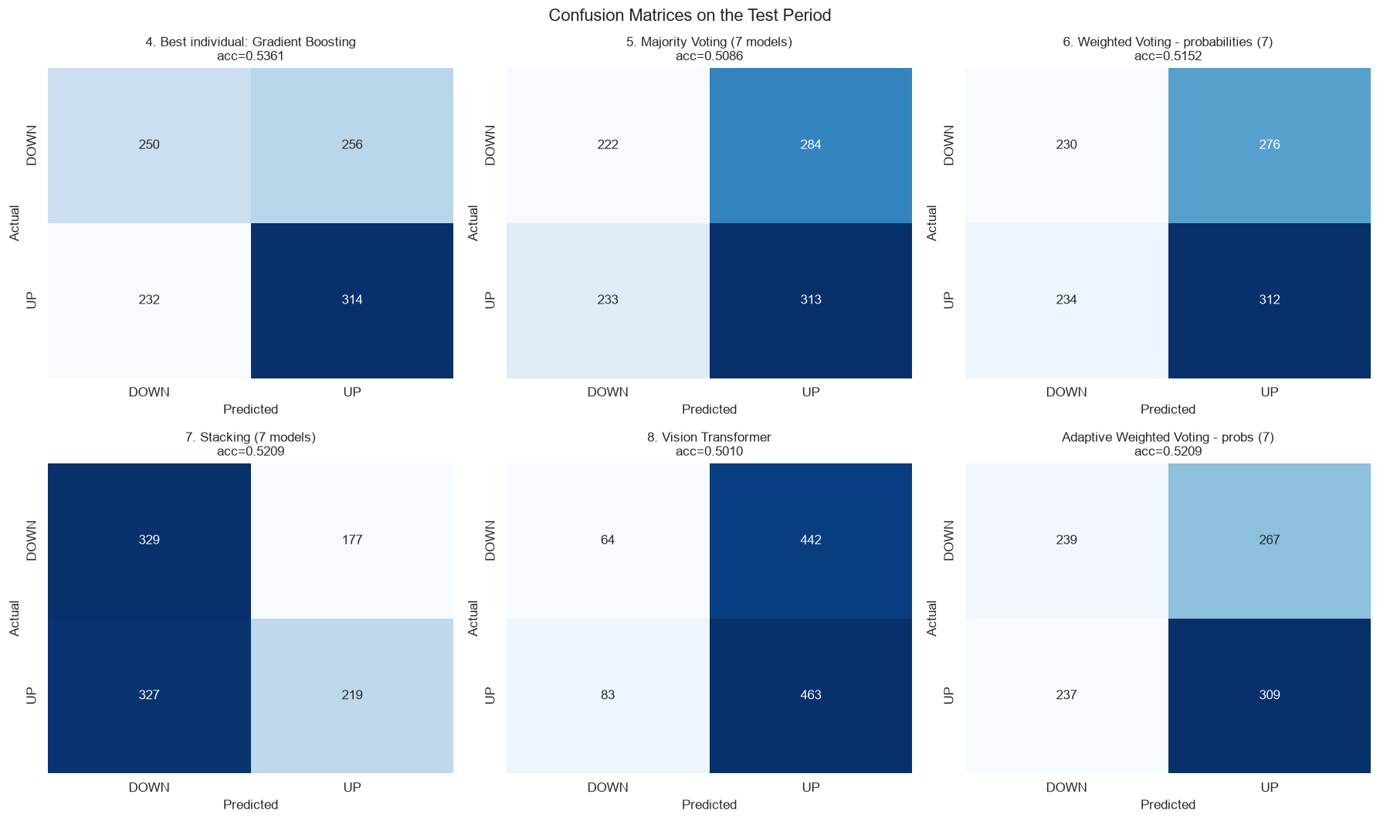
Fig. 7.2 Confusion Matrices of the Best Model, the ViT and Four Ensembles
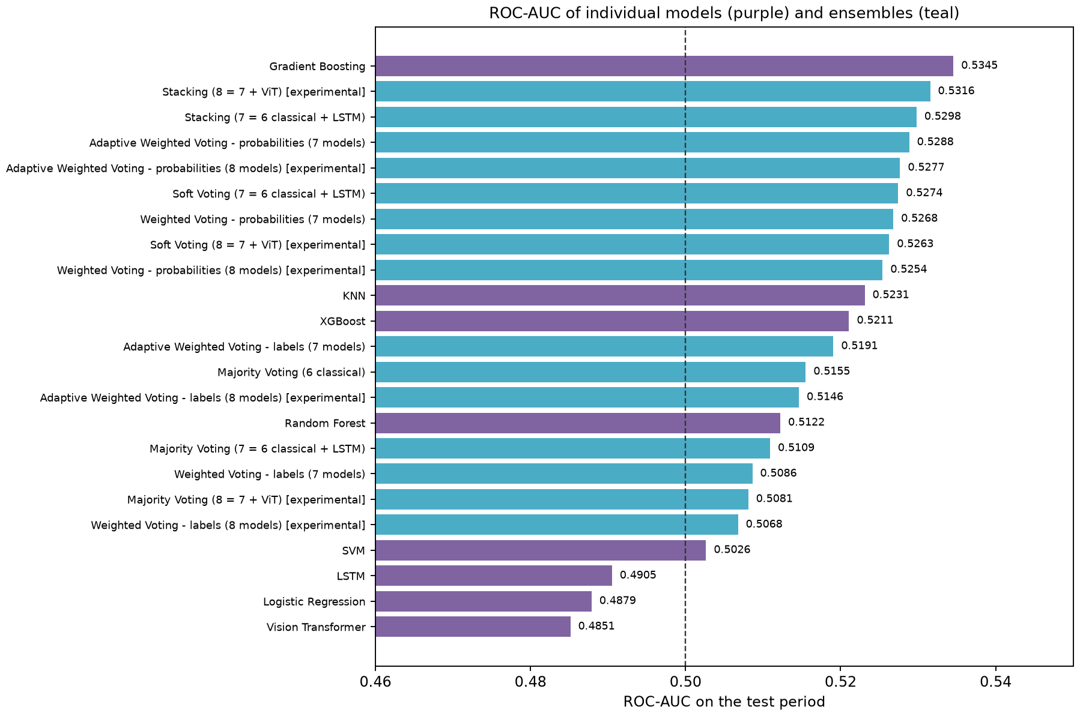
Fig. 7.3 ROC-AUC of the Individual Models and the Ensembles on the Test Period

7.3 Behaviour of the Deep Models
The two deep models were the weakest performers, but in opposite ways. The LSTM was pessimistic: it predicted UP on only 403 days (38%), its average predicted probability of UP was 0.484, and its recall was 0.377. The ViT was optimistic: it predicted UP on 905 days (86%) with an average probability of 0.522. Both ended up near 50% accuracy. Their training curves (Fig. 6.4) explain why. In both networks the validation loss was lowest in the first few epochs and rose afterwards, while the training loss kept falling. Early stopping therefore kept weights from very early in training, when the networks had learned little more than a slight preference for one class.
This is not a sign that the implementation is broken. The sequence alignment and leakage checks all pass, and the same networks trained on random noise would behave in a similar way. Rather, it shows the scale of the problem. The LSTM has about 28,000 parameters and the ViT about 76,000, trained on 3,557 windows whose labels are close to random. With so little signal, a flexible model fits noise faster than it finds structure. The literature points in the same direction: deep models do not improve daily direction for every stock or sector (Kundu & Pinsky, 2025), and transformers do not automatically beat simpler models on time series (Zeng et al., 2023).
For RQ2 the answer is therefore negative on its own and mixed inside ensembles. As an individual model the ViT did not beat the majority-class rate. As a member of an ensemble it helped some rules and hurt others: majority voting improved from 50.86% (7 models) to 51.43% (8 models) and stacking from 52.09% to 52.38%, while static weighted voting with probabilities fell from 51.52% to 51.24% and adaptive voting with probabilities from 52.09% to 51.90%. All of these changes are well inside the sampling band. Interestingly, the stacking meta-model gave the ViT a negative coefficient (Section 7.7), which means it used the ViT's optimism as a mild contrary signal.

7.4 Feature Selection (Experiment 3)
On walk-forward validation inside the training period, both selected subsets beat the full feature set: the mean validation F1 of the six classical models was 0.5607 with MI Top-20, 0.5592 with Tree Top-20 and 0.5562 with all 37 features (Fig. 7.4). MI Top-20 was therefore the preferred subset and was also used to retrain the LSTM and the ViT.
Table 7.2 gives the test results of all fourteen feature-selected variants, and Fig. 7.5 compares them model by model with the all-feature baseline.
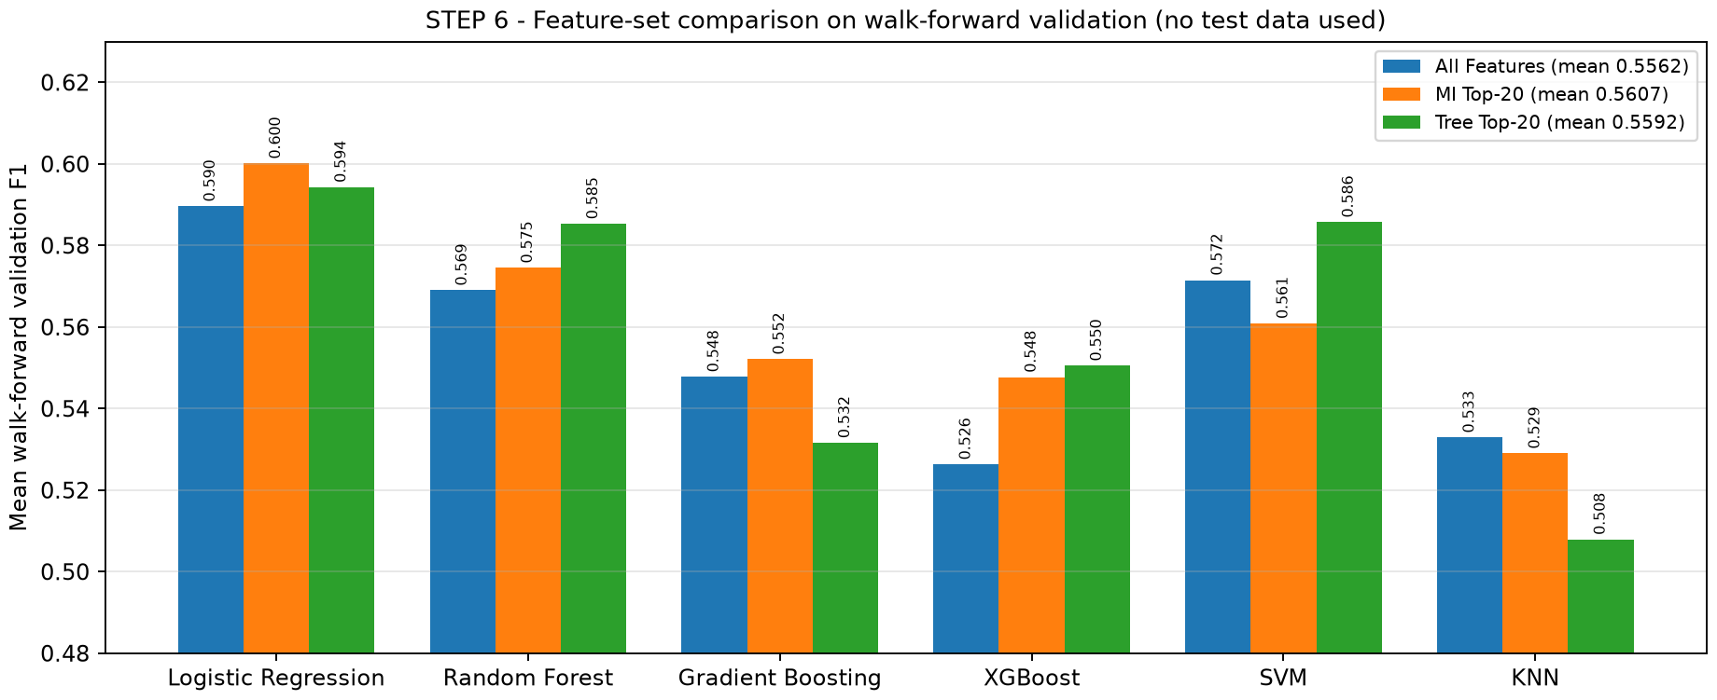
Fig. 7.4 Walk-Forward Validation F1 of the Three Candidate Feature Sets
Table 7.2 Test Performance of the Feature-Selected Model Variants
Model [feature set] | Accuracy | Precision | Recall | F1 | ROC-AUC
Random Forest [MI Top-20] | 0.5295 | 0.5397 | 0.6355 | 0.5837 | 0.5291
XGBoost [MI Top-20] | 0.5266 | 0.5407 | 0.5842 | 0.5616 | 0.5176
Gradient Boosting [Tree Top-20] | 0.5190 | 0.5358 | 0.5476 | 0.5417 | 0.5284
Random Forest [Tree Top-20] | 0.5152 | 0.5282 | 0.6172 | 0.5693 | 0.5227
KNN [Tree Top-20] | 0.5152 | 0.5328 | 0.5348 | 0.5338 | 0.5206
KNN [MI Top-20] | 0.5124 | 0.5304 | 0.5275 | 0.5289 | 0.5292
Logistic Regression [Tree Top-20] | 0.5124 | 0.5246 | 0.6447 | 0.5785 | 0.4912
XGBoost [Tree Top-20] | 0.5095 | 0.5260 | 0.5568 | 0.5409 | 0.5167
LSTM [MI Top-20] | 0.5095 | 0.5225 | 0.6374 | 0.5743 | 0.4788
SVM [Tree Top-20] | 0.5076 | 0.5234 | 0.5733 | 0.5472 | 0.4929
Gradient Boosting [MI Top-20] | 0.5038 | 0.5203 | 0.5623 | 0.5405 | 0.5054
Vision Transformer [MI Top-20] | 0.5029 | 0.5188 | 0.5824 | 0.5487 | 0.5040
SVM [MI Top-20] | 0.5019 | 0.5171 | 0.6099 | 0.5597 | 0.5045
Logistic Regression [MI Top-20] | 0.4762 | 0.4963 | 0.6190 | 0.5509 | 0.4889

The test results do not confirm the validation advantage in a consistent way. The best feature-selected variant, Random Forest with MI Top-20, reached 52.95%, which improved Random Forest by 2.8 points but is still 0.67 points below the all-feature Gradient Boosting. MI selection helped four of the eight models (Random Forest, XGBoost, LSTM and ViT), left the SVM unchanged and hurt Logistic Regression, KNN and, most of all, Gradient Boosting, which fell from 53.61% to 50.38%. Tree selection helped four of the six classical models but also lowered Gradient Boosting. The average accuracy of the fourteen variants (51.0%) is about the same as that of the eight baseline models (50.7%).
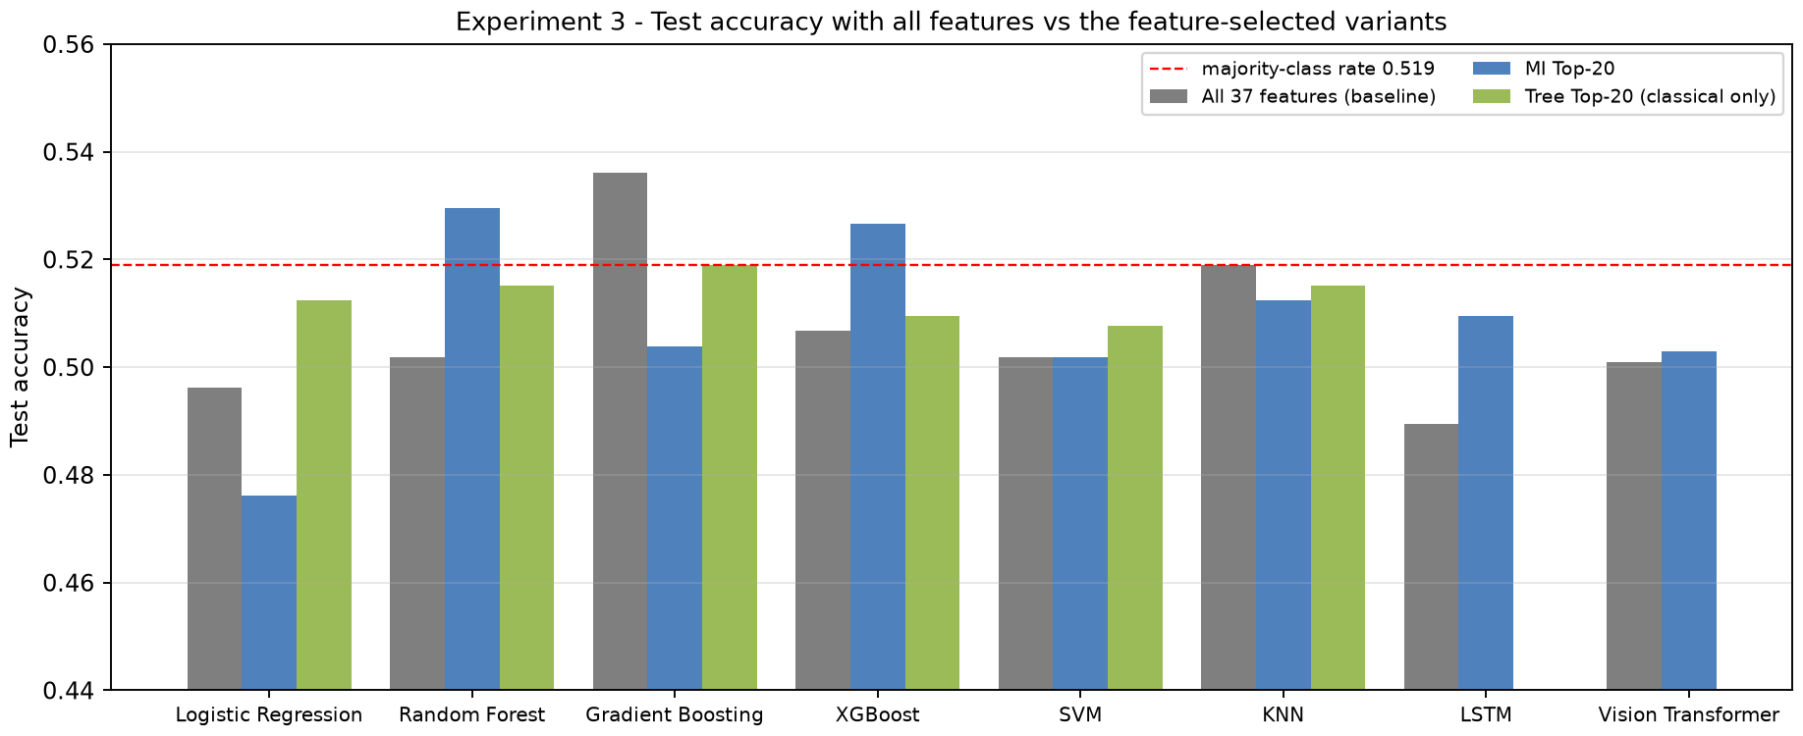
Fig. 7.5 Test Accuracy with All Features Versus the Feature-Selected Variants
The answer to RQ4 is that feature selection does not reliably improve on the full feature set for this problem. It tends to help the weaker or more noise-sensitive models and to hurt the model that was strongest with all features. A likely reason is the very low information content of every feature: the largest mutual-information score is only 0.015, so the selectors are choosing among features that are nearly equally uninformative, and the choice partly reflects noise in the training years.

7.5 Walk-Forward Validation Scores and Static Weights
Table 7.3 gives the out-of-fold validation scores of all eight models on the 2,102 OOF days and the resulting static weights of the 7-model ensemble. Fig. 7.6 shows the same scores graphically.
Table 7.3 Walk-Forward Validation Scores (Training Period Only) and Static Weights
Model | Val. accuracy | Val. balanced acc. | Val. F1 | Val. ROC-AUC | Weight (7)
LSTM | 0.4952 | 0.5006 | 0.6304 | 0.4907 | 0.1587
Logistic Regression | 0.5086 | 0.5115 | 0.5896 | 0.5164 | 0.1485
SVM | 0.4905 | 0.4933 | 0.5721 | 0.5055 | 0.1441
Random Forest | 0.4986 | 0.5011 | 0.5701 | 0.5093 | 0.1436
Gradient Boosting | 0.5162 | 0.5173 | 0.5486 | 0.5226 | 0.1381
KNN | 0.5186 | 0.5191 | 0.5336 | 0.5146 | 0.1344
XGBoost | 0.4995 | 0.5005 | 0.5270 | 0.5098 | 0.1327
Vision Transformer | 0.4881 | 0.4891 | 0.5175 | 0.4898 | –

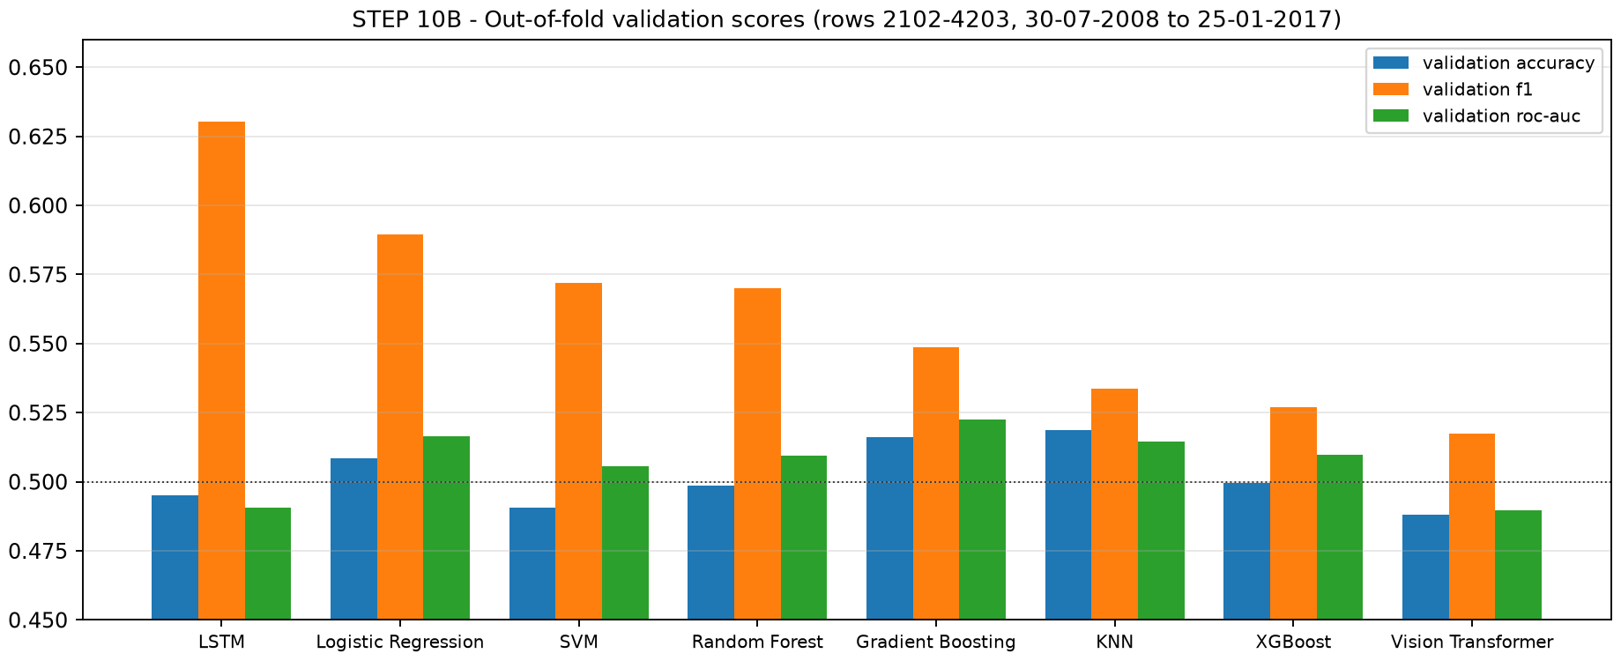
Fig. 7.6 Out-of-Fold Validation Scores of the Eight Models
Two observations stand out. First, the validation scores agree with the test results on the broad picture. Gradient Boosting and KNN had the best validation accuracy (51.6% and 51.9%) and were the two best models on the test period. Second, F1 is a misleading weighting metric for this task. The LSTM had the highest validation F1 (0.630) and therefore received the largest weight (0.159), although its validation accuracy was below 50% and its balanced accuracy was 0.501. Its high F1 came from predicting UP often during the validation years, the same effect that inflates the ViT's F1 on the test set. Gradient Boosting, the most accurate model, received one of the smallest weights (0.138).
Because all F1 values lie between 0.527 and 0.630, the weights are close to equal: the 7-model weights range only from 0.133 to 0.159. This has an exact consequence for the label-based weighted vote. Any four models together carry at least 0.1327 + 0.1344 + 0.1381 + 0.1436 = 0.549 of the weight, and any three carry at most 0.1587 + 0.1485 + 0.1441 = 0.451. The weighted label vote therefore always agrees with the simple four-of-seven majority, which is why “Weighted Voting – labels (7 models)” and “Majority Voting (7)” have identical accuracy, precision, recall and F1 in Table 7.4. Only their ROC-AUC differs, because the continuous weighted score ranks days differently from the vote count. With eight models the weights can break 4–4 ties, so the 8-model rows do differ.

7.6 Ensemble Results
Table 7.4 lists all fifteen ensembles, and Fig. 7.7 and Fig. 7.8 show their accuracy and F1 next to the individual models.
Table 7.4 Test Performance of the Fifteen Ensemble Variants
Ensemble | Accuracy | Precision | Recall | F1 | ROC-AUC
Stacking (8 = 7 + ViT) [exp.] | 0.5238 | 0.5652 | 0.3571 | 0.4377 | 0.5316
Adaptive weighted - probabilities (7) | 0.5209 | 0.5365 | 0.5659 | 0.5508 | 0.5288
Stacking (7 = 6 classical + LSTM) | 0.5209 | 0.5530 | 0.4011 | 0.4650 | 0.5298
Adaptive weighted - probabilities (8) [exp.] | 0.5190 | 0.5338 | 0.5788 | 0.5554 | 0.5277
Weighted - probabilities (7) | 0.5152 | 0.5306 | 0.5714 | 0.5503 | 0.5268
Adaptive weighted - labels (7) | 0.5143 | 0.5298 | 0.5696 | 0.5490 | 0.5191
Soft voting (8) [exp.] | 0.5143 | 0.5286 | 0.5916 | 0.5583 | 0.5263
Majority voting (8) [exp.] | 0.5143 | 0.5306 | 0.5549 | 0.5425 | 0.5081
Soft voting (7) | 0.5133 | 0.5288 | 0.5714 | 0.5493 | 0.5274
Weighted - probabilities (8) [exp.] | 0.5124 | 0.5271 | 0.5879 | 0.5558 | 0.5254
Majority voting (6 classical) | 0.5095 | 0.5275 | 0.5275 | 0.5275 | 0.5155
Majority voting (7) | 0.5086 | 0.5243 | 0.5733 | 0.5477 | 0.5109
Weighted - labels (7) | 0.5086 | 0.5243 | 0.5733 | 0.5477 | 0.5086
Adaptive weighted - labels (8) [exp.] | 0.5086 | 0.5229 | 0.6062 | 0.5615 | 0.5146
Weighted - labels (8) [exp.] | 0.5076 | 0.5227 | 0.5897 | 0.5542 | 0.5068

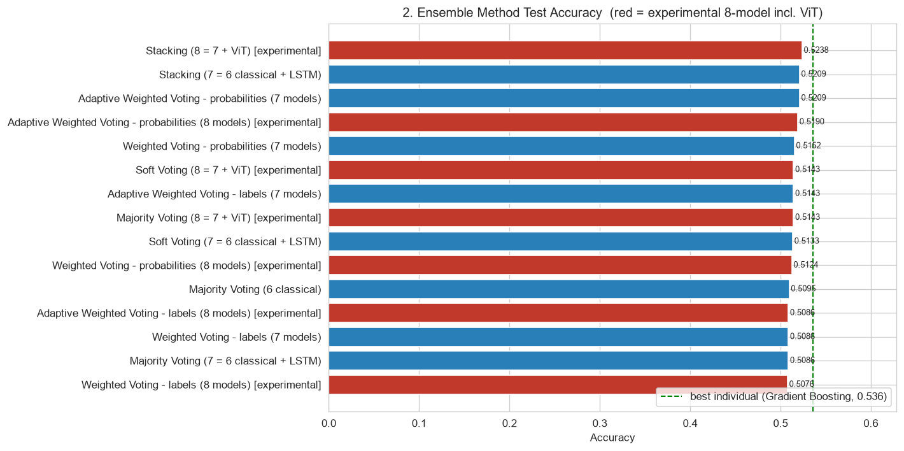
Fig. 7.7 Test Accuracy of the Ensembles Compared with the Best Individual Model
The best ensemble overall was the experimental 8-model stacking ensemble at 52.38%, followed by 7-model adaptive weighted voting with probabilities and 7-model stacking, both at 52.09%. None of the fifteen ensembles beat Gradient Boosting on its own: the best ensemble was 1.24 points behind it. The program states this outcome explicitly in its output rather than hiding it.
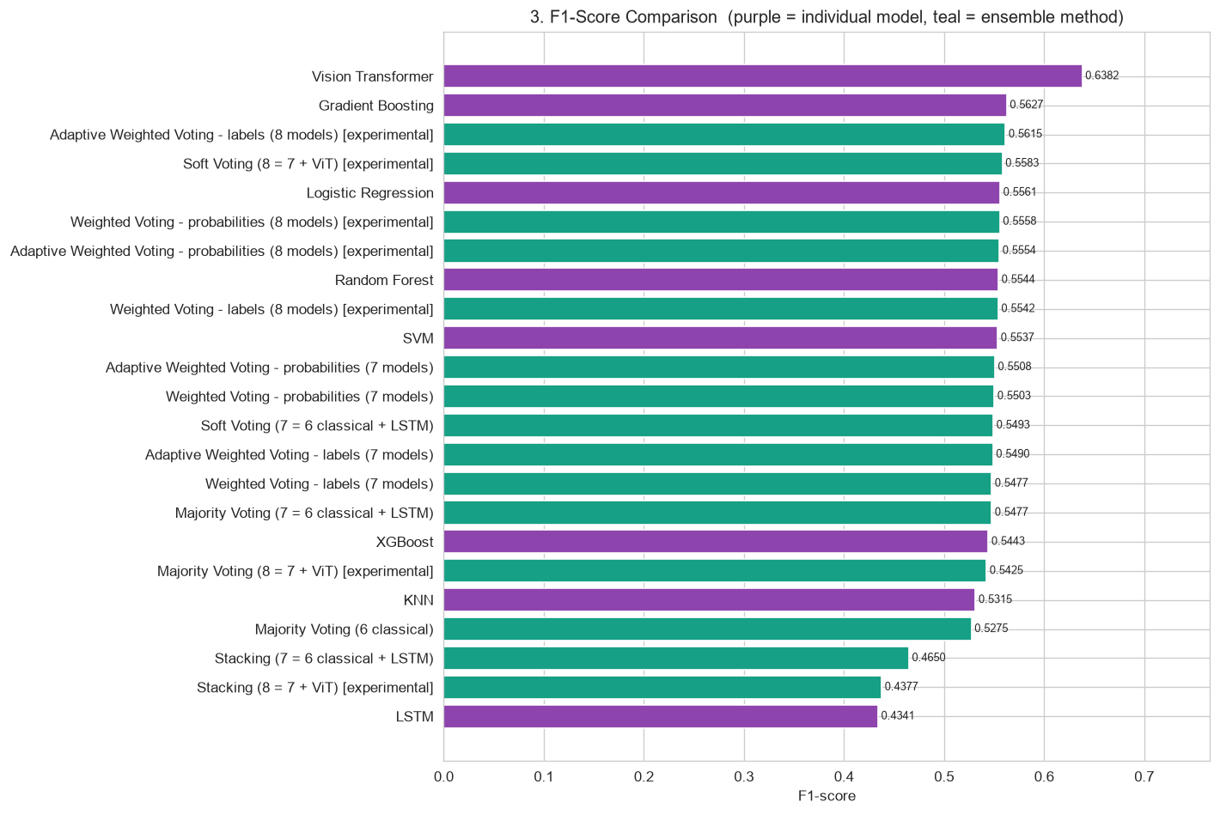
Fig. 7.8 F1-Score of the Individual Models (Purple) and the Ensembles (Teal)
That result needs some context, however. Gradient Boosting was the best of eight models, picked after seeing the test results; in advance, nobody could have known which of the eight would do best. Before the test period, in the walk-forward validation, KNN rather than Gradient Boosting had the best accuracy. The ensembles are much more consistent than the individual models. The worst ensemble scored 50.76%, while the worst individual model scored 48.95%; the fifteen ensembles span only 1.6 points, against 4.7 points for the eight models; and the average ensemble accuracy (51.4%) is higher than the average individual accuracy (50.7%). In other words, ensembling did not produce the best single number, but it removed the risk of relying on a poor model, which is the classical argument for ensembles (Dietterich, 2000).
Two further patterns are visible in Table 7.4. Probability-based rules beat label-based rules in every comparable pair: soft voting beat majority voting, weighted probabilities beat weighted labels and adaptive probabilities beat adaptive labels, for both the 7- and the 8-model ensembles. Keeping each model's confidence evidently helps, even when that confidence is small. The stacking ensembles behave differently from the voting rules: they predict UP much less often (recall 0.40 and 0.36), which gives them the highest precision of all methods (0.553 and 0.565) but the lowest F1.

7.7 Majority Versus Static Weighted Versus Adaptive Weighted Voting
STEP 18 isolates the question raised in Review-I: should all models get an equal vote, a fixed vote proportional to their validation quality, or a vote that follows their recent performance? All rows in Table 7.5 use the same base-model predictions on the same days, so any difference comes only from the combination rule.
Table 7.5 Final Comparison of the Three Voting Methods (STEP 18)
Method | Rule | M | Weights | Accuracy | F1 | ROC-AUC
Majority | labels | 7 | 1 vote per model | 0.5086 | 0.5477 | 0.5109
Weighted (static) | labels | 7 | validation F1, fixed | 0.5086 | 0.5477 | 0.5086
Weighted (static) | probabilities | 7 | validation F1, fixed | 0.5152 | 0.5503 | 0.5268
Adaptive weighted | labels | 7 | last 250 days, β = 20 | 0.5143 | 0.5490 | 0.5191
Adaptive weighted | probabilities | 7 | last 250 days, β = 20 | 0.5209 | 0.5508 | 0.5288
Majority | labels | 8 | 1 vote per model | 0.5143 | 0.5425 | 0.5081
Weighted (static) | labels | 8 | validation F1, fixed | 0.5076 | 0.5542 | 0.5068
Weighted (static) | probabilities | 8 | validation F1, fixed | 0.5124 | 0.5558 | 0.5254
Adaptive weighted | labels | 8 | last 250 days, β = 20 | 0.5086 | 0.5615 | 0.5146
Adaptive weighted | probabilities | 8 | last 250 days, β = 20 | 0.5190 | 0.5554 | 0.5277

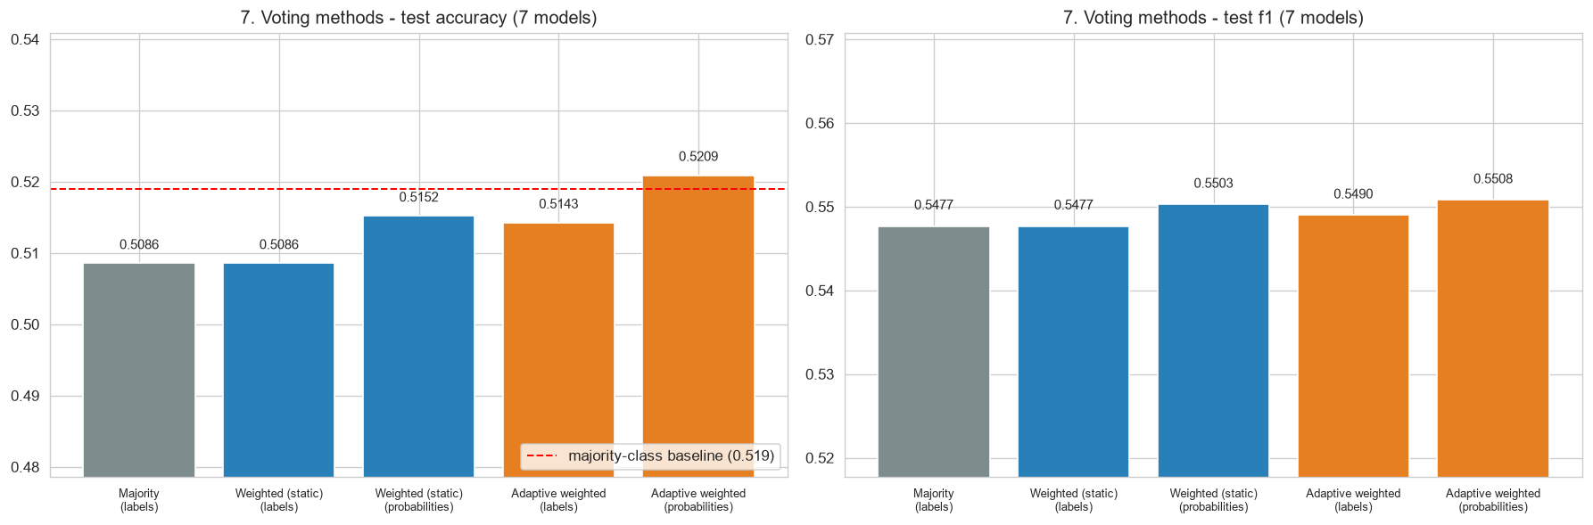
Fig. 7.9 Test Accuracy and F1 of the Three Voting Methods (7 Models)
For the main 7-model ensemble the ordering is the one the Review-I hypothesis predicted: adaptive weighted voting (52.09%) beat static weighted voting (51.52%), which beat majority voting (50.86%). The adaptive rule was the only voting rule above the majority-class rate, it had the best F1 (0.551) and the best ROC-AUC (0.529) of the voting rules, and it was right on 548 days against 535 for majority voting, a gain of 13 days or 1.24 points. For the 8-model ensemble the adaptive probability rule was again the best voting rule (51.90%).
The parameter search that chose the adaptive settings is shown in Fig. 7.10. For both ensembles the best OOF accuracy came from the longest window (250 days) and the sharpest weighting (β = 20), at 51.67% for 7 models against 51.57% for equal weights (β = 0). The margin in validation was tiny, only 0.1 points for the 7-model ensemble. Short windows were clearly harmful: with W = 20 and β = 20 the 7-model OOF accuracy dropped to 49.78%. A 20-day accuracy estimate is too noisy to steer the weights, whereas a year of history smooths out much of the noise.
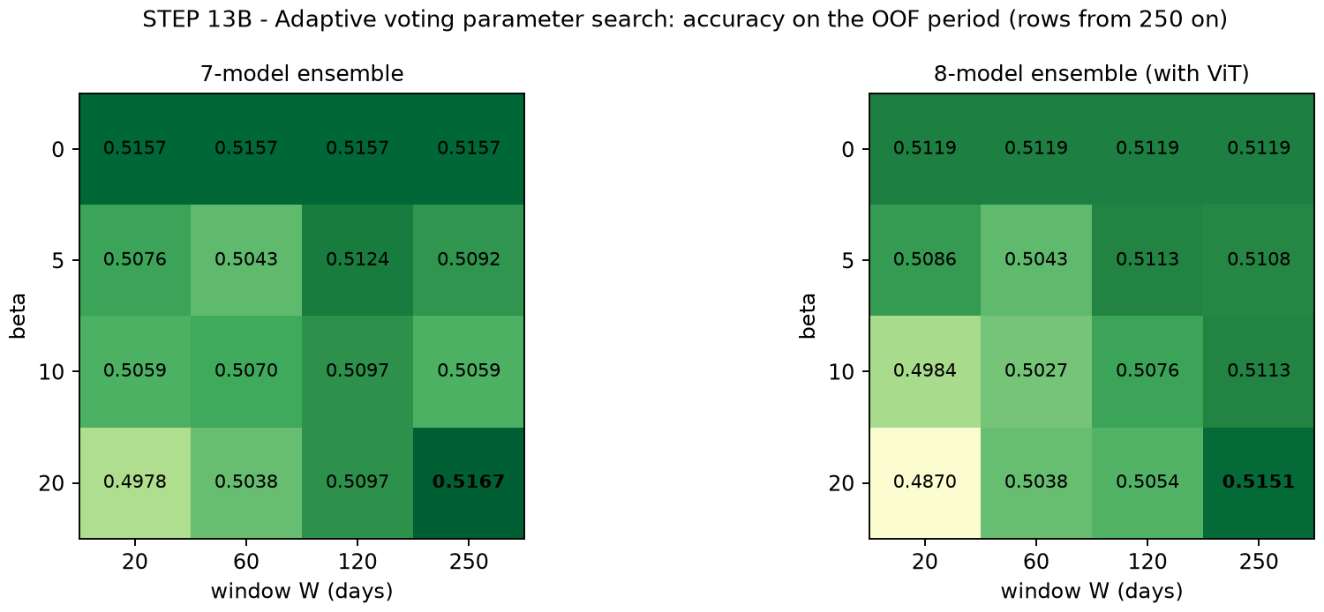
Fig. 7.10 OOF Accuracy for Each Adaptive Window and Sharpness Setting
Fig. 7.11 compares the static weights with the adaptive weights averaged over the test period, and Fig. 7.12 shows how the adaptive weights moved from day to day. The adaptive rule moved weight away from the LSTM (static 0.159, adaptive mean 0.092) and towards Gradient Boosting (mean 0.253, peak 0.529) and KNN (mean 0.218, peak 0.449), which are the two models that turned out to be best on the test period. It learned this from their track record over the previous 250 known days, not from the test labels of the days being predicted. The time series shows phases: KNN carried the largest weight in 2017, Gradient Boosting dominated through 2018 and much of 2019, and XGBoost and SVM gained weight from 2020 onwards.
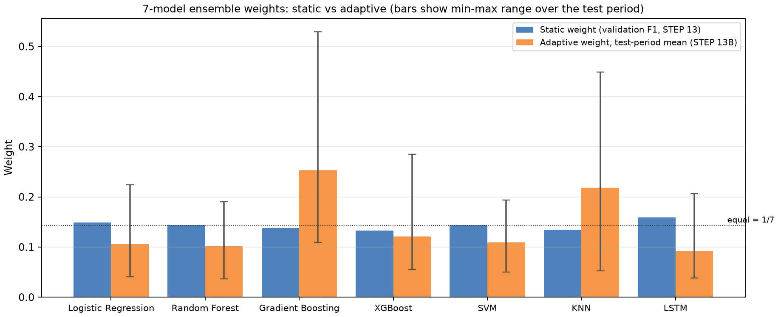
Fig. 7.11 Static Weights Versus Adaptive Weights (Mean and Range over the Test Period)
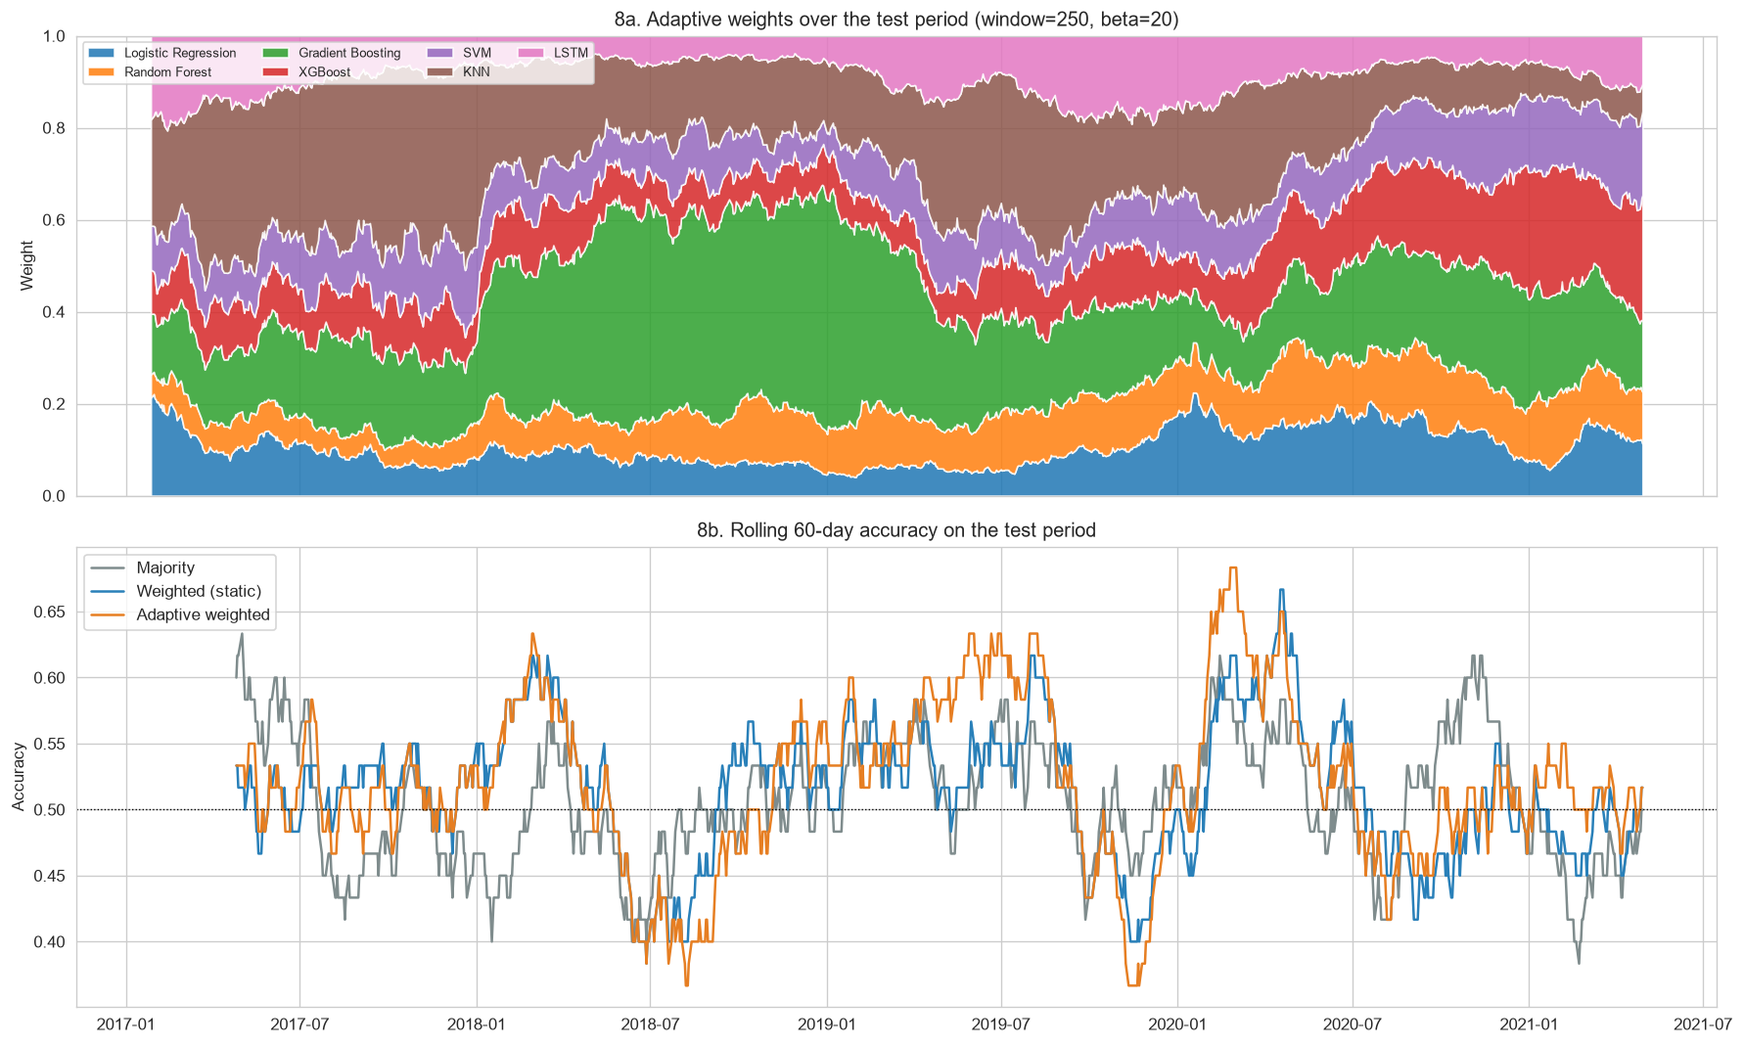
Fig. 7.12 Adaptive Weights over the Test Period and Rolling 60-Day Accuracy of the Three Voting Methods
The lower panel of Fig. 7.12 is a useful corrective. Over rolling 60-day windows, all three voting methods swing between roughly 37% and 68% accuracy and move largely together. The adaptive rule had its best stretch in early 2020, around the COVID-19 sell-off, and its worst stretches in mid-2018 and late 2019. No method is better in every period. The adaptive advantage is an average over many such swings.
For RQ3, then, the answer has two parts. Within voting, adaptive weighting did best, followed by static weighting and then equal voting, and the ordering matches the hypothesis. But the size of the advantage, 1.24 points over majority voting, is well below the ±3-point sampling band, so this single test period does not establish that adaptive weighting is genuinely better. It is suggestive evidence, not proof.

7.8 Stacking
Fig. 7.13 shows the coefficients the stacking meta-model learned from the OOF probabilities. The meta-model trusted Logistic Regression most (coefficient 0.74 in the 7-model version) and Gradient Boosting second (0.43). It gave small positive weight to SVM and KNN and negative weight to Random Forest, XGBoost and the LSTM; in the 8-model version the ViT also received a negative coefficient (−0.47).
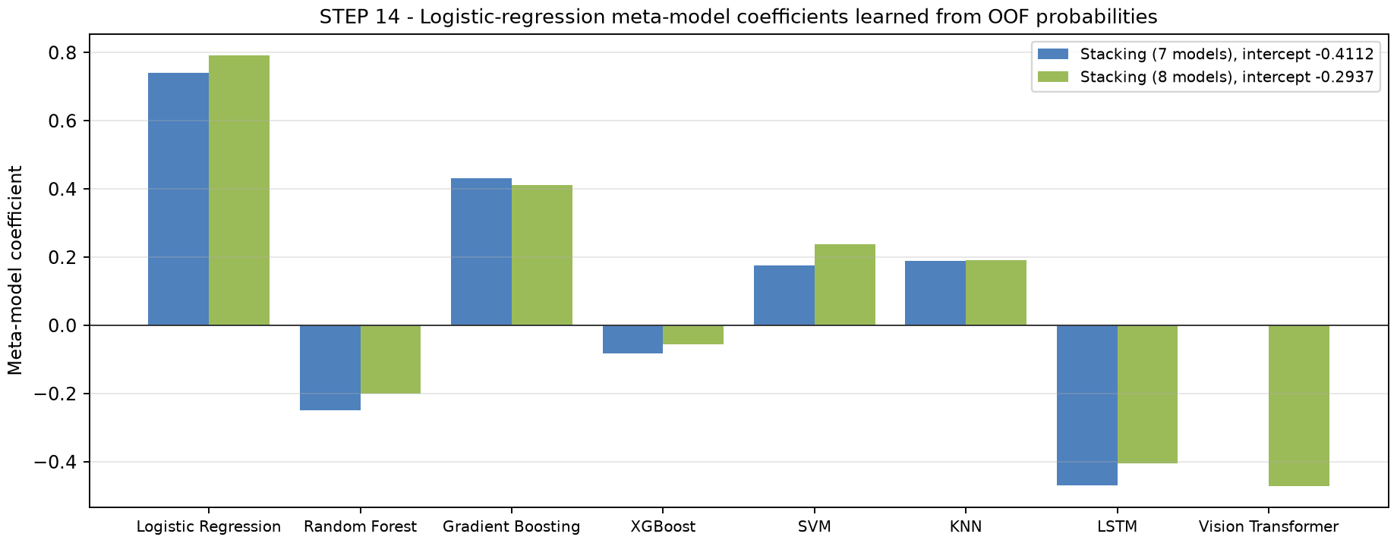
Fig. 7.13 Coefficients of the Stacking Meta-Model (7- and 8-Model Versions)
Negative coefficients should be read with care. The base models' probabilities are correlated with each other, and in a logistic regression on correlated inputs a negative coefficient often means “use this model to correct the others” rather than “this model is wrong”. The negative intercept (−0.41) shifts the stacked probability towards DOWN, which explains why the stacking ensembles predicted UP on only 396 (7 models) and 345 (8 models) of the 1,052 test days. They were the most precise methods in the study and reached the highest ensemble accuracy, but at the cost of missing many UP days.

7.9 Statistical Significance
To judge whether any result is more than luck, the main results were tested against the two reference points with a normal approximation to the binomial distribution (Table 7.6). Against a fair coin (50%), Gradient Boosting's 564 correct days out of 1,052 give z = 2.34 and a two-sided p-value of about 0.02. Against the more relevant majority-class rate (51.9%), however, z falls to 1.11 and p rises to 0.27. None of the ensembles is significantly better than the majority-class rate.
Table 7.6 Significance of the Main Results (n = 1,052 Test Days)
Method | Correct days | Accuracy | z vs 0.500 | p vs 0.500 | z vs 0.519 | p vs 0.519
Gradient Boosting | 564 | 0.5361 | 2.34 | 0.019 | 1.11 | 0.267
Stacking (8) [exp.] | 551 | 0.5238 | 1.54 | 0.123 | 0.31 | 0.758
Adaptive weighted - prob. (7) | 548 | 0.5209 | 1.36 | 0.175 | 0.12 | 0.902
Majority voting (7) | 535 | 0.5086 | 0.55 | 0.579 | −0.68 | 0.497

There is also a selection effect. Gradient Boosting was singled out as the best of eight models after the test results were known. If eight models with no real skill are tested, the best of them will often look significant against 50% by chance alone. Taken together, the evidence suggests that the models carry at most a very small amount of predictive information about RELIANCE's next-day direction in 2017 to 2021, and that the differences between methods cannot be separated from noise with a single stock and a single test period.

7.10 Comparison with Review-I and with the Literature
The final numbers are lower than many figures reported in the literature and lower than what an unchecked version of this pipeline would produce. That is expected. Review-I used raw price-level features, a single split and no automated leakage checks; the final system removes several ways in which optimistic numbers can arise, including fake crashes in the data, scaler drift, misaligned windows and test-tuned weights. The remaining accuracy is lower but trustworthy.
The results agree with the more cautious part of the literature. Kundu and Pinsky (2025) report that deep learning does not improve daily direction prediction for every stock and sector; here the LSTM and the ViT were the weakest models. Kulkarni et al. (2025) stress that the best model depends on context; here the best model in validation (KNN) and the best model on the test period (Gradient Boosting) differed, and the adaptive weights shifted between models over time. Bustos et al. (2025) connect weak forecasting performance with market efficiency, and the near-chance accuracies found here are what the efficient-market view would predict for a large, heavily traded stock (Fama, 1970). The adaptive markets hypothesis (Lo, 2004) offers a reading of the time-varying weights: small, temporary pockets of predictability may exist, but they move from one kind of model to another as conditions change.

7.11 Discussion
Three lessons stand out from the results. The first is that the evaluation protocol matters more than the model. Most of the work in this project went into making the comparison fair, and that work changed the conclusions far more than any choice of architecture. Without the stationary features and the correct window alignment, the deep models in particular would have looked very different.
The second lesson is that ensembles are a risk-management tool here rather than an accuracy booster. No ensemble beat the best single model, but every ensemble beat the worst one by a wide margin, and the ensembles were much less spread out. In a real setting, where the best model is not known in advance, that consistency is valuable. Among the ensembles, rules that use probabilities beat rules that use labels, and weights that follow recent performance beat fixed weights, although only by small margins.
The third lesson concerns metrics. F1 looked attractive as a weighting metric because it balances precision and recall, but with a slight UP majority it rewards models that predict UP often. This gave the LSTM the largest static weight and made the ViT look good on paper. Balanced accuracy, ROC-AUC or log-loss would be better choices for weighting, and this is one of the recommendations in Chapter 8.
Finally, these are classification results, not trading results. A 52% hit rate does not translate directly into profit: the size of the moves on correct and incorrect days, transaction costs, taxes and slippage all matter, and none of them is modelled here.

7.12 Threats to Validity
- One stock and one period. All results are for RELIANCE from 2017 to April 2021. Other stocks or periods may behave differently; the pipeline supports other stocks, but they were not part of this run.
- One random seed. The deep models and the forests depend on the seed. Results with other seeds would vary, especially for the LSTM and the ViT.
- Default hyperparameters. The models were not tuned, by design, to avoid overfitting a search to one period. Tuned models inside a proper nested walk-forward scheme might do somewhat better.
- Heuristic price adjustment. The corporate-action rule is a heuristic. It found the three known events for RELIANCE, but it could miss small splits or misread an extreme genuine crash in another stock.
- Survivorship. The dataset contains the NIFTY-50 members as of 2021, so stocks that left the index earlier are absent. This does not affect a single-stock experiment, but it would matter for any cross-sectional extension.
- Data ending in 2021. Market conditions after April 2021 are not represented.

CHAPTER 8
SUMMARY
QuantPredict set out to predict the next-day direction of a NIFTY-50 stock and, more importantly, to find out under fair conditions whether combining heterogeneous models with adaptive weights helps. The final system is a single, documented pipeline of eighteen steps. It adjusts the raw NSE prices for corporate actions, builds 37 stationary features, trains six classical models, an LSTM and a Vision Transformer adapted to financial feature matrices, and combines them with majority, soft, static weighted, adaptive weighted and stacked voting. Every weight and every tuning choice comes from walk-forward validation inside the training period, every model is scored on the same 1,052 test days, and 18 automated checks confirm the absence of look-ahead leakage.

8.1 Key Findings
- RQ1 (individual models). Gradient Boosting was the best individual model with 53.6% accuracy and the highest ROC-AUC (0.535). It is the only model clearly above the 51.9% majority-class rate, but even its margin over that rate is not statistically significant (p = 0.27).
- RQ2 (Vision Transformer). The adapted ViT reached 50.1% accuracy and leaned heavily towards UP. Adding it to the ensembles changed results by less than one point in either direction. On this data it did not add value, and the LSTM behaved similarly.
- RQ3 (ensembles). No ensemble beat Gradient Boosting, but the ensembles were far more consistent than the individual models. Among voting rules, adaptive weighted voting (52.1%) beat static weighted voting (51.5%) and majority voting (50.9%), as hypothesised, by margins that lie within sampling noise.
- RQ4 (feature selection). Mutual-information and tree-importance selection improved validation F1 but gave mixed test results: they helped weaker models and hurt the strongest one.
- Method. Probability-based combination beat label-based combination in every comparable pair, and F1 proved to be a poor weighting metric because it rewards predicting UP.

8.2 Contributions
The project's contributions are practical and methodological. It provides a reproducible pipeline for Indian equity data that handles corporate actions without external data, uses stationary features, and enforces leakage-free evaluation through assertions and a final checklist, including a label-scrambling test for the adaptive weights. It provides a like-for-like comparison of classical models, an LSTM and a patch-based ViT on identical inputs. And it provides a controlled comparison of five ensemble strategies whose weights are learned only from out-of-fold predictions, with results reported honestly, including the negative ones.

8.3 Limitations
The study uses one stock, one test period and one random seed, with default hyperparameters and price and volume data only. The improvements it measures are small compared with the sampling noise of a single 1,052-day test set, so the comparisons between methods are indicative rather than conclusive. The classification results are not a trading backtest and say nothing about profitability after costs.

8.4 Recommendations and Future Work
The following extensions follow directly from the results and would strengthen or test the conclusions.
- Run the pipeline on all 49 stocks. Because STOCK_SYMBOL is the only change needed, repeating the experiment across the NIFTY-50 would turn one noisy comparison into 49 and allow paired significance tests between ensemble rules.
- Use rolling-origin testing. Repeating the train-test split at several dates would show whether the ordering of methods is stable over time.
- Replace F1 as the weighting metric. Balanced accuracy, ROC-AUC or log-loss would avoid rewarding the UP bias seen in the LSTM and ViT.
- Add calibration and a trading layer. Calibrating the probabilities and adding a simple long/flat strategy with transaction costs would connect the classification results to economic value.
- Pool data for the ViT. Training one transformer on windows from many stocks, or pre-training it, would give it the amount of data that transformers usually need.
- Add new information sources. News sentiment, index-level and sector features, or market-wide volatility could add signal that price and volume alone do not contain, as several of the reviewed studies suggest.
- Explore other adaptive schemes. Regime-detection models, decayed rather than windowed accuracy, or online-learning algorithms with proven regret bounds could make the adaptive weighting more stable.
To conclude, QuantPredict did not find a way to predict next-day stock direction reliably, and the evidence suggests that, for a large and liquid stock like Reliance Industries, there is very little such predictability to find in daily prices and volumes. What the project does deliver is a careful, transparent framework in which claims like “the ensemble is better” can be tested properly, and a set of results that can be trusted because the ways they could have been inflated were checked for and ruled out.

CHAPTER 9
REFERENCES
References are listed in APA (7th edition) style, in alphabetical order of the first author.
Abd-Elwahab, A. M., El-Horbaty, Y. S., Abd-Elfattah, M. H., & Bahloul, M. M. (2026). A hybrid machine learning framework integrating technical and fundamental analysis for stock market prediction. Future Business Journal, 12, Article 191. https://doi.org/10.1186/s43093-026-00897-4
Appel, G. (2005). Technical analysis: Power tools for active investors. FT Prentice Hall.
Ba, J. L., Kiros, J. R., & Hinton, G. E. (2016). Layer normalization (arXiv:1607.06450). arXiv. https://doi.org/10.48550/arXiv.1607.06450
Ballings, M., Van den Poel, D., Hespeels, N., & Gryp, R. (2015). Evaluating multiple classifiers for stock price direction prediction. Expert Systems with Applications, 42(20), 7046–7056. https://doi.org/10.1016/j.eswa.2015.05.013
Bergmeir, C., & Benítez, J. M. (2012). On the use of cross-validation for time series predictor evaluation. Information Sciences, 191, 192–213. https://doi.org/10.1016/j.ins.2011.12.028
Bollinger, J. (2002). Bollinger on Bollinger Bands. McGraw-Hill.
Breiman, L. (2001). Random forests. Machine Learning, 45(1), 5–32. https://doi.org/10.1023/A:1010933404324
Bustos, O., Pomares-Quimbaya, A., & Stellian, R. (2025). Machine learning, stock market forecasting, and market efficiency: A comparative study. International Journal of Data Science and Analytics, 20(7), 6815–6839. https://doi.org/10.1007/s41060-025-00854-4
Chaudhary, T., & Minirani, S. (2025). Machine learning and time series approaches for stock price prediction: A case study of Indian banks. Procedia Computer Science, 260, 626–634. https://doi.org/10.1016/j.procs.2025.03.241
Chen, P., Boukouvalas, Z., & Corizzo, R. (2024). A deep fusion model for stock market prediction with news headlines and time series data. Neural Computing and Applications, 36(34), 21229–21271. https://doi.org/10.1007/s00521-024-10303-1
Chen, T., & Guestrin, C. (2016). XGBoost: A scalable tree boosting system. In Proceedings of the 22nd ACM SIGKDD International Conference on Knowledge Discovery and Data Mining (pp. 785–794). ACM. https://doi.org/10.1145/2939672.2939785
Cortes, C., & Vapnik, V. (1995). Support-vector networks. Machine Learning, 20(3), 273–297. https://doi.org/10.1007/BF00994018
Cover, T., & Hart, P. (1967). Nearest neighbor pattern classification. IEEE Transactions on Information Theory, 13(1), 21–27. https://doi.org/10.1109/TIT.1967.1053964
Cruz, R. M. O., Sabourin, R., & Cavalcanti, G. D. C. (2018). Dynamic classifier selection: Recent advances and perspectives. Information Fusion, 41, 195–216. https://doi.org/10.1016/j.inffus.2017.09.010
Dietterich, T. G. (2000). Ensemble methods in machine learning. In Multiple Classifier Systems (Lecture Notes in Computer Science, Vol. 1857, pp. 1–15). Springer. https://doi.org/10.1007/3-540-45014-9_1
Din, R. U., Ahmed, S., Khan, S. H., Albanyan, A., Hoxha, J., & Alkhamees, B. (2025). A novel decision ensemble framework: Attention-customized BiLSTM and XGBoost for speculative stock price forecasting. PLOS ONE, 20(4), Article e0320089. https://doi.org/10.1371/journal.pone.0320089
Dosovitskiy, A., Beyer, L., Kolesnikov, A., Weissenborn, D., Zhai, X., Unterthiner, T., Dehghani, M., Minderer, M., Heigold, G., Gelly, S., Uszkoreit, J., & Houlsby, N. (2021). An image is worth 16x16 words: Transformers for image recognition at scale. In International Conference on Learning Representations (ICLR 2021). https://openreview.net/forum?id=YicbFdNTTy
Fama, E. F. (1970). Efficient capital markets: A review of theory and empirical work. The Journal of Finance, 25(2), 383–417. https://doi.org/10.2307/2325486
Fattoh, I. E., El Maghawry Ibrahim, M., & Mousa, F. A. (2025). Unveiling market dynamics: A machine and deep learning approach to Egyptian stock prediction. Future Business Journal, 11, Article 18. https://doi.org/10.1186/s43093-025-00421-0
Fawcett, T. (2006). An introduction to ROC analysis. Pattern Recognition Letters, 27(8), 861–874. https://doi.org/10.1016/j.patrec.2005.10.010
Fischer, T., & Krauss, C. (2018). Deep learning with long short-term memory networks for financial market predictions. European Journal of Operational Research, 270(2), 654–669. https://doi.org/10.1016/j.ejor.2017.11.054
Freund, Y., & Schapire, R. E. (1997). A decision-theoretic generalization of on-line learning and an application to boosting. Journal of Computer and System Sciences, 55(1), 119–139. https://doi.org/10.1006/jcss.1997.1504
Friedman, J. H. (2001). Greedy function approximation: A gradient boosting machine. The Annals of Statistics, 29(5), 1189–1232. https://doi.org/10.1214/aos/1013203451
Gama, J., Žliobaitė, I., Bifet, A., Pechenizkiy, M., & Bouchachia, A. (2014). A survey on concept drift adaptation. ACM Computing Surveys, 46(4), Article 44. https://doi.org/10.1145/2523813
Granville, J. E. (1963). Granville's new key to stock market profits. Prentice-Hall.
He, K., Zhang, X., Ren, S., & Sun, J. (2016). Deep residual learning for image recognition. In Proceedings of the IEEE Conference on Computer Vision and Pattern Recognition (pp. 770–778). https://doi.org/10.1109/CVPR.2016.90
Hendrycks, D., & Gimpel, K. (2016). Gaussian error linear units (GELUs) (arXiv:1606.08415). arXiv. https://doi.org/10.48550/arXiv.1606.08415
Hochreiter, S., & Schmidhuber, J. (1997). Long short-term memory. Neural Computation, 9(8), 1735–1780. https://doi.org/10.1162/neco.1997.9.8.1735
Jiang, W. (2021). Applications of deep learning in stock market prediction: Recent progress. Expert Systems with Applications, 184, Article 115537. https://doi.org/10.1016/j.eswa.2021.115537
Kingma, D. P., & Ba, J. (2015). Adam: A method for stochastic optimization. In International Conference on Learning Representations (ICLR 2015). https://doi.org/10.48550/arXiv.1412.6980
Kittler, J., Hatef, M., Duin, R. P. W., & Matas, J. (1998). On combining classifiers. IEEE Transactions on Pattern Analysis and Machine Intelligence, 20(3), 226–239. https://doi.org/10.1109/34.667881
Kraskov, A., Stögbauer, H., & Grassberger, P. (2004). Estimating mutual information. Physical Review E, 69(6), Article 066138. https://doi.org/10.1103/PhysRevE.69.066138
Krauss, C., Do, X. A., & Huck, N. (2017). Deep neural networks, gradient-boosted trees, random forests: Statistical arbitrage on the S&P 500. European Journal of Operational Research, 259(2), 689–702. https://doi.org/10.1016/j.ejor.2016.10.031
Kulkarni, M. S., Vijayakumar Bharathi, S., Perdana, A., & Kilari, D. (2025). A quest for context-specific stock price prediction: A comparison between time series, machine learning and deep learning models. SN Computer Science, 6(4), Article 335. https://doi.org/10.1007/s42979-025-03848-y
Kundu, T., & Pinsky, E. (2025). Predicting daily stock price directions with deep learning models. Machine Learning with Applications, 22, Article 100744. https://doi.org/10.1016/j.mlwa.2025.100744
Lee, H., Kim, J. H., & Jung, H. S. (2024). Deep-learning-based stock market prediction incorporating ESG sentiment and technical indicators. Scientific Reports, 14, Article 10262. https://doi.org/10.1038/s41598-024-61106-2
Littlestone, N., & Warmuth, M. K. (1994). The weighted majority algorithm. Information and Computation, 108(2), 212–261. https://doi.org/10.1006/inco.1994.1009
Lo, A. W. (2004). The adaptive markets hypothesis. The Journal of Portfolio Management, 30(5), 15–29. https://doi.org/10.3905/jpm.2004.442611
López de Prado, M. (2018). Advances in financial machine learning. Wiley.
Mochurad, L., & Dereviannyi, A. (2024). An ensemble approach integrating LSTM and ARIMA models for enhanced financial market predictions. Royal Society Open Science, 11(9), Article 240699. https://doi.org/10.1098/rsos.240699
Mohapatra, S., Mukherjee, R., Apergis, N., & Sengupta, A. (2025). Exploring predictive prowess of ensemble machine learning models in banking stocks: A technical, fundamental, and macroeconomic analysis. IIMB Management Review, 37(2), Article 100570. https://doi.org/10.1016/j.iimb.2025.100570
Mostafavi, S. M., & Hooman, A. R. (2025). Key technical indicators for stock market prediction. Machine Learning with Applications, 20, Article 100631. https://doi.org/10.1016/j.mlwa.2025.100631
Nie, Y., Nguyen, N. H., Sinthong, P., & Kalagnanam, J. (2023). A time series is worth 64 words: Long-term forecasting with transformers. In International Conference on Learning Representations (ICLR 2023). https://doi.org/10.48550/arXiv.2211.14730
Nugroho, W. A., Rachman, F. D., Siahu, B. K., Iswanto, I. A., & Joddy, S. (2025). Hybrid ensemble model approaches for stock price forecasting using LSTM, random forest, ARIMA, and linear regression as meta-learner. Procedia Computer Science, 269, 901–910. https://doi.org/10.1016/j.procs.2025.09.033
Padial, D. L. (2018). Technical Analysis Library in Python (ta) (Version 0.11.0) [Computer software]. GitHub. https://github.com/bukosabino/ta
Parra-Domínguez, J., & Sanz-Martín, L. (2024). Artificial intelligence in the new era of decision-making: A case study of the Euro Stoxx 50. Mathematics, 12(24), Article 3918. https://doi.org/10.3390/math12243918
Patel, J., Shah, S., Thakkar, P., & Kotecha, K. (2015). Predicting stock and stock price index movement using trend deterministic data preparation and machine learning techniques. Expert Systems with Applications, 42(1), 259–268. https://doi.org/10.1016/j.eswa.2014.07.040
Paszke, A., Gross, S., Massa, F., Lerer, A., Bradbury, J., Chanan, G., Killeen, T., Lin, Z., Gimelshein, N., Antiga, L., Desmaison, A., Köpf, A., Yang, E., DeVito, Z., Raison, M., Tejani, A., Chilamkurthy, S., Steiner, B., Fang, L., … Chintala, S. (2019). PyTorch: An imperative style, high-performance deep learning library. In Advances in Neural Information Processing Systems 32 (pp. 8024–8035).
Pedregosa, F., Varoquaux, G., Gramfort, A., Michel, V., Thirion, B., Grisel, O., Blondel, M., Prettenhofer, P., Weiss, R., Dubourg, V., Vanderplas, J., Passos, A., Cournapeau, D., Brucher, M., Perrot, M., & Duchesnay, É. (2011). Scikit-learn: Machine learning in Python. Journal of Machine Learning Research, 12, 2825–2830.
Phuoc, T., Anh, P. T. K., Tam, P. H., & Nguyen, C. V. (2024). Applying machine learning algorithms to predict the stock price trend in the stock market – The case of Vietnam. Humanities and Social Sciences Communications, 11, Article 393. https://doi.org/10.1057/s41599-024-02807-x
Rao, R. (2021). NIFTY-50 stock market data (2000–2021) [Data set]. Kaggle. https://www.kaggle.com/datasets/rohanrao/nifty50-stock-market-data
Ross, B. C. (2014). Mutual information between discrete and continuous data sets. PLOS ONE, 9(2), Article e87357. https://doi.org/10.1371/journal.pone.0087357
Saud, A. S., & Shakya, S. (2024). Technical indicator empowered intelligent strategies to predict stock trading signals. Journal of Open Innovation: Technology, Market, and Complexity, 10(4), Article 100398. https://doi.org/10.1016/j.joitmc.2024.100398
Sezer, O. B., Gudelek, M. U., & Ozbayoglu, A. M. (2020). Financial time series forecasting with deep learning: A systematic literature review: 2005–2019. Applied Soft Computing, 90, Article 106181. https://doi.org/10.1016/j.asoc.2020.106181
Sokolova, M., & Lapalme, G. (2009). A systematic analysis of performance measures for classification tasks. Information Processing & Management, 45(4), 427–437. https://doi.org/10.1016/j.ipm.2009.03.002
Tang, P., Tang, C., & Wang, K. (2024). Stock movement prediction: A multi-input LSTM approach. Journal of Forecasting, 43(5), 1199–1211. https://doi.org/10.1002/for.3071
Vaswani, A., Shazeer, N., Parmar, N., Uszkoreit, J., Jones, L., Gomez, A. N., Kaiser, Ł., & Polosukhin, I. (2017). Attention is all you need. In Advances in Neural Information Processing Systems 30 (pp. 5998–6008).
Wang, Y., Zhang, H., Huang, B., Lin, Z., & Pang, C. (2025). LSTM stock prediction model based on blockchain. High-Confidence Computing, 5(4), Article 100316. https://doi.org/10.1016/j.hcc.2025.100316
Wilder, J. W. (1978). New concepts in technical trading systems. Trend Research.
Wolpert, D. H. (1992). Stacked generalization. Neural Networks, 5(2), 241–259. https://doi.org/10.1016/S0893-6080(05)80023-1
Zeng, A., Chen, M., Zhang, L., & Xu, Q. (2023). Are transformers effective for time series forecasting? Proceedings of the AAAI Conference on Artificial Intelligence, 37(9), 11121–11128. https://doi.org/10.1609/aaai.v37i9.26317
Zhang, Z., Liu, Q., Hu, Y., & Liu, H. (2025). Multi-feature stock price prediction by LSTM networks based on VMD and TMFG. Journal of Big Data, 12, Article 74. https://doi.org/10.1186/s40537-025-01127-4
Zong, C., Wan, J., Cascone, L., & Zhou, H. (2025). Stock movement prediction with multimodal stable fusion via gated cross-attention mechanism. Complex & Intelligent Systems, 11(9), Article 396. https://doi.org/10.1007/s40747-025-02023-3

APPENDIX A
This appendix contains selected excerpts of the source code of Quantpredict.py and the complete comparison table written by the program. Only the most important parts of the code are reproduced; the full file is submitted separately.

A.1 Corporate-Action Detection and Back-Adjustment (STEP 2a)
CA_THRESHOLD = 0.78 # open AND close below 78% of yesterday -> corporate action
# Every "clean" fraction a/b with b <= 10 (1/2, 1/3, 2/3, 1/5, 3/4, 1/10 ...).
CLEAN_RATIOS = sorted({a / b for b in range(2, 11) for a in range(1, b)})

def adjust_corporate_actions(frame):
"""Back-adjust prices/volume for splits & bonuses. Returns (adjusted frame, event log)."""
frame = frame.copy()
frame[["Open", "High", "Low", "Close", "Volume"]] = (
frame[["Open", "High", "Low", "Close", "Volume"]].astype(float)
)
prev_close = frame["Close"].shift(1)
gap = frame["Open"] / prev_close # overnight jump, e.g. 0.50 for a 1:1 bonus
ret = frame["Close"] / prev_close # full-day move
events = frame.index[(gap < CA_THRESHOLD) & (ret < CA_THRESHOLD)]
log = []
for i in events:
raw = float(gap.loc[i])
# Snap to the nearest clean ratio (0.506 -> 0.5) if it is within 4%;
# otherwise (e.g. a demerger) use the observed gap as-is.
nearest = min(CLEAN_RATIOS, key=lambda r: abs(r - raw))
factor = nearest if abs(nearest - raw) / nearest < 0.04 else raw
# Scale everything BEFORE the event so the series has no artificial jump.
before = frame.index < i
frame.loc[before, ["Open", "High", "Low", "Close"]] *= factor
frame.loc[before, "Volume"] /= factor # more shares after a split -> scale old volume up
log.append((frame.loc[i, "Date"].date(), raw, factor))
return frame, log

A.2 Stationary Feature Engineering (STEP 4)
close = df["Close"]
ret_1 = close.pct_change() # today's % change vs yesterday
vol_mean_20 = df["Volume"].rolling(20).mean() # "normal" volume over the last month

# ---- Price action: momentum and the shape of today's candle ---------------------
df["Return_1"] = ret_1
df["Return_5"] = close.pct_change(5)
df["Return_20"] = close.pct_change(20)
df["Overnight_Gap"] = df["Open"] / close.shift(1) - 1 # jump between yesterday's close and today's open
df["Intraday_Return"] = close / df["Open"] - 1 # move from open to close
df["High_Low_Range"] = df["High"] / df["Low"] - 1 # size of today's range
hl_range = (df["High"] - df["Low"]).replace(0, np.nan)
df["Close_Position"] = ((close - df["Low"]) / hl_range).fillna(0.5) # 0 = closed at low, 1 = at high

# ---- Indicators made scale-free (divided by, or measured relative to, Close) ----
df["MACD_Pct"] = df["MACD"] / close
df["MACD_Signal_Pct"] = df["MACD_signal"] / close
df["MACD_Hist_Pct"] = df["MACD_hist"] / close
for col in ["SMA_20", "SMA_50", "EMA_12", "EMA_26"]:
df[f"{col}_Dist"] = close / df[col] - 1 # +0.03 = price 3% above that average
df["Rolling_Mean_5_Dist"] = close / close.rolling(5).mean() - 1
band = (df["BB_upper"] - df["BB_lower"]).replace(0, np.nan)
df["BB_PctB"] = (close - df["BB_lower"]) / band # 0 = lower band, 1 = upper band
df["BB_Width"] = band / df["BB_middle"] # wide = volatile market
df["ATR_Pct"] = df["ATR"] / close
df["OBV_Slope_5"] = (df["OBV"] - df["OBV"].shift(5)) / (vol_mean_20 * 5) # 5-day OBV change, in "days of volume"

# ---- Volatility and volume ------------------------------------------------------
df["Volatility_5"] = ret_1.rolling(5).std()
df["Volatility_20"] = ret_1.rolling(20).std()
df["Volume_Change"] = np.log((df["Volume"] + 1) / (df["Volume"].shift(1) + 1)) # log, so spikes don't dominate
df["Volume_Ratio_20"] = df["Volume"] / vol_mean_20 # 2.0 = twice the usual volume

# ---- Lags: the same signals 1, 2, 3 and 5 days ago (short-term memory) ----------
for lag in [1, 2, 3, 5]:
df[f"Return_Lag_{lag}"] = ret_1.shift(lag)
df[f"Volume_Ratio_Lag_{lag}"] = df["Volume_Ratio_20"].shift(lag)
df[f"RSI_Lag_{lag}"] = df["RSI"].shift(lag)

df.replace([np.inf, -np.inf], np.nan, inplace=True) # e.g. division by zero volume -> treat as missing

A.3 Expanding Walk-Forward Folds (STEP 5b)
def make_walk_forward_folds(n_train, n_splits=None, initial_train_frac=None):
"""
Expanding-window ("walk-forward") folds INSIDE the training period.

HOW THIS PREVENTS FUTURE INFORMATION FROM ENTERING TRAINING OR WEIGHTING
-----------------------------------------------------------------------
* Each fold is (train = [0, tr_end), validate = [tr_end, va_end)). The
validation block always sits strictly AFTER its own training block in
calendar time, so a model is only ever scored on days it has never seen.
* The training block only grows forwards (expanding window). Fold k+1 may
learn from fold k's validation days because by then those days are in the
past - exactly what a real trading system would be allowed to do.
* Nothing is shuffled. Rows keep their chronological order everywhere.
* n_train is always passed as split_idx, so va_end can never cross the
train/test boundary. Every weight, every feature-selection decision and
every stacking meta-model below is therefore computed without the TEST set.

fold 1: train [......] val [--]
fold 2: train [........] val [--]
fold 3: train [..........] val [--]
fold 4: train [............] val [--]
|------------- TRAINING PERIOD -------------| TEST (never used here) |
"""
n_splits = WF_N_SPLITS if n_splits is None else n_splits
initial_train_frac = (
WF_INITIAL_TRAIN_FRAC if initial_train_frac is None else initial_train_frac
)

first_train_end = int(n_train * initial_train_frac)
block = (n_train - first_train_end) // n_splits
assert block > 0, "Walk-forward blocks are empty. Reduce WF_N_SPLITS or use a longer history."

folds = []
for k in range(n_splits):
tr_end = first_train_end + k * block
va_end = tr_end + block if k < n_splits - 1 else n_train
folds.append((0, tr_end, tr_end, va_end))

# Hard leakage guard: no fold may reach into the test period.
for (_, tr_end, va_start, va_end) in folds:
assert 0 < tr_end <= va_start < va_end <= n_train, "Malformed walk-forward fold."
assert va_end <= split_idx, "Walk-forward fold leaked into the TEST period."
return folds

A.4 Sequence Construction with the Corrected Alignment (STEP 5b)
def build_sequences(X_scaled, y_arr, start, end, window):
"""
Build LSTM/ViT sequences using the project's CORRECTED alignment:

sequence X[i-window+1 : i+1] -> label y[i]

The sequence ENDS at day i (inclusive) because Target[i] compares Close[i+1]
with Close[i], so day i's own features must be inside the window. This is the
alignment the existing LSTM already uses and it is left unchanged.
"""
assert start >= window - 1, "Not enough history to build the first sequence."
xs, ys, idx = [], [], []
for i in range(start, end):
xs.append(X_scaled[i - window + 1:i + 1])
ys.append(y_arr[i])
idx.append(i)
return (
np.asarray(xs, dtype=np.float32),
np.asarray(ys, dtype=np.float32),
np.asarray(idx, dtype=np.int64),
)

A.5 Patching for the Vision Transformer (STEP 9)
def vit_patchify(sequences, patch_t=VIT_PATCH_T, feature_patches=VIT_FEATURE_PATCHES):
"""
(B, T, F) financial feature matrices -> (B, n_patches, patch_dim) ViT patches.

The T x F matrix is cut into a (T / patch_t) x feature_patches grid of
rectangles, exactly like a ViT cuts an image into square patches. Each
rectangle is then flattened into one patch vector.

If F is not divisible by feature_patches the feature axis is zero-padded.
Because the features are already standardised, a zero equals the training
mean of that feature, so the padding adds no information.
"""
B, T, F = sequences.shape
assert T % patch_t == 0
patch_f = int(np.ceil(F / feature_patches))
padded_F = patch_f * feature_patches
if padded_F != F:
sequences = np.pad(sequences, ((0, 0), (0, 0), (0, padded_F - F)), mode="constant")
n_t = T // patch_t
out = sequences.reshape(B, n_t, patch_t, feature_patches, patch_f)
out = out.transpose(0, 1, 3, 2, 4) # (B, n_t, n_f, patch_t, patch_f)
out = out.reshape(B, n_t * feature_patches, patch_t * patch_f)
return np.ascontiguousarray(out, dtype=np.float32)

A.6 PyTorch Vision Transformer (STEP 9)
class TorchViT(nn.Module):
"""PyTorch equivalent of the Keras ViT above (same sizes, pre-norm blocks)."""

def __init__(self, n_patches, patch_dim):
super().__init__()
self.patch_embedding = nn.Linear(patch_dim, VIT_D_MODEL)
self.pos_emb = nn.Parameter(torch.randn(1, n_patches, VIT_D_MODEL) * 0.02)
self.drop = nn.Dropout(VIT_DROPOUT)
layer = nn.TransformerEncoderLayer(
d_model=VIT_D_MODEL, nhead=VIT_HEADS, dim_feedforward=VIT_MLP_DIM,
dropout=VIT_DROPOUT, activation="gelu", batch_first=True, norm_first=True,
)
self.encoder = nn.TransformerEncoder(layer, num_layers=VIT_LAYERS)
self.norm = nn.LayerNorm(VIT_D_MODEL)
self.head = nn.Sequential(
nn.Dropout(VIT_DROPOUT), nn.Linear(VIT_D_MODEL, 32), nn.ReLU(),
nn.Linear(32, 1), nn.Sigmoid(),
)

def forward(self, x):
z = self.drop(self.patch_embedding(x) + self.pos_emb)
z = self.encoder(z)
return self.head(self.norm(z).mean(dim=1))

A.7 Adaptive Weighted Voting and Its Parameter Search (STEP 13B)
def adaptive_weight_path(correct, window, beta):
"""
correct: (n_rows, n_models) 1/0 matrix of past hits, in date order.
Returns (n_rows + 1, n_models): row t holds the weights for day t, built
from correct[t-window : t] only. The extra last row is for the next,
still-unlabelled day (used by the STEP 16 latest prediction).
"""
n, m = correct.shape
# Running totals of hits, so "hits in rows lo..t-1" = csum[t] - csum[lo] (fast window sums).
csum = np.vstack([np.zeros((1, m)), np.cumsum(correct, axis=0)])
weights = np.full((n + 1, m), 1.0 / m) # day 0 has no history -> equal weights
for t in range(1, n + 1):
lo = max(0, t - window)
acc = (csum[t] - csum[lo]) / (t - lo) # each model's recent accuracy (rows < t only)
z = np.exp(beta * (acc - 0.5)) # reward accuracy above coin-flip level
weights[t] = z / z.sum() # normalise so the weights sum to 1
return weights

def adaptive_history(names, y_test_override=None):
"""OOF + test predictions and labels as one contiguous, date-ordered history."""
preds = np.vstack([stack_columns(oof_pred, names), stack_columns(model_predictions, names)])
labels = np.concatenate([
oof_y, y_test_common if y_test_override is None else y_test_override
])
return preds, (preds == labels[:, None]).astype(np.float64)

def tune_adaptive(names):
"""Pick (window, beta) by adaptive probability-vote accuracy on the OOF period only."""
P = stack_columns(oof_pred, names)
Q = stack_columns(oof_prob, names)
correct = (P == oof_y[:, None]).astype(np.float64)
start = max(ADAPTIVE_WINDOWS) # score every setting on the same rows
grid = []
for beta in ADAPTIVE_BETAS:
for window in ADAPTIVE_WINDOWS:
W = adaptive_weight_path(correct, window, beta)[:-1]
prob = np.sum(W * Q, axis=1)
acc = accuracy_score(oof_y[start:], (prob[start:] >= THRESHOLD).astype(int))
grid.append({"window": window, "beta": beta, "oof_accuracy": acc})
grid_df = pd.DataFrame(grid)
best = grid_df.loc[grid_df["oof_accuracy"].idxmax()] # idxmax -> first max -> beta=0 wins ties
return int(best["window"]), float(best["beta"]), grid_df

A.8 Label-Scrambling Test for the Adaptive Weights (STEP 17)
def adaptive_ignores_future(key, k):
"""Scramble every test label from day k onwards: weights up to day k must not change."""
a = adaptive[key]
y_scrambled = y_test_common.copy()
y_scrambled[k:] = 1 - y_scrambled[k:]
_, corr = adaptive_history(a["names"], y_test_override=y_scrambled)
W = adaptive_weight_path(corr, a["window"], a["beta"])[len(oof_y):-1]
return np.allclose(W[:k + 1], a["test_weights"][:k + 1])

check("Adaptive weights for day t never use the label of day t or later",
all(adaptive_ignores_future(key, k)
for key in adaptive for k in [0, len(y_test_common) // 2, len(y_test_common) - 1]))

A.9 Complete Comparison Table Written to RELIANCE_results.csv
The table below reproduces all 37 rows of the results file, sorted by test accuracy as in the program output.
Table A.1 Complete Test Results of All Individual, Ensemble and Feature-Selected Rows
Model / ensemble | Kind | Acc. | Prec. | Recall | F1 | AUC
Gradient Boosting | Individual | 0.5361 | 0.5509 | 0.5751 | 0.5627 | 0.5345
Random Forest [MI Top-20] | Feature-selected | 0.5295 | 0.5397 | 0.6355 | 0.5837 | 0.5291
XGBoost [MI Top-20] | Feature-selected | 0.5266 | 0.5407 | 0.5842 | 0.5616 | 0.5176
Stacking (8 = 7 + ViT) [exp.] | Ensemble | 0.5238 | 0.5652 | 0.3571 | 0.4377 | 0.5316
Adaptive Weighted Voting - probabilities (7 models) | Ensemble | 0.5209 | 0.5365 | 0.5659 | 0.5508 | 0.5288
Stacking (7 = 6 classical + LSTM) | Ensemble | 0.5209 | 0.5530 | 0.4011 | 0.4650 | 0.5298
KNN | Individual | 0.5190 | 0.5375 | 0.5256 | 0.5315 | 0.5231
Adaptive Weighted Voting - probabilities (8 models) [exp.] | Ensemble | 0.5190 | 0.5338 | 0.5788 | 0.5554 | 0.5277
Gradient Boosting [Tree Top-20] | Feature-selected | 0.5190 | 0.5358 | 0.5476 | 0.5417 | 0.5284
Random Forest [Tree Top-20] | Feature-selected | 0.5152 | 0.5282 | 0.6172 | 0.5693 | 0.5227
KNN [Tree Top-20] | Feature-selected | 0.5152 | 0.5328 | 0.5348 | 0.5338 | 0.5206
Weighted Voting - probabilities (7 models) | Ensemble | 0.5152 | 0.5306 | 0.5714 | 0.5503 | 0.5268
Adaptive Weighted Voting - labels (7 models) | Ensemble | 0.5143 | 0.5298 | 0.5696 | 0.5490 | 0.5191
Soft Voting (8 = 7 + ViT) [exp.] | Ensemble | 0.5143 | 0.5286 | 0.5916 | 0.5583 | 0.5263
Majority Voting (8 = 7 + ViT) [exp.] | Ensemble | 0.5143 | 0.5306 | 0.5549 | 0.5425 | 0.5081
Soft Voting (7 = 6 classical + LSTM) | Ensemble | 0.5133 | 0.5288 | 0.5714 | 0.5493 | 0.5274
Weighted Voting - probabilities (8 models) [exp.] | Ensemble | 0.5124 | 0.5271 | 0.5879 | 0.5558 | 0.5254
Logistic Regression [Tree Top-20] | Feature-selected | 0.5124 | 0.5246 | 0.6447 | 0.5785 | 0.4912
KNN [MI Top-20] | Feature-selected | 0.5124 | 0.5304 | 0.5275 | 0.5289 | 0.5292
LSTM [MI Top-20] | Feature-selected | 0.5095 | 0.5225 | 0.6374 | 0.5743 | 0.4788
XGBoost [Tree Top-20] | Feature-selected | 0.5095 | 0.5260 | 0.5568 | 0.5409 | 0.5167
Majority Voting (6 classical) | Ensemble | 0.5095 | 0.5275 | 0.5275 | 0.5275 | 0.5155
Majority Voting (7 = 6 classical + LSTM) | Ensemble | 0.5086 | 0.5243 | 0.5733 | 0.5477 | 0.5109
Weighted Voting - labels (7 models) | Ensemble | 0.5086 | 0.5243 | 0.5733 | 0.5477 | 0.5086
Adaptive Weighted Voting - labels (8 models) [exp.] | Ensemble | 0.5086 | 0.5229 | 0.6062 | 0.5615 | 0.5146
Weighted Voting - labels (8 models) [exp.] | Ensemble | 0.5076 | 0.5227 | 0.5897 | 0.5542 | 0.5068
SVM [Tree Top-20] | Feature-selected | 0.5076 | 0.5234 | 0.5733 | 0.5472 | 0.4929
XGBoost | Individual | 0.5067 | 0.5228 | 0.5678 | 0.5443 | 0.5211
Gradient Boosting [MI Top-20] | Feature-selected | 0.5038 | 0.5203 | 0.5623 | 0.5405 | 0.5054
Vision Transformer [MI Top-20] | Feature-selected | 0.5029 | 0.5188 | 0.5824 | 0.5487 | 0.5040
SVM [MI Top-20] | Feature-selected | 0.5019 | 0.5171 | 0.6099 | 0.5597 | 0.5045
Random Forest | Individual | 0.5019 | 0.5175 | 0.5971 | 0.5544 | 0.5122
SVM | Individual | 0.5019 | 0.5175 | 0.5952 | 0.5537 | 0.5026
Vision Transformer | Individual | 0.5010 | 0.5116 | 0.8480 | 0.6382 | 0.4851
Logistic Regression | Individual | 0.4962 | 0.5123 | 0.6081 | 0.5561 | 0.4879
LSTM | Individual | 0.4895 | 0.5112 | 0.3773 | 0.4341 | 0.4905
Logistic Regression [MI Top-20] | Feature-selected | 0.4762 | 0.4963 | 0.6190 | 0.5509 | 0.4889

