NAME: ADITYA RAJ

USN NO: 1NZ18MCA05

DEPARTMENT: MCA

SEM2nd

MINI PROJECT TITLE: VOTING SYSTEM

# CHAPTER 1

**INTRODUCTION**

* 1. **General Introduction**

The **Voting System** is an application-based project. It is designed for the election to store the voter’s information. The manual and the paper-based voting which is voted on paper and counted manually that is not so much good and also time consuming. This will bring a new kind of voting system which can be counted automatically. The online voting system is for the citizens that consist of the data and information about voters.

In our country, especially in North-East India the voting percentage is very low due to locally sponsored terrorism and in these places the security condition which is also not very strong so that people of the area feel scared to come out of their residence and go to vote. All those problems solve by voting system is a thought as a solution to improve voting percentage our country. This is the main reason, due to this the voting percentage across the country is very less. Through this software those people who live out of their home town will also be able to cast their votes as this system in online.

* 1. **Problem Statement**

The present system people have to visit the booth to cast their vote and some people who live out of their home town city is not able to cast vote during the elections. As responsible citizens of the country voting are our fundamental duty because we reside is a democratic system but now a days 100% citizen does not come to the vote at that time of the election in their region. Powerful people keep their man at the polling booths to pressure the common to vote for then in the rural areas.

* 1. **Existing System**

The existing system is manual and the paper-based voting which is voted on paper and counted manually that is not so much good and also time consuming. . The manual and the paper-based voting which is voted on paper and counted manually that is not so much good and also time consuming. This will bring a new kind of voting system which can be counted automatically. The online voting system is for the citizens that consist of the data and information about voters.

* 1. **Objective of the Work**

The fundamental goal of this venture is to build the general voting system rate and the undertaking is to make and overseen surveying and decision subtleties like general client subtleties, named clients, and race and result subtleties proficiently. The electronic classification acquires new sort of voting system framework which the electronic cards with all applicant's image is stamped physically and this can be checked electronically. The electronic voting system framework are currently various sorts known as the punch card, mark sense and the computerized pen voting system framework. The Electronic Ballot Marker makes the voter simpler to cast a ballot by giving the determinations on the presentation to cast a ballot present on the electronic machine. The electronic tickets are associated with the focal tally frameworks which straightforwardly acknowledge and get the refreshed record everything being equal.

**1.5 Proposed System with Methodology**

The web-based casting a voting system is for the natives from all over India that comprises of the information and data. These are,

• Voter's Id

• Calculation of all out votes

• Checking data by the voter

• Remove wrong data

• The data quickly exchanges to Election Commission.

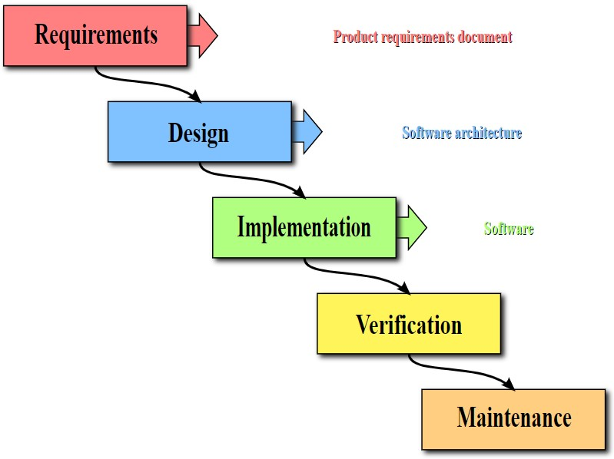

# CHAPTER 2

**REVIEW OF LITERATURE**

2.1 **Review Summary**

Writing Review all researchers who have done work in or are keen on electronic voting system appear to concur that web-based voting system does not meet the prerequisites for open decisions and that the flow broadly sent voting system need improvement. Voting system on the Internet has weaknesses dependent on the regions of mystery and assurance against intimidation and additionally vote selling. It's such a really ill-conceived notion, that there is by all accounts no tenable scholastic exertion to convey it by any means. The Kenyan General decisions of 2007 conveyed national thoughtfulness regarding issues with current strategies for throwing and including cast a ballot in open races. The vast majority trust that the present framework ought to be changed; there is much difference on how such changes ought to be made. Kenyans in the Diaspora have started marking a request in a crisp endeavor to drive the discretionary body to permit them vote online in the following General Election.

The overall review of this voting system is to develop a project which will provide an interface between the control of the applications which is written in the Data Structure using C language and Operating Systems. The concept of Linked List in C is used for storing the data dynamically. The concept of Linked Lists is used from Data Structure. Linked Lists are a type of data structure which provides an alternative to an array-based structure. It is a collection of nodes that collectively form linear sequence. In a Linked Lists, each node stores a reference to an object that is an element of the sequence, as well as a reference to the next. The Operating System that is WINDOWS 10 is used in developing of this proposed system.

# CHAPTER 3

**SYSTEM CONFIGURATION**

**3.1 Hardware requirements**

* Monitor
* Processor – i3
* Hard Disk – 500 GB
* Memory – 4GB RAM

**3.2 Software requirements**

* Linux (UBUNTU)
* GNU C Compiler
* Windows 10
* Turbo C

# CHAPTER 4

**MODULE DESCRIPTION**

**4.1 Admin:**

It is the login session for the administrator voter and exit. A admin can logged in through its login name and login password. Then, admin can see how much vote is there for the required candidates.

**4.2** **Voter details**

It is used to add a voter such as national id, voter’s name, fathers name, mothers name. If all the required details will match the only go for vote. Otherwise, it will not possible to give vote.

**4.3 Winner**

It will check all the particular vote information. Then, calculate all particular votes for particular candidates. Then a winner will be announced.

**4.4 Voting**

If national id will match, a voting screen will come and display all the candidate’s name and symbol. Then a voter can choose particular candidate and he/she can give votes to them.

**4.5 Not Again**

If a voter already given vote and if he/she is trying to give vote again. Then a message will come, as you have already given vote. A voter can give only one-time vote.

**4.6 Exit**

After doing all the required function. Admin and also voter can exit using exit menu.

**CHAPTER 5**

**SYSTEM DESIGN**

**5.1 DFD / UML Diagrams**



**Level 0 DFD**



**Level 1 DFD**

**CHAPTER 6**

**SYSTEM IMPLEMENTATION**

**6.1 Implementation**

#include<stdio.h>

#include<conio.h>

#include<stdlib.h>

#include<string.h>

#include<dos.h>

typedef struct voterInformation

{

char id[10];

char name[20];

char birthDate[15];

char fatherName[20];

char motherName[20];

struct voterInformation *next;

}node;

node *head;

int cunt1=0,cunt2=0,cunt3=0,cunt4=0,cunt5=0;

void mainLoad();

void voterInsert();

void voting();

void admin();

void show();

void winner();

void notAgain();

void stop();

void exi();

int main()

{

int v;

clrscr();

printf("\n\n\n");

printf("\t\t\t\tWelcome to Voting System\n\n");

printf("Please Press One(1),For Loging Vote Mainu \n\n\n");

printf("Press Zero(0),For Exit\n");

scanf("%d",&v);

if(v==1)

{

mainLoad();

}

return 0;

}

void mainLoad()

{

int ch;

clrscr();

printf("\n\n\n");

printf("\t\t\t1.For Vote Entry ---|||\n");

printf("\t\t\t2.For Admin Panel ---|||\n");

printf("\t\t\t3.For Winner ---|||\n");

printf("\t\t\t4.For Exit ---|||\n");

printf("\t\t-----------Please Choose Options-----------\n\n\n");

scanf("%d",&ch);

if(ch==1)

{

voterInsert();

}

if(ch==2)

{

admin();

}

if(ch==3)

{

winner();

}

if(ch==4)

{

exi();

}

}

int cunt=0;

int count=0,t=3;

void voterInsert()

{

node *temp;

char name[20],bDate[15],fName[25],mName[25],nid[10];

clrscr();

printf("\n\n\n\n");

printf("\tIf national id,Your name,Birth date,Your father name,Your mother name-\n\tMatch You Can Give Vote Otherwise Not\n\n");

printf("\tIf you do worng (%d) times, The programe will be stop automatically\n\n\n",t);

printf("\n\t\tEnter Your National Id Number: ");

gets(nid);

gets(nid);

printf("\n\t\tEnter Your Name:");

gets(name);

printf("\n\t\tEnter Your Birth Date:");

gets(bDate);

printf("\n\t\tEnter Your Father Name:");

gets(fName);

printf("\n\t\tEnter Your Mother Name:");

gets(mName);

temp=(node *)malloc(sizeof(node));

strcpy(temp->id,nid);

strcpy(temp->name,name);

strcpy(temp->birthDate,bDate);

strcpy(temp->fatherName,fName);

strcpy(temp->motherName,mName);

temp->next=NULL;

head=temp;

while(temp!=NULL)

{

if((strcmp(temp->id,"10001")==0 && strcmp(temp->name,"Aditya")==0 && strcmp(temp->birthDate,"11-07-1997")==0 && strcmp(temp->fatherName,"Shiv Kumar")==0 &&strcmp(temp->motherName,"Kiran")==0)||

(strcmp(temp->id,"10002")==0 && strcmp(temp->name,"Rizwan Alam")==0 && strcmp(temp->birthDate,"11-08-1997")==0 && strcmp(temp->fatherName,"MD.Alam")==0 &&strcmp(temp->motherName,"Rizwana")==0)||

(strcmp(temp->id,"10003")==0 && strcmp(temp->name,"Abhshek Kumar")==0 && strcmp(temp->birthDate,"11-07-1997")==0 && strcmp(temp->fatherName,"Jack")==0 &&strcmp(temp->motherName,"Lusi")==0)||

(strcmp(temp->id,"10004")==0 && strcmp(temp->name,"Abhimanyu Raj")==0 && strcmp(temp->birthDate,"11-07-1997")==0 && strcmp(temp->fatherName,"Suresh")==0 &&strcmp(temp->motherName,"Mina")==0)||

(strcmp(temp->id,"10005")==0 && strcmp(temp->name,"Rakesh")==0 && strcmp(temp->birthDate,"11-07-1997")==0 && strcmp(temp->fatherName,"Suresh")==0 &&strcmp(temp->motherName,"Mina")==0)||

(strcmp(temp->id,"10006")==0 && strcmp(temp->name,"Toney")==0 && strcmp(temp->birthDate,"11-07-1997")==0 && strcmp(temp->fatherName,"Caption")==0 &&strcmp(temp->motherName,"Arena")==0))

{

cunt++;

if(cunt>3)

{

notAgain();

break;

}

else

{

system("pause");

voting();

}

}

else

{

t--;

count++;

if(count==3)

{

stop();

break;

}

printf("\n\n\n\n");

printf("\t\tYou voter Id or Name or Date of Birth or Father's Name is Worng\n\n");

printf("\t\t\t\t\tPlease Re enter\n\n");

system("pause");

mainLoad();

}

temp=temp->next;

}

}

void voting()

{

int b,j;

int r;

clrscr();

printf("\n\n\n\n");

printf("\t\t ***List Of Candidates *** \n\n\n");

printf("\t\t\t Name - - - - - - - - - - - -Symbol\n\n");

printf("\t\t\t 1.Modi 1.Kamal\n");

printf("\t\t\t 2.Rahul 2.Hath\n");

printf("\t\t\t 3.Arvind 3.Teer\n");

printf("\t\t\t 4.Mamta 4.Mala\n");

printf("\t\t\t 5.APBP 5.Book\n\n\n");

printf("\t\t\tPlease Choose Your Voter\n");

printf("\t\t\tPlease Enter Your Choice:");

for(j=1;j<=1;j++)

{

scanf("%d",&b);

if(b==1)

{

cunt1++;

}

if(b==2)

{

cunt2++;

}

if(b==3)

{

cunt3++;

}

if(b==4)

{

cunt4++;

}

if(b==5)

{

cunt5++;

}

if(b!=1 && b!=2 && b!=3 && b!=4 && b!=5)

{

printf("\t\t\tYour vote is invalid\n");

mainLoad();

}

}

clrscr();

printf("\n\n\n\n");

printf("\t\t\t If you want to see present winner Enter One (1) Or\n\n\n \t\tZero (0) For Main Loges\n\n\n");

scanf("%d",&r);

if(r==1)

{

winner();

}

if(r!=1)

{

mainLoad();

}

}

void admin()

{

int b;

printf("\n\n\n\n");

printf("\t\t\tEnter Password To Unlock Admin Panel\n\n");

scanf("%d",&b);

if(b==10101)

{

show();

}

else

{

printf("Wrong Password\n");

getch();

mainLoad();

}

}

void show()

{

int r;

clrscr();

printf("\n\n\n");

printf("\t\t\t How Many Votes Who Get\n\n\n");

printf("\t\t\t Modi got %d votes\n",cunt1);

printf("\t\t\t Rahul got %d votes\n",cunt2);

printf("\t\t\t Arvind got %d votes\n",cunt3);

printf("\t\t\t Mamta got %d votes\n",cunt4);

printf("\t\t\t ABPB got %d votes\n",cunt5);

printf("\t\t\t Enter One(1) For Main Loges Or \n\n\n \t\tZero(0) For Exit\n");

scanf("%d",&r);

if(r==1)

{

mainLoad();

}

else

{

exi();

}

}

void winner()

{

int t;

clrscr();

printf("\n\n\n\n");

if(cunt2<cunt1 && cunt3<cunt1 && cunt4<cunt1 &&cunt5<cunt1)

printf("\t\tThe present Winner Person is Modi and he is got %d votes\n\n\n\n\n",cunt1);

if(cunt1<cunt2 && cunt3<cunt2 && cunt4<cunt2 && cunt5<cunt2)

printf("\t\tThe present Winner Person is Rahul and he is got %d votes\n\n\n\n\n",cunt2);

if(cunt1<cunt3 &&cunt2<cunt3 &&cunt4<cunt3 &&cunt5<cunt3)

printf("\t\tThe present Winner Person is Arvind and he is got %d votes\n\n\n\n\n",cunt3);

if(cunt1<cunt4 &&cunt2<cunt4 &&cunt3<cunt4 && cunt5<cunt4)

printf("\t\tThe present Winner Person is Mamta and she is got %d votes\n\n\n\n\n",cunt4);

if(cunt1<cunt5 && cunt2<cunt5 && cunt3<cunt5 &&cunt4<cunt5)

printf("\t\tThe present Winner Person is Other and he is got %d votes\n\n\n\n\n",cunt5);

printf("\t\t\tEnter One(1) for Main Loges or Zero(0) for exit\n");

scanf("%d",&t);

if(t==1)

{

mainLoad();

}

if(t!=1)

{

exi();

}

}

void stop()

{

clrscr();

printf("\n\n\n");

printf("\t- - - - - - - (:-Sorry you can not give vote for your worng entry three(3) Times -:)- - - -\n\n\n");

printf("\t\t\t* * * * *~~~~~~Please Try Again After A Few Moment ~~~~~~~* * * *\n\n\n");

printf("\t\t\t\t* * * * *~~~~~~~Thank You ~~~~~~`* * * * \n\n\n\n");

}

//Its function for not again more vote

void notAgain()

{

clrscr();

printf("\n\n\n");

printf("\t\tSorry You Have Already Given Vote Sucessfully.\n\t\tSo You can't ! Give Vote More Then One Time.\n\n");

printf("\t\t\t If You Want To See Present Winner Enter One(1) Or \n\t\t\t\tTwo(2) For Main Loges\n");

printf("\t\t\t\tZero (0) For Exit\n\n");

scanf("%d",&t);

if(t==1)

{

winner();

}

if(t==2)

{

mainLoad();

}

if((t!=1) || (t!=2))

{

exi();

}

}

void exi()

{

clrscr();

printf("\n\n\n");

printf("\t\t - - - - @You Have To Given ");

printf("\t\t\t\t*****Thank You*****\n\n\n");

}

**6.2 Screen Shots**

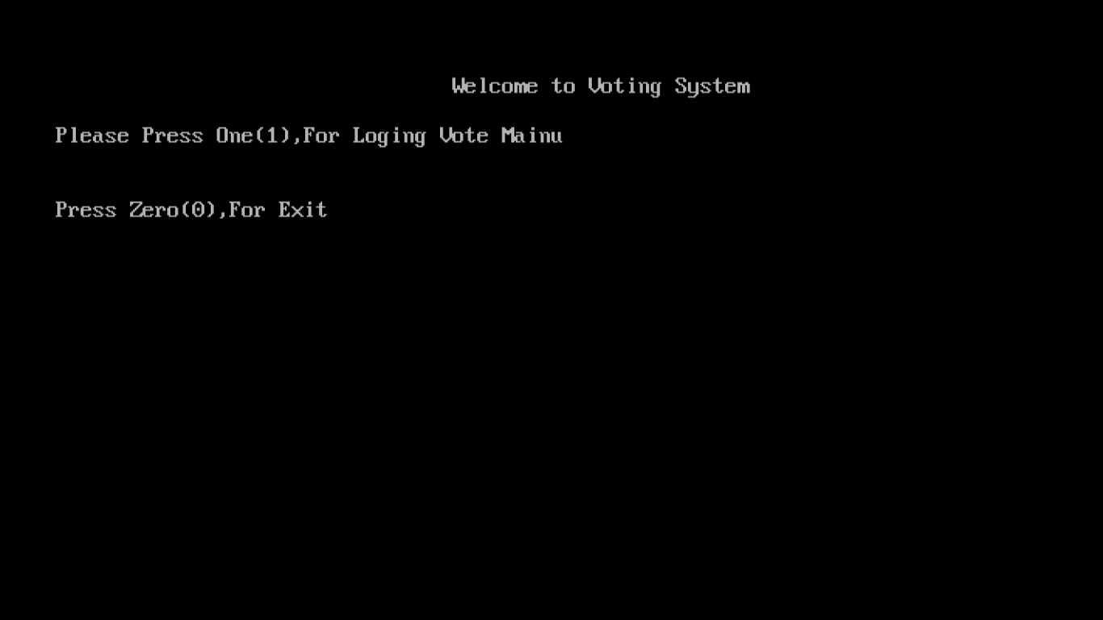

**Fig:6.1** **Welcome Screen**

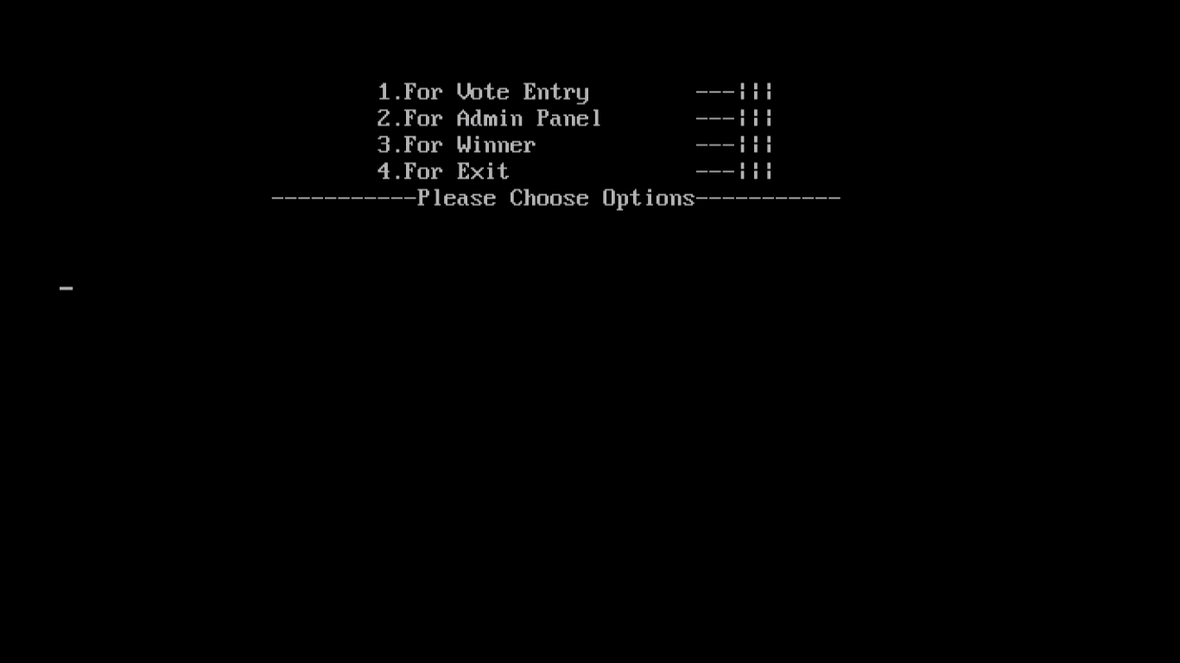

**Fig:6.2** **Main Page**

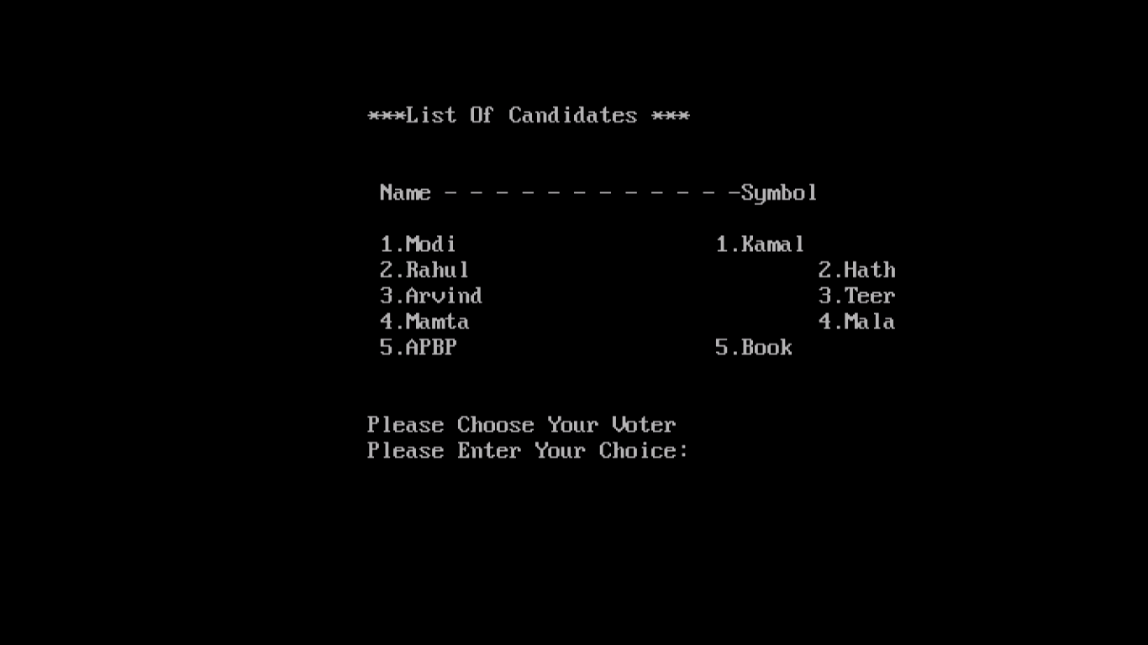

**Fig:6.3** **Candidate List**

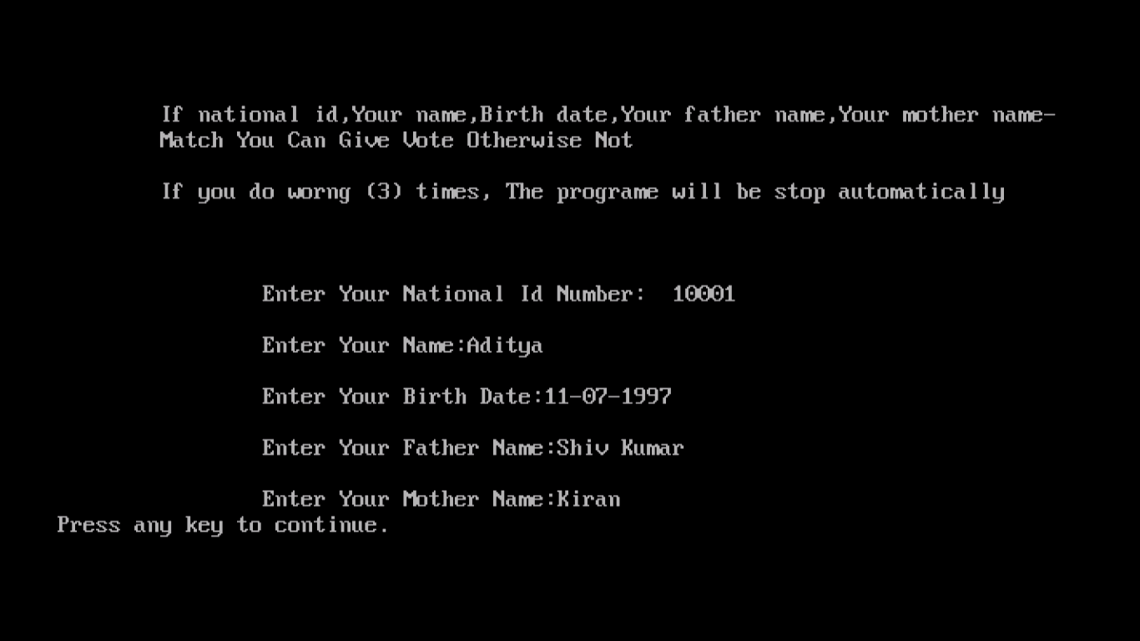

**Fig:6.4 Voter Details**

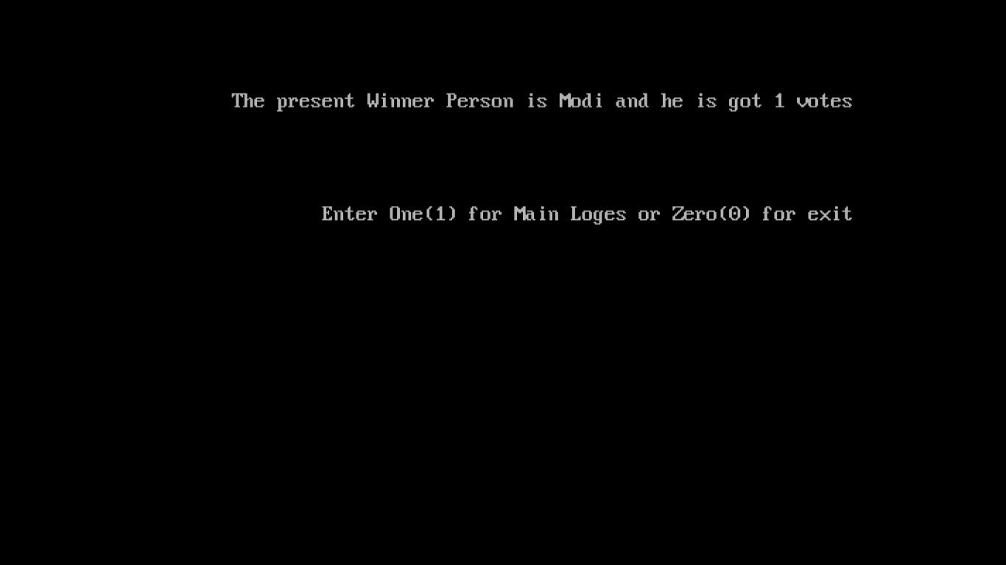

**Fig:6.5 Winner**

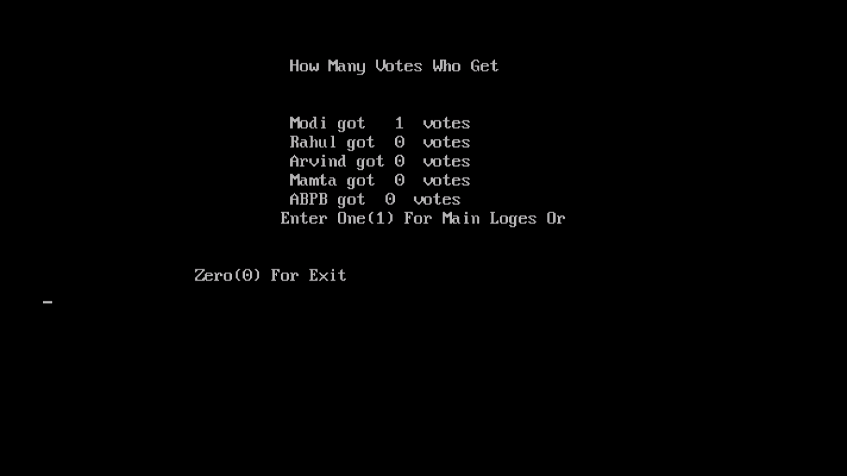

**Fig:6.6 Admin Page**

**`CHAPTER 7**

**SYSTEM TESTING**

**7.1 Test Cases**

We can find error by testing. If we want to make our software error free then testing is very essential step. Until we test our software by different test processes, we cannot say the software is right or wrong.

**Characteristics of good test:**

* High probability of finding errors
* Test should not very simple or very complicated.
* It should not be redundant

**White-box Testing-**

* Here internal program logic is checked.
* Then code of the program is checked.
* Then program flow is checked.

**Black-box testing-**

* Here functional requirement of the program is checked.
* Any function is missing or incorrect that will be checked.
* Performance of the program is will be checked.

**Unit Testing-**

This is primitive level of testing. Here every part of program will be tested independently.

**Integration Testing-**

After integrating all modules if any error occurred or not that will be tested.

**System Testing**

Recovery Testing- system fault will be checked.

Security Testing- checked improper or unauthorized access.

Stress Testing- It will be check how much abnormal quantity, frequency or volume software can handle.

Performance testing- run time performance of the software is tested.

**7.2 Maintenance**

Maintenance has been an important subject for software since several years and it is the problem of future.

To maintain higher quality of software, different types modification at different times maintenance is very important.

**Different types of software maintenance**

**a) Corrective Maintenance**

- Removing defects in programs

**b) Adaptive Maintenance**

- Modifying or changing the application for a new set of features (hardware,

OS, programming language etc.…)

**c) Perfective Maintenance**

**-** Improving the performance by paying stress on quality parameters

**d) Preventive Maintenance**

- Detecting faults much ahead of time

**e) Emergency Maintenance**

- Sudden changes being accommodated into the system e.g.: intrusion detection systems, real-time systems

**CHAPTER 8**

**RESULTS AND DISCUSSIONS**

**8.1 Conclusion**

This Online Voting framework will deal with the Voter's data by which voter can login and use voting system right. The framework will fuse all highlights of Voting framework. It gives the devices to keeping up voter's vote to each gathering and it tally all out no. of votes of each gathering for effectively. There is an information which is put away and kept up by the ELECTION COMMISION OF INDIA in which every one of the names of voter with complete data is put away in database. Those clients who is over multi year's registers his/her data on the database and when he/she need to cast a ballot he/she needs to login by his id and secret phrase and can cast a ballot to any gathering just single time. Voting system detail store in database and the outcome is appearing by count. By web-based voting system framework level of voting system is increments. It diminishes the expense and time of voting system procedure. It is exceptionally simple to utilize and It is shifting less tedious. It is easy to understand.

**8.2 Limitations**

Time factor was the best hindrance to the effective fruition of this activity since it must be done inside the semester. I likewise had monetary limitations since every one of the exercises included were self-supported.

**8.3 Future Enhancements**

The Voting System stage can be made increasingly secure by utilizing the accompanying techniques:

* Password Changing
* Fingerprinting
* Cornea Detection

The secret key utilized by the client to cast a ballot is given by the overseer. Later on, the client can be given the benefit of changing the secret word. Along these lines, it expands the security of the framework. The other two strategies that can be utilized are cornea recognition and fingerprinting. Be that as it may, here the issue is that it diminishes the extent of the stage on the grounds that these frameworks need some electronic segments to actualize. Along these lines, it will maintain a strategic distance from the client's benefit to cast the votes readily available. In any case, it can ensure that phony voting system will be outlandish.

**CHAPTER 9**

**REFERENCES**

* + 1. **TEXT REFERENCE**
  1. Programming in c using Linux (Gaurav Jindal, Ritu Aggarwal, Arun Bakshi, Sumit Chauhan)
  2. Data Structures Through C in Depth
  3. Programming in Ansi C (E. Balagurusamy)
     1. **WEB REFERENCE**

[1] <https://www.geeksforgeeks.org/data-structures/>

[2] <https://www.javatpoint.com/data-structure-tutorial>

[3] <https://www.w3schools.in/category/data-structures-tutorial/>

[4] <https://www.studytonight.com/data-structures/introduction-to-data-structures>