API Security Risk Analysis Report
JSONPlaceholder & ReqRes: Read-Only API Security Assessment
Prepared for: Future Interns, Cyber Security Task 3 (2026)
Prepared by: Aditya Rajora
Date: June 2026

Table of Contents
1. Executive Summary 3
2. Scope, Methodology & Tools 5
2.1 Objective 5
2.2 APIs Tested 5
2.3 Tools Used 5
2.4 Allowed Scope (per task brief) 5
2.5 Out of Scope / Not Performed 5
2.6 Methodology 6
3. Detailed Findings 7
4. Overall Risk Assessment & Recommendations 17
4.1 Overall Posture 17
4.2 Priority Order for Remediation 17
4.3 Closing Note 17
5. Appendix 18
5.1 Endpoints Tested 18
5.2 Reference Material (Study Only) 18

1. Executive Summary
This report presents the findings of a read-only API Security Risk Analysis performed on two publicly available test APIs: JSONPlaceholder (an unauthenticated mock REST API) and ReqRes (a key-based authenticated test API). The engagement followed the methodology outlined in the Future Interns Cyber Security Task 3 (2026) brief, simulating the type of API security audit performed by AppSec consultants and SaaS security teams for real clients.
All testing was conducted using Postman, restricted to safe, non-destructive requests (GET and read-only operations). No exploitation, brute-force, or denial-of-service techniques were used, in line with the task's ethical scope.
Nine findings were documented across six risk categories defined in the task brief: unauthenticated access, excessive data exposure, authentication weaknesses, authorization (IDOR), rate limiting, and input validation. Five findings represent genuine security risks on JSONPlaceholder; four findings confirm that ReqRes and JSONPlaceholder correctly handle certain conditions (authentication enforcement and input validation), and are documented as positive controls rather than risks.
The most significant issue identified is a broken object-level authorization (IDOR) vulnerability, present consistently across the /users, /posts, and /comments endpoints on JSONPlaceholder, which would allow any user to retrieve another user's full data by simply changing a numeric ID. While JSONPlaceholder is a mock API with no real user data, this finding is reported because it reflects a pattern seen in real-world production APIs, and is exactly the kind of issue a paid API security audit is designed to catch.
Summary of findings by severity
# | Finding | API | Severity | Type
1 | Unauthenticated endpoint access | JSONPlaceholder | Medium | Risk
2 | IDOR on /users endpoint | JSONPlaceholder | High | Risk
3 | Excessive data exposure (PII, geo-coordinates) | JSONPlaceholder | Medium | Risk
4 | IDOR pattern repeats on /posts and /comments | JSONPlaceholder | High | Risk
5 | Auth correctly blocks unauthenticated requests | ReqRes | N/A | Positive control
6 | Auth correctly rejects key sent via query string | ReqRes | N/A | Positive control
7 | Auth correctly allows valid API key | ReqRes | N/A | Positive control
8 | No rate limiting on repeated requests | JSONPlaceholder | Medium | Risk
9 | Graceful input validation on malformed IDs | JSONPlaceholder | N/A | Positive control
2. Scope, Methodology & Tools

2.1 Objective
Analyze two public test APIs to identify common API security risks, assess their authentication and access control mechanisms, explain the risks in plain business language, and recommend clear remediation steps, consistent with how a real AppSec consultancy would scope a client API audit.

2.2 APIs Tested
API | Base URL | Auth model | Role in this assessment
JSONPlaceholder | jsonplaceholder.typicode.com | None (open) | Represents an unauthenticated/legacy-style API, used to surface access control and exposure risks
ReqRes | reqres.in | API key (header-based) | Represents a key-protected API, used as a control to confirm auth enforcement works as intended

2.3 Tools Used
- Postman: primary tool for constructing, sending, and inspecting API requests/responses
- Browser DevTools: used for quick header and response spot-checks
- Manual analysis & documentation: Microsoft Word for the report, GitHub for the public repository

2.4 Allowed Scope (per task brief)
- Testing public/demo APIs only (JSONPlaceholder, ReqRes)
- Read-only requests: GET, and safe POST where explicitly allowed by the API
- Header, token, and response inspection
- Documentation-based analysis

2.5 Out of Scope / Not Performed
- No exploitation or authentication bypass attempts
- No flooding or denial-of-service testing. Rate-limit checks were limited to a small burst of requests (20) purely to observe whether throttling exists, not to disrupt the service
- No private or production systems were tested

2.6 Methodology
Testing followed the six-step process below for each API:
- Reviewed available API documentation for both APIs
- Sent baseline requests in Postman to observe default behavior (no auth headers)
- Inspected authentication requirements, response headers, and response body content
- Tested object-level access control by modifying resource IDs in the URL path (e.g. /users/1 → /users/2)
- Tested authentication enforcement on ReqRes using no key, a key sent in the wrong location (query string), and a valid key sent correctly
- Tested input validation by submitting non-numeric and negative IDs, and tested rate limiting by sending 20 rapid sequential requests to a single JSONPlaceholder endpoint

3. Detailed Findings

Finding 1: Unauthenticated Endpoint Access
API Tested | JSONPlaceholder
Risk Category | Open / Unauthenticated Endpoints
Severity | Medium

Description
All tested JSONPlaceholder endpoints (/users, /posts, /comments) returned full data with HTTP 200 OK when called with no Authorization header, no API key, and no token of any kind. There is no authentication layer on the API at all.
Evidence
GET https://jsonplaceholder.typicode.com/users/1 sent with zero auth headers returned a complete user object (name, email, address, phone, company) with no challenge or restriction.
Business Impact
In a real production API, this means anyone on the internet, not just registered users, could read application data. There is no way to know who is accessing data, no way to revoke access, and no audit trail of who requested what.
Remediation
- Require an authentication mechanism (API key, OAuth2 bearer token, or session token) on every endpoint that returns user or business data
- Apply authentication at the API gateway / middleware level so it cannot be accidentally skipped on a new endpoint
- Log and monitor unauthenticated request attempts to detect scanning or abuse
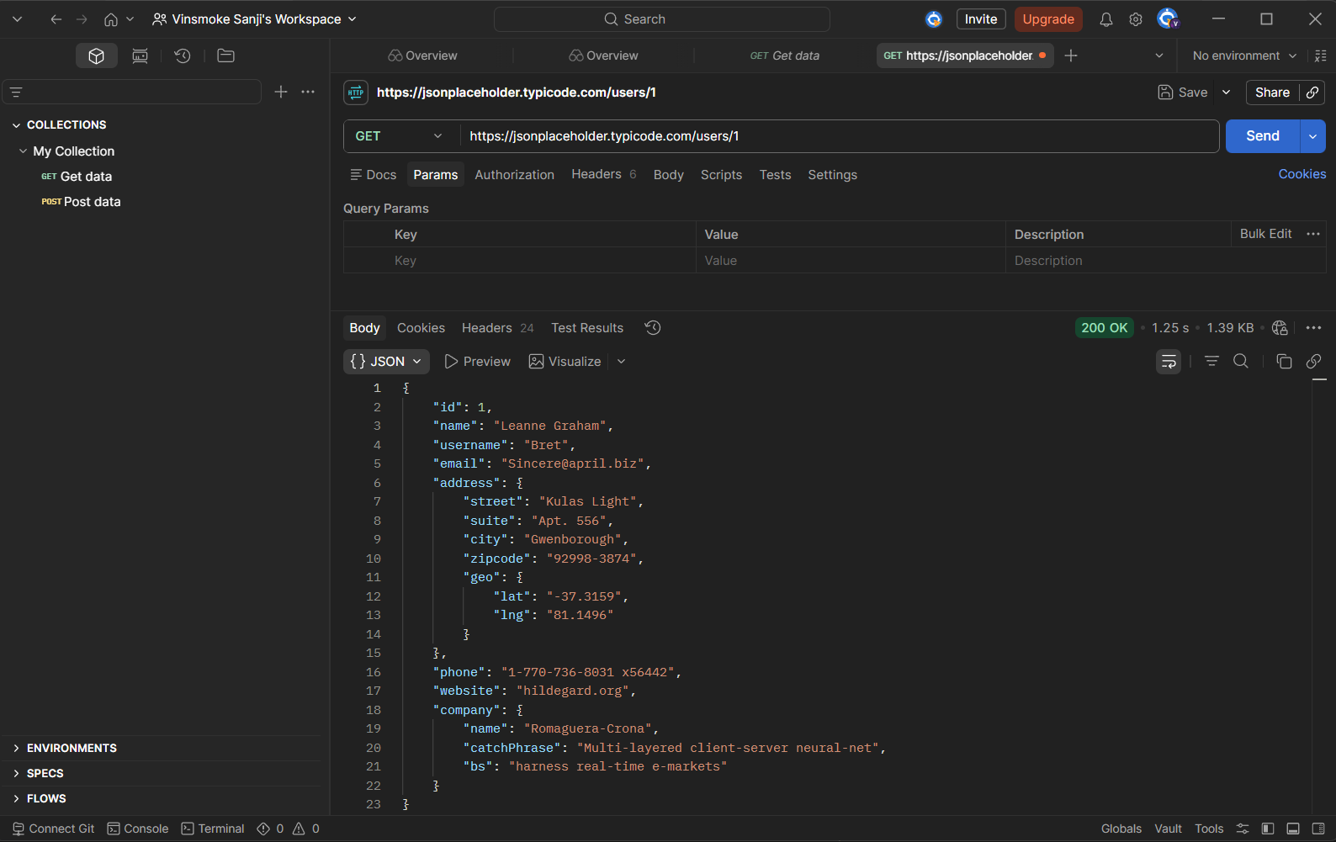
Screenshot 1: Postman, GET /users/1 with no auth header, 200 OK

Finding 2: Broken Object-Level Authorization (IDOR) on /users
API Tested | JSONPlaceholder
Risk Category | Authorization Issues
Severity | High

Description
Changing the numeric ID in the URL path (e.g. /users/1, /users/2, /users/3 ...) returns a different user's complete profile every time, with no ownership or permission check of any kind. This is a textbook Insecure Direct Object Reference (IDOR), also tracked as OWASP API1:2023 Broken Object Level Authorization.
Evidence
Sequential requests to /users/1 through /users/10 each returned a different individual's full name, username, email, address, phone number, and company details, confirming there is no per-user access boundary. The side-by-side comparison below shows /users/1 and /users/2 returning two completely different identities from the same unguarded endpoint pattern.
Business Impact
If this pattern existed on a real production system, it would mean any single authenticated (or in this case, even unauthenticated) actor could enumerate the entire user base and harvest personal data at scale, simply by incrementing a number in the URL. This is one of the most common and most damaging API vulnerabilities found in real-world breaches.
Remediation
- Implement object-level authorization checks on every request: verify the requesting identity owns or is permitted to access the specific resource ID requested
- Avoid exposing sequential, guessable primary keys in URLs; consider UUIDs where feasible
- Add automated tests that specifically attempt cross-user ID access as part of the CI/CD pipeline
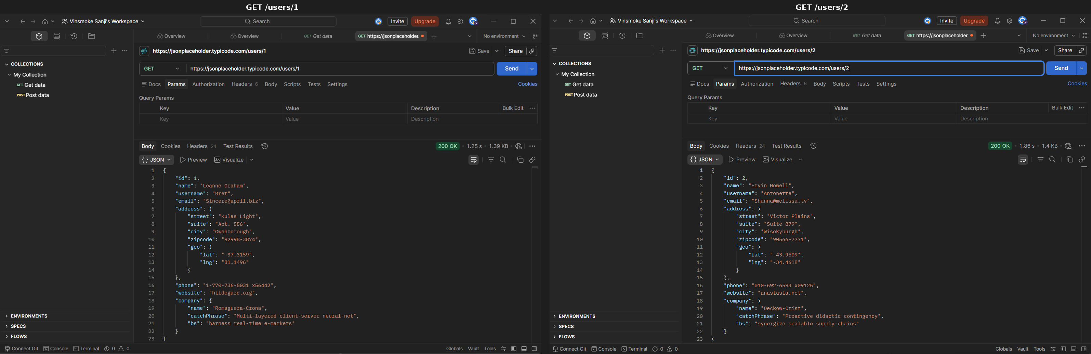
Screenshot 2: Postman, GET /users/1 vs GET /users/2 side by side, full profile data returned for both

Finding 3: Excessive Data Exposure
API Tested | JSONPlaceholder
Risk Category | Excessive Data Exposure
Severity | Medium

Description
API responses include fields that go well beyond what a typical client application would need for normal functionality, most notably full phone numbers and precise GPS latitude/longitude coordinates embedded in the address object.
Evidence
The /users endpoint response includes a geo object with lat/lng coordinates alongside the user's phone number, in addition to standard contact fields, none of which were requested or filtered by the client.
Business Impact
Returning more data than the client needs increases the impact of any future breach or interception. If a frontend only needs a display name, but the API always returns phone number and precise location, that sensitive data is now exposed to anyone who can read the response, including third-party scripts, browser extensions, or logging systems that capture the response body.
Remediation
- Apply response filtering so endpoints return only the fields a given client/role actually needs
- Use field-level or view-based serialization (e.g. separate 'public profile' vs 'full profile' response shapes)
- Avoid storing or returning precise geolocation data unless there is a specific, justified product need
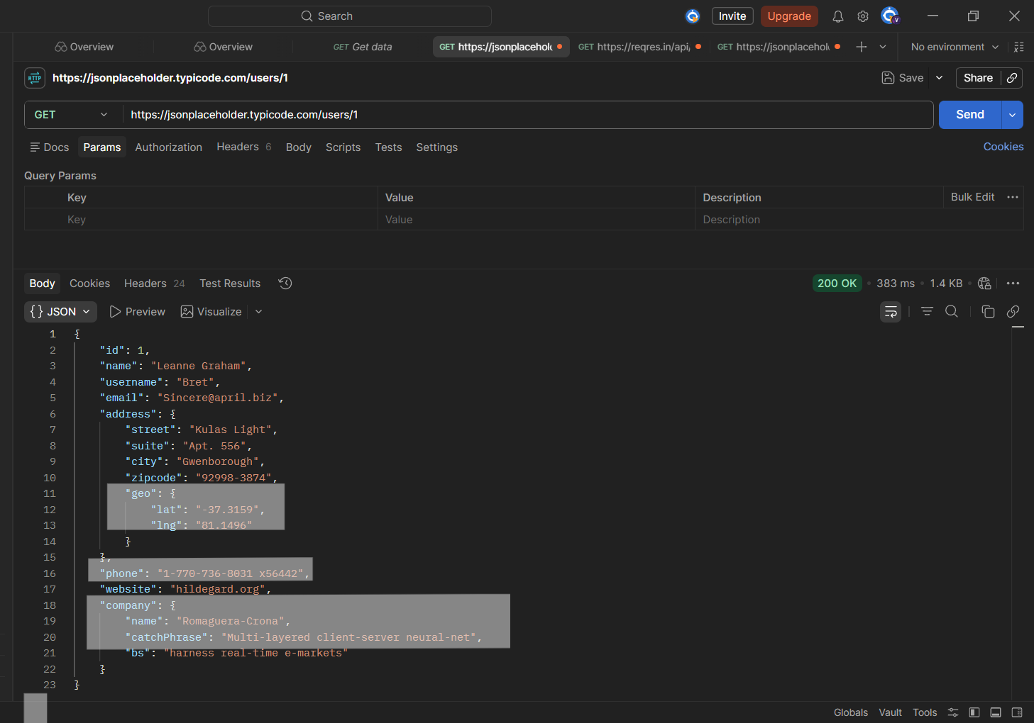
Screenshot 3: Postman, /users/1 response highlighting phone and geo coordinates

Finding 4: IDOR Pattern Confirmed Across /posts and /comments
API Tested | JSONPlaceholder
Risk Category | Authorization Issues
Severity | High

Description
The same broken object-level authorization identified in Finding 2 was retested against /posts and /comments and produced identical results: any ID returns full content belonging to a different (simulated) user, with no ownership check.
Evidence
Requests to /posts/{id} and /comments/{id} across multiple sequential IDs each returned complete post/comment bodies and associated user/email data tied to that ID, regardless of which 'user' was making the request. The comparison below shows /posts/1 and /comments/1 returning data tied to different underlying users, with the same lack of access control.
Business Impact
This confirms the IDOR issue is systemic: a design-level gap across the whole API rather than a one-off bug in a single endpoint. In a real system, this would mean a vulnerability fix applied only to /users would leave /posts and /comments (and likely other resources) equally exposed. This significantly raises the overall severity and remediation priority for the API.
Remediation
- Apply the same object-level authorization fix from Finding 2 consistently across every resource endpoint, not endpoint-by-endpoint
- Centralize authorization logic (e.g. a shared middleware or policy layer) rather than re-implementing checks per route, to prevent this kind of repeated gap
- Re-test all endpoints after the fix, not just the one originally reported
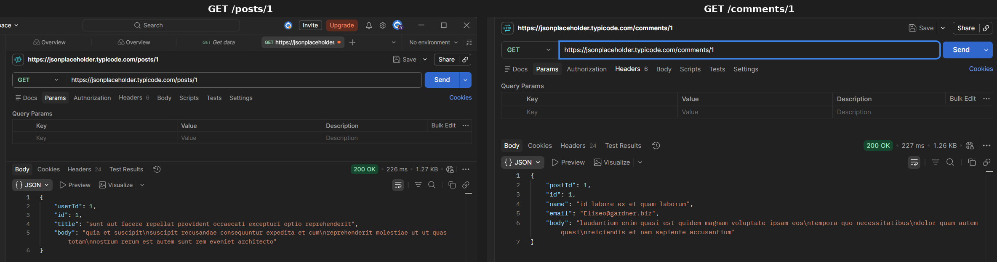
Screenshot 4: Postman, GET /posts/1 vs GET /comments/1 side by side, cross-resource access with no ownership check

Finding 5: Authentication Correctly Enforced: No API Key
API Tested | ReqRes
Risk Category | Weak or Missing Authentication
Severity | N/A (Positive Control)

Description
A request sent to a protected ReqRes endpoint with no API key supplied at all (no header, no query parameter) was correctly rejected with an HTTP 401 Unauthorized response, rather than silently allowing the request or returning partial data.
Evidence
Request sent with the x-api-key header omitted entirely returned 401 Unauthorized with a clear missing_api_key error message, no resource data leaked.
Business Impact
This is the expected, secure behavior and is documented here as a positive control. It confirms ReqRes's authentication gate is actually being enforced server-side rather than only checked client-side or inconsistently applied.
Remediation
- No remediation required. Document and preserve this behavior as a regression-test case for future changes to the API
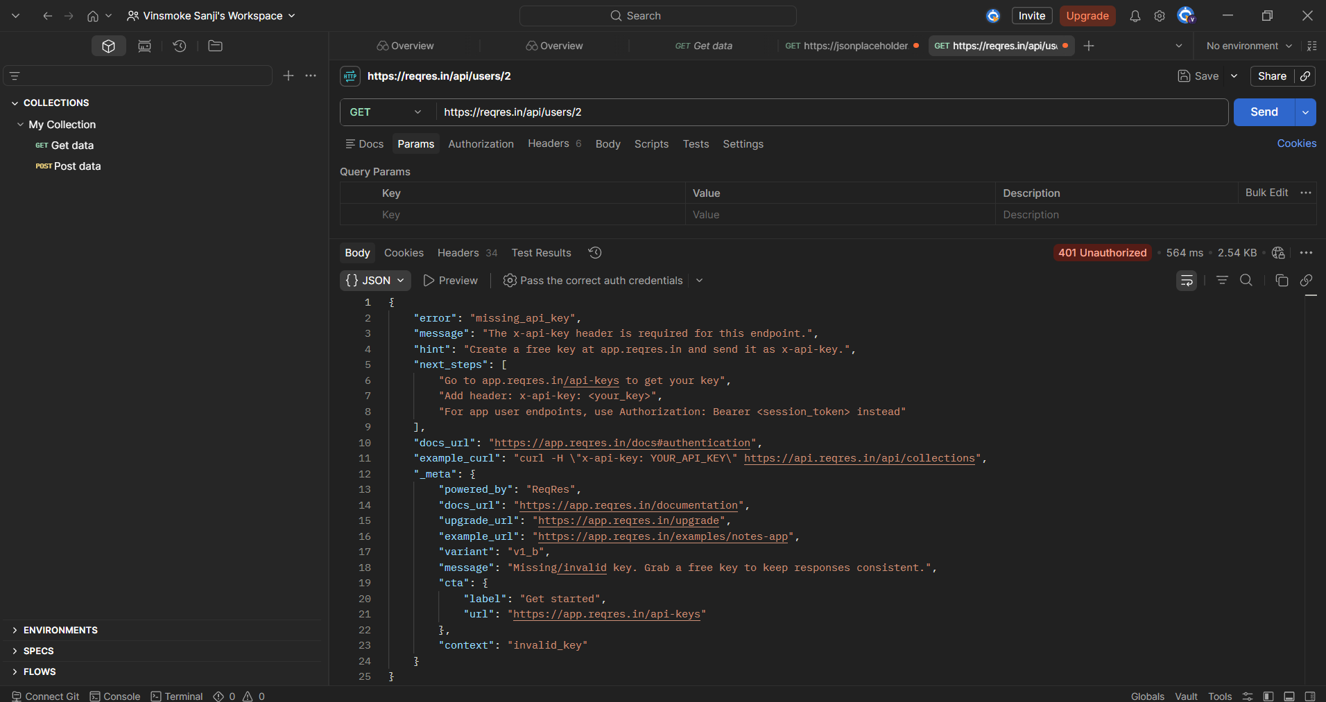
Screenshot 5: Postman, request with no API key supplied, 401 Unauthorized (missing_api_key)

Finding 6: Authentication Correctly Enforced: Key Sent Incorrectly
API Tested | ReqRes
Risk Category | Weak or Missing Authentication
Severity | N/A (Positive Control)

Description
A follow-up test attempted to supply an API key via the URL query string (?x-api-key=invalid-key-xyz123) rather than as a proper request header. ReqRes correctly rejected this with HTTP 401 Unauthorized, since it only recognizes x-api-key when sent as a header, not as a query parameter.
Evidence
Request sent with x-api-key placed in the query string returned 401 Unauthorized with the same missing_api_key error as Finding 5, confirming the API does not fall back to reading credentials from the URL. The response explicitly instructs the caller to 'Add header: x-api-key: <your_key>', reinforcing that only the header location is honored.
Business Impact
This is a secondary positive control: it shows ReqRes does not silently accept credentials passed in non-standard locations, which would otherwise create an inconsistent or confusing authentication surface (e.g. keys leaking into server logs or browser history via the URL). It also highlights a common real-world mistake, sending an otherwise-correct key in the wrong part of the request, that legitimate API consumers can hit during integration.
Remediation
- No remediation required for ReqRes. For API consumers: always confirm from documentation whether credentials are expected in headers, query parameters, or both, since sending them in the wrong place produces the same rejection as sending no credentials at all
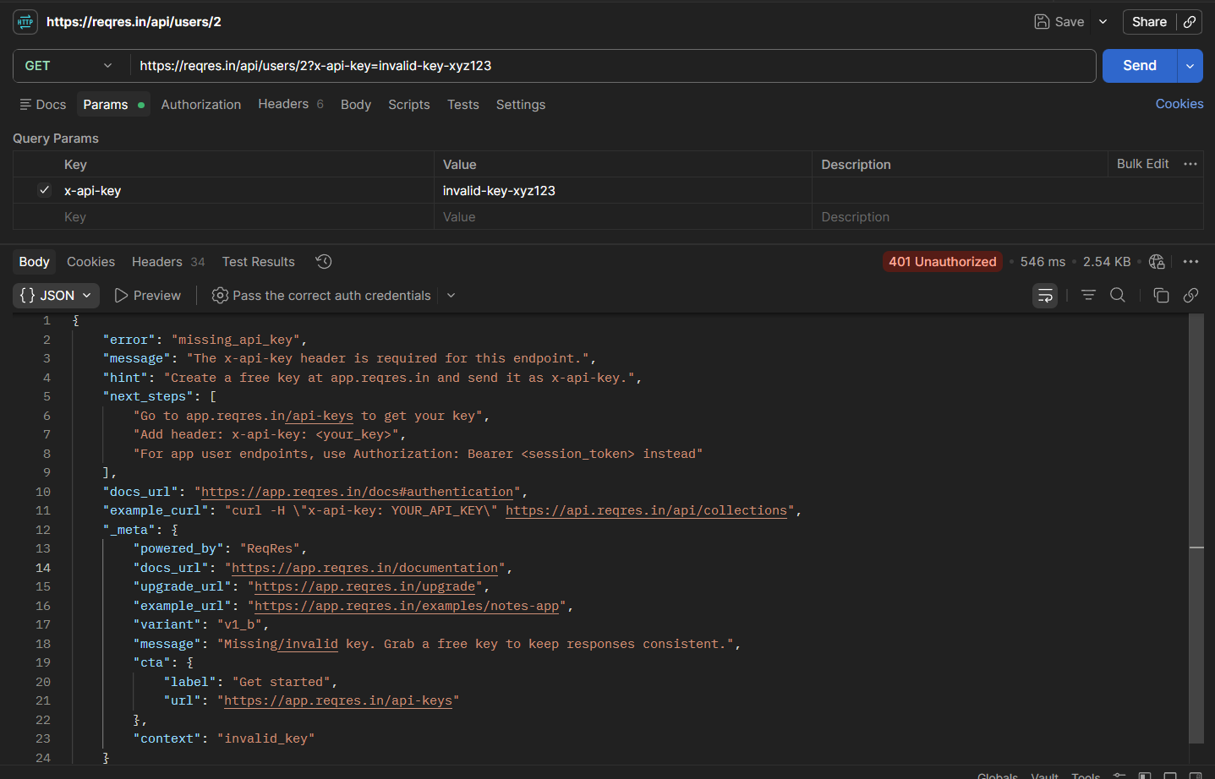
Screenshot 6: Postman, x-api-key sent as a query parameter instead of a header, 401 Unauthorized (missing_api_key)

Finding 7: Authentication Correctly Enforced: Valid API Key
API Tested | ReqRes
Risk Category | Weak or Missing Authentication
Severity | N/A (Positive Control)

Description
A request sent with a valid, correctly formatted API key as a header was accepted and returned the expected resource data with HTTP 200 OK, completing the test of ReqRes's authentication enforcement across no key, key sent incorrectly, and a correctly supplied valid key.
Evidence
Request sent with a valid x-api-key header returned 200 OK with the expected JSON payload.
Business Impact
Together with Findings 5 and 6, this confirms ReqRes implements a complete and correctly functioning authentication gate: it blocks absent credentials, blocks credentials sent in the wrong location, and allows correctly supplied valid credentials through. This is the standard way to verify an auth layer is genuinely working rather than only appearing to work.
Remediation
- No remediation required. Confirmed secure behavior
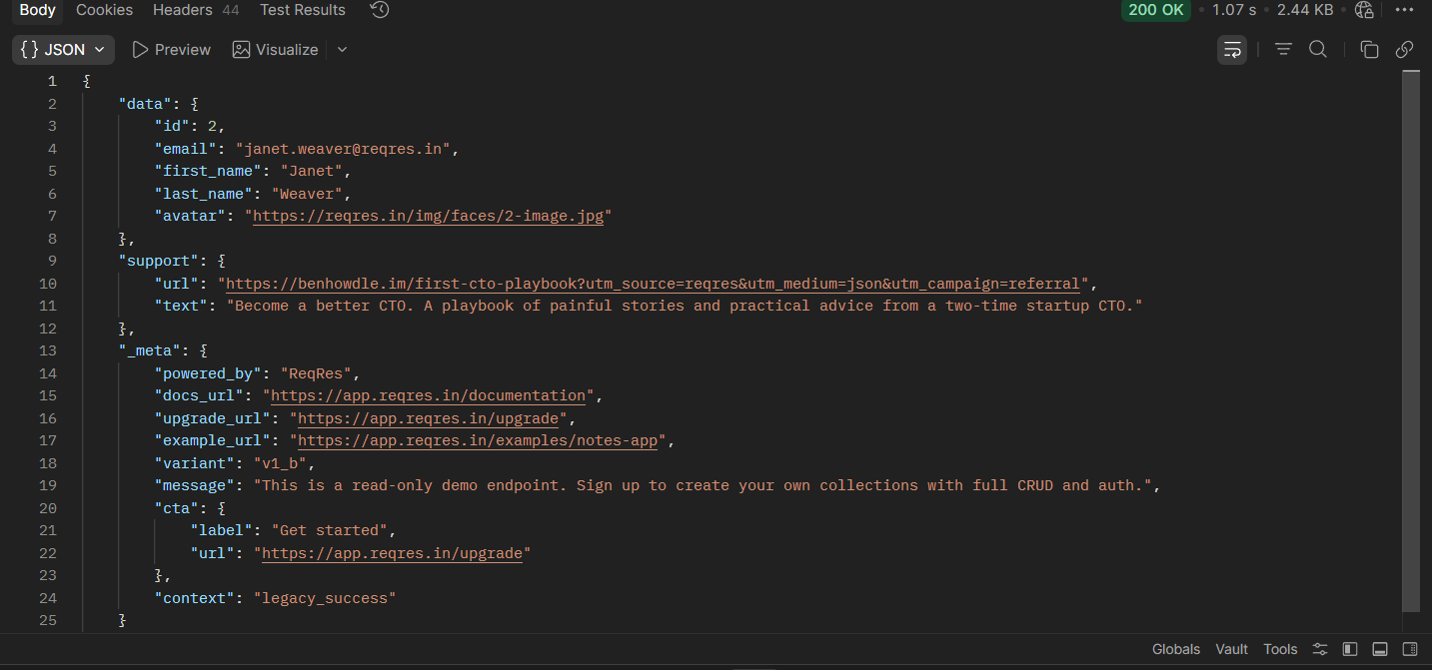
Screenshot 7: Postman, request with valid API key header, 200 OK

Finding 8: Missing Rate Limiting
API Tested | JSONPlaceholder
Risk Category | Missing Rate Limiting
Severity | Medium

Description
Twenty rapid sequential requests were sent to a single JSONPlaceholder endpoint to observe whether any throttling, rate limiting, or abuse-prevention mechanism exists. Every single request returned HTTP 200 OK with no slowdown, warning header, or rejection of any kind.
Evidence
20 consecutive GET requests to the same endpoint within a short window all returned 200 OK; no Retry-After header, 429 status code, or other throttling indicator was observed at any point.
Business Impact
Without rate limiting, an API is exposed to scraping at scale, credential-stuffing style abuse on auth endpoints, and resource-exhaustion style attacks. This testing intentionally stayed at a small scale (20 requests) per the task's ethical boundaries, but the consistent 200 OK responses with zero throttling signal strongly suggest the same would hold at a much larger volume.
Remediation
- Implement per-IP and/or per-API-key rate limiting (e.g. token bucket or sliding window) at the gateway level
- Return HTTP 429 Too Many Requests with a Retry-After header once a threshold is exceeded
- Apply stricter limits to higher-risk endpoints such as authentication and search/enumeration-prone routes

Finding 9: Graceful Input Validation Handling
API Tested | JSONPlaceholder
Risk Category | Input Validation Issues
Severity | N/A (Positive Control)

Description
Malformed inputs, including non-numeric IDs (e.g. letters) and negative numeric IDs, were sent to JSONPlaceholder endpoints to check how the API handles unexpected input. In every case the API returned a clean HTTP 404 Not Found with no server error, no stack trace, and no crash.
Evidence
Requests such as GET /users/abc and GET /users/-1 both returned a clean 404 response rather than a 500-series server error or an unhandled exception.
Business Impact
This is documented as a positive control. Many real-world APIs leak internal details (stack traces, framework versions, database error messages) when given malformed input, which can hand an attacker a roadmap of the backend. JSONPlaceholder avoids this: input validation here fails safely and cleanly.
Remediation
- No remediation required. Recommended as a model pattern: validate input types/ranges early and return generic 4xx errors without internal implementation details
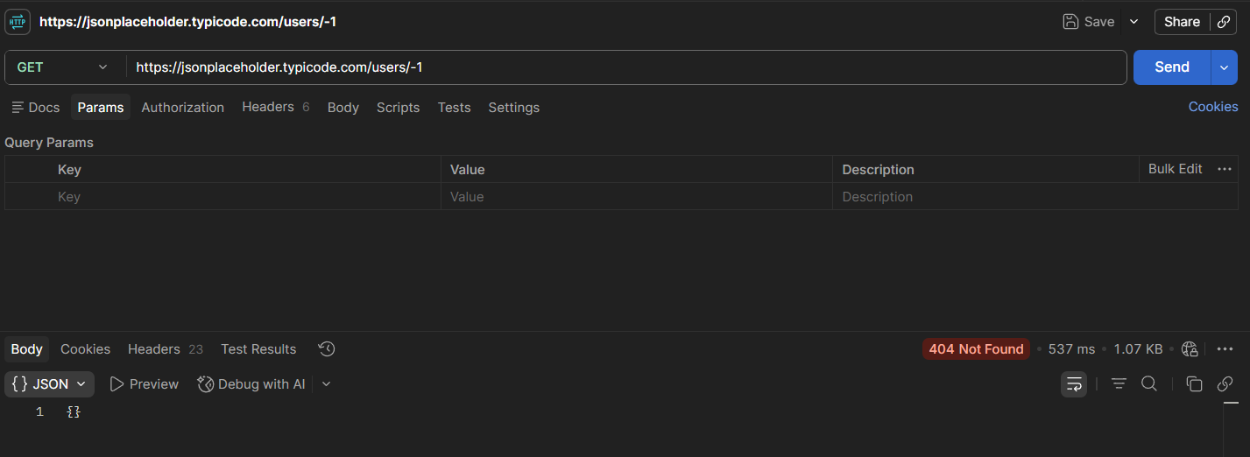
Screenshot 8: Postman, GET /users/-1, clean 404 Not Found response

4. Overall Risk Assessment & Recommendations

4.1 Overall Posture
JSONPlaceholder, evaluated as a stand-in for an unauthenticated legacy-style API, shows the risk pattern typical of APIs built without a security-first design: no authentication layer, no object-level authorization, excessive data in responses, and no rate limiting. None of this is surprising for a public mock API whose entire purpose is open testing, but the pattern mirrors real production findings from paid API security audits, which is exactly why it was selected for this exercise.
ReqRes, evaluated as a stand-in for a key-protected API, demonstrated correctly functioning authentication across all three test conditions (no key, key sent in the wrong location, valid key sent correctly) and handled malformed input safely. This contrast is intentional: it shows the assessment is balanced and capable of recognizing secure behavior, not just hunting for problems.

4.2 Priority Order for Remediation
- Fix broken object-level authorization (Findings 2 & 4): highest severity, systemic, highest real-world impact
- Add authentication to all data-returning endpoints (Finding 1): foundational control that several other fixes depend on
- Reduce excessive data exposure in responses (Finding 3): lower effort, immediate risk reduction
- Implement rate limiting (Finding 8): protects against abuse once the above are in place

4.3 Closing Note
This assessment was performed strictly within the read-only, ethical scope defined in the Future Interns Task 3 brief. No exploitation, bypass, or denial-of-service technique was used at any point. All findings are reported in the spirit of a professional, responsible API security audit: identifying risk and recommending fixes, not demonstrating exploitation.

5. Appendix

5.1 Endpoints Tested
- JSONPlaceholder: /users, /users/{id}, /posts, /posts/{id}, /comments, /comments/{id}
- ReqRes: protected resource endpoint (tested with no key / key in wrong location / valid key)

5.2 Reference Material (Study Only)
- OWASP API Security Top 10: github.com/OWASP/API-Security
- API Security Checklist: github.com/shieldfy/API-Security-Checklist

