Introduce Yourself

1.Who are you?
An Associate Automation Test Engineer with 2.5 YOE in Java , Selenium
2.Why are you here?
To learn Playwright skills for automating web applications and leverage AI to do testing
3.Are you working?
No.
4.Drop your Linkedin and github links
LinkedIn: https://linkedin.com/in/aditya-ramekar-9a15221b5
Github: https://github.com/AdityaRamekar

[Task] 28th Sept 2026 -done
- Create the github.com :
- app.thetestingacademy.com:
- VS Code
- Medium

[Task] 30th Sept 2026-not done
Research about the Open source Models Vs Close Source
AI Glossary - Keywords – QA
parameter, temperature.....
Gen AI
Token, RAG, Agentic AI, Bias, Embedding,, Fine Tune, Hallcination
Context Window, Vector DB, Schema, Prompt, MCP
LangChain, Skills, Neural Network which can learn, Agents
Weights, chatbot, Attention Number, RAG, Harness
Prompt Injection, GuardRails, Parding, Evals, Chunks
Grounth Truth, ....
Generate the Test Plan for vwo.com using the PRD + Anti Hallucination / Rules

[Task 2 Oct] Create a Test Plan using RICEPOT template
Prompt:
Create TestPlan 04_RICE_POT_Generic_QA_Template.md, We want to create a test plan by using this port generic template. I want you to ask me the question related to it and then we will create a proper test plan for it.
Sir’s Github Repo : https://github.com/PramodDutta/LearnJSTSPlaywright4x/tree/main/00_chapter_Prompt_Eng
Prompting Course : https://learnprompting.org/courses/chatgpt-for-everyone

[Task- 5 Oct] Javascript basics ,VS code and Learning logs- done
Task 1: DOM is tree-like structure of HTML document. Javascript can access, modify or interact with page elements using objects such as Element, document and Node.
Task 2: Create Project on VS code and do simple practice - Results displayed
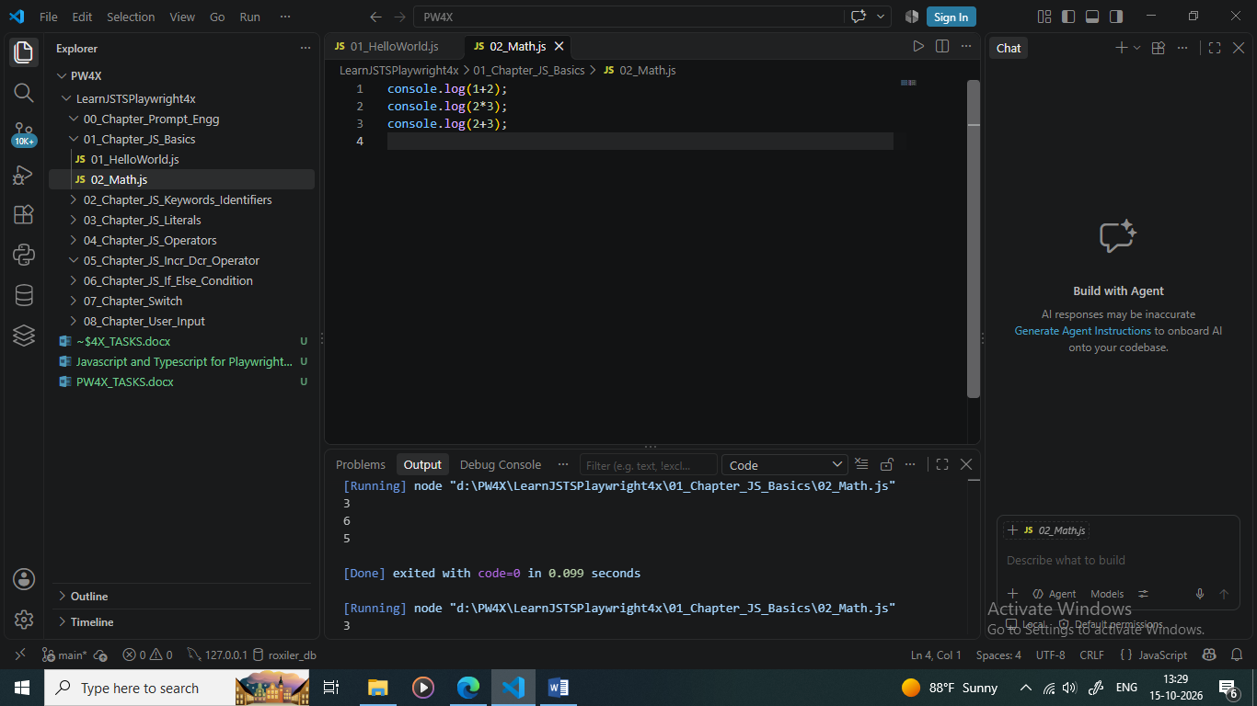
Task 3: Added Learning Activity
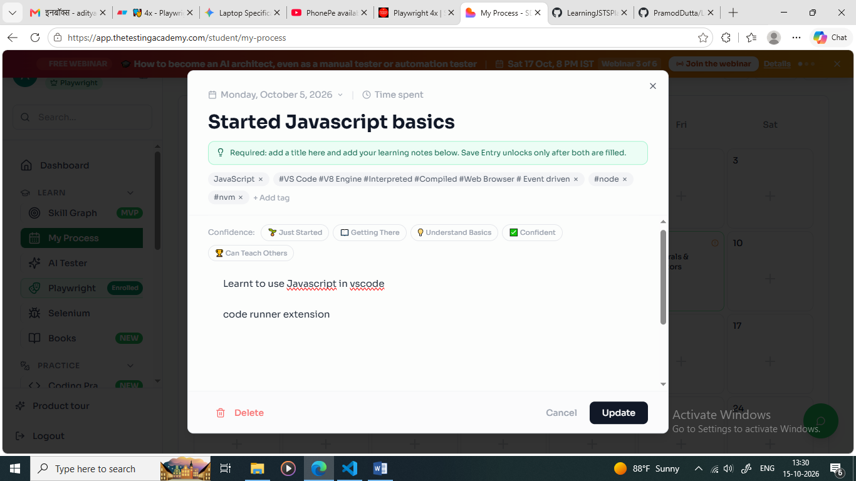

Task #3- Add your learning on app.thetestingacademy.com
URL : https://app.thetestingacademy.com/student/my-process

[Task - 7 Oct] Research Keywords,Identifiers and Practice code - done
- Research about the rules of Keywords and Identifiers and share your learnings in the comments below. (Do not create a seperate post for it)
Keywords:
var,let,const
function ,await, asyn,
class,this,new,super,extends,continue,constructor,if else,switch,case,break,try,catch,finally throw,new,return
import ,export
//'require' is a identifier not keyword

identifiers
rules:
1) should start with letter not numbers e.g start,Start123,start@
2) can start with underscore not with symbol '_' e.g _abc
3) case sensitive e.g abc and ABC are different
4)keyword can't be used as identifiers like let , var, const can't be used

- Practice and replicate all the 9 exercises done so far and commit and push the code to your github repository. https://github.com/PramodDutta/LearnJSTSPlaywright4x/tree/f6f4161264b43281d0ef6a7ddbebece40b8f9b11/02_chapter_JS_Keywrods_Identifiers
Sir Repository : https://github.com/PramodDutta/LearnJSTSPlaywright4x

[Task -9 Oct] Practice 25 exercises and fill learning log/attendance
- Practice till Exercise 25_CC.js and push code to your github repository. Paste your repo link in comments below.
Sir’s repo link : https://github.com/PramodDutta/LearnJSTSPlaywright4x/tree/main
- Fill your learning logs/ attendance in app.thetestingacademy.com
URL : https://app.thetestingacademy.com/student/my-process

[Task] 30th Sept 2026
- Research about the Open source Models Vs Close Source
- AI Glossary - Keywords - QA
  - parameter, temperature.....
  - Gen AI
  - Token, RAG, Agentic AI, Bias, Embedding,, Fine Tune, Hallcination
  - Context Window, Vector DB, Schema, Prompt, MCP
  - LangChain, Skills, Neural Network which can learn, Agents
  - Weights, chatbot, Attention Number, RAG, Harness
  - Prompt Injection, GuardRails, Parding, Evals, Chunks
  - Grounth Truth, ....
- Generate the Test Plan foe vwo.com using the PRD + Anti Hallucination / Rules
2/10/2026
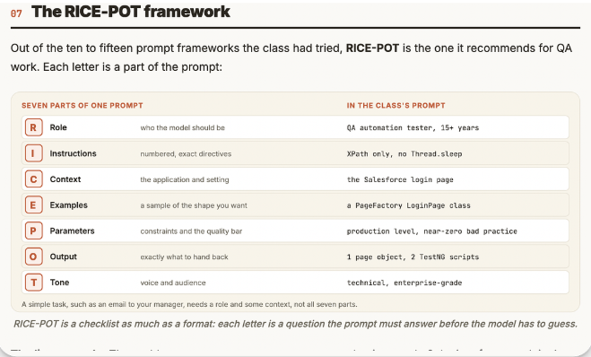
Prompt Engineering for QA: Five Principles, the RICE-POT Framework and Pushing to GitHub | The Testing Academy
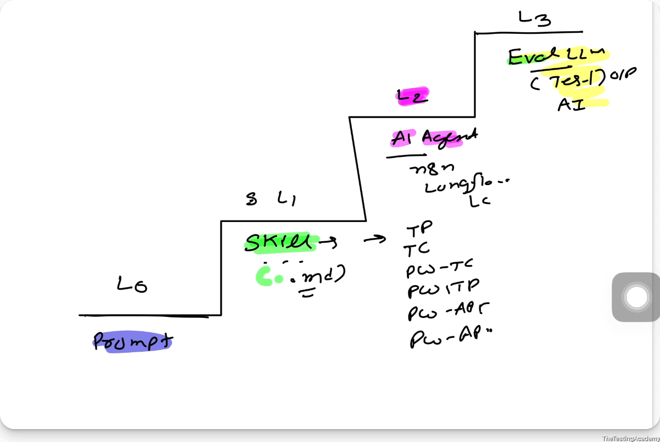Prompt
Create TestPlan 04_RICE_POT_Generic_QA_Template.md, We want to create a test plan by using this port generic template. I want you to ask me the question related to it and then we will create a proper test plan for it.
﻿learnprompting.org/courses/chatgpt-for-everyone

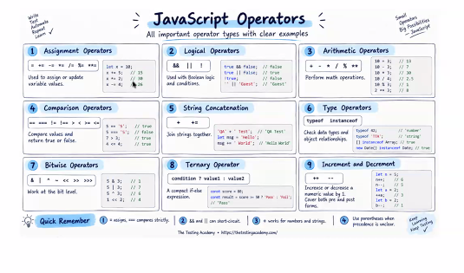

[Task -9 Oct] Practice 25 exercises and fill learning log/attendance
- Practice till Exercise 25_CC.js and push code to your github repository. Paste your repo link in comments below.
Sir’s repo link : https://github.com/PramodDutta/LearnJSTSPlaywright4x/tree/main
- Fill your learning logs/ attendance in app.thetestingacademy.com
URL : https://app.thetestingacademy.com/student/my-process

12/10/2026

[Task 12 Oct] Increment Decrement Operator-done
• What is the output of the following expressions. Answer in the comments below.
1.
let a = 100;
console.log(a++ + ++a +a++ + ++a);
console.log(a);
2.
let a = 37;
console.log(—a + a—);
console.log(a);
3.
let a = 5;
let b = a-- - --a;
console.log(b, a);
4.
let i = 1;
let r = i++ > 1 ? i++ : ++i;
console.log(r, i);
ans-
1)
a = 100
a++ = 100
++a = 102
a++ = 102
++a = 104
-----------
output- 408 & 104

---------------------
2)
a=37
--a = 36
a-- = 36
----------
output- 72 & 35

---------------------
3)
a= 5
a-- = 5
--a = 3
--------
output- 2 & 3

--------------
4)
i = 1
i++ = 1
++i = 3
----------
output- 3 & 3
2.Add your attendance /learning log:
https://app.thetestingacademy.com/student/my-process
3.Practice all exercises done in class and push it to your github repository.
Sir’s repo : https://github.com/PramodDutta/LearnJSTSPlaywright4x
[Task- 14 Oct] Coding Practice-done
Practice below 5 questions on:
https://app.thetestingacademy.com/student/coding-practice
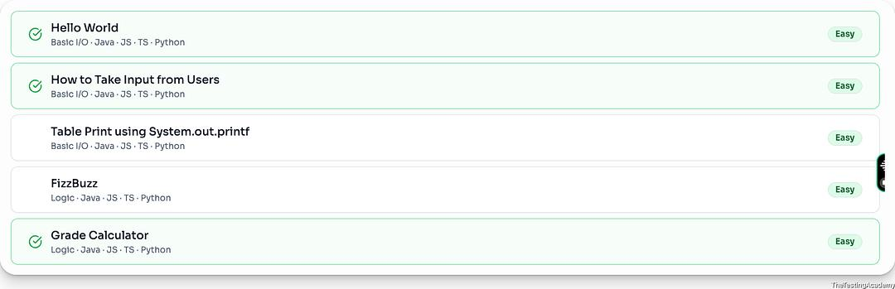
Submit the screenshot of result in the comments below.
Note:
Make sure the output is in format of Examples shown(not Test Cases) and be careful about space while printing.
Like for Printing table - Output should be in different lines not same line
Ans-
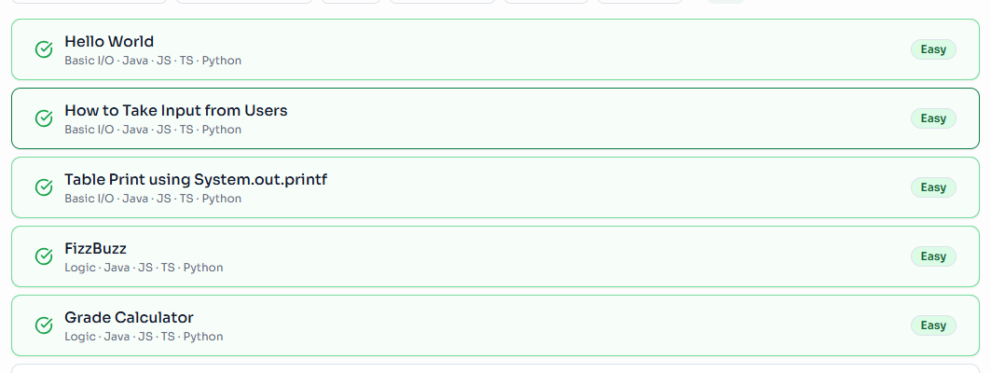
16/10/2026

