**🖼 Image Classification App**

A simple Tkinter-based desktop application that allows users to classify images using a pre-trained Logistic Regression model.

**📌 Features**

* Upload an image through a graphical interface
* Display the uploaded image
* Predict and display the image class
* Uses a pre-trained LogisticRegression model saved as Fash.joblib

**🖼 Screenshots**

**Home Screen**

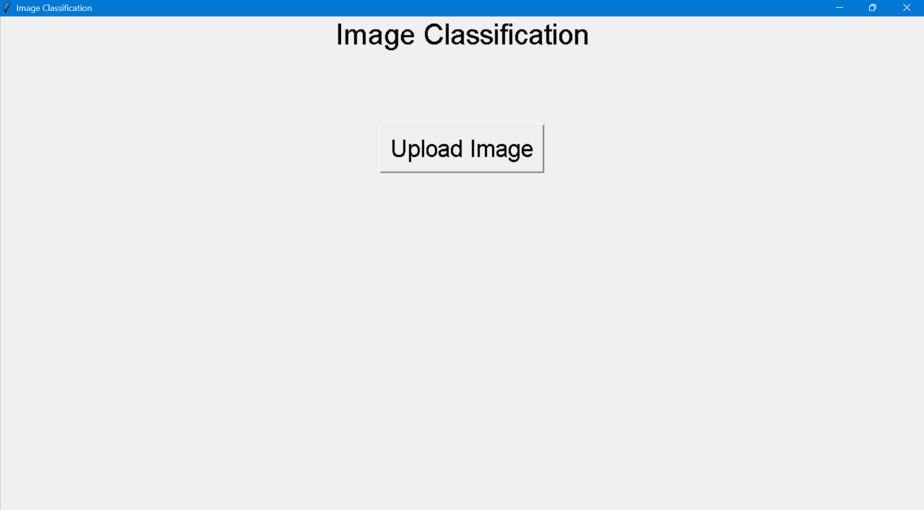

**Prediction Example**

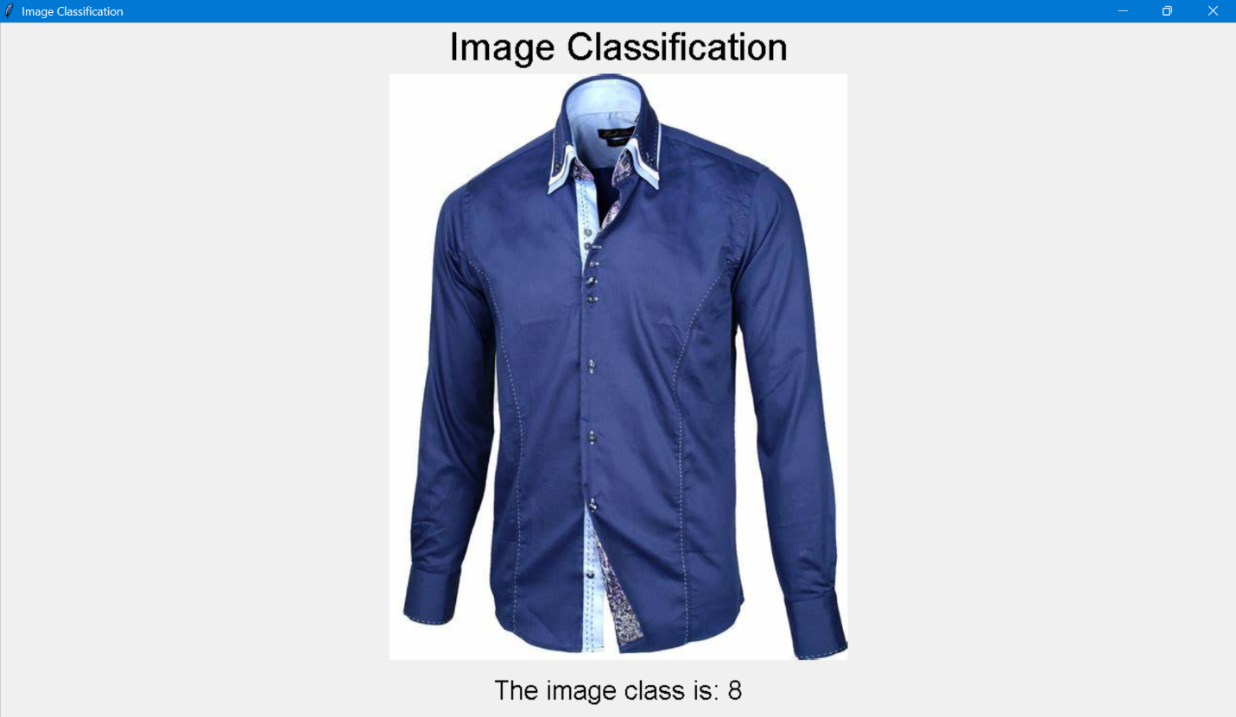

**🛠 Requirements**

Before running the application, install the required dependencies:

* bash
* CopyEdit
* pip install -r requirements.txt

**📜 requirements.txt**

Make sure you create a requirements.txt file with the following dependencies:

* nginx
* CopyEdit
* tkinter
* pillow
* numpy
* scikit-learn
* joblib

**🚀 Usage**

1. Clone the repository:

bash

CopyEdit

git clone https://github.com/AdityaRana-beepbeep/ImageClassifierApp.git

cd ImageClassifierApp

1. Install dependencies:

bash

CopyEdit

pip install -r requirements.txt

1. Run the application:

bash

CopyEdit

python frontend.py

1. Click "Upload Image" and select an image to classify.

**📂 Project Structure**

bash

CopyEdit

ImageClassifierApp/

│-- frontend.py # Tkinter GUI implementation

│-- Fash.joblib # Pre-trained logistic regression model

│-- requirements.txt # Dependencies list

│-- README.md # Documentation

│-- Screenshots/ # Folder containing UI screenshots

**🤖 Model Details**

* The model (Fash.joblib) is trained on a dataset of fashion items.
* Uses Scikit-Learn's LogisticRegression for classification.
* Expects grayscale images resized to 28x28.

**📝 License**

This project is open-source under the MIT License.