**Check whether /user/acadgild directory exists or not in the HDFS.**

**If it doesn't exist, then create this.**

**Create a directory /user/acadgild/Hadoop**

* First of all, there is no **cd** command for hadoop filesystem.
* To go through hadoop filesystem, we mostly use **ls**command.
* Eg-: lets start from root directory of hadoop filesystem with following command

hadoop fs -ls /

this above command will list all directories under root directory.(**/**is same as in linux)

* Now coming to the current assignment, to check wether /user/acadgild directory exist or not and if not then create one.

Steps-:

hadoop fs -ls /              (we can see /user in snapshot1)

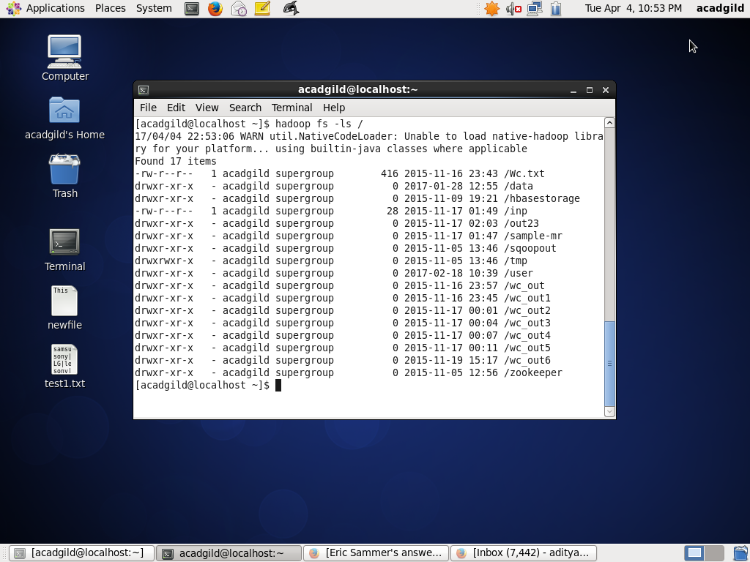

hadoop fs -ls /user/       (we see the /user/acadgild directory in snapshot2)

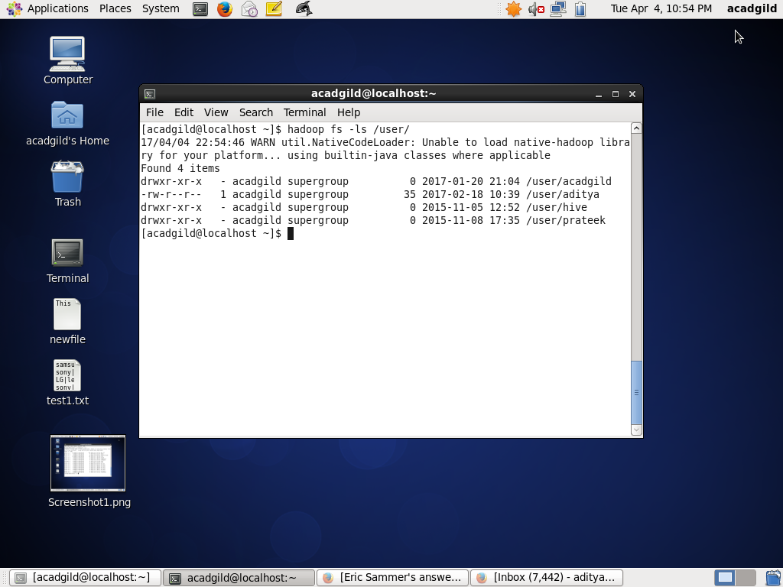

therefore the directory /user/acadgild does exist

Now if suppose the directory did not exist(eg,. create /user/Testdir)

Steps-:

hadoop fs -mkdir /user/Testdir

(Some time one may get the foll error **Name node is in safe mode**which means that the NN is in read only mode and would not allow any  modification in the existing dir or structure. Refer foll link   
<http://data-flair.training/forums/topic/mkdir-cannot-create-directory-data-name-node-is-in-safe-mode>)**.To come out of safe mode**  
hdfs dfsadmin -safemode leave       (safemode is OFF)  
  
hadoop fs -mkdir /user/Testdir      (snapshot3)

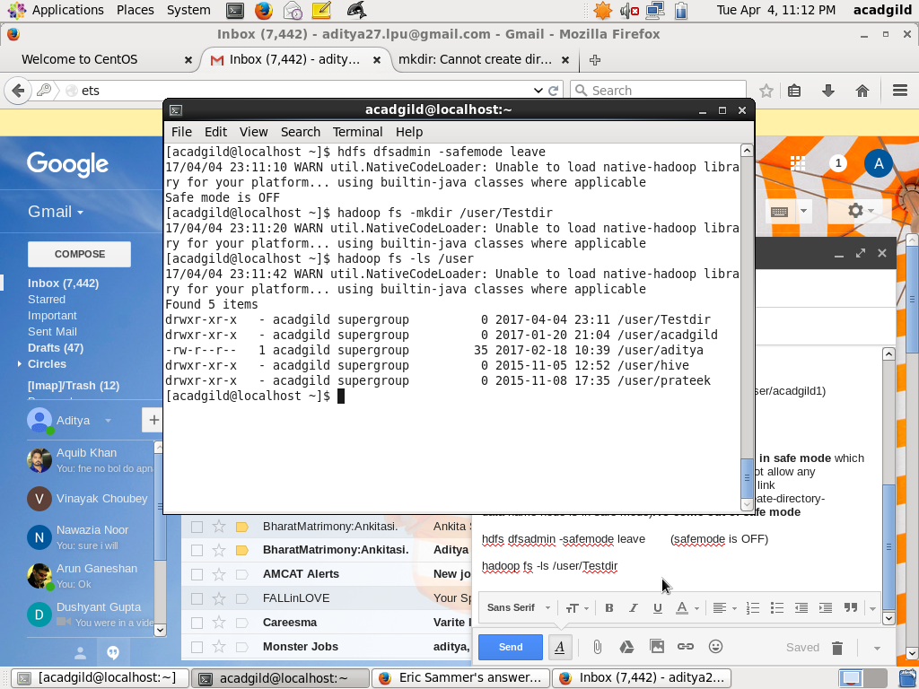

And following the above steps, one can create a new directory.

Similarly for creating Hadoop directory

* hadoop fs -mkdir /user/acadgild/hadoop

**Create a file in HDFS under directory /user/acadgild/hadoop, with name word-count.txt.**

**Whatever we type on screen should get appended to the file.**

To create file

Hadoop fs -touchz /user/acadgild/Hadoop/word-count.txt

To edit data into that file

Echo “welcome” | hdfs dfs -appendToFile - /user/acadgild/Hadoop/word-count.txt

Echo “to Hadoop” | hdfs dfs -appendToFile - /user/acadgild/Hadoop/word-count.txt

Echo “classes” | hdfs dfs -appendToFile - /user/acadgild/Hadoop/word-count.txt

To check the data in it

Hadoop fs -cat /user/acadgild/Hadoop/word-count.txt

o/p-: welcome to Hadoop classes