Moveo: An Enterprise-Scale Event-Driven Distributed Travel Booking Platform
Group No.: 22
Project Group Members:
- Aarush Saxena (A-1/12584200001)
- Aditya Gaur (A-4/12584200012)
3. Aryan Shekhar (A-14/12584200047)

Project Supervisor: Dr. Sachendra Singh Chauhan, Assistant Professor

About the Project:
Moveo is a unified travel booking platform designed to simplify travel planning and booking by bringing flights, hotels, and buses together in a single place. It allows users to search and compare travel options, check availability, make bookings and payments, and manage their trips through a convenient platform. The project addresses common problems faced by travellers, such as fragmented booking services, outdated availability information, booking conflicts, and difficulties in comparing different options. Moveo also aims to provide personalized travel recommendations and a smooth booking experience. The platform is designed to support a large number of users and booking requests while maintaining reliable and consistent operations.
Motivation:
The motivation behind Moveo is to provide a single platform that makes travel planning more convenient by combining flight, hotel, and bus services. It addresses real-world challenges such as fragmented services, outdated availability, booking conflicts, and difficulties during high-demand periods. The project is suitable as a major project because it involves multiple interconnected travel services and complex booking processes. It can benefit society by making travel planning and booking more accessible, convenient, and reliable.
Project Planning:
The project will follow an Iterative Development Model, where the system will be developed in planned stages with continuous refinement and improvement throughout the development process. The project will begin with Requirements Analysis and Feasibility Study in August 2026 to identify the project objectives, scope, user requirements, and feasibility. This will be followed by System and Database Design in September 2026, covering the overall system structure, database design, and major functional modules.

The Implementation (Coding) phase will be carried out from October 2026 to January 2027. During this phase, the major functionalities of the platform, including flight, hotel, and bus search, inventory management, booking, payment, user management, and related features will be developed iteratively. System Integration and Testing will take place during January and February 2027, where the developed modules will be integrated, tested, and refined based on identified issues.
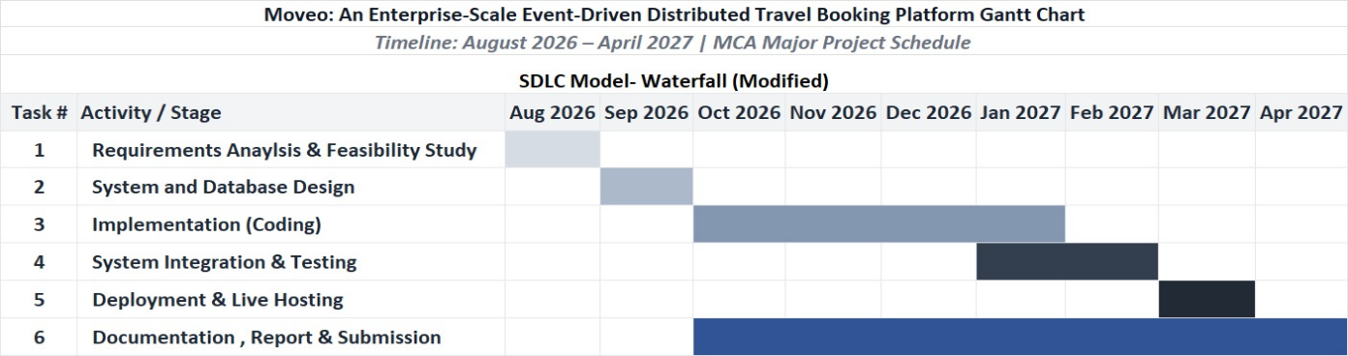
The Deployment and Live Hosting phase is planned for March 2027. The final stage will focus on Documentation, Report Preparation, and Submission, which will continue alongside development from October 2026 and be completed by April 2027. The approximate duration and sequence of these phases are represented in the Gantt Chart.

Tools Required:

- Hardware Requirements:
  - Processor: Intel Core i3/ AMD Ryzen 3 or equivalent
  - RAM: Minimum 8 GB
  - Storage: Minimum 50 GB available SSD space
  - Network: High-speed internet connection

- Software Requirements:
  - Operating System: Windows / Ubuntu Linux / macOS
  - Programming Languages: Python 3.11+, TypeScript 5.x, Java 26.x
  - Frontend: Next.js 15, React 19, Redux Toolkit, Tailwind CSS
  - Backend: Fast Api, Spring Boot , JWT, RBAC
  - Databases: PostgreSQL 15, Redis 7, Elasticsearch 8
  - Messaging: Apache Kafka
  - Containerization Tools: Docker Desktop & Docker Compose
  - API Testing: Postman / Swagger UI
  - Version Control: Git & GitHub

Signature of Project Supervisor: _____________________

