The mcmc samplers (NUTS, MetropolisHastings, Ensemble Slice Sampling) are all biased towards trying to find the highest density region of probability. This bias causes problems during rough response surfaces which depend on many parameters  (very rapidly above 4 parameters). It means one cannot be confident in the result since there may be more than one result.

So CheKiPEUQ also has \*\*unbiased\*\* sampling. This has two advantages:  a) no rejection of samples, b) can be used to make sure that the bias from the mcmc is not affecting the final distribution found.  A simple example is below, and is now Example 00f in the official examples.

Below is example 00f and works well.

Here is regular Metropolis Hastings (00f1):

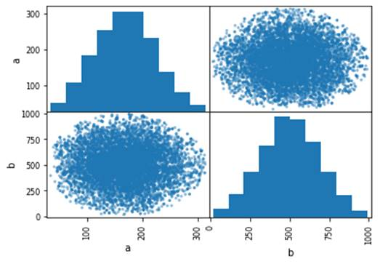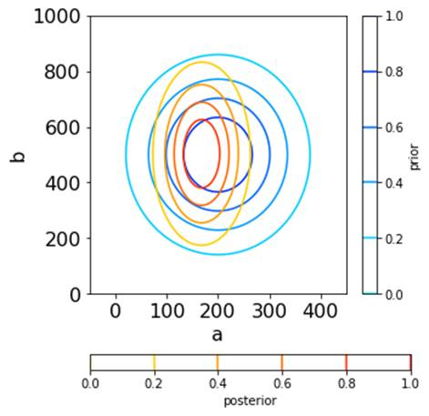

Here is the gridsearch (00f3):

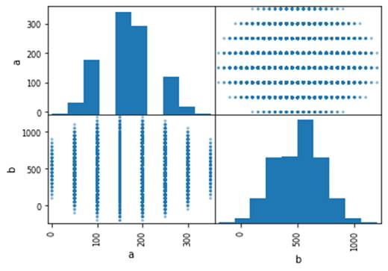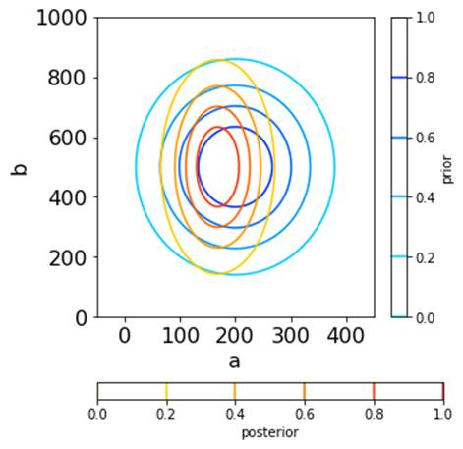

Here is the uniform random sampling (00f4):

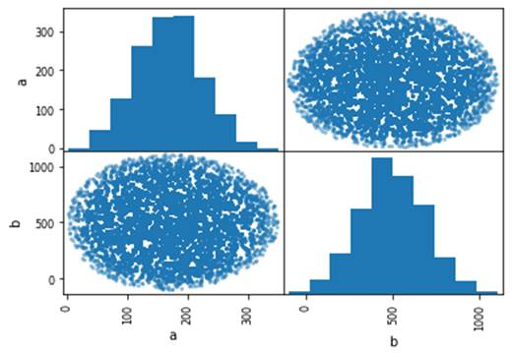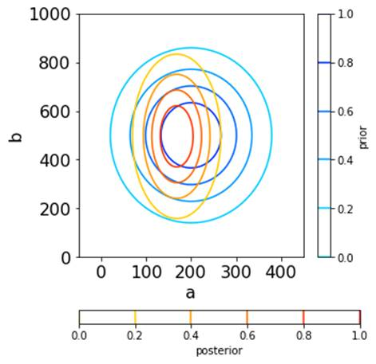

This feature is important because some response surfaces are too rough to sample properly with mcmc.  It was always a huge pain that some other packages had no way of doing this.  And with CheKiPEUQ I implemented the grid search, but still hadn’t gotten that gridsearch to convert to a distribution.  Now I have gotten CheKiPEUQ to do it, and it now happens automatically, almost like if we had done mcmc!

There is another example comparing c6 to c8 showing that the uniform distribution sampling (and of course also the grid sampling) can be performed for arbitrary distributions. Below is from the document 0-Example00Explanation.docx and shows the uniform distribution sampling giving the same answer as Metropolis Hastings, within error. However, as described in that document, knowledge of the HPD region and its size was utilized to make c8. Without that knowledge, c8 would have required very substantial excess sampling. Still, one could take the HPD interval according to mcmc and then do uniform random sampling in a region that is simply several times that size.

C6 sampling:

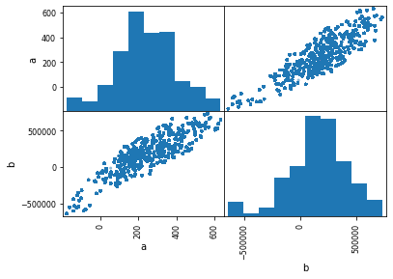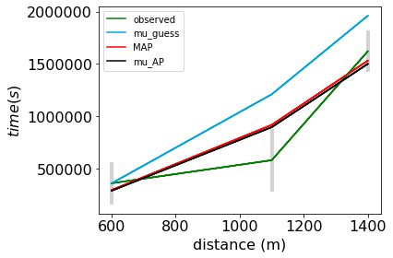

C8 uniform distribution random sampling:

