# Example 3a

# 03a3 is ESS sampling with length of 1000 and automatic other seettings. This ends up with 24 walkers and 41 samplings. It’s around 10 hours of time.

# Example 03d

03d: Final map results from gridsearch: (20.0, 40, 11.0, 13.0, -1.4901161138336505e-09, 0.09999999850988389) final logP: -3169.1366742547816

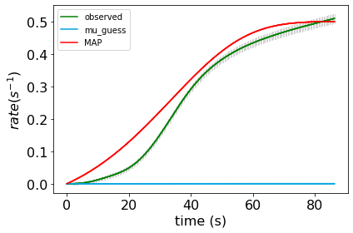

03d2 with burn_in of 1 and MH mcmc length of 100 (this burn in length is too low, and this sampling length is also low, but we are mostly comparing the effects of gridsearch here). On the order of 3 seconds per mcmc sample. < 3 hours.

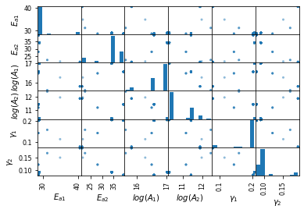

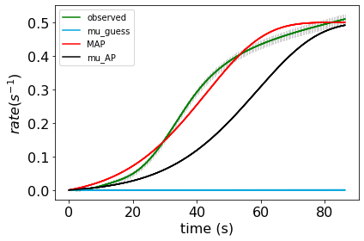

03d3 ESS with burn_in of ‘auto’ and mcmc_length of 10. In this case, that is giving a burn in of 0 and 1 step since there are 12 walkers. The iterations are just 1 step (but 12 different at the same time) and are on the order of 20 seconds per iteration. After around 3-10 hours:

Overall, we see that for this problem the MetropolisHastings algorithm (regular mcmc) finds a good solution faster than the EnsembleSliceSampling does. This is probably mainly because the example is somewhat pathological. The test done above should not be taken to mean that the EnsembleSliceSampling is worse – just that it is *initially* slower to converge to a good solution. The ESS method keeps going ‘outwards’ from its starting points. Let’s do a longer sampling with ESS to make a more fair comparison:

03d4 ESS with burn_in of ‘auto’ and mcmc_length of 100. In this case, that is giving 8 steps and 0 burn in per sampling, since there are 12 walkers (100/12 = ~8). Started at 10:00 AM: The iterations are not just 1 step and are on the order of 20 seconds per iteration. After around 10-30 hours:

# Example 03e

Example 3e, a fine grid: Final map results from gridsearch: (44.0, 36.0, 13.0, 22.0, 0.1, 0.2) final logP: -44.74269267502692

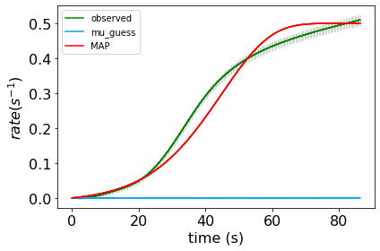

Example 3e2, a coarse grid MH mcmc with 1000 samples per gridpoint. ~ 1 hour total.

Final map results from gridsearch: [50.84736639 33.1785014 12.71535263 20.15766407 0.0606503 0.21544758] final logP: [376.08249122]

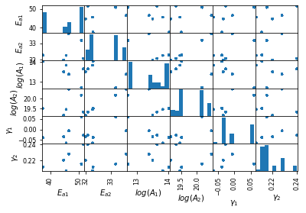/

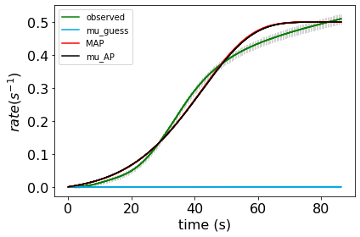

03e3 a coarse grid ESS mcmc with burn_in of ‘auto’ and mcmc_length of 10. In this case, that is giving a burn in of 0 and 1 step since there are 12 walkers. The iterations are just 1 step (but 12 different at the same time) and are on the order of 20 seconds per iteration, 1-2 hours total.

03e3 a coarse grid ESS mcmc with burn_in of ‘auto’ and mcmc_length of 100. In this case, that is giving a 12 steps with 12 walkers. 10-20 hours total.