This file is made later than 200524SamplingAndInfoGainProblems.

In files:

runfile_Example13_CO_H2O_four_parameters_replacement_doe_neg_1std_offset.py

runfile_Example13_CO_H2O_four_parameters_replacement_doe_pos_1std_offset.py

There is a flag set according to which file it is:

pos_or_neg = 'pos' #Put 'pos' or 'neg' here.

The model is a Langmuir replacement reaction. The simulation checks what happens if the person measures 3 temperatures (adding 25K above and 25K below) for any given pressure of CO. Pressure of water is fixed at 1 bar for this.

A positive or negative modulation is conducted, one standard deviation of the prior for deltaH_rxn.

Some sampling was done with these settings:

UserInput.parameter_estimation_settings['mcmc_burn_in'] = 1000

UserInput.parameter_estimation_settings['mcmc_length'] = 20000

For pos, we see this:

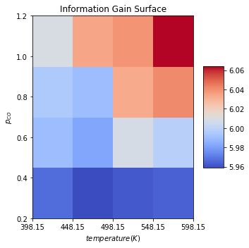

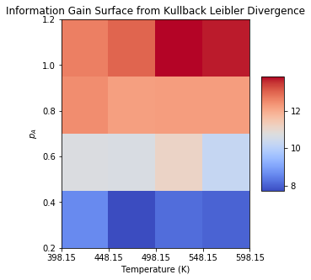

For neg, we see this:

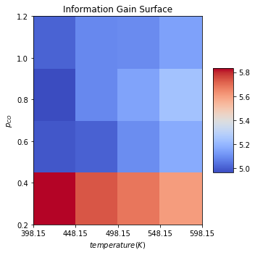

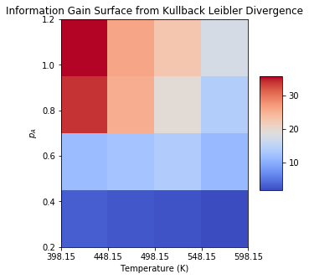

**Interpretation:** the log_ratio info gain (upper figures) is currently not giving us results that we can use. Either that, or the correct way to look at it is that the log_ratio case gives an inverse pattern when the parameter modulation is negative. **We will use the KL Divergence graph, which is made in the runfile. The built in KL divergence may have problems as of May 24th 2020.**

**The data suggest – within this range -- that a higher end of pressures for CO pressure is better, regardless of which temperature is the central temperature. If only a single dataset can be collected, PCO of 1.2 and a central temperature of ~500K might be a good choice as this will enable a higher end info_gain regardless of the direction of offset.**

**Positive modulation:**

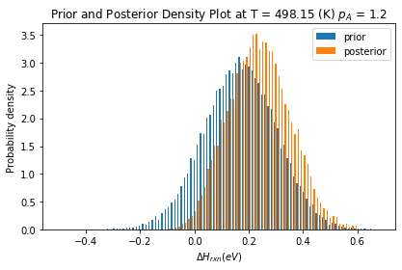

**Negative modulation:**

