Name of Runfile: runfile_Example16a_CPE_grid 1361367 points

|  |  |  |  |  |  |
| --- | --- | --- | --- | --- | --- |
| **Parameter Name** | **Initial Value** | **Uncertainty** | **Final Value** | **Interval Size** | **Num Intervals** |
| Scaling | 1.0 | 0.10 |  |  |  |
| Offset | 0.0 | 0.005 |  |  |  |
| Site2Ratio | 0.50 | 0.50/3 |  |  |  |
| Ea_1 | 41.5 | 20 |  |  |  |
| Ea_2 | 41.5 | 20 |  |  |  |
| log_A1 | 13.0 | 2 |  |  |  |
| log_A2 | 13.0 | 2 |  |  |  |
| gamma1 | 0.1 | 0.1 |  |  |  |
| gamma2 | 0.1 | 0.1 |  |  |  |
| logP |  | N/A |  | N/A | N/A |

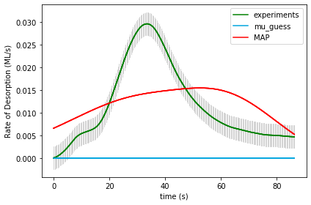

UserInput.model['InputParameterPriorValues'] = [ 1.0, 0.0, 0.50, 41.5, 41.5, 13.0, 13.0, 0.1, 0.1]  
Final map results from gridsearch: (1.1, 0.0, 0.16666666666666669, 21.5, 21.5, 11.0, 13.0, 0.2, 0.1) final logP: -8738.991106967724

gridSamplingAbsoluteIntervalSize=[ 0.10, 0.005, 0.50/3, 20, 20, 2, 2, 0.1, 0.1], gridSamplingNumOfIntervals=[1,1,3,3,3,3,3,1,1]

Name of Runfile: runfile_Example16a_BPE_grid 1361367 points

|  |  |  |  |  |  |
| --- | --- | --- | --- | --- | --- |
| **Parameter Name** | **Initial Value** | **Uncertainty** | **Final Value** | **Interval Size** | **Num Intervals** |
| Scaling | 1.0 | 0.10 |  |  |  |
| Offset | 0.0 | 0.005 |  |  |  |
| Site2Ratio | 0.50 | 0.50/3 |  |  |  |
| Ea_1 | 41.5 | 20 |  |  |  |
| Ea_2 | 41.5 | 20 |  |  |  |
| log_A1 | 13.0 | 2 |  |  |  |
| log_A2 | 13.0 | 2 |  |  |  |
| gamma1 | 0.1 | 0.1 |  |  |  |
| gamma2 | 0.1 | 0.1 |  |  |  |
| logP |  | N/A |  | N/A | N/A |



UserInput.model['InputParameterPriorValues'] = [ 1.0, 0.0, 0.50, 41.5, 41.5, 13.0, 13.0, 0.1, 0.1]

Final map results from gridsearch: (1.1, 0.0, 0.16666666666666669, 21.5, 21.5, 11.0, 13.0, 0.2, 0.1) final logP: -8752.761553714412

gridSamplingAbsoluteIntervalSize=[ 0.10, 0.005, 0.50/3, 20, 20, 2, 2, 0.1, 0.1], gridSamplingNumOfIntervals=[1,1,3,3,3,3,3,1,1]

Name of Runfile: runfile_Example16a_CPE_grid_opt 243 points

|  |  |  |  |  |  |
| --- | --- | --- | --- | --- | --- |
| **Parameter Name** | **Initial Value** | **Uncertainty** | **Final Value** | **Interval Size** | **Num Intervals** |
| Scaling | 1.0 | 0.10 |  |  |  |
| Offset | 0.0 | 0.005 |  |  |  |
| Site2Ratio | 0.50 | 0.50/3 |  |  |  |
| Ea_1 | 41.5 | 20 |  |  |  |
| Ea_2 | 41.5 | 20 |  |  |  |
| log_A1 | 13.0 | 2 |  |  |  |
| log_A2 | 13.0 | 2 |  |  |  |
| gamma1 | 0.1 | 0.1 |  |  |  |
| gamma2 | 0.1 | 0.1 |  |  |  |
| logP |  | N/A |  | N/A | N/A |

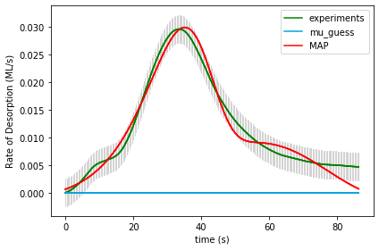

UserInput.model['InputParameterPriorValues'] = [ 1.0, 0.0, 0.50, 41.5, 41.5, 13.0, 13.0, 0.1, 0.1]

Final map results from gridsearch: [1.17855879e+00 1.56599493e-03 4.89378831e-01 5.01380589e+01

2.47742710e+01 3.31859754e+01 1.33279804e+01 1.37736928e-02

1.18045551e-01] final logP: 831.2464561309017

gridSamplingAbsoluteIntervalSize=[ 0.10, 0.005, 0.50/3, 20, 20, 2, 2, 0.1, 0.1], gridSamplingNumOfIntervals=[0,0,1,1,1,1,1,0,0]

Name of Runfile: runfile_Example16a_BPE_grid_opt 243 points

|  |  |  |  |  |  |
| --- | --- | --- | --- | --- | --- |
| **Parameter Name** | **Initial Value** | **Uncertainty** | **Final Value** | **Interval Size** | **Num Intervals** |
| Scaling | 1.0 | 0.10 |  |  |  |
| Offset | 0.0 | 0.005 |  |  |  |
| Site2Ratio | 0.50 | 0.50/3 |  |  |  |
| Ea_1 | 41.5 | 20 |  |  |  |
| Ea_2 | 41.5 | 20 |  |  |  |
| log_A1 | 13.0 | 2 |  |  |  |
| log_A2 | 13.0 | 2 |  |  |  |
| gamma1 | 0.1 | 0.1 |  |  |  |
| gamma2 | 0.1 | 0.1 |  |  |  |
| logP |  | N/A |  | N/A | N/A |

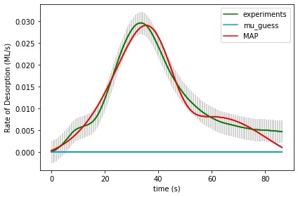

UserInput.model['InputParameterPriorValues'] = [ 1.0, 0.0, 0.50, 41.5, 41.5, 13.0, 13.0, 0.1, 0.1]

Final map results from gridsearch: [1.23943326e+00 1.95055604e-03 5.62199599e-01 2.60209307e+01

4.47401296e+01 1.40086172e+01 2.92348678e+01 4.22570091e-02

2.22870485e-02] final logP: 779.8462737897203

gridSamplingAbsoluteIntervalSize=[ 0.10, 0.005, 0.50/3, 20, 20, 2, 2, 0.1, 0.1], gridSamplingNumOfIntervals=[0,0,1,1,1,1,1,0,0]

Name of Runfile: 16a_CPE_grid_mcmc 243 points

|  |  |  |  |  |  |
| --- | --- | --- | --- | --- | --- |
| **Parameter Name** | **Initial Value** | **Uncertainty** | **Final Value** | **Interval Size** | **Num Intervals** |
| Scaling | 1.0 | 0.10 |  |  |  |
| Offset | 0.0 | 0.005 |  |  |  |
| Site2Ratio | 0.50 | 0.50/3 |  |  |  |
| Ea_1 | 41.5 | 20 |  |  |  |
| Ea_2 | 41.5 | 20 |  |  |  |
| log_A1 | 13.0 | 2 |  |  |  |
| log_A2 | 13.0 | 2 |  |  |  |
| gamma1 | 0.1 | 0.1 |  |  |  |
| gamma2 | 0.1 | 0.1 |  |  |  |
| logP |  | N/A |  | N/A | N/A |

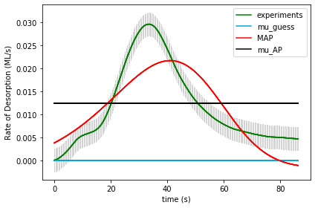

UserInput.model['InputParameterPriorValues'] = [ 1.0, 0.0, 0.50, 41.5, 41.5, 13.0, 13.0, 0.1, 0.1]

Final map results from gridsearch: [1.11903275e+00 1.42841706e-03 4.24304405e-01 2.56838078e+01

2.37503902e+01 1.49342760e+01 1.30921583e+01 1.25084700e-01

1.39916679e-01] final logP: [-1561.09178969]

gridSamplingAbsoluteIntervalSize=[ 0.10, 0.005, 0.50/3, 20, 20, 2, 2, 0.1, 0.1], gridSamplingNumOfIntervals=[0,0,1,1,1,1,1,0,0]

Name of Runfile: 16a_BPE_grid_mcmc 243 points

|  |  |  |  |  |  |
| --- | --- | --- | --- | --- | --- |
| **Parameter Name** | **Initial Value** | **Uncertainty** | **Final Value** | **Interval Size** | **Num Intervals** |
| Scaling | 1.0 | 0.10 |  |  |  |
| Offset | 0.0 | 0.005 |  |  |  |
| Site2Ratio | 0.50 | 0.50/3 |  |  |  |
| Ea_1 | 41.5 | 20 |  |  |  |
| Ea_2 | 41.5 | 20 |  |  |  |
| log_A1 | 13.0 | 2 |  |  |  |
| log_A2 | 13.0 | 2 |  |  |  |
| gamma1 | 0.1 | 0.1 |  |  |  |
| gamma2 | 0.1 | 0.1 |  |  |  |
| logP |  | N/A |  |  |  |



UserInput.model['InputParameterPriorValues'] = [ 1.0, 0.0, 0.50, 41.5, 41.5, 13.0, 13.0, 0.1, 0.1]

Final map results from gridsearch: [1.11903275e+00 1.42841706e-03 4.24304405e-01 2.56838078e+01

2.37503902e+01 1.49342760e+01 1.30921583e+01 1.25084700e-01

1.39916679e-01] final logP: [-1572.50098997]

gridSamplingAbsoluteIntervalSize=[ 0.10, 0.005, 0.50/3, 20, 20, 2, 2, 0.1, 0.1], gridSamplingNumOfIntervals=[0,0,1,1,1,1,1,0,0]

Name of Runfile: runfile_Example16a_CPE_grid_fine 1361367 points

|  |  |  |  |  |  |
| --- | --- | --- | --- | --- | --- |
| **Parameter Name** | **Initial Value** | **Uncertainty** | **Final Value** | **Interval Size** | **Num Intervals** |
| Scaling | 1.0 | 0.10 |  |  |  |
| Offset | 0.0 | 0.005 |  |  |  |
| Site2Ratio | 0.50 | 0.50/3 |  |  |  |
| Ea_1 | 41.5 | 20 |  |  |  |
| Ea_2 | 41.5 | 20 |  |  |  |
| log_A1 | 13.0 | 2 |  |  |  |
| log_A2 | 13.0 | 2 |  |  |  |
| gamma1 | 0.1 | 0.1 |  |  |  |
| gamma2 | 0.1 | 0.1 |  |  |  |
| logP |  | N/A |  | N/A | N/A |

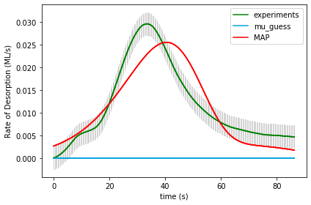

UserInput.model['InputParameterPriorValues'] = [ 1.0, 0.0, 0.50, 41.5, 41.5, 13.0, 13.0, 0.1, 0.1]

Final map results from gridsearch: (1.0, 0.0, 0.16666666666666669, 35.5, 23.5, 22.0, 12.0, 0.1, 0.1) final logP: -249.1898675955598

gridSamplingAbsoluteIntervalSize=[ 0.10, 0.005, 0.50/3, 20/10, 20/10, 1, 1, 0.1, 0.1], gridSamplingNumOfIntervals=[0,0,3,10,10,10,10,0,0]

Name of Runfile: runfile_Example16a_BPE_grid_fine 1361367 points

|  |  |  |  |  |  |
| --- | --- | --- | --- | --- | --- |
| **Parameter Name** | **Initial Value** | **Uncertainty** | **Final Value** | **Interval Size** | **Num Intervals** |
| Scaling | 1.0 | 0.10 |  |  |  |
| Offset | 0.0 | 0.005 |  |  |  |
| Site2Ratio | 0.50 | 0.50/3 |  |  |  |
| Ea_1 | 41.5 | 20 |  |  |  |
| Ea_2 | 41.5 | 20 |  |  |  |
| log_A1 | 13.0 | 2 |  |  |  |
| log_A2 | 13.0 | 2 |  |  |  |
| gamma1 | 0.1 | 0.1 |  |  |  |
| gamma2 | 0.1 | 0.1 |  |  |  |
| logP |  | N/A |  | N/A | N/A |



UserInput.model['InputParameterPriorValues'] = [ 1.0, 0.0, 0.50, 41.5, 41.5, 13.0, 13.0, 0.1, 0.1]

Final map results from gridsearch: (1.0, 0.0, 0.16666666666666669, 35.5, 23.5, 22.0, 12.0, 0.1, 0.1) final logP: -271.1603143422478

gridSamplingAbsoluteIntervalSize=[ 0.10, 0.005, 0.50/3, 20/10, 20/10, 1, 1, 0.1, 0.1], gridSamplingNumOfIntervals=[0,0,3,10,10,10,10,0,0]

Name of Runfile: 17a_CPE_grid 1361367 points

|  |  |  |  |  |  |
| --- | --- | --- | --- | --- | --- |
| **Parameter Name** | **Initial Value** | **Uncertainty** | **Final Value** | **Interval Size** | **Num Intervals** |
| Scaling | 1.0 | 0.10 |  |  |  |
| Offset | 0.0 | 0.005 |  |  |  |
| Site2Ratio | 0.50 | 0.50/3 |  |  |  |
| Ea_1 | 41.5 | 20 |  |  |  |
| Ea_2 | 41.5 | 20 |  |  |  |
| log_A1 | 13.0 | 2 |  |  |  |
| log_A2 | 13.0 | 2 |  |  |  |
| gamma1 | 0.1 | 0.1 |  |  |  |
| gamma2 | 0.1 | 0.1 |  |  |  |
| logP |  | N/A |  |  |  |

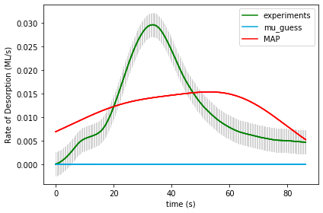

UserInput.model['InputParameterPriorValues'] = [ 1.0, 0.0, 0.50, 41.5, 41.5, 13.0, 13.0, 0.1, 0.1]

Final map results from gridsearch: (1.1, 0.0, 0.8333333333333333, 21.5, 21.5, 13.0, 11.0, 0.1, 0.2) final logP: -9054.061365650756 Final map results from gridsearch: (1.1, 0.0, 0.8333333333333333, 21.5, 21.5, 13.0, 11.0, 0.1, 0.2) final logP: -9054.061365650756

gridSamplingAbsoluteIntervalSize=[ 0.10, 0.005, 0.50/3, 20, 20, 2, 2, 0.1, 0.1], gridSamplingNumOfIntervals=[1,1,3,3,3,3,3,1,1]

Name of Runfile: 17a_BPE_grid 1361367 points

|  |  |  |  |  |  |
| --- | --- | --- | --- | --- | --- |
| **Parameter Name** | **Initial Value** | **Uncertainty** | **Final Value** | **Interval Size** | **Num Intervals** |
| Scaling | 1.0 | 0.10 |  |  |  |
| Offset | 0.0 | 0.005 |  |  |  |
| Site2Ratio | 0.50 | 0.50/3 |  |  |  |
| Ea_1 | 41.5 | 20 |  |  |  |
| Ea_2 | 41.5 | 20 |  |  |  |
| log_A1 | 13.0 | 2 |  |  |  |
| log_A2 | 13.0 | 2 |  |  |  |
| gamma1 | 0.1 | 0.1 |  |  |  |
| gamma2 | 0.1 | 0.1 |  |  |  |
| logP |  | N/A |  |  |  |



UserInput.model['InputParameterPriorValues'] = [ 1.0, 0.0, 0.50, 41.5, 41.5, 13.0, 13.0, 0.1, 0.1]

Final map results from gridsearch: (1.1, 0.0, 0.8333333333333333, 21.5, 21.5, 13.0, 11.0, 0.1, 0.2) final logP: -9067.831812397444

gridSamplingAbsoluteIntervalSize=[ 0.10, 0.005, 0.50/3, 20, 20, 2, 2, 0.1, 0.1], gridSamplingNumOfIntervals=[1,1,3,3,3,3,3,1,1]

Name of Runfile: 17a_CPE_grid_mcmc 243 points

|  |  |  |  |  |  |
| --- | --- | --- | --- | --- | --- |
| **Parameter Name** | **Initial Value** | **Uncertainty** | **Final Value** | **Interval Size** | **Num Intervals** |
| Scaling | 1.0 | 0.10 |  |  |  |
| Offset | 0.0 | 0.005 |  |  |  |
| Site2Ratio | 0.50 | 0.50/3 |  |  |  |
| Ea_1 | 41.5 | 20 |  |  |  |
| Ea_2 | 41.5 | 20 |  |  |  |
| log_A1 | 13.0 | 2 |  |  |  |
| log_A2 | 13.0 | 2 |  |  |  |
| gamma1 | 0.1 | 0.1 |  |  |  |
| gamma2 | 0.1 | 0.1 |  |  |  |
| logP |  | N/A |  |  |  |

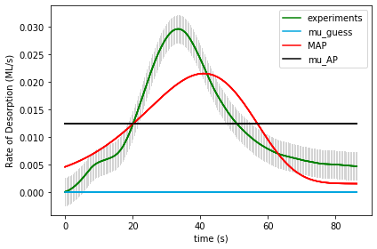

UserInput.model['InputParameterPriorValues'] = [ 1.0, 0.0, 0.50, 41.5, 41.5, 13.0, 13.0, 0.1, 0.1]

Final map results from gridsearch: [ 1.02795809e+00 -1.47194475e-03 2.06950152e-01 3.01093572e+01

4.79243481e+01 1.79804764e+01 1.24238115e+01 1.37345490e-01

1.94422092e-01] final logP: [-2177.48537425]

gridSamplingAbsoluteIntervalSize=[ 0.10, 0.005, 0.50/3, 20, 20, 2, 2, 0.1, 0.1], gridSamplingNumOfIntervals=[0,0,1,1,1,1,1,0,0]

Name of Runfile: 17a_BPE_grid_mcmc 243 points

|  |  |  |  |  |  |
| --- | --- | --- | --- | --- | --- |
| **Parameter Name** | **Initial Value** | **Uncertainty** | **Final Value** | **Interval Size** | **Num Intervals** |
| Scaling | 1.0 | 0.10 |  |  |  |
| Offset | 0.0 | 0.005 |  |  |  |
| Site2Ratio | 0.50 | 0.50/3 |  |  |  |
| Ea_1 | 41.5 | 20 |  |  |  |
| Ea_2 | 41.5 | 20 |  |  |  |
| log_A1 | 13.0 | 2 |  |  |  |
| log_A2 | 13.0 | 2 |  |  |  |
| gamma1 | 0.1 | 0.1 |  |  |  |
| gamma2 | 0.1 | 0.1 |  |  |  |
| logP |  | N/A |  |  |  |



UserInput.model['InputParameterPriorValues'] = [ 1.0, 0.0, 0.50, 41.5, 41.5, 13.0, 13.0, 0.1, 0.1]

Final map results from gridsearch: [ 1.02795809e+00 -1.47194475e-03 2.06950152e-01 3.01093572e+01

4.79243481e+01 1.79804764e+01 1.24238115e+01 1.37345490e-01

1.94422092e-01] final logP: [-2192.25547096]

gridSamplingAbsoluteIntervalSize=[ 0.10, 0.005, 0.50/3, 20, 20, 2, 2, 0.1, 0.1], gridSamplingNumOfIntervals=[0,0,1,1,1,1,1,0,0]

Name of Runfile: 17a_CPE_grid_opt 243 points

|  |  |  |  |  |  |
| --- | --- | --- | --- | --- | --- |
| **Parameter Name** | **Initial Value** | **Uncertainty** | **Final Value** | **Interval Size** | **Num Intervals** |
| Scaling | 1.0 | 0.10 |  |  |  |
| Offset | 0.0 | 0.005 |  |  |  |
| Site2Ratio | 0.50 | 0.50/3 |  |  |  |
| Ea_1 | 41.5 | 20 |  |  |  |
| Ea_2 | 41.5 | 20 |  |  |  |
| log_A1 | 13.0 | 2 |  |  |  |
| log_A2 | 13.0 | 2 |  |  |  |
| gamma1 | 0.1 | 0.1 |  |  |  |
| gamma2 | 0.1 | 0.1 |  |  |  |
| logP |  | N/A |  |  |  |

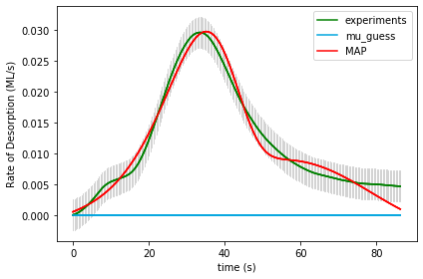

UserInput.model['InputParameterPriorValues'] = [ 1.0, 0.0, 0.50, 41.5, 41.5, 13.0, 13.0, 0.1, 0.1]

Final map results from gridsearch: [1.25384964e+00 2.04001014e-03 5.45932317e-01 5.46374259e+01

2.26561529e+01 3.61464156e+01 1.18133568e+01 5.02161431e-01

gridSamplingAbsoluteIntervalSize=[ 0.10, 0.005, 0.50/3, 20, 20, 2, 2, 0.1, 0.1], gridSamplingNumOfIntervals=[0,0,1,1,1,1,1,0,0]

Name of Runfile: 17a_BPE_grid_opt 243 points

|  |  |  |  |  |  |
| --- | --- | --- | --- | --- | --- |
| **Parameter Name** | **Initial Value** | **Uncertainty** | **Final Value** | **Interval Size** | **Num Intervals** |
| Scaling | 1.0 | 0.10 |  |  |  |
| Offset | 0.0 | 0.005 |  |  |  |
| Site2Ratio | 0.50 | 0.50/3 |  |  |  |
| Ea_1 | 41.5 | 20 |  |  |  |
| Ea_2 | 41.5 | 20 |  |  |  |
| log_A1 | 13.0 | 2 |  |  |  |
| log_A2 | 13.0 | 2 |  |  |  |
| gamma1 | 0.1 | 0.1 |  |  |  |
| gamma2 | 0.1 | 0.1 |  |  |  |
| logP |  | N/A |  |  |  |

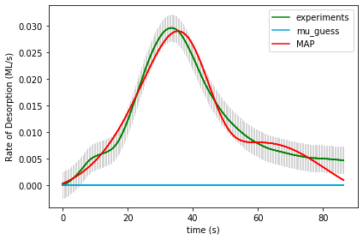

UserInput.model['InputParameterPriorValues'] = [ 1.0, 0.0, 0.50, 41.5, 41.5, 13.0, 13.0, 0.1, 0.1]

Final map results from gridsearch: [1.24054728e+00 1.97315172e-03 5.70160486e-01 2.68941949e+01

4.42378634e+01 1.45793537e+01 2.88717211e+01 7.62517142e-02

3.18229310e-03] final logP: 779.9344100773503

gridSamplingAbsoluteIntervalSize=[ 0.10, 0.005, 0.50/3, 20, 20, 2, 2, 0.1, 0.1], gridSamplingNumOfIntervals=[0,0,1,1,1,1,1,0,0]Name of Runfile: runfile_Example17a_CPE_grid_fine 1361367 points

|  |  |  |  |  |  |
| --- | --- | --- | --- | --- | --- |
| **Parameter Name** | **Initial Value** | **Uncertainty** | **Final Value** | **Interval Size** | **Num Intervals** |
| Scaling | 1.0 | 0.10 |  |  |  |
| Offset | 0.0 | 0.005 |  |  |  |
| Site2Ratio | 0.50 | 0.50/3 |  |  |  |
| Ea_1 | 41.5 | 20 |  |  |  |
| Ea_2 | 41.5 | 20 |  |  |  |
| log_A1 | 13.0 | 2 |  |  |  |
| log_A2 | 13.0 | 2 |  |  |  |
| gamma1 | 0.1 | 0.1 |  |  |  |
| gamma2 | 0.1 | 0.1 |  |  |  |
| logP |  | N/A |  | N/A | N/A |

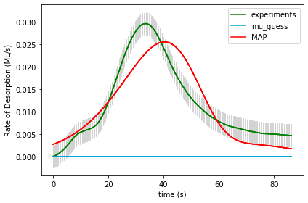

UserInput.model['InputParameterPriorValues'] = [ 1.0, 0.0, 0.50, 41.5, 41.5, 13.0, 13.0, 0.1, 0.1]

Final map results from gridsearch: (1.0, 0.0, 0.8333333333333333, 23.5, 35.5, 12.0, 22.0, 0.1, 0.1) final logP: -203.37919742701536

gridSamplingAbsoluteIntervalSize=[ 0.10, 0.005, 0.50/3, 20/10, 20/10, 1, 1, 0.1, 0.1], gridSamplingNumOfIntervals=[0,0,3,10,10,10,10,0,0]

Name of Runfile: runfile_Example17a_BPE_grid_fine 1361367 points

|  |  |  |  |  |  |
| --- | --- | --- | --- | --- | --- |
| **Parameter Name** | **Initial Value** | **Uncertainty** | **Final Value** | **Interval Size** | **Num Intervals** |
| Scaling | 1.0 | 0.10 |  |  |  |
| Offset | 0.0 | 0.005 |  |  |  |
| Site2Ratio | 0.50 | 0.50/3 |  |  |  |
| Ea_1 | 41.5 | 20 |  |  |  |
| Ea_2 | 41.5 | 20 |  |  |  |
| log_A1 | 13.0 | 2 |  |  |  |
| log_A2 | 13.0 | 2 |  |  |  |
| gamma1 | 0.1 | 0.1 |  |  |  |
| gamma2 | 0.1 | 0.1 |  |  |  |
| logP |  | N/A |  | N/A | N/A |



UserInput.model['InputParameterPriorValues'] = [ 1.0, 0.0, 0.50, 41.5, 41.5, 13.0, 13.0, 0.1, 0.1]

Final map results from gridsearch: (1.0, 0.0, 0.8333333333333333, 23.5, 35.5, 12.0, 22.0, 0.1, 0.1) final logP: -225.34964417370335

gridSamplingAbsoluteIntervalSize=[ 0.10, 0.005, 0.50/3, 20/10, 20/10, 1, 1, 0.1, 0.1], gridSamplingNumOfIntervals=[0,0,3,10,10,10,10,0,0]

Name of Runfile: 18a_CPE_grid 59535 points

|  |  |  |  |  |  |
| --- | --- | --- | --- | --- | --- |
| **Parameter Name** | **Initial Value** | **Uncertainty** | **Final Value** | **Interval Size** | **Num Intervals** |
| Scaling | 1 | .1 |  |  |  |
| Offset | 0 | .005 |  |  |  |
| Ea_1 | 40 | 20 |  |  |  |
| Log_A1 | 13 | 2 |  |  |  |
| gamma_1 | 0.1 | 0.3 |  |  |  |
| gamma_mod1 | 0 | 0.1 |  |  |  |
| gamma_mod2 | 0 | 0.1 |  |  |  |
| gamma_mod3 | 0 | 0.1 |  |  |  |
| gamma_mod4 | 0 | 0.1 |  |  |  |
| gamma_mod5 | 0 | 0.1 |  |  |  |
| gamma_mod6 | 0 | 0.1 |  |  |  |
| logP |  |  |  |  |  |

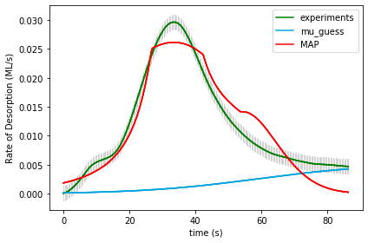

UserInput.model['InputParameterPriorValues'] = [1.0, 0.0, 40.0, 13.0, 0.1,

0.0, 0.0, 0.0, 0.0, 0.0, 0.0]

Final map results from gridsearch: (1.0, 0.0, 20.0, 11.0, -0.3, 0.3, -0.1, 0.1, 0.0, 0.0, -0.1) final logP: -1527.5171602395776

gridSamplingAbsoluteIntervalSize= [.1, 0.005, 20, 2, 0.3,

0.1, 0.1, 0.1, 0.1, 0.1, 0.1]

gridSamplingNumOfIntervals=[0,0,3,3,2, 0,1,1,1,1,1]

Name of Runfile: 18a_BPE_grid 59535 points

|  |  |  |  |  |  |
| --- | --- | --- | --- | --- | --- |
| **Parameter Name** | **Initial Value** | **Uncertainty** | **Final Value** | **Interval Size** | **Num Intervals** |
| Scaling | 1 | .1 |  |  |  |
| Offset | 0 | .005 |  |  |  |
| Ea_1 | 40 | 20 |  |  |  |
| Log_A1 | 13 | 2 |  |  |  |
| gamma_1 | 0.1 | 0.3 |  |  |  |
| gamma_mod1 | 0 | 0.1 |  |  |  |
| gamma_mod2 | 0 | 0.1 |  |  |  |
| gamma_mod3 | 0 | 0.1 |  |  |  |
| gamma_mod4 | 0 | 0.1 |  |  |  |
| gamma_mod5 | 0 | 0.1 |  |  |  |
| gamma_mod6 | 0 | 0.1 |  |  |  |
| logP |  |  |  |  |  |



UserInput.model['InputParameterPriorValues'] = [1.0, 0.0, 40.0, 13.0, 0.1,

0.0, 0.0, 0.0, 0.0, 0.0, 0.0]

Final map results from gridsearch: (1.0, 0.0, 20.0, 11.0, -0.3, 0.3, -0.1, 0.1, 0.0, 0.0, -0.1) final logP: -1527.5828666259995

gridSamplingAbsoluteIntervalSize= [.1, 0.005, 20, 2, 0.3,

0.1, 0.1, 0.1, 0.1, 0.1, 0.1]

gridSamplingNumOfIntervals=[0,0,3,3,2, 0,1,1,1,1,1]

Name of Runfile: 18a_CPE_grid_opt 243 points

|  |  |  |  |  |  |
| --- | --- | --- | --- | --- | --- |
| **Parameter Name** | **Initial Value** | **Uncertainty** | **Final Value** | **Interval Size** | **Num Intervals** |
| Scaling | 1 | .1 |  |  |  |
| Offset | 0 | .005 |  |  |  |
| Ea_1 | 40 | 20 |  |  |  |
| Log_A1 | 13 | 2 |  |  |  |
| gamma_1 | 0.1 | 0.3 |  |  |  |
| gamma_mod1 | 0 | 0.1 |  |  |  |
| gamma_mod2 | 0 | 0.1 |  |  |  |
| gamma_mod3 | 0 | 0.1 |  |  |  |
| gamma_mod4 | 0 | 0.1 |  |  |  |
| gamma_mod5 | 0 | 0.1 |  |  |  |
| gamma_mod6 | 0 | 0.1 |  |  |  |
| logP |  |  |  |  |  |

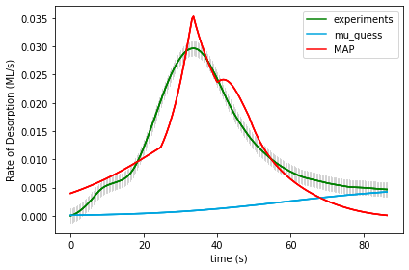

UserInput.model['InputParameterPriorValues'] = [1.0, 0.0, 40.0, 13.0, 0.1,

0.0, 0.0, 0.0, 0.0, 0.0, 0.0]

Final map results from gridsearch: [ 9.72403839e-01 2.45807149e-04 2.16720262e+01 1.17139968e+01

-2.39634576e-05 2.00249952e-01 6.62735737e-05 -1.06494051e-01

2.17505358e-05 -1.00161392e-01 1.44611048e-04] final logP: -3653.765327218868

gridSamplingAbsoluteIntervalSize= [.1, 0.005, 20, 2, 0.3,

0.1, 0.1, 0.1, 0.1, 0.1, 0.1]

gridSamplingNumOfIntervals=[0,0,1,1,0, 1,0,1,0,1,0]

Name of Runfile: 18a_BPE_grid_opt 243 points

|  |  |  |  |  |  |
| --- | --- | --- | --- | --- | --- |
| **Parameter Name** | **Initial Value** | **Uncertainty** | **Final Value** | **Interval Size** | **Num Intervals** |
| Scaling | 1 | .1 |  |  |  |
| Offset | 0 | .005 |  |  |  |
| Ea_1 | 40 | 20 |  |  |  |
| Log_A1 | 13 | 2 |  |  |  |
| gamma_1 | 0.1 | 0.3 |  |  |  |
| gamma_mod1 | 0 | 0.1 |  |  |  |
| gamma_mod2 | 0 | 0.1 |  |  |  |
| gamma_mod3 | 0 | 0.1 |  |  |  |
| gamma_mod4 | 0 | 0.1 |  |  |  |
| gamma_mod5 | 0 | 0.1 |  |  |  |
| gamma_mod6 | 0 | 0.1 |  |  |  |
| logP |  |  |  |  |  |



UserInput.model['InputParameterPriorValues'] = [1.0, 0.0, 40.0, 13.0, 0.1,

0.0, 0.0, 0.0, 0.0, 0.0, 0.0]

Final map results from gridsearch: [ 9.72403839e-01 2.45807149e-04 2.16720262e+01 1.17139968e+01

-2.39634576e-05 2.00249952e-01 6.62735737e-05 -1.06494051e-01

2.17505358e-05 -1.00161392e-01 1.44611048e-04] final logP: -3649.737299338728

gridSamplingAbsoluteIntervalSize= [.1, 0.005, 20, 2, 0.3,

0.1, 0.1, 0.1, 0.1, 0.1, 0.1]

gridSamplingNumOfIntervals=[0,0,1,1,0, 1,0,1,0,1,0]

Name of Runfile: 18a_CPE_grid_mcmc 243 points

|  |  |  |  |  |  |
| --- | --- | --- | --- | --- | --- |
| **Parameter Name** | **Initial Value** | **Uncertainty** | **Final Value** | **Interval Size** | **Num Intervals** |
| Scaling | 1 | .1 |  |  |  |
| Offset | 0 | .005 |  |  |  |
| Ea_1 | 40 | 20 |  |  |  |
| Log_A1 | 13 | 2 |  |  |  |
| gamma_1 | 0.1 | 0.3 |  |  |  |
| gamma_mod1 | 0 | 0.1 |  |  |  |
| gamma_mod2 | 0 | 0.1 |  |  |  |
| gamma_mod3 | 0 | 0.1 |  |  |  |
| gamma_mod4 | 0 | 0.1 |  |  |  |
| gamma_mod5 | 0 | 0.1 |  |  |  |
| gamma_mod6 | 0 | 0.1 |  |  |  |
| logP |  |  |  |  |  |

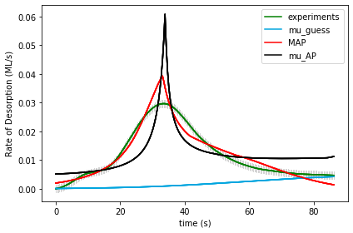

UserInput.model['InputParameterPriorValues'] = [1.0, 0.0, 40.0, 13.0, 0.1,

0.0, 0.0, 0.0, 0.0, 0.0, 0.0]

Final map results from gridsearch: [ 1.09118167e+00 5.06351739e-04 1.82224641e+01 9.09312805e+00

-2.73876168e-01 3.92896709e-01 -5.89138698e-02 1.57091955e-02

5.75251210e-02 -8.98549984e-02 -1.02258301e-01] final logP: [-282.54585778]

gridSamplingAbsoluteIntervalSize= [.1, 0.005, 20, 2, 0.3,

0.1, 0.1, 0.1, 0.1, 0.1, 0.1]

gridSamplingNumOfIntervals=[0,0,1,1,0, 1,0,1,0,1,0]

Name of Runfile: 18a_BPE_grid_mcmc 243 points

|  |  |  |  |  |  |
| --- | --- | --- | --- | --- | --- |
| **Parameter Name** | **Initial Value** | **Uncertainty** | **Final Value** | **Interval Size** | **Num Intervals** |
| Scaling | 1 | .1 |  |  |  |
| Offset | 0 | .005 |  |  |  |
| Ea_1 | 40 | 20 |  |  |  |
| Log_A1 | 13 | 2 |  |  |  |
| gamma_1 | 0.1 | 0.3 |  |  |  |
| gamma_mod1 | 0 | 0.1 |  |  |  |
| gamma_mod2 | 0 | 0.1 |  |  |  |
| gamma_mod3 | 0 | 0.1 |  |  |  |
| gamma_mod4 | 0 | 0.1 |  |  |  |
| gamma_mod5 | 0 | 0.1 |  |  |  |
| gamma_mod6 | 0 | 0.1 |  |  |  |
| logP |  |  |  |  |  |



UserInput.model['InputParameterPriorValues'] = [1.0, 0.0, 40.0, 13.0, 0.1,

0.0, 0.0, 0.0, 0.0, 0.0, 0.0]

Final map results from gridsearch: [ 1.09118167e+00 5.06351739e-04 1.82224641e+01 9.09312805e+00

-2.73876168e-01 3.92896709e-01 -5.89138698e-02 1.57091955e-02

5.75251210e-02 -8.98549984e-02 -1.02258301e-01] final logP: [-287.41712814]

gridSamplingAbsoluteIntervalSize= [.1, 0.005, 20, 2, 0.3,

0.1, 0.1, 0.1, 0.1, 0.1, 0.1]

gridSamplingNumOfIntervals=[0,0,1,1,0, 1,0,1,0,1,0]

Name of Runfile: 18a_CPE_grid_fine 68921 points

|  |  |  |  |  |  |
| --- | --- | --- | --- | --- | --- |
| **Parameter Name** | **Initial Value** | **Uncertainty** | **Final Value** | **Interval Size** | **Num Intervals** |
| Scaling | 1 | .1 |  |  |  |
| Offset | 0 | .005 |  |  |  |
| Ea_1 | 40 | 20 |  |  |  |
| Log_A1 | 13 | 2 |  |  |  |
| gamma_1 | 0.1 | 0.3 |  |  |  |
| gamma_mod1 | 0 | 0.1 |  |  |  |
| gamma_mod2 | 0 | 0.1 |  |  |  |
| gamma_mod3 | 0 | 0.1 |  |  |  |
| gamma_mod4 | 0 | 0.1 |  |  |  |
| gamma_mod5 | 0 | 0.1 |  |  |  |
| gamma_mod6 | 0 | 0.1 |  |  |  |
| logP |  |  |  |  |  |

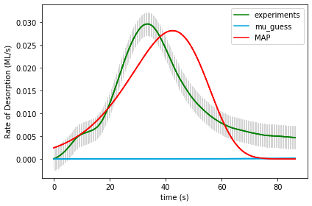

UserInput.model['InputParameterPriorValues'] = [1.0, 0.0, 40.0, 13.0, 0.1,

0.0, 0.0, 0.0, 0.0, 0.0, 0.0]

Final map results from gridsearch: (1.0, 0.0, 35.0, 21.5, 0.0, 0.0, 0.0, 0.0, 0.0, 0.0, 0.0) final logP: -1170.3915981999953

(1.0, 0.0, 35.0, 21.5, 0.0, 0.0, 0.0, 0.0, 0.0, 0.0, 0.0) -1170.3915981999953

gridSamplingAbsoluteIntervalSize=[0,0,1.0,0.5,0.05, 0,0,0,0,0,0], gridSamplingNumOfIntervals=[0,0,20,20,20, 0,0,0,0,0,0]

Name of Runfile: 18a_BPE_grid_fine 68921 points

|  |  |  |  |  |  |
| --- | --- | --- | --- | --- | --- |
| **Parameter Name** | **Initial Value** | **Uncertainty** | **Final Value** | **Interval Size** | **Num Intervals** |
| Scaling | 1 | .1 |  |  |  |
| Offset | 0 | .005 |  |  |  |
| Ea_1 | 40 | 20 |  |  |  |
| Log_A1 | 13 | 2 |  |  |  |
| gamma_1 | 0.1 | 0.3 |  |  |  |
| gamma_mod1 | 0 | 0.1 |  |  |  |
| gamma_mod2 | 0 | 0.1 |  |  |  |
| gamma_mod3 | 0 | 0.1 |  |  |  |
| gamma_mod4 | 0 | 0.1 |  |  |  |
| gamma_mod5 | 0 | 0.1 |  |  |  |
| gamma_mod6 | 0 | 0.1 |  |  |  |
| logP |  |  |  |  |  |



UserInput.model['InputParameterPriorValues'] = [1.0, 0.0, 40.0, 13.0, 0.1,

0.0, 0.0, 0.0, 0.0, 0.0, 0.0]

Final map results from gridsearch: (1.0, 0.0, 35.0, 21.5, 0.0, 0.0, 0.0, 0.0, 0.0, 0.0, 0.0) final logP: -1171.686471253084

gridSamplingAbsoluteIntervalSize=[0,0,1.0,0.5,0.05, 0,0,0,0,0,0], gridSamplingNumOfIntervals=[0,0,20,20,20, 0,0,0,0,0,0]

Name of Runfile: 18a_CPE_grid_fine_10kJ 68921 points

|  |  |  |  |  |  |
| --- | --- | --- | --- | --- | --- |
| **Parameter Name** | **Initial Value** | **Uncertainty** | **Final Value** | **Interval Size** | **Num Intervals** |
| Scaling | 1 | .1 |  |  |  |
| Offset | 0 | .005 |  |  |  |
| Ea_1 | 40 | 10 |  |  |  |
| Log_A1 | 13 | 2 |  |  |  |
| gamma_1 | 0.1 | 0.3 |  |  |  |
| gamma_mod1 | 0 | 0.1 |  |  |  |
| gamma_mod2 | 0 | 0.1 |  |  |  |
| gamma_mod3 | 0 | 0.1 |  |  |  |
| gamma_mod4 | 0 | 0.1 |  |  |  |
| gamma_mod5 | 0 | 0.1 |  |  |  |
| gamma_mod6 | 0 | 0.1 |  |  |  |
| logP |  |  |  |  |  |



UserInput.model['InputParameterPriorValues'] = [1.0, 0.0, 40.0, 13.0, 0.1,

0.0, 0.0, 0.0, 0.0, 0.0, 0.0]

Final map results from gridsearch: (1.0, 0.0, 35.0, 21.5, 0.0, 0.0, 0.0, 0.0, 0.0, 0.0, 0.0) final logP: -1170.3915981999953

gridSamplingAbsoluteIntervalSize=[0,0,1.0,0.5,0.05, 0,0,0,0,0,0], gridSamplingNumOfIntervals=[0,0,20,20,20, 0,0,0,0,0,0]

Name of Runfile: 18a_BPE_grid_fine_10kJ 68921 points

|  |  |  |  |  |  |
| --- | --- | --- | --- | --- | --- |
| **Parameter Name** | **Initial Value** | **Uncertainty** | **Final Value** | **Interval Size** | **Num Intervals** |
| Scaling | 1 | .1 |  |  |  |
| Offset | 0 | .005 |  |  |  |
| Ea_1 | 40 | 10 |  |  |  |
| Log_A1 | 13 | 2 |  |  |  |
| gamma_1 | 0.1 | 0.3 |  |  |  |
| gamma_mod1 | 0 | 0.1 |  |  |  |
| gamma_mod2 | 0 | 0.1 |  |  |  |
| gamma_mod3 | 0 | 0.1 |  |  |  |
| gamma_mod4 | 0 | 0.1 |  |  |  |
| gamma_mod5 | 0 | 0.1 |  |  |  |
| gamma_mod6 | 0 | 0.1 |  |  |  |
| logP |  |  |  |  |  |



UserInput.model['InputParameterPriorValues'] = [1.0, 0.0, 40.0, 13.0, 0.1,

0.0, 0.0, 0.0, 0.0, 0.0, 0.0]

Final map results from gridsearch: (1.0, 0.0, 35.0, 21.5, 0.0, 0.0, 0.0, 0.0, 0.0, 0.0, 0.0) final logP: -1171.087074072524

gridSamplingAbsoluteIntervalSize=[0,0,1.0,0.5,0.05, 0,0,0,0,0,0], gridSamplingNumOfIntervals=[0,0,20,20,20, 0,0,0,0,0,0]