Name of Runfile: runfile_Example16a_CPE_grid 1361367 points

|  |  |  |  |
| --- | --- | --- | --- |
| **Parameter Name** | **Initial Value** | **Uncertainty** | **Final Value** |
| Scaling | 1.0 | 0.10 |  |
| Offset | 0.0 | 0.005 |  |
| Site2Ratio | 0.50 | 0.50/3 |  |
| Ea_1 | 41.5 | 20 |  |
| Ea_2 | 41.5 | 20 |  |
| log_A1 | 13.0 | 2 |  |
| log_A2 | 13.0 | 2 |  |
| gamma1 | 0.1 | 0.1 |  |
| gamma2 | 0.1 | 0.1 |  |
| logP |  | N/A |  |

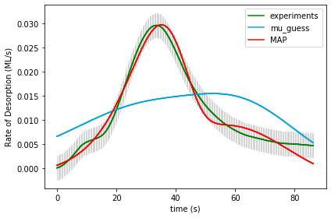

Final results from doOptimizeNegLogP: [1.20211634e+00 1.70181657e-03 4.94458588e-01 2.36031461e+01

5.18978020e+01 1.25026762e+01 3.43682980e+01 1.81157414e-01

3.71989231e-01] final logP: 832.9235718175272

Name of Runfile: runfile_Example16a_BPE_grid 1361367 points

|  |  |  |  |  |
| --- | --- | --- | --- | --- |
| **Parameter Name** | **Initial Value** | **Uncertainty** | **Final Value** | **Uncertainty** |
| Scaling | 1.0 | 0.10 |  |  |
| Offset | 0.0 | 0.005 |  |  |
| Site2Ratio | 0.50 | 0.50/3 |  |  |
| Ea_1 | 41.5 | 20 |  |  |
| Ea_2 | 41.5 | 20 |  |  |
| log_A1 | 13.0 | 2 |  |  |
| log_A2 | 13.0 | 2 |  |  |
| gamma1 | 0.1 | 0.1 |  |  |
| gamma2 | 0.1 | 0.1 |  |  |
| logP |  | N/A |  | N/A |

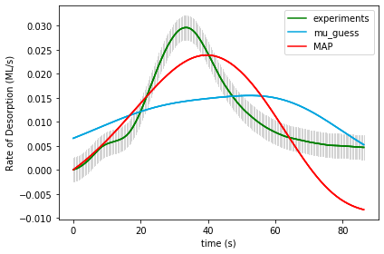

UserInput.model['InputParameterPriorValues'] = [ 1.0, 0.0, 0.50, 41.5, 41.5, 13.0, 13.0, 0.1, 0.1]

Final map results from gridsearch: (1.1, 0.0, 0.16666666666666669, 21.5, 21.5, 11.0, 13.0, 0.2, 0.1) final logP: -8752.761553714412

gridSamplingAbsoluteIntervalSize=[ 0.10, 0.005, 0.50/3, 20, 20, 2, 2, 0.1, 0.1], gridSamplingNumOfIntervals=[1,1,3,3,3,3,3,1,1]

Final results from doOptimizeNegLogP: [1.68784163e+00 5.38353983e-03 1.41341920e-01 2.43896706e+01

2.52727839e+01 1.36148958e+01 1.53103564e+01 2.59078221e-01

2.42100425e-12] final logP: -474.00154051790724

Name of Runfile: runfile_Example16a_CPE_grid_opt 243 points

|  |  |  |  |  |
| --- | --- | --- | --- | --- |
| **Parameter Name** | **Initial Value** | **Uncertainty** | **Final Value** | **Uncertainty** |
| Scaling | 1.0 | 0.10 |  |  |
| Offset | 0.0 | 0.005 |  |  |
| Site2Ratio | 0.50 | 0.50/3 |  |  |
| Ea_1 | 41.5 | 20 |  |  |
| Ea_2 | 41.5 | 20 |  |  |
| log_A1 | 13.0 | 2 |  |  |
| log_A2 | 13.0 | 2 |  |  |
| gamma1 | 0.1 | 0.1 |  |  |
| gamma2 | 0.1 | 0.1 |  |  |
| logP |  | N/A |  | N/A |

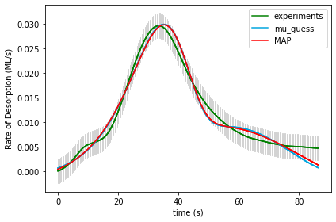

UserInput.model['InputParameterPriorValues'] = [ 1.0, 0.0, 0.50, 41.5, 41.5, 13.0, 13.0, 0.1, 0.1]

Final map results from gridsearch: [1.17855879e+00 1.56599493e-03 4.89378831e-01 5.01380589e+01

2.47742710e+01 3.31859754e+01 1.33279804e+01 1.37736928e-02

1.18045551e-01] final logP: 831.2464561309017

gridSamplingAbsoluteIntervalSize=[ 0.10, 0.005, 0.50/3, 20, 20, 2, 2, 0.1, 0.1], gridSamplingNumOfIntervals=[0,0,1,1,1,1,1,0,0]

Final results from doOptimizeNegLogP: [1.31421932e+00 2.35426700e-03 5.83002034e-01 5.13330577e+01

2.45940382e+01 3.40421731e+01 1.28288185e+01 7.02821337e-08

1.72447219e+00] final logP: 834.2305768936641

Name of Runfile: runfile_Example16a_BPE_grid_opt 243 points

|  |  |  |  |  |
| --- | --- | --- | --- | --- |
| **Parameter Name** | **Initial Value** | **Uncertainty** | **Final Value** | **Uncertainty** |
| Scaling | 1.0 | 0.10 |  |  |
| Offset | 0.0 | 0.005 |  |  |
| Site2Ratio | 0.50 | 0.50/3 |  |  |
| Ea_1 | 41.5 | 20 |  |  |
| Ea_2 | 41.5 | 20 |  |  |
| log_A1 | 13.0 | 2 |  |  |
| log_A2 | 13.0 | 2 |  |  |
| gamma1 | 0.1 | 0.1 |  |  |
| gamma2 | 0.1 | 0.1 |  |  |
| logP |  | N/A |  | N/A |

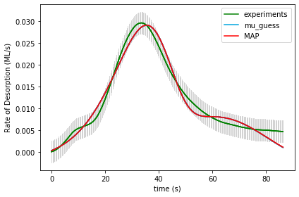

UserInput.model['InputParameterPriorValues'] = [ 1.0, 0.0, 0.50, 41.5, 41.5, 13.0, 13.0, 0.1, 0.1]

Final map results from gridsearch: [1.23943326e+00 1.95055604e-03 5.62199599e-01 2.60209307e+01

4.47401296e+01 1.40086172e+01 2.92348678e+01 4.22570091e-02

2.22870485e-02] final logP: 779.8462737897203

gridSamplingAbsoluteIntervalSize=[ 0.10, 0.005, 0.50/3, 20, 20, 2, 2, 0.1, 0.1], gridSamplingNumOfIntervals=[0,0,1,1,1,1,1,0,0]

Final results from doOptimizeNegLogP: [1.24082528e+00 1.95328330e-03 5.60072548e-01 2.60380582e+01

4.47210752e+01 1.40087694e+01 2.92286114e+01 1.03069701e-01

1.79576929e-09] final logP: 780.1042889944097

Name of Runfile: 16a_CPE_grid_mcmc 243 points

|  |  |  |  |  |
| --- | --- | --- | --- | --- |
| **Parameter Name** | **Initial Value** | **Uncertainty** | **Final Value** | **Uncertainty** |
| Scaling | 1.0 | 0.10 |  |  |
| Offset | 0.0 | 0.005 |  |  |
| Site2Ratio | 0.50 | 0.50/3 |  |  |
| Ea_1 | 41.5 | 20 |  |  |
| Ea_2 | 41.5 | 20 |  |  |
| log_A1 | 13.0 | 2 |  |  |
| log_A2 | 13.0 | 2 |  |  |
| gamma1 | 0.1 | 0.1 |  |  |
| gamma2 | 0.1 | 0.1 |  |  |
| logP |  | N/A |  | N/A |

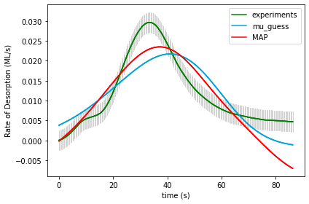

UserInput.model['InputParameterPriorValues'] = [ 1.0, 0.0, 0.50, 41.5, 41.5, 13.0, 13.0, 0.1, 0.1]

Final map results from gridsearch: [1.11903275e+00 1.42841706e-03 4.24304405e-01 2.56838078e+01

2.37503902e+01 1.49342760e+01 1.30921583e+01 1.25084700e-01

1.39916679e-01] final logP: [-1561.09178969]

gridSamplingAbsoluteIntervalSize=[ 0.10, 0.005, 0.50/3, 20, 20, 2, 2, 0.1, 0.1], gridSamplingNumOfIntervals=[0,0,1,1,1,1,1,0,0]

Final results from doOptimizeNegLogP: [1.76790946e+00 5.49443957e-03 4.52973126e-01 2.48833920e+01

2.62763349e+01 1.47619158e+01 1.44338901e+01 1.44211740e-02

1.26259207e-10] final logP: -31.361728419116957

Name of Runfile: 16a_BPE_grid_mcmc 243 points

|  |  |  |  |  |
| --- | --- | --- | --- | --- |
| **Parameter Name** | **Initial Value** | **Uncertainty** | **Final Value** | **Uncertainty** |
| Scaling | 1.0 | 0.10 |  |  |
| Offset | 0.0 | 0.005 |  |  |
| Site2Ratio | 0.50 | 0.50/3 |  |  |
| Ea_1 | 41.5 | 20 |  |  |
| Ea_2 | 41.5 | 20 |  |  |
| log_A1 | 13.0 | 2 |  |  |
| log_A2 | 13.0 | 2 |  |  |
| gamma1 | 0.1 | 0.1 |  |  |
| gamma2 | 0.1 | 0.1 |  |  |
| logP |  | N/A |  |  |

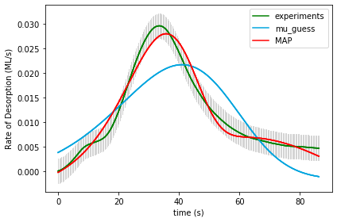

UserInput.model['InputParameterPriorValues'] = [ 1.0, 0.0, 0.50, 41.5, 41.5, 13.0, 13.0, 0.1, 0.1]

Final map results from gridsearch: [1.11903275e+00 1.42841706e-03 4.24304405e-01 2.56838078e+01

2.37503902e+01 1.49342760e+01 1.30921583e+01 1.25084700e-01

1.39916679e-01] final logP: [-1572.50098997]

gridSamplingAbsoluteIntervalSize=[ 0.10, 0.005, 0.50/3, 20, 20, 2, 2, 0.1, 0.1], gridSamplingNumOfIntervals=[0,0,1,1,1,1,1,0,0]

Final results from doOptimizeNegLogP: [1.61877311e+00 3.30444982e-03 5.59236064e-01 4.32139323e+01

1.66917954e+01 2.79693502e+01 7.41367471e+00 5.42706331e-01

2.06385225e-11] final logP: 730.9222455073057

Name of Runfile: runfile_Example16a_CPE_grid_fine 1361367 points

|  |  |  |  |  |
| --- | --- | --- | --- | --- |
| **Parameter Name** | **Initial Value** | **Uncertainty** | **Final Value** | **Uncertainty** |
| Scaling | 1.0 | 0.10 |  |  |
| Offset | 0.0 | 0.005 |  |  |
| Site2Ratio | 0.50 | 0.50/3 |  |  |
| Ea_1 | 41.5 | 20 |  |  |
| Ea_2 | 41.5 | 20 |  |  |
| log_A1 | 13.0 | 2 |  |  |
| log_A2 | 13.0 | 2 |  |  |
| gamma1 | 0.1 | 0.1 |  |  |
| gamma2 | 0.1 | 0.1 |  |  |
| logP |  | N/A |  | N/A |

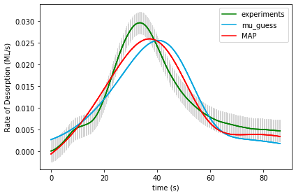

UserInput.model['InputParameterPriorValues'] = [ 1.0, 0.0, 0.50, 41.5, 41.5, 13.0, 13.0, 0.1, 0.1]

Final map results from gridsearch: (1.0, 0.0, 0.16666666666666669, 35.5, 23.5, 22.0, 12.0, 0.1, 0.1) final logP: -249.1898675955598

gridSamplingAbsoluteIntervalSize=[ 0.10, 0.005, 0.50/3, 20/10, 20/10, 1, 1, 0.1, 0.1], gridSamplingNumOfIntervals=[0,0,3,10,10,10,10,0,0]

Final results from doOptimizeNegLogP: [1.97414341e+00 3.97844007e-03 4.58532911e-01 2.96667546e+01

1.89905007e+01 1.81043133e+01 8.32550743e+00 1.22172150e-12

4.38660989e-01] final logP: 597.3214719404916

Name of Runfile: runfile_Example16a_BPE_grid_fine 1361367 points

|  |  |  |  |  |
| --- | --- | --- | --- | --- |
| **Parameter Name** | **Initial Value** | **Uncertainty** | **Final Value** | **Uncertainty** |
| Scaling | 1.0 | 0.10 |  |  |
| Offset | 0.0 | 0.005 |  |  |
| Site2Ratio | 0.50 | 0.50/3 |  |  |
| Ea_1 | 41.5 | 20 |  |  |
| Ea_2 | 41.5 | 20 |  |  |
| log_A1 | 13.0 | 2 |  |  |
| log_A2 | 13.0 | 2 |  |  |
| gamma1 | 0.1 | 0.1 |  |  |
| gamma2 | 0.1 | 0.1 |  |  |
| logP |  | N/A |  | N/A |

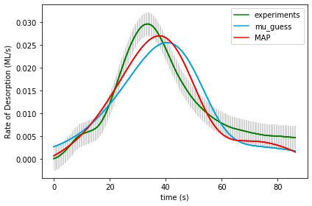

UserInput.model['InputParameterPriorValues'] = [ 1.0, 0.0, 0.50, 41.5, 41.5, 13.0, 13.0, 0.1, 0.1]

Final map results from gridsearch: (1.0, 0.0, 0.16666666666666669, 35.5, 23.5, 22.0, 12.0, 0.1, 0.1) final logP: -271.1603143422478

gridSamplingAbsoluteIntervalSize=[ 0.10, 0.005, 0.50/3, 20/10, 20/10, 1, 1, 0.1, 0.1], gridSamplingNumOfIntervals=[0,0,3,10,10,10,10,0,0]

Final results from doOptimizeNegLogP: [1.30665226e+00 2.46317266e-03 2.71185420e-01 3.44391842e+01

2.93006130e+01 2.15180409e+01 1.56903543e+01 3.90324451e-12

1.98063053e-01] final logP: 532.5838500139719

Name of Runfile: 17a_CPE_grid 1361367 points

|  |  |  |  |  |
| --- | --- | --- | --- | --- |
| **Parameter Name** | **Initial Value** | **Uncertainty** | **Final Value** | **Uncertainty** |
| Scaling | 1.0 | 0.10 |  |  |
| Offset | 0.0 | 0.005 |  |  |
| Site2Ratio | 0.50 | 0.50/3 |  |  |
| Ea_1 | 41.5 | 20 |  |  |
| Ea_2 | 41.5 | 20 |  |  |
| log_A1 | 13.0 | 2 |  |  |
| log_A2 | 13.0 | 2 |  |  |
| gamma1 | 0.1 | 0.1 |  |  |
| gamma2 | 0.1 | 0.1 |  |  |
| logP |  | N/A |  |  |

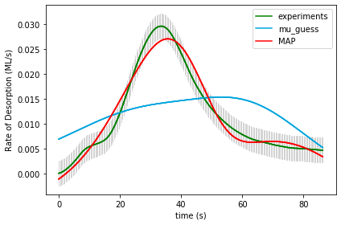

UserInput.model['InputParameterPriorValues'] = [ 1.0, 0.0, 0.50, 41.5, 41.5, 13.0, 13.0, 0.1, 0.1]

Final map results from gridsearch: (1.1, 0.0, 0.8333333333333333, 21.5, 21.5, 13.0, 11.0, 0.1, 0.2) final logP: -9054.061365650756 Final map results from gridsearch: (1.1, 0.0, 0.8333333333333333, 21.5, 21.5, 13.0, 11.0, 0.1, 0.2) final logP: -9054.061365650756

gridSamplingAbsoluteIntervalSize=[ 0.10, 0.005, 0.50/3, 20, 20, 2, 2, 0.1, 0.1], gridSamplingNumOfIntervals=[1,1,3,3,3,3,3,1,1]

Final results from doOptimizeNegLogP: [1.74369653e+00 3.85583260e-03 4.65236701e-01 3.43843984e+01

2.33926769e+01 2.16637499e+01 1.16939088e+01 2.98832055e-02

2.03512673e-01] final logP: 750.1823861877374

Name of Runfile: 17a_BPE_grid 1361367 points

|  |  |  |  |  |
| --- | --- | --- | --- | --- |
| **Parameter Name** | **Initial Value** | **Uncertainty** | **Final Value** | **Uncertainty** |
| Scaling | 1.0 | 0.10 |  |  |
| Offset | 0.0 | 0.005 |  |  |
| Site2Ratio | 0.50 | 0.50/3 |  |  |
| Ea_1 | 41.5 | 20 |  |  |
| Ea_2 | 41.5 | 20 |  |  |
| log_A1 | 13.0 | 2 |  |  |
| log_A2 | 13.0 | 2 |  |  |
| gamma1 | 0.1 | 0.1 |  |  |
| gamma2 | 0.1 | 0.1 |  |  |
| logP |  | N/A |  |  |

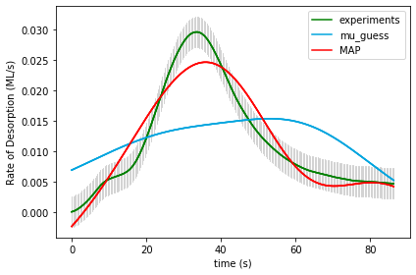

UserInput.model['InputParameterPriorValues'] = [ 1.0, 0.0, 0.50, 41.5, 41.5, 13.0, 13.0, 0.1, 0.1]

Final map results from gridsearch: (1.1, 0.0, 0.8333333333333333, 21.5, 21.5, 13.0, 11.0, 0.1, 0.2) final logP: -9067.831812397444

gridSamplingAbsoluteIntervalSize=[ 0.10, 0.005, 0.50/3, 20, 20, 2, 2, 0.1, 0.1], gridSamplingNumOfIntervals=[1,1,3,3,3,3,3,1,1]

Final results from doOptimizeNegLogP: [2.58835610e+00 5.55838469e-03 5.93048816e-01 2.77248776e+01

2.59244984e+01 1.41188897e+01 1.51686366e+01 9.52300561e-11

4.13615104e-01] final logP: 383.1917838785625

Name of Runfile: 17a_CPE_grid_mcmc 243 points

|  |  |  |  |  |
| --- | --- | --- | --- | --- |
| **Parameter Name** | **Initial Value** | **Uncertainty** | **Final Value** | **Uncertainty** |
| Scaling | 1.0 | 0.10 |  |  |
| Offset | 0.0 | 0.005 |  |  |
| Site2Ratio | 0.50 | 0.50/3 |  |  |
| Ea_1 | 41.5 | 20 |  |  |
| Ea_2 | 41.5 | 20 |  |  |
| log_A1 | 13.0 | 2 |  |  |
| log_A2 | 13.0 | 2 |  |  |
| gamma1 | 0.1 | 0.1 |  |  |
| gamma2 | 0.1 | 0.1 |  |  |
| logP |  | N/A |  |  |

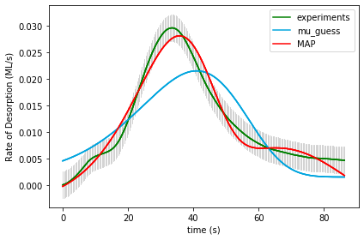

UserInput.model['InputParameterPriorValues'] = [ 1.0, 0.0, 0.50, 41.5, 41.5, 13.0, 13.0, 0.1, 0.1]

Final map results from gridsearch: [ 1.02795809e+00 -1.47194475e-03 2.06950152e-01 3.01093572e+01

4.79243481e+01 1.79804764e+01 1.24238115e+01 1.37345490e-01

1.94422092e-01] final logP: [-2177.48537425]

gridSamplingAbsoluteIntervalSize=[ 0.10, 0.005, 0.50/3, 20, 20, 2, 2, 0.1, 0.1], gridSamplingNumOfIntervals=[0,0,1,1,1,1,1,0,0]

Final results from doOptimizeNegLogP: [1.39603735e+00 2.77496348e-03 4.21606751e-01 3.92761524e+01

2.79373537e+01 2.52280353e+01 1.49492243e+01 7.35775644e-12

5.44236063e-01] final logP: 802.1342928174244

Name of Runfile: 17a_BPE_grid_mcmc 243 points

|  |  |  |  |  |
| --- | --- | --- | --- | --- |
| **Parameter Name** | **Initial Value** | **Uncertainty** | **Final Value** | **Uncertainty** |
| Scaling | 1.0 | 0.10 |  |  |
| Offset | 0.0 | 0.005 |  |  |
| Site2Ratio | 0.50 | 0.50/3 |  |  |
| Ea_1 | 41.5 | 20 |  |  |
| Ea_2 | 41.5 | 20 |  |  |
| log_A1 | 13.0 | 2 |  |  |
| log_A2 | 13.0 | 2 |  |  |
| gamma1 | 0.1 | 0.1 |  |  |
| gamma2 | 0.1 | 0.1 |  |  |
| logP |  | N/A |  |  |

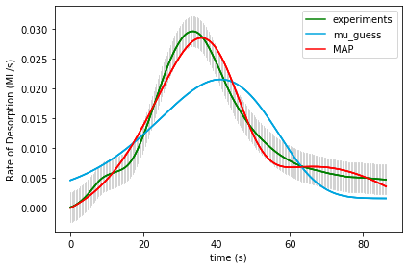

UserInput.model['InputParameterPriorValues'] = [ 1.0, 0.0, 0.50, 41.5, 41.5, 13.0, 13.0, 0.1, 0.1]

Final map results from gridsearch: [ 1.02795809e+00 -1.47194475e-03 2.06950152e-01 3.01093572e+01

4.79243481e+01 1.79804764e+01 1.24238115e+01 1.37345490e-01

1.94422092e-01] final logP: [-2192.25547096]

gridSamplingAbsoluteIntervalSize=[ 0.10, 0.005, 0.50/3, 20, 20, 2, 2, 0.1, 0.1], gridSamplingNumOfIntervals=[0,0,1,1,1,1,1,0,0]

Final results from doOptimizeNegLogP: [1.44966733e+00 2.64194593e-03 4.67683589e-01 4.08711199e+01

2.19278705e+01 2.63776806e+01 1.08551706e+01 6.10610118e-12

1.66079425e-01] final logP: 761.3830078436066

Name of Runfile: 17a_CPE_grid_opt 243 points

|  |  |  |  |  |
| --- | --- | --- | --- | --- |
| **Parameter Name** | **Initial Value** | **Uncertainty** | **Final Value** | **Uncertainty** |
| Scaling | 1.0 | 0.10 |  |  |
| Offset | 0.0 | 0.005 |  |  |
| Site2Ratio | 0.50 | 0.50/3 |  |  |
| Ea_1 | 41.5 | 20 |  |  |
| Ea_2 | 41.5 | 20 |  |  |
| log_A1 | 13.0 | 2 |  |  |
| log_A2 | 13.0 | 2 |  |  |
| gamma1 | 0.1 | 0.1 |  |  |
| gamma2 | 0.1 | 0.1 |  |  |
| logP |  | N/A |  |  |

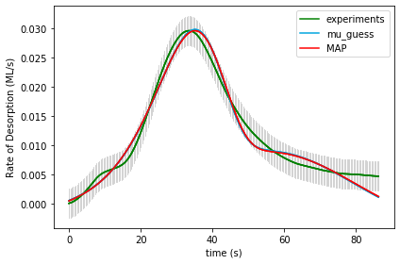

UserInput.model['InputParameterPriorValues'] = [ 1.0, 0.0, 0.50, 41.5, 41.5, 13.0, 13.0, 0.1, 0.1]

Final map results from gridsearch: [1.31850027e+00 2.39650171e-03 5.76140992e-01 5.48880289e+01

1.94775168e+01 3.63448101e+01 9.70069391e+00 4.86434241e-01

8.92942906e-04] final logP: 834.3528120580175

gridSamplingAbsoluteIntervalSize=[ 0.10, 0.005, 0.50/3, 20, 20, 2, 2, 0.1, 0.1], gridSamplingNumOfIntervals=[0,0,1,1,1,1,1,0,0]

Final results from doOptimizeNegLogP: [1.31895963e+00 2.38174246e-03 5.68716783e-01 5.49538416e+01

1.95200967e+01 3.63140352e+01 9.71309790e+00 6.21532524e-01

2.53615019e-09] final logP: 834.5316718252357

Name of Runfile: 17a_BPE_grid_opt 243 points

|  |  |  |  |  |
| --- | --- | --- | --- | --- |
| **Parameter Name** | **Initial Value** | **Uncertainty** | **Final Value** | **Uncertainty** |
| Scaling | 1.0 | 0.10 |  |  |
| Offset | 0.0 | 0.005 |  |  |
| Site2Ratio | 0.50 | 0.50/3 |  |  |
| Ea_1 | 41.5 | 20 |  |  |
| Ea_2 | 41.5 | 20 |  |  |
| log_A1 | 13.0 | 2 |  |  |
| log_A2 | 13.0 | 2 |  |  |
| gamma1 | 0.1 | 0.1 |  |  |
| gamma2 | 0.1 | 0.1 |  |  |
| logP |  | N/A |  |  |

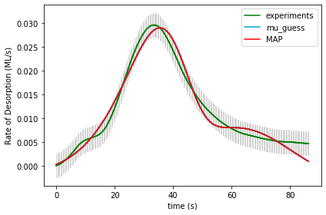

UserInput.model['InputParameterPriorValues'] = [ 1.0, 0.0, 0.50, 41.5, 41.5, 13.0, 13.0, 0.1, 0.1]

Final map results from gridsearch: [1.24054728e+00 1.97315172e-03 5.70160486e-01 2.68941949e+01

4.42378634e+01 1.45793537e+01 2.88717211e+01 7.62517142e-02

3.18229310e-03] final logP: 779.9344100773503

gridSamplingAbsoluteIntervalSize=[ 0.10, 0.005, 0.50/3, 20, 20, 2, 2, 0.1, 0.1], gridSamplingNumOfIntervals=[0,0,1,1,1,1,1,0,0]

Final results from doOptimizeNegLogP: [1.23988793e+00 1.96983437e-03 5.70178180e-01 2.68896317e+01

4.42408853e+01 1.45785811e+01 2.88760608e+01 7.15839421e-02

1.73719278e-08] final logP: 779.952102479041

Name of Runfile: runfile_Example17a_CPE_grid_fine 1361367 points

|  |  |  |  |  |
| --- | --- | --- | --- | --- |
| **Parameter Name** | **Initial Value** | **Uncertainty** | **Final Value** | **Uncertainty** |
| Scaling | 1.0 | 0.10 |  |  |
| Offset | 0.0 | 0.005 |  |  |
| Site2Ratio | 0.50 | 0.50/3 |  |  |
| Ea_1 | 41.5 | 20 |  |  |
| Ea_2 | 41.5 | 20 |  |  |
| log_A1 | 13.0 | 2 |  |  |
| log_A2 | 13.0 | 2 |  |  |
| gamma1 | 0.1 | 0.1 |  |  |
| gamma2 | 0.1 | 0.1 |  |  |
| logP |  | N/A |  | N/A |

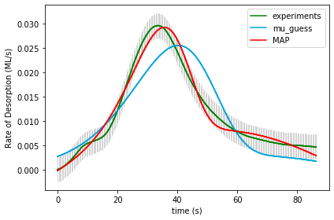

UserInput.model['InputParameterPriorValues'] = [ 1.0, 0.0, 0.50, 41.5, 41.5, 13.0, 13.0, 0.1, 0.1]

Final map results from gridsearch: (1.0, 0.0, 0.8333333333333333, 23.5, 35.5, 12.0, 22.0, 0.1, 0.1) final logP: -203.37919742701536

gridSamplingAbsoluteIntervalSize=[ 0.10, 0.005, 0.50/3, 20/10, 20/10, 1, 1, 0.1, 0.1], gridSamplingNumOfIntervals=[0,0,3,10,10,10,10,0,0]

Final results from doOptimizeNegLogP: [3.05906353e+00 5.28243686e-03 1.81917087e-01 9.18307078e+00

5.43232363e+01 2.10504512e+00 3.55820328e+01 1.36765638e-11

9.55367229e-01] final logP: 823.0684450136623

Name of Runfile: runfile_Example17a_BPE_grid_fine 1361367 points

|  |  |  |  |  |
| --- | --- | --- | --- | --- |
| **Parameter Name** | **Initial Value** | **Uncertainty** | **Final Value** | **Uncertainty** |
| Scaling | 1.0 | 0.10 |  |  |
| Offset | 0.0 | 0.005 |  |  |
| Site2Ratio | 0.50 | 0.50/3 |  |  |
| Ea_1 | 41.5 | 20 |  |  |
| Ea_2 | 41.5 | 20 |  |  |
| log_A1 | 13.0 | 2 |  |  |
| log_A2 | 13.0 | 2 |  |  |
| gamma1 | 0.1 | 0.1 |  |  |
| gamma2 | 0.1 | 0.1 |  |  |
| logP |  | N/A |  | N/A |

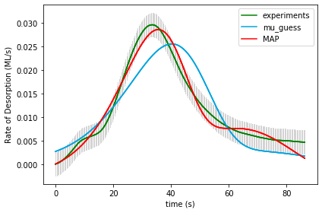

UserInput.model['InputParameterPriorValues'] = [ 1.0, 0.0, 0.50, 41.5, 41.5, 13.0, 13.0, 0.1, 0.1]

Final map results from gridsearch: (1.0, 0.0, 0.8333333333333333, 23.5, 35.5, 12.0, 22.0, 0.1, 0.1) final logP: -225.34964417370335

gridSamplingAbsoluteIntervalSize=[ 0.10, 0.005, 0.50/3, 20/10, 20/10, 1, 1, 0.1, 0.1], gridSamplingNumOfIntervals=[0,0,3,10,10,10,10,0,0]

Final results from doOptimizeNegLogP: [1.30268084e+00 2.32063837e-03 5.74915803e-01 2.68178886e+01

4.20019418e+01 1.44178209e+01 2.72364247e+01 1.37800501e-01

4.97558094e-12] final logP: 777.1862272402608

Name of Runfile: 18a_CPE_grid 59535 points

|  |  |  |  |  |
| --- | --- | --- | --- | --- |
| **Parameter Name** | **Initial Value** | **Uncertainty** | **Final Value** | **Uncertainty** |
| Scaling | 1 | .1 |  |  |
| Offset | 0 | .005 |  |  |
| Ea_1 | 40 | 20 |  |  |
| Log_A1 | 13 | 2 |  |  |
| gamma_1 | 0.1 | 0.3 |  |  |
| gamma_mod1 | 0 | 0.1 |  |  |
| gamma_mod2 | 0 | 0.1 |  |  |
| gamma_mod3 | 0 | 0.1 |  |  |
| gamma_mod4 | 0 | 0.1 |  |  |
| gamma_mod5 | 0 | 0.1 |  |  |
| gamma_mod6 | 0 | 0.1 |  |  |
| logP |  |  |  |  |

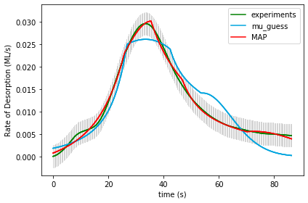

UserInput.model['InputParameterPriorValues'] = [1.0, 0.0, 40.0, 13.0, 0.1,

0.0, 0.0, 0.0, 0.0, 0.0, 0.0]

Final map results from gridsearch: (1.0, 0.0, 20.0, 11.0, -0.3, 0.3, -0.1, 0.1, 0.0, 0.0, -0.1) final logP: -1527.5171602395776

gridSamplingAbsoluteIntervalSize= [.1, 0.005, 20, 2, 0.3,

0.1, 0.1, 0.1, 0.1, 0.1, 0.1]

gridSamplingNumOfIntervals=[0,0,3,3,2, 0,1,1,1,1,1]

Final results from doOptimizeNegLogP: [ 1.49475745e+00 3.69922267e-03 1.17403976e+01 4.12858389e+00

-1.61526492e+00 1.83629589e+00 -2.83504285e-01 2.25140058e-01

1.25845442e-02 -8.90996289e-02 -1.62914152e-01] final logP: 854.35964687082

Name of Runfile: 18a_BPE_grid 59535 points

|  |  |  |  |  |
| --- | --- | --- | --- | --- |
| **Parameter Name** | **Initial Value** | **Uncertainty** | **Final Value** | **Uncertainty** |
| Scaling | 1 | .1 |  |  |
| Offset | 0 | .005 |  |  |
| Ea_1 | 40 | 20 |  |  |
| Log_A1 | 13 | 2 |  |  |
| gamma_1 | 0.1 | 0.3 |  |  |
| gamma_mod1 | 0 | 0.1 |  |  |
| gamma_mod2 | 0 | 0.1 |  |  |
| gamma_mod3 | 0 | 0.1 |  |  |
| gamma_mod4 | 0 | 0.1 |  |  |
| gamma_mod5 | 0 | 0.1 |  |  |
| gamma_mod6 | 0 | 0.1 |  |  |
| logP |  |  |  |  |

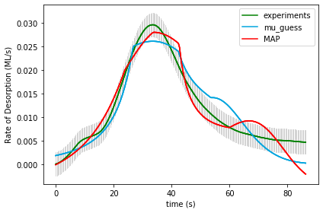

UserInput.model['InputParameterPriorValues'] = [1.0, 0.0, 40.0, 13.0, 0.1,

0.0, 0.0, 0.0, 0.0, 0.0, 0.0]

Final map results from gridsearch: (1.0, 0.0, 20.0, 11.0, -0.3, 0.3, -0.1, 0.1, 0.0, 0.0, -0.1) final logP: -1527.5828666259995

gridSamplingAbsoluteIntervalSize= [.1, 0.005, 20, 2, 0.3,

0.1, 0.1, 0.1, 0.1, 0.1, 0.1]

gridSamplingNumOfIntervals=[0,0,3,3,2, 0,1,1,1,1,1]

Final results from doOptimizeNegLogP: [ 1.43414583e+00 4.86048308e-03 1.99681345e+01 1.07325667e+01

-4.01086022e-01 1.50429067e-01 -2.57624879e-02 2.96729175e-01

-2.82641509e-03 -1.73812373e-02 -4.71442808e-02] final logP: 773.6082687145074

Name of Runfile: 18a_CPE_grid_opt 243 points

|  |  |  |  |  |
| --- | --- | --- | --- | --- |
| **Parameter Name** | **Initial Value** | **Uncertainty** | **Final Value** | **Uncertainty** |
| Scaling | 1 | .1 |  |  |
| Offset | 0 | .005 |  |  |
| Ea_1 | 40 | 20 |  |  |
| Log_A1 | 13 | 2 |  |  |
| gamma_1 | 0.1 | 0.3 |  |  |
| gamma_mod1 | 0 | 0.1 |  |  |
| gamma_mod2 | 0 | 0.1 |  |  |
| gamma_mod3 | 0 | 0.1 |  |  |
| gamma_mod4 | 0 | 0.1 |  |  |
| gamma_mod5 | 0 | 0.1 |  |  |
| gamma_mod6 | 0 | 0.1 |  |  |
| logP |  |  |  |  |

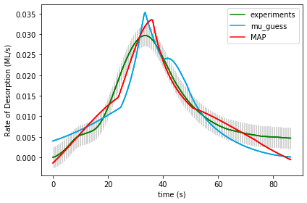

UserInput.model['InputParameterPriorValues'] = [1.0, 0.0, 40.0, 13.0, 0.1,

0.0, 0.0, 0.0, 0.0, 0.0, 0.0]

Final map results from gridsearch: [ 9.72403839e-01 2.45807149e-04 2.16720262e+01 1.17139968e+01

-2.39634576e-05 2.00249952e-01 6.62735737e-05 -1.06494051e-01

2.17505358e-05 -1.00161392e-01 1.44611048e-04] final logP: -3653.765327218868

gridSamplingAbsoluteIntervalSize= [.1, 0.005, 20, 2, 0.3, 0.1, 0.1, 0.1, 0.1, 0.1, 0.1]

Final results from doOptimizeNegLogP: [ 2.44625048e+00 1.36001729e-02 3.20197080e+01 1.59517899e+01

-8.29328212e-05 2.60325814e-01 3.06755700e-03 -3.24064073e-02

6.91923394e-04 -6.18787420e-02 -1.37050830e-02] final logP: 769.9356555408942

Name of Runfile: 18a_BPE_grid_opt 243 points

|  |  |  |  |  |
| --- | --- | --- | --- | --- |
| **Parameter Name** | **Initial Value** | **Uncertainty** | **Final Value** | **Uncertainty** |
| Scaling | 1 | .1 |  |  |
| Offset | 0 | .005 |  |  |
| Ea_1 | 40 | 20 |  |  |
| Log_A1 | 13 | 2 |  |  |
| gamma_1 | 0.1 | 0.3 |  |  |
| gamma_mod1 | 0 | 0.1 |  |  |
| gamma_mod2 | 0 | 0.1 |  |  |
| gamma_mod3 | 0 | 0.1 |  |  |
| gamma_mod4 | 0 | 0.1 |  |  |
| gamma_mod5 | 0 | 0.1 |  |  |
| gamma_mod6 | 0 | 0.1 |  |  |
| logP |  |  |  |  |

UserInput.model['InputParameterPriorValues'] = [1.0, 0.0, 40.0, 13.0, 0.1,

0.0, 0.0, 0.0, 0.0, 0.0, 0.0]

Final map results from gridsearch: [ 9.72403839e-01 2.45807149e-04 2.16720262e+01 1.17139968e+01

-2.39634576e-05 2.00249952e-01 6.62735737e-05 -1.06494051e-01

2.17505358e-05 -1.00161392e-01 1.44611048e-04] final logP: -3649.737299338728

gridSamplingAbsoluteIntervalSize= [.1, 0.005, 20, 2, 0.3, 0.1, 0.1, 0.1, 0.1, 0.1, 0.1]

gridSamplingNumOfIntervals=[0,0,1,1,0, 1,0,1,0,1,0]

Name of Runfile: 18a_CPE_grid_mcmc 243 points

|  |  |  |  |  |
| --- | --- | --- | --- | --- |
| **Parameter Name** | **Initial Value** | **Uncertainty** | **Final Value** | **Uncertainty** |
| Scaling | 1 | .1 |  |  |
| Offset | 0 | .005 |  |  |
| Ea_1 | 40 | 20 |  |  |
| Log_A1 | 13 | 2 |  |  |
| gamma_1 | 0.1 | 0.3 |  |  |
| gamma_mod1 | 0 | 0.1 |  |  |
| gamma_mod2 | 0 | 0.1 |  |  |
| gamma_mod3 | 0 | 0.1 |  |  |
| gamma_mod4 | 0 | 0.1 |  |  |
| gamma_mod5 | 0 | 0.1 |  |  |
| gamma_mod6 | 0 | 0.1 |  |  |
| logP |  |  |  |  |

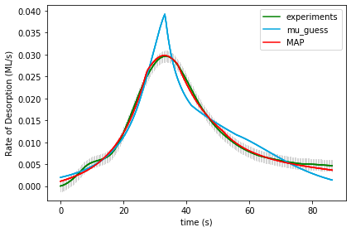

UserInput.model['InputParameterPriorValues'] = [1.0, 0.0, 40.0, 13.0, 0.1,

0.0, 0.0, 0.0, 0.0, 0.0, 0.0]

Final map results from gridsearch: [ 1.09118167e+00 5.06351739e-04 1.82224641e+01 9.09312805e+00 -2.73876168e-01 3.92896709e-01 -5.89138698e-02 1.57091955e-02

5.75251210e-02 -8.98549984e-02 -1.02258301e-01] final logP: [-282.54585778]

gridSamplingAbsoluteIntervalSize= [.1, 0.005, 20, 2, 0.3,

0.1, 0.1, 0.1, 0.1, 0.1, 0.1]

gridSamplingNumOfIntervals=[0,0,1,1,0, 1,0,1,0,1,0]

Final results from doOptimizeNegLogP: [ 1.50763009e+00 2.27835260e-03 2.00355544e+01 7.23191623e+00 -3.23071624e-01 6.18930963e-01 1.76734664e-01 6.67196925e-04

-6.84659213e-02 -1.03788062e-01 -1.46864981e-01] final logP: 965.6442904046731

Name of Runfile: 18a_BPE_grid_mcmc 243 points

|  |  |  |  |  |
| --- | --- | --- | --- | --- |
| **Parameter Name** | **Initial Value** | **Uncertainty** | **Final Value** | **Uncertainty** |
| Scaling | 1 | .1 |  |  |
| Offset | 0 | .005 |  |  |
| Ea_1 | 40 | 20 |  |  |
| Log_A1 | 13 | 2 |  |  |
| gamma_1 | 0.1 | 0.3 |  |  |
| gamma_mod1 | 0 | 0.1 |  |  |
| gamma_mod2 | 0 | 0.1 |  |  |
| gamma_mod3 | 0 | 0.1 |  |  |
| gamma_mod4 | 0 | 0.1 |  |  |
| gamma_mod5 | 0 | 0.1 |  |  |
| gamma_mod6 | 0 | 0.1 |  |  |
| logP |  |  |  |  |

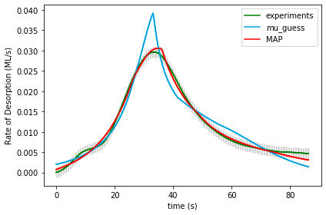

UserInput.model['InputParameterPriorValues'] = [1.0, 0.0, 40.0, 13.0, 0.1,

0.0, 0.0, 0.0, 0.0, 0.0, 0.0]

Final map results from gridsearch: [ 1.09118167e+00 5.06351739e-04 1.82224641e+01 9.09312805e+00 -2.73876168e-01 3.92896709e-01 -5.89138698e-02 1.57091955e-02

5.75251210e-02 -8.98549984e-02 -1.02258301e-01] final logP: [-287.41712814]

gridSamplingAbsoluteIntervalSize= [.1, 0.005, 20, 2, 0.3, 0.1, 0.1, 0.1, 0.1, 0.1, 0.1]

gridSamplingNumOfIntervals=[0,0,1,1,0, 1,0,1,0,1,0]

Final results from doOptimizeNegLogP: [ 1.53134984e+00 3.42952645e-03 1.71220438e+01 6.58162396e+00

-1.76188886e-01 3.17045025e-01 1.47847950e-01 3.09337209e-02

-2.08155010e-02 -9.84113877e-02 -1.27753873e-01] final logP: 957.0082738121508

Name of Runfile: 18a_CPE_grid_fine 68921 points

|  |  |  |  |  |
| --- | --- | --- | --- | --- |
| **Parameter Name** | **Initial Value** | **Uncertainty** | **Final Value** | **Uncertainty** |
| Scaling | 1 | .1 |  |  |
| Offset | 0 | .005 |  |  |
| Ea_1 | 40 | 20 |  |  |
| Log_A1 | 13 | 2 |  |  |
| gamma_1 | 0.1 | 0.3 |  |  |
| gamma_mod1 | 0 | 0.1 |  |  |
| gamma_mod2 | 0 | 0.1 |  |  |
| gamma_mod3 | 0 | 0.1 |  |  |
| gamma_mod4 | 0 | 0.1 |  |  |
| gamma_mod5 | 0 | 0.1 |  |  |
| gamma_mod6 | 0 | 0.1 |  |  |
| logP |  |  |  |  |

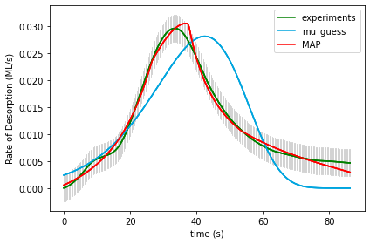

UserInput.model['InputParameterPriorValues'] = [1.0, 0.0, 40.0, 13.0, 0.1,

0.0, 0.0, 0.0, 0.0, 0.0, 0.0]

Final map results from gridsearch: (1.0, 0.0, 35.0, 21.5, 0.0, 0.0, 0.0, 0.0, 0.0, 0.0, 0.0) final logP: -1170.3915981999953

(1.0, 0.0, 35.0, 21.5, 0.0, 0.0, 0.0, 0.0, 0.0, 0.0, 0.0) -1170.3915981999953

gridSamplingAbsoluteIntervalSize=[0,0,1.0,0.5,0.05, 0,0,0,0,0,0], gridSamplingNumOfIntervals=[0,0,20,20,20, 0,0,0,0,0,0]

Final results from doOptimizeNegLogP: [ 1.85410831e+00 5.67533771e-03 6.17874804e+00 3.67574450e-05

8.89034823e-02 -1.83535985e-01 2.17463994e-01 6.68894279e-02

1.57936323e-01 -1.94729854e-01 -3.25183095e-01] final logP: 850.7205494709239

Name of Runfile: 18a_BPE_grid_fine 68921 points

|  |  |  |  |  |
| --- | --- | --- | --- | --- |
| **Parameter Name** | **Initial Value** | **Uncertainty** | **Final Value** | **Uncertainty** |
| Scaling | 1 | .1 |  |  |
| Offset | 0 | .005 |  |  |
| Ea_1 | 40 | 20 |  |  |
| Log_A1 | 13 | 2 |  |  |
| gamma_1 | 0.1 | 0.3 |  |  |
| gamma_mod1 | 0 | 0.1 |  |  |
| gamma_mod2 | 0 | 0.1 |  |  |
| gamma_mod3 | 0 | 0.1 |  |  |
| gamma_mod4 | 0 | 0.1 |  |  |
| gamma_mod5 | 0 | 0.1 |  |  |
| gamma_mod6 | 0 | 0.1 |  |  |
| logP |  |  |  |  |

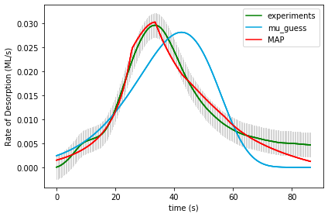

UserInput.model['InputParameterPriorValues'] = [1.0, 0.0, 40.0, 13.0, 0.1,

0.0, 0.0, 0.0, 0.0, 0.0, 0.0]

Final map results from gridsearch: (1.0, 0.0, 35.0, 21.5, 0.0, 0.0, 0.0, 0.0, 0.0, 0.0, 0.0) final logP: -1171.686471253084

gridSamplingAbsoluteIntervalSize=[0,0,1.0,0.5,0.05, 0,0,0,0,0,0], gridSamplingNumOfIntervals=[0,0,20,20,20, 0,0,0,0,0,0]

Final results from doOptimizeNegLogP: [ 1.19200915e+00 1.76854660e-03 7.14123472e+00 1.65495923e+00

5.22706037e-02 -1.79773045e-01 2.51029341e-01 -4.53617877e-02

2.10860832e-02 -1.12693530e-01 -3.32170973e-01] final logP: 773.0533384344002

Name of Runfile: 18a_CPE_grid_fine_10kJ 68921 points

|  |  |  |  |  |
| --- | --- | --- | --- | --- |
| **Parameter Name** | **Initial Value** | **Uncertainty** | **Final Value** | **Uncertainty** |
| Scaling | 1 | .1 |  |  |
| Offset | 0 | .005 |  |  |
| Ea_1 | 40 | 10 |  |  |
| Log_A1 | 13 | 2 |  |  |
| gamma_1 | 0.1 | 0.3 |  |  |
| gamma_mod1 | 0 | 0.1 |  |  |
| gamma_mod2 | 0 | 0.1 |  |  |
| gamma_mod3 | 0 | 0.1 |  |  |
| gamma_mod4 | 0 | 0.1 |  |  |
| gamma_mod5 | 0 | 0.1 |  |  |
| gamma_mod6 | 0 | 0.1 |  |  |
| logP |  |  |  |  |



UserInput.model['InputParameterPriorValues'] = [1.0, 0.0, 40.0, 13.0, 0.1,

0.0, 0.0, 0.0, 0.0, 0.0, 0.0]

Final map results from gridsearch: (1.0, 0.0, 35.0, 21.5, 0.0, 0.0, 0.0, 0.0, 0.0, 0.0, 0.0) final logP: -1170.3915981999953

gridSamplingAbsoluteIntervalSize=[0,0,1.0,0.5,0.05, 0,0,0,0,0,0], gridSamplingNumOfIntervals=[0,0,20,20,20, 0,0,0,0,0,0]

Final results from doOptimizeNegLogP: [ 1.85410831e+00 5.67533771e-03 6.17874804e+00 3.67574450e-05

8.89034823e-02 -1.83535985e-01 2.17463994e-01 6.68894279e-02

1.57936323e-01 -1.94729854e-01 -3.25183095e-01] final logP: 850.7205494709239

Name of Runfile: 18a_BPE_grid_fine_10kJ 68921 points

|  |  |  |  |  |
| --- | --- | --- | --- | --- |
| **Parameter Name** | **Initial Value** | **Uncertainty** | **Final Value** | **Uncertainty** |
| Scaling | 1 | .1 |  |  |
| Offset | 0 | .005 |  |  |
| Ea_1 | 40 | 10 |  |  |
| Log_A1 | 13 | 2 |  |  |
| gamma_1 | 0.1 | 0.3 |  |  |
| gamma_mod1 | 0 | 0.1 |  |  |
| gamma_mod2 | 0 | 0.1 |  |  |
| gamma_mod3 | 0 | 0.1 |  |  |
| gamma_mod4 | 0 | 0.1 |  |  |
| gamma_mod5 | 0 | 0.1 |  |  |
| gamma_mod6 | 0 | 0.1 |  |  |
| logP |  |  |  |  |

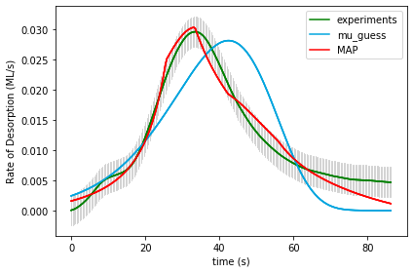

UserInput.model['InputParameterPriorValues'] = [1.0, 0.0, 40.0, 13.0, 0.1,

0.0, 0.0, 0.0, 0.0, 0.0, 0.0]

Final map results from gridsearch: (1.0, 0.0, 35.0, 21.5, 0.0, 0.0, 0.0, 0.0, 0.0, 0.0, 0.0) final logP: -1171.087074072524

gridSamplingAbsoluteIntervalSize=[0,0,1.0,0.5,0.05, 0,0,0,0,0,0], gridSamplingNumOfIntervals=[0,0,20,20,20, 0,0,0,0,0,0]

Final results from doOptimizeNegLogP: [ 1.16045824e+00 1.51879429e-03 7.60168673e+00 1.99725708e+00

6.87164798e-02 -1.87802288e-01 2.84705258e-01 -9.56262297e-02

2.57323455e-02 -1.04636970e-01 -3.16851085e-01] final logP: 755.6085439637255