Name of Runfile: 18a_CPE_grid 59535 points

|  |  |  |  |  |  |
| --- | --- | --- | --- | --- | --- |
| **Parameter Name** | **Initial Value** | **Uncertainty** | **Final Value** | **Interval Size** | **Num Intervals** |
| Scaling | 1 | .1 |  |  |  |
| Offset | 0 | .005 |  |  |  |
| Ea_1 | 40 | 20 |  |  |  |
| Log_A1 | 13 | 2 |  |  |  |
| gamma_1 | 0.1 | 0.3 |  |  |  |
| gamma_mod1 | 0 | 0.1 |  |  |  |
| gamma_mod2 | 0 | 0.1 |  |  |  |
| gamma_mod3 | 0 | 0.1 |  |  |  |
| gamma_mod4 | 0 | 0.1 |  |  |  |
| gamma_mod5 | 0 | 0.1 |  |  |  |
| gamma_mod6 | 0 | 0.1 |  |  |  |
| logP |  |  |  |  |  |

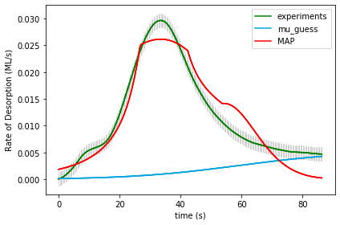

UserInput.model['InputParameterPriorValues'] = [1.0, 0.0, 40.0, 13.0, 0.1,

0.0, 0.0, 0.0, 0.0, 0.0, 0.0]

Final map results from gridsearch: (1.0, 0.0, 20.0, 11.0, -0.3, 0.3, -0.1, 0.1, 0.0, 0.0, -0.1) final logP: -1527.5171602395776

gridSamplingAbsoluteIntervalSize= [.1, 0.005, 20, 2, 0.3,

0.1, 0.1, 0.1, 0.1, 0.1, 0.1]

gridSamplingNumOfIntervals=[0,0,3,3,2, 0,1,1,1,1,1]

Name of Runfile: 18a_BPE_grid 59535 points

|  |  |  |  |  |  |
| --- | --- | --- | --- | --- | --- |
| **Parameter Name** | **Initial Value** | **Uncertainty** | **Final Value** | **Interval Size** | **Num Intervals** |
| Scaling | 1 | .1 |  |  |  |
| Offset | 0 | .005 |  |  |  |
| Ea_1 | 40 | 20 |  |  |  |
| Log_A1 | 13 | 2 |  |  |  |
| gamma_1 | 0.1 | 0.3 |  |  |  |
| gamma_mod1 | 0 | 0.1 |  |  |  |
| gamma_mod2 | 0 | 0.1 |  |  |  |
| gamma_mod3 | 0 | 0.1 |  |  |  |
| gamma_mod4 | 0 | 0.1 |  |  |  |
| gamma_mod5 | 0 | 0.1 |  |  |  |
| gamma_mod6 | 0 | 0.1 |  |  |  |
| logP |  |  |  |  |  |



UserInput.model['InputParameterPriorValues'] = [1.0, 0.0, 40.0, 13.0, 0.1,

0.0, 0.0, 0.0, 0.0, 0.0, 0.0]

Final map results from gridsearch: (1.0, 0.0, 20.0, 11.0, -0.3, 0.3, -0.1, 0.1, 0.0, 0.0, -0.1) final logP: -1527.5828666259995

gridSamplingAbsoluteIntervalSize= [.1, 0.005, 20, 2, 0.3,

0.1, 0.1, 0.1, 0.1, 0.1, 0.1]

gridSamplingNumOfIntervals=[0,0,3,3,2, 0,1,1,1,1,1]

Name of Runfile: 18a_CPE_grid_opt 243 points

|  |  |  |  |  |  |
| --- | --- | --- | --- | --- | --- |
| **Parameter Name** | **Initial Value** | **Uncertainty** | **Final Value** | **Interval Size** | **Num Intervals** |
| Scaling | 1 | .1 |  |  |  |
| Offset | 0 | .005 |  |  |  |
| Ea_1 | 40 | 20 |  |  |  |
| Log_A1 | 13 | 2 |  |  |  |
| gamma_1 | 0.1 | 0.3 |  |  |  |
| gamma_mod1 | 0 | 0.1 |  |  |  |
| gamma_mod2 | 0 | 0.1 |  |  |  |
| gamma_mod3 | 0 | 0.1 |  |  |  |
| gamma_mod4 | 0 | 0.1 |  |  |  |
| gamma_mod5 | 0 | 0.1 |  |  |  |
| gamma_mod6 | 0 | 0.1 |  |  |  |
| logP |  |  |  |  |  |

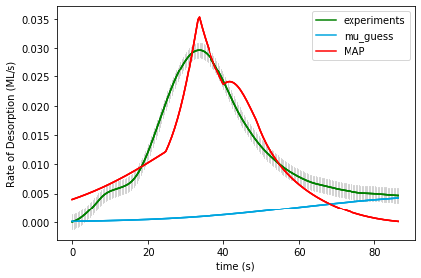

UserInput.model['InputParameterPriorValues'] = [1.0, 0.0, 40.0, 13.0, 0.1,

0.0, 0.0, 0.0, 0.0, 0.0, 0.0]

Final map results from gridsearch: [ 9.72403839e-01 2.45807149e-04 2.16720262e+01 1.17139968e+01

-2.39634576e-05 2.00249952e-01 6.62735737e-05 -1.06494051e-01

2.17505358e-05 -1.00161392e-01 1.44611048e-04] final logP: -3653.765327218868

gridSamplingAbsoluteIntervalSize= [.1, 0.005, 20, 2, 0.3,

0.1, 0.1, 0.1, 0.1, 0.1, 0.1]

gridSamplingNumOfIntervals=[0,0,1,1,0, 1,0,1,0,1,0]

Name of Runfile: 18a_BPE_grid_opt 243 points

|  |  |  |  |  |  |
| --- | --- | --- | --- | --- | --- |
| **Parameter Name** | **Initial Value** | **Uncertainty** | **Final Value** | **Interval Size** | **Num Intervals** |
| Scaling | 1 | .1 |  |  |  |
| Offset | 0 | .005 |  |  |  |
| Ea_1 | 40 | 20 |  |  |  |
| Log_A1 | 13 | 2 |  |  |  |
| gamma_1 | 0.1 | 0.3 |  |  |  |
| gamma_mod1 | 0 | 0.1 |  |  |  |
| gamma_mod2 | 0 | 0.1 |  |  |  |
| gamma_mod3 | 0 | 0.1 |  |  |  |
| gamma_mod4 | 0 | 0.1 |  |  |  |
| gamma_mod5 | 0 | 0.1 |  |  |  |
| gamma_mod6 | 0 | 0.1 |  |  |  |
| logP |  |  |  |  |  |



UserInput.model['InputParameterPriorValues'] = [1.0, 0.0, 40.0, 13.0, 0.1,

0.0, 0.0, 0.0, 0.0, 0.0, 0.0]

Final map results from gridsearch: [ 9.72403839e-01 2.45807149e-04 2.16720262e+01 1.17139968e+01

-2.39634576e-05 2.00249952e-01 6.62735737e-05 -1.06494051e-01

2.17505358e-05 -1.00161392e-01 1.44611048e-04] final logP: -3649.737299338728

gridSamplingAbsoluteIntervalSize= [.1, 0.005, 20, 2, 0.3,

0.1, 0.1, 0.1, 0.1, 0.1, 0.1]

gridSamplingNumOfIntervals=[0,0,1,1,0, 1,0,1,0,1,0]

Name of Runfile: 18a_CPE_grid_mcmc 243 points

|  |  |  |  |  |  |
| --- | --- | --- | --- | --- | --- |
| **Parameter Name** | **Initial Value** | **Uncertainty** | **Final Value** | **Interval Size** | **Num Intervals** |
| Scaling | 1 | .1 |  |  |  |
| Offset | 0 | .005 |  |  |  |
| Ea_1 | 40 | 20 |  |  |  |
| Log_A1 | 13 | 2 |  |  |  |
| gamma_1 | 0.1 | 0.3 |  |  |  |
| gamma_mod1 | 0 | 0.1 |  |  |  |
| gamma_mod2 | 0 | 0.1 |  |  |  |
| gamma_mod3 | 0 | 0.1 |  |  |  |
| gamma_mod4 | 0 | 0.1 |  |  |  |
| gamma_mod5 | 0 | 0.1 |  |  |  |
| gamma_mod6 | 0 | 0.1 |  |  |  |
| logP |  |  |  |  |  |

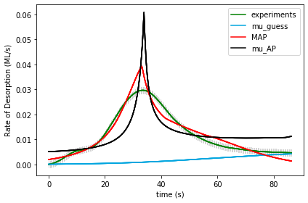

UserInput.model['InputParameterPriorValues'] = [1.0, 0.0, 40.0, 13.0, 0.1,

0.0, 0.0, 0.0, 0.0, 0.0, 0.0]

Final map results from gridsearch: [ 1.09118167e+00 5.06351739e-04 1.82224641e+01 9.09312805e+00

-2.73876168e-01 3.92896709e-01 -5.89138698e-02 1.57091955e-02

5.75251210e-02 -8.98549984e-02 -1.02258301e-01] final logP: [-282.54585778]

gridSamplingAbsoluteIntervalSize= [.1, 0.005, 20, 2, 0.3,

0.1, 0.1, 0.1, 0.1, 0.1, 0.1]

gridSamplingNumOfIntervals=[0,0,1,1,0, 1,0,1,0,1,0]

Name of Runfile: 18a_BPE_grid_mcmc 243 points

|  |  |  |  |  |  |
| --- | --- | --- | --- | --- | --- |
| **Parameter Name** | **Initial Value** | **Uncertainty** | **Final Value** | **Interval Size** | **Num Intervals** |
| Scaling | 1 | .1 |  |  |  |
| Offset | 0 | .005 |  |  |  |
| Ea_1 | 40 | 20 |  |  |  |
| Log_A1 | 13 | 2 |  |  |  |
| gamma_1 | 0.1 | 0.3 |  |  |  |
| gamma_mod1 | 0 | 0.1 |  |  |  |
| gamma_mod2 | 0 | 0.1 |  |  |  |
| gamma_mod3 | 0 | 0.1 |  |  |  |
| gamma_mod4 | 0 | 0.1 |  |  |  |
| gamma_mod5 | 0 | 0.1 |  |  |  |
| gamma_mod6 | 0 | 0.1 |  |  |  |
| logP |  |  |  |  |  |



UserInput.model['InputParameterPriorValues'] = [1.0, 0.0, 40.0, 13.0, 0.1,

0.0, 0.0, 0.0, 0.0, 0.0, 0.0]

Final map results from gridsearch: [ 1.09118167e+00 5.06351739e-04 1.82224641e+01 9.09312805e+00

-2.73876168e-01 3.92896709e-01 -5.89138698e-02 1.57091955e-02

5.75251210e-02 -8.98549984e-02 -1.02258301e-01] final logP: [-287.41712814]

gridSamplingAbsoluteIntervalSize= [.1, 0.005, 20, 2, 0.3,

0.1, 0.1, 0.1, 0.1, 0.1, 0.1]

gridSamplingNumOfIntervals=[0,0,1,1,0, 1,0,1,0,1,0]

Name of Runfile: 18a_CPE_grid_fine 68921 points

|  |  |  |  |  |  |
| --- | --- | --- | --- | --- | --- |
| **Parameter Name** | **Initial Value** | **Uncertainty** | **Final Value** | **Interval Size** | **Num Intervals** |
| Scaling | 1 | .1 |  |  |  |
| Offset | 0 | .005 |  |  |  |
| Ea_1 | 40 | 20 |  |  |  |
| Log_A1 | 13 | 2 |  |  |  |
| gamma_1 | 0.1 | 0.3 |  |  |  |
| gamma_mod1 | 0 | 0.1 |  |  |  |
| gamma_mod2 | 0 | 0.1 |  |  |  |
| gamma_mod3 | 0 | 0.1 |  |  |  |
| gamma_mod4 | 0 | 0.1 |  |  |  |
| gamma_mod5 | 0 | 0.1 |  |  |  |
| gamma_mod6 | 0 | 0.1 |  |  |  |
| logP |  |  |  |  |  |

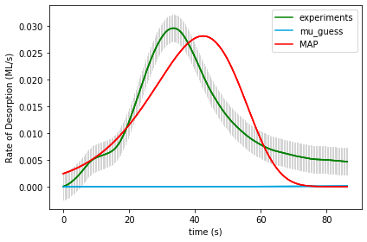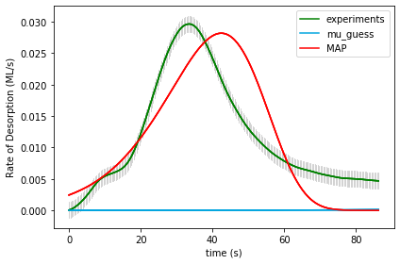

UserInput.model['InputParameterPriorValues'] = [1.0, 0.0, 40.0, 13.0, 0.1,

0.0, 0.0, 0.0, 0.0, 0.0, 0.0]

Final map results from gridsearch: (1.0, 0.0, 35.0, 21.5, 0.0, 0.0, 0.0, 0.0, 0.0, 0.0, 0.0) final logP: -7112.551484755328

gridSamplingAbsoluteIntervalSize=[0,0,1.0,0.5,0.05, 0,0,0,0,0,0], gridSamplingNumOfIntervals=[0,0,20,20,20, 0,0,0,0,0,0]

Name of Runfile: 18a_BPE_grid_fine 68921 points

|  |  |  |  |  |  |
| --- | --- | --- | --- | --- | --- |
| **Parameter Name** | **Initial Value** | **Uncertainty** | **Final Value** | **Interval Size** | **Num Intervals** |
| Scaling | 1 | .1 |  |  |  |
| Offset | 0 | .005 |  |  |  |
| Ea_1 | 40 | 20 |  |  |  |
| Log_A1 | 13 | 2 |  |  |  |
| gamma_1 | 0.1 | 0.3 |  |  |  |
| gamma_mod1 | 0 | 0.1 |  |  |  |
| gamma_mod2 | 0 | 0.1 |  |  |  |
| gamma_mod3 | 0 | 0.1 |  |  |  |
| gamma_mod4 | 0 | 0.1 |  |  |  |
| gamma_mod5 | 0 | 0.1 |  |  |  |
| gamma_mod6 | 0 | 0.1 |  |  |  |
| logP |  |  |  |  |  |



UserInput.model['InputParameterPriorValues'] = [1.0, 0.0, 40.0, 13.0, 0.1,

0.0, 0.0, 0.0, 0.0, 0.0, 0.0]

Final map results from gridsearch: (1.0, 0.0, 35.0, 21.5, 0.0, 0.0, 0.0, 0.0, 0.0, 0.0, 0.0) final logP: -7113.8463578084165

gridSamplingAbsoluteIntervalSize=[0,0,1.0,0.5,0.05, 0,0,0,0,0,0], gridSamplingNumOfIntervals=[0,0,20,20,20, 0,0,0,0,0,0]

Name of Runfile: 18a_CPE_grid_fine_10kJ 68921 points

|  |  |  |  |  |  |
| --- | --- | --- | --- | --- | --- |
| **Parameter Name** | **Initial Value** | **Uncertainty** | **Final Value** | **Interval Size** | **Num Intervals** |
| Scaling | 1 | .1 |  |  |  |
| Offset | 0 | .005 |  |  |  |
| Ea_1 | 40 | 10 |  |  |  |
| Log_A1 | 13 | 2 |  |  |  |
| gamma_1 | 0.1 | 0.3 |  |  |  |
| gamma_mod1 | 0 | 0.1 |  |  |  |
| gamma_mod2 | 0 | 0.1 |  |  |  |
| gamma_mod3 | 0 | 0.1 |  |  |  |
| gamma_mod4 | 0 | 0.1 |  |  |  |
| gamma_mod5 | 0 | 0.1 |  |  |  |
| gamma_mod6 | 0 | 0.1 |  |  |  |
| logP |  |  |  |  |  |



UserInput.model['InputParameterPriorValues'] = [1.0, 0.0, 40.0, 13.0, 0.1,

0.0, 0.0, 0.0, 0.0, 0.0, 0.0]

Final map results from gridsearch: (1.0, 0.0, 35.0, 21.5, 0.0, 0.0, 0.0, 0.0, 0.0, 0.0, 0.0) final logP: -7112.551484755328

gridSamplingAbsoluteIntervalSize=[0,0,1.0,0.5,0.05, 0,0,0,0,0,0], gridSamplingNumOfIntervals=[0,0,20,20,20, 0,0,0,0,0,0]

Name of Runfile: 18a_BPE_grid_fine_10kJ 68921 points

|  |  |  |  |  |  |
| --- | --- | --- | --- | --- | --- |
| **Parameter Name** | **Initial Value** | **Uncertainty** | **Final Value** | **Interval Size** | **Num Intervals** |
| Scaling | 1 | .1 |  |  |  |
| Offset | 0 | .005 |  |  |  |
| Ea_1 | 40 | 10 |  |  |  |
| Log_A1 | 13 | 2 |  |  |  |
| gamma_1 | 0.1 | 0.3 |  |  |  |
| gamma_mod1 | 0 | 0.1 |  |  |  |
| gamma_mod2 | 0 | 0.1 |  |  |  |
| gamma_mod3 | 0 | 0.1 |  |  |  |
| gamma_mod4 | 0 | 0.1 |  |  |  |
| gamma_mod5 | 0 | 0.1 |  |  |  |
| gamma_mod6 | 0 | 0.1 |  |  |  |
| logP |  |  |  |  |  |



UserInput.model['InputParameterPriorValues'] = [1.0, 0.0, 40.0, 13.0, 0.1,

0.0, 0.0, 0.0, 0.0, 0.0, 0.0]

Final map results from gridsearch: (1.0, 0.0, 35.0, 21.5, 0.0, 0.0, 0.0, 0.0, 0.0, 0.0, 0.0) final logP: -7113.8463578084165

gridSamplingAbsoluteIntervalSize=[0,0,1.0,0.5,0.05, 0,0,0,0,0,0], gridSamplingNumOfIntervals=[0,0,20,20,20, 0,0,0,0,0,0]