Name of Runfile: 18a_CPE_grid 59535 points

|  |  |  |  |  |
| --- | --- | --- | --- | --- |
| **Parameter Name** | **Initial Value** | **Uncertainty** | **Final Value** | **Uncertainty** |
| Scaling | 1 | .1 |  |  |
| Offset | 0 | .005 |  |  |
| Ea_1 | 40 | 20 |  |  |
| Log_A1 | 13 | 2 |  |  |
| gamma_1 | 0.1 | 0.3 |  |  |
| gamma_mod1 | 0 | 0.1 |  |  |
| gamma_mod2 | 0 | 0.1 |  |  |
| gamma_mod3 | 0 | 0.1 |  |  |
| gamma_mod4 | 0 | 0.1 |  |  |
| gamma_mod5 | 0 | 0.1 |  |  |
| gamma_mod6 | 0 | 0.1 |  |  |
| logP |  |  |  |  |

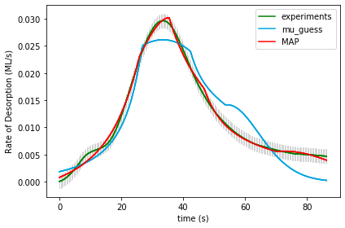

UserInput.model['InputParameterPriorValues'] = [1.0, 0.0, 40.0, 13.0, 0.1,

0.0, 0.0, 0.0, 0.0, 0.0, 0.0]

Final map results from gridsearch: (1.0, 0.0, 20.0, 11.0, -0.3, 0.3, -0.1, 0.1, 0.0, 0.0, -0.1) final logP: -1527.5171602395776

gridSamplingAbsoluteIntervalSize= [.1, 0.005, 20, 2, 0.3,

0.1, 0.1, 0.1, 0.1, 0.1, 0.1]

gridSamplingNumOfIntervals=[0,0,3,3,2, 0,1,1,1,1,1]

Final results from doOptimizeNegLogP: [ 1.49475745e+00 3.69922267e-03 1.17403976e+01 4.12858389e+00

-1.61526492e+00 1.83629589e+00 -2.83504285e-01 2.25140058e-01

1.25845442e-02 -8.90996289e-02 -1.62914152e-01] final logP: 986.4534955279314

Name of Runfile: 18a_BPE_grid 59535 points

|  |  |  |  |  |
| --- | --- | --- | --- | --- |
| **Parameter Name** | **Initial Value** | **Uncertainty** | **Final Value** | **Uncertainty** |
| Scaling | 1 | .1 |  |  |
| Offset | 0 | .005 |  |  |
| Ea_1 | 40 | 20 |  |  |
| Log_A1 | 13 | 2 |  |  |
| gamma_1 | 0.1 | 0.3 |  |  |
| gamma_mod1 | 0 | 0.1 |  |  |
| gamma_mod2 | 0 | 0.1 |  |  |
| gamma_mod3 | 0 | 0.1 |  |  |
| gamma_mod4 | 0 | 0.1 |  |  |
| gamma_mod5 | 0 | 0.1 |  |  |
| gamma_mod6 | 0 | 0.1 |  |  |
| logP |  |  |  |  |

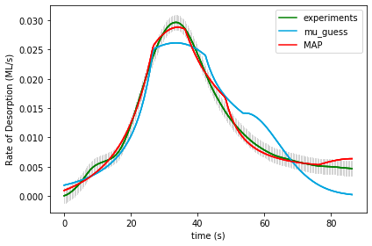

UserInput.model['InputParameterPriorValues'] = [1.0, 0.0, 40.0, 13.0, 0.1,

0.0, 0.0, 0.0, 0.0, 0.0, 0.0]

Final map results from gridsearch: (1.0, 0.0, 20.0, 11.0, -0.3, 0.3, -0.1, 0.1, 0.0, 0.0, -0.1) final logP: -1527.5828666259995

gridSamplingAbsoluteIntervalSize= [.1, 0.005, 20, 2, 0.3,

0.1, 0.1, 0.1, 0.1, 0.1, 0.1]

gridSamplingNumOfIntervals=[0,0,3,3,2, 0,1,1,1,1,1]

Final results from doOptimizeNegLogP: [ 1.45876083e+00 2.59911775e-03 1.73870602e+01 7.70357254e+00

-7.16993668e-01 7.28877700e-01 -1.79565463e-01 3.15711682e-01

1.32376971e-02 -4.69623174e-02 -1.18230749e-01] final logP: 916.2750683174896

Name of Runfile: 18a_CPE_grid_opt 243 points

|  |  |  |  |  |
| --- | --- | --- | --- | --- |
| **Parameter Name** | **Initial Value** | **Uncertainty** | **Final Value** | **Uncertainty** |
| Scaling | 1 | .1 |  |  |
| Offset | 0 | .005 |  |  |
| Ea_1 | 40 | 20 |  |  |
| Log_A1 | 13 | 2 |  |  |
| gamma_1 | 0.1 | 0.3 |  |  |
| gamma_mod1 | 0 | 0.1 |  |  |
| gamma_mod2 | 0 | 0.1 |  |  |
| gamma_mod3 | 0 | 0.1 |  |  |
| gamma_mod4 | 0 | 0.1 |  |  |
| gamma_mod5 | 0 | 0.1 |  |  |
| gamma_mod6 | 0 | 0.1 |  |  |
| logP |  |  |  |  |

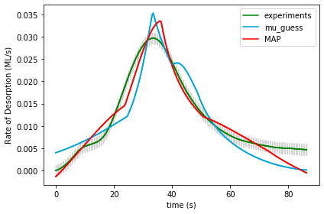

UserInput.model['InputParameterPriorValues'] = [1.0, 0.0, 40.0, 13.0, 0.1,

0.0, 0.0, 0.0, 0.0, 0.0, 0.0]

Final map results from gridsearch: [ 9.72403839e-01 2.45807149e-04 2.16720262e+01 1.17139968e+01

-2.39634576e-05 2.00249952e-01 6.62735737e-05 -1.06494051e-01

2.17505358e-05 -1.00161392e-01 1.44611048e-04] final logP: -3653.765327218868

gridSamplingAbsoluteIntervalSize= [.1, 0.005, 20, 2, 0.3, 0.1, 0.1, 0.1, 0.1, 0.1, 0.1]

gridSamplingNumOfIntervals=[0,0,1,1,0, 1,0,1,0,1,0]

Final results from doOptimizeNegLogP: [ 2.44625018e+00 1.36001709e-02 3.20197042e+01 1.59517881e+01

-8.29328337e-05 2.60325775e-01 3.06755641e-03 -3.24063935e-02

6.91923309e-04 -6.18787480e-02 -1.37050804e-02] final logP: 648.7575340508599

Name of Runfile: 18a_BPE_grid_opt 243 points

|  |  |  |  |  |
| --- | --- | --- | --- | --- |
| **Parameter Name** | **Initial Value** | **Uncertainty** | **Final Value** | **Uncertainty** |
| Scaling | 1 | .1 |  |  |
| Offset | 0 | .005 |  |  |
| Ea_1 | 40 | 20 |  |  |
| Log_A1 | 13 | 2 |  |  |
| gamma_1 | 0.1 | 0.3 |  |  |
| gamma_mod1 | 0 | 0.1 |  |  |
| gamma_mod2 | 0 | 0.1 |  |  |
| gamma_mod3 | 0 | 0.1 |  |  |
| gamma_mod4 | 0 | 0.1 |  |  |
| gamma_mod5 | 0 | 0.1 |  |  |
| gamma_mod6 | 0 | 0.1 |  |  |
| logP |  |  |  |  |

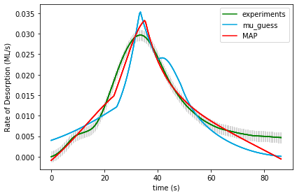

UserInput.model['InputParameterPriorValues'] = [1.0, 0.0, 40.0, 13.0, 0.1,

0.0, 0.0, 0.0, 0.0, 0.0, 0.0]

Final map results from gridsearch: [ 9.72403839e-01 2.45807149e-04 2.16720262e+01 1.17139968e+01

-2.39634576e-05 2.00249952e-01 6.62735737e-05 -1.06494051e-01

2.17505358e-05 -1.00161392e-01 1.44611048e-04] final logP: -3649.737299338728

gridSamplingAbsoluteIntervalSize= [.1, 0.005, 20, 2, 0.3, 0.1, 0.1, 0.1, 0.1, 0.1, 0.1]

gridSamplingNumOfIntervals=[0,0,1,1,0, 1,0,1,0,1,0]

Final results from doOptimizeNegLogP: [ 2.13854431e+00 1.12573598e-02 2.78693882e+01 1.39647519e+01

1.24711743e-04 1.90989577e-01 4.32665977e-03 1.10964467e-03

6.59588727e-04 -6.20212000e-02 -1.55467271e-02] final logP: 621.9777841531777

Name of Runfile: 18a_CPE_grid_mcmc 243 points

|  |  |  |  |  |
| --- | --- | --- | --- | --- |
| **Parameter Name** | **Initial Value** | **Uncertainty** | **Final Value** | **Uncertainty** |
| Scaling | 1 | .1 |  |  |
| Offset | 0 | .005 |  |  |
| Ea_1 | 40 | 20 |  |  |
| Log_A1 | 13 | 2 |  |  |
| gamma_1 | 0.1 | 0.3 |  |  |
| gamma_mod1 | 0 | 0.1 |  |  |
| gamma_mod2 | 0 | 0.1 |  |  |
| gamma_mod3 | 0 | 0.1 |  |  |
| gamma_mod4 | 0 | 0.1 |  |  |
| gamma_mod5 | 0 | 0.1 |  |  |
| gamma_mod6 | 0 | 0.1 |  |  |
| logP |  |  |  |  |

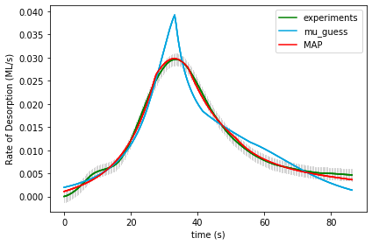

UserInput.model['InputParameterPriorValues'] = [1.0, 0.0, 40.0, 13.0, 0.1,

0.0, 0.0, 0.0, 0.0, 0.0, 0.0]

Final map results from gridsearch: [ 1.09118167e+00 5.06351739e-04 1.82224641e+01 9.09312805e+00 -2.73876168e-01 3.92896709e-01 -5.89138698e-02 1.57091955e-02

5.75251210e-02 -8.98549984e-02 -1.02258301e-01] final logP: [-282.54585778]

gridSamplingAbsoluteIntervalSize= [.1, 0.005, 20, 2, 0.3,

0.1, 0.1, 0.1, 0.1, 0.1, 0.1]

gridSamplingNumOfIntervals=[0,0,1,1,0, 1,0,1,0,1,0]

Final results from doOptimizeNegLogP: [ 1.50763009e+00 2.27835260e-03 2.00355544e+01 7.23191623e+00 -3.23071624e-01 6.18930963e-01 1.76734664e-01 6.67196925e-04

-6.84659213e-02 -1.03788062e-01 -1.46864981e-01] final logP: 965.6442904046731

Name of Runfile: 18a_BPE_grid_mcmc 243 points

|  |  |  |  |  |
| --- | --- | --- | --- | --- |
| **Parameter Name** | **Initial Value** | **Uncertainty** | **Final Value** | **Uncertainty** |
| Scaling | 1 | .1 |  |  |
| Offset | 0 | .005 |  |  |
| Ea_1 | 40 | 20 |  |  |
| Log_A1 | 13 | 2 |  |  |
| gamma_1 | 0.1 | 0.3 |  |  |
| gamma_mod1 | 0 | 0.1 |  |  |
| gamma_mod2 | 0 | 0.1 |  |  |
| gamma_mod3 | 0 | 0.1 |  |  |
| gamma_mod4 | 0 | 0.1 |  |  |
| gamma_mod5 | 0 | 0.1 |  |  |
| gamma_mod6 | 0 | 0.1 |  |  |
| logP |  |  |  |  |

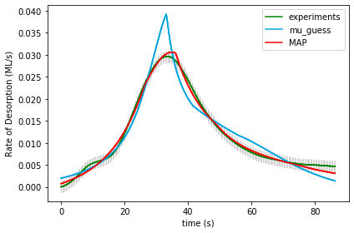

UserInput.model['InputParameterPriorValues'] = [1.0, 0.0, 40.0, 13.0, 0.1,

0.0, 0.0, 0.0, 0.0, 0.0, 0.0]

Final map results from gridsearch: [ 1.09118167e+00 5.06351739e-04 1.82224641e+01 9.09312805e+00 -2.73876168e-01 3.92896709e-01 -5.89138698e-02 1.57091955e-02

5.75251210e-02 -8.98549984e-02 -1.02258301e-01] final logP: [-287.41712814]

gridSamplingAbsoluteIntervalSize= [.1, 0.005, 20, 2, 0.3, 0.1, 0.1, 0.1, 0.1, 0.1, 0.1]

gridSamplingNumOfIntervals=[0,0,1,1,0, 1,0,1,0,1,0]

Final results from doOptimizeNegLogP: [ 1.53134984e+00 3.42952645e-03 1.71220438e+01 6.58162396e+00

-1.76188886e-01 3.17045025e-01 1.47847950e-01 3.09337209e-02

-2.08155010e-02 -9.84113877e-02 -1.27753873e-01] final logP: 957.0082738121508

Name of Runfile: 18a_CPE_grid_fine 68921 points

|  |  |  |  |  |
| --- | --- | --- | --- | --- |
| **Parameter Name** | **Initial Value** | **Uncertainty** | **Final Value** | **Uncertainty** |
| Scaling | 1 | .1 |  |  |
| Offset | 0 | .005 |  |  |
| Ea_1 | 40 | 20 |  |  |
| Log_A1 | 13 | 2 |  |  |
| gamma_1 | 0.1 | 0.3 |  |  |
| gamma_mod1 | 0 | 0.1 |  |  |
| gamma_mod2 | 0 | 0.1 |  |  |
| gamma_mod3 | 0 | 0.1 |  |  |
| gamma_mod4 | 0 | 0.1 |  |  |
| gamma_mod5 | 0 | 0.1 |  |  |
| gamma_mod6 | 0 | 0.1 |  |  |
| logP |  |  |  |  |

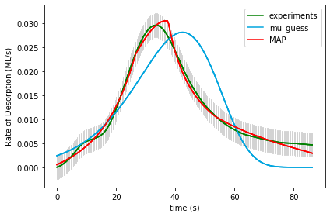

UserInput.model['InputParameterPriorValues'] = [1.0, 0.0, 40.0, 13.0, 0.1,

0.0, 0.0, 0.0, 0.0, 0.0, 0.0]

Final map results from gridsearch: (1.0, 0.0, 35.0, 21.5, 0.0, 0.0, 0.0, 0.0, 0.0, 0.0, 0.0) final logP: -1170.3915981999953

(1.0, 0.0, 35.0, 21.5, 0.0, 0.0, 0.0, 0.0, 0.0, 0.0, 0.0) -1170.3915981999953

gridSamplingAbsoluteIntervalSize=[0,0,1.0,0.5,0.05, 0,0,0,0,0,0], gridSamplingNumOfIntervals=[0,0,20,20,20, 0,0,0,0,0,0]

Final results from doOptimizeNegLogP: [ 1.85410831e+00 5.67533771e-03 6.17874804e+00 3.67574450e-05

8.89034823e-02 -1.83535985e-01 2.17463994e-01 6.68894279e-02

1.57936323e-01 -1.94729854e-01 -3.25183095e-01] final logP: 850.7205494709239

Name of Runfile: 18a_BPE_grid_fine 68921 points

|  |  |  |  |  |
| --- | --- | --- | --- | --- |
| **Parameter Name** | **Initial Value** | **Uncertainty** | **Final Value** | **Uncertainty** |
| Scaling | 1 | .1 |  |  |
| Offset | 0 | .005 |  |  |
| Ea_1 | 40 | 20 |  |  |
| Log_A1 | 13 | 2 |  |  |
| gamma_1 | 0.1 | 0.3 |  |  |
| gamma_mod1 | 0 | 0.1 |  |  |
| gamma_mod2 | 0 | 0.1 |  |  |
| gamma_mod3 | 0 | 0.1 |  |  |
| gamma_mod4 | 0 | 0.1 |  |  |
| gamma_mod5 | 0 | 0.1 |  |  |
| gamma_mod6 | 0 | 0.1 |  |  |
| logP |  |  |  |  |

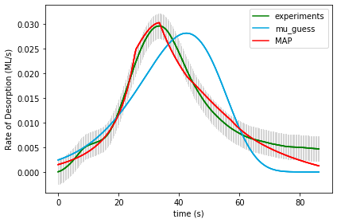

UserInput.model['InputParameterPriorValues'] = [1.0, 0.0, 40.0, 13.0, 0.1,

0.0, 0.0, 0.0, 0.0, 0.0, 0.0]

Final map results from gridsearch: (1.0, 0.0, 35.0, 21.5, 0.0, 0.0, 0.0, 0.0, 0.0, 0.0, 0.0) final logP: -1171.686471253084

gridSamplingAbsoluteIntervalSize=[0,0,1.0,0.5,0.05, 0,0,0,0,0,0], gridSamplingNumOfIntervals=[0,0,20,20,20, 0,0,0,0,0,0]

Final results from doOptimizeNegLogP: [ 1.19200915e+00 1.76854660e-03 7.14123472e+00 1.65495923e+00

5.22706037e-02 -1.79773045e-01 2.51029341e-01 -4.53617877e-02

2.10860832e-02 -1.12693530e-01 -3.32170973e-01] final logP: 773.0533384344002

Name of Runfile: 18a_CPE_grid_fine_10kJ 68921 points

|  |  |  |  |  |
| --- | --- | --- | --- | --- |
| **Parameter Name** | **Initial Value** | **Uncertainty** | **Final Value** | **Uncertainty** |
| Scaling | 1 | .1 |  |  |
| Offset | 0 | .005 |  |  |
| Ea_1 | 40 | 10 |  |  |
| Log_A1 | 13 | 2 |  |  |
| gamma_1 | 0.1 | 0.3 |  |  |
| gamma_mod1 | 0 | 0.1 |  |  |
| gamma_mod2 | 0 | 0.1 |  |  |
| gamma_mod3 | 0 | 0.1 |  |  |
| gamma_mod4 | 0 | 0.1 |  |  |
| gamma_mod5 | 0 | 0.1 |  |  |
| gamma_mod6 | 0 | 0.1 |  |  |
| logP |  |  |  |  |



UserInput.model['InputParameterPriorValues'] = [1.0, 0.0, 40.0, 13.0, 0.1,

0.0, 0.0, 0.0, 0.0, 0.0, 0.0]

Final map results from gridsearch: (1.0, 0.0, 35.0, 21.5, 0.0, 0.0, 0.0, 0.0, 0.0, 0.0, 0.0) final logP: -1170.3915981999953

gridSamplingAbsoluteIntervalSize=[0,0,1.0,0.5,0.05, 0,0,0,0,0,0], gridSamplingNumOfIntervals=[0,0,20,20,20, 0,0,0,0,0,0]

Final results from doOptimizeNegLogP: [ 1.85410831e+00 5.67533771e-03 6.17874804e+00 3.67574450e-05

8.89034823e-02 -1.83535985e-01 2.17463994e-01 6.68894279e-02

1.57936323e-01 -1.94729854e-01 -3.25183095e-01] final logP: 850.7205494709239

Name of Runfile: 18a_BPE_grid_fine_10kJ 68921 points

|  |  |  |  |  |
| --- | --- | --- | --- | --- |
| **Parameter Name** | **Initial Value** | **Uncertainty** | **Final Value** | **Uncertainty** |
| Scaling | 1 | .1 |  |  |
| Offset | 0 | .005 |  |  |
| Ea_1 | 40 | 10 |  |  |
| Log_A1 | 13 | 2 |  |  |
| gamma_1 | 0.1 | 0.3 |  |  |
| gamma_mod1 | 0 | 0.1 |  |  |
| gamma_mod2 | 0 | 0.1 |  |  |
| gamma_mod3 | 0 | 0.1 |  |  |
| gamma_mod4 | 0 | 0.1 |  |  |
| gamma_mod5 | 0 | 0.1 |  |  |
| gamma_mod6 | 0 | 0.1 |  |  |
| logP |  |  |  |  |

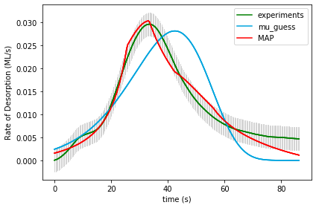

UserInput.model['InputParameterPriorValues'] = [1.0, 0.0, 40.0, 13.0, 0.1,

0.0, 0.0, 0.0, 0.0, 0.0, 0.0]

Final map results from gridsearch: (1.0, 0.0, 35.0, 21.5, 0.0, 0.0, 0.0, 0.0, 0.0, 0.0, 0.0) final logP: -1171.087074072524

gridSamplingAbsoluteIntervalSize=[0,0,1.0,0.5,0.05, 0,0,0,0,0,0], gridSamplingNumOfIntervals=[0,0,20,20,20, 0,0,0,0,0,0]

Final results from doOptimizeNegLogP: [ 1.16045824e+00 1.51879429e-03 7.60168673e+00 1.99725708e+00

6.87164798e-02 -1.87802288e-01 2.84705258e-01 -9.56262297e-02

2.57323455e-02 -1.04636970e-01 -3.16851085e-01] final logP: 755.6085439637255