Name of Runfile: runfile_Example19a_CPE_grid 1361367 points

|  |  |  |  |  |  |
| --- | --- | --- | --- | --- | --- |
| Parameter Name | Initial Value | Uncertainty | Final Value | Interval Size | Num Intervals |
| Scaling | 1.0 | 0.10 |  |  |  |
| Offset | 0.0 | 0.005 |  |  |  |
| Site2Ratio | 0.50 | 0.50/3 |  |  |  |
| Ea_1 | 41.5 | 20 |  |  |  |
| Ea_2 | 41.5 | 20 |  |  |  |
| log_A1 | 13.0 | 2 |  |  |  |
| log_A2 | 13.0 | 2 |  |  |  |
| gamma1 | 0.1 | 0.1 |  |  |  |
| gamma2 | 0.1 | 0.1 |  |  |  |
| logP |  | N/A |  | N/A | N/A |

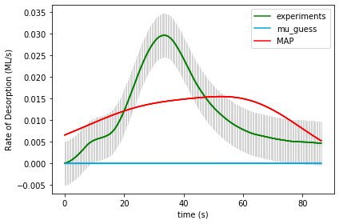

UserInput.model['InputParameterPriorValues'] = [ 1.0, 0.0, 0.50, 41.5, 41.5, 13.0, 13.0, 0.1, 0.1]  
Final map results from gridsearch: (1.1, 0.0, 0.16666666666666669, 21.5, 21.5, 11.0, 13.0, 0.2, 0.1) final logP: -1693.9700904725842

gridSamplingAbsoluteIntervalSize=[ 0.10, 0.005, 0.50/3, 20, 20, 2, 2, 0.1, 0.1], gridSamplingNumOfIntervals=[1,1,3,3,3,3,3,1,1]

Name of Runfile: runfile_Example19a_BPE_grid 1361367 points

|  |  |  |  |  |  |
| --- | --- | --- | --- | --- | --- |
| Parameter Name | Initial Value | Uncertainty | Final Value | Interval Size | Num Intervals |
| Scaling | 1.0 | 0.10 |  |  |  |
| Offset | 0.0 | 0.005 |  |  |  |
| Site2Ratio | 0.50 | 0.50/3 |  |  |  |
| Ea_1 | 41.5 | 20 |  |  |  |
| Ea_2 | 41.5 | 20 |  |  |  |
| log_A1 | 13.0 | 2 |  |  |  |
| log_A2 | 13.0 | 2 |  |  |  |
| gamma1 | 0.1 | 0.1 |  |  |  |
| gamma2 | 0.1 | 0.1 |  |  |  |
| logP |  | N/A |  | N/A | N/A |



UserInput.model['InputParameterPriorValues'] = [ 1.0, 0.0, 0.50, 41.5, 41.5, 13.0, 13.0, 0.1, 0.1]

Final map results from gridsearch: (1.1, 0.0, 0.16666666666666669, 21.5, 21.5, 11.0, 13.0, 0.2, 0.1) final logP: -1707.7405372192723gridSamplingAbsoluteIntervalSize=[ 0.10, 0.005, 0.50/3, 20, 20, 2, 2, 0.1, 0.1], gridSamplingNumOfIntervals=[1,1,3,3,3,3,3,1,1]

Name of Runfile: runfile_Example19a_CPE_grid_opt 243 points

|  |  |  |  |  |  |
| --- | --- | --- | --- | --- | --- |
| Parameter Name | Initial Value | Uncertainty | Final Value | Interval Size | Num Intervals |
| Scaling | 1.0 | 0.10 |  |  |  |
| Offset | 0.0 | 0.005 |  |  |  |
| Site2Ratio | 0.50 | 0.50/3 |  |  |  |
| Ea_1 | 41.5 | 20 |  |  |  |
| Ea_2 | 41.5 | 20 |  |  |  |
| log_A1 | 13.0 | 2 |  |  |  |
| log_A2 | 13.0 | 2 |  |  |  |
| gamma1 | 0.1 | 0.1 |  |  |  |
| gamma2 | 0.1 | 0.1 |  |  |  |
| logP |  | N/A |  | N/A | N/A |

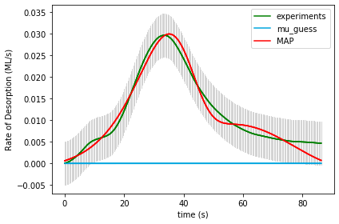

UserInput.model['InputParameterPriorValues'] = [ 1.0, 0.0, 0.50, 41.5, 41.5, 13.0, 13.0, 0.1, 0.1]

Final map results from gridsearch: [1.17855879e+00 1.56599493e-03 4.89378831e-01 5.01380589e+01

2.47742710e+01 3.31859754e+01 1.33279804e+01 1.37736928e-02

1.18045551e-01] final logP: 698.5893003020717

gridSamplingAbsoluteIntervalSize=[ 0.10, 0.005, 0.50/3, 20, 20, 2, 2, 0.1, 0.1], gridSamplingNumOfIntervals=[0,0,1,1,1,1,1,0,0]

Name of Runfile: runfile_Example19a_BPE_grid_opt 243 points

|  |  |  |  |  |  |
| --- | --- | --- | --- | --- | --- |
| Parameter Name | Initial Value | Uncertainty | Final Value | Interval Size | Num Intervals |
| Scaling | 1.0 | 0.10 |  |  |  |
| Offset | 0.0 | 0.005 |  |  |  |
| Site2Ratio | 0.50 | 0.50/3 |  |  |  |
| Ea_1 | 41.5 | 20 |  |  |  |
| Ea_2 | 41.5 | 20 |  |  |  |
| log_A1 | 13.0 | 2 |  |  |  |
| log_A2 | 13.0 | 2 |  |  |  |
| gamma1 | 0.1 | 0.1 |  |  |  |
| gamma2 | 0.1 | 0.1 |  |  |  |
| logP |  | N/A |  | N/A | N/A |

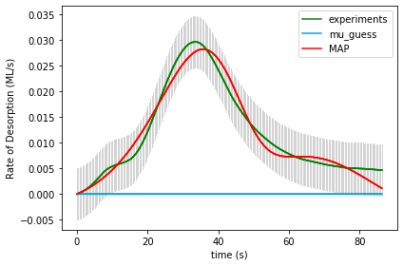

UserInput.model['InputParameterPriorValues'] = [ 1.0, 0.0, 0.50, 41.5, 41.5, 13.0, 13.0, 0.1, 0.1]

Final map results from gridsearch: [1.31490688e+00 2.42812476e-03 3.94914061e-01 4.04733411e+01

2.83349021e+01 2.60903516e+01 1.53898803e+01 6.21559490e-02

1.17508227e-01] final logP: 655.8701616424628

gridSamplingAbsoluteIntervalSize=[ 0.10, 0.005, 0.50/3, 20, 20, 2, 2, 0.1, 0.1], gridSamplingNumOfIntervals=[0,0,1,1,1,1,1,0,0]

Name of Runfile: 19a_CPE_grid_mcmc 243 points

|  |  |  |  |  |  |
| --- | --- | --- | --- | --- | --- |
| Parameter Name | Initial Value | Uncertainty | Final Value | Interval Size | Num Intervals |
| Scaling | 1.0 | 0.10 |  |  |  |
| Offset | 0.0 | 0.005 |  |  |  |
| Site2Ratio | 0.50 | 0.50/3 |  |  |  |
| Ea_1 | 41.5 | 20 |  |  |  |
| Ea_2 | 41.5 | 20 |  |  |  |
| log_A1 | 13.0 | 2 |  |  |  |
| log_A2 | 13.0 | 2 |  |  |  |
| gamma1 | 0.1 | 0.1 |  |  |  |
| gamma2 | 0.1 | 0.1 |  |  |  |
| logP |  | N/A |  | N/A | N/A |

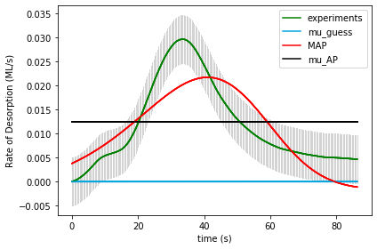

UserInput.model['InputParameterPriorValues'] = [ 1.0, 0.0, 0.50, 41.5, 41.5, 13.0, 13.0, 0.1, 0.1]

Final map results from gridsearch: [1.11903275e+00 1.42841706e-03 4.24304405e-01 2.56838078e+01

2.37503902e+01 1.49342760e+01 1.30921583e+01 1.25084700e-01

1.39916679e-01] final logP: [100.50473885]

gridSamplingAbsoluteIntervalSize=[ 0.10, 0.005, 0.50/3, 20, 20, 2, 2, 0.1, 0.1], gridSamplingNumOfIntervals=[0,0,1,1,1,1,1,0,0]

Name of Runfile: 19a_BPE_grid_mcmc 243 points

|  |  |  |  |  |  |
| --- | --- | --- | --- | --- | --- |
| Parameter Name | Initial Value | Uncertainty | Final Value | Interval Size | Num Intervals |
| Scaling | 1.0 | 0.10 |  |  |  |
| Offset | 0.0 | 0.005 |  |  |  |
| Site2Ratio | 0.50 | 0.50/3 |  |  |  |
| Ea_1 | 41.5 | 20 |  |  |  |
| Ea_2 | 41.5 | 20 |  |  |  |
| log_A1 | 13.0 | 2 |  |  |  |
| log_A2 | 13.0 | 2 |  |  |  |
| gamma1 | 0.1 | 0.1 |  |  |  |
| gamma2 | 0.1 | 0.1 |  |  |  |
| logP |  | N/A |  |  |  |



UserInput.model['InputParameterPriorValues'] = [ 1.0, 0.0, 0.50, 41.5, 41.5, 13.0, 13.0, 0.1, 0.1]

Final map results from gridsearch: [1.11903275e+00 1.42841706e-03 4.24304405e-01 2.56838078e+01

2.37503902e+01 1.49342760e+01 1.30921583e+01 1.25084700e-01

1.39916679e-01] final logP: [89.09553857]

gridSamplingAbsoluteIntervalSize=[ 0.10, 0.005, 0.50/3, 20, 20, 2, 2, 0.1, 0.1], gridSamplingNumOfIntervals=[0,0,1,1,1,1,1,0,0]

Name of Runfile: runfile_Example19a_CPE_grid_fine 1361367 points

|  |  |  |  |  |  |
| --- | --- | --- | --- | --- | --- |
| Parameter Name | Initial Value | Uncertainty | Final Value | Interval Size | Num Intervals |
| Scaling | 1.0 | 0.10 |  |  |  |
| Offset | 0.0 | 0.005 |  |  |  |
| Site2Ratio | 0.50 | 0.50/3 |  |  |  |
| Ea_1 | 41.5 | 20 |  |  |  |
| Ea_2 | 41.5 | 20 |  |  |  |
| log_A1 | 13.0 | 2 |  |  |  |
| log_A2 | 13.0 | 2 |  |  |  |
| gamma1 | 0.1 | 0.1 |  |  |  |
| gamma2 | 0.1 | 0.1 |  |  |  |
| logP |  | N/A |  | N/A | N/A |

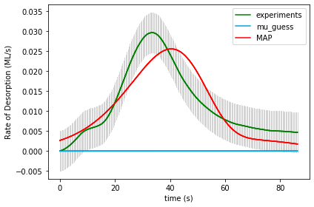

UserInput.model['InputParameterPriorValues'] = [ 1.0, 0.0, 0.50, 41.5, 41.5, 13.0, 13.0, 0.1, 0.1]

Final map results from gridsearch: (1.0, 0.0, 0.16666666666666669, 35.5, 23.5, 22.0, 12.0, 0.1, 0.1) final logP: 428.48021937045627

gridSamplingAbsoluteIntervalSize=[ 0.10, 0.005, 0.50/3, 20/10, 20/10, 1, 1, 0.1, 0.1], gridSamplingNumOfIntervals=[0,0,3,10,10,10,10,0,0]

Name of Runfile: runfile_Example19a_BPE_grid_fine 1361367 points

|  |  |  |  |  |  |
| --- | --- | --- | --- | --- | --- |
| Parameter Name | Initial Value | Uncertainty | Final Value | Interval Size | Num Intervals |
| Scaling | 1.0 | 0.10 |  |  |  |
| Offset | 0.0 | 0.005 |  |  |  |
| Site2Ratio | 0.50 | 0.50/3 |  |  |  |
| Ea_1 | 41.5 | 20 |  |  |  |
| Ea_2 | 41.5 | 20 |  |  |  |
| log_A1 | 13.0 | 2 |  |  |  |
| log_A2 | 13.0 | 2 |  |  |  |
| gamma1 | 0.1 | 0.1 |  |  |  |
| gamma2 | 0.1 | 0.1 |  |  |  |
| logP |  | N/A |  | N/A | N/A |



UserInput.model['InputParameterPriorValues'] = [ 1.0, 0.0, 0.50, 41.5, 41.5, 13.0, 13.0, 0.1, 0.1]

Final map results from gridsearch: (1.0, 0.0, 0.16666666666666669, 35.5, 23.5, 22.0, 12.0, 0.1, 0.1) final logP: 406.5097726237683

gridSamplingAbsoluteIntervalSize=[ 0.10, 0.005, 0.50/3, 20/10, 20/10, 1, 1, 0.1, 0.1], gridSamplingNumOfIntervals=[0,0,3,10,10,10,10,0,0]

Name of Runfile: 20a_CPE_grid 1361367 points

|  |  |  |  |  |  |
| --- | --- | --- | --- | --- | --- |
| Parameter Name | Initial Value | Uncertainty | Final Value | Interval Size | Num Intervals |
| Scaling | 1.0 | 0.10 |  |  |  |
| Offset | 0.0 | 0.005 |  |  |  |
| Site2Ratio | 0.50 | 0.50/3 |  |  |  |
| Ea_1 | 41.5 | 20 |  |  |  |
| Ea_2 | 41.5 | 20 |  |  |  |
| log_A1 | 13.0 | 2 |  |  |  |
| log_A2 | 13.0 | 2 |  |  |  |
| gamma1 | 0.1 | 0.1 |  |  |  |
| gamma2 | 0.1 | 0.1 |  |  |  |
| logP |  | N/A |  |  |  |

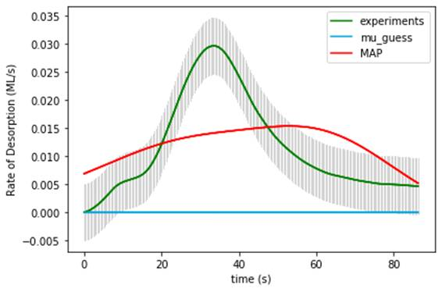

UserInput.model['InputParameterPriorValues'] = [ 1.0, 0.0, 0.50, 41.5, 41.5, 13.0, 13.0, 0.1, 0.1]

Final map results from gridsearch: (1.1, 0.0, 0.8333333333333333, 21.5, 21.5, 13.0, 11.0, 0.1, 0.2) final logP: -1772.7376551433426

gridSamplingAbsoluteIntervalSize=[ 0.10, 0.005, 0.50/3, 20, 20, 2, 2, 0.1, 0.1], gridSamplingNumOfIntervals=[1,1,3,3,3,3,3,1,1]

Name of Runfile: 20a_BPE_grid 1361367 points

|  |  |  |  |  |  |
| --- | --- | --- | --- | --- | --- |
| Parameter Name | Initial Value | Uncertainty | Final Value | Interval Size | Num Intervals |
| Scaling | 1.0 | 0.10 |  |  |  |
| Offset | 0.0 | 0.005 |  |  |  |
| Site2Ratio | 0.50 | 0.50/3 |  |  |  |
| Ea_1 | 41.5 | 20 |  |  |  |
| Ea_2 | 41.5 | 20 |  |  |  |
| log_A1 | 13.0 | 2 |  |  |  |
| log_A2 | 13.0 | 2 |  |  |  |
| gamma1 | 0.1 | 0.1 |  |  |  |
| gamma2 | 0.1 | 0.1 |  |  |  |
| logP |  | N/A |  |  |  |

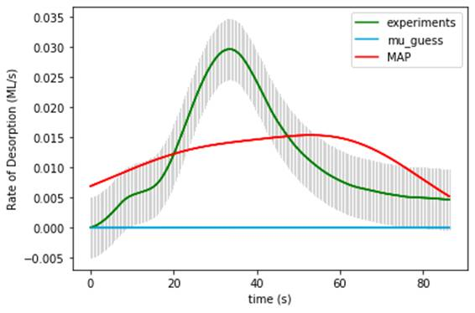

UserInput.model['InputParameterPriorValues'] = [ 1.0, 0.0, 0.50, 41.5, 41.5, 13.0, 13.0, 0.1, 0.1]

Final map results from gridsearch: (1.1, 0.0, 0.8333333333333333, 21.5, 21.5, 13.0, 11.0, 0.1, 0.2) final logP: -1786.5081018900307

gridSamplingAbsoluteIntervalSize=[ 0.10, 0.005, 0.50/3, 20, 20, 2, 2, 0.1, 0.1], gridSamplingNumOfIntervals=[1,1,3,3,3,3,3,1,1]

Name of Runfile: 20a_CPE_grid_opt 243 points

|  |  |  |  |  |  |
| --- | --- | --- | --- | --- | --- |
| Parameter Name | Initial Value | Uncertainty | Final Value | Interval Size | Num Intervals |
| Scaling | 1.0 | 0.10 |  |  |  |
| Offset | 0.0 | 0.005 |  |  |  |
| Site2Ratio | 0.50 | 0.50/3 |  |  |  |
| Ea_1 | 41.5 | 20 |  |  |  |
| Ea_2 | 41.5 | 20 |  |  |  |
| log_A1 | 13.0 | 2 |  |  |  |
| log_A2 | 13.0 | 2 |  |  |  |
| gamma1 | 0.1 | 0.1 |  |  |  |
| gamma2 | 0.1 | 0.1 |  |  |  |
| logP |  | N/A |  |  |  |

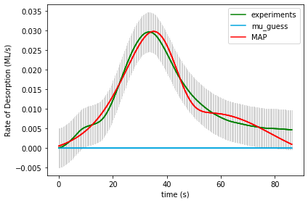

UserInput.model['InputParameterPriorValues'] = [ 1.0, 0.0, 0.50, 41.5, 41.5, 13.0, 13.0, 0.1, 0.1]

Final map results from gridsearch: [1.25384964e+00 2.04001014e-03 5.45932317e-01 5.46374259e+01

2.26561529e+01 3.61464156e+01 1.18133568e+01 5.02161431e-01

3.14296393e-01] final logP: 699.1170245948291

gridSamplingAbsoluteIntervalSize=[ 0.10, 0.005, 0.50/3, 20, 20, 2, 2, 0.1, 0.1], gridSamplingNumOfIntervals=[0,0,1,1,1,1,1,0,0]

Name of Runfile: 20a_BPE_grid_opt 243 points

|  |  |  |  |  |  |
| --- | --- | --- | --- | --- | --- |
| Parameter Name | Initial Value | Uncertainty | Final Value | Interval Size | Num Intervals |
| Scaling | 1.0 | 0.10 |  |  |  |
| Offset | 0.0 | 0.005 |  |  |  |
| Site2Ratio | 0.50 | 0.50/3 |  |  |  |
| Ea_1 | 41.5 | 20 |  |  |  |
| Ea_2 | 41.5 | 20 |  |  |  |
| log_A1 | 13.0 | 2 |  |  |  |
| log_A2 | 13.0 | 2 |  |  |  |
| gamma1 | 0.1 | 0.1 |  |  |  |
| gamma2 | 0.1 | 0.1 |  |  |  |
| logP |  | N/A |  |  |  |

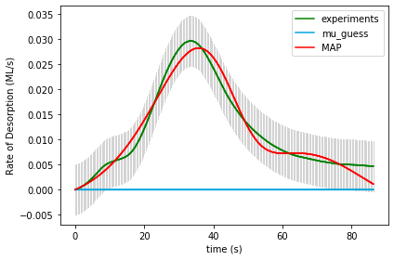

UserInput.model['InputParameterPriorValues'] = [ 1.0, 0.0, 0.50, 41.5, 41.5, 13.0, 13.0, 0.1, 0.1]

Final map results from gridsearch: [1.31535905e+00 2.43309713e-03 6.06589289e-01 2.83997455e+01

4.03489182e+01 1.54373699e+01 2.59927644e+01 5.35609925e-02

3.97826792e-02] final logP: 655.837122773111

gridSamplingAbsoluteIntervalSize=[ 0.10, 0.005, 0.50/3, 20, 20, 2, 2, 0.1, 0.1], gridSamplingNumOfIntervals=[0,0,1,1,1,1,1,0,0]

Name of Runfile: 20a_CPE_grid_mcmc 243 points

|  |  |  |  |  |  |
| --- | --- | --- | --- | --- | --- |
| Parameter Name | Initial Value | Uncertainty | Final Value | Interval Size | Num Intervals |
| Scaling | 1.0 | 0.10 |  |  |  |
| Offset | 0.0 | 0.005 |  |  |  |
| Site2Ratio | 0.50 | 0.50/3 |  |  |  |
| Ea_1 | 41.5 | 20 |  |  |  |
| Ea_2 | 41.5 | 20 |  |  |  |
| log_A1 | 13.0 | 2 |  |  |  |
| log_A2 | 13.0 | 2 |  |  |  |
| gamma1 | 0.1 | 0.1 |  |  |  |
| gamma2 | 0.1 | 0.1 |  |  |  |
| logP |  | N/A |  |  |  |

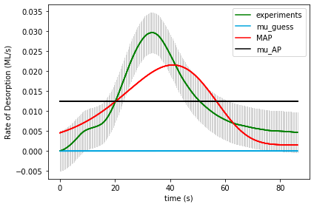

UserInput.model['InputParameterPriorValues'] = [ 1.0, 0.0, 0.50, 41.5, 41.5, 13.0, 13.0, 0.1, 0.1]

Final map results from gridsearch: [ 1.02795809e+00 -1.47194475e-03 2.06950152e-01 3.01093572e+01

4.79243481e+01 1.79804764e+01 1.24238115e+01 1.37345490e-01

1.94422092e-01] final logP: [-53.59365729]

gridSamplingAbsoluteIntervalSize=[ 0.10, 0.005, 0.50/3, 20, 20, 2, 2, 0.1, 0.1], gridSamplingNumOfIntervals=[0,0,1,1,1,1,1,0,0]

Name of Runfile: 20a_BPE_grid_mcmc 243 points

|  |  |  |  |  |  |
| --- | --- | --- | --- | --- | --- |
| Parameter Name | Initial Value | Uncertainty | Final Value | Interval Size | Num Intervals |
| Scaling | 1.0 | 0.10 |  |  |  |
| Offset | 0.0 | 0.005 |  |  |  |
| Site2Ratio | 0.50 | 0.50/3 |  |  |  |
| Ea_1 | 41.5 | 20 |  |  |  |
| Ea_2 | 41.5 | 20 |  |  |  |
| log_A1 | 13.0 | 2 |  |  |  |
| log_A2 | 13.0 | 2 |  |  |  |
| gamma1 | 0.1 | 0.1 |  |  |  |
| gamma2 | 0.1 | 0.1 |  |  |  |
| logP |  | N/A |  |  |  |



UserInput.model['InputParameterPriorValues'] = [ 1.0, 0.0, 0.50, 41.5, 41.5, 13.0, 13.0, 0.1, 0.1]

Final map results from gridsearch: [ 1.02795809e+00 -1.47194475e-03 2.06950152e-01 3.01093572e+01

4.79243481e+01 1.79804764e+01 1.24238115e+01 1.37345490e-01

1.94422092e-01] final logP: [-68.363754]

gridSamplingAbsoluteIntervalSize=[ 0.10, 0.005, 0.50/3, 20, 20, 2, 2, 0.1, 0.1], gridSamplingNumOfIntervals=[0,0,1,1,1,1,1,0,0]

Name of Runfile: runfile_Example20a_CPE_grid_fine 1361367 points

|  |  |  |  |  |  |
| --- | --- | --- | --- | --- | --- |
| Parameter Name | Initial Value | Uncertainty | Final Value | Interval Size | Num Intervals |
| Scaling | 1.0 | 0.10 |  |  |  |
| Offset | 0.0 | 0.005 |  |  |  |
| Site2Ratio | 0.50 | 0.50/3 |  |  |  |
| Ea_1 | 41.5 | 20 |  |  |  |
| Ea_2 | 41.5 | 20 |  |  |  |
| log_A1 | 13.0 | 2 |  |  |  |
| log_A2 | 13.0 | 2 |  |  |  |
| gamma1 | 0.1 | 0.1 |  |  |  |
| gamma2 | 0.1 | 0.1 |  |  |  |
| logP |  | N/A |  | N/A | N/A |

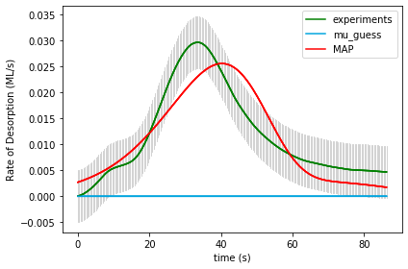

UserInput.model['InputParameterPriorValues'] = [ 1.0, 0.0, 0.50, 41.5, 41.5, 13.0, 13.0, 0.1, 0.1]

Final map results from gridsearch: (1.0, 0.0, 0.8333333333333333, 23.5, 35.5, 12.0, 22.0, 0.1, 0.1) final logP: 439.9328869125924

gridSamplingAbsoluteIntervalSize=[ 0.10, 0.005, 0.50/3, 20/10, 20/10, 1, 1, 0.1, 0.1], gridSamplingNumOfIntervals=[0,0,3,10,10,10,10,0,0]

Name of Runfile: runfile_Example20a_BPE_grid_fine 1361367 points

|  |  |  |  |  |  |
| --- | --- | --- | --- | --- | --- |
| Parameter Name | Initial Value | Uncertainty | Final Value | Interval Size | Num Intervals |
| Scaling | 1.0 | 0.10 |  |  |  |
| Offset | 0.0 | 0.005 |  |  |  |
| Site2Ratio | 0.50 | 0.50/3 |  |  |  |
| Ea_1 | 41.5 | 20 |  |  |  |
| Ea_2 | 41.5 | 20 |  |  |  |
| log_A1 | 13.0 | 2 |  |  |  |
| log_A2 | 13.0 | 2 |  |  |  |
| gamma1 | 0.1 | 0.1 |  |  |  |
| gamma2 | 0.1 | 0.1 |  |  |  |
| logP |  | N/A |  | N/A | N/A |



UserInput.model['InputParameterPriorValues'] = [ 1.0, 0.0, 0.50, 41.5, 41.5, 13.0, 13.0, 0.1, 0.1]

Final map results from gridsearch: (1.0, 0.0, 0.8333333333333333, 23.5, 35.5, 12.0, 22.0, 0.1, 0.1) final logP: 417.9624401659044

gridSamplingAbsoluteIntervalSize=[ 0.10, 0.005, 0.50/3, 20/10, 20/10, 1, 1, 0.1, 0.1], gridSamplingNumOfIntervals=[0,0,3,10,10,10,10,0,0]

Name of Runfile: 21a_CPE_grid 59535 points

|  |  |  |  |  |  |
| --- | --- | --- | --- | --- | --- |
| Parameter Name | Initial Value | Uncertainty | Final Value | Interval Size | Num Intervals |
| Scaling | 1 | .1 |  |  |  |
| Offset | 0 | .005 |  |  |  |
| Ea_1 | 41.5 | 20 |  |  |  |
| Log_A1 | 13 | 2 |  |  |  |
| gamma_1 | 0.1 | 0.3 |  |  |  |
| gamma_mod1 | 0 | 0.1 |  |  |  |
| gamma_mod2 | 0 | 0.1 |  |  |  |
| gamma_mod3 | 0 | 0.1 |  |  |  |
| gamma_mod4 | 0 | 0.1 |  |  |  |
| gamma_mod5 | 0 | 0.1 |  |  |  |
| gamma_mod6 | 0 | 0.1 |  |  |  |
| logP |  |  |  |  |  |

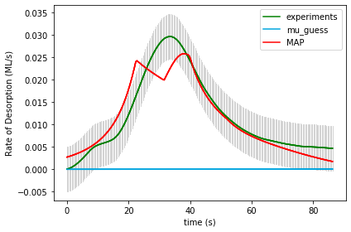

UserInput.model['InputParameterPriorValues'] = [1.0, 0.0, 41.5, 13.0, 0.1,

0.0, 0.0, 0.0, 0.0, 0.0, 0.0]

Final map results from gridsearch: (1.0, 0.0, 21.5, 11.0, 0.1, 0.0, 0.1, 0.0, -0.1, 0.0, -0.1) finalLogP 284.8473500188951

gridSamplingAbsoluteIntervalSize= [.1, 0.005, 20, 2, 0.3,

0.1, 0.1, 0.1, 0.1, 0.1, 0.1]

gridSamplingNumOfIntervals=[0,0,3,3,2, 0,1,1,1,1,1]

Name of Runfile: 21a_BPE_grid 59535 points

|  |  |  |  |  |  |
| --- | --- | --- | --- | --- | --- |
| Parameter Name | Initial Value | Uncertainty | Final Value | Interval Size | Num Intervals |
| Scaling | 1 | .1 |  |  |  |
| Offset | 0 | .005 |  |  |  |
| Ea_1 | 41.5 | 20 |  |  |  |
| Log_A1 | 13 | 2 |  |  |  |
| gamma_1 | 0.1 | 0.3 |  |  |  |
| gamma_mod1 | 0 | 0.1 |  |  |  |
| gamma_mod2 | 0 | 0.1 |  |  |  |
| gamma_mod3 | 0 | 0.1 |  |  |  |
| gamma_mod4 | 0 | 0.1 |  |  |  |
| gamma_mod5 | 0 | 0.1 |  |  |  |
| gamma_mod6 | 0 | 0.1 |  |  |  |
| logP |  |  |  |  |  |



UserInput.model['InputParameterPriorValues'] = [1.0, 0.0, 41.5, 13.0, 0.1,

0.0, 0.0, 0.0, 0.0, 0.0, 0.0]

Final map results from gridsearch: (1.0, 0.0, 21.5, 11.0, 0.1, 0.0, 0.1, 0.0, -0.1, 0.0, -0.1) final logP: 290.1705325213621

gridSamplingAbsoluteIntervalSize= [.1, 0.005, 20, 2, 0.3,

0.1, 0.1, 0.1, 0.1, 0.1, 0.1]

gridSamplingNumOfIntervals=[0,0,3,3,2, 0,1,1,1,1,1]

Name of Runfile: 21a_CPE_grid_opt 243 points

|  |  |  |  |  |  |
| --- | --- | --- | --- | --- | --- |
| Parameter Name | Initial Value | Uncertainty | Final Value | Interval Size | Num Intervals |
| Scaling | 1 | .1 |  |  |  |
| Offset | 0 | .005 |  |  |  |
| Ea_1 | 41.5 | 20 |  |  |  |
| Log_A1 | 13 | 2 |  |  |  |
| gamma_1 | 0.1 | 0.3 |  |  |  |
| gamma_mod1 | 0 | 0.1 |  |  |  |
| gamma_mod2 | 0 | 0.1 |  |  |  |
| gamma_mod3 | 0 | 0.1 |  |  |  |
| gamma_mod4 | 0 | 0.1 |  |  |  |
| gamma_mod5 | 0 | 0.1 |  |  |  |
| gamma_mod6 | 0 | 0.1 |  |  |  |
| logP |  |  |  |  |  |

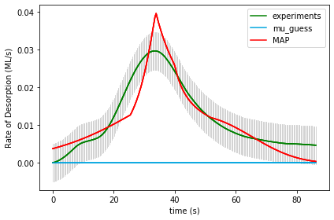

UserInput.model['InputParameterPriorValues'] = [1.0, 0.0, 41.5, 13.0, 0.1,

0.0, 0.0, 0.0, 0.0, 0.0, 0.0]

Final map results from gridsearch: [ 9.93009342e-01 1.29766120e-04 2.26806868e+01 1.24669034e+01

9.76401954e-02 -1.03490036e-01 2.65703192e-05 9.85685434e-02

3.98592895e-05 -1.02576953e-01 5.80915528e-05]final logP: 493.9879889336341

gridSamplingAbsoluteIntervalSize= [.1, 0.005, 20, 2, 0.3,

0.1, 0.1, 0.1, 0.1, 0.1, 0.1]

gridSamplingNumOfIntervals=[0,0,1,1,0, 1,0,1,0,1,0]

Name of Runfile: 21a_BPE_grid_opt 243 points

|  |  |  |  |  |  |
| --- | --- | --- | --- | --- | --- |
| Parameter Name | Initial Value | Uncertainty | Final Value | Interval Size | Num Intervals |
| Scaling | 1 | .1 |  |  |  |
| Offset | 0 | .005 |  |  |  |
| Ea_1 | 41.5 | 20 |  |  |  |
| Log_A1 | 13 | 2 |  |  |  |
| gamma_1 | 0.1 | 0.3 |  |  |  |
| gamma_mod1 | 0 | 0.1 |  |  |  |
| gamma_mod2 | 0 | 0.1 |  |  |  |
| gamma_mod3 | 0 | 0.1 |  |  |  |
| gamma_mod4 | 0 | 0.1 |  |  |  |
| gamma_mod5 | 0 | 0.1 |  |  |  |
| gamma_mod6 | 0 | 0.1 |  |  |  |
| logP |  |  |  |  |  |



UserInput.model['InputParameterPriorValues'] = [1.0, 0.0, 41.5, 13.0, 0.1,

0.0, 0.0, 0.0, 0.0, 0.0, 0.0]

Final map results from gridsearch: [ 9.93009342e-01 1.29766120e-04 2.26806868e+01 1.24669034e+01

9.76401954e-02 -1.03490036e-01 2.65703192e-05 9.85685434e-02

3.98592895e-05 -1.02576953e-01 5.80915528e-05] final logP: 499.78272895176445

gridSamplingAbsoluteIntervalSize= [.1, 0.005, 20, 2, 0.3,

0.1, 0.1, 0.1, 0.1, 0.1, 0.1]

gridSamplingNumOfIntervals=[0,0,1,1,0, 1,0,1,0,1,0]

Name of Runfile: 21a_CPE_grid_mcmc 243 points

|  |  |  |  |  |  |
| --- | --- | --- | --- | --- | --- |
| Parameter Name | Initial Value | Uncertainty | Final Value | Interval Size | Num Intervals |
| Scaling | 1 | .1 |  |  |  |
| Offset | 0 | .005 |  |  |  |
| Ea_1 | 41.5 | 20 |  |  |  |
| Log_A1 | 13 | 2 |  |  |  |
| gamma_1 | 0.1 | 0.3 |  |  |  |
| gamma_mod1 | 0 | 0.1 |  |  |  |
| gamma_mod2 | 0 | 0.1 |  |  |  |
| gamma_mod3 | 0 | 0.1 |  |  |  |
| gamma_mod4 | 0 | 0.1 |  |  |  |
| gamma_mod5 | 0 | 0.1 |  |  |  |
| gamma_mod6 | 0 | 0.1 |  |  |  |
| logP |  |  |  |  |  |

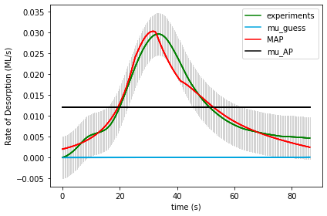

UserInput.model['InputParameterPriorValues'] = [1.0, 0.0, 41.5, 13.0, 0.1,

0.0, 0.0, 0.0, 0.0, 0.0, 0.0]

Final map results from gridsearch: [ 1.02108190e+00 -8.00396340e-05 2.90224016e+01 1.52825640e+01

2.10130769e-01 1.39310716e-01 -6.38196790e-02 -7.10803609e-02

-2.60649187e-02 -5.42407029e-02 -7.80006088e-02] final logP: [641.03254227]

gridSamplingAbsoluteIntervalSize= [.1, 0.005, 20, 2, 0.3,

0.1, 0.1, 0.1, 0.1, 0.1, 0.1]

gridSamplingNumOfIntervals=[0,0,1,1,0, 1,0,1,0,1,0]

Name of Runfile: 21a_BPE_grid_mcmc 243 points

|  |  |  |  |  |  |
| --- | --- | --- | --- | --- | --- |
| Parameter Name | Initial Value | Uncertainty | Final Value | Interval Size | Num Intervals |
| Scaling | 1 | .1 |  |  |  |
| Offset | 0 | .005 |  |  |  |
| Ea_1 | 41.5 | 20 |  |  |  |
| Log_A1 | 13 | 2 |  |  |  |
| gamma_1 | 0.1 | 0.3 |  |  |  |
| gamma_mod1 | 0 | 0.1 |  |  |  |
| gamma_mod2 | 0 | 0.1 |  |  |  |
| gamma_mod3 | 0 | 0.1 |  |  |  |
| gamma_mod4 | 0 | 0.1 |  |  |  |
| gamma_mod5 | 0 | 0.1 |  |  |  |
| gamma_mod6 | 0 | 0.1 |  |  |  |
| logP |  |  |  |  |  |

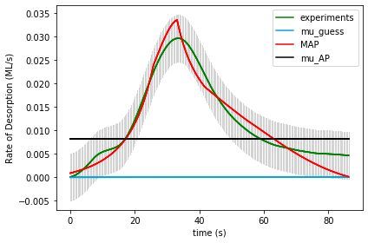

UserInput.model['InputParameterPriorValues'] = [1.0, 0.0, 41.5, 13.0, 0.1,

0.0, 0.0, 0.0, 0.0, 0.0, 0.0]

Final map results from gridsearch: [ 1.13397708e+00 1.55082976e-03 2.08069686e+01 1.08004356e+01

8.01758423e-02 4.28019818e-02 -2.87835511e-02 -4.09191781e-03

2.28636570e-02 -5.34830799e-02 -9.49331136e-02] final logP: [676.20139307]

gridSamplingAbsoluteIntervalSize= [.1, 0.005, 20, 2, 0.3,

0.1, 0.1, 0.1, 0.1, 0.1, 0.1]

gridSamplingNumOfIntervals=[0,0,1,1,0, 1,0,1,0,1,0]

Name of Runfile: 21a_CPE_grid_fine 68921 points

|  |  |  |  |  |  |
| --- | --- | --- | --- | --- | --- |
| Parameter Name | Initial Value | Uncertainty | Final Value | Interval Size | Num Intervals |
| Scaling | 1 | .1 |  |  |  |
| Offset | 0 | .005 |  |  |  |
| Ea_1 | 41.5 | 20 |  |  |  |
| Log_A1 | 13 | 2 |  |  |  |
| gamma_1 | 0.1 | 0.3 |  |  |  |
| gamma_mod1 | 0 | 0.1 |  |  |  |
| gamma_mod2 | 0 | 0.1 |  |  |  |
| gamma_mod3 | 0 | 0.1 |  |  |  |
| gamma_mod4 | 0 | 0.1 |  |  |  |
| gamma_mod5 | 0 | 0.1 |  |  |  |
| gamma_mod6 | 0 | 0.1 |  |  |  |
| logP |  |  |  |  |  |

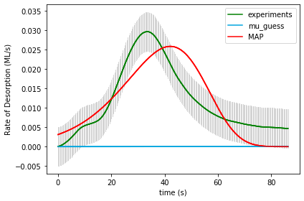

UserInput.model['InputParameterPriorValues'] = [1.0, 0.0, 41.5, 13.0, 0.1,

0.0, 0.0, 0.0, 0.0, 0.0, 0.0]

Final map results from gridsearch: (1.0, 0.0, 31.5, 19.0, 0.0, 0.0, 0.0, 0.0, 0.0, 0.0, 0.0) final logP: 221.3461747047919

gridSamplingAbsoluteIntervalSize=[0,0,1.0,0.5,0.05, 0,0,0,0,0,0], gridSamplingNumOfIntervals=[0,0,20,20,20, 0,0,0,0,0,0]

Name of Runfile: 21a_BPE_grid_fine 68921 points

|  |  |  |  |  |  |
| --- | --- | --- | --- | --- | --- |
| Parameter Name | Initial Value | Uncertainty | Final Value | Interval Size | Num Intervals |
| Scaling | 1 | .1 |  |  |  |
| Offset | 0 | .005 |  |  |  |
| Ea_1 | 41.5 | 20 |  |  |  |
| Log_A1 | 13 | 2 |  |  |  |
| gamma_1 | 0.1 | 0.3 |  |  |  |
| gamma_mod1 | 0 | 0.1 |  |  |  |
| gamma_mod2 | 0 | 0.1 |  |  |  |
| gamma_mod3 | 0 | 0.1 |  |  |  |
| gamma_mod4 | 0 | 0.1 |  |  |  |
| gamma_mod5 | 0 | 0.1 |  |  |  |
| gamma_mod6 | 0 | 0.1 |  |  |  |
| logP |  |  |  |  |  |



UserInput.model['InputParameterPriorValues'] = [1.0, 0.0, 41.5, 13.0, 0.1,

0.0, 0.0, 0.0, 0.0, 0.0, 0.0]

Final map results from gridsearch: (1.0, 0.0, 31.5, 19.0, 0.0, 0.0, 0.0, 0.0, 0.0, 0.0, 0.0) final logP: 224.4888016517033

gridSamplingAbsoluteIntervalSize=[0,0,1.0,0.5,0.05, 0,0,0,0,0,0], gridSamplingNumOfIntervals=[0,0,20,20,20, 0,0,0,0,0,0]

Name of Runfile: 21a_CPE_grid_fine_10kJ 68921 points

|  |  |  |  |  |  |
| --- | --- | --- | --- | --- | --- |
| Parameter Name | Initial Value | Uncertainty | Final Value | Interval Size | Num Intervals |
| Scaling | 1 | .1 |  |  |  |
| Offset | 0 | .005 |  |  |  |
| Ea_1 | 41.5 | 10 |  |  |  |
| Log_A1 | 13 | 2 |  |  |  |
| gamma_1 | 0.1 | 0.3 |  |  |  |
| gamma_mod1 | 0 | 0.1 |  |  |  |
| gamma_mod2 | 0 | 0.1 |  |  |  |
| gamma_mod3 | 0 | 0.1 |  |  |  |
| gamma_mod4 | 0 | 0.1 |  |  |  |
| gamma_mod5 | 0 | 0.1 |  |  |  |
| gamma_mod6 | 0 | 0.1 |  |  |  |
| logP |  |  |  |  |  |



UserInput.model['InputParameterPriorValues'] = [1.0, 0.0, 41.5, 13.0, 0.1,

0.0, 0.0, 0.0, 0.0, 0.0, 0.0]

Final map results from gridsearch: (1.0, 0.0, 31.5, 19.0, 0.0, 0.0, 0.0, 0.0, 0.0, 0.0, 0.0) final logP: 221.3461747047919

gridSamplingAbsoluteIntervalSize=[0,0,1.0,0.5,0.05, 0,0,0,0,0,0], gridSamplingNumOfIntervals=[0,0,20,20,20, 0,0,0,0,0,0]

Name of Runfile: 21a_BPE_grid_fine_10kJ 68921 points

|  |  |  |  |  |  |
| --- | --- | --- | --- | --- | --- |
| Parameter Name | Initial Value | Uncertainty | Final Value | Interval Size | Num Intervals |
| Scaling | 1 | .1 |  |  |  |
| Offset | 0 | .005 |  |  |  |
| Ea_1 | 41.5 | 10 |  |  |  |
| Log_A1 | 13 | 2 |  |  |  |
| gamma_1 | 0.1 | 0.3 |  |  |  |
| gamma_mod1 | 0 | 0.1 |  |  |  |
| gamma_mod2 | 0 | 0.1 |  |  |  |
| gamma_mod3 | 0 | 0.1 |  |  |  |
| gamma_mod4 | 0 | 0.1 |  |  |  |
| gamma_mod5 | 0 | 0.1 |  |  |  |
| gamma_mod6 | 0 | 0.1 |  |  |  |
| logP |  |  |  |  |  |



UserInput.model['InputParameterPriorValues'] = [1.0, 0.0, 41.5, 13.0, 0.1,

0.0, 0.0, 0.0, 0.0, 0.0, 0.0]

Final map results from gridsearch: (1.0, 0.0, 31.5, 19.0, 0.0, 0.0, 0.0, 0.0, 0.0, 0.0, 0.0) final logP: -224.80694883226326

gridSamplingAbsoluteIntervalSize=[0,0,1.0,0.5,0.05, 0,0,0,0,0,0], gridSamplingNumOfIntervals=[0,0,20,20,20, 0,0,0,0,0,0]