**2022 Fall ACS National Meeting Open Source Software Workshops Preparation for Participants:**

Contents

1. Expectations of participants BEFORE workshops. 1

2. Possible Infrastructure Needs: 1

3. Individual Workshop Requirements 1

4. Infrastructure installation instructions 2

A. Notepad++ (~5 minutes) 2

B. Anaconda on Windows (~30 minutes) 2

# 1. Expectations of participants BEFORE workshops.

Each participant is expected to bring a portable computer with the infrastructure needs met and also with the software’s files downloaded. It is recommended to install each software ahead of time.

2. Possible Infrastructure Needs:

Instructions are in Section 4 for installing infrastructure needs. These should be installed before installing the workshop software.

* Notepad++
* Anaconda on windows (Python >3.5) (~30 minutes).

# 3. Individual Workshop Requirements

|  |  |
| --- | --- |
| MSRESOLVE (~10 minutes) | **Infrastructure:** Notepad++, Anaconda **Software Installation (~5 min):** Materials for the workshop:  Download zip from green button at:  <https://github.com/AdityaSavara/MSRESOLVE_Workshop>  Then, from an anaconda prompt, use the following command in that directory:  pip install -r requirements.txt  **Test:**  In directory 01-Example-Analysis, run runfile.py from spyder, or type “python runfile.py” from an anaconda prompt. Close any graphs that appear. If “Logfile complete” appears at the end of the run, assume the program is working. Do not worry about any warnings. |

# 4. Infrastructure installation instructions

## A. Notepad++ (~5 minutes)

Required for some workshops, recommended for all workshops. Simple to install:

<https://notepad-plus-plus.org/downloads/>

If you don’t have any existing programming software (IDE), then we also recommend that you set Notepad++ and set it as a default for opening .py files. Notepad++ adds color to various variables making it easier to decipher different variables.

## B. Anaconda on Windows (~30 minutes)

For most computers, the easiest way to use python for scientific work is to install Anaconda. Download Anaconda from the official website.

URL for Anaconda: <https://www.anaconda.com/products/individual>

**Figure 1: Anaconda Site**

Click download and install. installing, make sure that **Anaconda Prompt** and **Spyder** are present on your computer. If you are using Windows, this can be done by typing in “Anaconda Prompt” into the Window search bar. The **Anaconda Prompt** should show up as an application (don’t open the program, yet). Now, try typing **Spyder** in the window search bar (don’t open the program, yet).

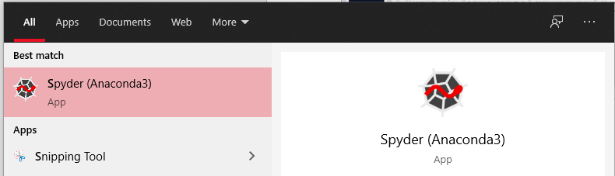

**Figure 2: Spyder program’s Icon that appears when Spyder is installed.**

If Spyder does not appear, open the Anaconda Navigator application. If the Spyder icon has the word “Install” shown, rather than “Launch”, then click install. After installing Spyder, if Spyder still does not appear among your windows programs, you may need to always launch it from Anaconda Navigator, or by typing “Spyder” in an anaconda prompt (see next section).

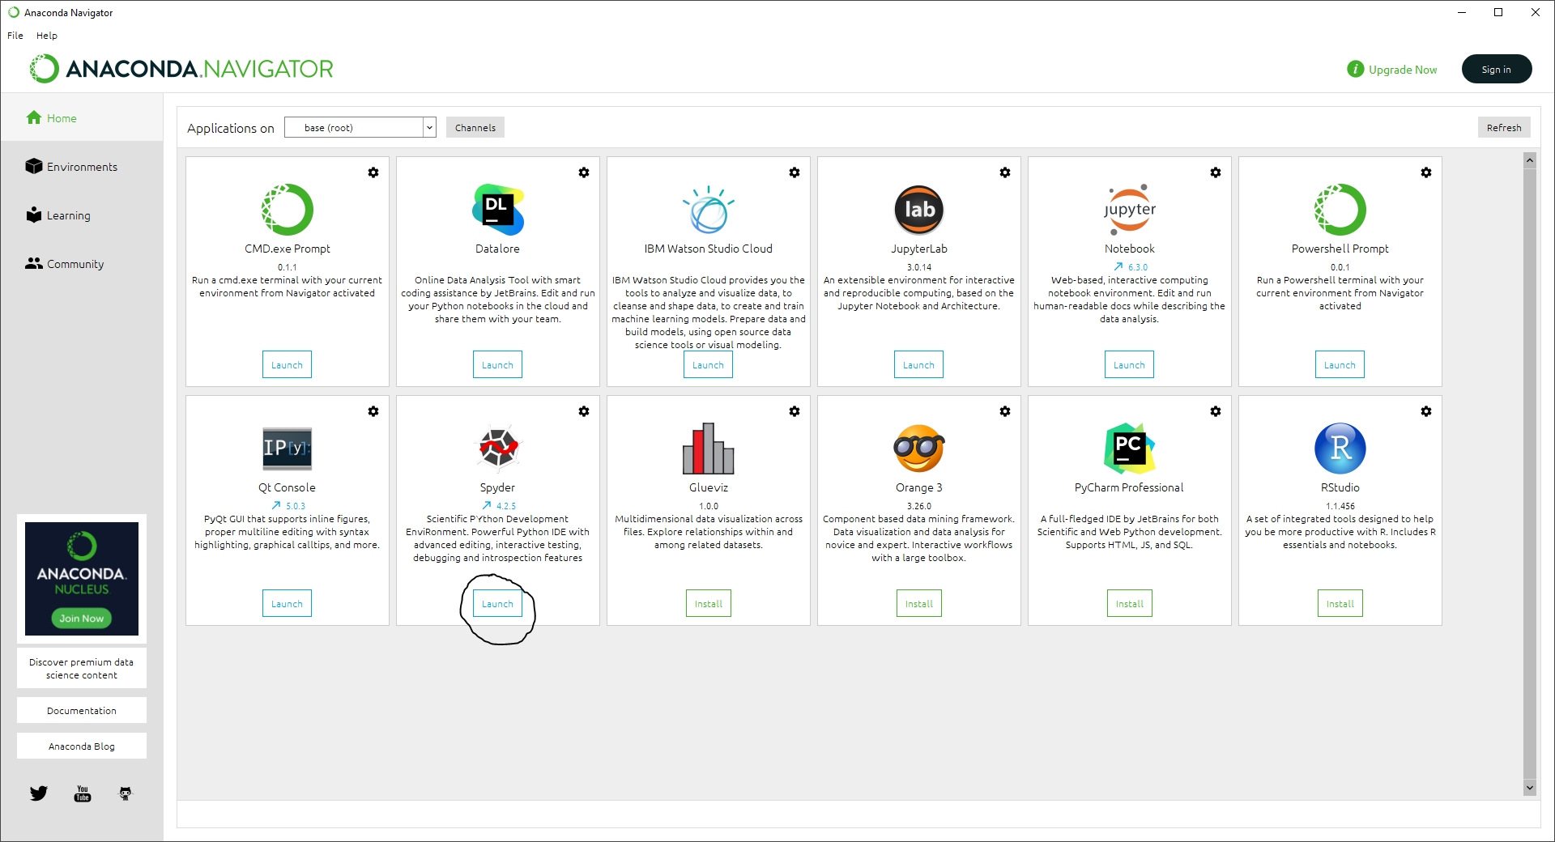

**Figure: Anaconda Navigator view when first opened. The icon demonstrating whether Spyder still needs to be installed or is ready to launch is circled.**