In general, mcmc samplers (including Metropolis Hastings, Ensemble Slice Sampling) are all biased towards trying to find the highest density region of probability. This bias can inhibit complete parameter space exploration during sampling of rough response surfaces with many parameter (the difficulty of exploring parameter space scales very rapidly above 4 parameters). Generally, one cannot be confident in the result in high parameter spaces since there may be more than one result.

Thus, PEUQSE also has \*\*unbiased\*\* non-MCMC sampling as well as MCMC methods with multiple walkers that can be started from random initial points. Using non-MCMC sampling has two advantages in some scenarios: a) no rejection of samples, b) can be used to make sure that the bias from the mcmc is not affecting the final distribution found.  A simple example is below and is Example 00f.

Below is example 00f and works well.

Here is regular Metropolis Hastings (00f1):

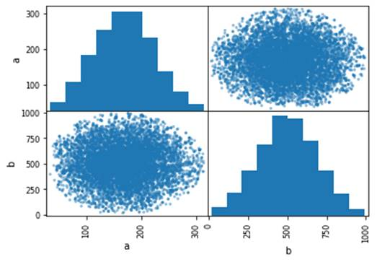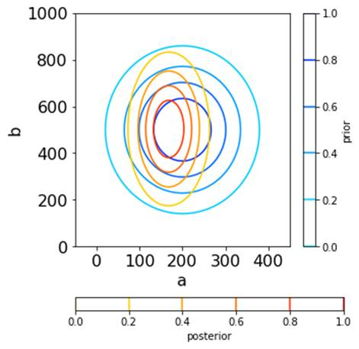

Here is the gridsearch (00f3):

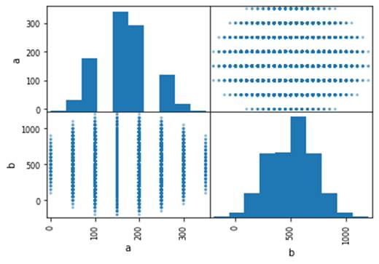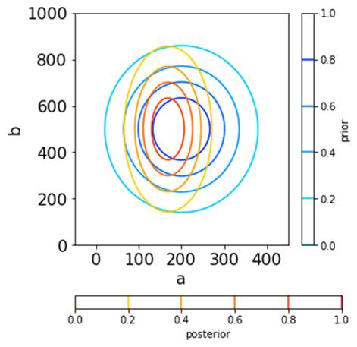

Here is the uniform random sampling (00f4):

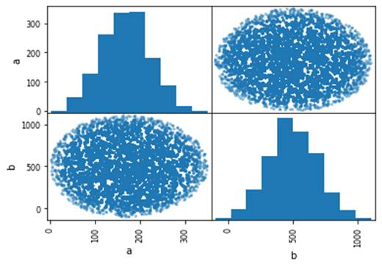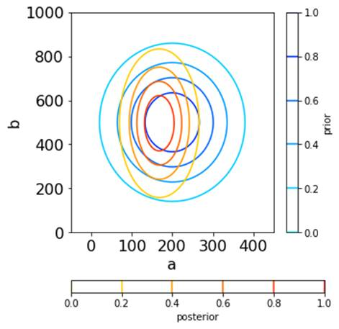

This feature is important because some response surfaces are too rough to sample properly with mcmc.  It was always a huge pain that some other packages had no way of doing this.  And with PEUQSE I implemented the grid search, but still hadn’t gotten that gridsearch to convert to a distribution.  Now I have gotten PEUQSE to do it, and it now happens automatically, almost like if we had done mcmc!

There are different initial distribution types that can be better for randomly sampling different response surfaces. A sobol initial distribution randomly samples like uniform, but contains less clustering. Sobol is generally a better choice than uniform, but it all depends on the system

Here is the sobol random sampling (00f8):

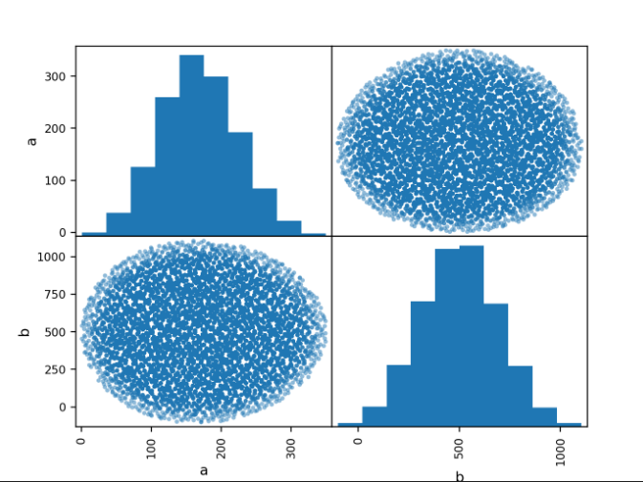 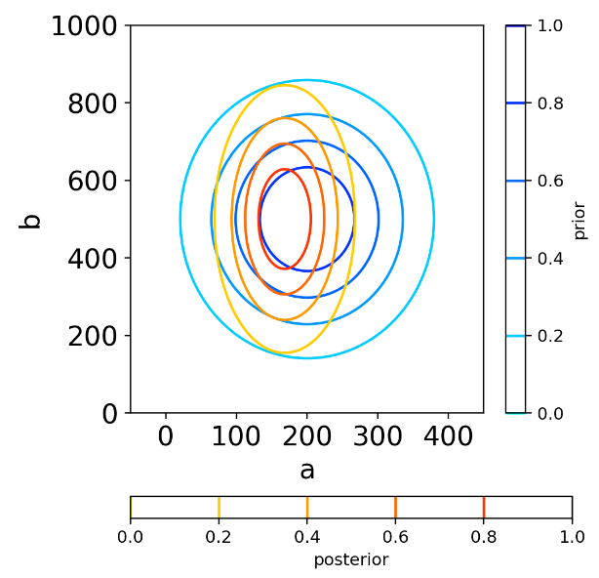

PEUQSE also contains different initial distribution types that concentrate different areas of the response surface. Astroidal distribution type is a random sampling that is concentrated at the initial guess. Shell distribution type is a random sampling that is concentrated at the edges or away from the initial guess. These distribution types might help a user understand specific regions of the response surface without generating as many points as a uniform or sobol would.

Here is the astroidal random sampling (00f9):

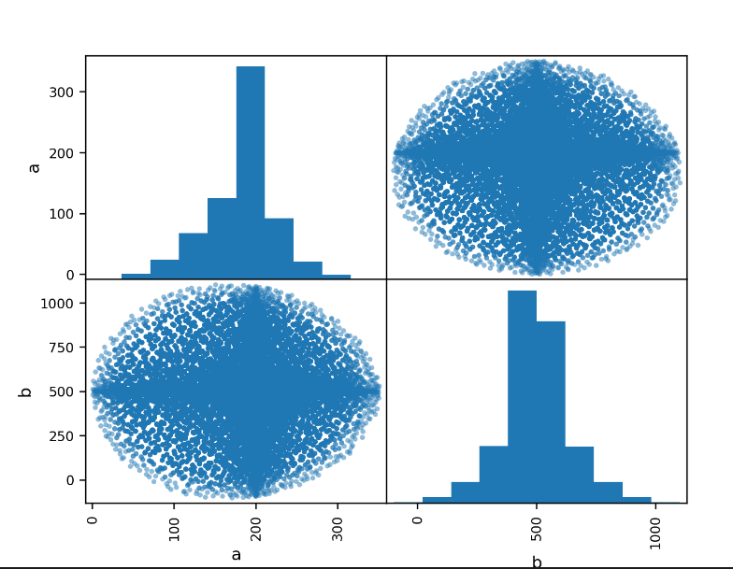 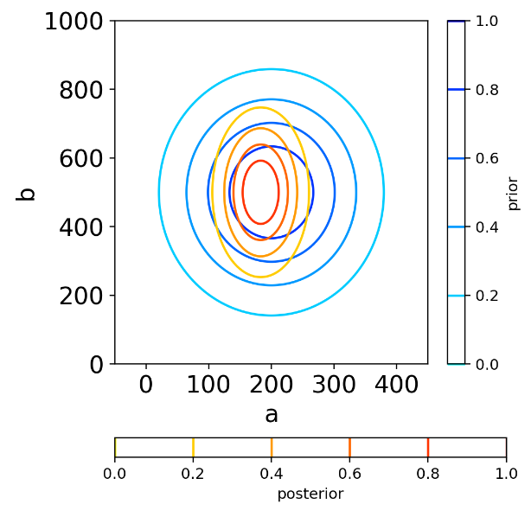

Here is the shell random sampling (00f10):

Note that shell sampling looks like it works badly for this problem because it is not designed for this type of distribution: shell sampling is used to ensure that solutions which are far away from the initial points are sampled. Thus, shell sampling may be useful for exploration in certain scenarios, and is not recommended as a thorough sampler.

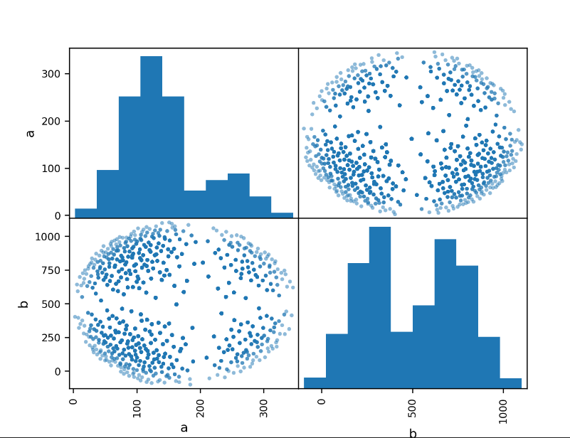 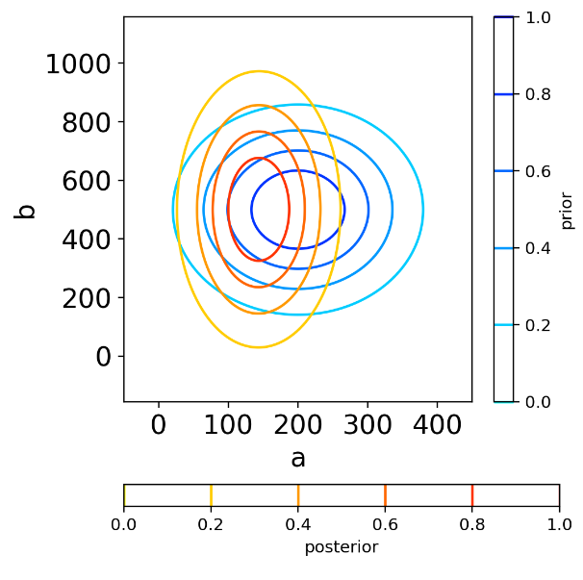

There is another example comparing c6 to c8 showing that the uniform distribution sampling (and of course also the grid sampling) can be performed for arbitrary distributions. Below is from the document 0-Example00Explanation.docx and shows the uniform distribution sampling giving the same answer as Metropolis Hastings, within error. However, as described in that document, knowledge of the HPD region and its size was utilized to make c8. Without that knowledge, c8 would have required very substantial excess sampling. Still, one could take the HPD interval according to mcmc and then do uniform random sampling in a region that is simply several times that size.

C6 sampling:

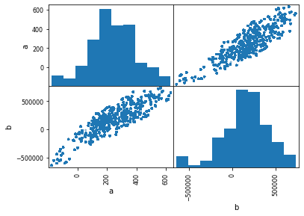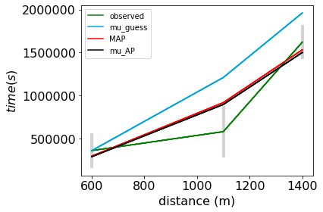

C8 uniform distribution random sampling:

