This document shows the different plotting options for scatter matrix plots and scatter heatmap plots. The first plots show the default settings according the UserInput.py in the PEUQSE module. The subsequent plots show the changes to the plots with adjusted plot settings. The plots are generated from the Example_00c4.

Default

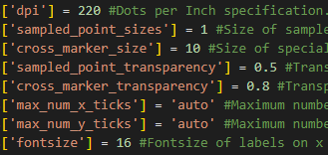

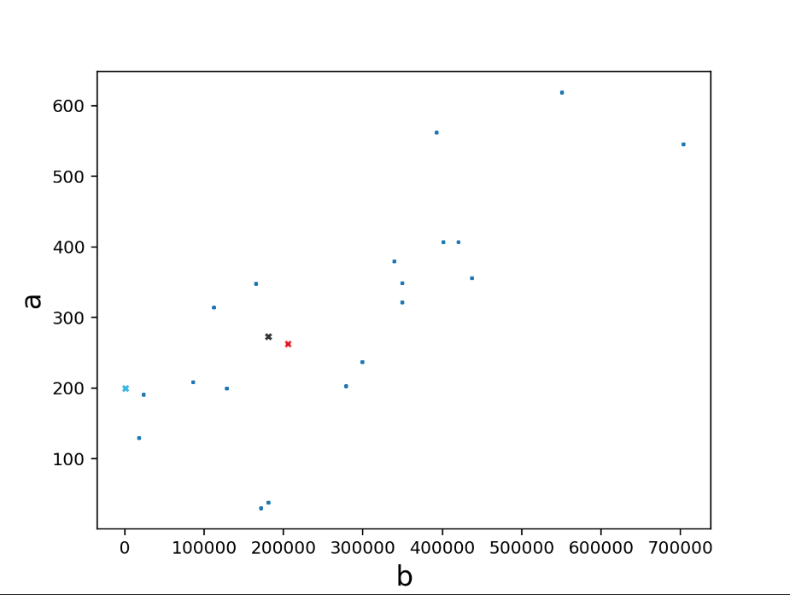

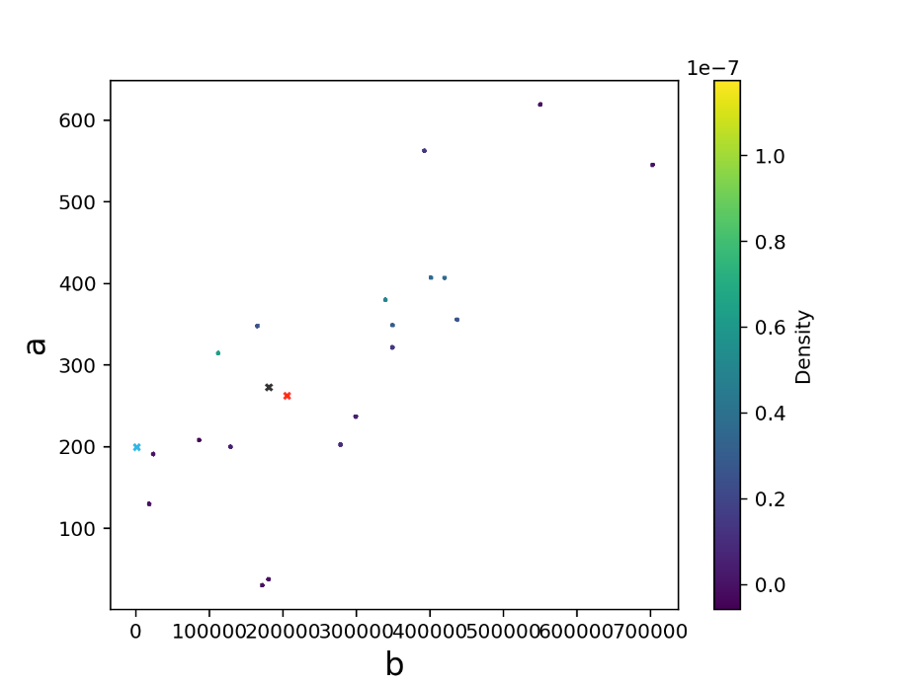

['dpi'] = 320 # this changes the resolution of the image. Higher values give a higher quality image.

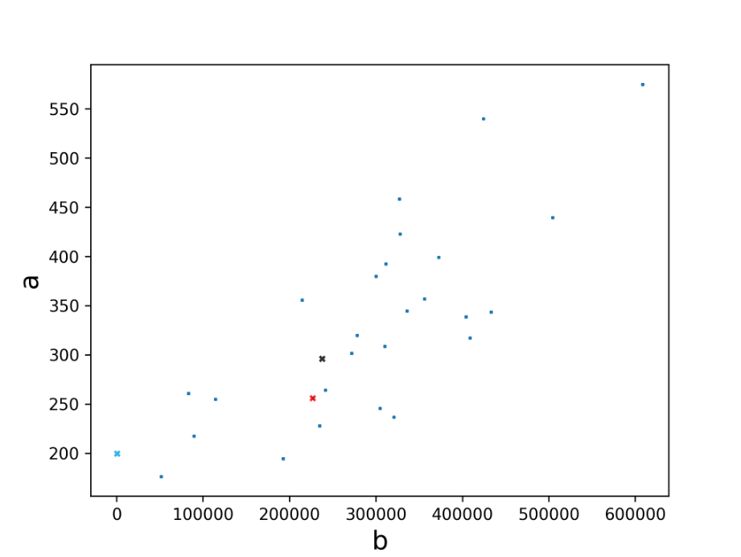

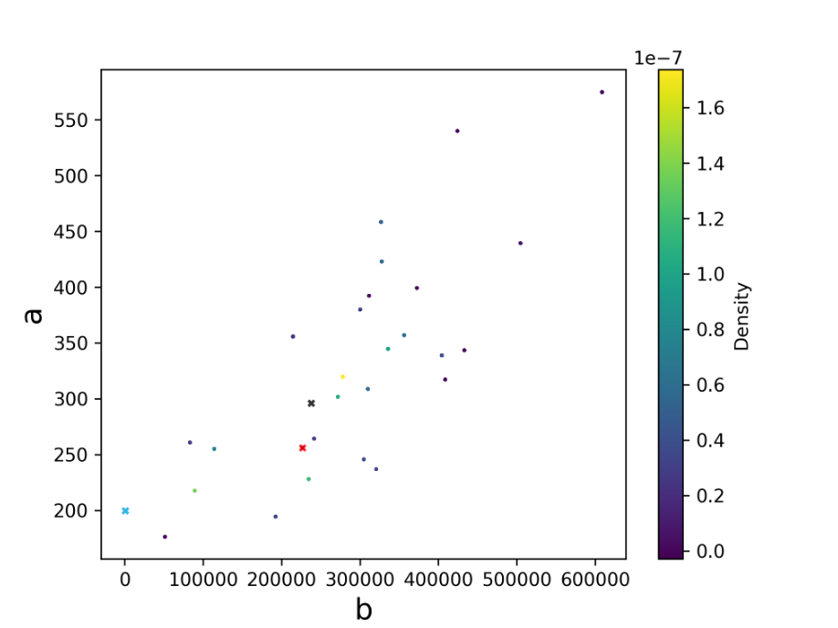

['sampled_point_sizes'] = 10 #changes the size of the blue dots (sampled points)

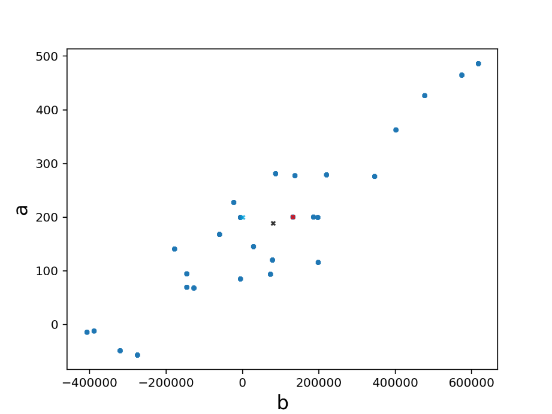

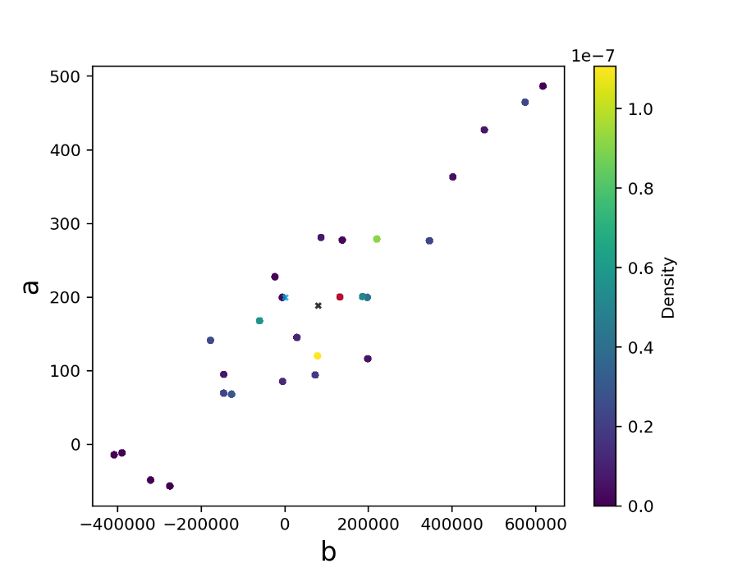

['cross_marker_size'] = 20 #this controls the size of the crosses in the plots.

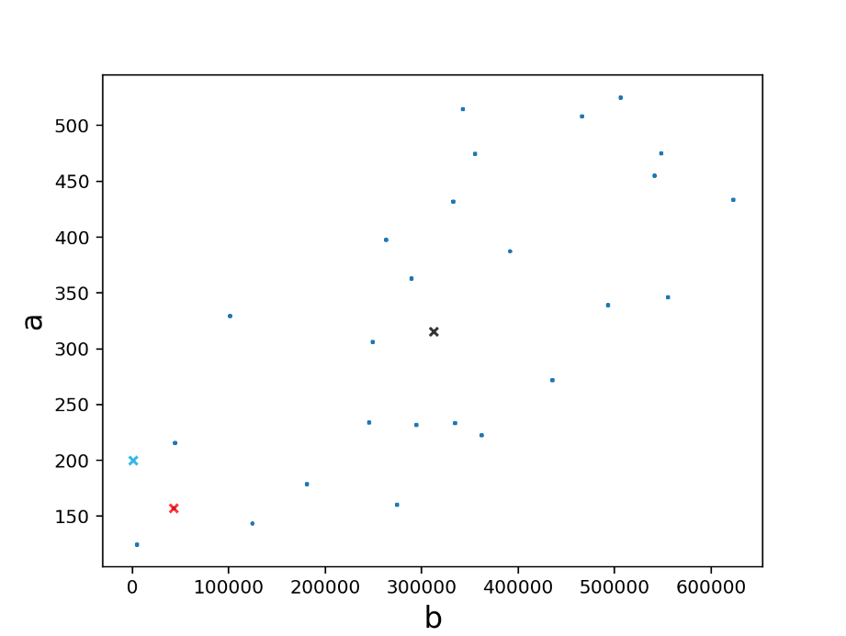

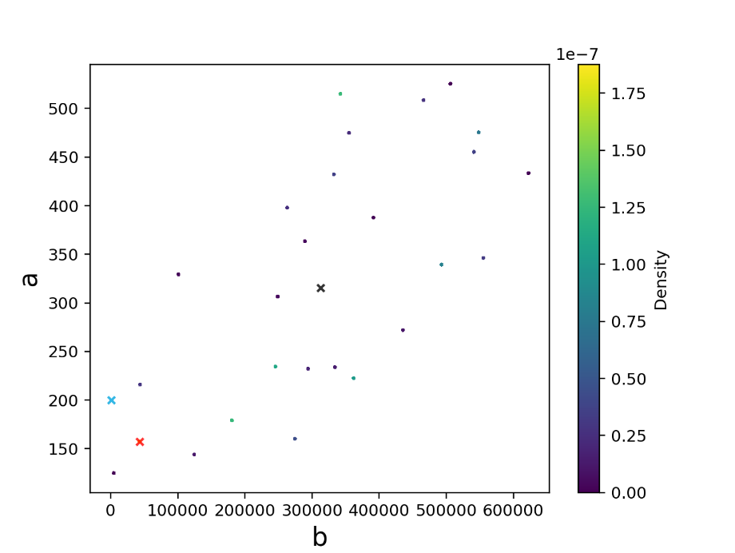

['cross_marker_size'] = 0 # this turns off the crosses

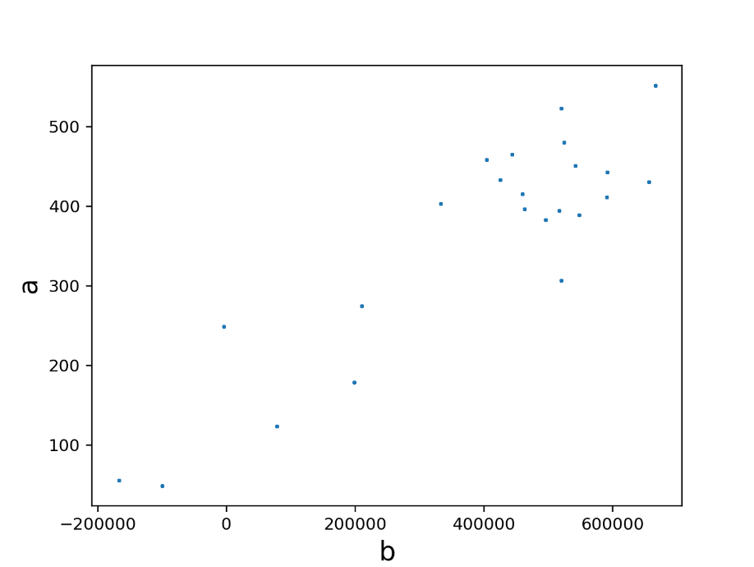

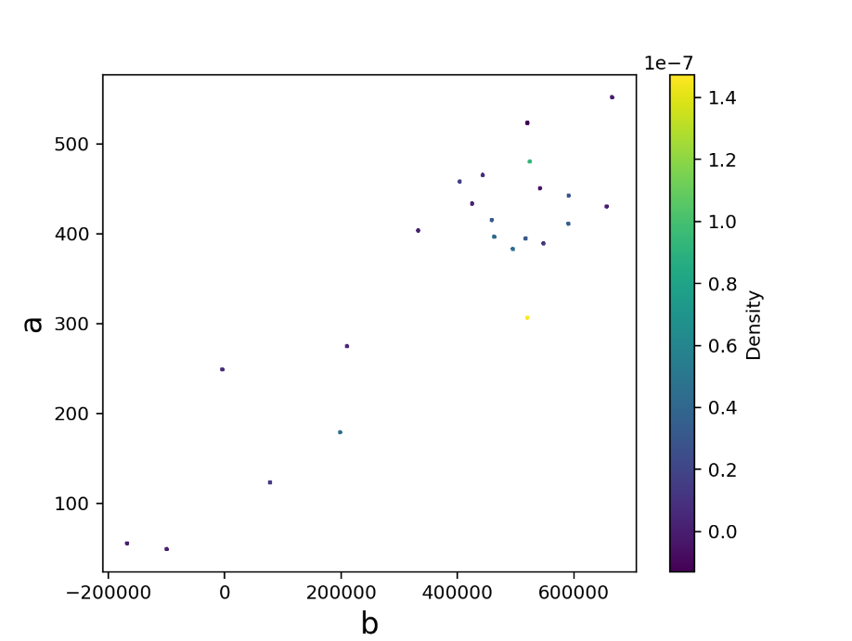

['sampled_point_transparency'] = 0.9 #the blue points became less transparent since the value increased. The points disappear as the value approaches 0.

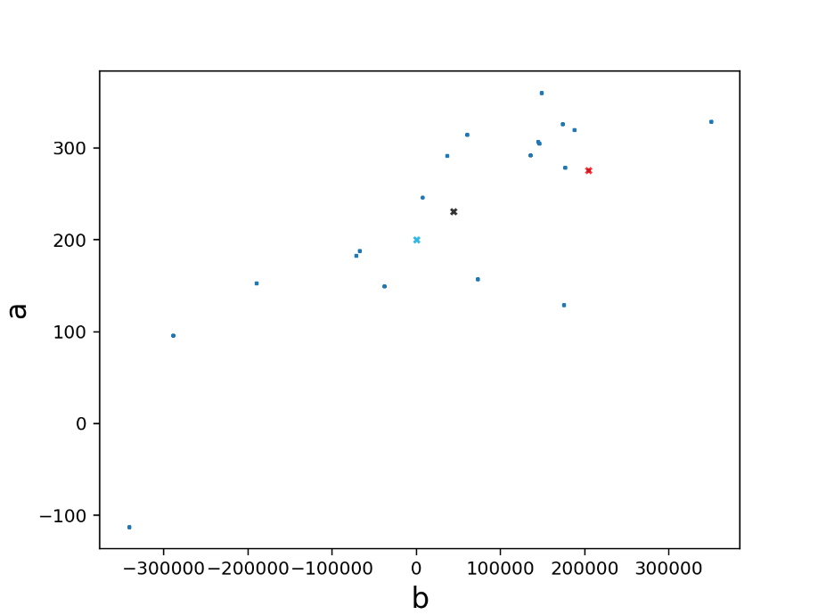

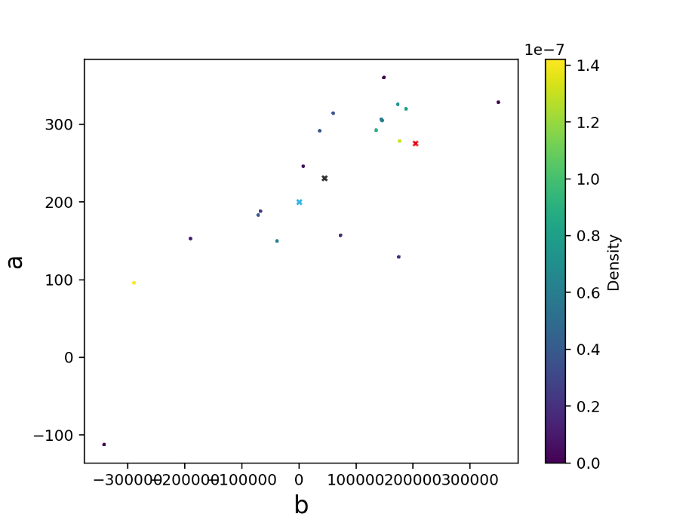

['cross_marker_transparency'] = 0.5 #the crosses became more transparent.

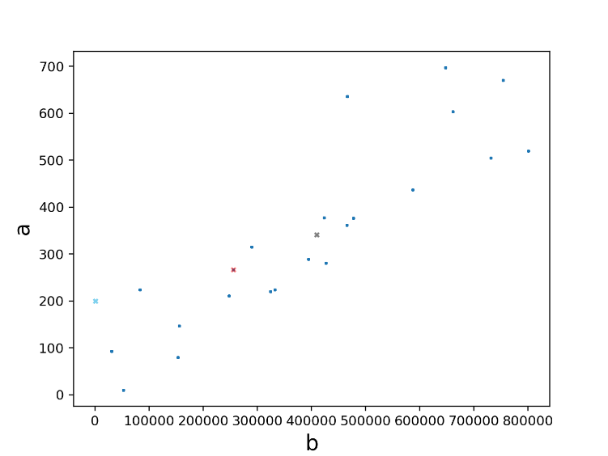

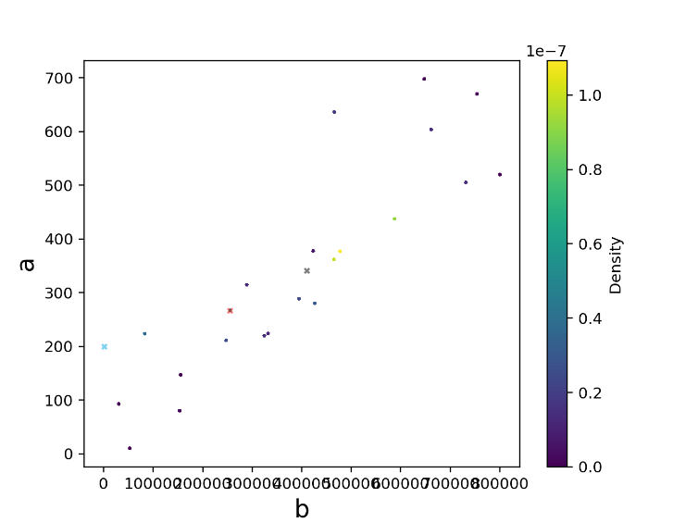

['max_num_x_ticks'] = 4 #changed the number of tick marks on x axis.

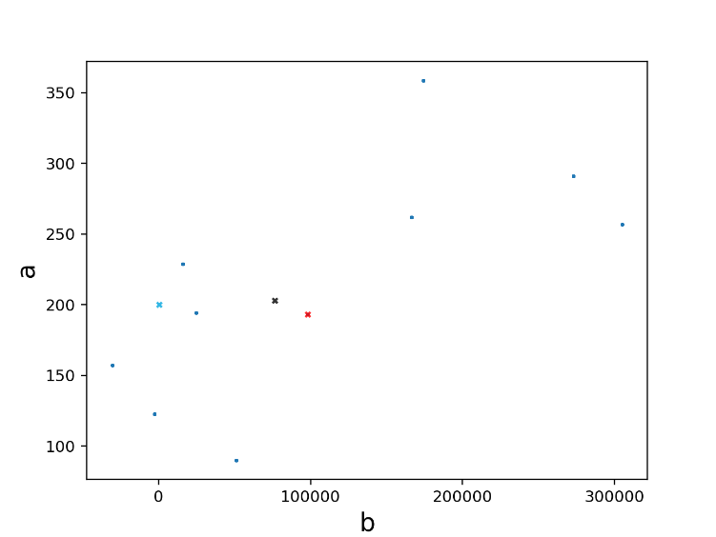

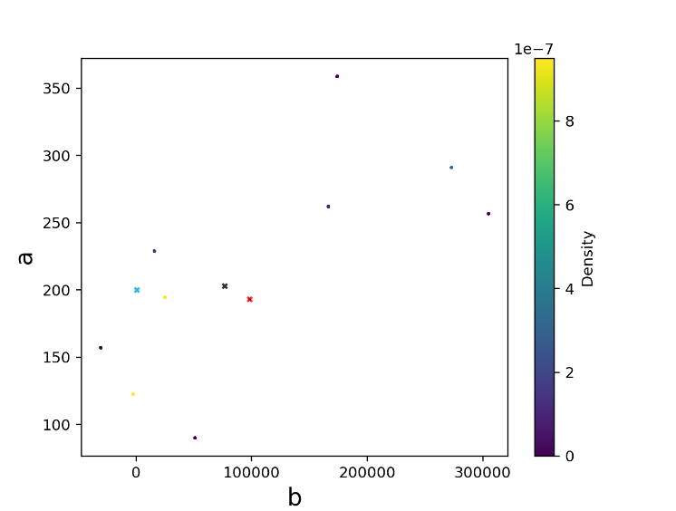

['max_y_ticks'] = 4 #changed the number of ticks on the y axis.

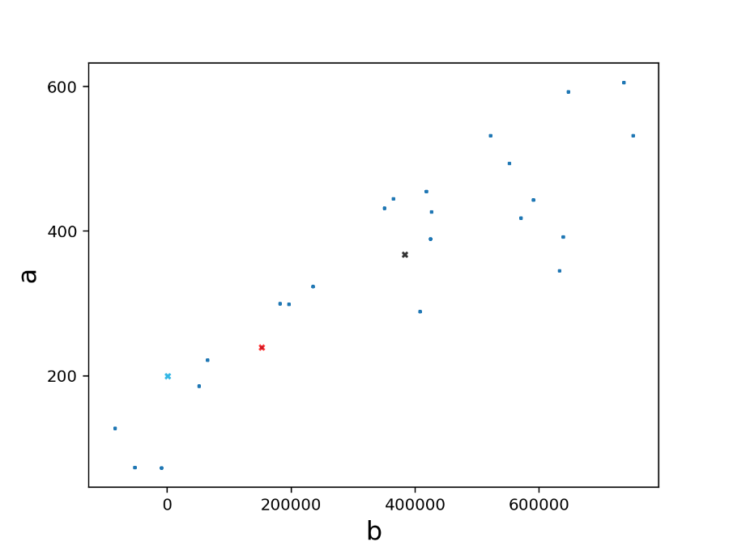

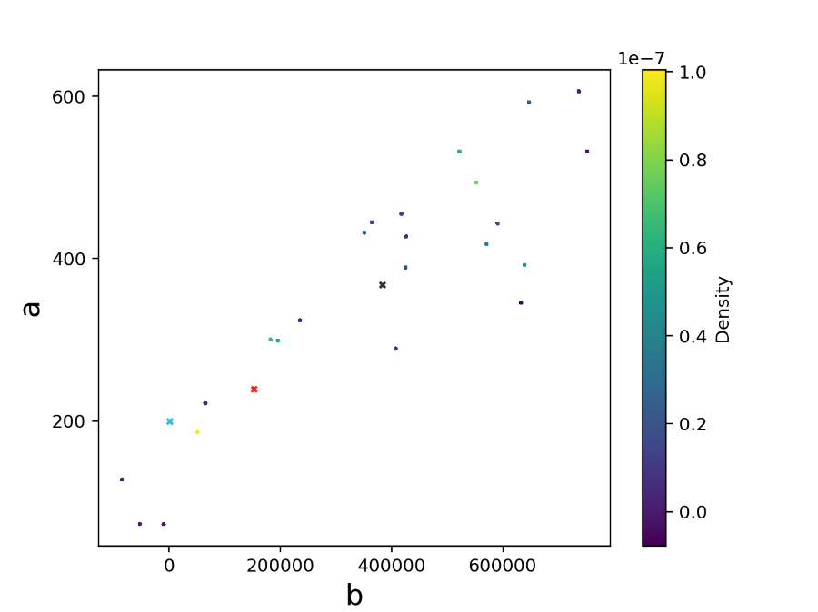

['fontsize'] = 22 #changed the font size of the x and y axis labels.

