Views

Here I am giving 5 view examples !

1. Create a view TRaveller_data from traveller table. This view contains only name and address of all travellers. And we are creating this in airline_management_company1 schema.

Query :

Create view TRaveller_data AS

SELECT t_naame, addres FROM airline_management_company1.traveller;

Execution Query :

SELECT * FROM TRaveller_data;

Output:

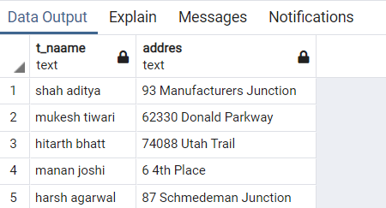

1. Create a view User_details from user table. This view contains only name and email id of all users. And we are creating this in airline_management_company1 schema.

Query :

Create view User_details AS

SELECT u_naame,u_email_id FROM airline_management_company1.users;

Execution Query :

SELECT * FROM User_details;

Output:

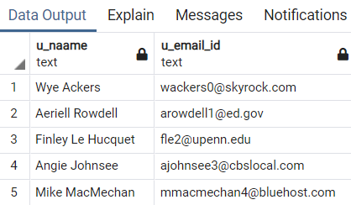

1. Create a view Airplane_seat_cap from airplane table. This view contains only airplane id of only those airplanes whose seat capacity is < 400. And we are creating this in airline_management_company1 schema.

Query :

Create view Airplane_seat_cap AS

SELECT airplane_id FROM airline_management_company1.airplane WHERE seat_capacity < 400;

Execution Query :

SELECT * FROM Airplane_seat_cap;

Output:

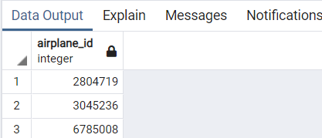

1. Create a view Airline_company_fare from airline company and fare tables. This view contains company name and final fare of only those airplanes whose company ids are similar. And we are creating this in airline_management_company1 schema.

Query :

Create view Airline_company_fare AS

SELECT aa.company_name, f.final_fare FROM airline_management_company1.airline_company aa, airline_management_company1.fare f WHERE aa.company_id = f.company_id;

Execution Query :

SELECT * FROM Airline_company_fare;

Output:

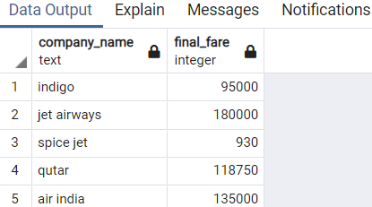

1. Create a view traveller_seatno from traveller and journey plan of traveller tables. This view contains traveller name, his/her seat number and class of only those travellers whose journey id is similar. And we are creating this in airline_management_company1 schema.

Query :

Create view traveller_seatno AS

SELECT j.seat_number, j.cllass, tt.t_naame FROM airline_management_company1.journey_plan_of_traveller j, airline_management_company1.traveller tt WHERE tt.traveller_id = j.traveller_id ;

Execution Query :

SELECT * FROM traveller_seatno;

Output:

