ISFCR Research Internship

University: PES University Department: MCA

Problem Statement: Blockchain-based digital evidence chain of custody tracker

Title: NyayaSetu – "Nyaya" (කç ¤) means "justice" and "Setu" (zೕൡ) means “bridge”.
NyayaSetu represents a "bridge to justice" through blockchain.

Team Members:

Member Name | SRN
HARSHITH J | PES1PG23CA053
D S SUCHITRA | PES1PG23CA037
KARANAM SAI PRANAVI | PES1PG23CA067

Abstract:

NyayaSetu is a blockchain-powered legal solution designed to securely digitize legal proceedings, track case progress and manage evidence files while ensuring their integrity, confidentiality and transparency. By leveraging blockchain technology, the system guarantees that every action related to digital evidence - from its collection and acquisition to access, sharing and presentation in court - is immutably recorded, preventing tampering and ensuring a verifiable chain of custody.
User authentication is securely managed using Aadhaar UID and MetaMask Wallet, ensuring that only authorized individuals - such as Admin, Investigation officer, collector and Forensic analyst - can interact with the system. Role-based access control (RBAC) ensures that only designated users can view or handle case-related files. Investigation officer specific to a case can upload case progress updates and associated evidence, with every action - uploads, access, sharing - being logged as blockchain transactions, creating a tamper-proof and auditable history of interactions.

To protect the confidentiality and authenticity of digital evidence, files are encrypted using AES-256 before being stored on IPFS. The
cryptographic hash of each file ensures file integrity verification, allowing authorized users to confirm that evidence remains unaltered. Additionally, the Content Identifier (CID) is encrypted and stored on the blockchain, ensuring that even metadata remains secure. Access logs provide complete transparency over who accessed or modified any file, enhancing accountability.
NyayaSetu serves as a comprehensive platform for digital case management and legal proceedings, ensuring that all case-related files and progress updates are securely stored and accessible only to authorized parties. By combining blockchain’s immutability with encryption, file integrity verification, CID security and access
control, the system establishes a trusted, auditable and tamper-resistant framework for handling digital evidence in legal proceedings.

Features of NyayaSetu:

Secure Authentication:

- MetaMask Wallet and Aadhaar UID-based authentication.
- JWT stores user role, Aadhaar and MetaMask details for secure session handling.
- Ensures only authorized users can access the system.

Role-Based Access Control (RBAC):

- Collector – Uploads evidence for assigned cases only.
- Forensic Analyst – Analyzes evidence and performs forensic analysis for assigned cases.
- Investigating Officer – Registers cases, uploads evidence and performs forensic analysis for assigned cases.
- Admin – Full authority to create, modify, delete cases and assign roles.
- Granular access control ensures that only authorized users can perform specific actions.

Case Management:

- Investigating Officer registers cases and manages case progress.

- Judges and lawyers can update case status and add evidence- related reports.
- Secure and auditable tracking of case-related files and updates.

Evidence Encryption:

- Files are encrypted using AES-256 before storage on IPFS.
- Ensures confidentiality and prevents unauthorized access.

CID Encryption:

- Content Identifier (CID) generated for each file is encrypted.
- CID is encrypted using AES-256 before being stored on the blockchain to secure metadata.

File Integrity Verification:

- Cryptographic hash (SHA-256) generated for each file.
- Ensures file integrity and authenticity during retrieval and verification.
- Confirms that evidence remains unchanged after upload.

Forensic Analysis Management

- Forensic Analyst accesses evidence and performs analysis.
- Analysis reports are securely uploaded and logged on the blockchain.
- Ensures accuracy and immutability of forensic findings.

Controlled Evidence Sharing

- Secure evidence sharing with revocable access permissions.
- Ensures that only authorized users can access shared files.

Transparent Access Logs

- Every action (upload, access, modification) is logged as a blockchain transaction.

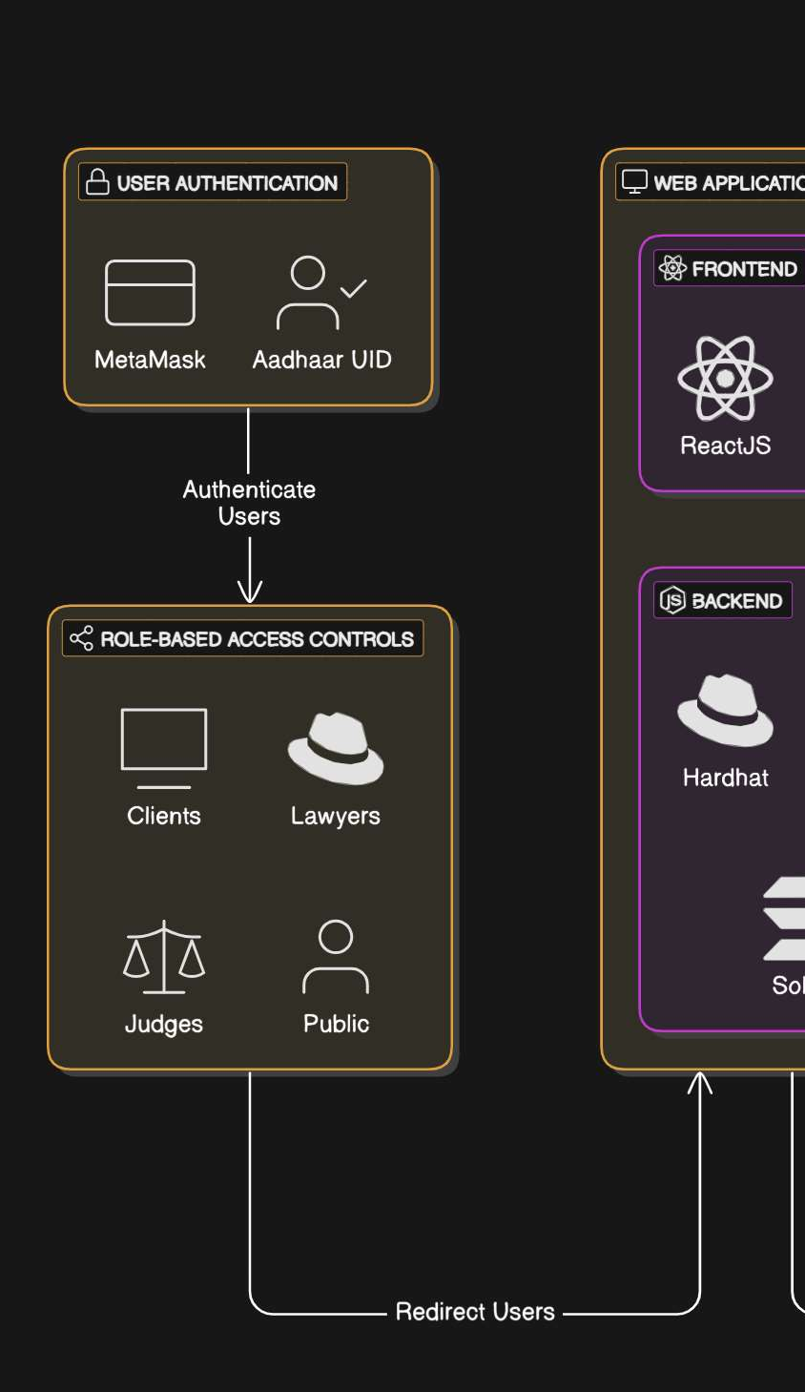
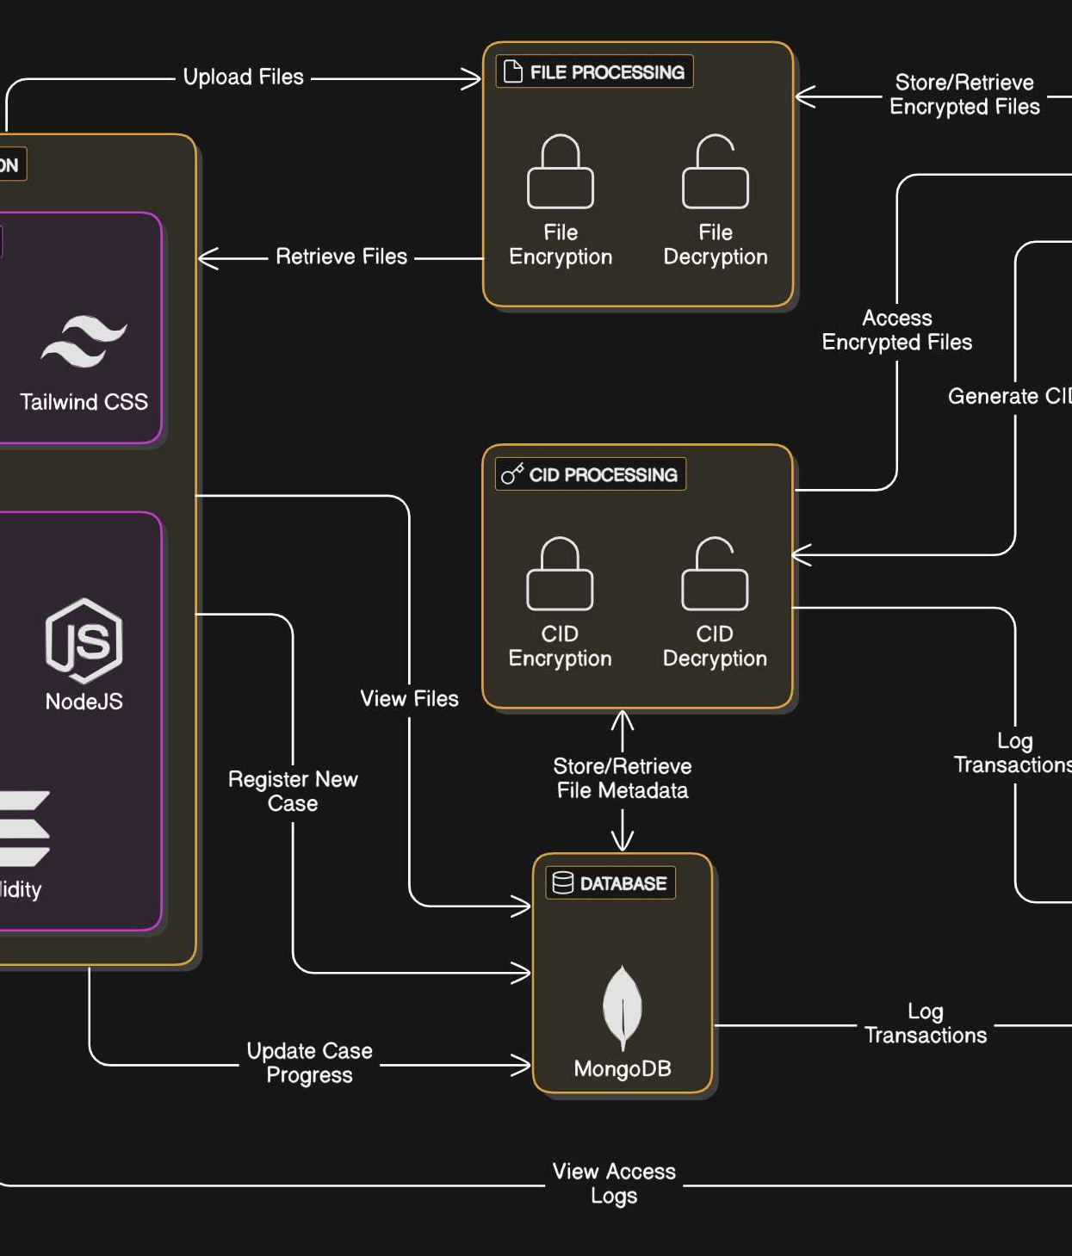
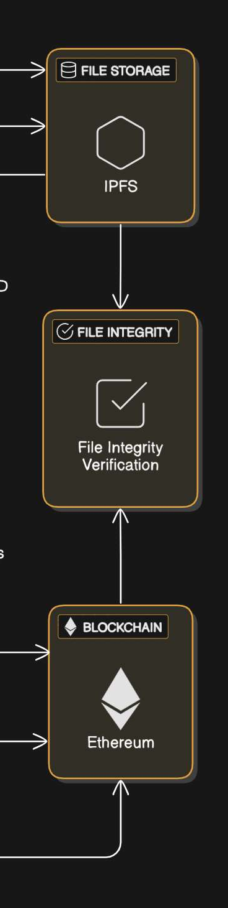

- Provides a tamper-proof and auditable history of interactions.

Modules Pending:

- Role-Based Access Control (RBAC)
- Controlled Evidence Sharing
- User Management
- Immutable Log
- Blockchain Implementation to certain modules

Architecture diagram

