**Exercise 1: Freestyle Job - Windows File Transfer Automation**

1. Objective: Automate file transfer between two directories on a Windows machine.
2. Steps:
   * Create a Freestyle Job in Jenkins.
   * Configure the job to execute a Windows batch command:
   * xcopy C:\source-directory C:\target-directory /E /I /H /Y
   * Add a post-build action to check the success of the transfer using a
   * custom message.
3. Task: Test the job by placing some files in the source directory and verifying they
4. are transferred to the target directory.

**Configurations**

**Windows Batch Command :**

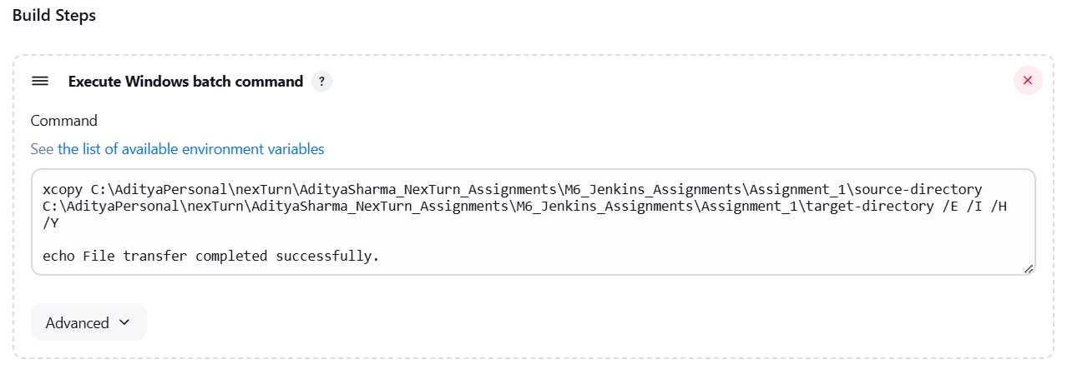

**Console Output :**

