**Exercise 2: Freestyle Job - Build and Deploy a JavaScript Project**

1. Objective: Build and deploy a JavaScript-based web project.
2. Steps:
   1. Create a Freestyle Job.
   2. Configure the job to:

▪ Clone a JavaScript repository (e.g., a React project) from GitHub.

▪ Run npm install to install dependencies.

▪ Build the project using npm run build.

▪ Copy the build folder to a deployment directory using a Windows batch command or PowerShell.

* 1. Archive the build artifacts for future reference.

1. Task: Verify the deployment by accessing the web application from the
2. deployment directory.

**Configurations**

**Parameterised :**

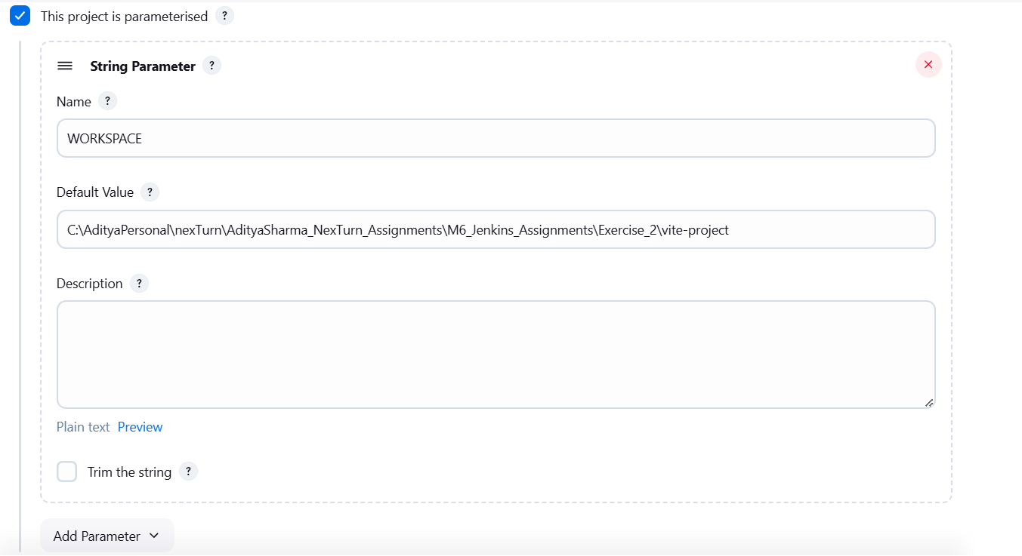

**Source Code Management (SCM) :**

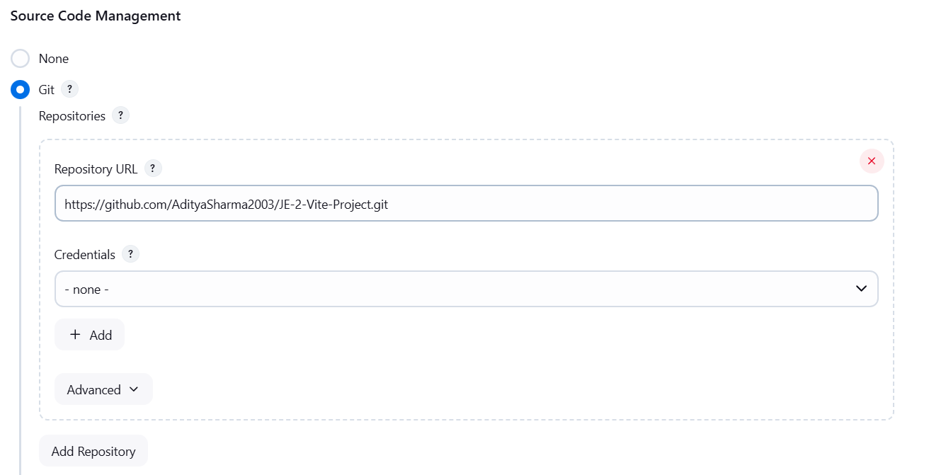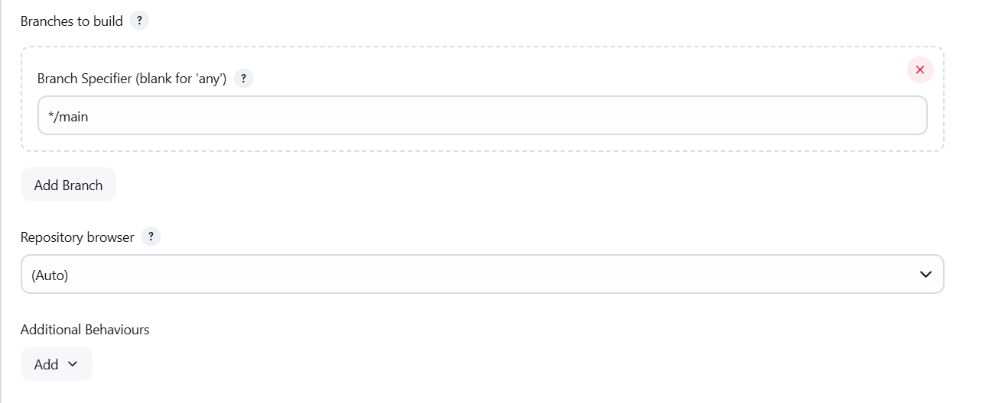

**Windows Batch Command :**

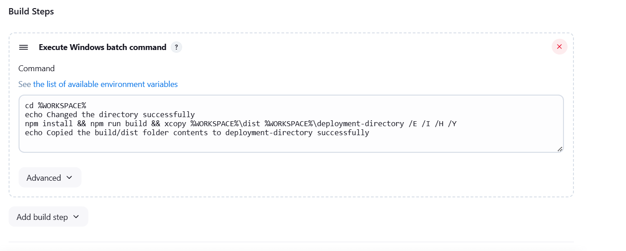

**Console Output :**

