**Exercise 3: Freestyle Job - Flask Application Deployment**

1. Objective: Automate the deployment of a Flask application.
2. Steps:
   1. Create a Freestyle Job.
   2. Configure the job to:

▪Pull the Flask application repository from GitHub.

▪ Set up a virtual environment using Python:

python -m venv venv

.\venv\Scripts\activate

pip install -r requirements.txt

▪ Start the Flask development server.

* 1. Add a post-build action to verify the server is running (e.g., using curl or a

1. similar tool to hit a test endpoint).
2. Task: Test the application deployment by accessing it via localhost

**Configurations**

**Source Code Management :**

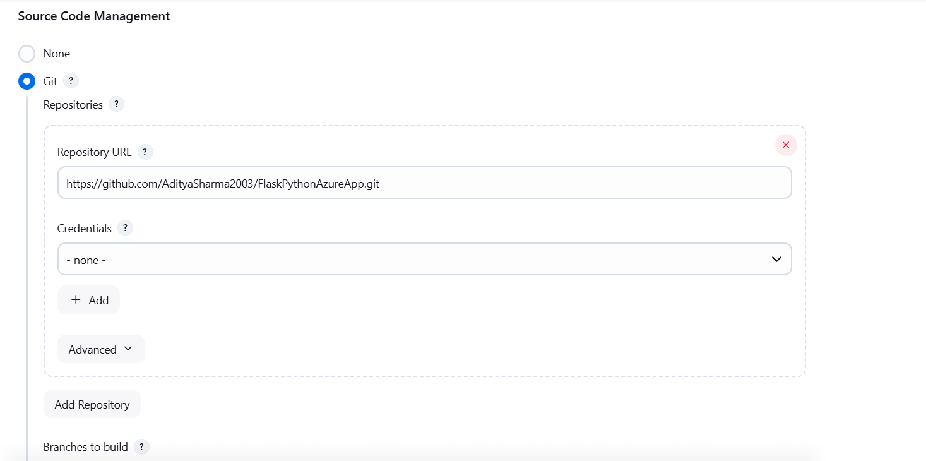

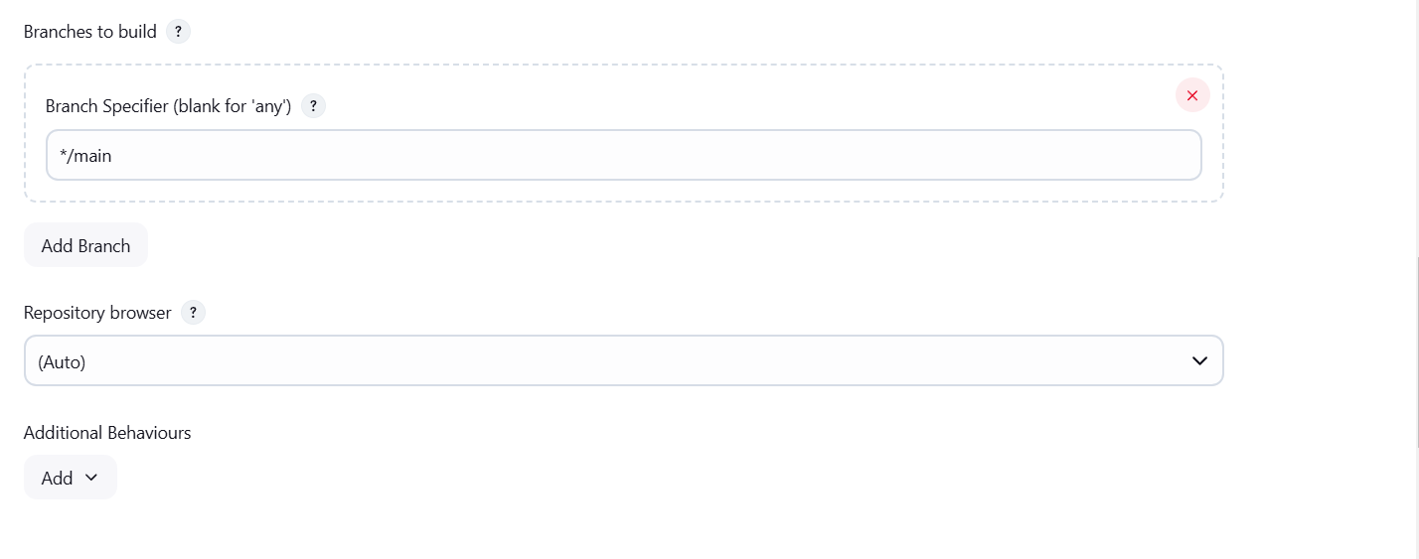

**Windows Batch Command :**

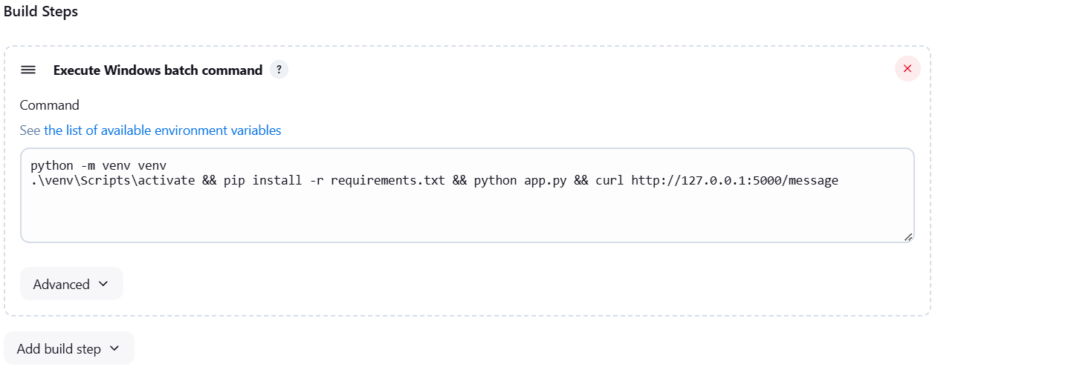

**Console Ouput :**

