**Exercise 4: Pipeline Job - End-to-End CI/CD for a React Application**

1. Objective: Implement a CI/CD pipeline for a React web application.
2. Steps:
   1. Create a Pipeline Job.
   2. Write a Jenkinsfile to:

▪ Clone the React project from GitHub.

▪ Install dependencies (npm install).

▪ Run tests (npm test).

▪ Build the project (npm run build).

▪ Deploy the application by copying the build folder to a deployment directory.

* 1. Add stages for:

▪ Linting using ESLint.

▪ Post-deployment testing using curl to verify the app is running.

1. Task: Run the pipeline and validate each stage's output.

**Configurations**

**Pipeline :**

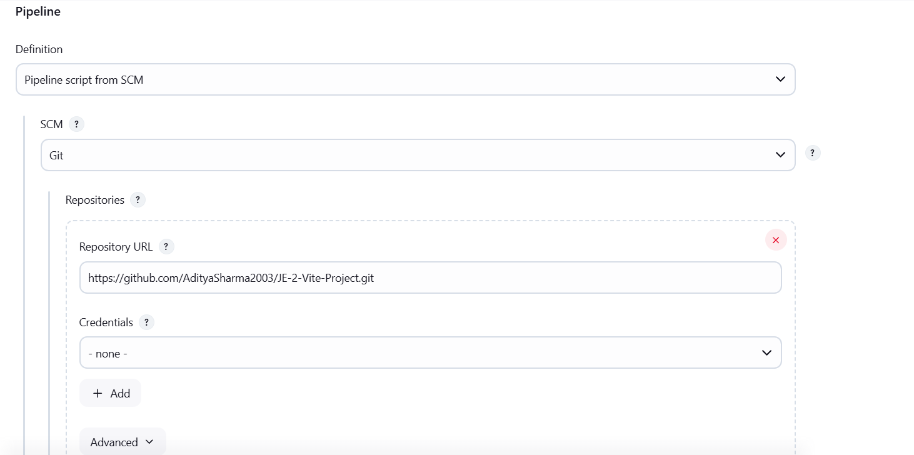

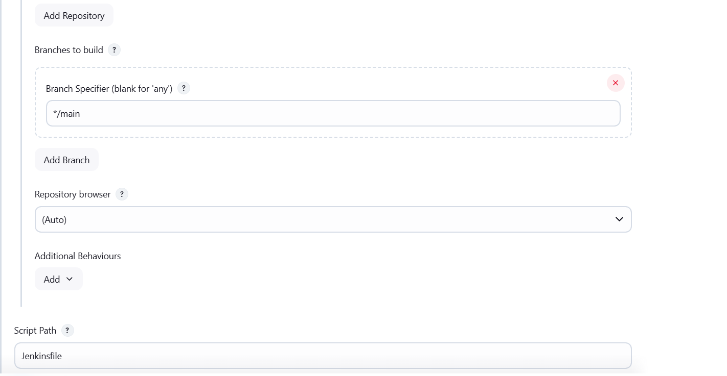

**Console Output :**

