**Exercise 5: Pipeline Job - Deploy a Flask Application with Gunicorn**

1. Objective: Automate the deployment of a Flask application with Gunicorn on Windows.
2. Steps:
   1. Create a Pipeline Job.
   2. Write a Jenkinsfile to:

▪ Clone a Flask application from GitHub.

▪ Set up a Python virtual environment.

▪ Install required packages using pip install -r requirements.txt.

▪ Configure and start the Gunicorn server:

gunicorn -b 127.0.0.1:8000 app:app

▪ Verify the deployment using a curl command in the pipeline.

* 1. Add stages for:

▪ Unit tests using pytest.

▪ Post-deployment endpoint checks.

1. Task: Trigger the pipeline and ensure the Flask app is accessible on localhost

**Configurations**

**Pipeline :**

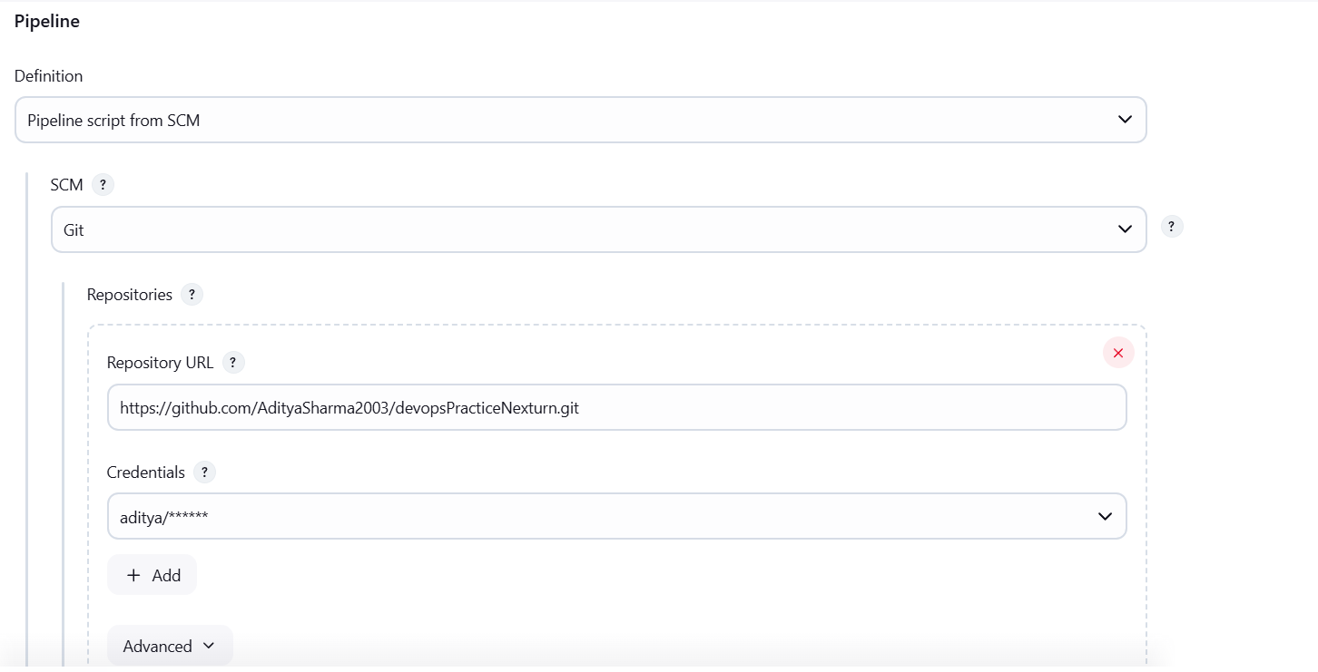

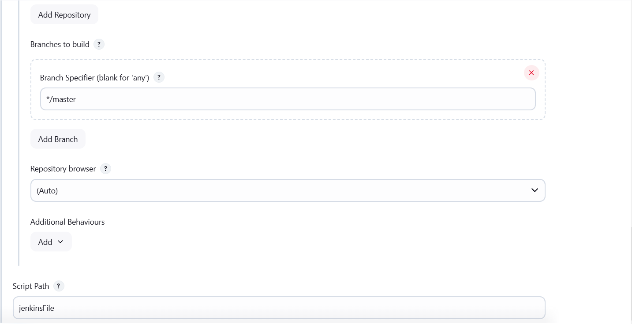

**Console Output :**

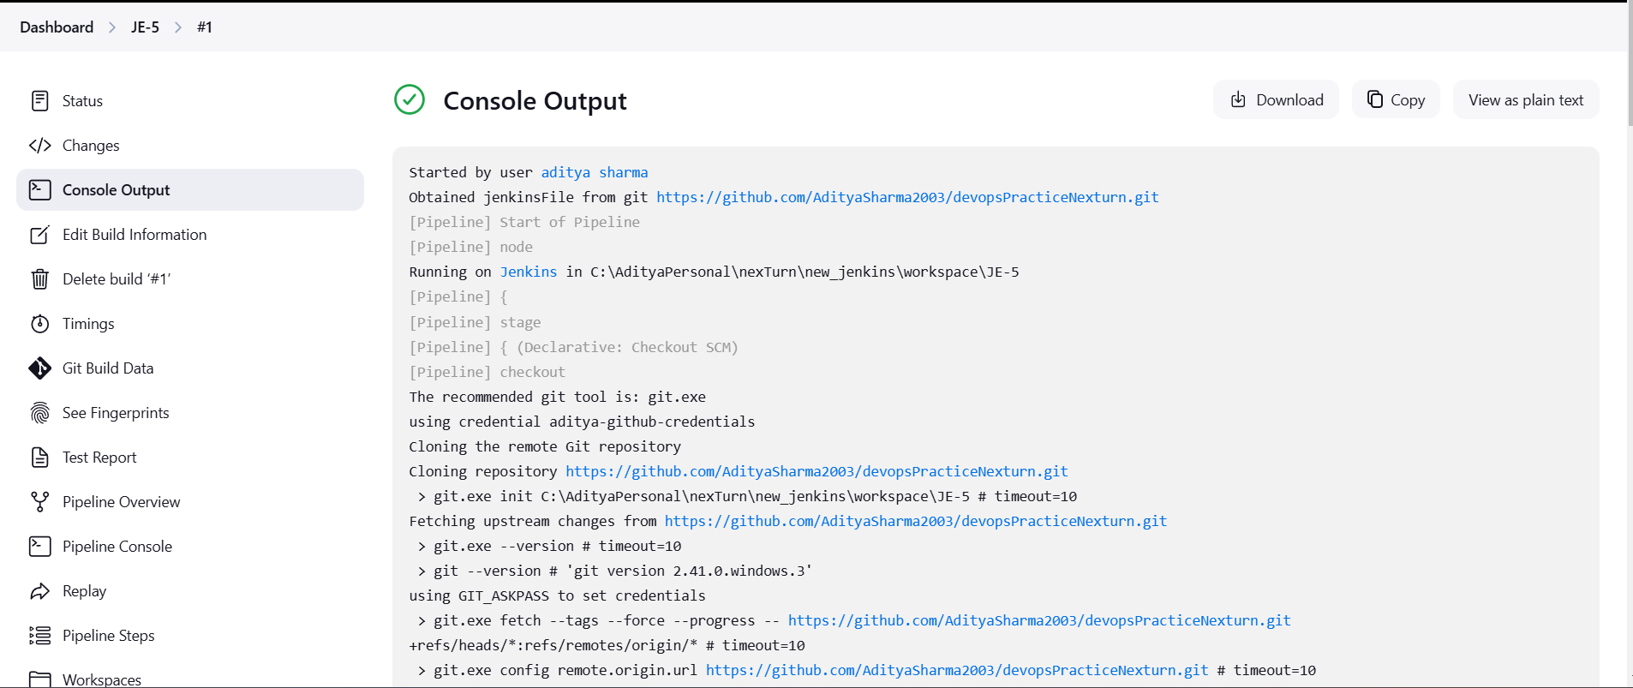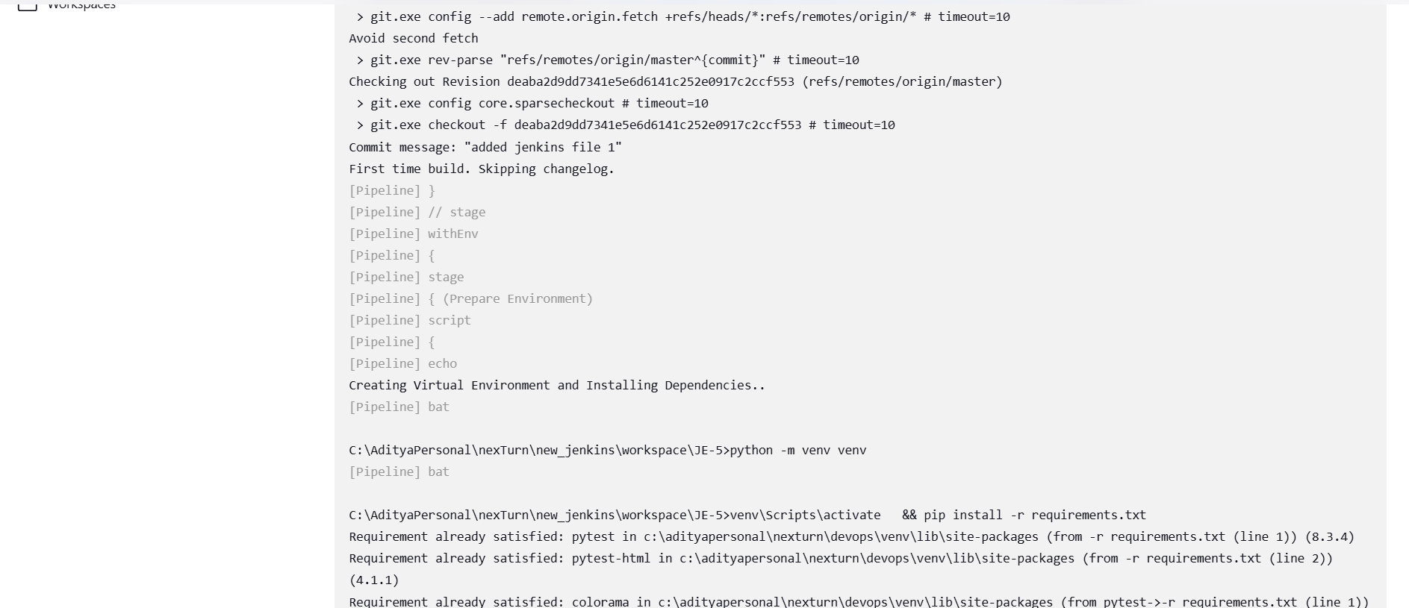

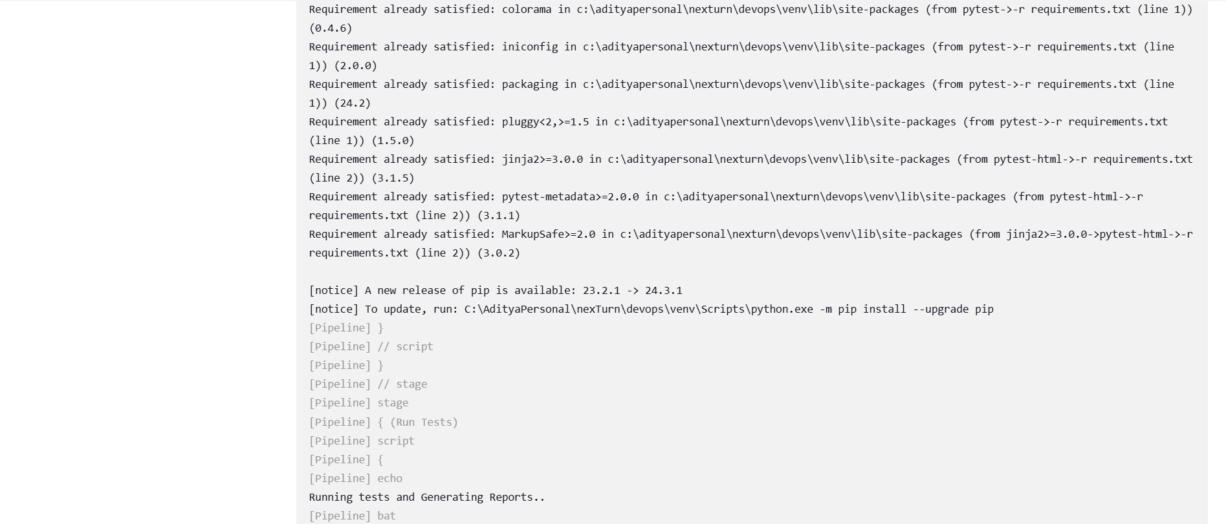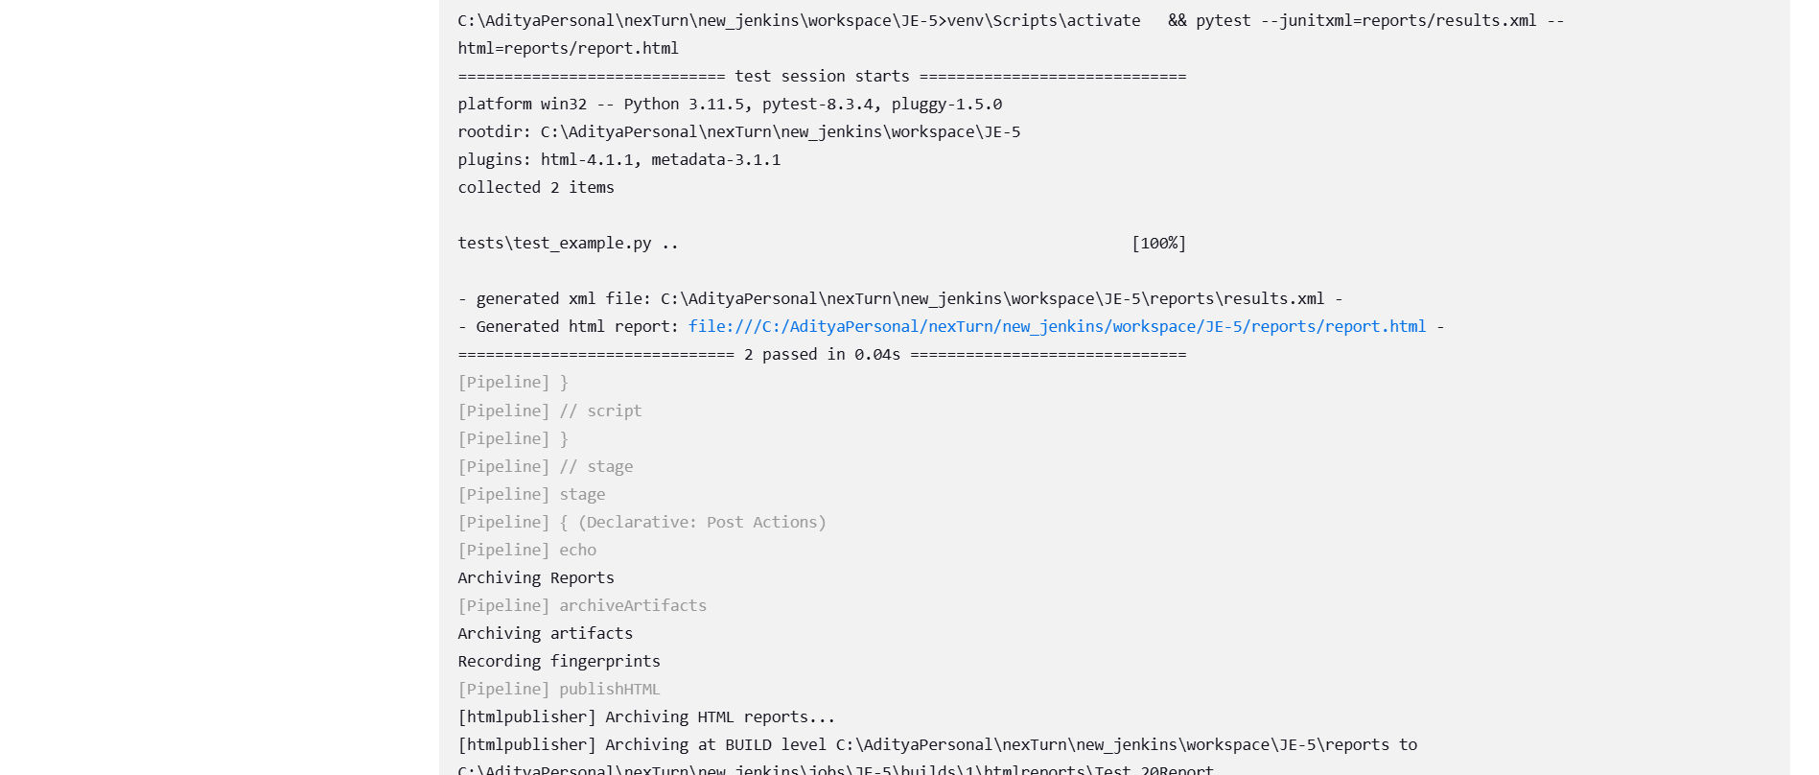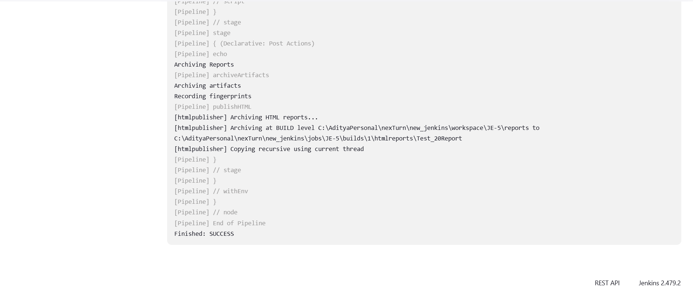

**Reports.html :**

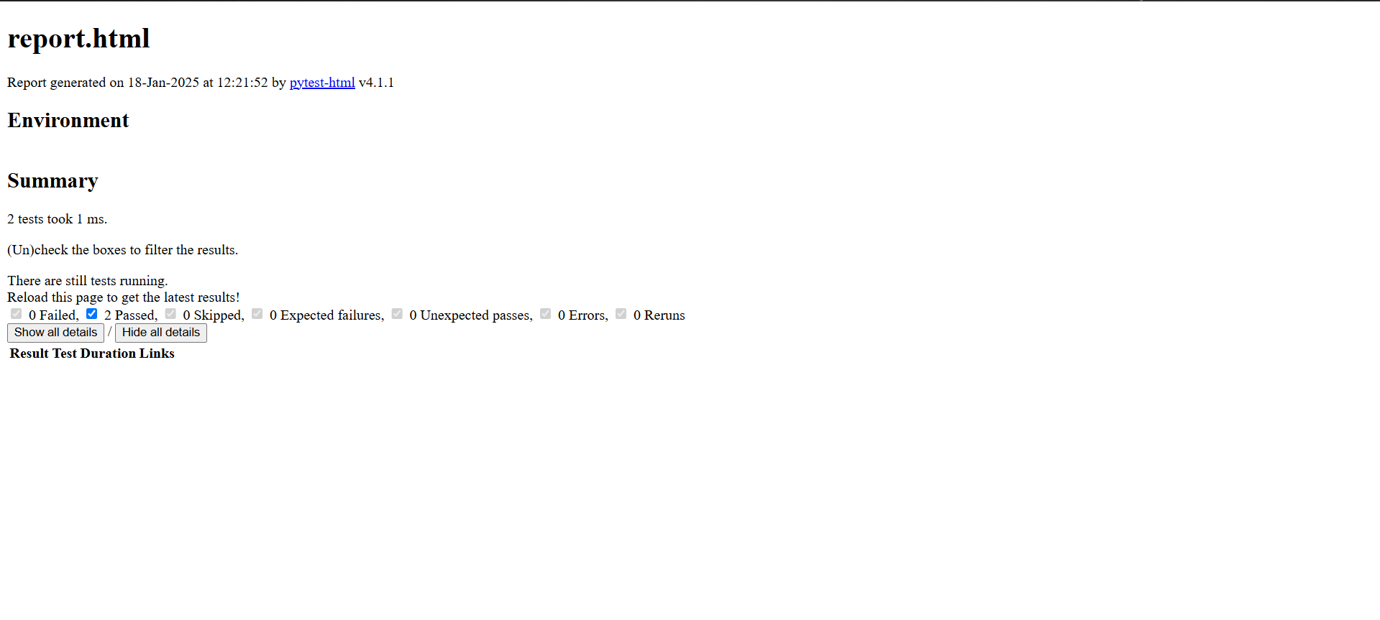

**Results.xml :**

