QuickStart Guide: Java Eclipse Terminal Setup

This is a quickstart guide on how to get started on setting up and using the program. If you already imported the program into eclipse or IntelliJ, then skip to Step 4 to setup the external JAR libraries.

Step 1: Clone the repo

Step 2: Open the project to the following directory/workspace inside the repo using Eclipse, or IntelliJ or the IDE of your choice: ‘JAVA-ECLIPSE-TERMINAL’. Alternatively, you can also import the project using *JAVA-ECLIPSE-TERMINAL.zip file*

Step 3: Setup the JSON Jackson API Jars to process JSON files. This is shown on page 4

***If you need more detail on changing workspaces, below shows how to change the workspace to the directory given above in Eclipse.***

**Step A**: Navigate to the ‘JAVA-ECLIPSE-TERMINAL’ folder inside the directory of the repo.

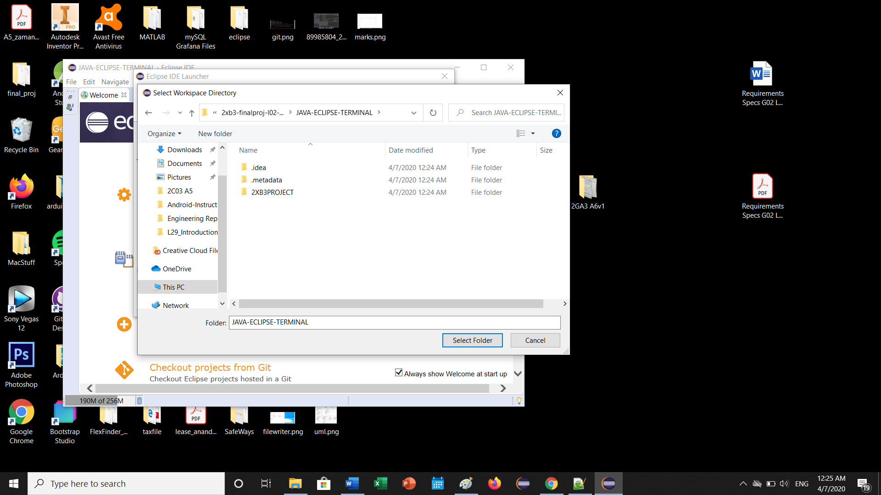

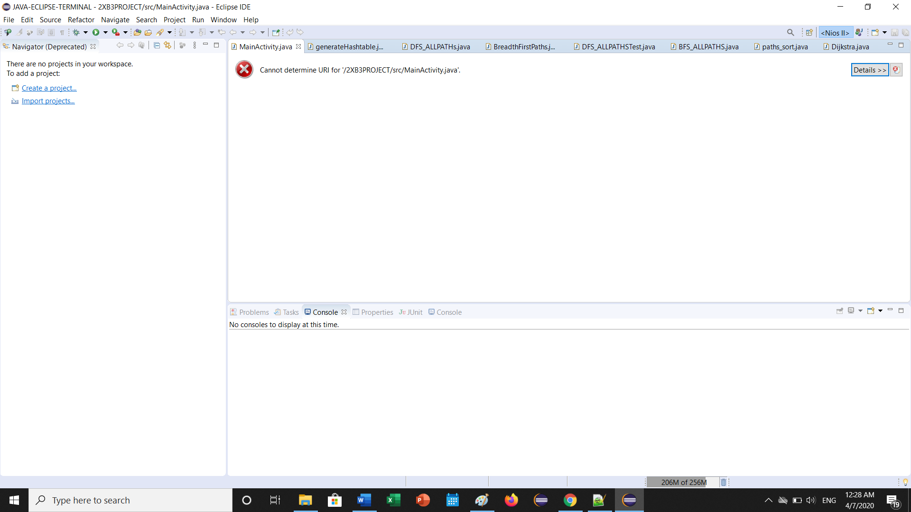

**Step B:** **If you get the following error above follow the next few steps. Otherwise, skip to step D.**

To fix this error, navigate to *File ->Open Projects from File System*. Then click ‘Directory’. The window below should appear. Click ‘Select Folder’.

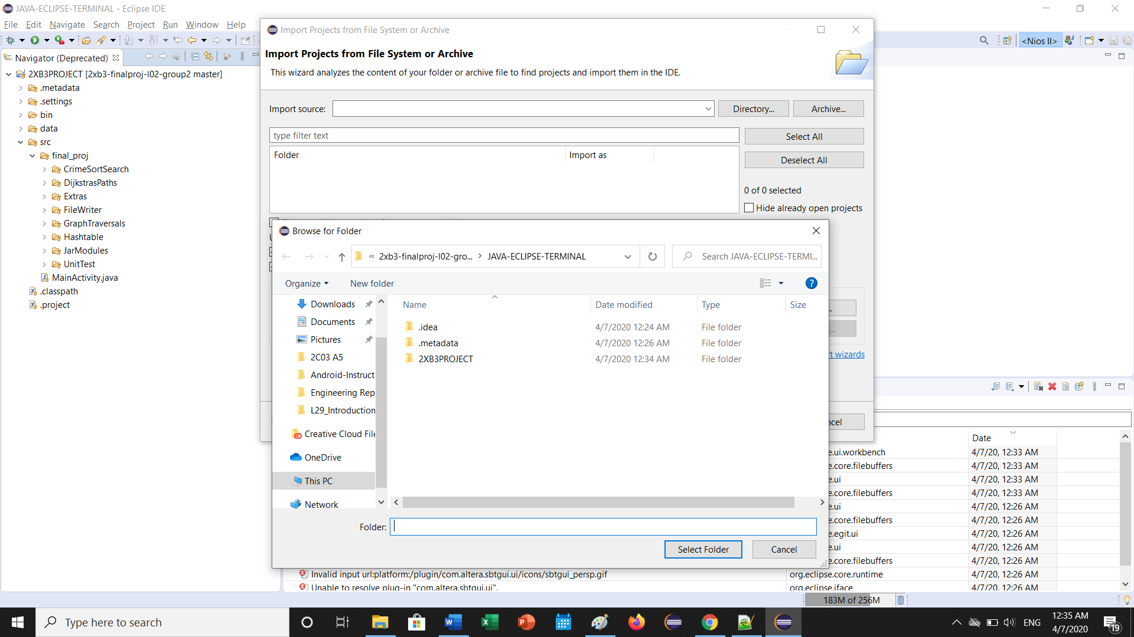

**Step C:** Select all the options available, then click Finish

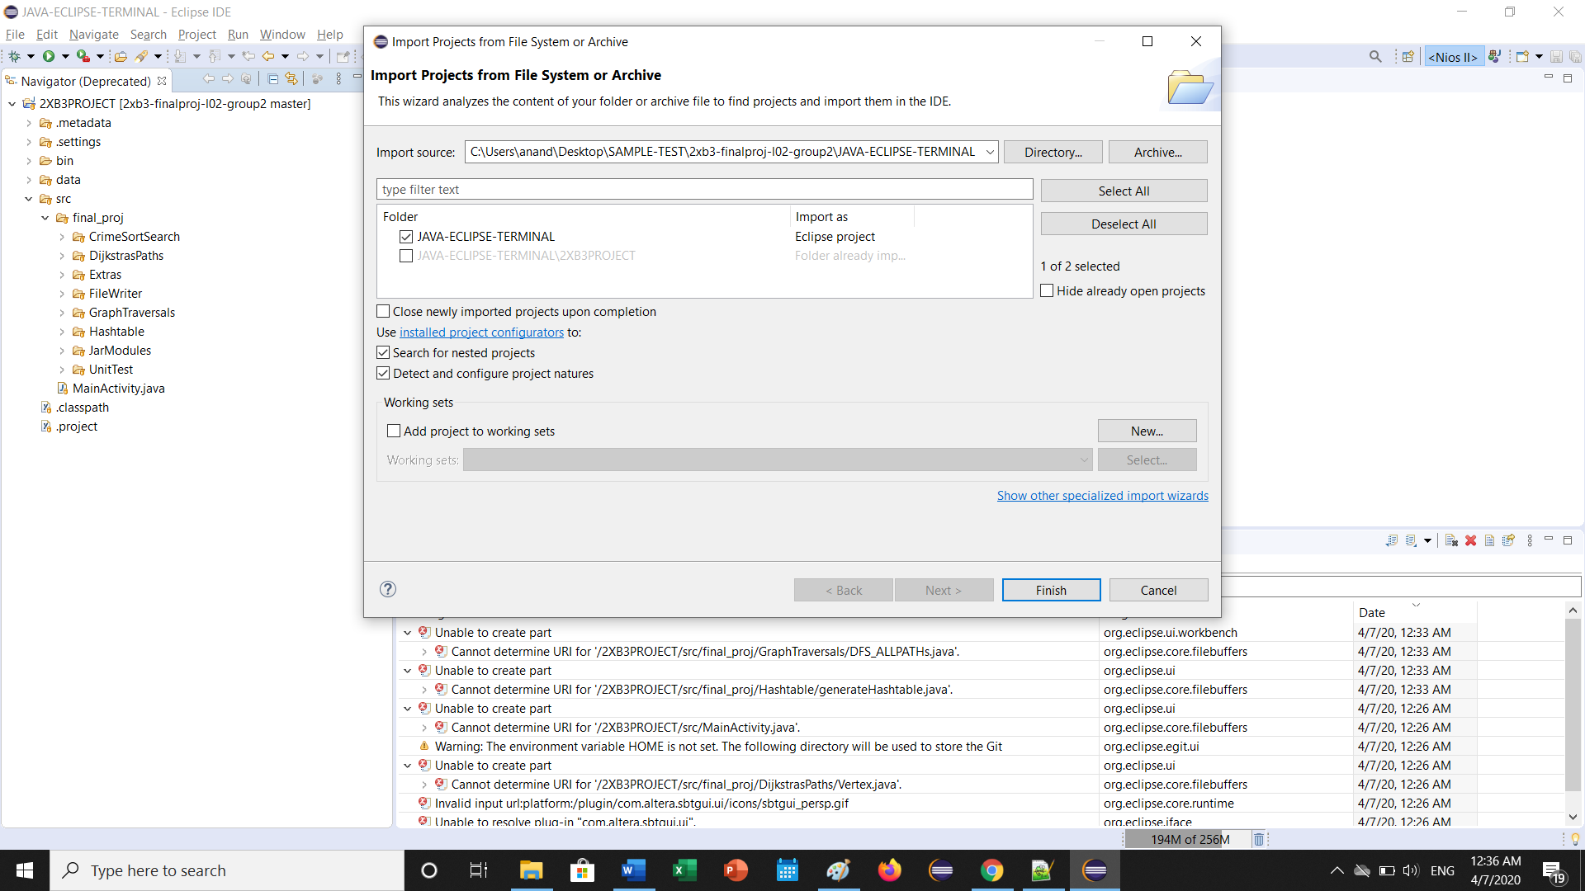

**Step D** below: Once complete, the code should appear.

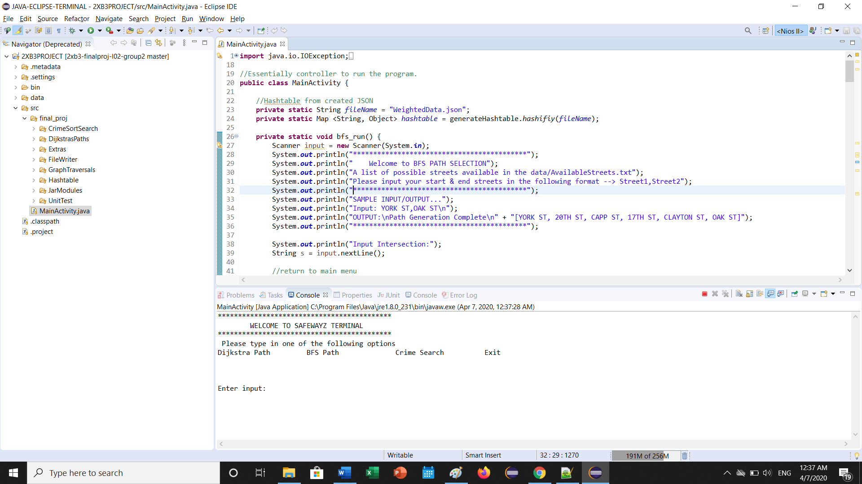

Step 4: **SETTING UP THE JAR LIBRARIES FOR JSON READ PARSING**

Click Project -> Properties

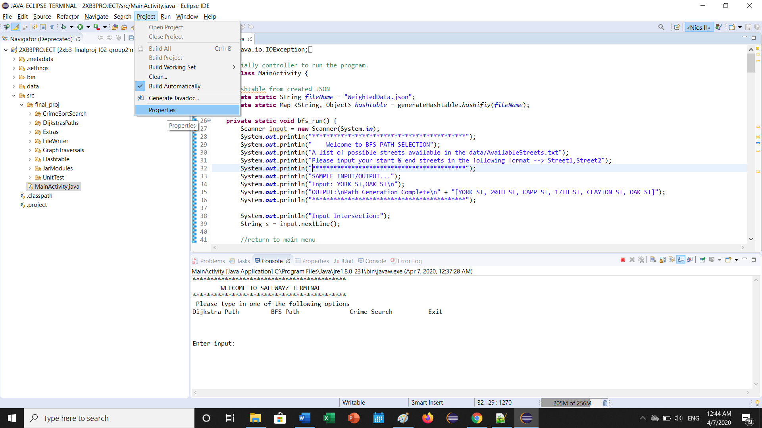

Step 5: Then click *“Java Build Path”,* and remove the highlighted libraries. This is because these libraries are pointing to a directory that is not on your computer, so must remove and re-add them

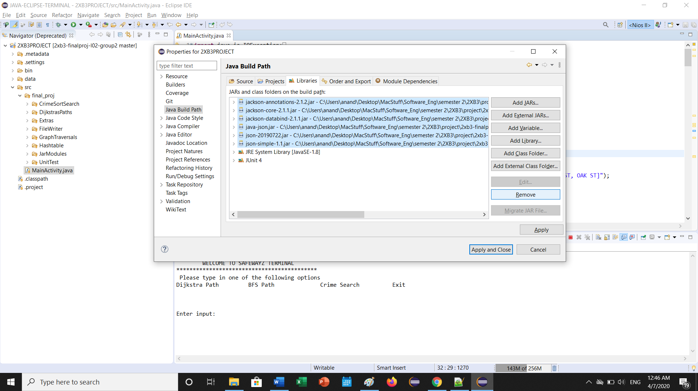

Step 6: Click “Add External JARs… button on the right-hand panel.

Navigate to the *JAVA-ECLIPSE-TERMINAL -> 2XB3PROJECT -> src -> final_proj -> JarModules* folder

Highlight all the available modules and click “open”. Click Apply and close, and you should be good to go!

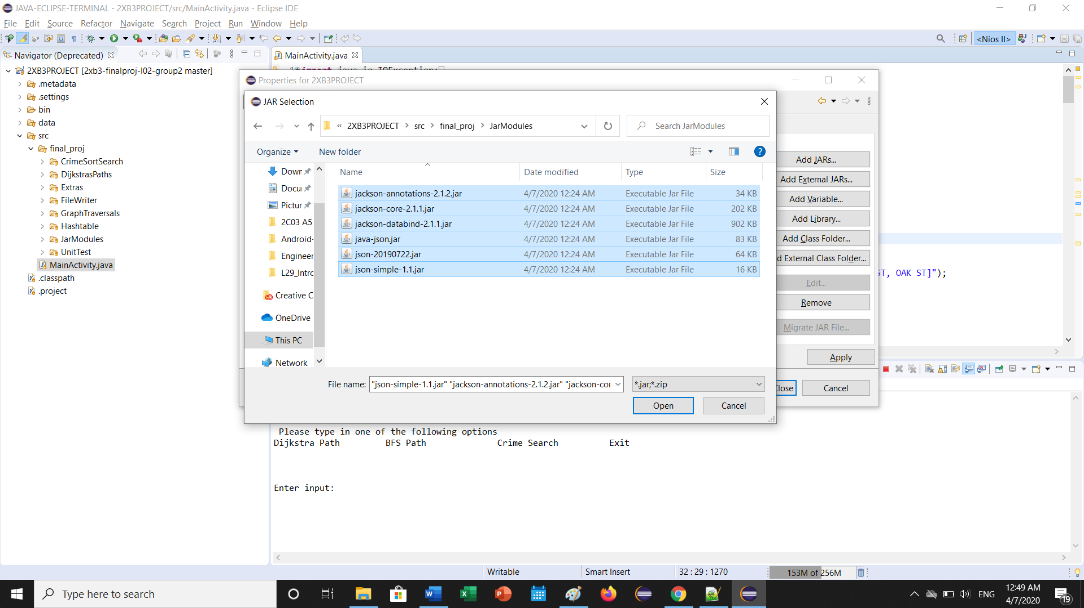

Step 7: Run MainActivity.java to execute the program in the console!