OPERATING SYSTEM

**Name:** Aditya Shimpi

**AI-DS Div C** Batch 2

**Roll no:** 26

**PRN no:** 12110021

**OS Lab Assignment No. 1 A] Basic Linux Commands.**

1. date: To display current date & time of the system.

2. cal :To display calendar of current month.

3. who:List who is currently logged on to the system.

4. Whoami:Report what user you are logged on as.

5. echo :Echo a string (or list of arguments) to the terminal

6. bc:To perform mathematical operations

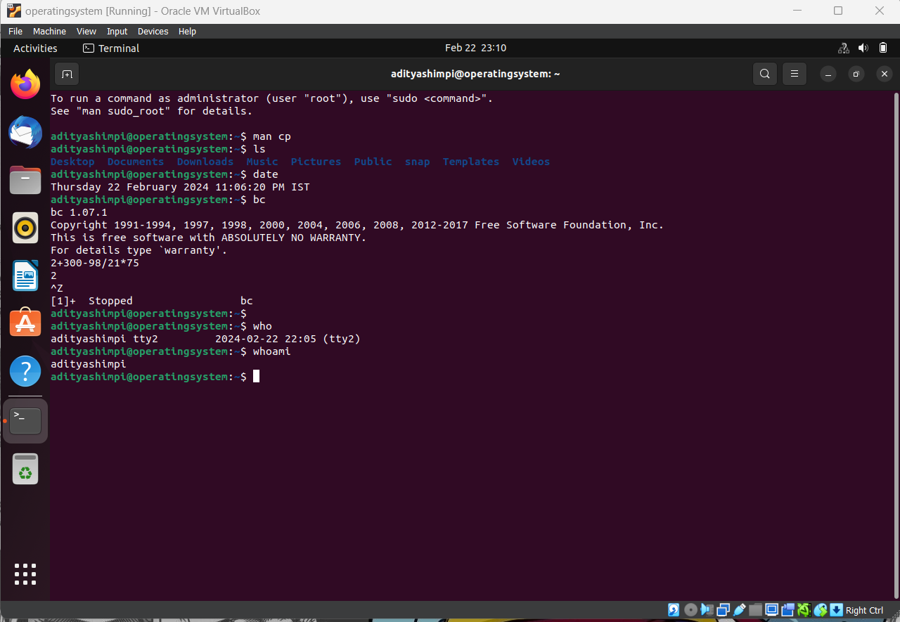

7. touch: To create a new file.

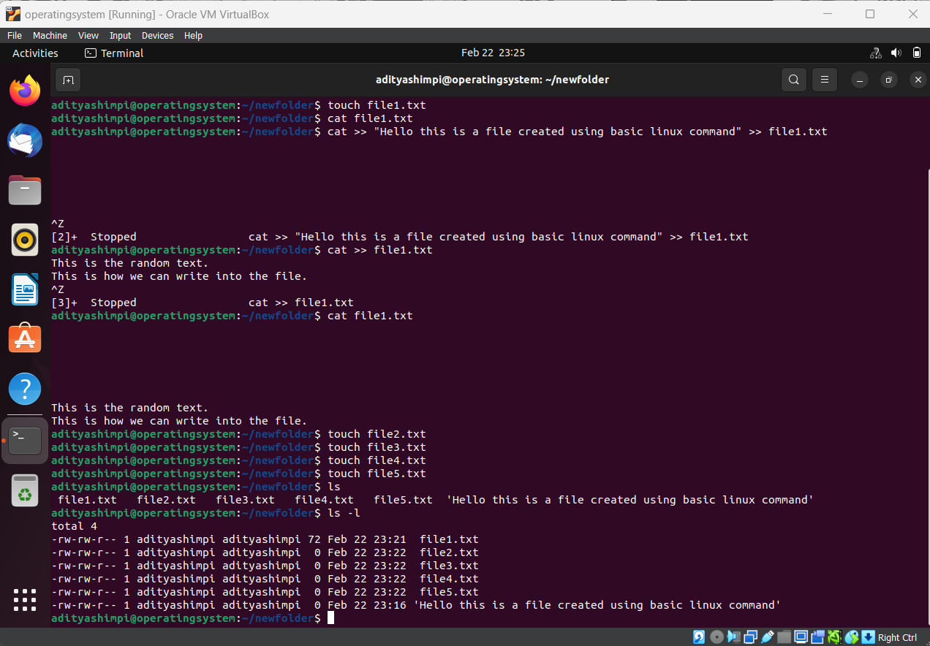

8. mkdir: To create a new directory.

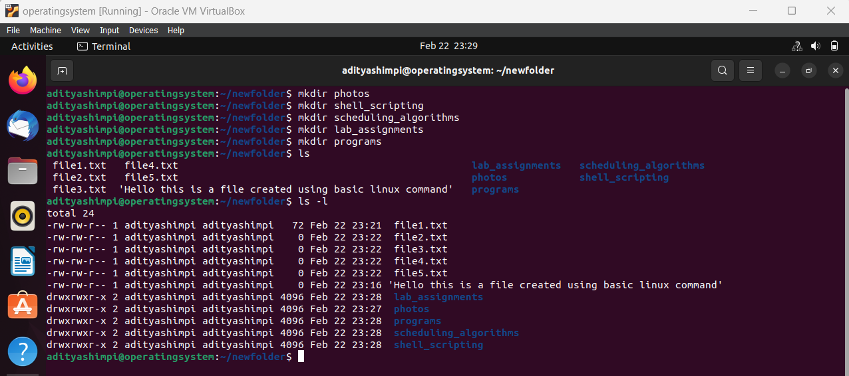

9. cat: To create new text files, append content and view the content.  
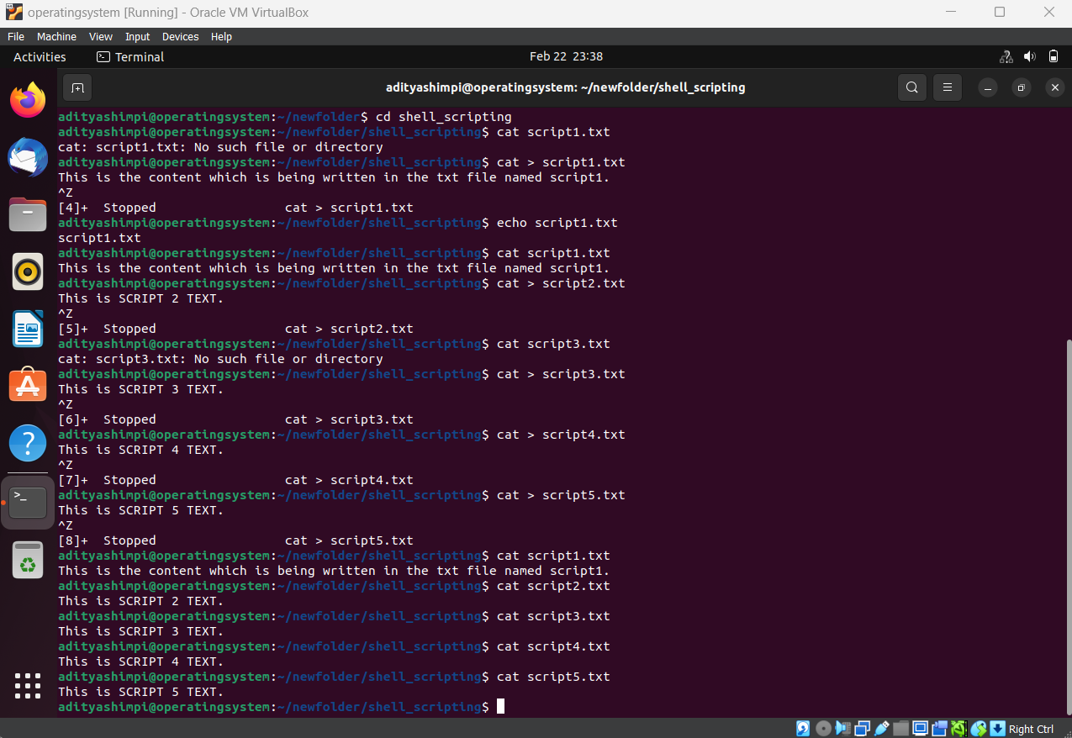

10. ls: To get the list of files present in the current folder.  
11. ls -l: To get the list of existing files in the current folder along with some more details.  
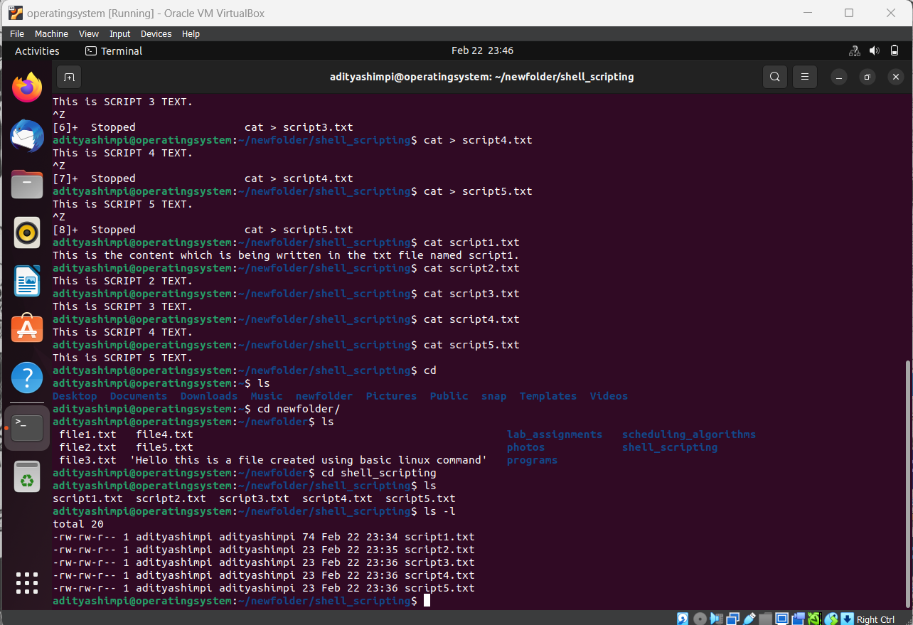

12. cp<file1><file2>: Copy the content of file1 to file2.  
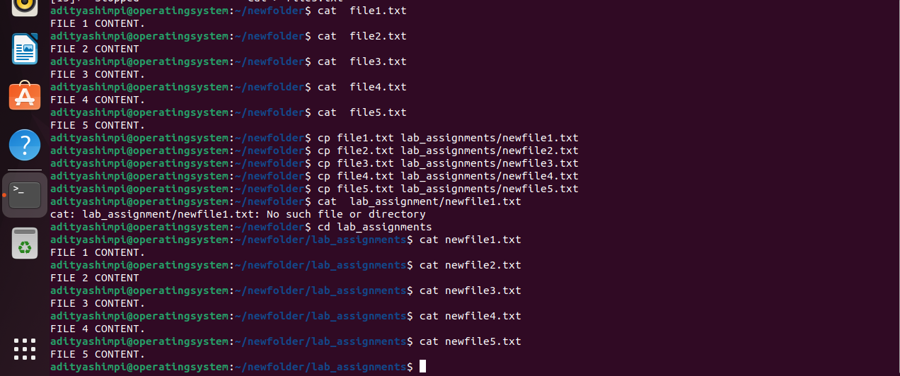

13. rmdir <directory name> : Removes only the empty directories  
14. rm<file name>: Removes the file in the current directory.  
