OPERATING SYSTEM

**Name:** Aditya Shimpi

**AI-DS Div C** Batch 2

**Roll no:** 26

**PRN no:** 12110021

**OS Lab Assignment No. 2: Shell Programming**

1. **Write a shell script to check whether entered number is prime number**

Code:   
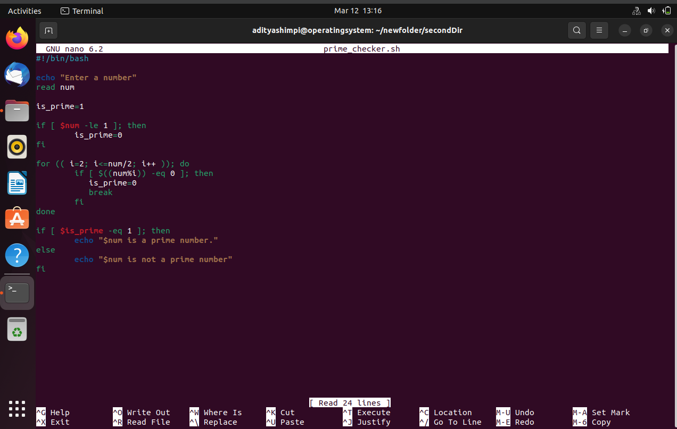  
  
Output:  
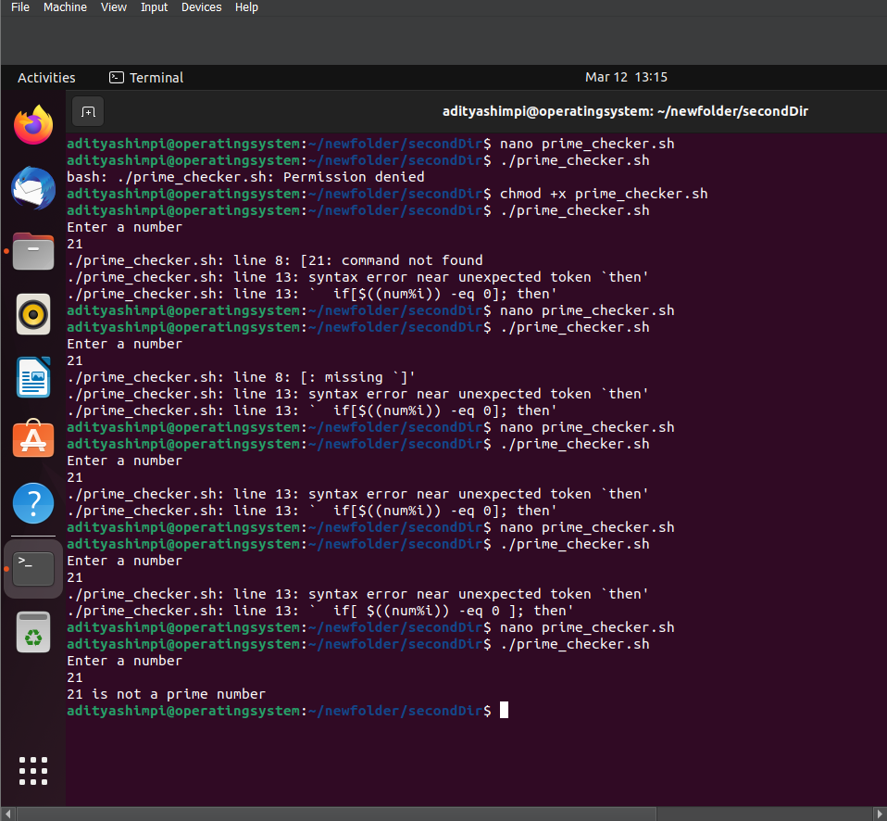

1. **Write a shell script to check whether an entered string is a palindrome.**

Code:  
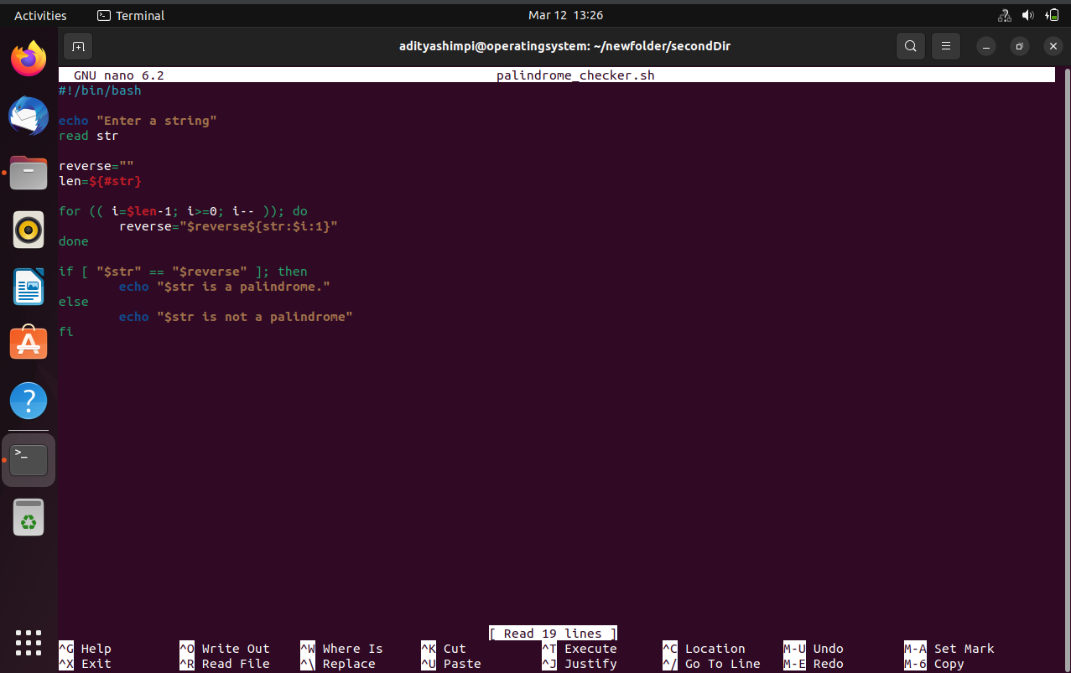

Output:  
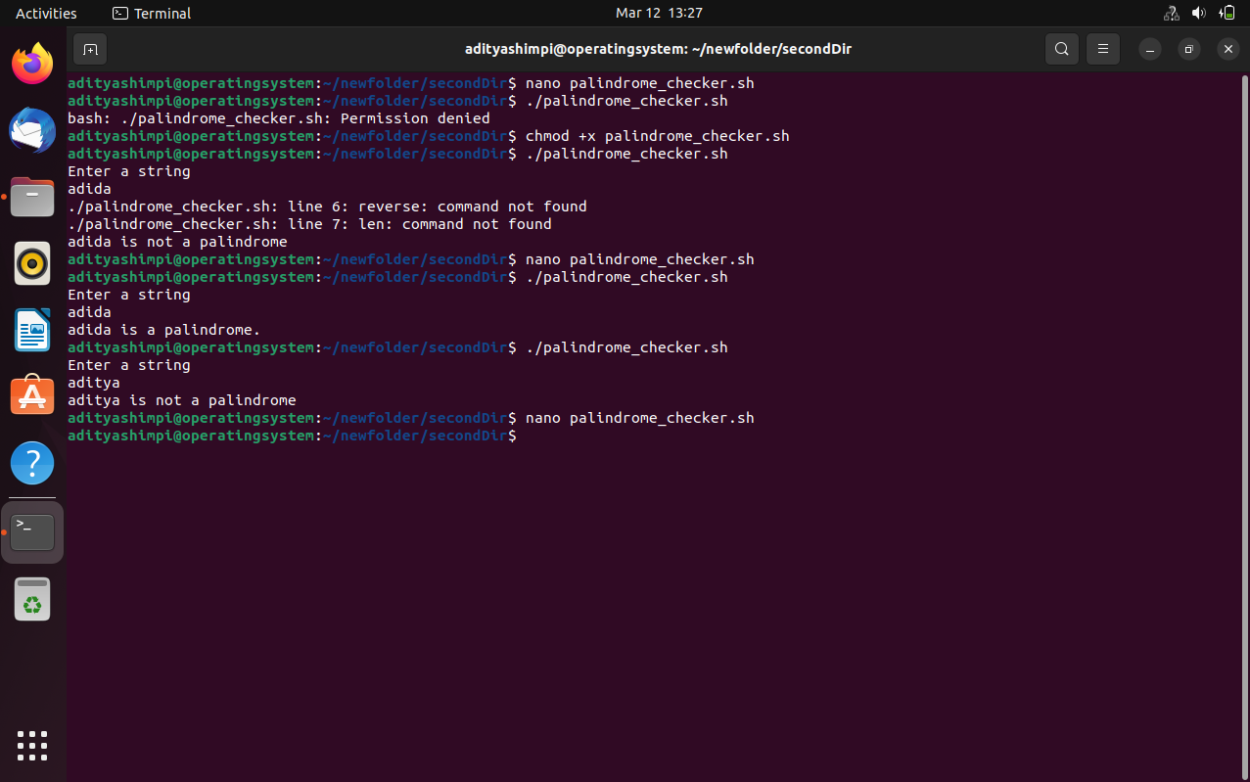

1. **Write a shell script to calculate the factorial of the entered number**

Code:  
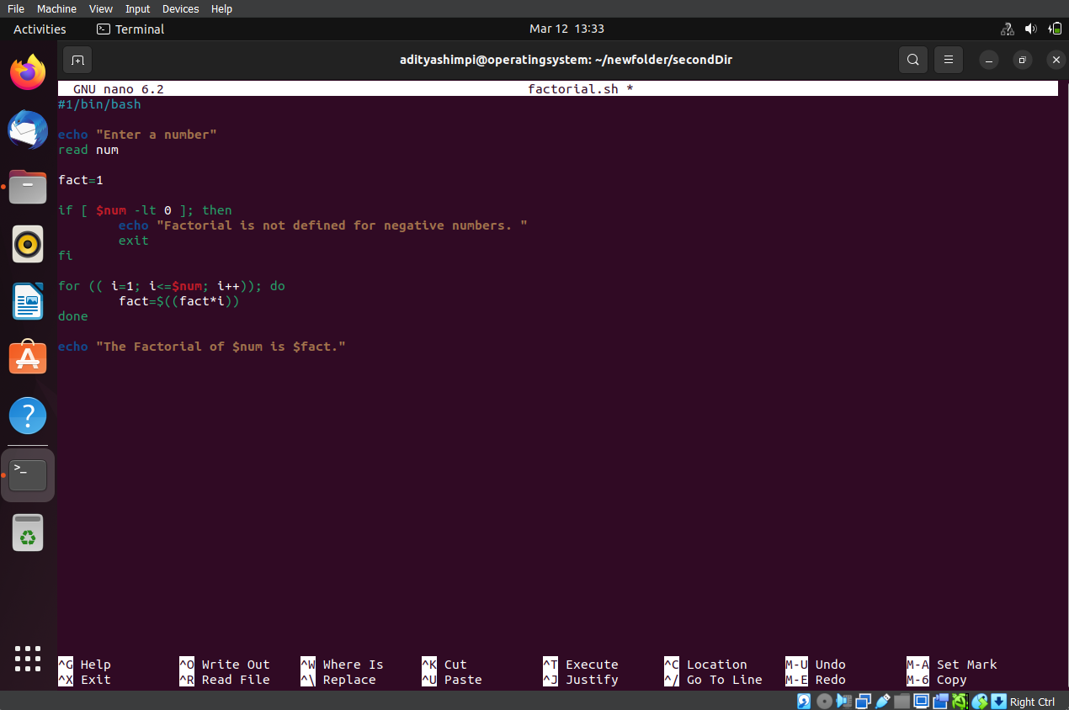

Output:  
