OPERATING SYSTEM

**Name:** Aditya Shimpi

**AI-DS Div C** Batch 2

**Roll no:** 26

**PRN no:** 12110021

**OS Lab Assignment No. 3: Mutex**

**Implementation of Classical Reader Writer problem using Threads and Mutex.**

**CODE:  
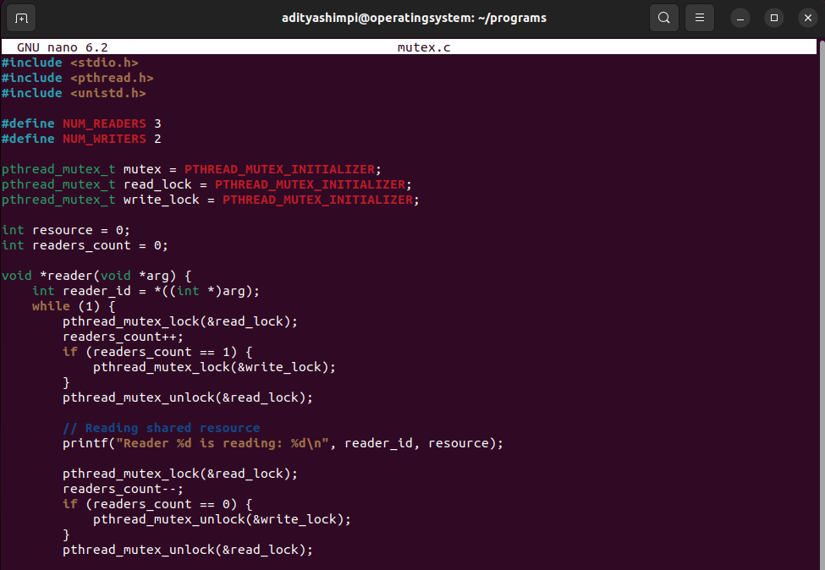  
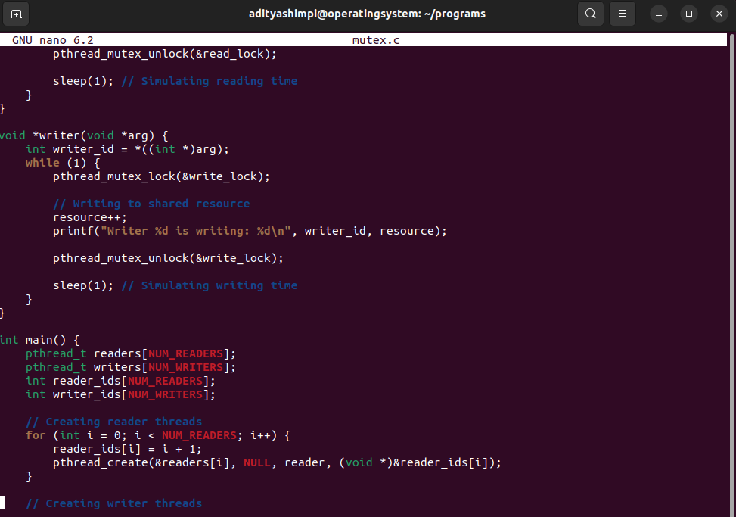  
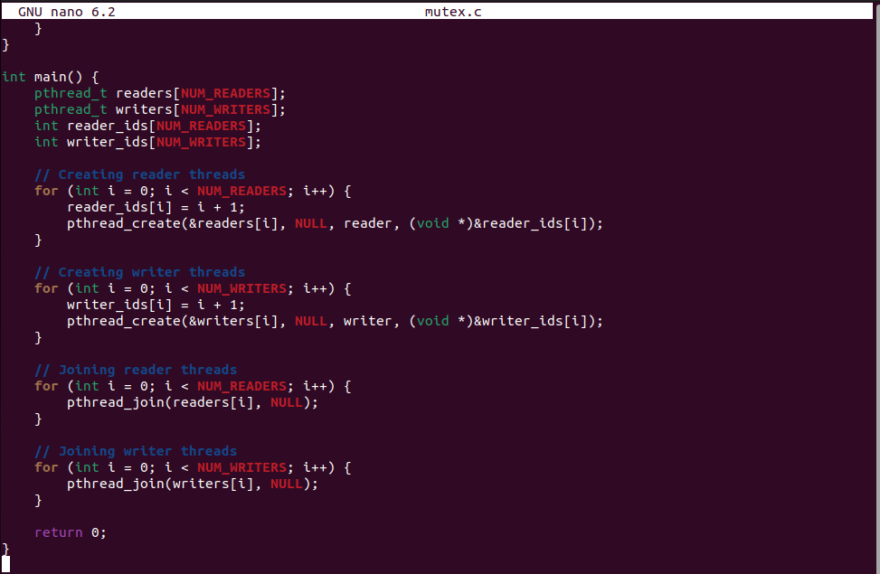**

**OUTPUT:**