OPERATING SYSTEM

**Name:** Aditya Shimpi

**AI-DS Div C** Batch 2

**Roll no:** 26

**PRN no:** 12110021

**OS Lab Assignment No. 4: System Calls**

**Write a program demonstrating the use of different system calls.**

**1) process-related system call: fork, wait,**

**2) file related: open, read, write, close**

**3)protection: chmod  
____________________________________________________________________________________________  
CODE:  
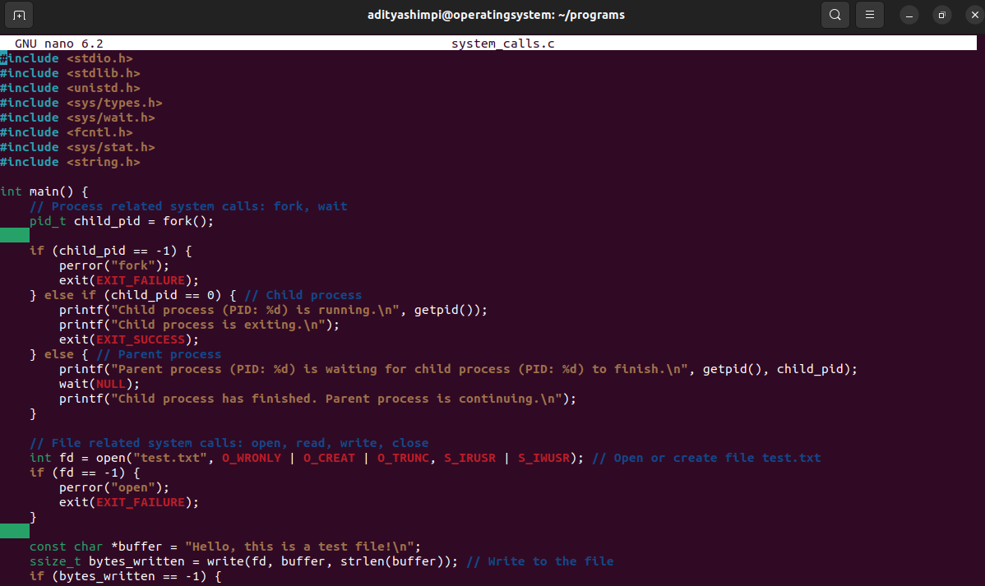  
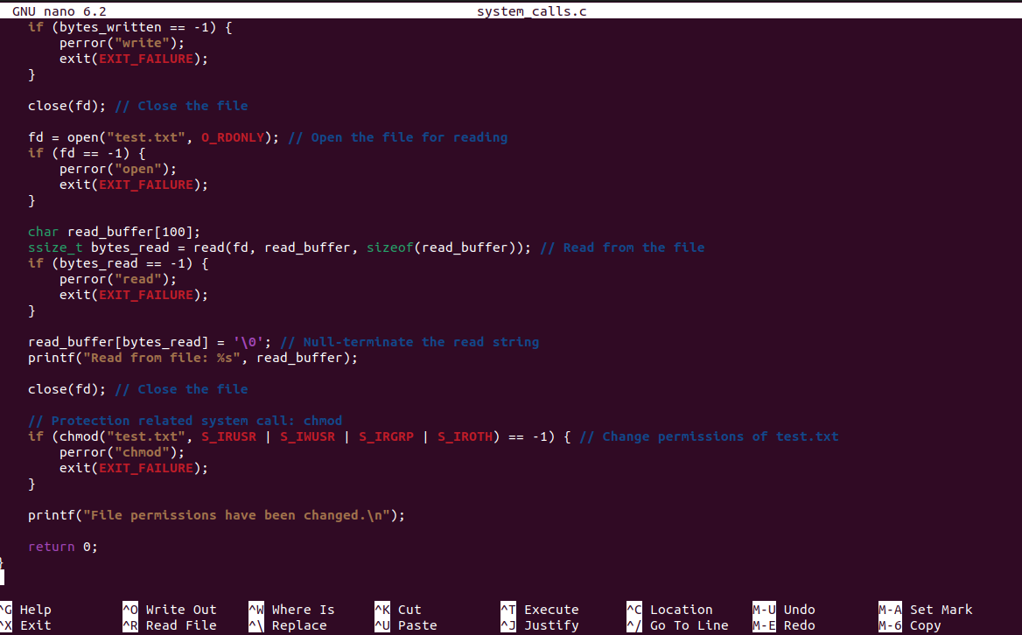  
____________________________________________________________________________________________  
  
OUTPUT:  
