OPERATING SYSTEM

**Name:** Aditya Shimpi

**AI-DS Div C** Batch 2

**Roll no:** 26

**PRN no:** 12110021

**OS Lab Assignment No. 6: CPU Scheduling Algorithms.**

**Write a program to compute the finish time, turnaround time and waiting time for the following algorithms: a) First come First serve b) Shortest Job First (Preemptive and Non-Preemptive) c) Priority (Preemptive and Non-Preemptive) d) Round robin**

1] FCFS:  
CODE:  
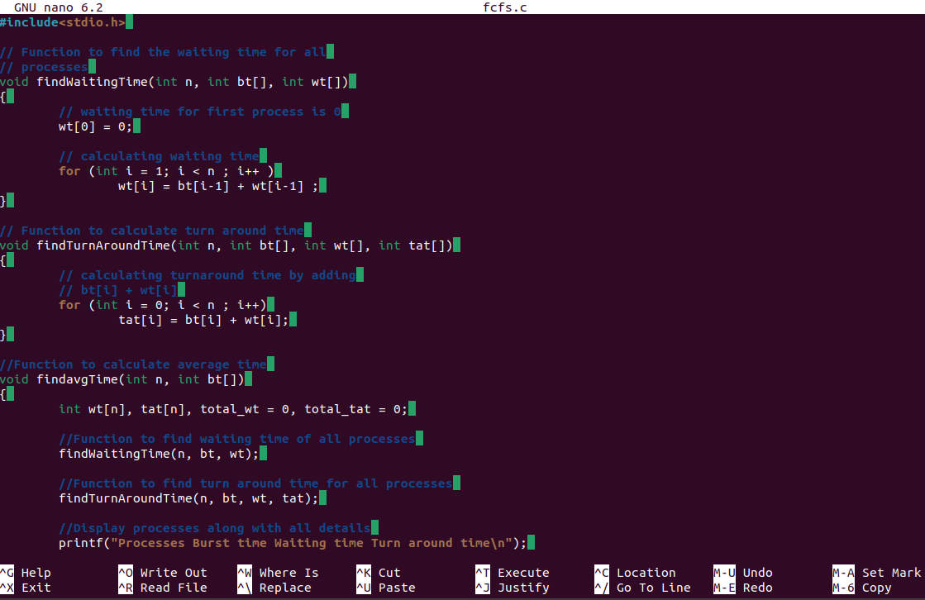

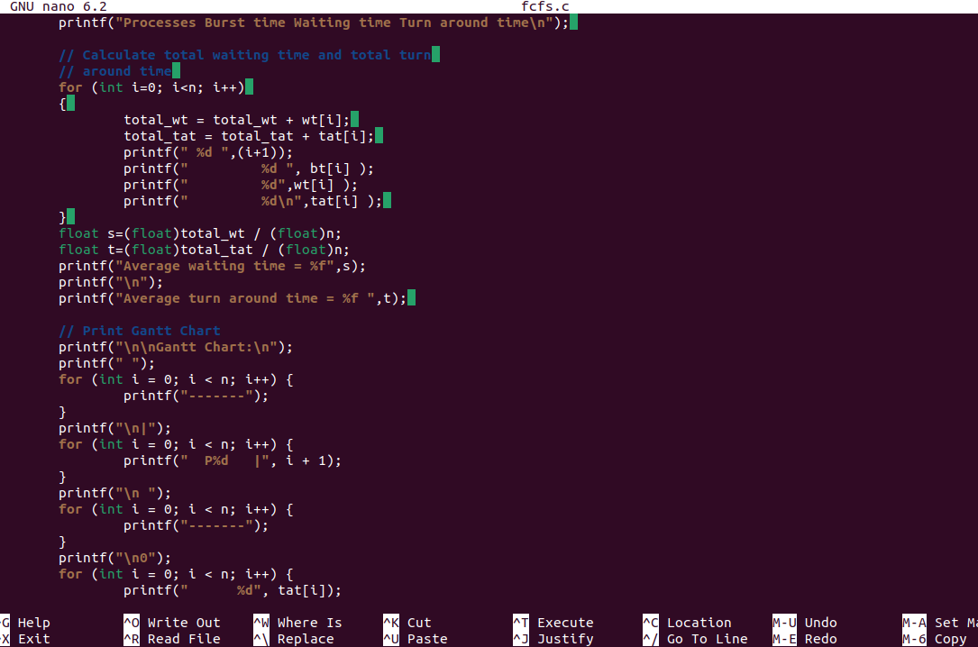

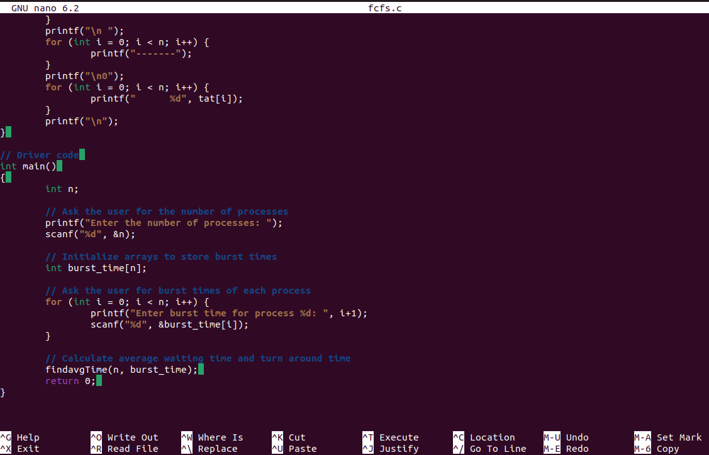

OUTPUT:  
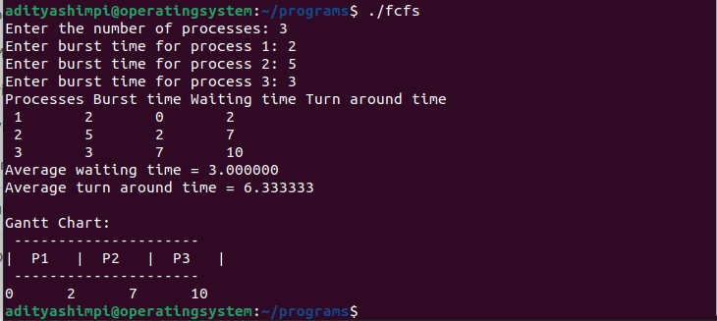

2] a) SJF (Non-pre-emptive)

CODE:

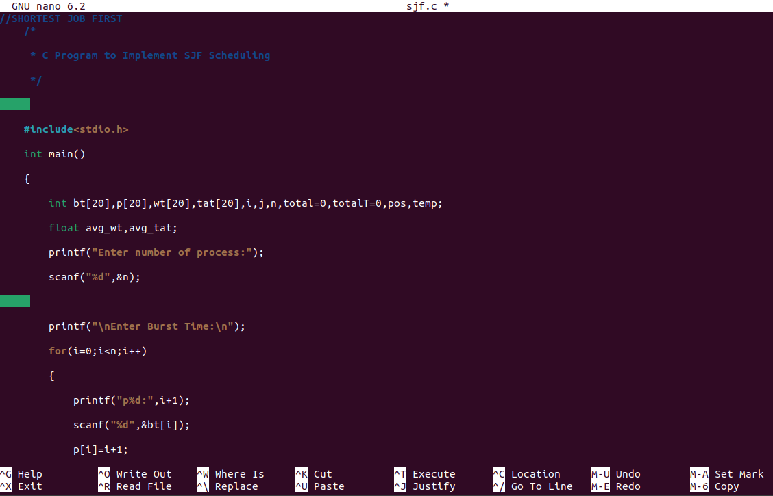

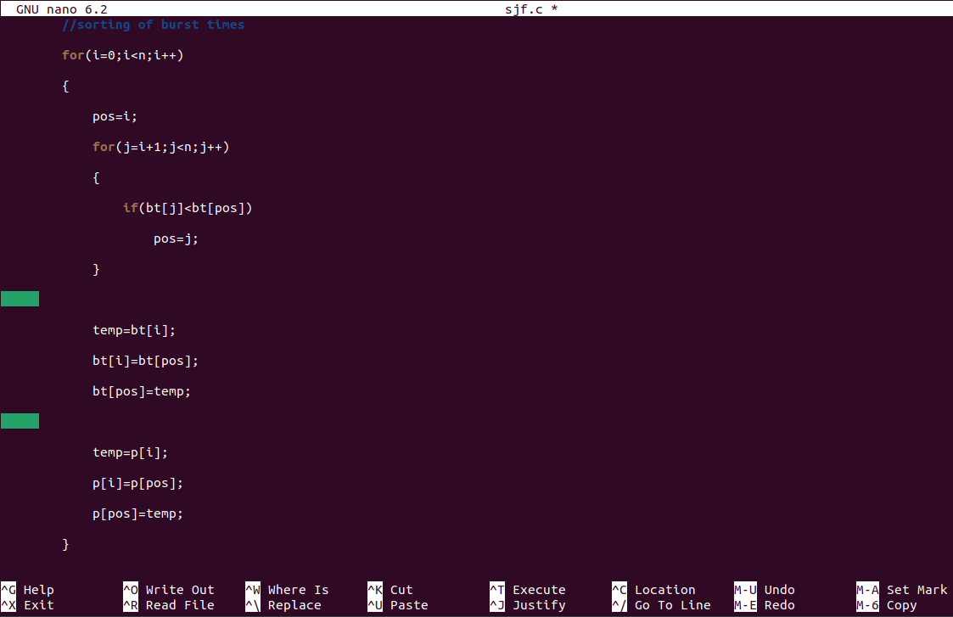

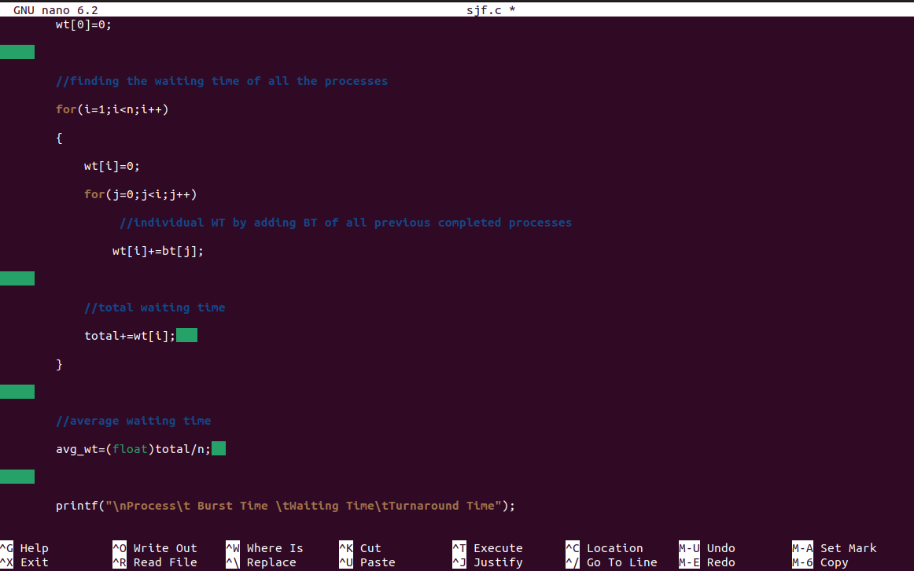

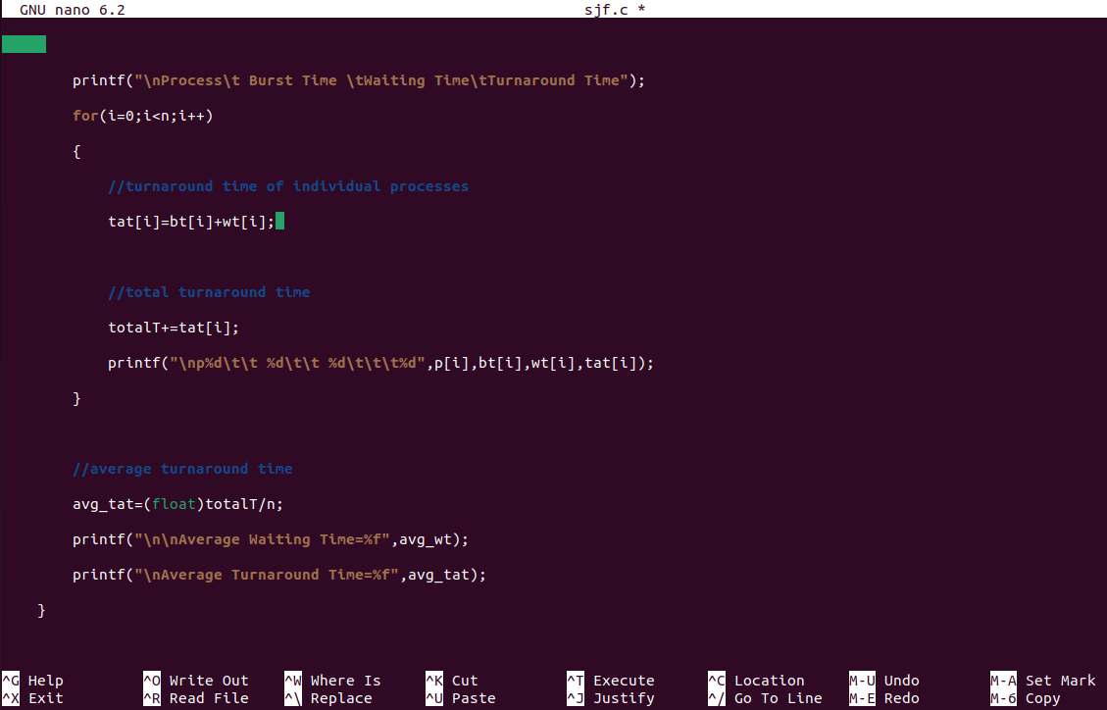

OUTPUT:  
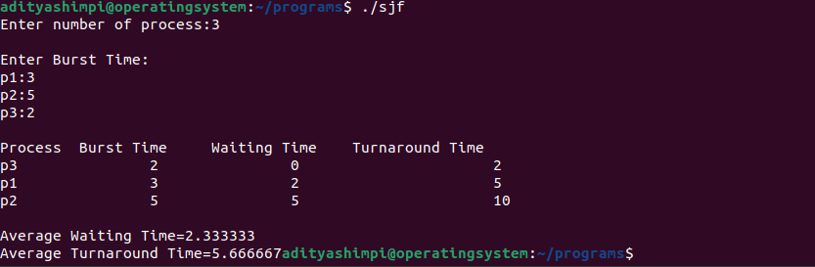

2] b) SRTF (SJF pre-emptive)

CODE:  
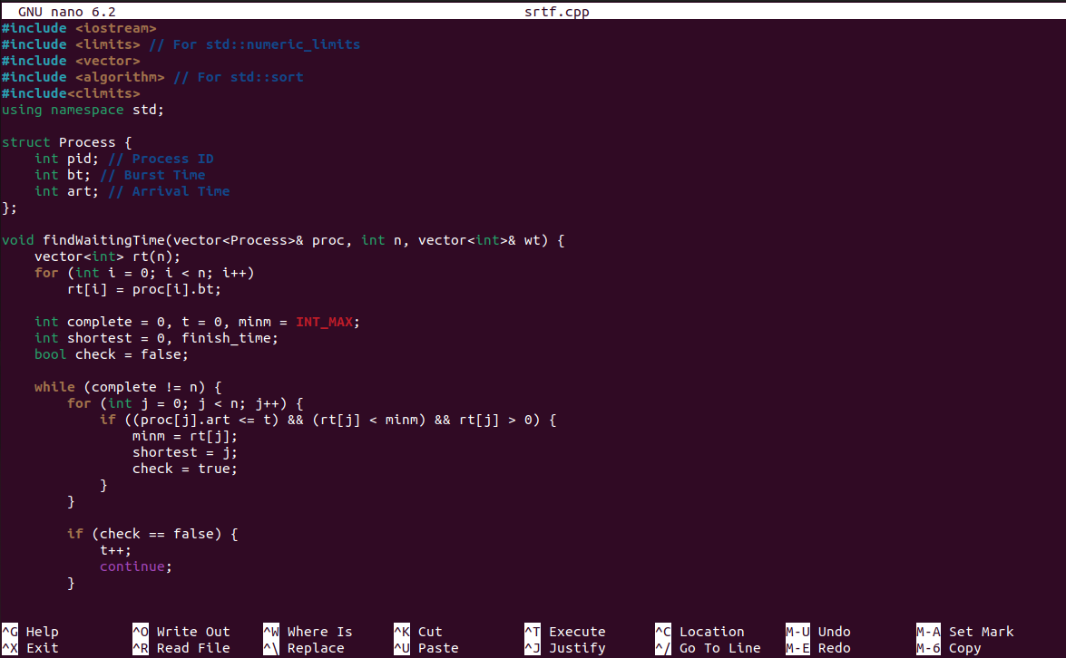

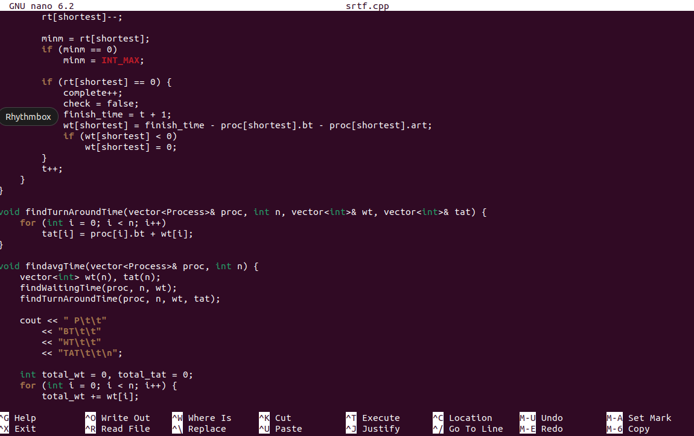

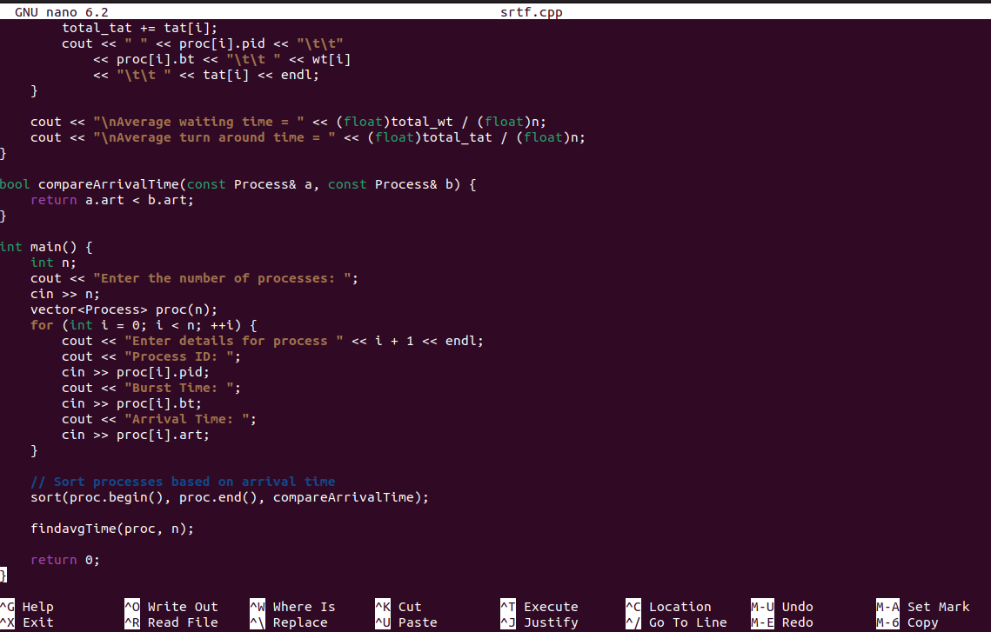

OUTPUT:  
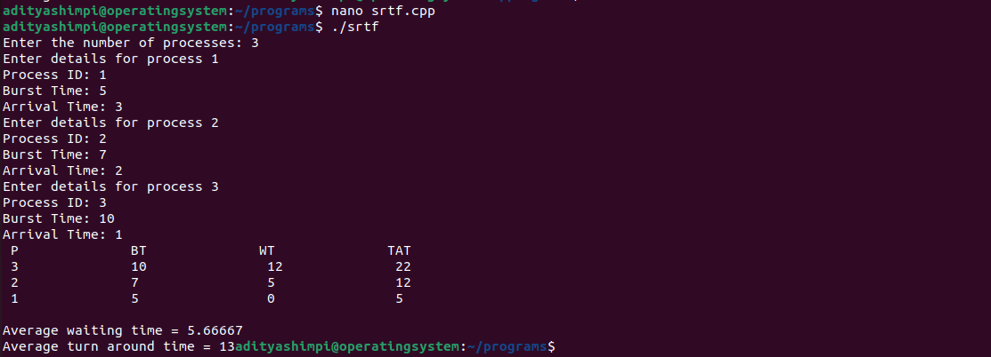

3] Priority Scheduling:

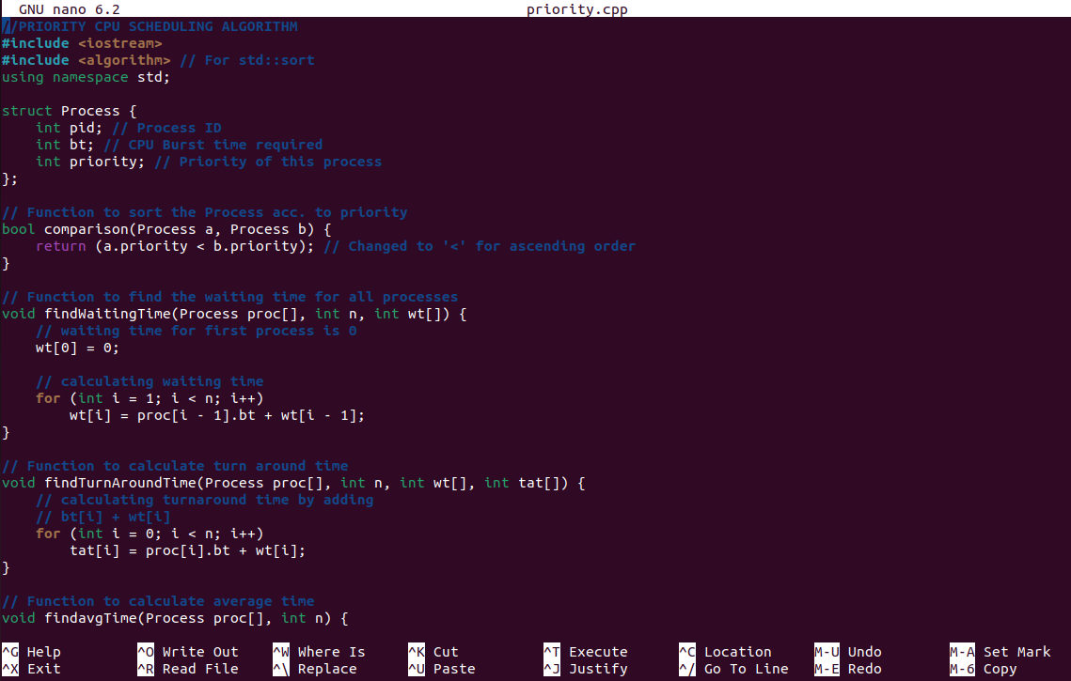

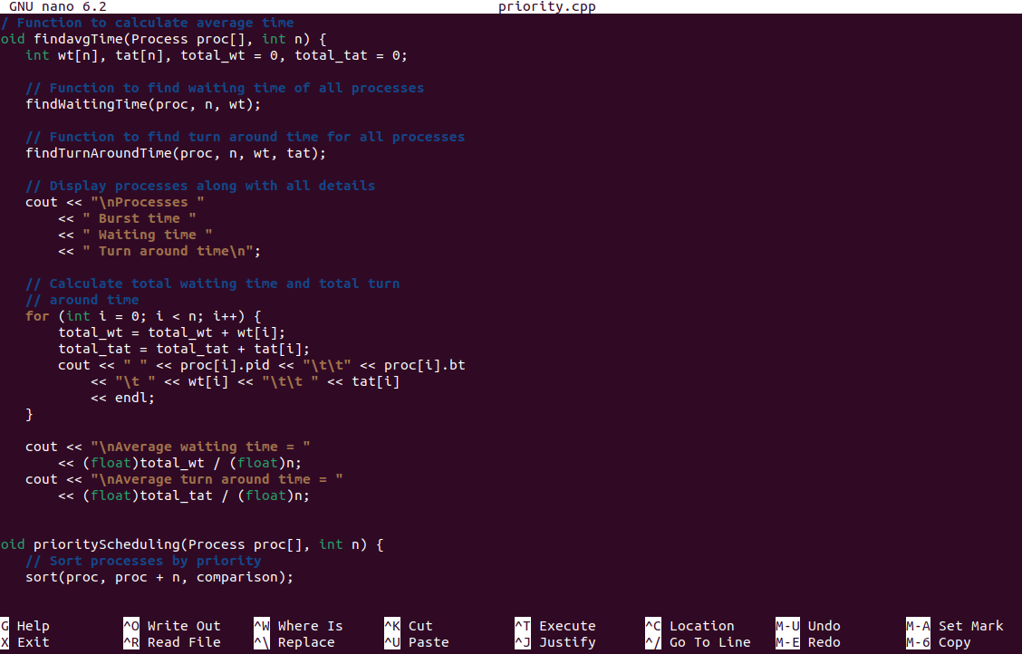

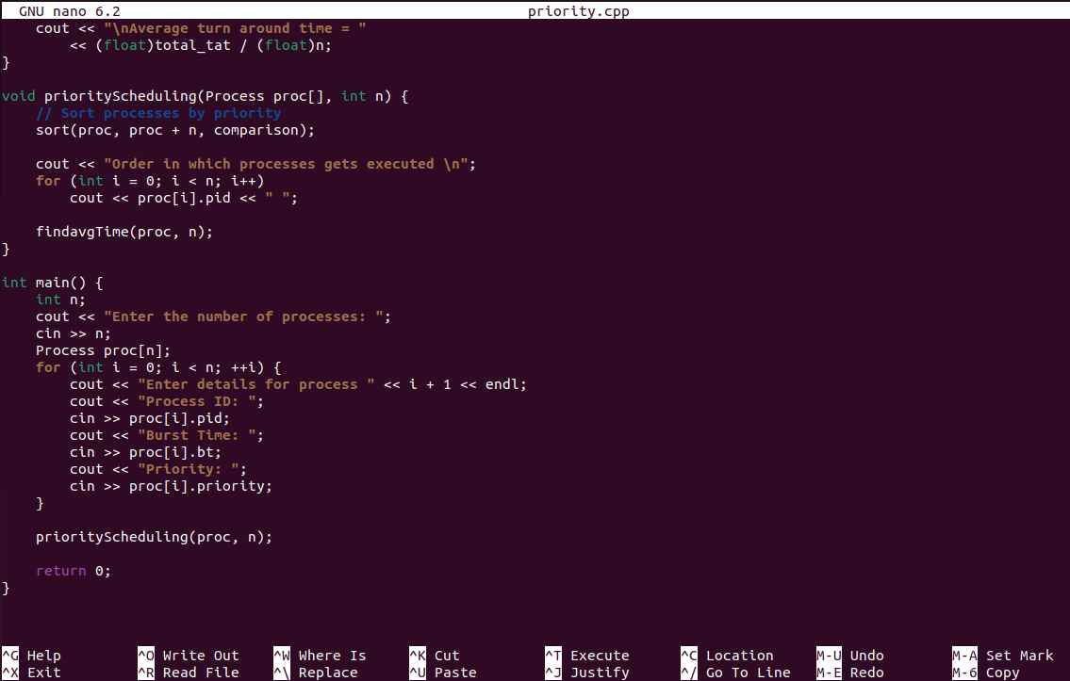

OUTPUT:  
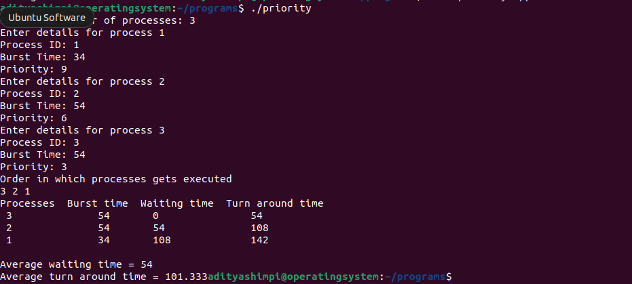

**4] Round robin**

**CODE:**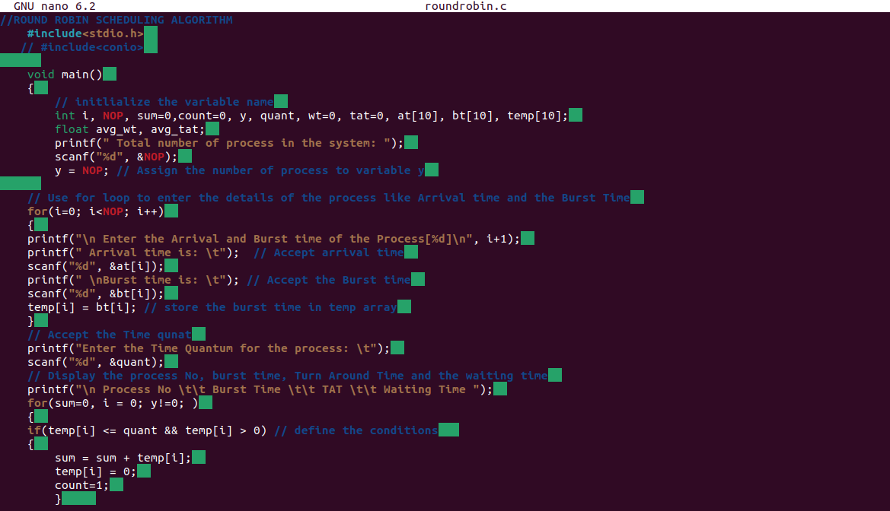

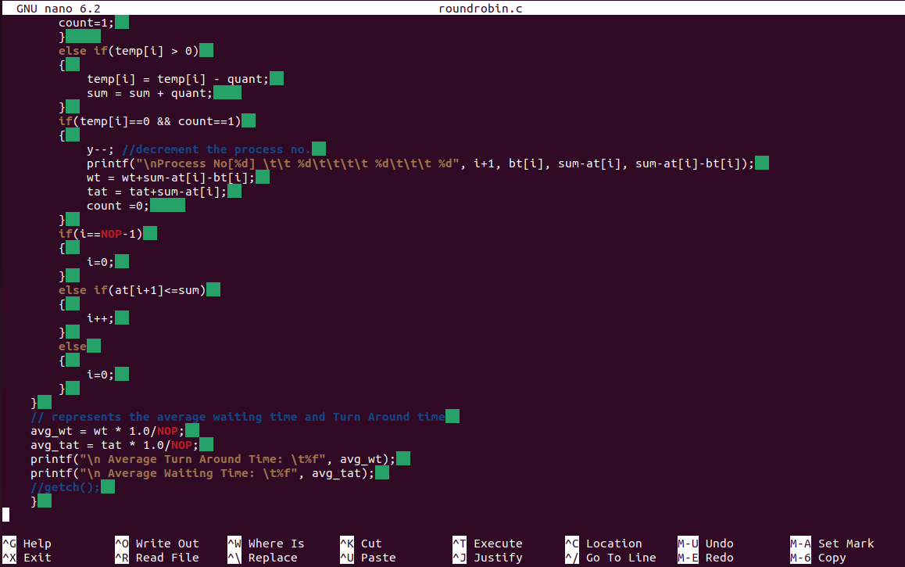

OUTPUT:  
