OPERATING SYSTEM

**Name:** Aditya Shimpi

**AI-DS Div C** Batch 2

**Roll no:** 26

**PRN no:** 12110021

**OS Lab Assignment No. 7: Paging**

**Write a program to calculate the number of page faults for a reference string for the following page replacement algorithms: a) FIFO b) LRU c) Optimal**

**CODE:**

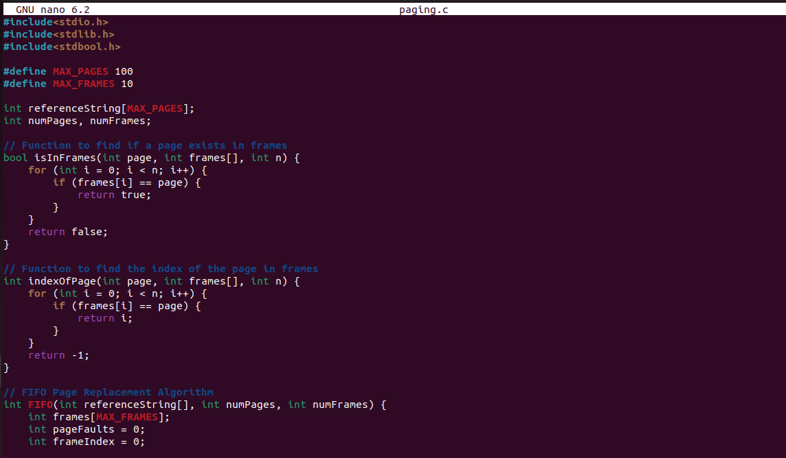

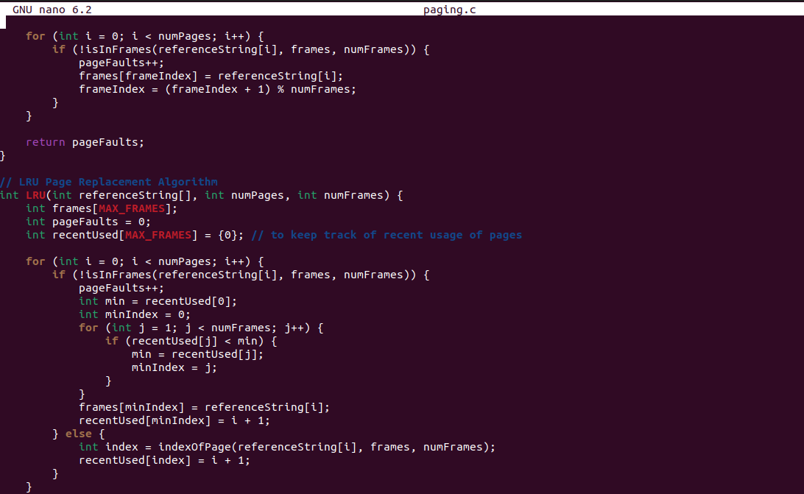

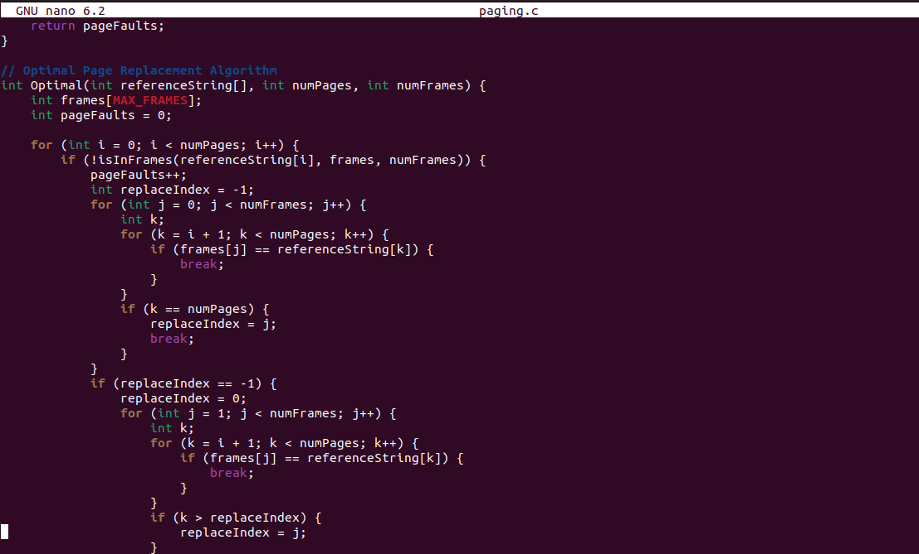

**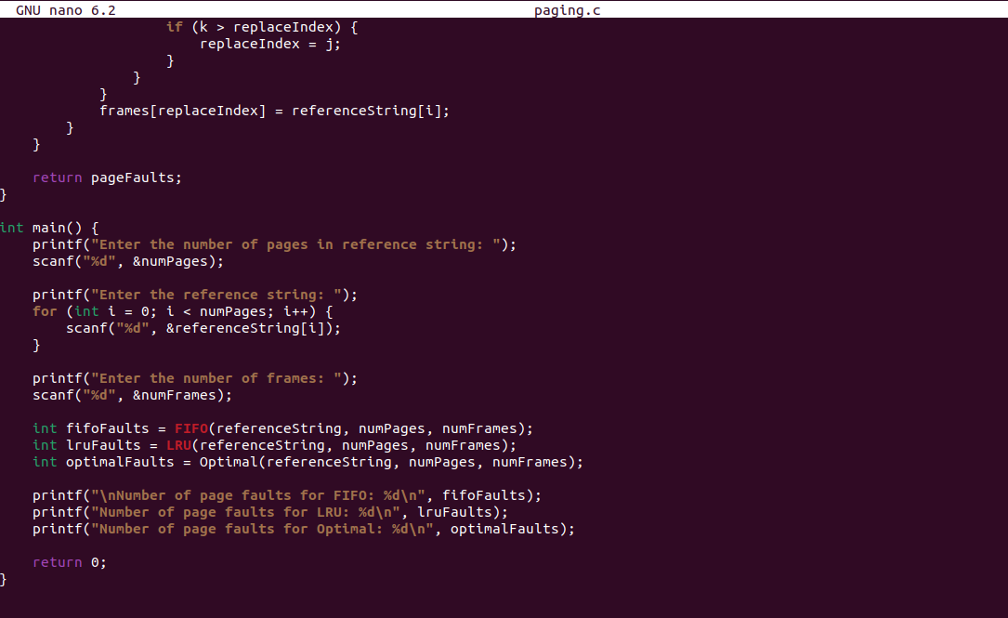  
OUTPUT:  
