OPERATING SYSTEM

**Name:** Aditya Shimpi

**AI-DS Div C** Batch 2

**Roll no:** 26

**PRN no:** 12110021

**OS Lab Assignment No. 4: System Calls**

**Implement Bankers algorithm for deadlock avoidance and find out a safe sequence for processes.(Optional Assignment)  
____________________________________________________________________________________________  
CODE:  
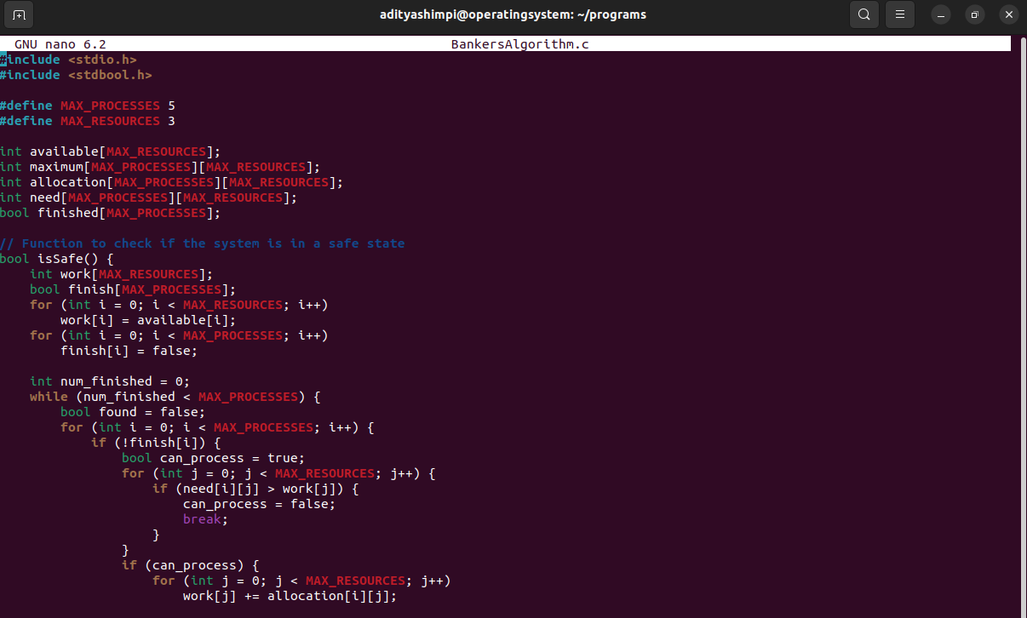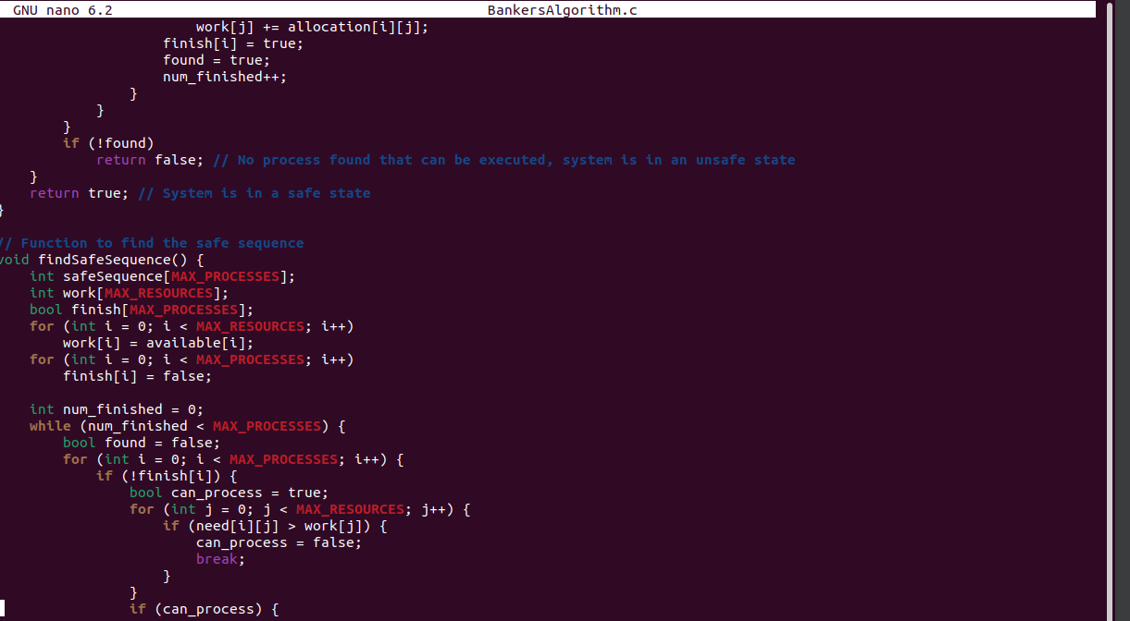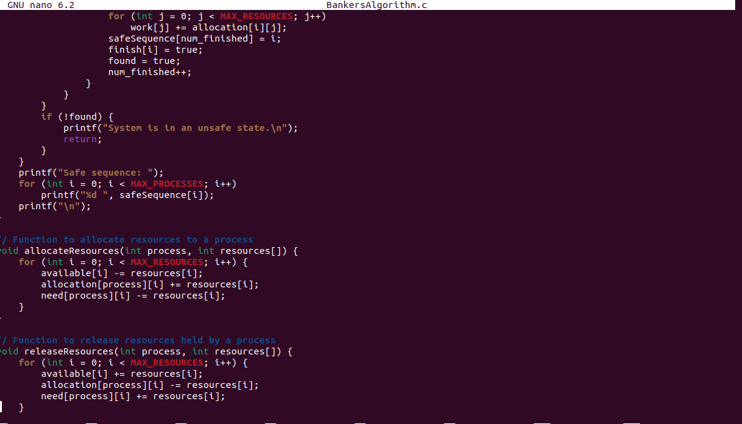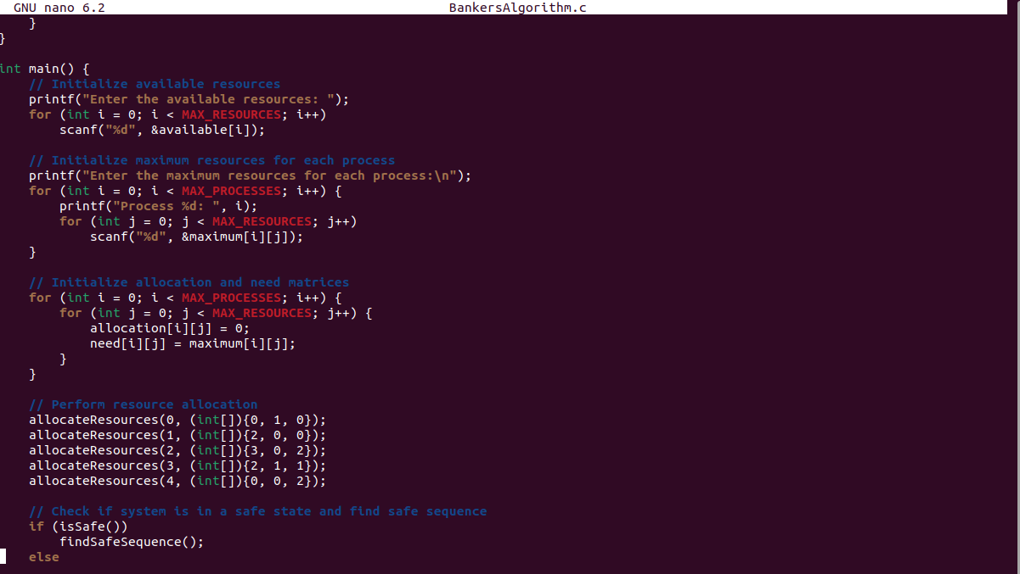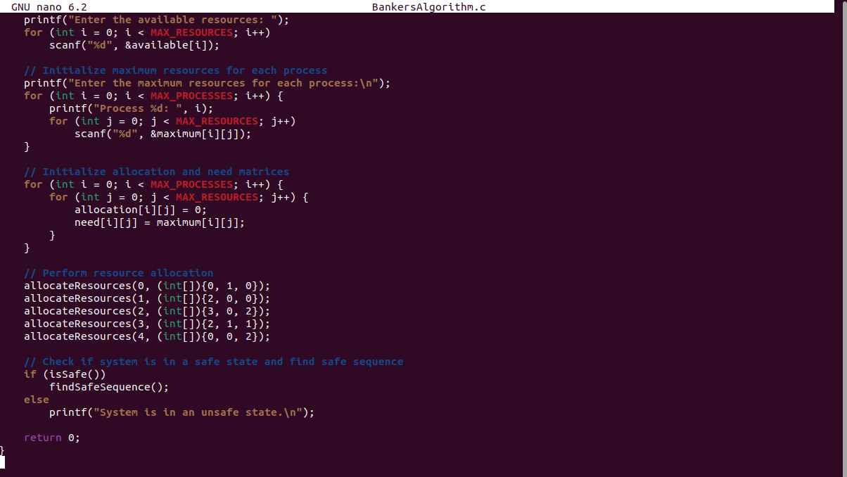 ____________________________________________________________________________________________**

**OUTPUT:**