# Annexure3b- Complete filing

# INVENTION DISCLOSURE FORM

Details of Invention for better understanding:

**1. TITLE:** Development of an AI-Driven Precision Oncology Model for Optimized Combination Chemotherapy and Targeted Radiation Therapy

**2. INTERNAL INVENTOR(S)/ STUDENT(S):** All fields in this column are mandatory to be filled

|  |  |
| --- | --- |
| A. Full name | Aditya Shukla |
| ­­­­­Mobile Number | 9129276030 |
| Email (personal) | adityasarika0292004@gmail.com |
| UID/Registration number | 12312951 |
| Address of Internal Inventors | Lovely Professional University, Punjab-144411, India |
| Signature (Mandatory) |  |

|  |  |
| --- | --- |
| B. Full name | Medha Jha |
| ­­­­­Mobile Number | 8709684588 |
| Email (personal) | medhajha810@gmail.com |
| UID/Registration number | 12305679 |
| Address of Internal Inventors | Lovely Professional University, Punjab-144411, India |
| Signature (Mandatory) | C:\Users\HP\OneDrive\Documents\mySign.jpg |

|  |  |
| --- | --- |
| C. Full name | Laukik Deshmukh |
| ­­­­­Mobile Number | 8623839776 |
| Email (personal) | deshmukhlaukik52@gmail.com |
| UID/Registration number | 12311170 |
| Address of Internal Inventors | Lovely Professional University, Punjab-144411, India |
| Signature (Mandatory) |  |

**EXTERNAL INVENTOR(S): (INVENTORS NOT WORKING IN LPU)**

|  |  |
| --- | --- |
| A. Full name | NA |
| Mobile Number | NA |
| Email | NA |
| ­­­­­­Address of External Affiliations | NA |
| Signature (Mandatory) | NA |

***For External Inventors*, NOC (No Objection Certificate) from the affiliated institute/university/Industry/lab etc. is mandatory for each individual inventor and their respective topic. For NOC, format is attached below.**

**3. DESCRIPTION OF THE INVENTION:** Challenges that cancer treatment faces include severe side effects from chemotherapy, damage to healthy tissues during radiation therapy, and high costs. This AI-driven precision model is going to revolutionize cancer care by combining artificial intelligence with personalized medicine. It collects and analyses patient-specific data, including genetic profiles, tumor characteristics, medical history, and treatment responses, to design optimized drug combinations and radiation plans. Using deep learning and machine learning, the system predicts the most effective chemotherapy dosages, minimizes toxic side effects, and ensures that radiation therapy targets only cancer cells without harming surrounding healthy tissues. Moreover, the model is continuously learning and improving through the monitoring of real-time patient responses, new medical research, and refinement of treatment strategies. It offers accurate treatments that decrease wasteful consumption of medicine, decrease lengths of stay within hospitals, and rehabilitations involved. Leverage AI with enhanced pattern recognition and natural language processes in conjunction with computer vision enhances this system to have the highly customized, efficient and cost-effective strategy in handling a patient in oncology towards more chances of surviving with higher life quality.

1. **PROBLEM ADDRESSED BY THE INVENTION:**

The Cancer treatment in the form of radiotherapy, chemotherapy, or precision medicine is confronted with a fundamental problem: standard procedures are static and fail to respond in real-time to the individual and evolving responses of individual patients. This rigidity too frequently leads to inadequate dosing, toxic side effects, drug resistance, and overall suboptimal outcomes. Additionally, current methodologies fail to incorporate heterogeneous, real-time patient data, which is the secret to truly personalized medicine. This invention provides an AI-driven digital twin platform that constructs a virtual representation of a patient's tumor and overall biological response. Through real-time data gathering and analysis with sophisticated machine learning algorithms, the platform forecasts how a tumor will respond to different treatments. It then adjusts radiation doses, chemotherapy regimens, and other personalized therapies dynamically to address the patient's changing condition. The outcome is a therapy that reduces side effects, overcomes drug resistance, and ultimately enhances survival rates by delivering each patient the best possible therapy at exactly the right time.

1. **OBJECTIVE OF THE INVENTION**

The primary objective of this invention is to develop an AI-powered precision oncology model that maximizes combination chemotherapy and targeted radiation therapy for improved cancer treatment results. This system will seek to marry artificial intelligence with personalized medicine to enhance treatment precision, responsiveness, and reliability while overcoming the shortcomings of traditional approaches. Being a first-time model development, the invention will focus on the following primary areas:

1. **Detailed Data Representation:**

For the purpose of ensuring robust and impartial AI performance, the model will utilize diverse datasets ranging from patient demographics and genetics to cancer type and stage, medical history, treatment response, and tumor information. This first step ensures the model is trained on representative data for guaranteed results.

1. **Seamless System Integration:**

The invention will utilize friendly API frameworks to support seamless integration with current hospital information systems. This ensures data continuity, eliminates silos, and allows healthcare practitioners to view crucial patient information in real-time for improved decision-making.

1. **Optimized Combination Chemotherapy:**

Drawing from sophisticated algorithms, the model will learn from previous treatment data to recommend the best drug combinations, dosages, and administration schedules. This approach seeks to minimize side effects and improve treatment efficacy through personalized strategies.

1. **Optimization of Targeted Radiation Therapy:**

The model will utilize machine learning algorithms to calculate optimal doses of radiation, predict tissue response, and minimize damage to healthy cells. This ensures safer and more efficient radiation therapy.

1. **Stringent Testing and Validation:**

For building confidence in the usability of the model in real-world settings, the invention will undergo systematic testing and validation in controlled environments. This step ensures the model's reliability and efficacy before widespread clinical use.

1. **Increased Generalizability of the Model:**

With the integration of techniques such as dropout and data augmentation, the model will not overfit and will be able to generalize to new, unseen data. This will provide flexibility across diverse patient populations and clinical settings.

1. **Improved Interpretability:**

The system will integrate Explainable AI (XAI) techniques to provide clear, interpretable insights into the AI's decision-making process. This encourages clinicians and healthcare professionals to trust and accept the AI.

1. **Cost-Effectiveness:**

The model will reduce wastage of drugs, shorten hospital stays, reduce rehabilitation costs, and improve resource utilization, making cancer care more cost-effective and affordable.

**C. DETAILED DESCRIPTION:**

**AI-Driven Precision Oncology Model**

The invention is for a state-of-the-art AI-driven precision oncology platform that integrates multi-modal patient data to optimally personalize combination chemotherapy and targeted radiation therapy. Leveraging real-time data capture, simulation-based digital twin models, and sophisticated machine learning algorithms, the system continuously optimizes cancer treatment protocols for maximum therapeutic response and minimum adverse effects. The software solution can be prototyped and optimized using standard machine learning frameworks and open-source software and is thus generalizable to initial prototyping and subsequent clinical optimizations. The architecture of the AI-driven oncology model comprises five key layers:

**Data Collection and Integration**

Integration and harvesting of oncology data is meant to generate an end-to-end and real-time cancer profile of each patient for the purpose of formulating individualized treatment plans. Below is a detailed review of its elements:

**Data Sources**

- **Imaging Data:** Radiologic studies of CT, MRI, or PET scans to assess tumor size, location, and shape.

- **Genomic and Molecular Profiles:** Genomic sequence and biomarker assay data that demonstrate tumor heterogeneity and therapeutic targets.

- **Biochemical Markers:** Bloodchemistry and metabolic panel results that reflect the patient's physiological status and response to treatment. Historical Treatment Data: Previous treatment history and outcome to serve as input for predictive modelling.

**Data Integration**

**-** Incorporation of different types of data in a uniform format by secure cloud storage or local databases to make the data streams interoperable with one another.

**-** Use of Application Programming Interfaces (APIs) to retrieve external databases and clinical records to be updated in real time.

**Preprocessing and Feature Extraction**

Preprocess, normalize, and extract actionable features from raw multi-modal data for downstream simulation and predictive analysis:

**- Data Cleaning and Normalization:** Employing libraries such as Pandas and NumPy in Python to eliminate noise, handle missing values, and normalize data across multiple scales.

**- Feature Engineering:** Quantitative feature extraction from imaging data (e.g., tumor size, texture analysis), genomic data (mutation burden, gene expression levels), and biochemical markers (trends in concentration of key proteins).

Composite index construction reflecting treatment sensitivity and potential toxicity.

**- Adaptive Sampling:** Utilizing adaptive algorithms to adjust data acquisition rates according to dynamic changes in patient status, achieving a balance between data richness and computational efficiency.

**Digital Twin Simulation and Modeling**

Develop a dynamic digital twin of the patient's tumor and microenvironment, continuously updated in real-time

**- Virtual Model Construction:** Employ historical and real-time information to construct a 3D digital twin capturing tumor geometry, spatial heterogeneity, and interaction with surrounding tissues.

Employ simulation methods such as finite element analysis (FEA) for biomechanical testing and kinematic modeling to model tumor evolution under therapeutic stress.

**- Dynamic Updating:** Develop program code routines to update the digital twin with each new input of data so that the virtual model is a precise replica of current biology.

**- Simulation of Treatment Regimens:** Employ simulations to forecast tumor response to changing dosages of chemotherapy and radiation doses to decide optimal treatment parameters for individualized treatment.

**AI Prediction and Adaptive Learning**

To forecast treatment outcomes from digital twin data and facilitate real-time optimization of combination chemotherapy and radiation therapy regimens.

**- Predictive Analytics:** Develop supervised learning models (e.g., feedforward neural networks, random forests) utilizing libraries such as TensorFlow, Keras, or PyTorch to forecast treatment responses and potential toxicities.

**- Adaptive Learning:** Use reinforcement learning approaches that modify treatment strategies as a function of real-time digital twin and patient response feedback.

**- Personalization:** Integrate patient-specific variables (e.g., genomic mutations, biomarker levels, and prior treatment responses) into the AI model to tailor predictions and treatment recommendations.

- **Optimization of Treatment Regimens:** Provide recommendations on the optimal combination of chemotherapy agents and radiation doses, balancing efficacy vs. side effects to optimize overall patient outcomes.

**SCADA-Based Monitoring and Feedback**

To merge monitoring of patient data, simulation outputs, and AI predictions on a Supervisory Control and Data Acquisition (SCADA) system, with real-time visibility and control of the treatment process.

**- Real-Time Data Visualization:** Develop dashboards to display key metrics such as tumor response, predicted outcomes, and real-time alerts on adverse trends.

**- Alerting and Anomaly Detection:** Configure the system to notify when predicted metrics indicate possible treatment failure, high toxicity, or other clinical problems.

**- Feedback Loop:** Enable clinicians to input observations and treatment updates, which are fed back into the AI model to continually enhance its predictive accuracy.

**System Operation Workflow**

**- Data Acquisition:** Multi-modal patient data (imaging genomic biochemical, historical treatment records) are continuously collected and transmitted to the system.

**- Data Preprocessing:** Analysis is obtained from the acquired data cleaned, normalized and transformed into a set of features.

**- Digital Twin Updating:** The digital twin model is dynamically updated with the latest features to represent the current state of the tumor and patient biology.

**- Predictive Analysis:** The AI model processes digital twin data to forecast treatment responses and identify optimal therapeutic combinations.

**- SCADA Monitoring:** A central dashboard visualizes real-time simulation outputs and predictive alerts enabling proactive management.

**- User Engagement:** Clinicians review system outputs and adjust treatment plans while patients receive personalized feedback both of which are integrated into the adaptive learning loop.

**E. RESULTS AND ADVANTAGES:**

The AI-based precision oncology model integrates a huge range of patient data—ranging from demographics and genetics, cancer stage and type, medical history, and treatment outcomes—to enable highly optimized and personalized treatment plans. The chemotherapy and radiation treatment plan for each patient is then precisely tailored based on their individual characteristics, with maximum therapeutic benefit and minimal side effects.

**Seamless Integration into Healthcare Systems for Real-Time Decision Support**

By integrating easy-to-deploy API frameworks, the model is seamlessly integrated into existing hospital information systems to enable continuous data flow and data silo elimination. The real-time integration enables healthcare professionals to receive real-time data on patients, enabling more timely and informed treatment decisions, leading to improved patient outcomes and clinical efficiency.

**Optimization of Combination Chemotherapy for Maximum Therapeutic Effectiveness**

The AI model analyzes historic treatment data to recommend optimal drug combinations, dosages, and administration schedules of chemotherapy drugs based on individual patient profiles. This evidence-based strategy eliminates unnecessary side effects while optimizing the overall efficacy of combination chemotherapy, enabling the delivery of most effective combinations of drugs with lower toxicity.

**Advanced Targeted Radiation Therapy for Precision Therapy**

Based on machine learning algorithms, the model calculates the optimal dose of radiation therapy based on each patient's tumor characteristics and tissue response. By targeting cancer cells with precision while minimizing damage to surrounding healthy tissue, the system optimizes the therapeutic efficacy of radiation therapy while minimizing the likelihood of long-term side effects, such as radiation-induced damage.

**Rigorous Testing and Validation for Real-World Use**

To ensure the system's reliability and robustness in real-world clinical settings, the model is rigorously tested and validated in controlled environments. The rigorous testing and validation process ensures the AI-based oncology system's reliability and consistency, enabling healthcare professionals to have a reliable tool for evidence-based treatment decisions.

**Adaptability Across Diverse Patient Populations and Cancers**

The model is learned to generalize across diverse patient populations and cancers and utilizes advanced techniques like dropout and data augmentation to prevent overfitting. The broad adaptability enables the AI system to provide accurate and effective treatment recommendations for diverse patients, regardless of demographic or cancer types, thereby benefiting different clinical settings.

**Transparent and Explainable Decision-Making using Explainable AI**

In order to provide ease of clinical acceptance and trust, the model utilizes Explainable AI (XAI) techniques so that clinical experts can understand the reasoning behind the system's treatment recommendations easily. Transparency not only increases the acceptability of AI-driven decisions but also assists clinicians in making data-driven choices based on the model's recommendations, ultimately enhancing patient care.

**Cost-Effective Cancer Treatment through Optimal Resource Utilization**

With the best drug combinations, radiation doses, and overall treatment protocols, the model reduces drug wastage and treatment inefficiencies by a significant amount. Reduced hospital stays, reduced rehabilitation costs, and optimal resource utilization result in a cost-effective cancer treatment regimen, enabling high-quality care to be more accessible and affordable to patients.

**F. EXPANSION:**

Expansion of Variables for Patent Coverage:

**1. Sensor Data Input Variables:** These encompass the type and placement of sensors used to capture real-time physiological data (e.g., pressure, motion, temperature) from the patient's anatomy. The sensors provide critical input for the digital twin's predictive analysis and adaptive capabilities.

**2. Machine Learning Algorithms:** Variables related to the types of machine learning models utilized (e.g., supervised, unsupervised, reinforcement learning) and their specific functions in adapting prosthetic performance over time. This includes the ability to learn from patient data and self-optimize for improved biomechanical compatibility.

**3. Prosthetic Design Parameters:** Variables pertaining to the physical characteristics of the prosthetic, such as materials, structural design, and interface with biological tissues. These parameters influence how the digital twin predicts performance and makes adjustments.

**4. Anatomical and Biomechanical Models:** The digital twin relies on individualized models of the patient's skeletal system, muscles, and tendons. Variables should cover the accuracy and resolution of these models, which are crucial for personalized fitting and optimization.

**5. Real-Time Adjustment Mechanisms:** The system's capacity to make real-time adjustments based on sensor feedback. Variables in this category cover the range and precision of the adjustments (e.g., fine-tuning joint movements, pressure distribution) enabled by the AI-driven digital twin.

**6. Patient-Specific Data:** Variables related to the individual patient’s health status, lifestyle, activity levels, and adaptation over time. This data is necessary for ongoing customization and ensuring the prosthetic remains aligned with the patient’s evolving needs.

**G. WORKING PROTOTYPE/ FORMULATION/ DESIGN:**

The following is the flow chart depicting the brief of the system:

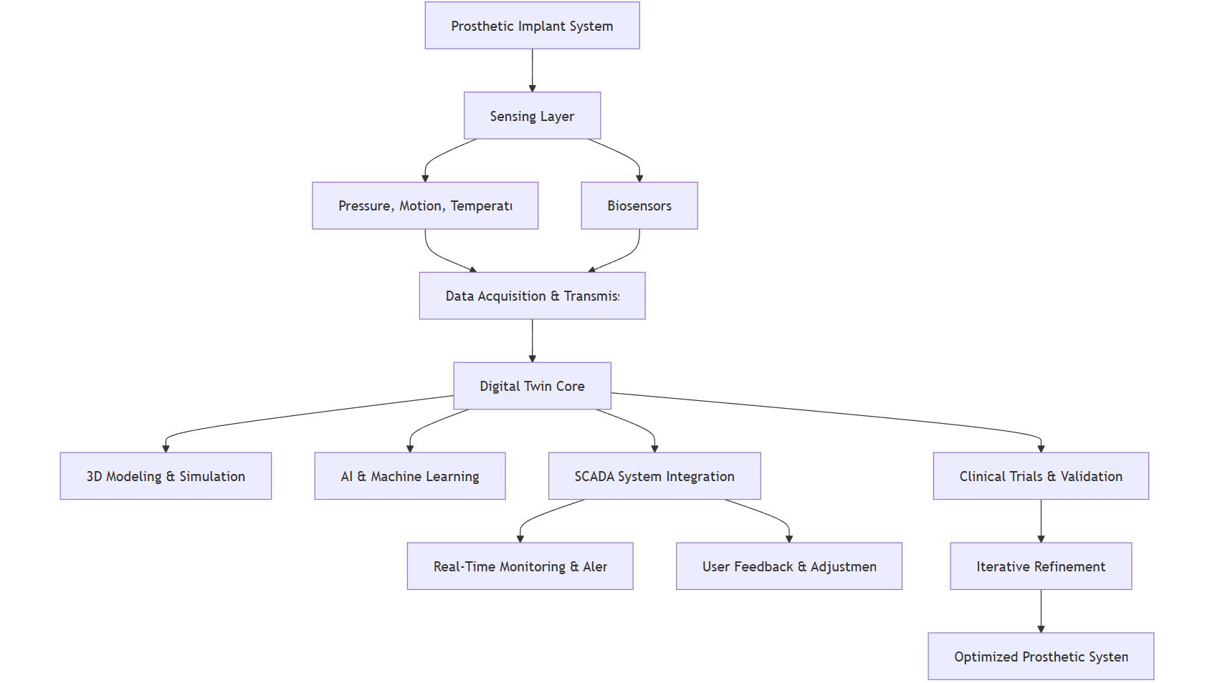

Figure 1 Flowchart for Prosthetic Implant System

The following is the state diagram depicting the brief of the system:

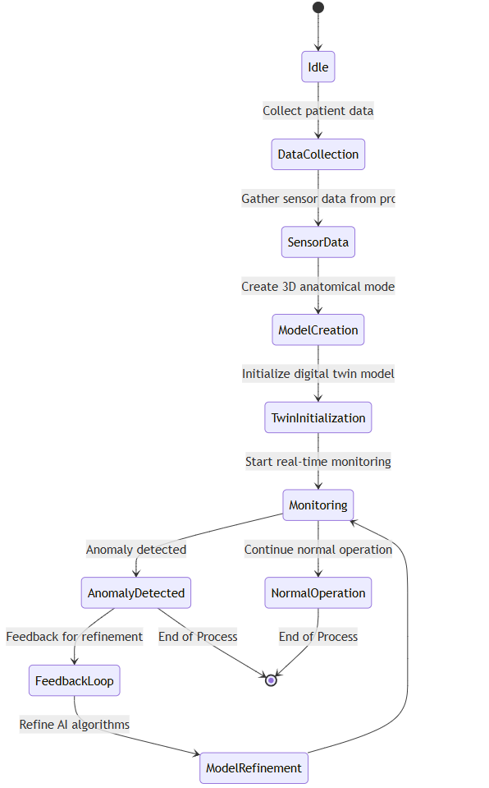

Figure 2 State chart for Prosthetic Implant System

The state diagram for the AI-powered Digital Twin system for Prosthetic Implants represents the various states that the system undergoes during its operation, along with the transitions between those states. Here's a brief explanation of each state:

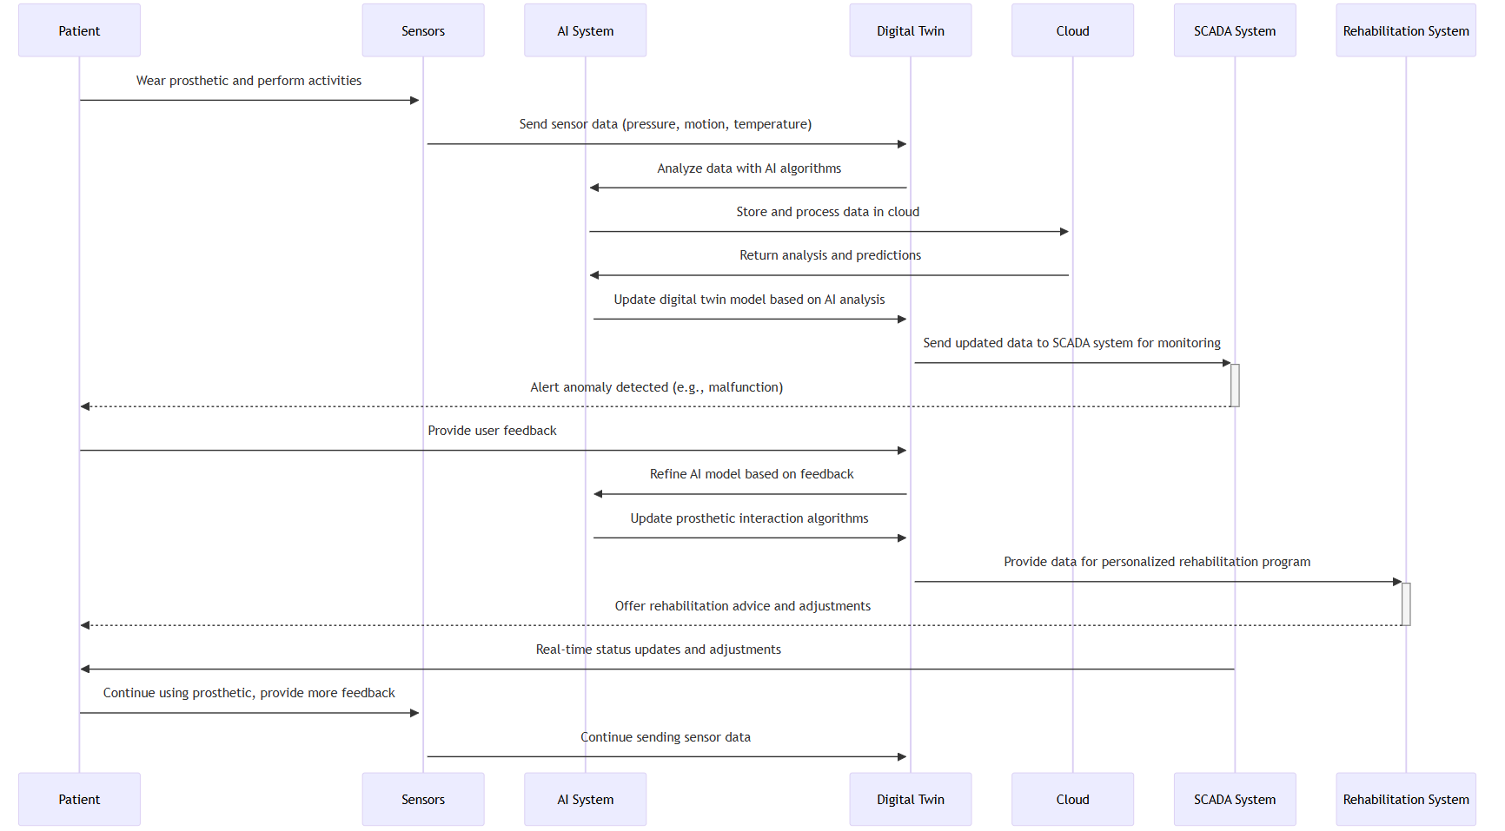

Figure 3 State Diagram for Prosthetic Implant System

**1. Idle**

**- Initial State:** This is the starting point of the system, where no actions are taking place yet.

**2. Data Collection**

**- Action:** Patient's anatomical data is collected using medical imaging techniques (e.g., MRI, CT scans). Sensor data from the prosthetic is also gathered to establish a baseline for the system.

**3. Sensor Data Collection**

**- Action:** Real-time data from various sensors embedded in the prosthetic (like pressure, motion, and temperature) is transmitted to the system for further analysis.

**4. Model Creation**

**- Action:** A 3D digital model of the patient's anatomy is created based on the collected data. This model represents the interaction between the biological tissues and the prosthetic.

**5. Digital Twin Initialization**

**- Action:** The digital twin (virtual model) of the patient's prosthetic and anatomical data is initialized. This enables real-time updates and analysis of the prosthetic's performance.

**6. Monitoring**

**- Action:** Continuous real-time monitoring begins, where the system tracks the prosthetic's functionality, the interaction with biological tissues, and overall performance.

**7. Anomaly Detected**

**- Action:** If an anomaly or issue (e.g., malfunction or discomfort) is detected, the system triggers a state where corrective actions can be initiated.

**8. Feedback Loop**

**- Action:** User feedback is collected, and based on this input, the system starts adjusting or refining its algorithms to improve the prosthetic's performance.

**9. Model Refinement**

**- Action:** The AI system refines the digital twin model based on the feedback received from the user, optimizing the prosthetic's interaction with the biological tissues.

**10. Normal Operation**

**- Action:** The prosthetic enters a state of normal operation, where everything functions as expected without any detected anomalies.

**11. End of Process**

**- Action:** Once the monitoring is complete, or if an anomaly is resolved, the process either returns to normal operation or ends.

**Transition Flow:**

- The state diagram shows the flow of actions from one state to another, triggered by events like data collection, anomaly detection, feedback, and real-time monitoring.

- Anomalies trigger corrective actions, while continuous feedback allows for system optimization and improvements in prosthetic performance.

This state diagram helps visualize how the system operates from the initial data collection to continuous monitoring and refinements, ensuring that the prosthetic is functioning optimally throughout its lifecycle.

**H. EXISTING DATA:** NA

**4. USE AND DISCLOSURE (IMPORTANT):** Please answer the following questions:

|  |  |  |
| --- | --- | --- |
| 1. Have you described or shown your invention/ design to anyone or in any conference? | YES ( ) | NO ( ) |
| 1. Have you made any attempts to commercialize your invention (for example, have you approached any companies about purchasing or manufacturing your invention)? | YES ( ) | NO ( ) |
| 1. Has your invention been described in any printed publication, or any other form of media, such as the Internet? | YES ( ) | NO ( ) |
| 1. Do you have any collaboration with any other institute or organization on the same? Provide name and other details. | YES ( ) | NO ( ) |
| 1. Name of Regulatory body or any other approvals if required.  **Drugs Controller General of India (DCGI)**  1. Central Drugs Standard Control Organization (CDSCO) 2. Indian Council of Medical Research (ICMR) 3. Ethics Committees (ECs) 4. Clinical Trials Registry of India (CTRI) | YES ( ) | NO ( ) |

**5. PROVIDE LINKS AND DATES FOR SUCH ACTIONS IF THE INFORMATION HAS BEEN MADE PUBLIC (GOOGLE, RESEARCH PAPERS, YOUTUBE VIDEOS, ETC.) BEFORE SHARING WITH US**. NA

**6. PROVIDE THE TERMS AND CONDITIONS OF THE MOU ALSO IF THE WORK IS DONE IN COLLABORATION WITHIN OR OUTSIDE UNIVERSITY** **(ANY INDUSTRY, OTHER UNIVERSITIES, OR ANY OTHER ENTITY).** NA

**7. POTENTIAL CHANCES OF COMMERCIALIZATION.**

**1. Growing Demand for Personalized Healthcare Solutions:**

With the increasing focus on personalized medicine and patient-specific treatments, AI-powered digital twin technology in prosthetics has significant commercial potential. As healthcare systems shift towards individualized care, prosthetic devices that can adapt in real-time to each patient’s unique anatomy and lifestyle offer a competitive edge.

**2. Expanding Market for Advanced Prosthetic Devices:**

The global prosthetics market is growing rapidly, driven by advances in materials, robotics, and AI. By offering dynamic adaptability and enhanced functionality, this invention has the potential to capture a significant share of the prosthetics market, especially for individuals with limb loss or impairment who demand more efficient, comfortable, and high-performance devices.

**3. Collaborative Opportunities with Healthcare Providers and Prosthetic Manufacturers:**

The technology can be licensed or co-developed with established prosthetic manufacturers, healthcare institutions, and rehabilitation centres, providing a pathway for integration into existing product lines or as an enhancement to current offerings. This collaborative model presents strong commercialization prospects through partnerships.

**4. High Potential for Integration with Wearable Technologies:**

With the rise of wearable health devices, the technology can expand beyond prosthetics to be integrated into broader health-monitoring platforms. By applying digital twin models to different parts of the musculoskeletal system, commercialization could reach adjacent markets such as orthopaedic implants, exoskeletons, and rehabilitation devices.

**5. Insurance and Healthcare Reimbursement Pathways:**

As healthcare systems become more inclined to support innovative, cost-effective solutions that improve patient outcomes and reduce long-term costs, the invention could benefit from reimbursement models and coverage by insurance providers, further driving adoption and market growth.

**6. Appeal to Military and Sports Rehabilitation Programs:**

Military veterans and athletes are major markets for advanced prosthetics. These groups have specific needs for high-performance, adaptive prosthetic solutions, creating a robust commercialization opportunity within defence and sports rehabilitation sectors.

**8. LIST OF COMPANIES WHICH CAN BE CONTACTED FOR COMMERCIALIZATION ALONG WITH THE WEBSITE LINK.**

**1. ReapMind**

ReapMind specializes in digital twin technology tailored for healthcare applications, including prosthetics. They focus on enhancing patient care and optimizing systems.

- Website: [reapmind.com] (https://reapmind.com)

**2. Wipro**

Wipro offers AI and digital twin solutions across various sectors, including healthcare. Their expertise can be leveraged for developing advanced prosthetic systems.

- Website: [wipro.com] (https://www.wipro.com)

**3. TCS (Tata Consultancy Services)**

TCS provides digital solutions, including digital twin technology, aimed at improving operational efficiency in healthcare settings.

- Website: [tcs.com] (https://www.tcs.com)

**4. Infosys**

Infosys is engaged in creating AI-driven solutions, including digital twins for healthcare applications that can enhance the design and functionality of prosthetics.

- Website: [infosys.com] (https://www.infosys.com)

**5. Siemens Healthineers India**

Siemens Healthineers offers innovative healthcare technologies, including digital twin applications for personalized medicine and prosthetic development.

- Website: [siemens-healthineers.com] (https://www.siemens-healthineers.com)

**6. Medtronic India**

Medtronic is a global leader in medical technology that utilizes advanced technologies, including digital twins, to improve device performance and patient outcomes.

- Website: [medtronic.com] (https://www.medtronic.com/in-en/index.html)

**7. Qure.ai**

Qure.ai focuses on AI solutions for radiology but is also exploring the use of digital twins in personalized healthcare applications.

- Website: [qure.ai] (https://qure.ai)

**8. Aster DM Healthcare**

Aster DM Healthcare integrates technology into their healthcare services, exploring innovations like digital twins for better patient management.

- Website: [asterdmhealthcare.com] (https://www.asterdmhealthcare.com)

**9. ANY BASIC PATENT WHICH HAS BEEN USED AND WE NEED TO PAY ROYALTY TO THEM.** NA

**10. FILING OPTIONS:** Please indicate the level of your work which can be considered for provisional/ complete/ PCT filings (Complete).

**11. KEYWORDS:** Please provide right keywords for searching your invention.

1. AI-powered digital twins
2. Prosthetic implants
3. Real-time monitoring
4. Predictive analysis
5. Machine learning in healthcare
6. Sensor-based feedback
7. Personalized prosthetics
8. Biomechanical compatibility
9. Adaptive prosthetic systems
10. Human anatomy modelling
11. Autonomous prosthetic adjustment
12. Prosthetic optimization
13. Gait analysis
14. Dynamic prosthetic adaptation
15. Material innovation in prosthetics
16. Patient-specific customization
17. Rehabilitation technology
18. Human-prosthetic interaction
19. Sensor data integration
20. Predictive healthcare solutions