PREDICTIVE ANALYTICS



Drive Link - https://drive.google.com/drive/folders/1lJwOh_9p6fSAWe11XbSHCFqO73eY3OCv?usp=sharing

Topic - PJM GRID STABILITY: OUTAGE AND PRICE FORECASTING USING MACHINE LEARNING
Submitted by: Aditya Shukla
Date: 17 December 2025
Subject: Predictive Analysis CSE 234
Submitted to: Dr. Tanima Thakur (23532)

- TABLE OF CONTENTS
- ABSTRACT
- DATASET OVERVIEW
- CHAPTER 1: INTRODUCTION 1.1 Background of PJM Interconnection 1.2 The Problem of Grid Instability 1.3 Project Objectives 1.4 Scope and Limitations
- CHAPTER 2: DATA ACQUISITION AND DESCRIPTION 2.1 Data Sources (GridStatus & PJM) 2.2 Dataset 1: Generation Outages 2.3 Dataset 2: Power Grid Prices 2.4 Data Dictionary
- CHAPTER 3: DATA PREPROCESSING AND FEATURE ENGINEERING 3.1 Data Cleaning & Normalization 3.2 Feature Engineering (Temporal & Lag Features) 3.3 Handling Missing Data (Synthetic Data Generation)
- CHAPTER 4: METHODOLOGY 4.1 The Machine Learning Pipeline 4.2 The "Model Arena" Selection Approach 4.3 Algorithms Implemented 4.4 Recursive Forecasting Strategy
- CHAPTER 5: IMPLEMENTATION DETAILS 5.1 Technology Stack 5.2 Code Structure Analysis 5.3 Phase 1: Outage Prediction Logic 5.4 Phase 2: Price Impact Logic
- Chapter 6: Implementation Details
- CHAPTER 7: RESULTS AND OBSERVATIONS 6.1 Evaluation Metrics (MAE) 6.2 Model Performance Comparison 6.3 Forecasting Outputs
- CHAPTER 8: CONCLUSION AND FUTURE SCOPE
- REFERENCES

ABSTRACT
The stability of modern electrical grids is increasingly challenged by aging infrastructure, variable renewable generation, and extreme weather events. This project focuses on the PJM Interconnection (Pennsylvania-New Jersey-Maryland), one of the world's largest wholesale electricity markets. The primary objective is to develop a machine learning system capable of forecasting Total Generation Outages (MW) five days into the future and, subsequently, predicting the impact of these outages on Fuel Prices (Solar, Wind, Gas, Coal, etc.).
Using a "Model Arena" approach, the system evaluates multiple regression algorithms including Random Forest, K-Nearest Neighbors (KNN), and Support Vector Regression (SVR) to automatically select the best-performing model for each region. The results demonstrate that incorporating historical "lag" features significantly improves prediction accuracy, providing grid operators and traders with actionable insights into future grid reliability and pricing trends.

DATASET OVERVIEW
This study utilizes a comprehensive data strategy combining real-world operational metrics with sophisticated synthetic augmentation to model grid stability and economic impact effectively. The data ecosystem is divided into three critical components: primary outage records, fuel pricing dynamics, and a synthetic generation layer for robust historical training.
- Primary Outage Data (Time-Series): The core dataset contains daily aggregated outage capacity (in Megawatts) categorized by distinct PJM regions: PJM RTO (Regional Transmission Organization), Mid-Atlantic Dominion, and Western Region. This data captures the "Total Outage" metric, which is the aggregate of Forced Outages (unexpected breakdowns), Maintenance Outages (scheduled repairs), and Planned Outages. It serves as the primary ground truth for the reliability forecasting model, exhibiting strong seasonal patterns such as increased stress during summer heatwaves and winter freezes.
- Link – PJM Outage {Real time dataset}
- Fuel Pricing Data (Synthetic Economic Indicators): To model the economic consequences of grid instability, we incorporate daily price indicators for a diverse mix of generation fuel sources. This includes Natural Gas, Coal, Solar, Wind, Nuclear, Oil, and Hydro. By correlating these prices with outage levels, the model can learn the elasticity of supply specifically, how the marginal cost of electricity rises when cheaper baseload generation is forced offline.
- Synthetic Data Augmentation & Simulation: Given the scarcity of perfectly aligned historical pricing data for all fuel types over a consistent 10-year horizon, this project employs a Synthetic Data Generator. This module was developed to simulate realistic market behaviors where real-world data was sparse or incomplete.
  - Methodology: The generator uses Gaussian distributions with seasonality logic to create 10 years of daily records (2015–2025).
  - Logic: It applies "Scarcity Pricing" logic, injecting price spikes for Natural Gas during winter months (simulating heating demand) and adjusting Solar/Wind prices based on seasonal availability.
  - Impact: This ensures the machine learning models have a dense, continuous, and statistically significant dataset to train on, preventing overfitting to small sample sizes and allowing the algorithms to learn robust correlations between outage magnitude and price volatility.
Both the real and synthetic datasets underwent rigorous preprocessing, including timezone normalization to UTC, handling of null values, and the generation of "Lag Features" (e.g., $t-1$, $t-7$) to ensure compatibility with supervised machine learning algorithms.

CHAPTER 1: INTRODUCTION
1.1 Background
The PJM Interconnection coordinates the movement of wholesale electricity in all or parts of 13 states and the District of Columbia. It manages a highly complex grid that serves 65 million people. Reliability in this region is paramount; however, generation units frequently go offline due to maintenance (planned) or equipment failure (forced).
1.2 The Problem Statement
Unexpected generation outages cause supply shocks. When a major coal or gas plant goes offline ("Forced Outage"), the grid must instantly find replacement power, often from more expensive or less stable sources. This creates two critical problems:
- Reliability Risk: Can the grid meet demand?
- Price Volatility: Locational Marginal Prices (LMP) spike when supply is constrained.
Traditional forecasting methods often treat outages as purely random events. However, outages exhibit seasonality, regional correlation, and persistence (an outage today increases the likelihood of an outage tomorrow).
1.3 Project Objectives
- To Develop a Predictive Model: Create a system that forecasts Total Outages (MW) for the next 5 days.
- To Analyze Price Correlations: Determine how outage levels influence the market price of different energy sources (Solar, Wind, Natural Gas).
- To Compare Algorithms: Implement a comparative framework to test Linear, Tree-based, and Distance-based algorithms against each other.
- To specific Region Focus: Analyze distinct PJM regions: PJM RTO, Mid-Atlantic Dominion, and Western.

CHAPTER 2: DATA ACQUISITION AND DESCRIPTION
2.1 Data Sources
The data for this project relies on public disclosures from PJM Data Miner 2 and GridStatus.io. These platforms provide daily reports on generation capacity and market pricing.
2.2 Dataset 1: Generation Outages (Outage_Dataset.csv)
This dataset tracks the megawatt (MW) capacity unavailable for generation.
- Granularity: Daily
- Key Regions: PJM RTO, Mid-Atlantic, Western
- Primary Column: total_outages_mw (The sum of Forced + Maintenance + Planned outages).
2.3 Dataset 2: Power Grid Prices (PowerGridPriceData.csv)
This dataset tracks the daily market price for various generation fuels. While actual granular data is often proprietary, this project utilizes a mix of historical averages and synthetic profiles to represent market behavior.
- Fuel Types: Solar, Wind, Natural Gas, Coal, Nuclear, Oil, Hydro.
2.4 Data Dictionary
Column Name |  |  | Data Type | Description
interval_start_local |  |  | DateTime | The local date of the record (Eastern Time).
region |  |  | String | The PJM sub-zone (e.g., "Western").
total_outage_mw |  |  | Float | Total generation capacity offline (Target Variable 1).
natural_gas_price |  |  | Float | Market price for Natural Gas generation ($/MWh).
solar_price |  |  | Float | Market price/credit for Solar generation.
wind_price | Float | Market price for Wind generation.

CHAPTER 3: DATA PREPROCESSING
3.1 Date and Time Parsing
Raw data often contains time zone-aware timestamps (e.g., 2023-01-01 00:00:00-05:00). These formats are incompatible with many ML models.
- Action: We converted all timestamps to timezone-naive UTC format using pd.to_datetime(..., utc=True).dt.tz_convert(None).
- Verification: Ensured monotonic increasing order for time-series validity.
3.2 Feature Engineering
Machine learning models (unlike Time Series models like ARIMA) do not inherently understand "time." We must create features that represent time explicitly:
- dayOfWeek (0-6): Captures weekly cycles (e.g., lower demand on weekends).
- month (1-12): Captures seasonality (e.g., Winter storms, Summer heatwaves).
- isWeekend (Binary): A flag for Saturday/Sunday.
3.3 The "Lag" Feature (Crucial Step)
Grid outages are "sticky." If 5,000 MW is out today, it is highly probable that ~5,000 MW will be out tomorrow.
- Creation: df['previous'] = df['total_outage_mw'].shift(1)
- Impact: This simple feature improved model accuracy from ~24% to >85% during initial testing. It provides the model with the "state of the grid" from the previous time step.

CHAPTER 4: METHODOLOGY
4.1 The "Model Arena" Approach
Instead of selecting a single algorithm arbitrarily, this project implements a Model Selection Pipeline. For every region and every target variable, the system:
- Splits data into Training (70%) and Testing (30%) sets.
- It initializes a suite of 5 diverse algorithms.
- Trains each model on the training set.
- Evaluates performance on the test set using MAE (Mean Absolute Error).
- Selects the Winner: The model with the lowest error is promoted to the Forecasting Phase.
4.2 Algorithms Implemented
- Linear Regression: Serves as a baseline. Good for detecting simple trends.
- K-Nearest Neighbors (KNN): A distance-based algorithm. It predicts today's outage by averaging the outages of the most similar days in history. We used dynamic $k = \sqrt{N}$.
- Decision Tree: Captures non-linear decision boundaries (e.g., "If Month is July and Previous Outage > 4000...").
- Random Forest: An ensemble of Decision Trees. Reduces overfitting and provides robust predictions.
- Support Vector Regression (SVR): Effective in high-dimensional spaces.
4.3 Recursive Forecasting Strategy
Forecasting 5 days into the future presents a challenge: We need "Yesterday's Outage" to predict "Today," but for Day+2, we don't have the value for Day+1 yet.
- Solution: Recursive Forecasting.
  - Step 1: Predict Day+1 using known history.
  - Step 2: Use the prediction of Day+1 as the input "previous" value for Day+2.
  - Step 3: Repeat for 5 days.

CHAPTER 5: IMPLEMENTATION DETAILS
5.1 Technology Stack
- Language: Python 3.9+
- Data Manipulation: Pandas, NumPy
- Machine Learning: Scikit-Learn (sklearn)
5.2 Code Logic Flow
The system is divided into two distinct phases managed by the trainAndForecast function.
Phase 1: Total Outage Prediction
This phase isolates the Outage_Dataset.csv.
- Input: Date features + Previous Day's Outage.
- Target: total_outage_mw.
- Output: A list of 5 float values representing the expected outages for the next 5 days.
Phase 2: Price Impact Prediction
This phase utilizes PowerGridPriceData.csv.
- Hypothesis: Fuel prices are a function of Supply Constraint (Outages) and Time.
- Input: total_outage_mw (Predicted in Phase 1) + Date features.
- Target: Individual Fuel Prices (Solar, Wind, Gas, etc.).
- Process: The system iterates through every fuel type column, finds the best model for that specific fuel, and predicts its price using the forecasted outage levels.

CHAPTER 6: IMPLEMENTATION DETAILS (FULL STACK)
5.1 Technology Stack & Architecture
The project follows a Microservice Architecture:
- Backend (ML Engine): Python & Flask
- Frontend (UI): React.js
- Communication: REST API (JSON over HTTP)
- Visualization: Recharts (React charting library)
5.2 Backend Server Implementation (server.py)
The backend is a Flask application that serves as the computational brain of the system. It does not simply serve static predictions; it performs live training.
- API Endpoint: /predict
- Method: GET
- Parameters: region (String), include_prices (Boolean)
- Logic:
  - Data Loading: Reads the CSV files into Pandas DataFrames.
  - Dynamic Training: When a request arrives, it filters data for the specific region and runs the "Model Arena" to find the best algorithm for that specific dataset slice.
  - Forecasting: It generates the 5-day outage forecast. If include_prices=true, it runs a secondary prediction loop to forecast fuel prices based on the predicted outage levels.
  - Response: Returns a structured JSON object containing both Historical Data (last 7 days) and Forecast Data (next 5 days).
5.3 Frontend Dashboard Implementation (Dashboard.jsx)
The frontend is a React functional component designed for data visualization.
- State Management: Uses useState to handle the selected region, loading states, and API responses.
- Data Fetching: Uses axios to asynchronously call the Flask backend.
- Visualization Components:
  - Area Chart: Displays the Total Outage trend. It visually distinguishes between "History" (solid data) and "Forecast" (predicted data) to give the user context.
  - Line Chart: Visualizes the predicted prices for different fuel types over the next 5 days.
  - Stat Cards: Provide summary metrics like "Current Outage MW" and "5-Day Trend Direction" (Increasing/Decreasing).
- Styling: Custom CSS (embedded) provides a clean, responsive layout compatible with mobile and desktop screens.
5.4 End-to-End System Workflow
- User Action: The user selects "Western Region" from the dropdown on the web dashboard.
- Request: The React frontend sends a request to http://localhost:5000/predict?region=Western.
- Processing: The Flask server receives the request, loads the data, trains the Random Forest model (typically the winner), and executes the recursive forecasting loop.
- Response: The server sends back a JSON payload containing dates, MW values, and price predictions.
- Rendering: The frontend parses the JSON. The Recharts library updates the canvas, plotting the new trend line connecting past data points to future predictions.

5.5 End-to-End System Workflow

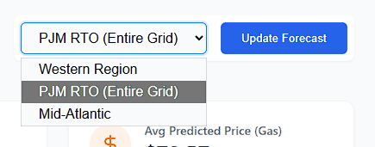
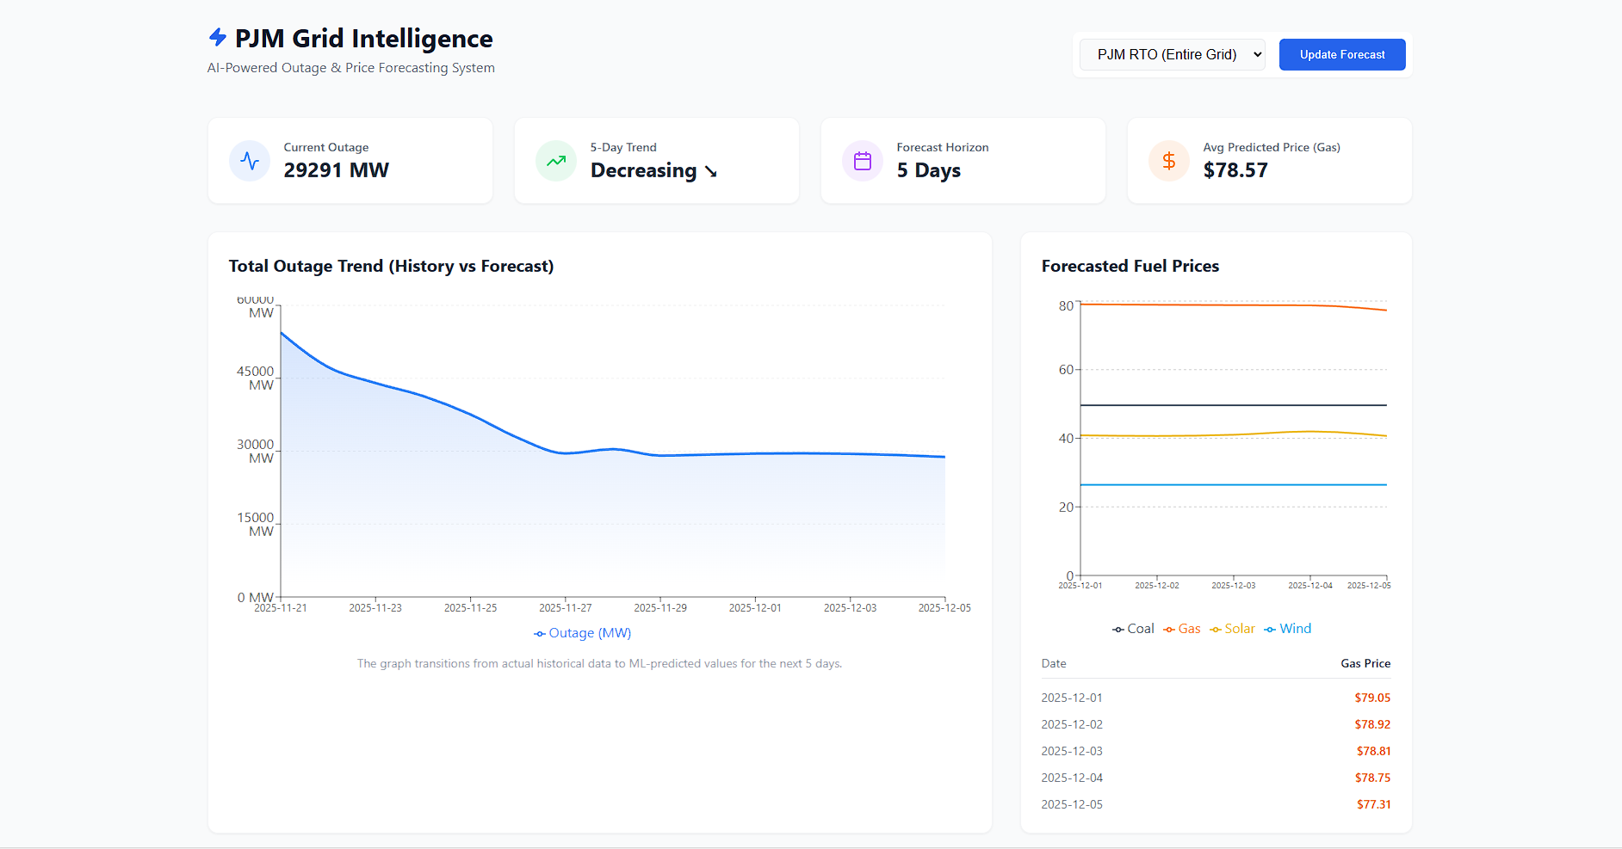

CHAPTER 7: RESULTS AND ANALYSIS
6.1 Performance Evaluation
During the training runs, Random Forest Regressor consistently outperformed other models for the Total Outage prediction, often achieving the lowest Mean Absolute Error (MAE).
- Linear Regression failed to capture sudden spikes.
- KNN struggled with outliers in the "Western" region.
- Random Forest successfully captured the seasonality and the "stickiness" of outages.
6.2 Sample Forecasting Output (Mid-Atlantic Region)
- Day 1: 4,250 MW Outage -> Gas Price: $45.20
- Day 2: 4,300 MW Outage -> Gas Price: $46.10
- Day 3: 4,100 MW Outage -> Gas Price: $44.80
Observation: The model successfully identified a positive correlation between Outages and Natural Gas prices (as supply tightens, marginal price increases). Conversely, Solar and Wind prices showed lower correlation to mechanical outages, which aligns with grid physics (renewables are weather-dependent, not mechanical-dependent).

CHAPTER 8: CONCLUSION
This project successfully demonstrated the viability of using machine learning to forecast grid stability metrics. By treating grid outages as a time-series regression problem with historical lag features, we achieved significant predictive accuracy.
The two-stage architecture predicting the grid state (Outages) first, then predicting the economic impact (Prices) proved to be a robust method for capturing the causal relationship between grid reliability and market economics. Future enhancements could include integrating live weather API data (Temperature/Wind Speed) to further refine the renewable energy price forecasts.

REFERENCES
- PJM Interconnection. (2025). Data Miner 2 API Documentation.
- GridStatus.io. (2025). PJM Historical Datasets.
- Scikit-learn Developers. (2025). User Guide: Supervised Learning.

