Counterfeit Medicine Detection
Explainable AI with a Blockchain Audit Trail
Progress write-up, 18 October 2026 | College project, team of two | Written in plain English, with the technical words explained
The short version. We have built and tested the part that looks at a photo of a pill or a medicine box and says genuine, counterfeit, or not sure. It catches about 85% of the fakes it is shown, at the price of some false alarms (roughly 1 genuine item in 6 is wrongly flagged). A small demo web page lets you try it live. The part that writes every decision into a tamper-proof blockchain record is not built yet. Everything below explains what we did, why, and what comes next.

1. What are we actually building?
Fake medicines are a real problem: they can look almost identical to the real thing, and an inspector cannot send every tablet to a lab. Most AI tools that try to help have two weaknesses. They are a black box (they say "fake" without any reason, so nobody can trust or challenge them), and their decisions are saved in ordinary files that anyone could quietly edit afterwards.
Our project tries to fix both. The finished system will do four things:
- Detect: a neural network (a CNN, explained in the glossary) looks at a photo and gives a probability that it is counterfeit.
- Explain: it draws a heatmap on the photo showing which parts made it suspicious (this technique is called Grad-CAM).
- Decide: if it is confident it acts on its own (APPROVE or FLAG); if it is not sure it passes the case to a human (ESCALATE).
- Record: it saves a fingerprint of the photo and the decision on a blockchain (a shared ledger nobody can edit), so anyone can later prove the record was not changed.
Think of it as a careful assistant to an inspector: it gives an opinion, shows its working, knows when to say "I am not sure", and keeps an honest diary.

2. Where we are right now
Phase | What it is | Status
1 | Planning and project folder on GitHub | Done
2 | Setting up the tools (Python, Node.js, Hardhat, GPU) | Done
3 | Getting real images of genuine medicines | Done (used different sources than planned, see 4.2)
4 | Making simulated fakes and splitting the data fairly | Done
5 | Training and testing the detector | Done (works, but fakes caught is 85%, below our 90% goal)
Extra | Naming the drug and comparing with genuine examples | Done (helps only a little)
6 | Explainability (heatmaps) | Partly (heatmaps work and were checked against the real edits; the SHAP/LIME comparison is still to do)
7 | Smart contract (the blockchain program) | Not started
8 | Connecting Python to the blockchain, plus a backup | Not started
9 | Full decision pipeline and tuned thresholds | Partly (basic thresholds work)
10 | The full web app | Partly (a prototype page exists)
11 | Full testing | Partly (sanity checks done)
12 | Final report and viva practice | Not started (this document is a progress note only)

3. The tools we used
Tool | What we use it for, in one line
Python 3.13 and PyTorch | All the AI code. PyTorch is the library that builds and trains neural networks.
Your NVIDIA RTX 4060 GPU | Makes training fast (about 20 to 50 seconds per round instead of many minutes on a normal processor).
MobileNetV2 | The neural network we start from. It is small and fast, and already knows how to see shapes and textures from being trained on millions of everyday photos.
pytorch-grad-cam | Draws the heatmaps.
scikit-learn, pandas, matplotlib | Scores, tables and charts.
Streamlit | Turns our Python code into a simple web page for the demo.
Hardhat and web3.py (ready, not used yet) | Hardhat runs a pretend blockchain on your laptop; web3.py lets Python talk to it. No real money is involved.
Git and GitHub | Saves every step so nothing is lost, and lets your teammate work on the same project.

4. What we did, step by step

4.1 Setting up
We made a project folder with a clear structure (data, source code, tests, outputs), a Python virtual environment (a private box of libraries so the project does not clash with other software), and a GitHub repository with two working branches: one for the data and model side, one for the blockchain and app side. A small script, smoke_test.py, checks that everything is installed and that the local blockchain answers. It prints all green.

4.2 Getting genuine images
The plan said to download a pill dataset from Kaggle, but Kaggle needs a login that our tools cannot use. So we found two open datasets with clear licences (both CC BY 4.0, which means free to use if we credit the authors):
- MEDISEG: photos of loose pills, with a box drawn around each pill and the drug it belongs to. We used 600 of them.
- Mobile-Captured Drug Packs: phone photos of real medicine boxes. We used 400 of them. You asked for boxes as well as loose pills, and this covers that.
Two details matter here. First, MEDISEG contains several slightly altered copies of the same photo; if we had split carelessly, near-identical pictures would have landed in both training and testing, which makes the scores look better than they are (this is called data leakage). We kept one photo per original. Second, the box photos show the same pack from many angles, so we grouped them by when they were taken and kept each group together.
All images were cleaned (broken, tiny and duplicate files removed) and saved in one identical format so that file type cannot give anything away.

4.3 Making the fake medicines
There is no public collection of real counterfeit medicine photos, so we simulated counterfeits by editing genuine photos. Each fake gets one to three of these edits, at a random strength (low, medium or high):
- Colour shift: the pill or box is a slightly different shade.
- Imprint blur or erase: the printed marking is smudged or wiped out.
- Wrong text: wrong or twisted letters are drawn on the pill or box.
- Shape change: slightly stretched, resized or tilted.
- Noise and compression: grainy, low-quality look.
For edits that affect only one area, we record exactly where (a bounding box) in a file called the manifest. We use this later to check whether the heatmap points at the right place. We also aimed the edits at the pill itself, using the pill outlines that MEDISEG provides, because our first attempt put edits on the background, which is meaningless.
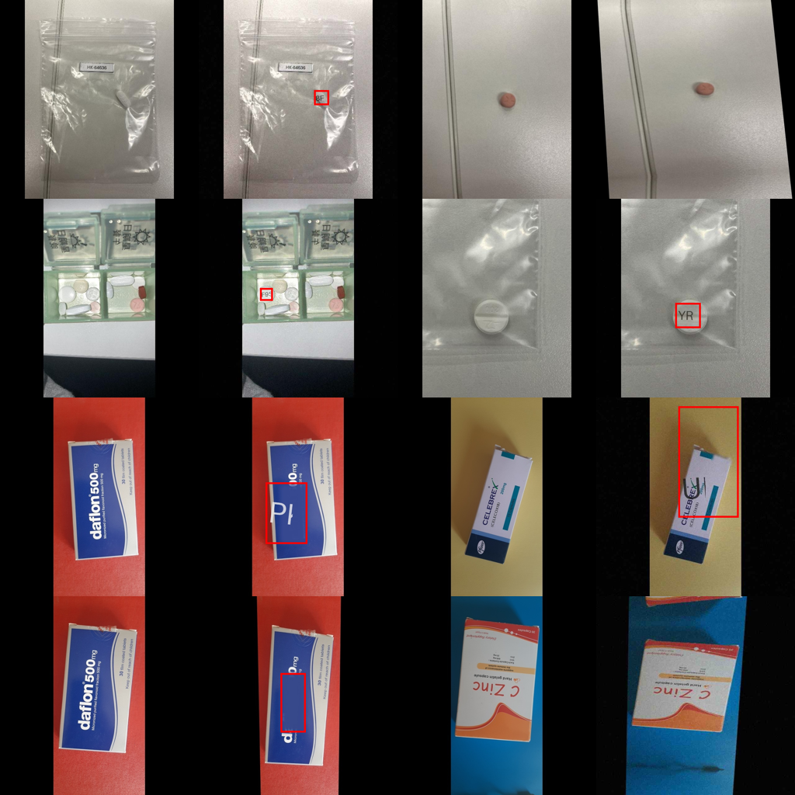
Figure 1: genuine (left of each pair) and simulated fake (right). Red boxes mark where the edit was made.
The result is 1,000 genuine and 1,000 fake images. We split them 70% for training, 15% for validation (tuning) and 15% for testing, and we split the originals first and made the fakes afterwards, so a genuine photo and its fake twin are never in different groups.
A design choice you asked for. Instead of folders called "genuine" and "counterfeit", every split is one mixed pile of images with random file names. The real answers live in a separate file (labels.csv) that only the training and scoring code read. After the model is tested, a script sorts any mixed pile into genuine, counterfeit and escalate folders. As a bonus this removes a hidden hint: our fakes used to have "_fake" in the name, which a model could in theory exploit.

4.4 Teaching the model
We used transfer learning: take MobileNetV2, which already understands general image features, and retrain it for our two-way question (genuine or counterfeit). It happens in two stages:
- Stage 1 (head only): freeze the network and train just the final decision layer. Quick, safe, but limited.
- Stage 2 (fine-tuning): unfreeze the layers and let the whole network adjust slowly. This is where most of the improvement came from.
We kept the training simple on purpose: only mirror-flip and slight rotation as augmentation, and no colour changes, because colour is one of the clues for a fake. We pick the best round by how many fakes it catches on the validation images, but only among rounds where at least 80% of what it flags is truly fake (otherwise "flag everything" would win). The test images are used once, at the very end.
The first attempt was weak, so we tried changes and compared them on the validation images only:
Attempt | Image size | Layers trained | Fakes caught (val) | Accuracy (val)
First run | 224 px | last few blocks | 66% | 79%
Experiment A | 224 px | most layers | 82% | 84%
Experiment B | 320 px | most layers | 84% | 87%
Experiment C (chosen) | 320 px | all layers | 85% | 86%
Bigger images helped a lot because many edits are tiny; we picked C because the plan values catching fakes most. These tuning runs happened before the shortcut fix in section 4.10; the final model was retrained on the fixed data with the same recipe.

4.5 How we checked we were not fooling ourselves
- Fresh test set: 298 images the model never saw while learning or tuning.
- Simple baseline: a trivial method (just looking at colour counts) scored AUC 0.61. Our model scored 0.90, so it is genuinely learning something.
- Shortcut check: can file size or image dimensions alone tell genuine from fake? No (0.51, which is a coin flip), so the model is not cheating on technical details.
- Overfit-16 test: a healthy training loop can memorise 16 images perfectly. Ours reached 100%.
- Leakage checks built into the code: automatic assertions fail if the same source image or pack appears in two splits.
- Breakdowns: we report results per edit type, per strength, pills vs boxes, so weak spots are visible.

4.6 The results
Measure | Result | Plain meaning
Accuracy | 83.6% | Out of every 100 test images, about 84 were judged correctly.
Counterfeit recall | 84.6% (goal 90%) | Of 100 fakes, about 85 were caught. Below our goal.
Counterfeit precision | 82.9% | When it says fake, it is right about 5 times out of 6.
Genuine passed | 82.6% | About 17 in 100 genuine items were wrongly called fake.
ROC-AUC | 0.904 | How well it ranks fakes above genuine items (1.0 is perfect, 0.5 is a coin flip).

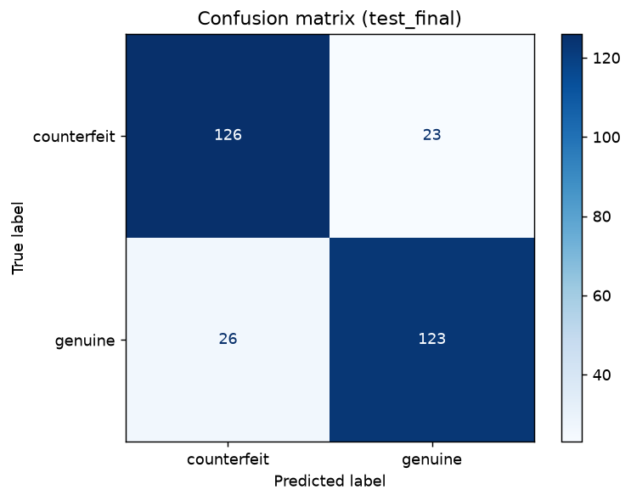
Figure 2: confusion matrix on the test set (rows are the truth, columns are what the model said).
Where it is strong and weak (share of fakes caught): noise 100%, wrong text 96%, shape change 90%, imprint blur 88%, and colour shift only 78%. By strength: low 82%, medium 85%, high 87%. Edits to one area (91%) are caught more often than whole-image edits (74%). Pills (86%) and boxes (84%) are about equal. In short, the subtle fakes are the hard ones, which is exactly what you would expect.

4.7 Drug matching (your extra idea)
You asked how we could judge a loose pill that is not in a box. We cannot know a pill is genuine from a photo alone, but we can ask: does it look like the genuine pills of the drug it seems to be? We trained a second network to name the drug (23 drugs, correct 88% of the time on photos it had never seen) and stored a "gallery" of the numeric fingerprints of known genuine photos of each drug. A new pill is compared with the gallery of its predicted drug; low similarity is extra suspicion.
Honest finding: it carries some signal on its own (AUC 0.79), but combining it with the main model only nudged AUC from 0.903 to 0.910 and fakes caught from 80% to 82%, while false alarms rose from 8% to 9%. So it is a weak helper, not a game-changer. We report that as it is. Note it works only for loose pills of those 23 drugs.

4.8 Sorting a mixed pile
sort_images.py takes the mixed test pile and puts each image in a genuine, counterfeit or escalate folder using the model's probability (below 15% genuine, above 85% counterfeit, otherwise escalate). Result on 298 images:
- It decided 51% automatically and was right on 94.8% of those.
- It missed 7 fakes (approved them by mistake) and wrongly flagged 1 genuine item.
- It escalated 145 images to a human: 107 genuine and 38 fake. Uncertain cases are the point of escalation.
The thresholds are not tuned yet. Making the APPROVE side stricter would reduce missed fakes at the cost of more escalations; that is a Phase 9 job.

4.9 The heatmaps and the demo page
A heatmap (the Grad-CAM family) paints in warm colours the parts of the photo that pushed the model toward "counterfeit". Red or yellow means strong evidence, blue means little. It takes about a tenth of a second. It is a hint about the model's attention, not proof that a medicine is fake.
You asked that the heatmap really works, so we measured it instead of trusting it. On the 95 test fakes where we know exactly where the edit was made, we asked: does the heatmap light up that spot? We also tried several heatmap methods and layers and picked the best on the validation images only (LayerCAM on an earlier layer, which is sharper than the default).
- The single hottest point lands inside the real edit 66% of the time (77% for strong edits, 59% for subtle ones).
- It puts 9 times more attention on the edited area than chance would.
- Control: on the genuine twin of the same photo, the hottest point lands in that same spot only 23% of the time, so the heatmap is reacting to the fake edit and not just to the pill.
- It is not staring at black borders any more (attention on black pixels is about neutral, 1.05 where 1.0 is neutral).
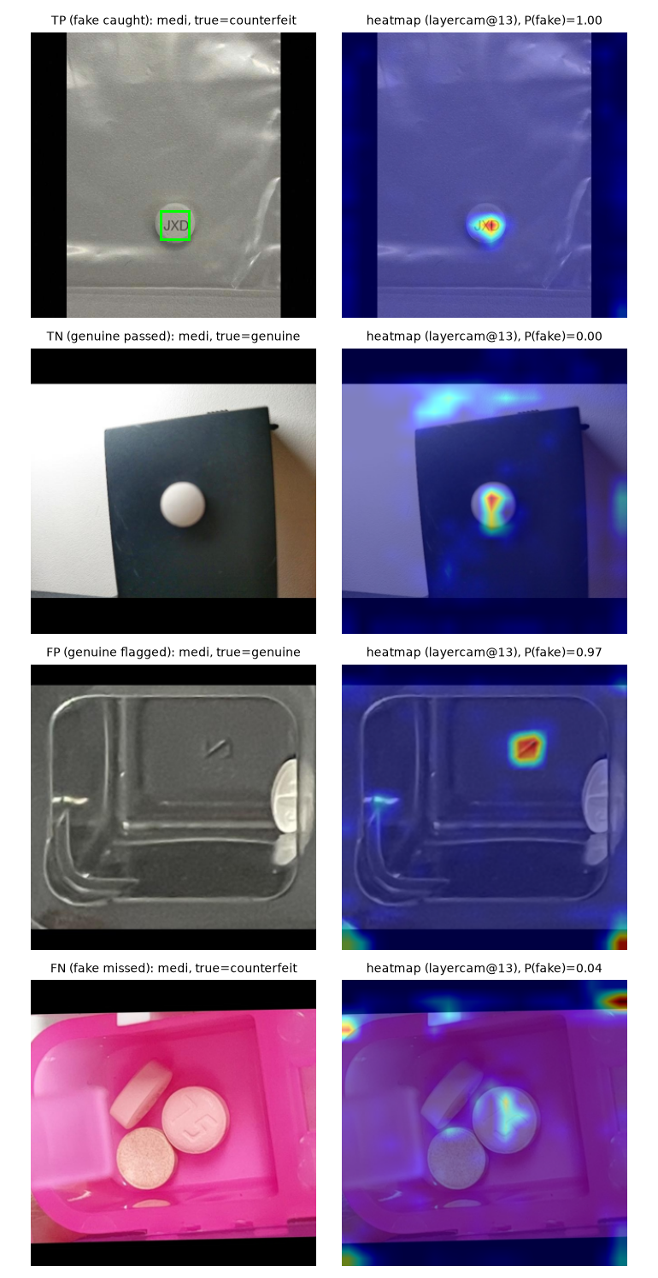
Figure 3: heatmaps on test images. Top to bottom: fake caught, genuine passed, genuine flagged by mistake, fake missed. Green box = where the edit really was.
Honest limits: the heatmap only matches the edit where the edit is local (colour shifts and noise affect the whole photo, so there is no spot to find); on the false alarms and misses the heatmap shows the model looking at the wrong thing, which is useful for debugging; and we have not yet compared it with LIME or SHAP.
The demo page (app.py, run with Streamlit) has three tabs: Check medicine (upload or pick a random test image; see verdict, confidence, heatmap, the drug match for pills, and the two SHA-256 fingerprints that the blockchain will store later), Model results (all the numbers above), and Project status (an honest checklist). It says clearly that nothing is written to a blockchain yet.

4.10 A shortcut we found and fixed
When you opened the demo, one heatmap was red along the bottom edge of the photo and blue over the pill. That told us the model was not looking at the medicine. The cause was my fake generator: the "shape change" edit warps the photo and leaves a black wedge at the border, and the model had learned that a black wedge means fake. This is called shortcut learning: the model passes the exam by spotting a side-effect of how the test was made, not the thing we care about.
We measured it (attention on black pixels was higher for shape-change fakes) and fixed it: the warp now fills those corners with mirrored image content, so there is no black wedge and the amount of black in a fake matches its genuine twin (a first fix that zoomed in cropped away the photo's own black bars and created a different cue, so we dropped it). Then we retrained on the fixed data with the same recipe. Before and after, on the same 298 test images:
Measure | Before the fix | After the fix
Fakes caught (recall) | 81.2% | 84.6%
When it says fake, it is right | 94.5% | 82.9%
Genuine items passed | 95.3% | 82.6%
Accuracy | 88.3% | 83.6%
ROC-AUC | 0.909 | 0.904
Heatmap hottest point inside the real edit | 49% | 66% (after also choosing a sharper heatmap)
Reading it honestly: the overall ranking quality (AUC) barely moved, so the model is not much worse. It just sits at a different balance, catching more fakes but raising more false alarms. Accuracy fell by about 5 points, which may be the part of the old score that came from the shortcut.

5. What each code file does
File | In plain words
src/config.py | One place for settings: seeds, image size, thresholds, folder paths.
src/smoke_test.py | Checks the whole setup works.
src/import_mediseg.py | Takes a sample of the pill dataset, with each pill's box and drug name.
src/import_drugpacks.py | Downloads the medicine-box photos (and checks their checksums so nothing is corrupted).
src/clean_dataset.py | Removes broken, tiny and duplicate files; saves everything in one format.
src/generate_fakes.py | Splits the data safely, creates the simulated fakes, writes the answer key and manifest.
src/dataset.py | Feeds images and answers to the model.
src/train.py | Trains and tests the genuine-vs-fake model; writes all the metrics and charts.
src/sanity_checks.py | Baseline, shortcut and overfit tests.
src/prepare_drugid.py, train_drugid.py | Build and train the drug-naming model and its gallery.
src/drug_match.py, evaluate_drugmatch.py | Use the drug model, and test whether it helps.
src/explain.py | Draws the heatmaps (Grad-CAM family) and loads the method chosen on validation data.
src/validate_explanations.py | Checks the heatmaps against the real edit locations, picks the best method, makes the example figures.
src/sort_images.py | Sorts a mixed pile into genuine, counterfeit and escalate.
app.py | The Streamlit demo page.
contracts/, tests/, chain.py and others | Empty placeholders for the blockchain work still to come.

6. Problems we hit (and what we learned)
- Fakes landed on the background. Fixed by aiming edits at the annotated pill.
- Ugly artefacts from the "fill-in" edit and from stretching images made fakes too easy to spot. Replaced with a gentle colour fill and black borders that match the dataset.
- Same pack in train and test. Fixed by grouping photos of one pack together before splitting.
- File names gave the answer away. Fixed with random names and a hidden answer file.
- A website blocked our Python downloader (a bot check). The script falls back to the system curl tool, which gets through.
- The model took a shortcut. It had learned to treat black wedges left by the shape-change edit as a sign of a fake. Found with the heatmap, fixed in the generator, retrained (section 4.10).
- The first model was too weak. Larger images and fine-tuning more layers fixed most of it. Lesson: judge on validation data, touch test data once.

7. Limits you should say out loud
- The fakes are simulated. The model has learned to spot our edits, not real counterfeiting methods. These scores are not real-world accuracy.
- Small data: 1,000 genuine images from two sources. Photos from other cameras, backgrounds or unfamiliar products may be misjudged; the model should answer "not sure" in such cases but is not guaranteed to.
- A "genuine" verdict is not proof. Only lab chemistry can confirm a medicine.
- Fakes caught is 85%, below the 90% target, and about 17% of genuine items are wrongly flagged. Subtle colour shifts (78%) are the main gap.
- Drug naming covers 23 drugs and loose pills only.

8. What comes next
- Finish Phase 6: compare the heatmaps with LIME or SHAP (the heatmap checks and the example figures are already done).
- Phase 7, the smart contract: a small Solidity program that stores, for each decision, the two fingerprints (image and heatmap), the verdict, the confidence, the time and who logged it. It can only be added to, never edited or deleted, and only approved accounts may write. Tests will cover each rule.
- Phase 8, Python meets blockchain: code to deploy the contract, log each decision, and verify any image later (MATCH or MISMATCH). Plus a backup "hash-chain" log in a file, in case the blockchain tools cost us too much time (the plan sets a Day-15 checkpoint).
- Phase 9: combine everything into one decision function and tune the thresholds on validation data to cut missed fakes.
- Phase 10 and 11: finish the app (ledger and verify tabs), run the tamper test (change one pixel and watch verification fail), the access-control test, timing and gas measurements, and a robustness test on unfamiliar photos.
- Phase 12: report, logbook and a rehearsed 5-minute demo with a backup recording.
Optional ideas: compare against ResNet18 (the plan's alternative network) in a table; add real phone photos to test generalisation; improve the colour-shift detection.

9. How to show it

Run the live demo
cd "C:\Users\adity\OneDrive\Desktop\Counterfiet Medicine Detection"
venv\Scripts\streamlit run app.py
Then open http://localhost:8501. Press the random-image button, then tick "Reveal" to show the true answer. For best results use test-pool images; for your own photo use a plain background.

Other things you can run
venv\Scripts\python src\smoke_test.py # environment check
venv\Scripts\python src\generate_fakes.py # rebuild data and fakes
venv\Scripts\python src\sort_images.py # sort the mixed test pile

A 60-second explanation for your teacher
"We built an AI that looks at a photo of a medicine and says genuine, fake or not sure, shows a heatmap of why, and will log each decision on a blockchain so it cannot be edited later. Because real counterfeit data does not exist publicly, we trained on genuine photos and simulated fakes, and we tested on images it never saw. It catches about 85% of fakes, with some false alarms (about 83% precision); the blockchain part is the next phase."
If asked why MobileNetV2: it is small and fast, and it works well when you have only a thousand images. If asked about trust: the heatmap is a hint, and a human reviews anything uncertain.

10. Glossary
Word | Meaning
CNN | Convolutional neural network, a kind of AI good at images.
Transfer learning | Starting from a network already trained on lots of images, then retraining it for our task.
Fine-tuning | Letting the pretrained layers adjust slowly to our data.
Training / validation / test | Practice questions / mock exam used for tuning / the real exam, taken once.
Data leakage | When near-copies of test images sneak into training, making scores look better than they are.
Recall (for counterfeit) | Of all real fakes, the share we caught.
Precision | Of everything we flagged, the share that really was fake.
ROC-AUC | A single score for how well the model separates the two groups. 1.0 is perfect; 0.5 is guessing.
Confusion matrix | A 2x2 table of right and wrong answers.
Grad-CAM / LayerCAM | Heatmap methods showing which parts of the image drove the decision.
Shortcut learning | When a model passes a test by using an accidental clue (like a black corner) instead of the real signal.
Threshold | The probability cut-off for acting (here 15% and 85%).
Escalate | Hand over to a human when the model is unsure.
SHA-256 hash | A fingerprint of a file; change one pixel and the fingerprint changes completely.
Blockchain / smart contract | A shared ledger that cannot be edited / a program that runs on it.
Hardhat | A pretend local blockchain used for development; no real money.
Gas | The small fee blockchains charge per operation; we will measure it.
Tamper-evident | You cannot always stop a change, but you can always detect one.

