<https://www.youtube.com/watch?v=nVG7eTiD2bY&list=PLgUwDviBIf0pwFf-BnpkXxs0Ra0eU2sJY&index=14>

In this case, i= end of n and j= end of m

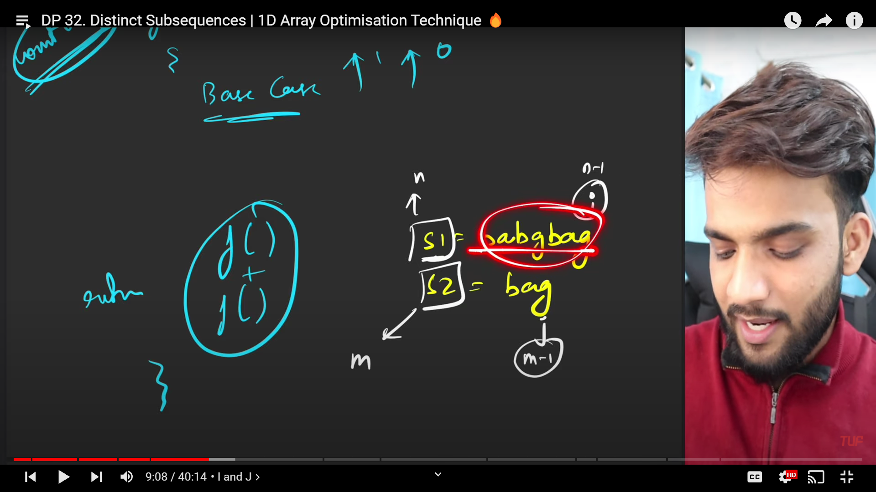

If a question asks you to "count the number of ways" then follow the rule below:

'''

1) function(){

2) Base Case which returns either 1 or 0

3) return function() + function();

}

'''

How to write a recurrence in case of strings?

1) Express everything in terms of (i,j) where i = first string, j = second string

2) Explore all possibilities

3) Return sum of all possibilities

4) Base case

* Normal Solution

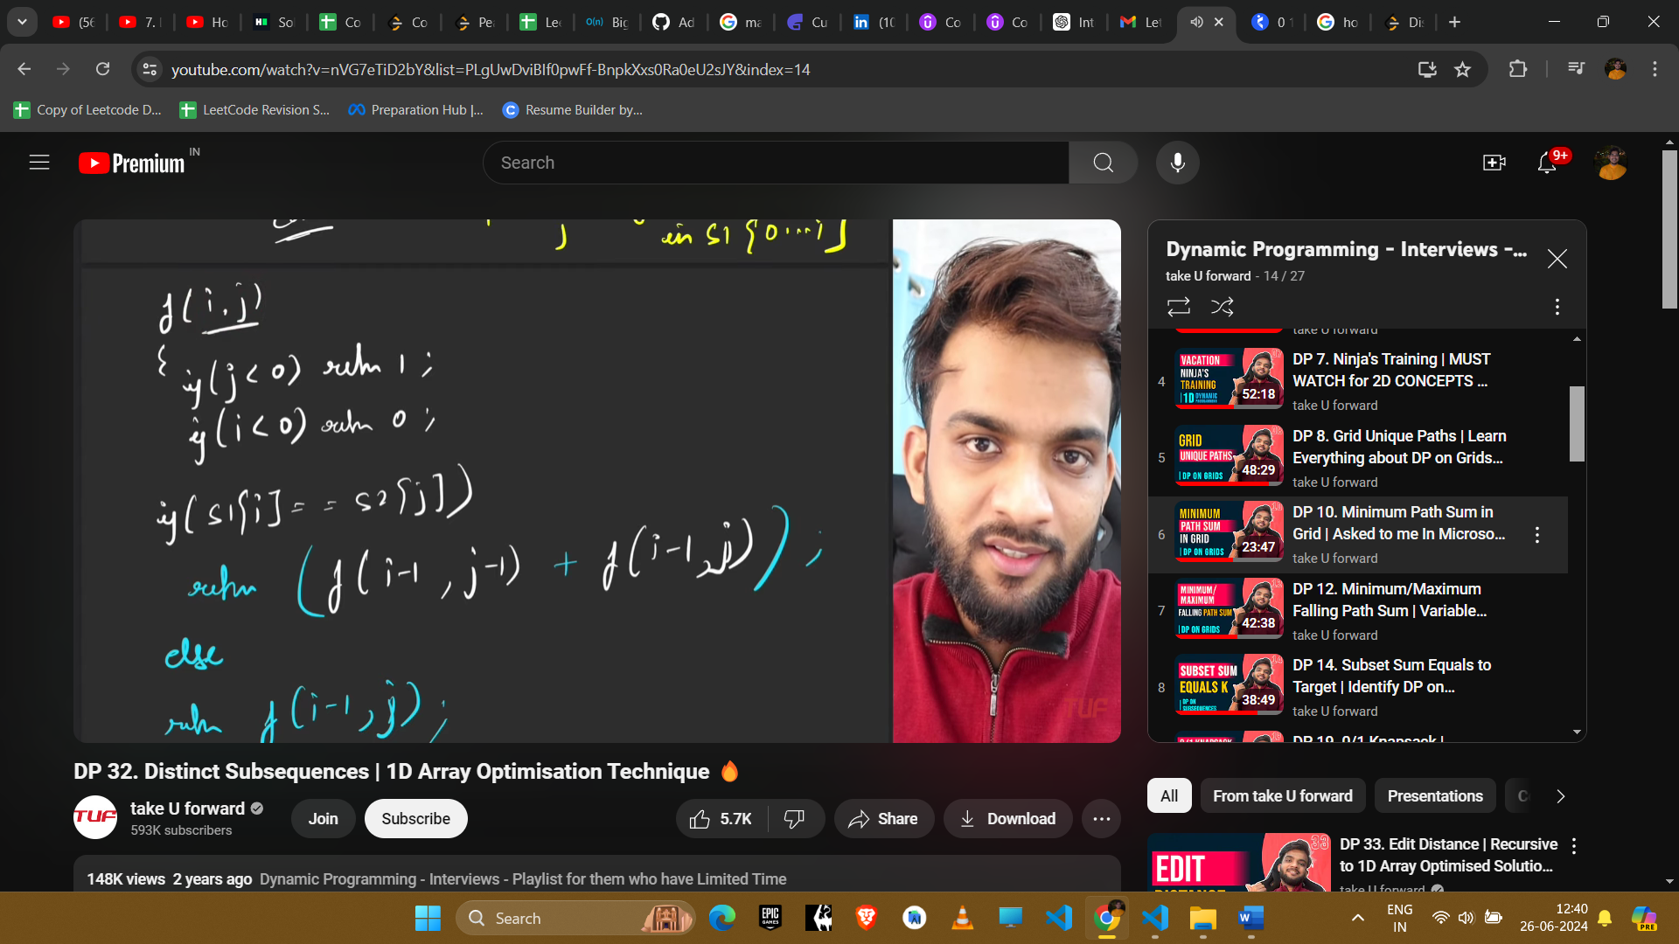

Time Comp : Exponential (2^n or 2^m)

Space Comp: O(N x M)

* Recursion + Memoization

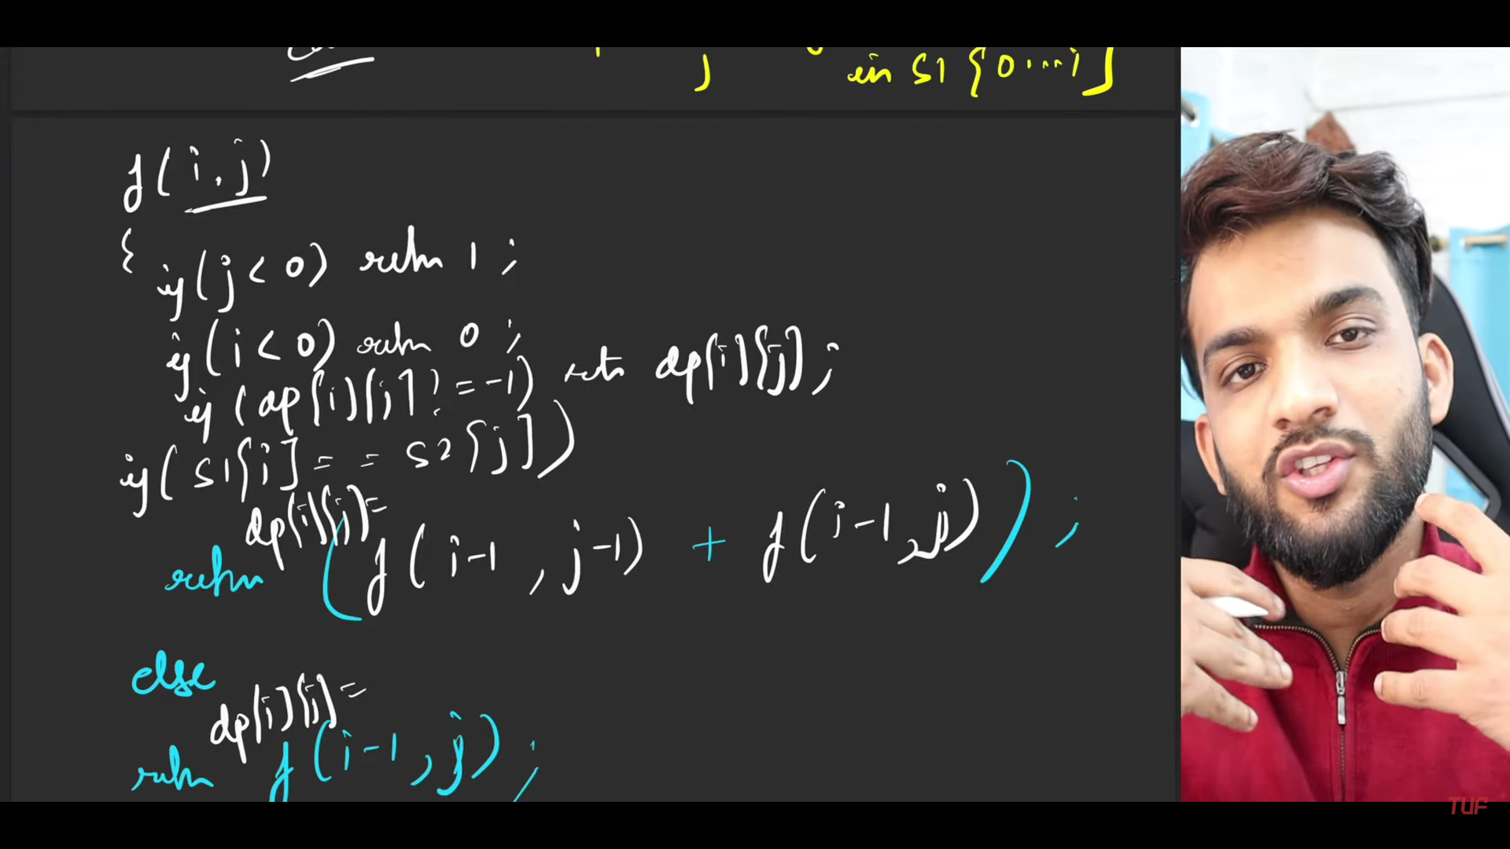

Time Complexity: O(N x M)

Space Complexity: O(N x M) + O(N + M) -> Auxiliary Stack Space

* Tabulation

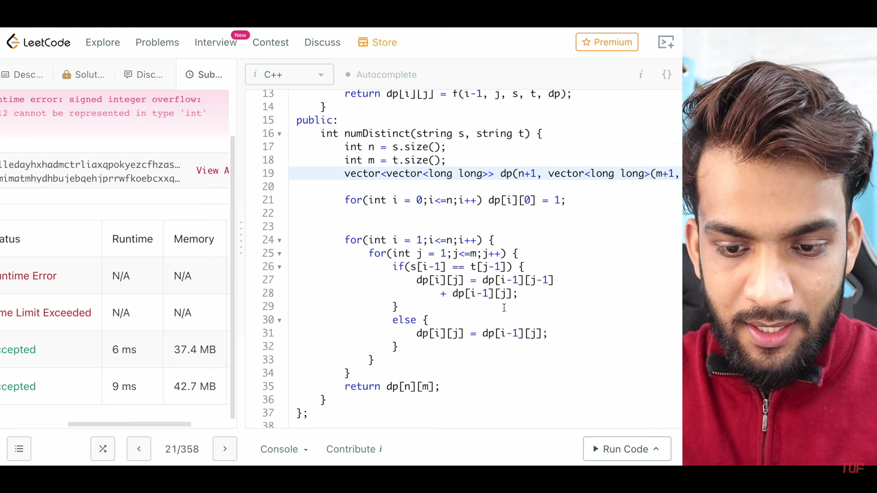

Time Complexity: O(N x M)

Space Complexity: O(N x M)