#Lab-work : 19.12.2025

- Reading from csv file:
import pandas as pd
df = pd.read_csv('DataSet.csv')
print(df)

- Output:
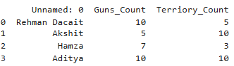

- Reading from json file:
import pandas as pd
df1 = pd.read_json('DataSet_json.json')
print(df1)

- Output:
