SHETH L.U.J. AND SIR M.V. COLLEGE
DEPARTMENT OF COMPUTER SCIENCE
ACADEMIC YEAR: 2026–2027
――――――――――――――――――――――――――――――――――――――――――――――――――――――――――
CampusLive: Real-Time Lecture Monitoring and Verification for Colleges
A Real-Time Academic Activity Management, Supervision & Attendance Verification Platform
Field Project Documentation ― S.Y. B.Sc. Computer Science (Semester III)
Student Name & Roll No. | Aditya Sudhir Rana | Roll Number: S105
Class & Semester | S.Y. B.Sc. Computer Science (Semester III)
Project Guide | Mr. Rohit Kumar Sahu
Course Coordinators | Ms. Jyoti Chauhan and Mr. Rohit Kumar Sahu
Official Student Email | ranaadityacs252612@gmail.com

1. Project Title & Official Descriptions
Exact Project Title: CampusLive: Real-Time Lecture Monitoring and Verification for Colleges
Main Description: "CampusLive is a real-time academic monitoring platform where teachers make lectures officially live, students confirm they are present with a class code, and principals and HODs see which lectures are actually being held across the college as they happen. Timetables, substitutions, reports and activity logs run on the same platform."
Short Description: "CampusLive is a real-time platform where teachers make lectures live, students verify them, and principals and HODs monitor what is actually being taught across the college."
2. Guide Interaction Diary
The following table records the periodic consultations and milestones completed with the Project Guide during the development lifecycle:
Meeting Date | Progress / Agenda Discussed | Remarks / Guide's Feedback
06-08-2026 | Initial project ideation: Identifying the need for real-time institutional visibility of ongoing lectures; project scope and objectives approval. | Recommended focusing on administrative monitoring, departmental hierarchy, and student verification.
11-08-2026 | Requirement specifications: Defining the 5-tier role structure (Root -> Principal -> HOD -> Teacher -> Student) and designing the relational database schema. | Approved database entities and recommended incorporating automated conflict checks for rooms and teachers.
18-08-2026 | Backend REST API design in Flask: Implementation of session authentication, PBKDF2 password hashing, and SQLite schema with Write-Ahead Logging (WAL). | Reviewed authentication security and classroom scheduling validation logic.
25-08-2026 | Integration of Server-Sent Events (SSE) for push synchronization and development of the background sweeper daemon for automated lecture lifecycle tracking. | Verified real-time event distribution and background state transitions.
01-09-2026 | Frontend single-page application (SPA) design: Implementing the live departures-style board, modal dialog registry, and the 4-digit student verification check-in. | Approved the student verification model and recommended keeping aggregate attendance statistics accessible to staff only.
08-09-2026 | Implementation of the multi-week recurring timetable generator, HOD substitution workflow, dynamic room reallocation, and CSV reports. | Advised verifying clash resolution logic across multi-week recurring slots.
05-10-2026 | End-to-end integration testing (tests/test_flow.py), field feedback review, edge-case fixes, and preparation of final documentation. | Approved the system and results for final documentation and academic submission.
3. The Project Itself & Problem Statement
Overview & Problem Solved
CampusLive is a real-time academic activity management and operational visibility platform designed specifically for collegiate institutions. In conventional college management, institutional leadership (Principals and HODs) lacks immediate operational visibility into daily lecture conduction without conducting physical floor rounds or manual inquiries. Furthermore, traditional paper registers consume valuable instructional time and require significant manual transcription.
CampusLive bridges this gap by transforming static timetables into an active, verifiable digital operational environment:
- Live Institutional Visibility: Provides institutional leadership with a live, consolidated departures-style board displaying active lectures, occupied classrooms, and start punctuality across all departments.
- Attendance and Student Verification of Lectures: Starting a lecture generates an ephemeral 4-digit class code on the teacher's screen. Students in class confirm their presence using this code, transitioning the lecture status to 'Verified by students' once 2 or more check-ins occur.
- Automated Conflict Resolution: Automatically verifies room and faculty availability during both single-lecture scheduling and multi-week recurring timetable creation, avoiding scheduling overlaps.
- Automated Lifecycle Closure: A background sweeper thread auto-closes forgotten live lectures after a 15-minute grace period and updates unstarted lectures to 'MISSED', maintaining accurate historical records.
- Reports and Analytics: Generates data-driven metrics including Held Rate (%), Average Start Delay (minutes), and Student Attendance (%) with one-click CSV export.
Users and Beneficiaries
The primary beneficiary of CampusLive is the College Administration (Principal, Vice-Principals, and Heads of Departments) for centralized governance and quality assurance, alongside faculty and students:
- Principal (College Administrator): Maintains a bird's-eye view of all academic activity, active classrooms, faculty schedules, and college-wide analytics.
- Heads of Department (HODs): Supervises departmental operations, assigns substitute teachers for pending lectures, reallocates rooms dynamically, and monitors departmental workload. Head of Department: Asst. Prof. Pradnya Kharade.
- Teachers / Faculty: Schedules lectures, activates live sessions, presents the verification PIN, monitors check-ins, and manages recurring weekly timetables. Core Department Faculty: Asst. Prof. Rohit Sahu (Project Guide) and Asst. Prof. Jyoti Chauhan (Course Coordinator).
- Students: Views active lectures for their class, enters the 4-digit code to confirm attendance, and views their personal timetable and attendance records. Registered Student Cohort: Aditya Rana (S105), Mohi Pathan, Suraj, Dhruv Choubey, and Akshat Halwai.
- Root Administrator: Platform administrator responsible for provisioning institutions and initial college administrator accounts.
4. Key Objectives, Modules & Technical Architecture
Core Modules and Features
- 1. Live Campus Monitoring Board: Centralized dashboard grouping running lectures by department, displaying elapsed timers, occupied rooms, active faculty, and 'Due but not started' punctuality indicators.
- 2. Attendance and Student Verification of Lectures: Dynamic 4-digit class code generated on lecture start; verified status triggered at >= 2 check-ins; student privacy enforced by reserving aggregated counts for staff only.
- 3. Reports and Analytics: Institutional performance metrics tracking Total, Held, Missed, and Cancelled lectures, Held Rate (%), Average Start Delay (minutes), and Average Attendance (%) with CSV export.
- 4. Lecture State Machine & Sweeper Daemon: Finite state machine (SCHEDULED -> LIVE -> COMPLETED / CANCELLED / MISSED) supported by a 30-second interval daemon sweeping expired sessions with a 15-minute grace window.
- 5. Weekly Timetable & Clash Resolution Engine: Generates up to 12 weeks of recurring timetable slots with automated conflict detection skipping room and teacher clashes.
- 6. Academic Administration & Substitution: Enables HODs to substitute teachers on unstarted lectures (tracked via covering_for) and reallocate classrooms in real time.
- 7. Security, Multi-Tenant RBAC & Central Activity Logging: Session-based authentication with PBKDF2 password hashing, 5-tier role enforcement, account deactivation toggles, and immutable chronological audit logs.
Technologies, Languages & Tools
- Languages: Python 3.13 / 3.x, Modern JavaScript (ES6+), HTML5, CSS3.
- Backend Framework: Flask 3.x WSGI microframework, Werkzeug Security (PBKDF2-SHA256).
- Real-Time Push Distribution: Server-Sent Events (SSE) utilizing Python queue.Queue, threading.Lock, and browser EventSource.
- Database Engine: SQLite 3 with Write-Ahead Logging (PRAGMA journal_mode=WAL) and automatic migration helpers.
- Frontend Architecture: Vanilla JavaScript Single-Page Application (SPA) architecture with declarative rendering, centralized modals, and tab hydration.
- Environment & Testing: Python development server with auto-port fallback (run.py), Windows OS, and automated test suite (tests/test_flow.py).
Scope Limitations
The current implementation intentionally focuses on on-campus physical/hybrid lecture activity monitoring. Remote video streaming (e.g. Zoom/Meet), biometric turnstiles, student fee accounting, and native mobile store wrappers are considered outside the functional scope of this project.
5. Field Work, Methodology & Testing
Requirements Gathering & Field Consultation
The field study for CampusLive was conducted during August 2026 at Sheth L.U.J. and Sir M.V. College, structured around faculty consultations and direct operational observation:
- Faculty and Departmental Interviews: Conducted focused interviews with 2 faculty members (1 Head of Department and 1 teaching faculty). Discussions highlighted the need for immediate operational visibility between classrooms and administrative offices, as well as the benefit of automating manual paper attendance.
- Classroom Workflow Observation: Directly observed the standard roll-call routine in undergraduate classrooms, noting that calling out names manually takes significant lecture time. This validated the requirement for a rapid digital check-in mechanism that can be completed within 15 seconds.
- Administrative Metric Definition: Consultations with the project guide and coordinators helped determine the key daily tracking metrics: verifying that scheduled lectures occur as planned, tracking start punctuality, and generating structured attendance records.
Build and Testing Methodology
The project followed an iterative prototyping model, first establishing the database schema and conflict algorithms, followed by real-time SSE streaming, the sweeper daemon, and the responsive user interface.
The system was validated using an automated end-to-end integration test suite (tests/test_flow.py), which verified 13 distinct workflow steps: tenant onboarding, departmental provisioning, conflict-free scheduling, live session activation, 4-digit code check-in, verification threshold update (>= 2 check-ins), HOD substitution, sweeper auto-completion, and CSV report export. All automated test checks passed successfully.
Future Improvements & Recommendations
- 1. Dynamic Rotating QR Codes: Introducing time-limited QR codes refreshing every 20 seconds for student check-in.
- 2. Automated Push Notifications: Integrating browser Web Push or email alerts for last-minute room adjustments and substitutions.
- 3. Interactive Visual Charts: Adding visual chart components (e.g. Chart.js) to the Reports and Analytics module for semester-long trend visualization.
- 4. Enterprise Scalability: Providing deployment profiles for PostgreSQL and Gunicorn containerization for multi-campus university deployments.
6. Evidence, Database & API Specifications
List of Documentation Figures
Figure No. | Screen / View Title | Description & Caption
Figure 1 | Public Landing Page | Overview of CampusLive, feature showcases, and public navigation.
Figure 2 | Student Self-Registration Modal | Student registration form with dynamic class selection based on college code.
Figure 3 | Principal Live Campus Monitoring Dashboard | Departures-style live monitoring board showing running lectures, elapsed timers, and student verification status.
Figure 4 | Lecture Detail & Timeline Modal | Comprehensive lecture audit drill-down showing exact timestamps, lifecycle events, and verified attendee roster.
Figure 5 | Department & HOD Management (Admin) | Administrator screen for provisioning departments, assigning HOD credentials, and viewing department live status.
Figure 6 | Faculty Directory & Live Status | Teacher management table with real-time 'Teaching Right Now' indicators, contact info, and account control menu.
Figure 7 | Lecture Scheduling Modal | Teacher lecture creation form featuring classroom selection, date, time, and automatic conflict detection.
Figure 8 | Weekly Timetable Slot Manager | Multi-week recurring schedule generator with conflict skipping and active slot removal.
Figure 9 | Teacher Active Lecture Controller | Teacher's live lecture interface showing the generated 4-digit class code, live timer, and 'End Lecture' button.
Figure 10 | Student Live Board & PIN Check-in | Student live screen showing current class lecture and the 4-digit code entry form to record attendance.
Figure 11 | HOD Substitution & Room Reallocation | Head of Department modal for reassigning active teachers to pending lectures and changing classrooms.
Figure 12 | Central Activity Audit Log | Searchable log table displaying chronological events with actor attribution.
Figure 13 | Academic Compliance & Punctuality Report | Faculty performance table displaying Held Rates, Start Delay (minutes), Attendance (%), and CSV download trigger.
Figure 14 | User Profile & Security Settings | Profile editor for updating contact info, viewing role permissions, and changing passwords.
System Interface Visual Evidence
Interface View: Figure 1: Public Landing Page
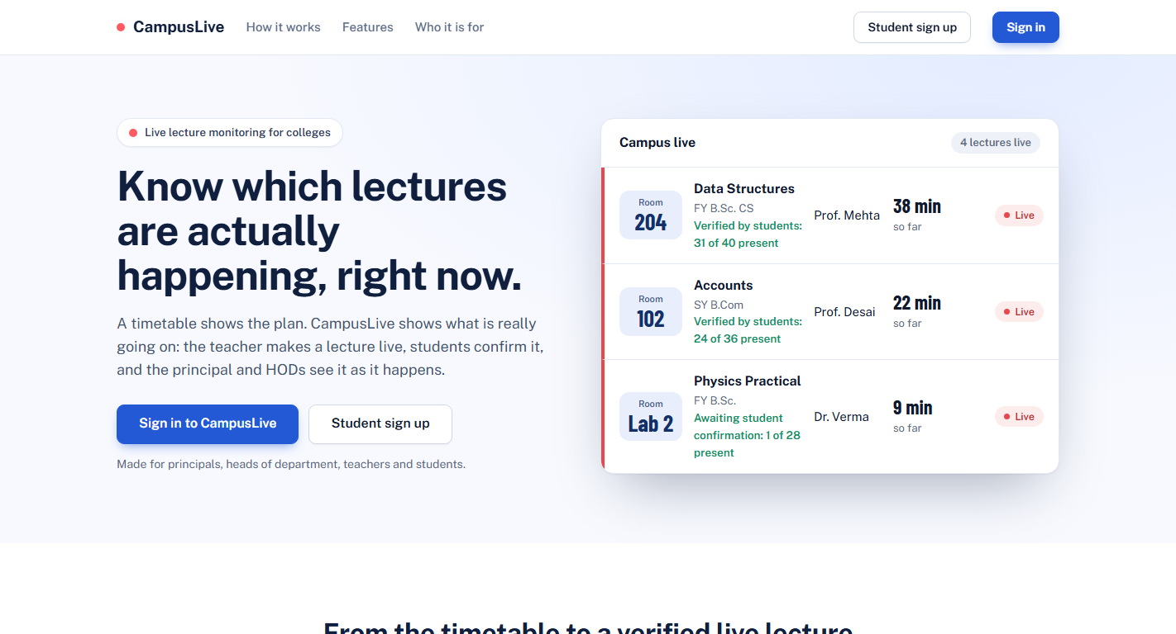
Figure 1: Public homepage featuring institutional overview, feature pillars, and live mock board.
Interface View: Figure 2: Student Self-Registration
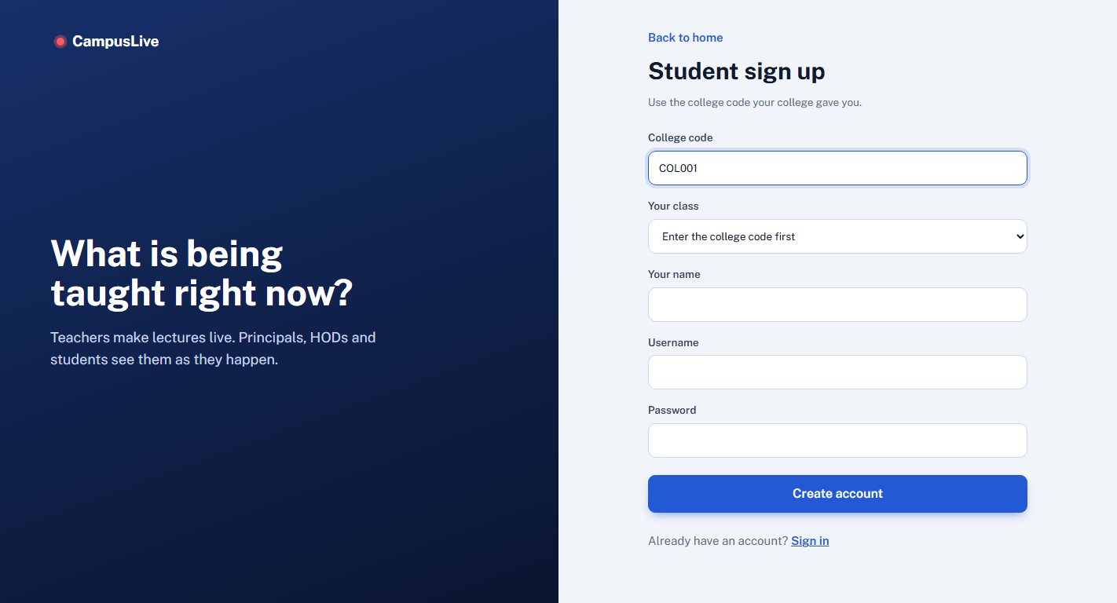
Figure 2: Registration screen validating college code COL001 and populating SY B.Sc. CS class.
Interface View: Figure 3: Principal Live Campus Monitoring Dashboard
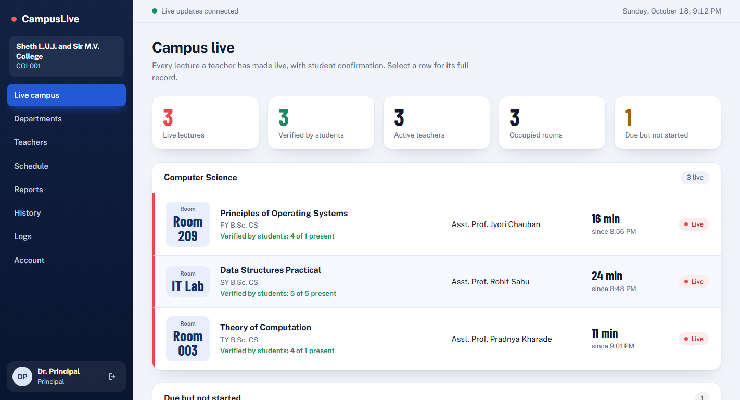
Figure 3: Live departures board showing 3 live sessions across FY, SY, TY, occupied rooms, and late alerts.
Interface View: Figure 4: Lecture Detail & Timeline Audit Modal
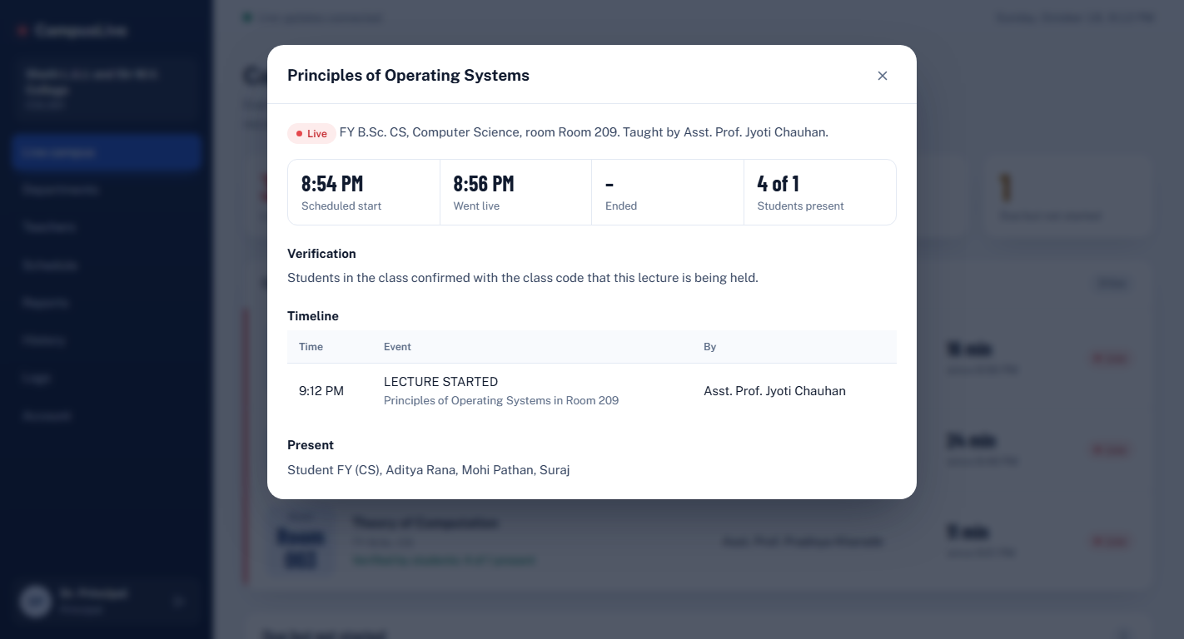
Figure 4: Audit drill-down showing exact timestamps, verified status, and attendee list (Aditya Rana, Mohi Pathan, Suraj, Dhruv Choubey, Akshat Halwai).
Interface View: Figure 5: Department & HOD Management
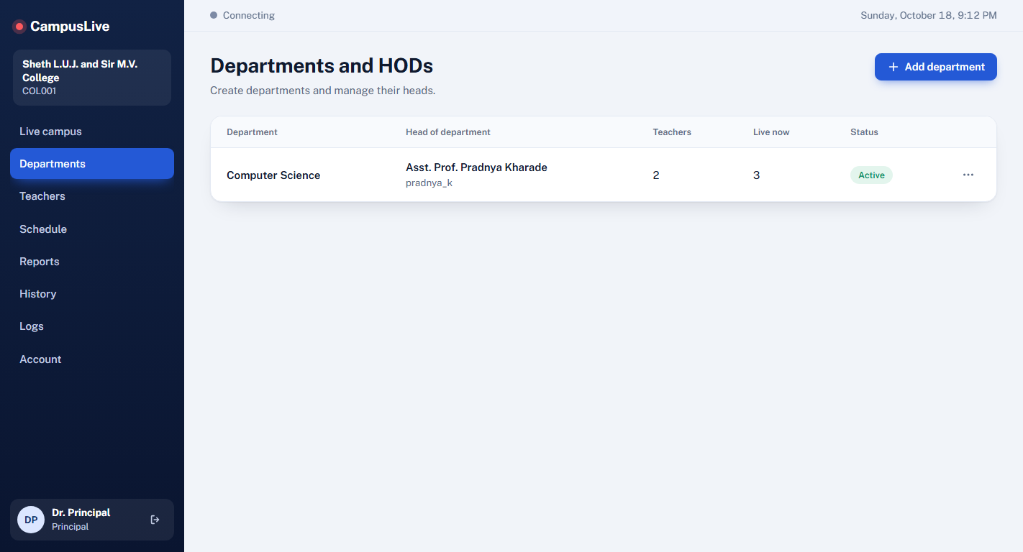
Figure 5: Administrative management of Computer Science department with HOD Asst. Prof. Pradnya Kharade.
Interface View: Figure 6: Faculty Directory & Live Status
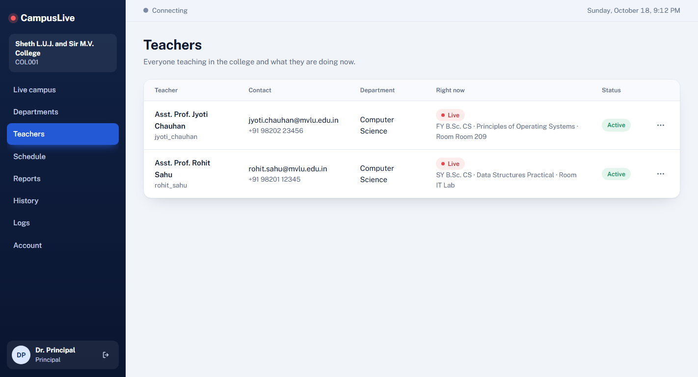
Figure 6: Faculty roster showing Asst. Prof. Pradnya Kharade, Asst. Prof. Rohit Sahu, and Asst. Prof. Jyoti Chauhan actively teaching live.
Interface View: Figure 7: Academic Reports and Analytics
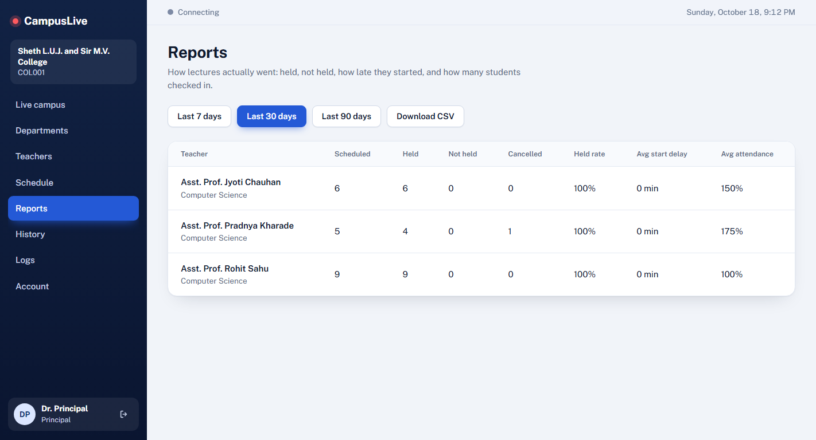
Figure 7: Performance analytics showing scheduled vs. held lectures, held rate (%), start delay (minutes), and attendance (%).
Interface View: Figure 8: Institutional Activity Audit Log
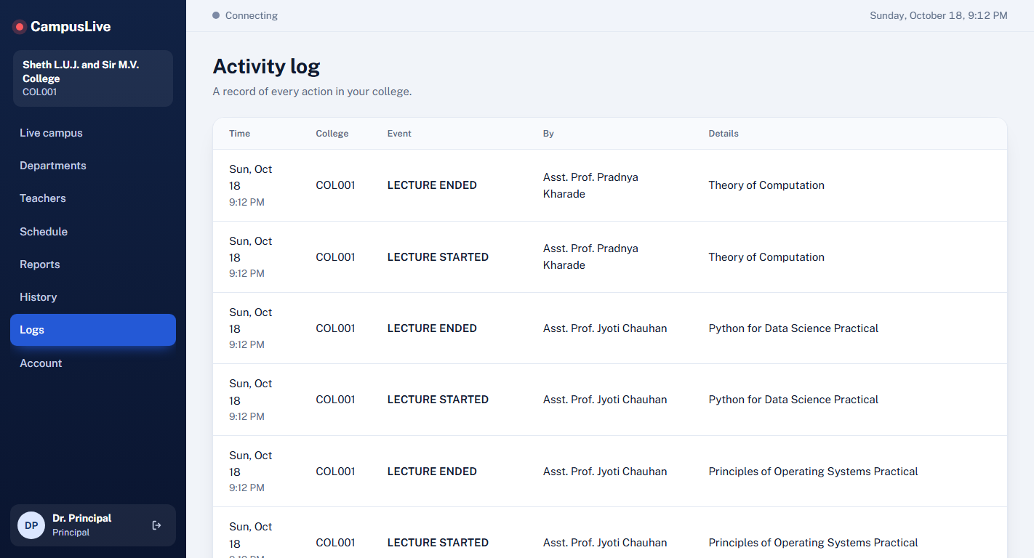
Figure 8: Chronological audit log tracking lifecycle actions with actor and timestamp attribution.
Interface View: Figure 9: Faculty Active Lecture Controller
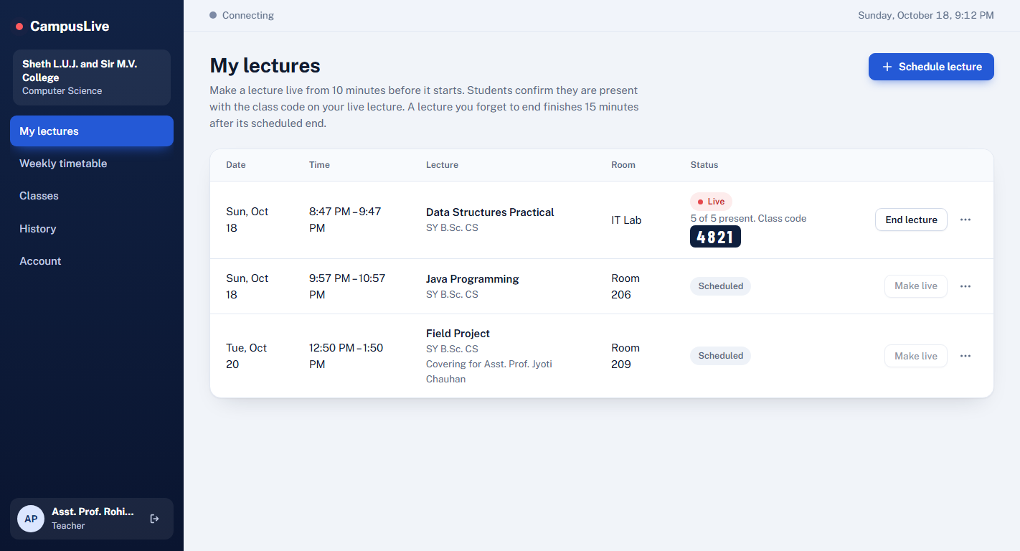
Figure 9: Teacher session controller showing live status in IT Lab, class code 4821, and End Lecture action.
Interface View: Figure 10: Lecture Scheduling Modal
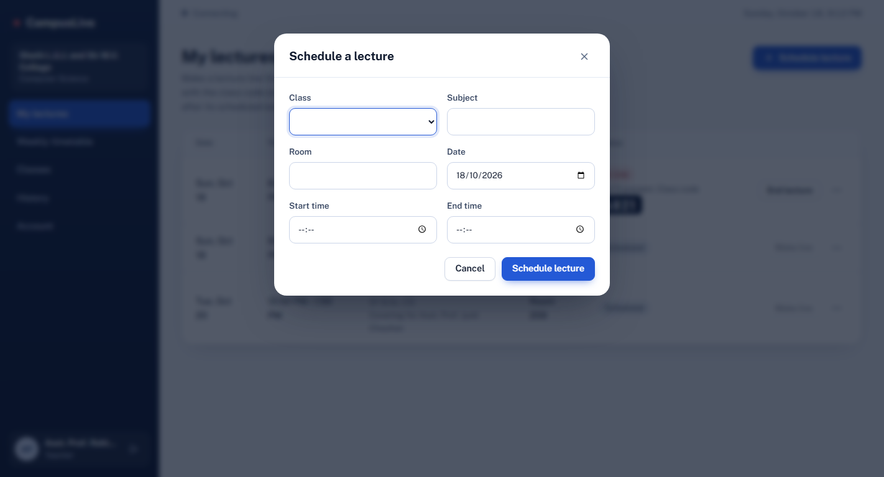
Figure 10: Lecture creation modal featuring classroom selection and automated conflict checking.
Interface View: Figure 11: Weekly Timetable Slot Manager
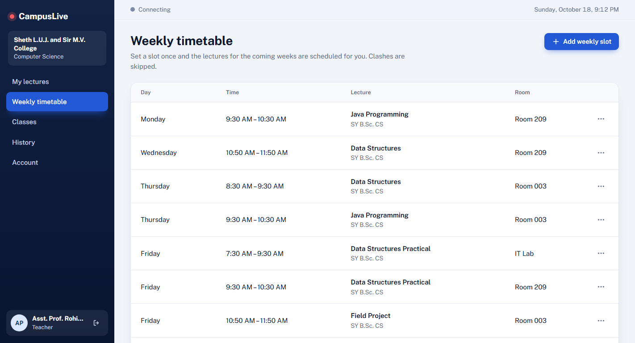
Figure 11: Recurring weekly schedule manager with official Sheth L.U.J. and Sir M.V. College timetable slots.
Interface View: Figure 12: HOD Teacher Substitution & Room Reallocation
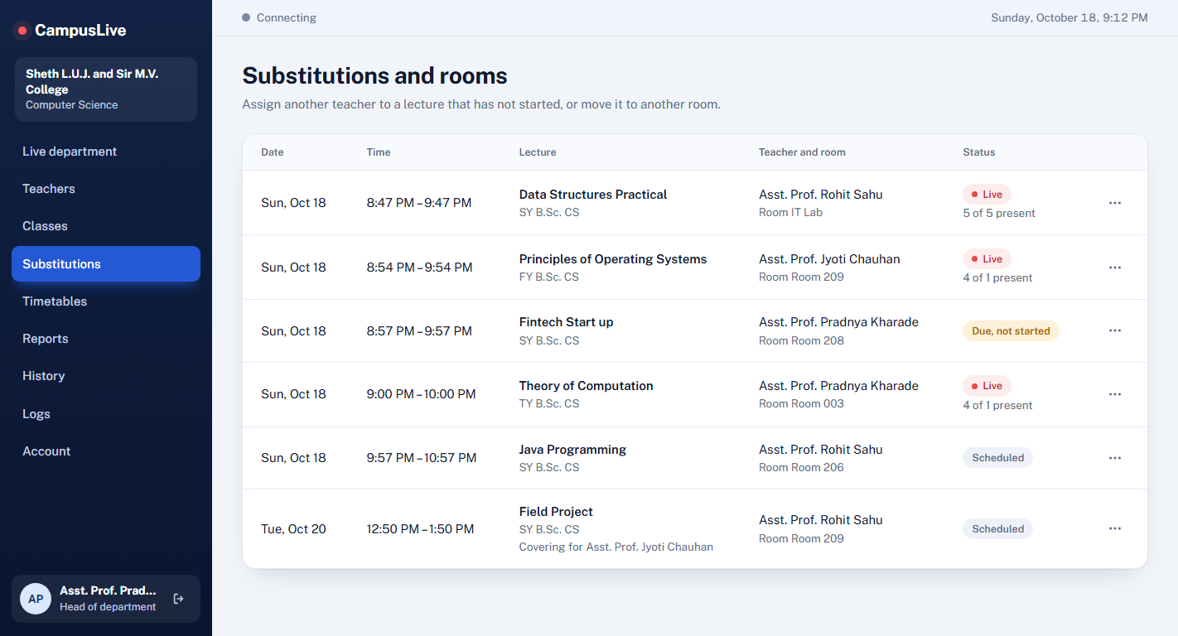
Figure 12: HOD operations screen for reallocating teachers and moving classroom venues.
Interface View: Figure 13: Student Live Check-In Interface
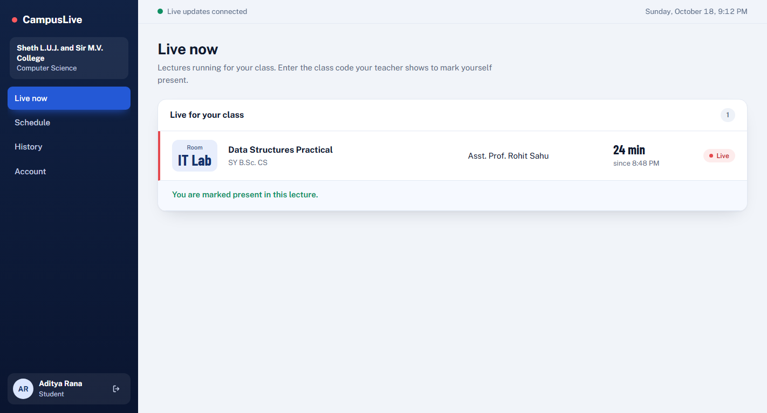
Figure 13: Student screen showing active live lecture for SY B.Sc. CS and presence verification.
Interface View: Figure 14: Student Personal Attendance History
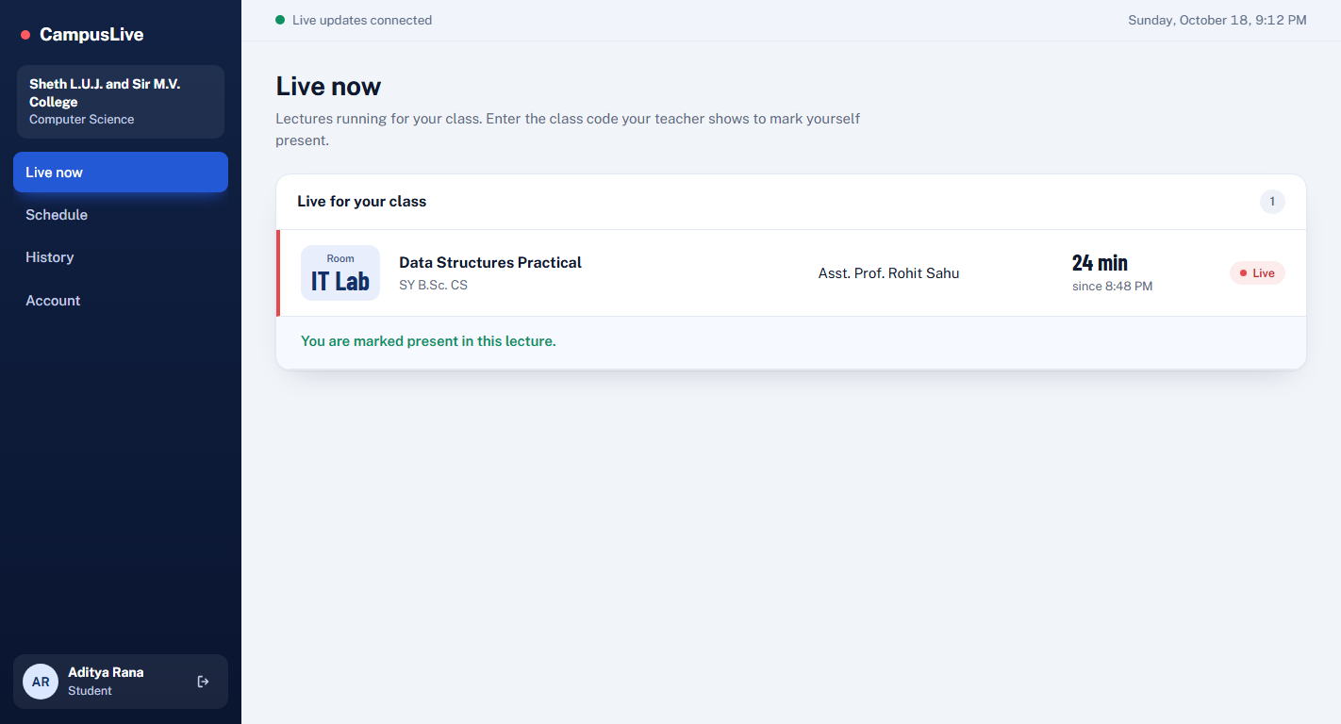
Figure 14: Student history view confirming Aditya Rana's attendance with Present status badges.
Interface View: Figure 15: User Profile & Security Settings
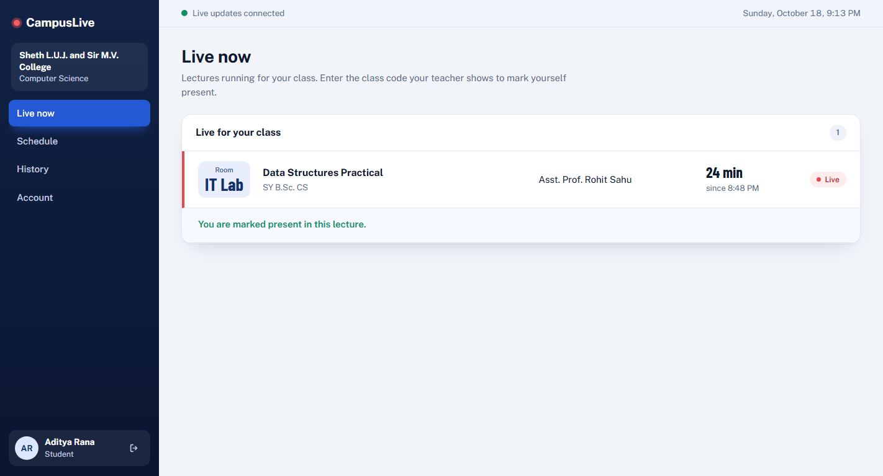
Figure 15: User profile management for viewing roles and updating contact information.
Database Schema & Entities
The SQLite database operates in Write-Ahead Logging (WAL) mode for concurrency, structured into the following core tables:
- colleges: id (PK), code (UNIQUE), name, created_at.
- depts: id (PK), college_id (FK), name, UNIQUE(college_id, name).
- classes: id (PK), college_id (FK), dept_id (FK), name, UNIQUE(dept_id, name).
- users: id (PK), role, username (UNIQUE), name, pw, college_id, dept_id, class_id, active, email, phone.
- lectures: id (PK), college_id, dept_id, class_id, teacher_id, orig_teacher_id, timetable_id, subject, room, date, start_time, end_time, status, code, started_at, ended_at.
- attendance: lecture_id (FK), student_id (FK), ts, PRIMARY KEY(lecture_id, student_id).
- timetable: id (PK), college_id, dept_id, class_id, teacher_id, subject, room, weekday, start_time, end_time.
- logs: id (PK), ts, college_id, dept_id, actor_id, event, lecture_id, detail.
REST API Specification Summary
Method | Endpoint | Role | Description
POST | /api/login | Public | Authenticates user; creates session cookie.
GET | /api/me | Auth | Returns profile and institution metadata for the current user.
POST | /api/register | Public | Student self-registration mapped to college code and class.
GET / POST | /api/colleges | Root Admin | Lists colleges or registers a new college and Principal.
GET / POST | /api/depts | Principal | Lists departments or adds department and assigns HOD.
GET / POST | /api/teachers | Principal / HOD | Lists faculty directory or registers new department teachers.
POST | /api/lectures | Teacher | Schedules single lecture with automated conflict checking.
POST | /api/lectures/<id>/start | Teacher | Makes lecture live, generates 4-digit code, notifies SSE stream.
POST | /api/lectures/<id>/checkin | Student | Records attendance using matching 4-digit class code.
POST | /api/lectures/<id>/substitute | HOD | Reassigns teacher on pending unstarted lecture.
GET / POST | /api/timetable | Teacher | Fetches timetable slots or generates recurring multi-week lectures.
GET | /api/live | All Users | Fetches running live lectures and punctuality alerts.
GET | /api/reports | Admin / HOD | Returns teacher compliance, punctuality, and attendance analytics.
GET | /api/reports.csv | Admin / HOD | Exports performance report as an RFC 4180 CSV download.
GET | /api/stream | Auth | Server-Sent Events (SSE) live push synchronization stream.
7. Literature Review References & Feedback Summary
Academic References
- Patel, R., & Patel, N. (2020). 'Automated Student Attendance Management System Using QR-Code and Dynamic Tokenization.' International Journal of Computer Applications, 175(12), pp. 24–29.
- Fette, I., & Melnikov, A. (2011). 'The WebSocket Protocol & Server-Sent Events for Web Applications.' RFC 6455 / IETF Standards Track.
- Sommerville, I. (2016). Software Engineering (10th ed.). Pearson Education.
- Grinberg, M. (2018). Flask Web Development: Developing Web Applications with Python (2nd ed.). O'Reilly Media.
- Kumar, S., & Sharma, M. (2022). 'Design and Implementation of Academic Information Systems for Real-Time Institutional Monitoring.' IEEE Transactions on Learning Technologies, 15(4), pp. 412–421.
Feedback Form Details
Student Name: Aditya Sudhir Rana
Roll Number: S105
Class & Semester: S.Y. B.Sc. Computer Science (Semester III)
College Name: SHETH L.U.J. AND SIR M.V. COLLEGE
Student Email ID: ranaadityacs252612@gmail.com
Project Guide: Mr. Rohit Kumar Sahu
Course Coordinators: Ms. Jyoti Chauhan and Mr. Rohit Kumar Sahu
Project Duration: 01-08-2026 to 10-10-2026

