Deploying a Microservices Application to EKS

Repository: https://github.com/AdityaSundarTripurari/udacity-movie-picture-pipeline
AWS Region: us-east-1
EKS Cluster Name: cluster
Kubernetes Version: 1.31

1. Frontend Continuous Integration (`frontend-ci.yaml`)

File location: `.github/workflows/frontend-ci.yaml`

- Runs on `pull_request` to `main` (path-filtered to `starter/frontend/**`)
- Also supports manual trigger via `workflow_dispatch`
- Lint and Test jobs run in parallel
- Uses npm caching for dependency install speed

Screenshot — successful workflow run (Actions tab):
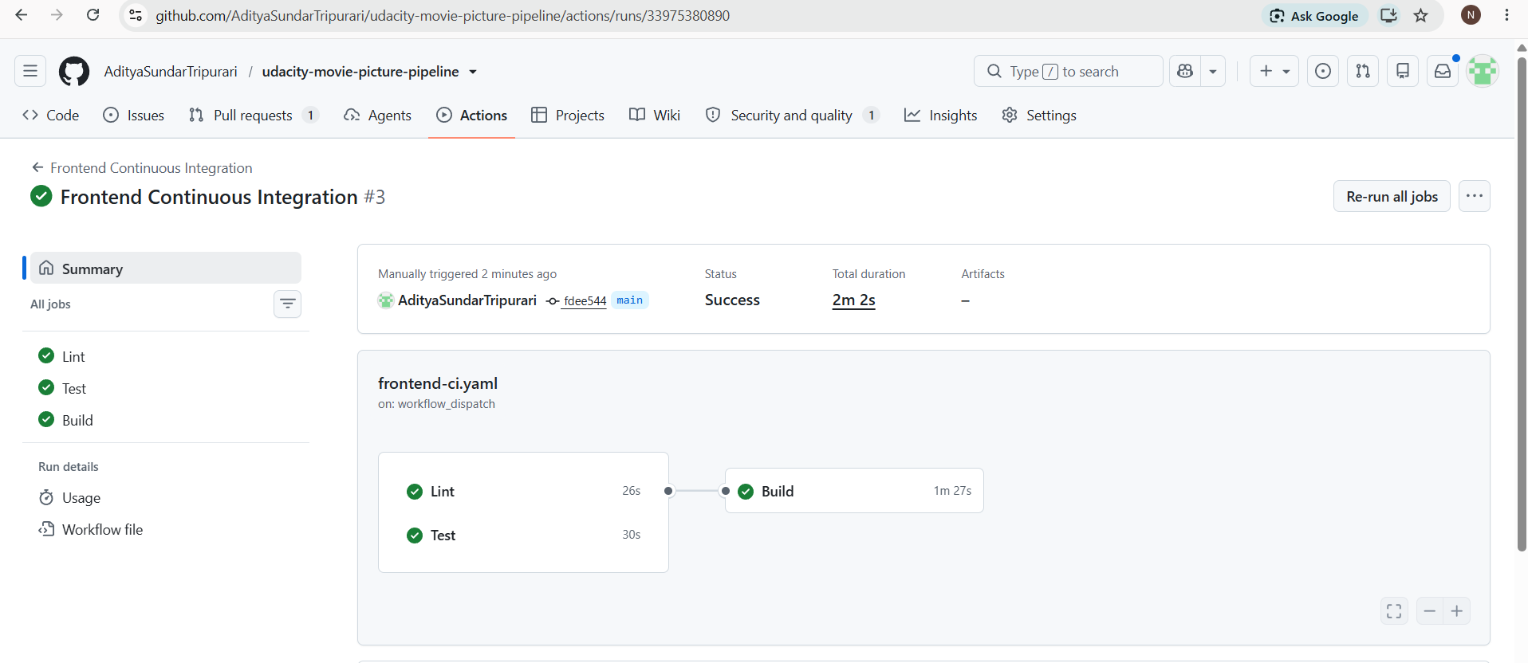
2. Backend Continuous Integration (`backend-ci.yaml`)

File location: `.github/workflows/backend-ci.yaml`

- Runs on `pull_request` to `main` (path-filtered to `starter/backend/**`)
- Also supports manual trigger via `workflow_dispatch`
- Lint and Test jobs run in sequence (lint completes before test proceeds)
- Uses pipenv with dev dependencies for flake8/pytest

Screenshot — successful workflow run (Actions tab):
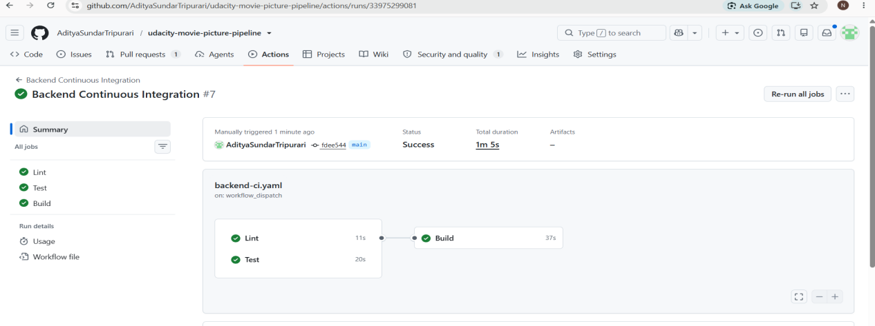

3. Frontend Continuous Deployment (`frontend-cd.yaml`)

File location: `.github/workflows/frontend-cd.yaml`

- Runs automatically on `push` to `main`
- Also supports manual trigger via `workflow_dispatch`
- Lint → Test → Build/Push/Deploy (using `needs`)
- Dynamically fetches the backend's LoadBalancer URL from the live EKS cluster and passes it as the `REACT_APP_MOVIE_API_URL` Docker build-arg
- Authenticates to ECR using `aws-actions/amazon-ecr-login@v2`, with credentials sourced from GitHub Secrets (`AWS_ACCESS_KEY_ID`, `AWS_SECRET_ACCESS_KEY`, `AWS_SESSION_TOKEN`) — no credentials hardcoded anywhere in the workflow
- Pushes image to ECR, deploys to EKS via `kubectl apply -k`

Screenshot — successful workflow run (Actions tab):

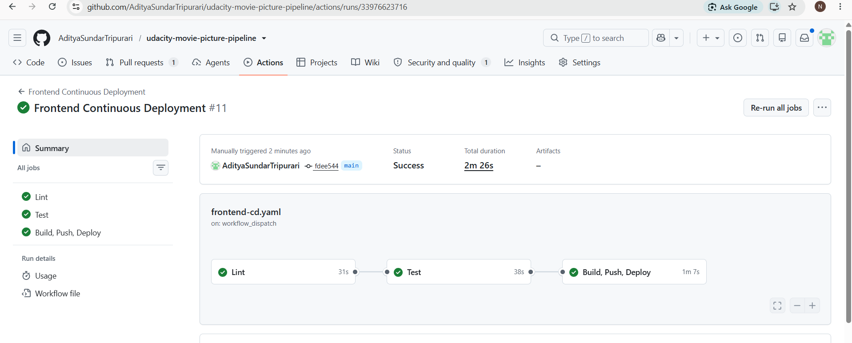

Screenshot — frontend application running and displaying the movie list (confirms `REACT_APP_MOVIE_API_URL` was correctly passed and the frontend successfully calls the backend):
URL: http://a756116b8264d45bbba087aa5208e791-214535649.us-east-1.elb.amazonaws.com/

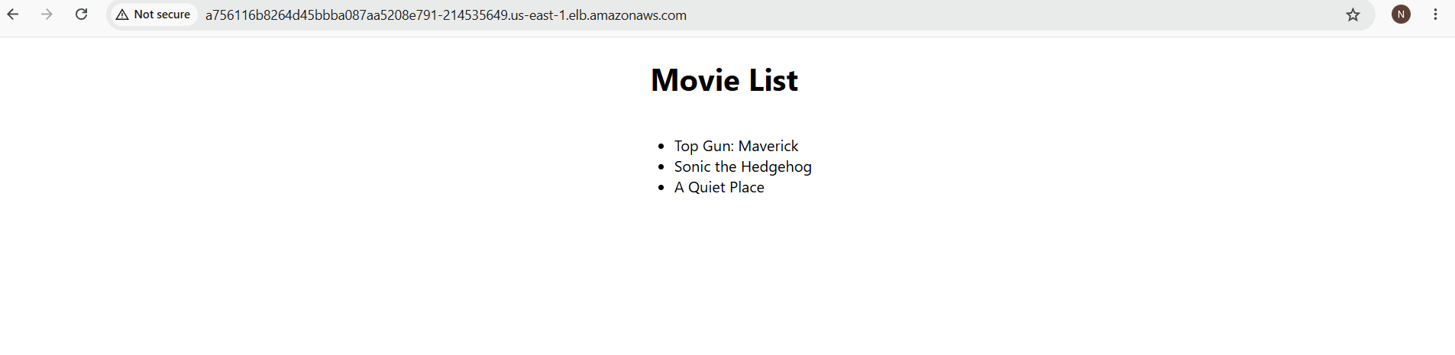

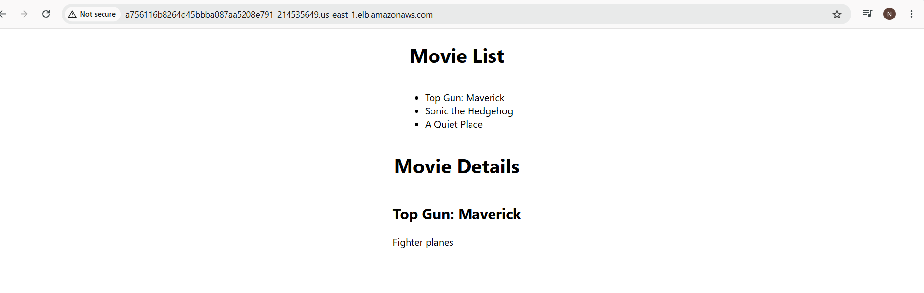

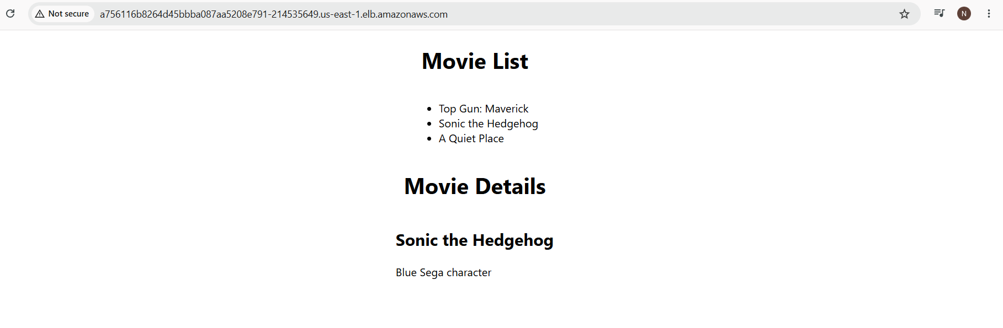

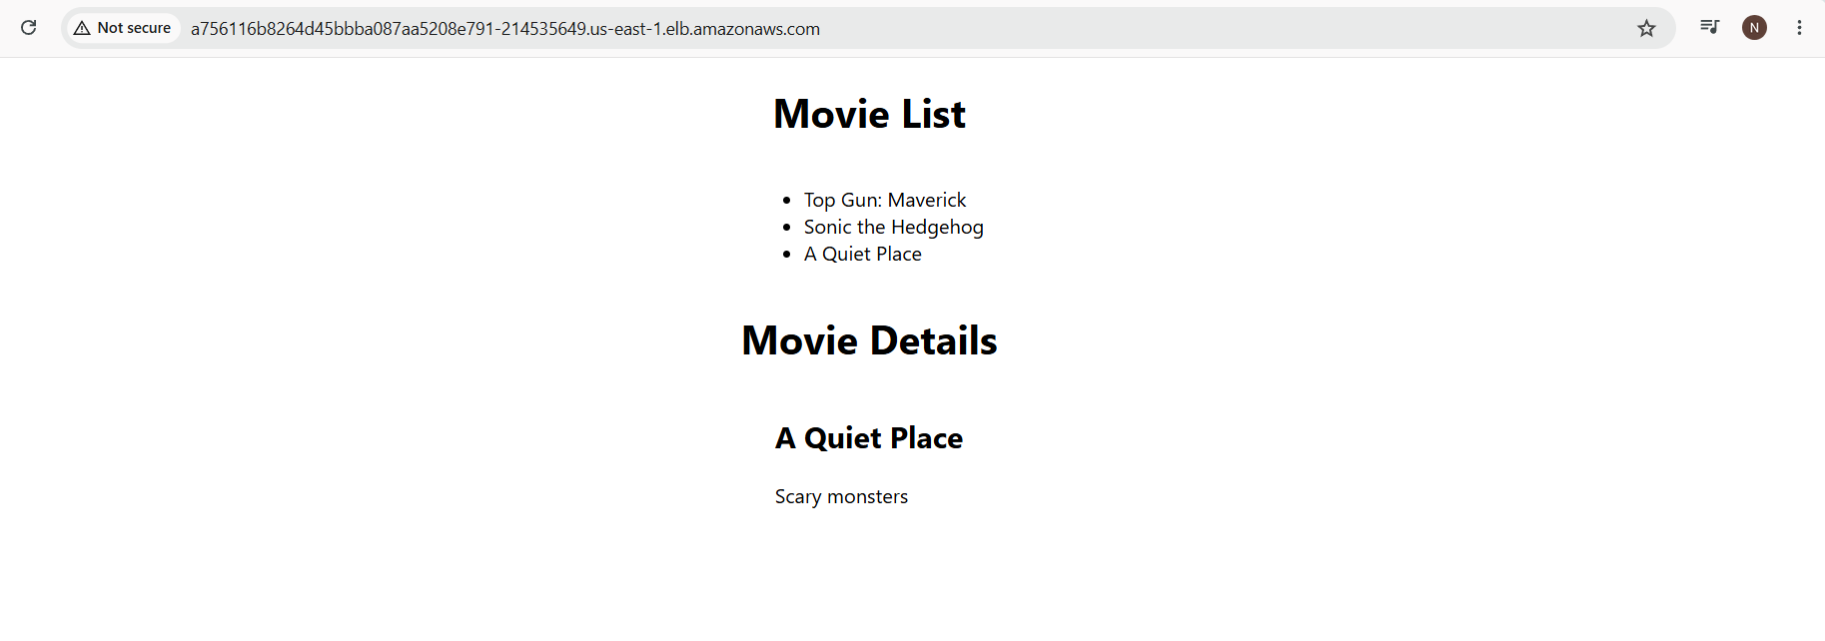
4. Backend Continuous Deployment (`backend-cd.yaml`)

File location: `.github/workflows/backend-cd.yaml`

- Runs automatically on `push` to `main`
- Also supports manual trigger via `workflow_dispatch`
- Lint → Test → Build/Push/Deploy (using `needs`)
- Dockerfile resolves the Alpine/GCC14 `uwsgi` compilation issue by installing `gcc`, `musl-dev`, `linux-headers`, `python3-dev` and setting `ENV CFLAGS="-Wno-error=incompatible-pointer-types"` before `pipenv install`
- Authenticates to ECR using `aws-actions/amazon-ecr-login@v2`, with credentials sourced from GitHub Secrets — no credentials hardcoded anywhere in the workflow
- Pushes image to ECR, deploys to EKS via `kubectl apply -k`

Screenshot — successful workflow run (Actions tab):

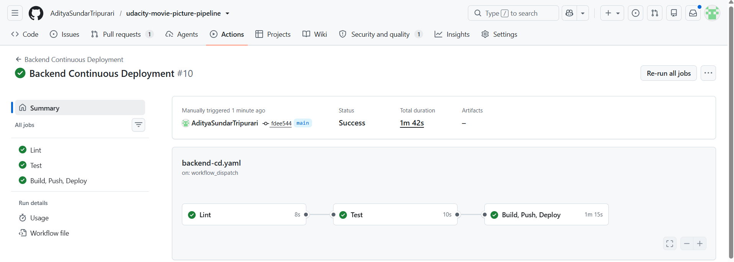

Screenshot — backend `/movies` endpoint returning raw JSON directly:
URL: http://a59261f65e72e4922be4219c6e592347-1326695326.us-east-1.elb.amazonaws.com/movies

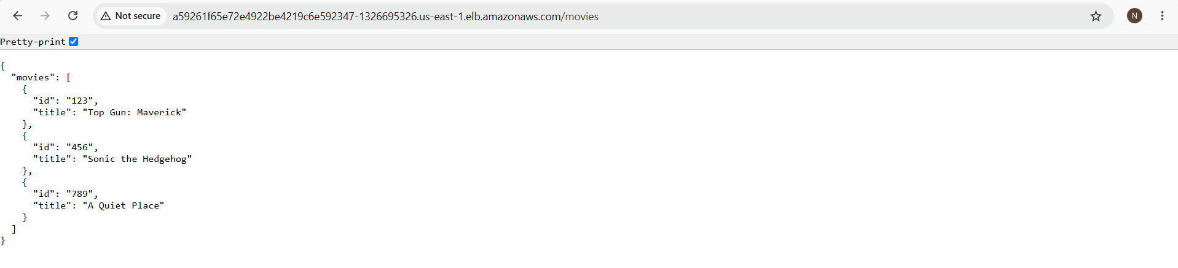

5. Infrastructure (Terraform)

Location: `setup/terraform/`

Provisions:
- VPC with public/private subnets
- EKS Cluster (`cluster`, Kubernetes 1.31)
- EKS Managed Node Group (`udacity`, t3.small)
- ECR repositories: `frontend`, `backend`
- IAM roles for EKS cluster and node group

Screenshot — `terraform apply` output showing successful provisioning:

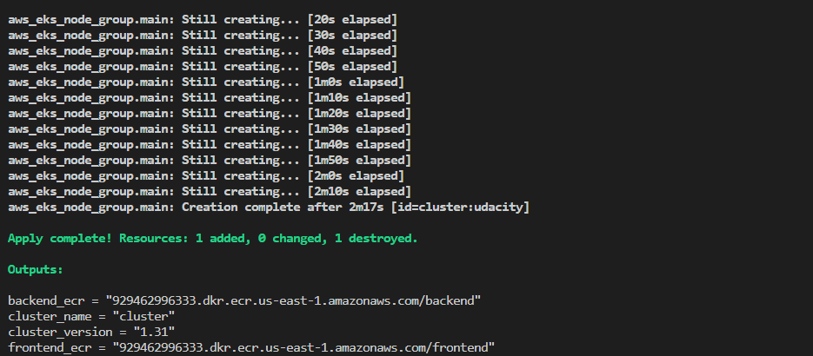

Screenshot — `kubectl get nodes` showing a Ready node:

Screenshot — `kubectl get pods` showing both backend and frontend pods Running:

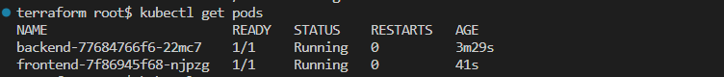

Screenshot — `kubectl get svc` showing both LoadBalancer services with external hostnames:

---

Security Notes

- No AWS credentials are hardcoded in any workflow file. All AWS authentication happens via `aws-actions/configure-aws-credentials@v4`, reading `AWS_ACCESS_KEY_ID`, `AWS_SECRET_ACCESS_KEY`, and `AWS_SESSION_TOKEN` from GitHub repository Secrets.
- IAM role creation for the EKS cluster and node group is handled entirely by Terraform using standard AWS managed policies (`AmazonEKSClusterPolicy`, `AmazonEKSServicePolicy`, `AmazonEKSWorkerNodePolicy`, `AmazonEKS_CNI_Policy`, `AmazonEC2ContainerRegistryReadOnly`) — no manual IAM console changes were made outside of Terraform.

Known Environment Limitation

This project was built and deployed using a Udacity AWS Learner Lab (Vocareum) sandbox account, which issues short-lived, time-boxed credentials. As a result, the live URLs above may become unreachable outside of an active lab session. All required screenshots above were captured during an active session to demonstrate full functionality; the underlying `main.tf`, Dockerfiles, and workflow files in the repository are fully reproducible and will redeploy an identical, working environment in any fresh AWS sandbox session by running `terraform apply` followed by triggering the four GitHub Actions workflows.

