**Data for metric 5 and 6**

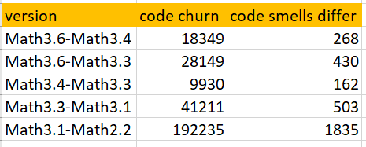

**Spearman coefficient: 0.9**

**Data for metric (1 or 2) and 6**

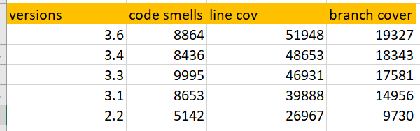

**Spearman coefficient for 1 and 6: 0.5**

**Spearman coefficient for 2 and 6: 0.5**