D.K.T.E. Society’s Textile and Engineering Institute, Ichalkaranji.
(An Empowered Autonomous Institute, Affiliated to Shivaji University, Kolhapur)
Department of Computer Science & Engineering (AIML)
2025-26


Project SRS
On
STEAMROLLER :
Stuttered Speech Processing System
Under the Guidance Of
Prof. R.S.Kamble
Submitted By:
- 23UAM132 Aditya Bhagwat Suryakar

- 23UAM122 Satyajeet Sanjaykumar Patil

- 23UAM121 Sanika Shital Sathe

- 23UAM124 Pranali Ravindra Sawant

- 23UAM138 Prachi Gajanan Yargatti

Prof. R.S.Kamble Prof. Dr. S. K.Shirgave
Project Guide Head of Department

INDEX
Sr. No. |  |  | Contents | Page No.
1 |  |  | Introduction | 3
1.1 |  |  | Problem Description | 3
1.2 |  |  | Problem Statement | 3
1.3 |  |  | Objectives | 3
1.4 |  |  | Scope | 4
2 |  |  | Overall Description | 5
2.1 |  |  | Product Perspective | 5
2.2 |  |  | Product Functions | 6
3 |  |  | Specific Requirements | 6
3.1 |  |  | External Interfaces | 6
3.2 |  |  | Functional Requirements | 6
3.3 |  |  | Performance Requirements | 6
3.4 |  |  | Design Constraints | 7
3.5 |  |  | Database Requirements | 7
3.6 |  |  | Software System Attributes | 7
4 |  |  | Software Design Document | 8
5 |  |  | Algorithms for Functional Requirements | 11
6 |  |  | References | 12

Software Requirements Specification (SRS)

1. Introduction
1.1 Introduction
The purpose of the STEAMROLLER system is to help people who stutter communicate more clearly by converting their speech into fluent and understandable speech.
The system is designed to:
- Convert stuttered speech into fluent speech
- Remove repetitions and errors
- Keep the original meaning
- Improve communication in daily use

1.2 Problem Description

a) Purpose of the SRS
The purpose of this SRS is to describe the requirements and working of the STEAMROLLER system, which helps people who stutter by converting their speech into fluent and clear speech.

b) Intended Audience This document is intended for:
- Software developers to design and implement the system
- Testers to verify system functionality and performance
- Project supervisors and evaluators to understand the system design and objectives
- Future developers or researchers who may extend or improve the system

1.3 Objectives
1. Audio Data Preprocessing
To design and implement a noise-robust audio preprocessing module that enhances input speech quality by reducing background noise, normalizing audio signals, and preparing the data for accurate speech recognition in real-world environments.

2. Repair Agents Creation
To develop multiple context-aware NLP-based repair agents (such as grammar correction, fluency enhancement, sequence correction, and stutter removal agents) that process transcribed text and generate improved, semantically meaningful outputs.

3. Master Agent Operation with Feedback Loop
To design a master agent that evaluates outputs from different repair agents using defined scoring metrics (semantic similarity, grammar, fluency, etc.), selects the best result, and incorporates a feedback loop mechanism to reprocess text when quality thresholds are not met.

4. Accuracy and Low Latency
To implement an advanced text-to-speech module capable of synthesizing natural, fluent, and stutter-free speech while preserving the original speaker's voice characteristics using voice cloning techniques.

5. Real-Time Input–Output Processing
To build a real-time speech processing pipeline that captures live audio input, performs speech-to-text conversion, applies intelligent text repair, and generates fluent audio output with minimal latency for seamless communication.

1.4 Scope

a) Software Product Name
The software product is STEAMROLLER, a system that converts stuttered speech into fluent speech.

b) What the System Will and Will Not Do The system will:
- Take speech as input
- Convert it into text
- Fix stuttering errors
- Generate clear speech The system will not:
- Cure stuttering
- Work without required tools or internet

c) Application, Benefits, and Goals
The system is used in communication applications like meetings and interviews.
Goals:
- Improve communication
- Increase accuracy
- Provide fluent speech output

2. Overall description
This section describes the overall structure and basic requirements of the STEAMROLLER system.

2.1 Product perspective
The STEAMROLLER system is a speech processing system that works as a pipeline. It takes stuttered speech as input, processes it using AI modules, and produces fluent speech as output.

2.1.1 Block Diagram

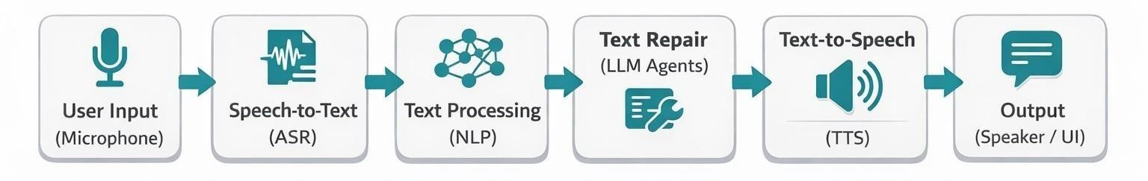
Fig. Block Diagram of Speech Processing Pipeline
The system consists of the following main components:
- Speech Input Module (Microphone/User Input)
- Speech-to-Text Module (ASR)
- Text Processing Module (NLP)
- Multi-Agent Text Repair Module
- Text-to-Speech Module (TTS)
- User Interface
2.1.2. Hardware Requirements
2.1.3. Software Requirements

2.1.2 Hardware Requirements
- Computer/Laptop
- Minimum 8GB RAM (16GB recommended)
- Processor: Intel i5 / Ryzen 5 or higher
- Microphone for audio input
- GPU

2.1.3 Software Requirements
- Operating System: Windows/Linux/Mac
- Programming Language: Python
- Tools: VS Code / PyCharm • Libraries: PyTorch, Transformers
- Models/APIs:
  - ASR (Whisper) o LLM (for text repair)
  - TTS (StyleTTS or similar)

2.2 Product functions
The STEAMROLLER system performs the following main functions:
- Accepts stuttered speech as input
- Converts speech into text using ASR
- Detects and removes stuttering errors
- Repairs text while keeping original meaning
- Converts corrected text into fluent speech
- Provides near real-time output

3. Specific requirements
This section describes the detailed requirements of the STEAMROLLER system, including inputs, outputs, and system behaviour.

3.1 External interfaces
Inputs:
- Stuttered speech (audio input from microphone or file) Outputs:
- Fluent speech (audio output with preserved voice) User Interface:
- Simple web interface
- Options to record or upload audio
- Display of original and corrected audio

3.2 Functional Requirements
The system shall:
- Accept speech input from the user
- Convert speech into text using ASR
- Detect stuttering such as repetitions and pauses
- Remove unnecessary repetitions and errors
- Preserve the original meaning of speech
- Convert corrected text into fluent speech, and provide output in near real-time

3.3 Performance requirements
Static Requirements:
- The system shall support multiple users (at least 5–10 users)
- The system shall handle audio input up to a few minutes Dynamic Requirements:
- The system should respond within 4-5 seconds
- The system should process speech continuously
- The system should maintain good accuracy in output

3.4 Design constraints
- The system depends on AI models (ASR, LLM, TTS)
- Requires internet connection for APIs
- Performance depends on hardware (CPU/GPU)
- Limited availability of stuttering datasets

3.5 Database requirements
Data Stored:
- Audio input (stuttered speech)
- Intermediate text (temporary processing only)
- Final output audio (fluent speech with preserved voice) Details:
- Audio data is used for processing and may be stored temporarily
- Text is generated only for internal processing (not final output)
- Final output is fluent audio that preserves the speaker’s voice characteristics
- No permanent storage of user data to ensure privacy Data Flow Structure:
User → Audio Input →Speech to Text → Text (Processing) → Repaired Audio Output

3.6 Software system attributes
The quality features of the STEAMROLLER system that ensure it works properly and efficiently.

3.6.1 Reliability
- The system should produce accurate and consistent results
- It should correctly handle different types of stuttering
- It should not fail during normal operation
- Error handling should be available for invalid inputs

3.6.2 Availability
- The system should be available most of the time (high uptime)
- It should quickly recover from failures
- The system should support continuous usage during operation

3.6.3 Security
- User audio data should be protected
- No unauthorized access to the system
- Secure communication with APIs and models
- No permanent storage of sensitive user data

3.6.4 Maintainability
- The system should be easy to update and improve
- Code should be modular and well-structured
- Bugs and errors should be easy to fix

• New features can be added easily

3.6.5 Portability
- The system should run on different platforms (Windows, Linux)
- It should be deployable on web and cloud environments
- Can be extended to mobile or edge devices

4. Software Design Document
This section describes the design of the STEAMROLLER system using different diagrams to explain structure, data flow, and behavior.

4.1. Structural Design a. Class Diagrams
It shows the main classes of the system such as:
- User
- Audio Input
- ASR Module
- Repair Module (Agents)
- TTS Module

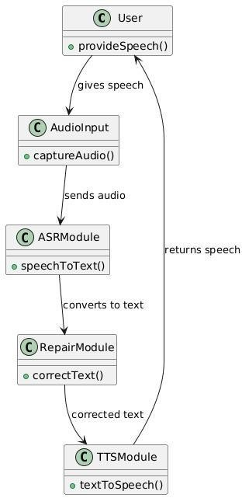
Fig. Class Diagram of STEAMROLLER System

4.2 Architectural Diagram
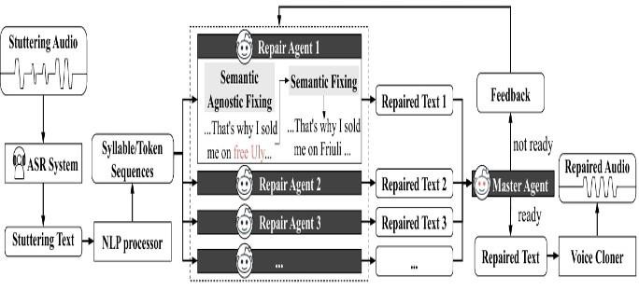
Fig. System Architecture with Multi-Agent Repair Pipeline

4.3. Behavioural Design
a. Sequence Diagram : It shows step-by-step interaction.

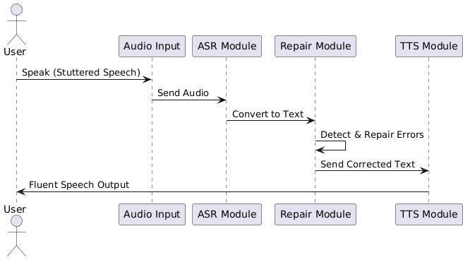

Fig. Sequence Diagram for Stuttered Speech Processing

b. Activity Diagram

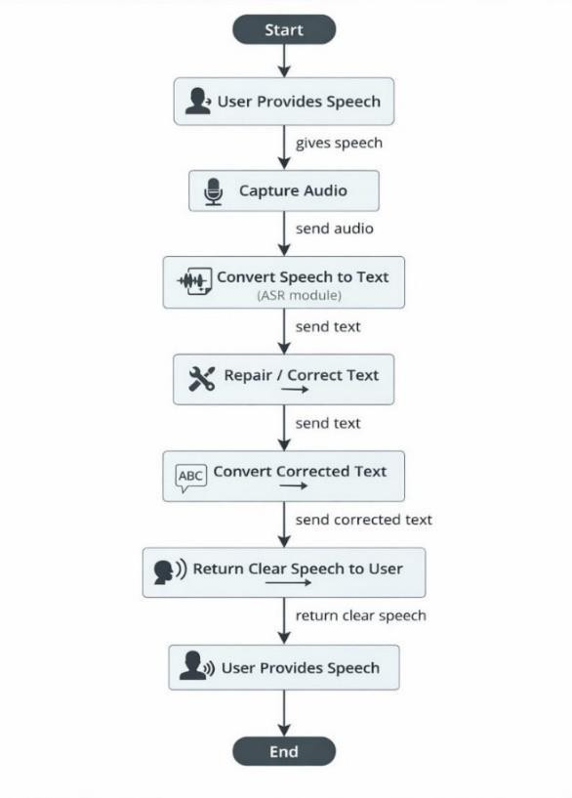
Fig. Activity Diagram of Speech Processing Workflow

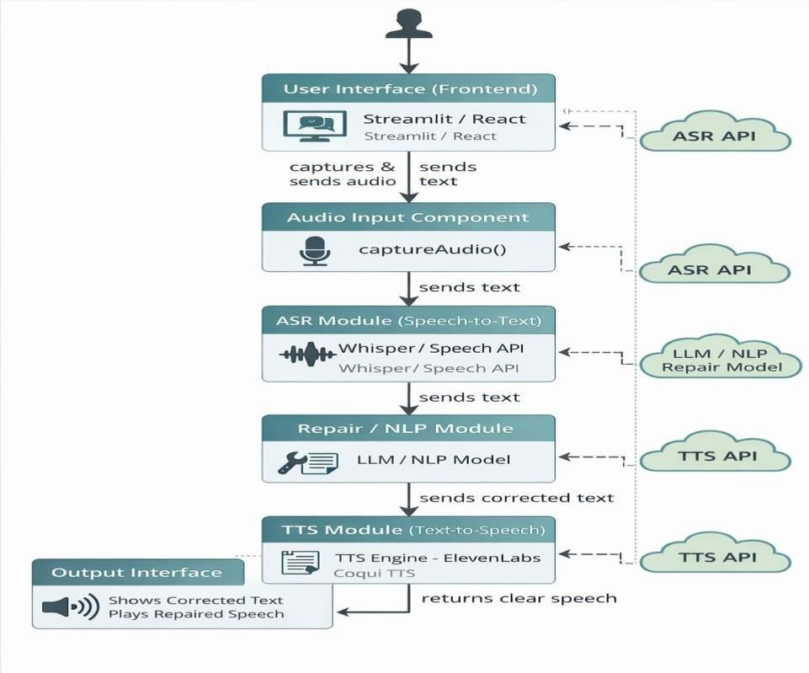
4.4.a Implementation Design : Component Diagram – It show all the components.

Fig. System Components and Integration Diagram
4.4.b Environment Design : Deployment Diagram - It shows where system runs.
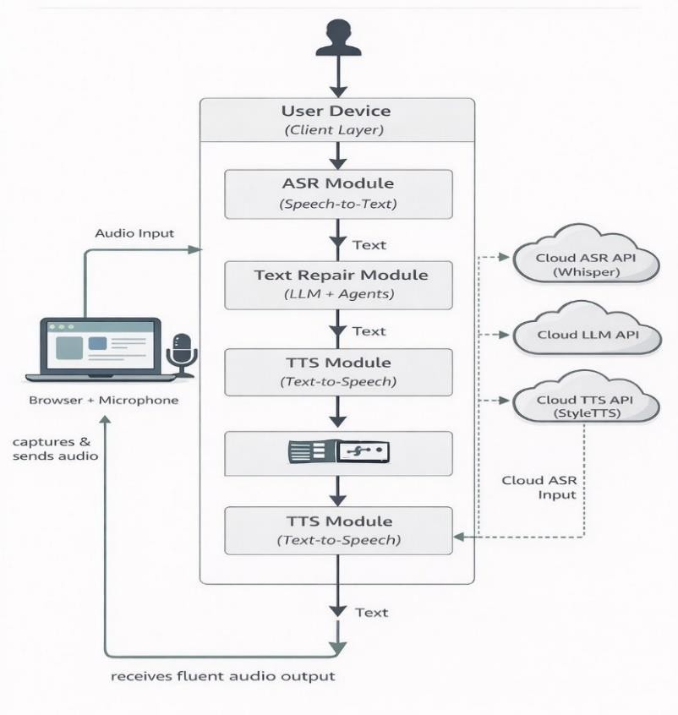
Fig. System Deployment Architecture

5.Algorithms for Functional Requirements
Input:S,prompt
Output: S`best
- S` []
- Initalize repair agents
- Ready FALSE
- While – Ready do
- for all agent ∈ repair agents do
- S`.append(agent.repair_text(S,prompt)
- end for
- Master Result MasterAgent(S`)
- if masterResult.eavaluation then
- Ready TRUE
- else
- S S`
- Prompt masterResult.feedback()
- end if
- end while
- return masterResult.S`best
6. References
- STEAMROLLER: A Multi-Agent System for Inclusive Automatic Speech Recognition for People Who Stutter, arXiv, 2026 by Z. Xu, Y. Liu, Y. Li, L. Shi, K. Wang, and Y.

- A. Radford et al., “Robust Speech Recognition via Large-Scale Weak Supervision,” in Proc. International Conference on Machine Learning (ICML), 2023.

- “StyleTTS 2: Towards Human-Level Text-to-Speech through Style Diffusion,” in Proc. Neural Information Processing Systems (NeurIPS), 2023 by Y. A. Li, C. Han, V. Raghavan, G. Mischler, and N. Mesgarani.

- “FluencyBank: A Resource for Fluency Research,” Journal of Fluency Disorders, 2018 by N. B. Ratner and B. MacWhinney,

-----------------------------

