- Difference between Frontend, Backend, and Full-Stack Developmen
Frontend development deals with the visual part of a website — what users see and interact with, using HTML, CSS, and JavaScript. Backend development focuses on server-side logic, databases, and APIs — for example, Node.js managing data from a website. Full-stack developers handle both sides, such as a developer building both the interface and the database for an e-commerce site.

- Client-Server Model Diagram
In the client-server model, the client (browser) sends a request to the server, and the server processes it and returns the required data. The client then displays this data to the user. Example: A browser requests a webpage from a hosting server.

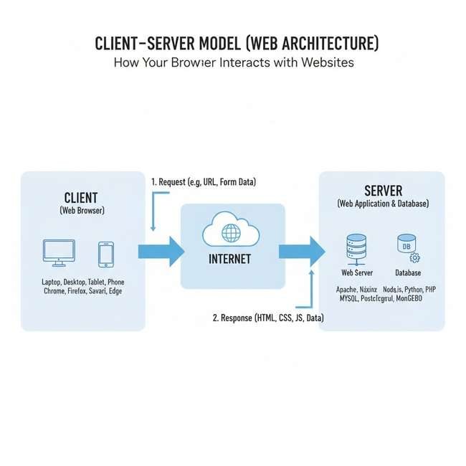

- Browser Request Process
When a browser requests a web page, it sends an HTTP request to the server. The server responds with HTML, CSS, and JavaScript files. The browser then renders these files to visually display the webpage to the user.
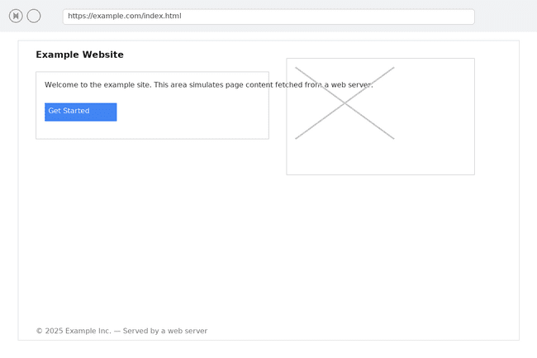

- Tools for Web Development
Essential tools include: VS Code (code editor), Git (version control), Node.js (runtime for JavaScript), Browser (testing), and XAMPP (local server). Each helps build, test, and manage web applications efficiently.

- What is a Web Server
A web server stores and delivers web content to users through HTTP. Examples include Apache, Nginx, and Microsoft IIS. They handle requests and send web pages or APIs to clients.

- Developer Roles
A frontend developer designs the user interface; a backend developer manages databases and server logic; a database administrator (DBA) maintains, secures, and optimizes the database systems.

- VS Code Setup
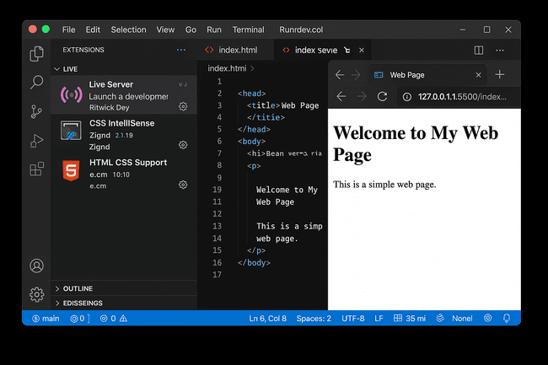

- Static vs Dynamic Websites
Static websites display fixed content coded directly in HTML and CSS, such as a portfolio site. Dynamic websites update content automatically using databases and scripts — for example, Facebook or YouTube.

- Web Browsers and Rendering Engines
Five browsers: Google Chrome (Blink), Mozilla Firefox (Gecko), Safari (WebKit), Microsoft Edge (Blink), and Opera (Blink). Rendering engines interpret and display web code differently, affecting performance and appearance.

- Web Architecture Flow Diagram
In basic web architecture, the client sends a request via a browser to the server. The server processes it, communicates with the database through APIs, and sends the response back to the client for display
