OpenMatch: A Harness-Independent, Open-Weight LLM Framework
for Explainable Career Guidance
CSE 573: Semantic Web Mining Project
Aditya Umesh Upadhyay  Arizona State University  aupadh47@asu.edu | Name1  Arizona State University  TBD | Name2  Arizona State University  TBD | Name3  Arizona State University  TBD | Name4  Arizona State University  TBD

Abstract: Prior LinkedIn-Assistant-style systems in this space wire resume parsing, job matching, and knowledge-graph reasoning to a single proprietary LLM (GPT, Gemini, or Claude), leaving no answer to whether a cheaper, self-hostable model would work just as well, and no clean way to swap models without touching the whole pipeline. OpenMatch takes the opposite architectural bet: the agent harness — orchestration, tools, state, and verification — is kept stable, while each task (parsing, knowledge-graph extraction, matching, conversation) is routed to an open-weight model chosen by capability, privacy, and cost. Knowledge-graph triples are extracted directly from unstructured resume and job-posting text through an LLM-driven chunk-extract-standardize-infer pipeline rather than assumed from pre-structured fields, and a lightweight LoRA fine-tuning experiment tests whether a small open model can match larger zero-shot models on structured extraction. We report ranking quality (Precision@K, nDCG, MRR), extraction accuracy (Precision/Recall/F1), and — as the project's central empirical contribution — cost and latency across open-weight model tiers benchmarked against a proprietary baseline.
Index Terms: Open-Weight LLMs, Harness-Independent Agents, Knowledge Graph Extraction, Retrieval-Augmented Generation, LoRA Fine-Tuning, Job Matching
I. PROBLEM DEFINITION
Existing LinkedIn-Assistant-style course projects and commercial tools share a common architectural pattern: a single proprietary LLM sits at the center of resume parsing, job matching, and conversational recommendation [1], [2]. This pattern creates three problems that none of these systems measure directly. First, vendor lock-in: swapping the model means re-validating every downstream prompt and pipeline stage. Second, unpredictable, seat- or token-based cost at scale, with resume PII sent to a third-party API for every parse. Third — and most importantly for a research project — no empirical evidence of how much accuracy is actually lost, if any, by using an open-weight model instead of a proprietary one.
We define the core problem as building and evaluating a system that:
- Keeps the agent harness (orchestration, tool use, state, verification) stable and model-agnostic, so any sub-task can be routed to a different model without redesigning the pipeline.
- Builds its knowledge graph directly from unstructured resume and job-posting text, using LLM-driven Subject–Predicate–Object (SPO) extraction rather than assuming clean, pre-structured input fields [2].
- Quantifies the accuracy, latency, and cost trade-off of open-weight models (served locally via Ollama and via ASU's Voyager endpoint) against a proprietary baseline, for both parsing and matching.
- Tests whether a small, LoRA-fine-tuned open model can close the gap with larger zero-shot models on structured extraction, at a fraction of the inference cost.
II. DATA SETS
A. Primary Sources
We combine open datasets with team-seeded data so the pipeline can be validated end to end before scaling up.
- LinkedIn Job Postings (Kaggle, 2023–2024): approximately 124K postings with title, company, description, qualifications, and location fields.
- Resume corpus (e.g., the 54K Resume Dataset, Kaggle CC0): anonymized résumés spanning multiple professions, used to validate the parser across formats.
- Team-seeded resumes: our own résumés, used first to sanity-check entity recognition and matching before touching external data.
- Hand-annotated benchmark set (300–500 résumé/job pairs): gold-standard structured fields and relevance labels, built by the team, used both to evaluate zero-shot models and to train the LoRA fine-tuning experiment (Sec. III-E).
B. Derived Data
From the primary sources we generate a CV-Parsed JSONL file, a Job-Parsed JSONL file, and a raw SPO-triple JSONL file extracted directly from unstructured text spans (not only from structured fields). These populate the Neo4j knowledge graph and the vector store used for retrieval.
III. STATE-OF-THE-ART METHODS AND ALGORITHMS
A. Harness-Independent Multi-Agent Architecture
A coding or career-assistant model and its harness are different layers: the model supplies language and reasoning, while the harness organizes orchestration, tool use, state, and verification around it. Open harnesses such as OpenCode and Cline already keep this separation for coding agents, routing among open models such as Kimi K2.5, Qwen, GLM-5.2, and Nemotron without rebuilding the surrounding workflow. OpenMatch applies the same separation to a career-assistant harness: Parser, KG-Build, Matching, Conversation, and Critic agents call a model-router interface rather than a specific model, so a model can be swapped or A/B-tested by editing one configuration file (Fig. 1).
B. Open-Weight Model Routing
Ollama runs open-weight models locally (Llama, Mistral, Gemma, DeepSeek) behind an OpenAI-compatible REST API, which keeps résumé data on-device for privacy-sensitive steps. For heavier or cloud-hosted inference we use ASU Voyager, a no-cost, OpenAI-compatible endpoint available to ASURITE users. The router can additionally direct agentic sub-tasks to larger open models (Kimi K2.5, Qwen, GLM-5.2, Nemotron) that enterprises already evaluate for agentic coding workloads, with reported cost savings of roughly 50–80% versus proprietary alternatives.
C. LLM-Driven Knowledge Graph Extraction from Unstructured Text
Text is split into overlapping chunks (approximately 500 words, with overlap to preserve boundary context); each chunk is sent to an LLM prompted to return a JSON array of Subject–Predicate–Object triples with short (1–3 word) predicates. Entity standardization first applies basic normalization (lowercasing, trimming) and then LLM-based clustering to merge variant mentions (e.g., “AI” and “artificial intelligence”). Relationship inference then fills gaps two ways: rule-based transitive closure (if A enables B and B drives C, infer A influences C) and LLM-assisted bridging between otherwise disconnected subgraphs, with inferred edges kept visually distinct from explicit ones. This pipeline is applied directly to résumé and job-posting free text, rather than only to pre-structured Kaggle fields.
D. Retrieval and Matching
Résumés and postings are encoded with an open sentence-embedding model (e.g., BGE or GTE) rather than a proprietary embedding API; cosine similarity between vectors produces a first-pass relevance score, normalized to a 0–100 scale for interpretability. A lightweight re-ranker then fuses this score with knowledge-graph features — shortest skill-path length and node centrality — so that the final ranking reflects both lexical/semantic similarity and structured reasoning over the graph.
E. Fine-Tuning Experiment
Following standard SFT+LoRA guidance, we freeze a small open base model and train low-rank adapter weights on the hand-annotated benchmark set (Sec. II-A) for the structured-extraction task. We evaluate the fine-tuned model against zero-shot open and proprietary baselines on held-out extraction accuracy and latency, not only training loss, to test whether fine-tuning a small model is a viable substitute for calling a much larger model at every request.
IV. RESEARCH PLAN
The plan is organized into seven research threads, R1–R7, executed roughly in sequence with overlap between adjacent threads. Fig. 1 shows the resulting system architecture, from the chat interface down through the stable agent harness, the model router, the three open-weight model tiers, and the data/output layers.
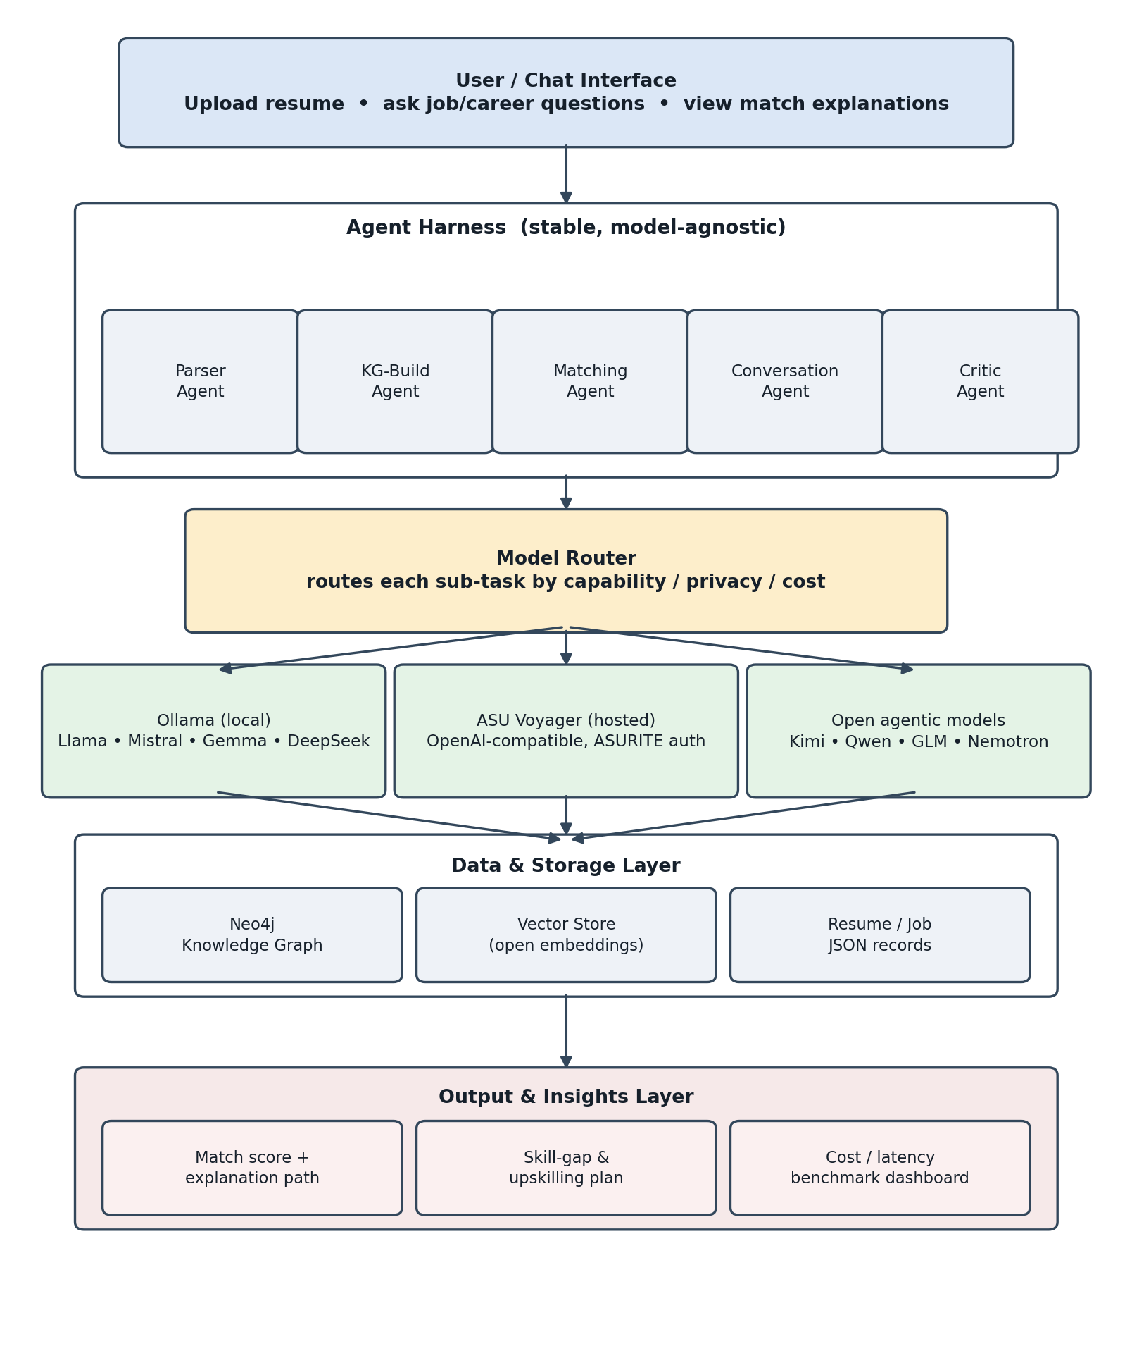
Fig. 1. OpenMatch system architecture: stable agent harness, capability/privacy/cost-aware model router, and open-weight model tiers.
- R1 — Data ingestion & annotation: pull Kaggle datasets, seed with team résumés, build the 300–500-pair gold annotation set.
- R2 — Parsing benchmark: heuristic baseline vs. Ollama-hosted vs. ASU-Voyager-hosted models, compared on field-extraction accuracy and latency.
- R3 — Unstructured-to-KG pipeline: chunk, extract SPO triples, standardize entities, infer relationships, load into Neo4j.
- R4 — Retrieval baseline: open-model embeddings + cosine similarity, then the KG-aware re-ranker.
- R5 — LoRA fine-tuning experiment on the annotated set, compared against the R2 zero-shot baselines.
- R6 — Harness integration: Parser, KG-Build, Matching, Conversation, and Critic agents wired to the model router.
- R7 — Cost/latency instrumentation: log tokens, wall-clock time, and estimated cost per document across every model tier.
V. EVALUATION PLAN
- Extraction accuracy: Precision/Recall/F1 for résumé and job-field extraction, compared across heuristic, Ollama, ASU Voyager, and the LoRA-fine-tuned model.
- Matching quality: Precision@K, nDCG, and MRR against team-labeled relevance judgments, in line with job-recommender evaluation practice [1].
- Knowledge-graph quality: coverage of skills/roles/companies and a human spot-check of triple correctness and explanation coherence.
- Cost and latency: tokens, wall-clock time, and estimated dollar cost per document across model tiers — the project's headline empirical result.
- Human evaluation: a small Likert-scale (1–5) user study on the clarity and trustworthiness of match explanations and skill-gap suggestions.
VI. PROJECT TIMELINE
TABLE I
Project Timeline for OpenMatch Development
Wk | Phase | Description
1–2 | Setup & data | Stand up Ollama/ASU Voyager/Neo4j; pull datasets; begin gold annotation set; heuristic parser baseline.
3–4 | Parsing bench. | Implement and benchmark heuristic, Ollama, and ASU Voyager parsers on field accuracy and latency.
5 | KG pipeline | Chunk, extract SPO triples, standardize entities, infer relationships; load into Neo4j.
6 | Fine-tuning | Open-model embeddings + cosine baseline; KG-aware re-ranker; run LoRA fine-tuning experiment.
7 | Integration | Wire Parser/KG-Build/Matching/Conversation/Critic agents to the model router; instrument cost/latency.
8 | Eval. & demo | Run human evaluation; finalize report, demo video, and slides.

VII. DIVISION OF WORK
TABLE II
Task Assignment
Task | Members
Data collection & annotation | Name1, Name3
Parsing benchmark (heuristic, Ollama, Voyager) | Name2, Aditya Upadhyay
Unstructured-to-KG pipeline & Neo4j | Name1, Name4
Embeddings, matching & re-ranking | Name3, Name2
LoRA fine-tuning experiment | Name2, Name1
Harness, model router & conversational UI | Aditya Upadhyay, Name4
Cost/latency benchmarking & evaluation | Name4, Name3, Aditya Upadhyay

REFERENCES
[1] D. Ç. Ertuğrul and S. Bitirim, “Job recommender systems: a systematic literature review, applications, open issues, and challenges,” Journal of Big Data, vol. 12, no. 140, 2025.
[2] Z. Sun, J. Zhang, Y. Hu, and Z. Yang, “TalentNet: A knowledge graph for job information extraction, representation, and inference,” IEEE Trans. on Knowledge and Data Engineering, vol. 33, no. 7, pp. 2831–2845, 2021.
[3] P. Lewis, E. Perez, A. Piktus, et al., “Retrieval-augmented generation for knowledge-intensive NLP tasks,” in Proc. NeurIPS, 2020.
[4] W. Hamilton, R. Ying, and J. Leskovec, “Inductive representation learning on large graphs,” in Proc. NeurIPS, 2017, pp. 1024–1034.
[5] P. Veličković, G. Cucurull, A. Casanova, A. Romero, P. Liò, and Y. Bengio, “Graph attention networks,” in Proc. ICLR, 2018.
[6] M. Alruwaili, F. Alshammari, and A. Alotaibi, “An intelligent approach for résumé information extraction,” J. King Saud Univ. – Comput. Inf. Sci., vol. 32, no. 9, 2020.
[7] E. J. Hu, Y. Shen, P. Wallis, et al., “LoRA: Low-Rank Adaptation of Large Language Models,” in Proc. ICLR, 2022.
[8] T. Dettmers, A. Pagnoni, A. Holtzman, and L. Zettlemoyer, “QLoRA: Efficient Finetuning of Quantized LLMs,” in Proc. NeurIPS, 2023.
[9] S. Gururangan, A. Marasović, S. Swayamdipta, et al., “Don’t Stop Pretraining: Adapt Language Models to Domains and Tasks,” in Proc. ACL, 2020.
[10] H. Yuan, Y. Yu, S. Wang, K. Li, and S. Ji, “Explainability in graph neural networks: A survey,” arXiv:2012.15445, 2020.
[11] R. Rafailov, A. Sharma, E. Mitchell, et al., “Direct Preference Optimization: Your Language Model is Secretly a Reward Model,” in Proc. NeurIPS, 2023.
[12] Ollama, “Ollama Documentation,” 2025. [Online]. Available: https://github.com/ollama/ollama
[13] Arizona State University Research Computing, “ASU Voyager: LLM API Access,” ASU RC Documentation, 2025. [Online]. Available: https://docs.rc.asu.edu
[14] Hugging Face, “The Alignment Handbook,” GitHub, 2024. [Online]. Available: https://github.com/huggingface/alignment-handbook
[15] G. Rajababu, “Transforming Unstructured Text into Interactive Knowledge Graphs with LLMs,” AI-Knowledge-Graph project documentation, 2024.

