# 

# **Assessment**

# **Ansible**

Trainee Name : Aditya Upadhyay

Newers ID : 3978

Mentor Name : Tarun Saxena

College : UPES

**1. Run Ansible Ad-hoc commands:**

**1.1 To execute command in bash and see the result**

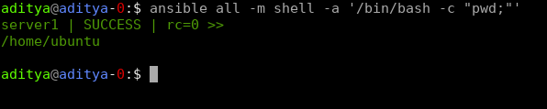

**1.2 To check all running processes on node.**

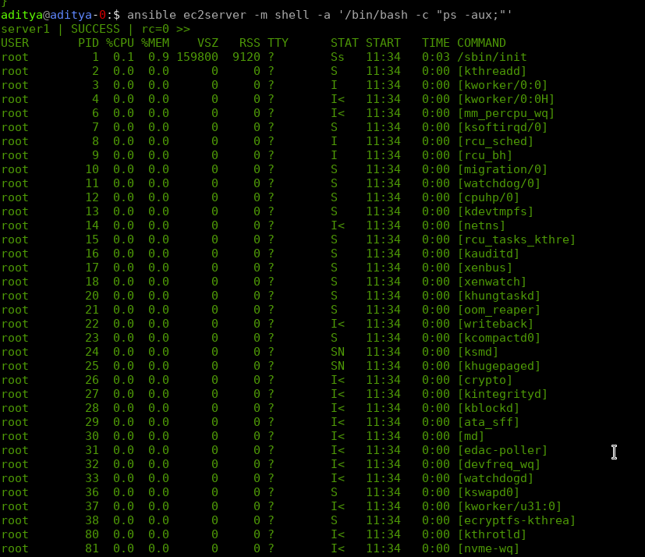

**1.3 To copying files to multiple nodes concurrently.**

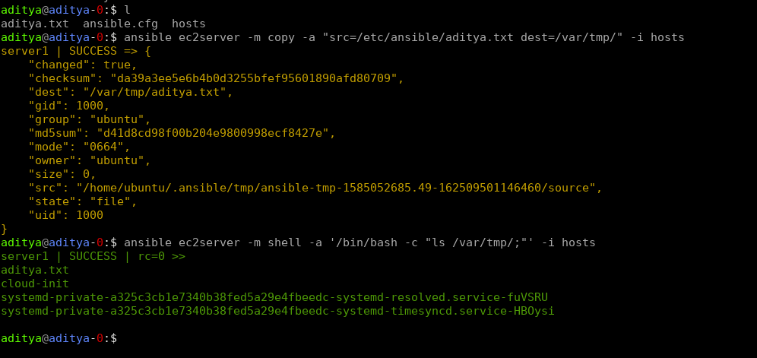

**1.4 To add and delete users.**

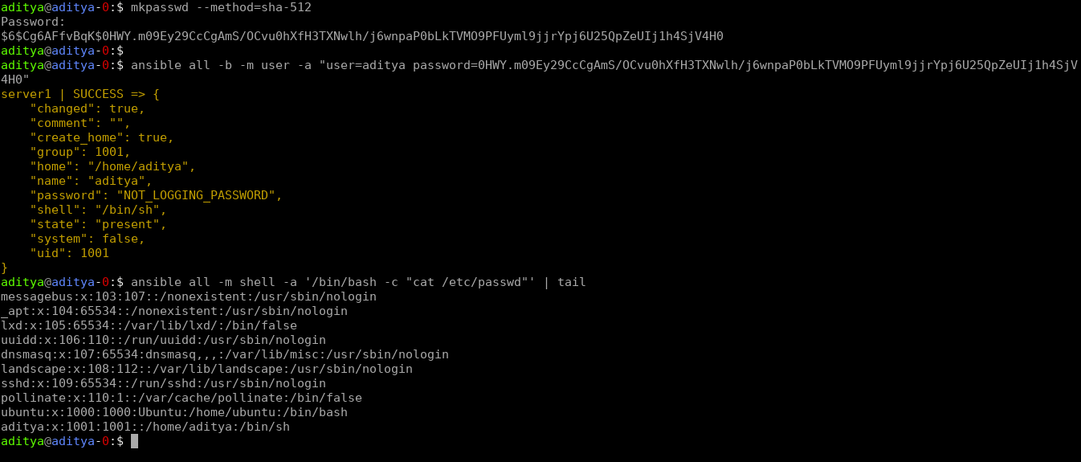

**2. Create nginx ansible-playbook and run the node, also check if nginx service and default page is running or not.**

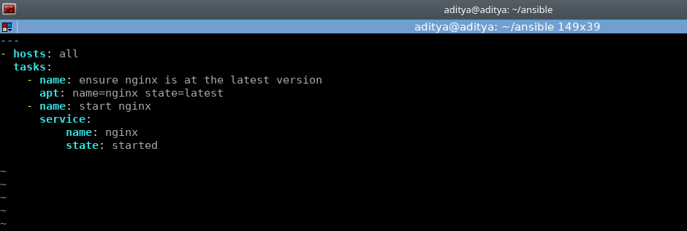

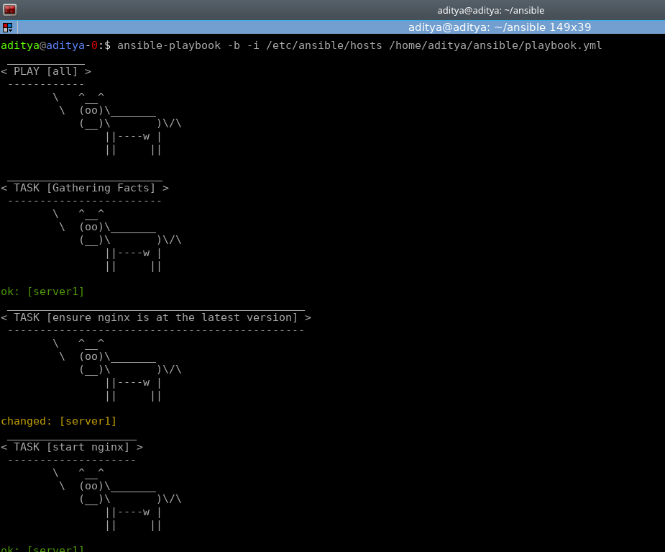

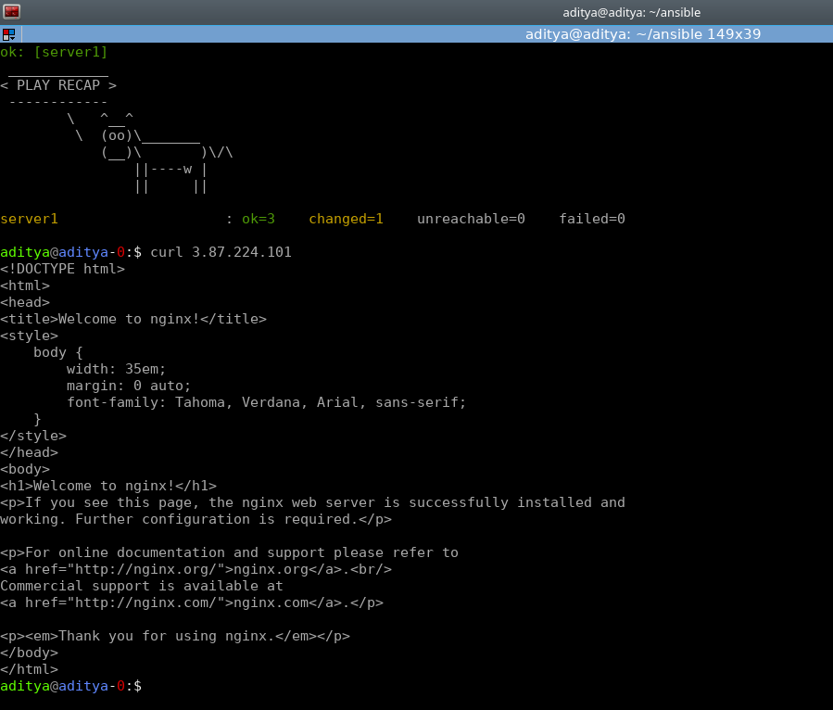

**3. Create the roles for the same playbook and use a custom conf file and index.html.**

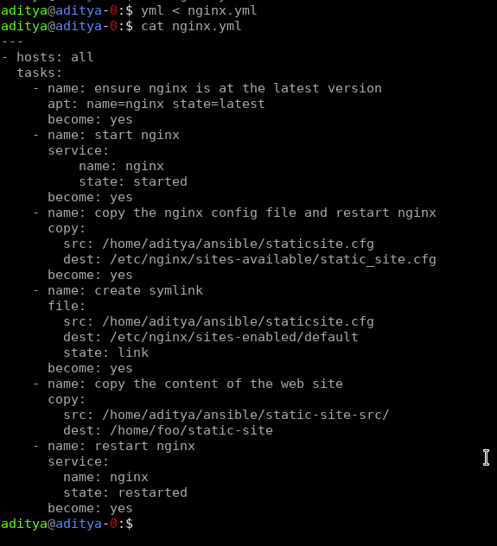

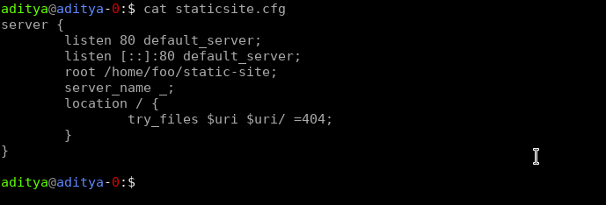



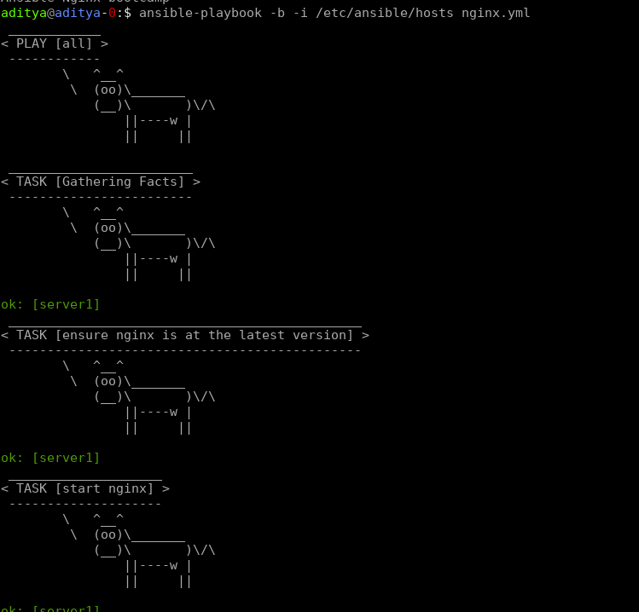

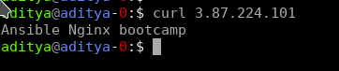

**4. Using loops, copy multiple files from ansible machine to remote node.**

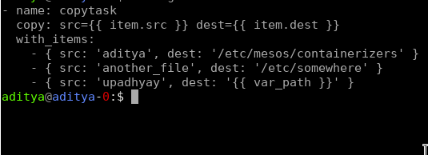

**5. Write a playbook to demonstrate the precedence of default and var file, override them from CLI.**





