# 

# 

# **Assessment**

# **Docker**

Trainee Name : Aditya Upadhyay

Newers ID : 3978

Mentor Name : Tarun Saxena

College : UPES

1. **Set the base image to Ubuntu**

* **Add File Author / Maintainer**
* **Install Nginx**
* **Install necessary tools: vim wget curl net-tools**
* **Remove the default Nginx configuration file**
* **Copy a configuration file from the current directory**
* **Expose ports (80)**
* **Set the default command to execute Nginx when creating a new container**

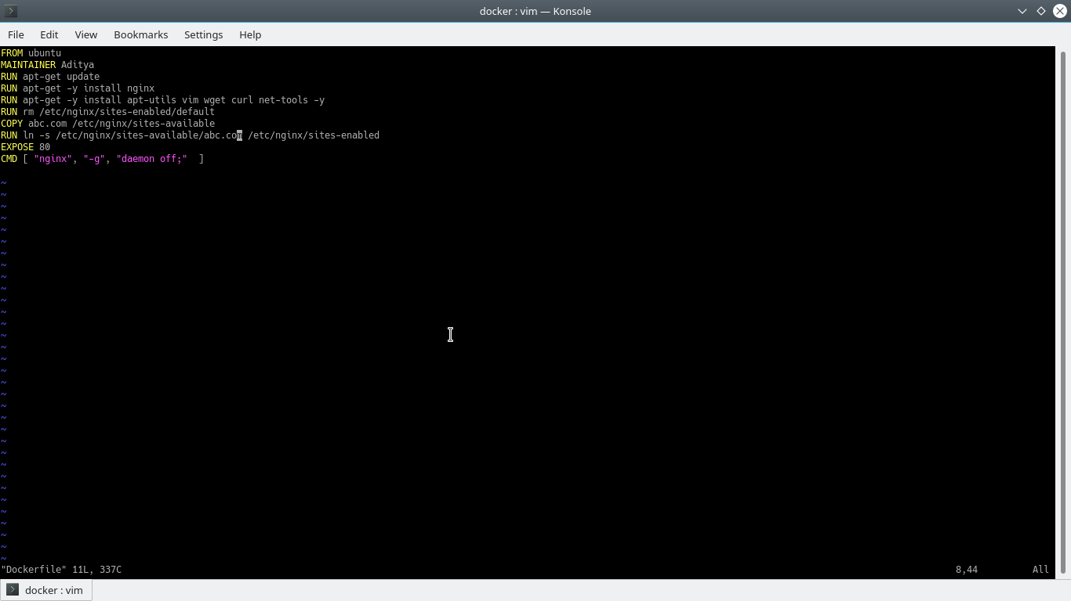

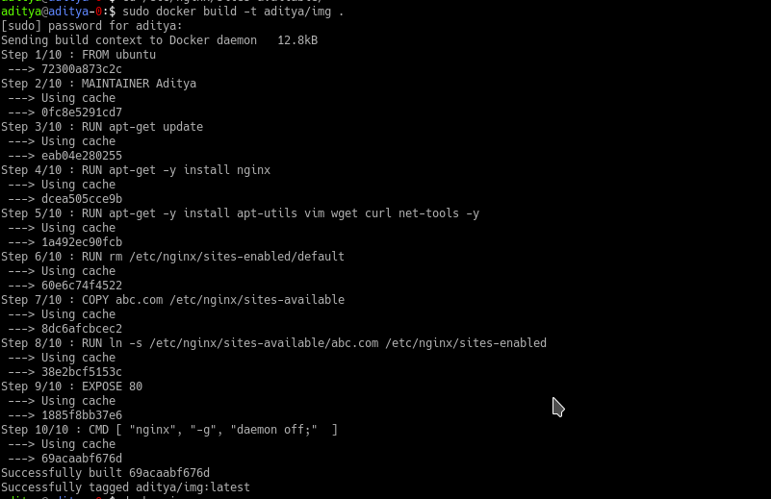

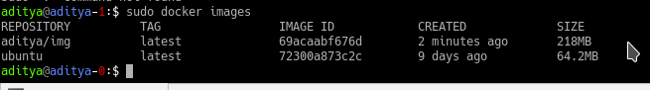

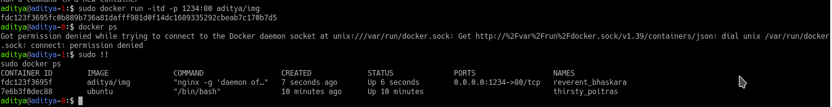

1. **What is the difference between 'RUN', 'CMD', & 'ENTRYPOINT' in dockerfile?**

**RUN:** executes the command(s) that you give in a new layer and creates a new image. This is mainly used for installing a new package.

**CMD:** is the default command to be run by the entrypoint. It sets default command and/or parameters, however, we can overwrite those commands or pass in and bypass the default parameters from the command line when docker runs.

**ENTRYPOINT:** is the program to run the given command. It is used when yo want to run a container as an executable.instruction allows you to configure a container that will run as an executable. It looks similar to CMD, because it also allows you to specify a command with parameters. The difference is ENTRYPOINT command and parameters are not ignored when Docker container runs with command line parameters. (There is a way to ignore ENTRYPOINT, but it is unlikely that you will do it.)

1. **How to connect docker client to docker daemon running on other host?**

