# 

# **Assessment**

# **Drupal**

Trainee Name : Aditya Upadhyay

Newers ID : 3978

Mentor Name : Tarun Saxena

College : UPES

**Ques1. Setup Wordpress with Apache + php fpm.**

*Install a LAMP stack: WordPress will need a web server, a database, and PHP in order to correctly function. Setting up a LAMP stack (Linux, Apache, MySQL, and PHP) fulfills all of these requirements.

**STEP 1:** Creating a MySQL Database and User for WordPress

|  |
| --- |
| mysql -u root -p  mysql> CREATE DATABASE wordpress DEFAULT CHARACTER SET utf8 COLLATE utf8_unicode_ci; Query OK, 1 row affected (0.01 sec)  mysql>  mysql> GRANT ALL ON wordpress.* TO 'wordpressuser'@'localhost' IDENTIFIED BY 'password'; Query OK, 0 rows affected, 1 warning (0.00 sec)  mysql> FLUSH PRIVILEGES; Query OK, 0 rows affected (0.01 sec)  mysql> EXIT; Bye |

**STEP 2:** Installing Additional PHP Extensions

|  |
| --- |
| **sudo apt install php-curl php-gd php-mbstring php-xml php-xmlrpc php-soap php-intl php-zip** |

**STEP 3:**We will restart Apache to load these new extensions in the next section. If you are returning here to install additional plugins, you can restart Apache now by typing



**STEP 4:** Open the Apache configuration file for your website:

|  |
| --- |
| **sudo nano /etc/apache2/sites-available/wordpress.conf** |

**STEP 5:**To allow .htaccess files, we need to set the AllowOverride directive within a Directory block pointing to our document root. Add the following block of text inside the VirtualHost block in your configuration file, being sure to use the correct web root directory:

|  |
| --- |
| **<Directory /var/www/wordpress/>  AllowOverride All </Directory>** |

**STEP 6:** Enabling the Rewrite Module:Next, we can enable mod_rewrite so that we can utilize the WordPress permalink feature:

|  |
| --- |
| **sudo a2enmod rewrite** |

**STEP 7:**Before we implement the changes we’ve made, check to make sure we haven’t made any syntax errors:



**STEP 8:** Restart Apache to implement the changes:

|  |
| --- |
| **sudo systemctl restart apache2** |

**STEP 9:** Downloading WordPress





**STEP 11:** Configuring the WordPress Directory

We’ll start by giving ownership of all the files to the www-data user and group. This is the user that the Apache webserver runs as, and Apache will need to be able to read and write WordPress files in order to serve the website and perform automatic updates.

|  |
| --- |
| **sudo chown -R www-data:www-data /var/www/wordpress** |

|  |
| --- |
| **sudo nano /var/www/wordpress/wp-config.php** |

**STEP 12:** Create wordpress.conf file in /etc/apache2/sites-availabe

|  |
| --- |
| <VirtualHost *:80>  ServerAdmin admin@example.com  DocumentRoot /var/www/wordpress  ServerName example.com  ServerAlias www.example.com   <Directory /var/www/wordpress/>  Options FollowSymlinks  AllowOverride All  Require all granted  </Directory>   ErrorLog ${APACHE_LOG_DIR}/error.log  CustomLog ${APACHE_LOG_DIR}/access.log combined   <Directory /var/www/wordpress/>  RewriteEngine on  RewriteBase /  RewriteCond %{REQUEST_FILENAME} !-f  RewriteRule ^(.*) index.php [PT,L]  </Directory> </VirtualHost> "/etc/apache2/sites-available/wordpress.conf" 23L, 620C written 8,25 All |

**STEP 13:** Check wordpress.

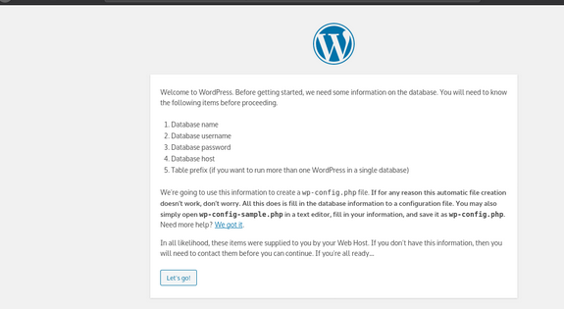

**Q 2) Setup Drupal with Nginx and Perform FPM Configuration**

**STEP 1:** Install Nginx

Install PHP-5.3.29 with PHP-FPM

Install MySQL

**STEP 2:** To create a database named "drupal" that is accessible by user "drupaluser" with password "drupalpassword".

|  |
| --- |
| mysql -u root -p |

|  |
| --- |
| mysql> create database drupal; mysql> create user 'drupaluser'@'localhost' identified by 'drupal password'; mysql> use drupal; mysql> grant all on drupal.* to 'drupaluser'@'localhost'; |

**STEP 3:** Install and configure Drupal

|  |
| --- |
| cd /tmp && wget  https://ftp.drupal.org/files/projects/drupal-8.3.7.tar.gz |

|  |
| --- |
| sudo tar -xvzf drupal*.gz -C /var/www/html sudo mv /var/www/html/drupal-8.3.7/ /var/www/html/drupal |

**STEP 4:** Configure nginx

|  |
| --- |
| server {  listen 80;  listen [::]:80;  root /var/www/html/drupal;  index index.php index.html index.htm;  server_name drupal.com;    location / {  try_files $uri /index.php?$query_string;  }   location @rewrite {  rewrite ^/(.*)$ /index.php?q=$1;  }   location ~ [^/]\.php(/|$) {  include snippets/fastcgi-php.conf;  fastcgi_pass unix:/var/run/php/php7.4-fpm.sock;  fastcgi_param SCRIPT_FILENAME $document_root$fastcgi_script_name;  include fastcgi_params;  }   location ~ ^/sites/.*/files/styles/ { # For Drupal >= 7  try_files $uri @rewrite;  }   location ~ ^(/[a-z\-]+)?/system/files/ { # For Drupal >= 7  try_files $uri /index.php?$query_string;  } } |

