# 

# 

# **Assessment**

# **EKS**

Trainee Name : Aditya Upadhyay

Newers ID : 3978

Mentor Name : Tarun Saxena

College : UPES

1. **Create eks cluster using eksctl**

**During creation, Specify**

* **Cluster name**
* **Kubernetes version**
* **Control plane role**
* **Subnets for Control Plane**
* **Control Plane security Group**
* **Add tag: owner, purpose on Control Plane**
* **Node Group Name**
* **Node Instance Role**
* **Subnets for Node Group**
* **Node Instance SSH key pair**
* **Node Instance Security Group**
* **Node Instance Instance Type**
* **Node Instance Disk**
* **Add tag: owner, purpose on Node Group**
* **Node Group Size: min, max**

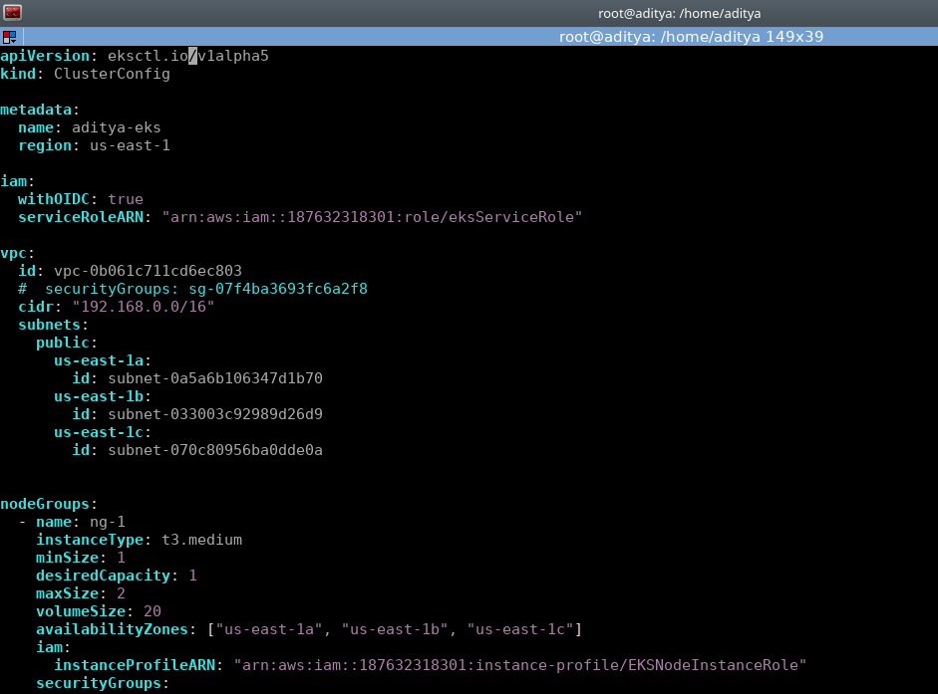

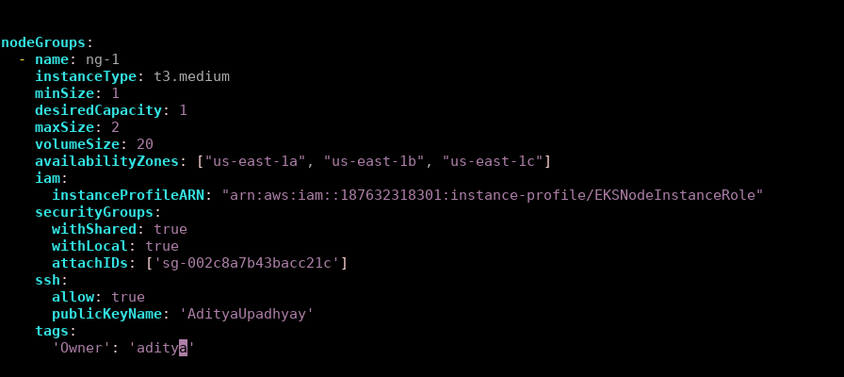

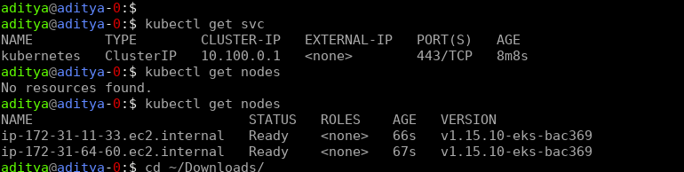

1. **Authentication Management**
   1. **Add new 2 IAM user into the cluster**

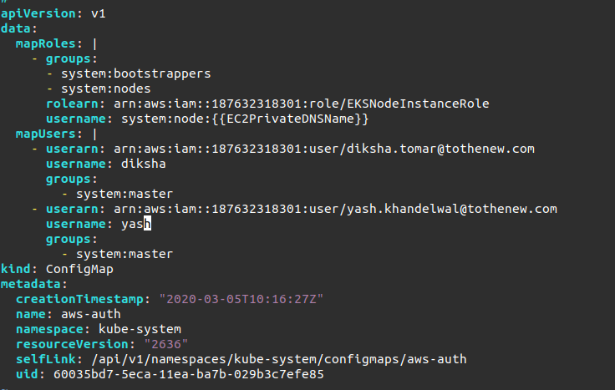

* 1. **Enable a EC2 server to access Cluster master API without using access/secret key**

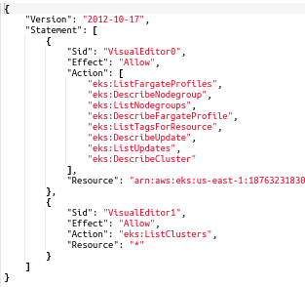

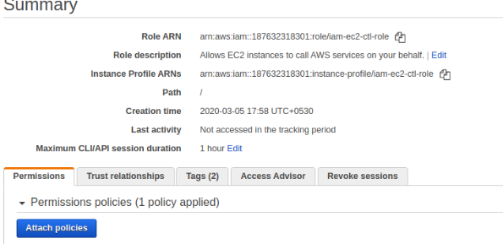

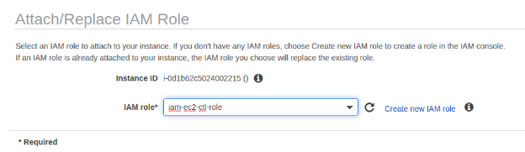

**3. Eksctl command to terminate the stack**

